SUPPLEMENTARY MATERIALS

Table S1: The distribution of respondents across various demographic categories (village, age, education level, tribe, resident status, and gender), providing insights into the characteristics of the surveyed population.
Independent variables |  | Frequency (N) | Percent (%)
Village | Kisiwani | 30 | 16.67
Village | Maore | 30 | 16.67
Village | Karamba | 30 | 16.67
Village | Ndungu | 30 | 16.67
 | Uzambara | 30 | 16.67
 | Mgandu | 30 | 16.67
Age | 18-30 | 37 | 20.6
Age | 31-40 | 85 | 47.2
Age | 41-50 | 42 | 23.3
Age | 51-60 | 13 | 7.2
Age | 61-70 | 3 | 1.7
Education level | Primary school | 70 | 38.9
Education level | Secondary and above | 110 | 61.1
Tribe | Pare | 139 | 77.2
Tribe | Sambaa | 41 | 22.8
Resident status | Resident | 147 | 81.7
Resident status | Immigrant | 33 | 18.3
Gender | Male | 115 | 63.9
Gender | Female | 65 | 36.1

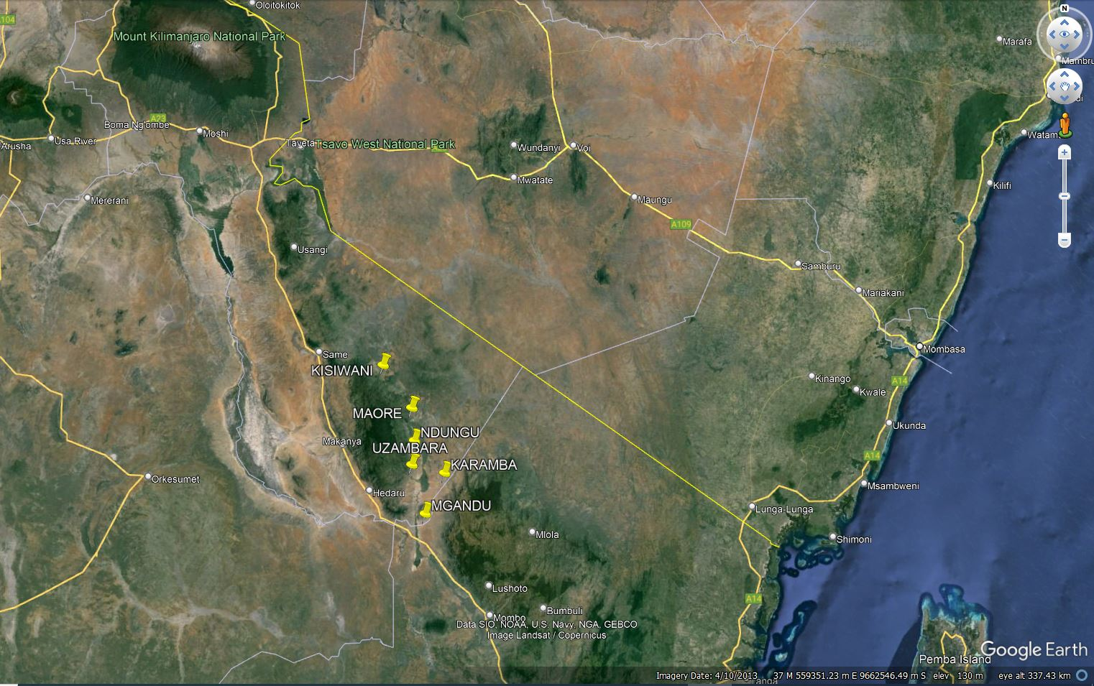
Figure S1: Surveyed villages using Google Erat Pro, showing their distribution on the distance gradient from Mkomazi National Park boundary.

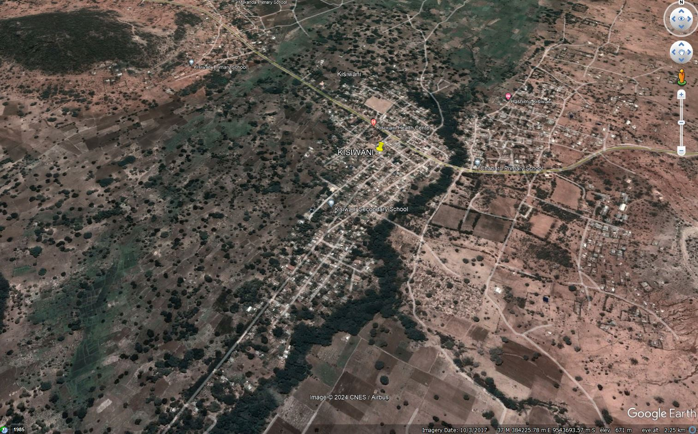
Figure S2: Kisiwani village as an example showing distribution of settlements across various land use plans, including settlements, farms, shrubland, and forest.

