Appendix: Supplementary data
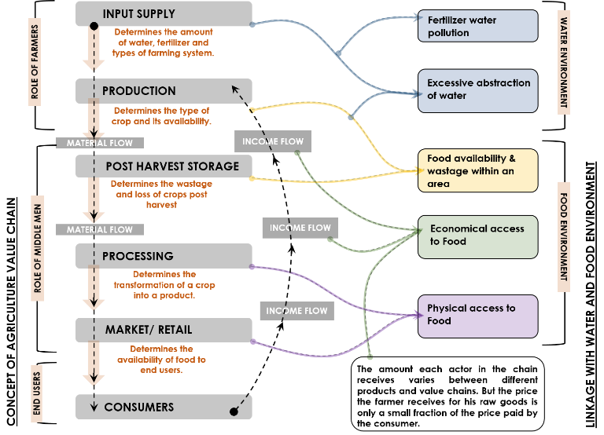
Fig 1: Agriculture value chain links with Water & Food environments (Author generated based on (FAO, 2014))

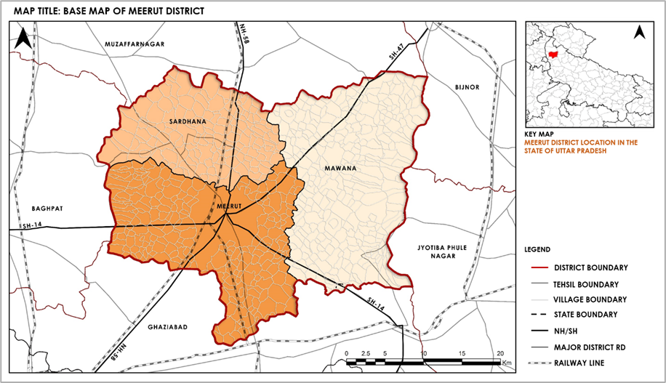
Fig 2: Base map of Study area – Meerut District (Author generated)

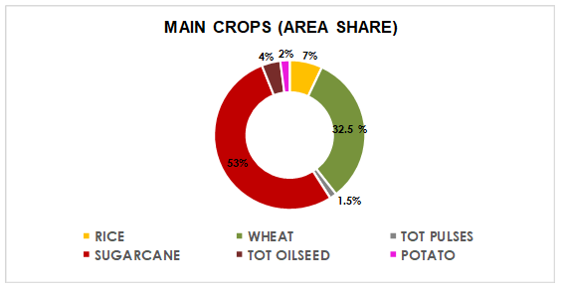
Fig 3: Area wise share of Main Crops in Meerut District
(Author generated based on (Agriculture-Department, 2020))
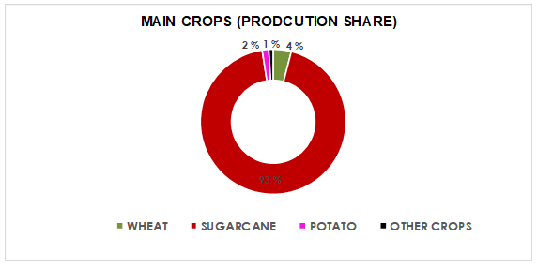
Fig 4: Production wise share of Main Crops in Meerut District
(Author generated based on (Agriculture-Department, 2020))

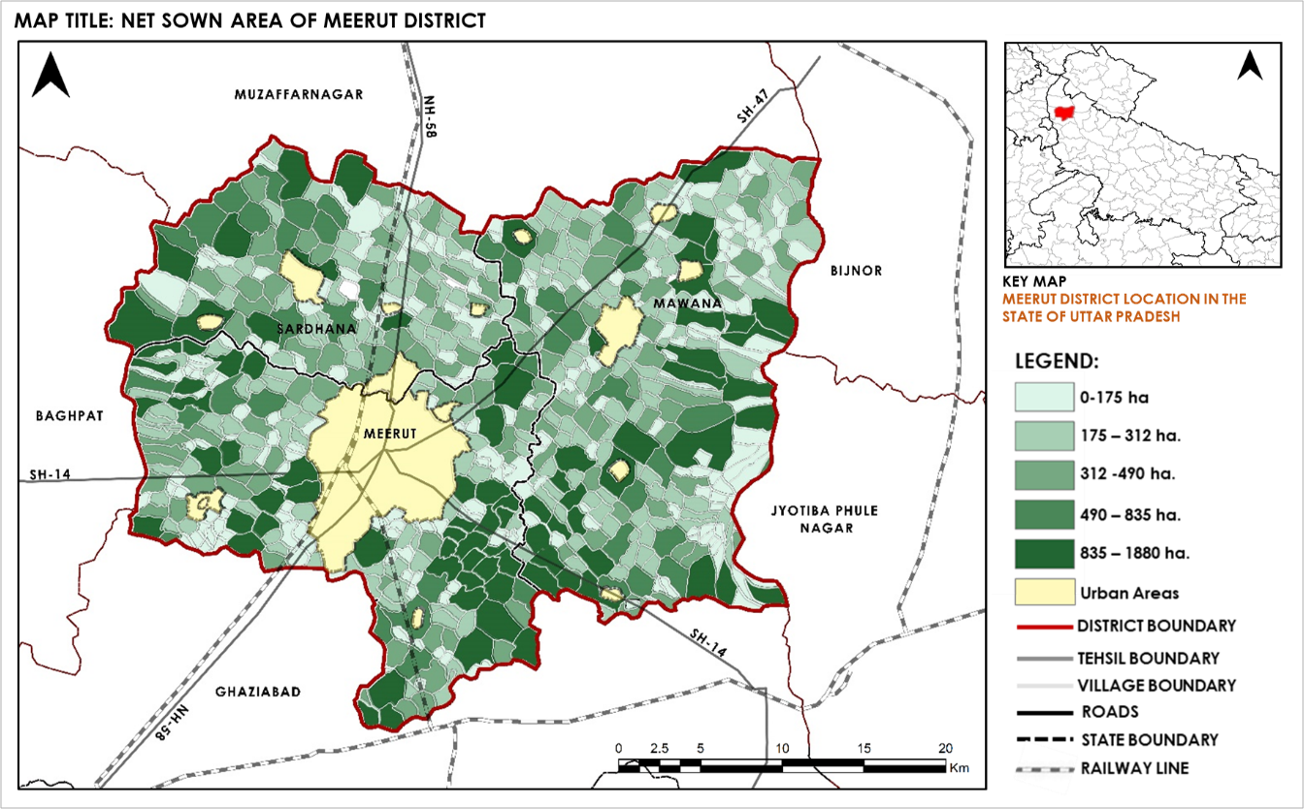
Fig 5: Net Sown Area, Meerut District (Author generated based on (Census, 2011))

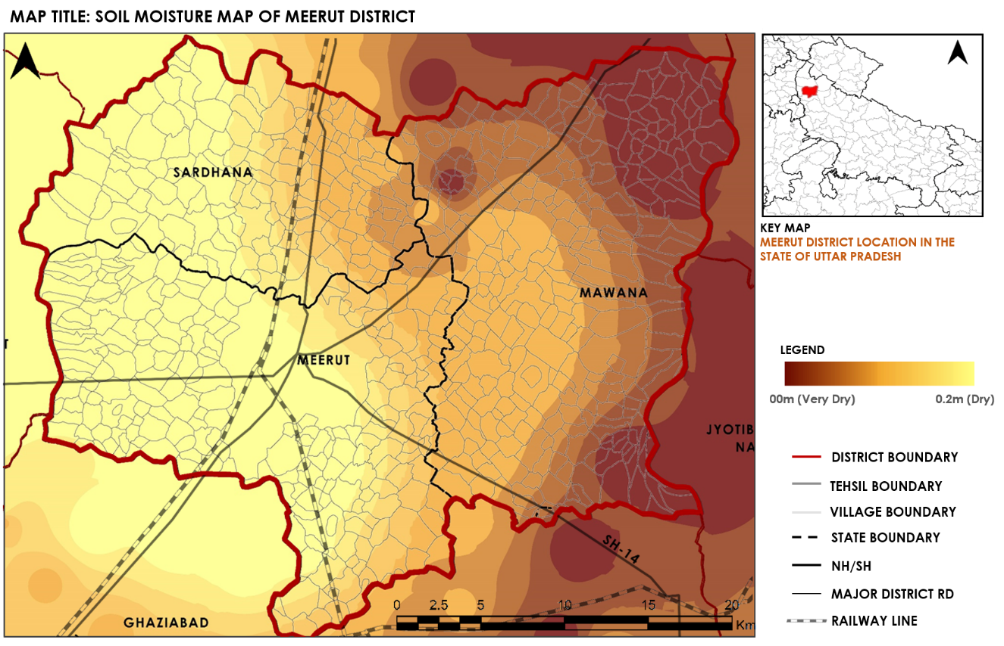
Fig 6: Soil Moisture Map, Meerut District (Author generated based on (UP-NCR Report (2013))
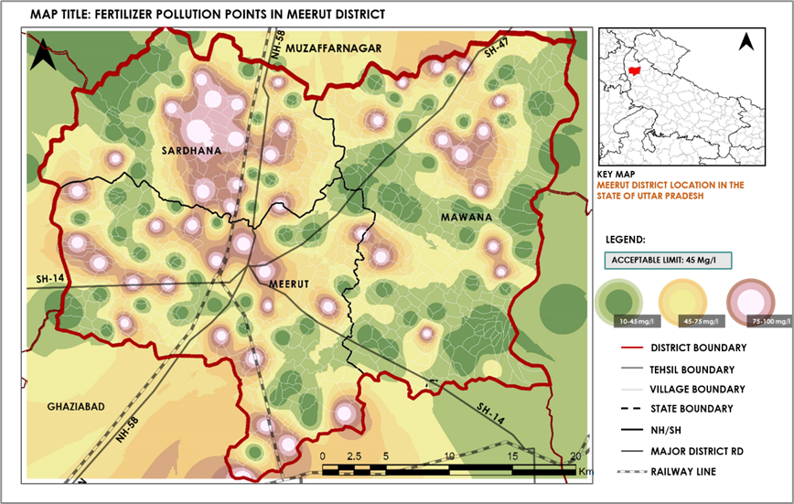
Fig 7: Nitrate concentration points indicating fertilizer pollution across the district, with concentrations observed to exceed the permissible limit of 45 mg/l (Author generated based on Central Ground Water Board, UP-NCR Report (2013), Jal Nigam (2013))

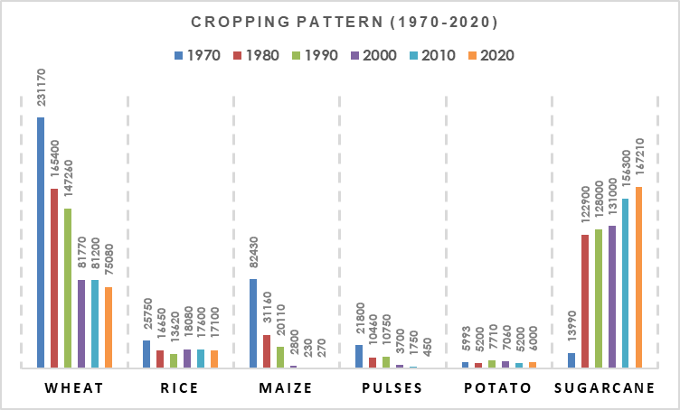
Fig 8: Bar graph depicting the area under crop cultivation (in hectares) from 1970 to 2020, highlighting the evolving cropping patterns in the Meerut District (Author generated based on Ministry of Agriculture, Department of Economics, Lucknow, Uttar Pradesh (1970-2020))
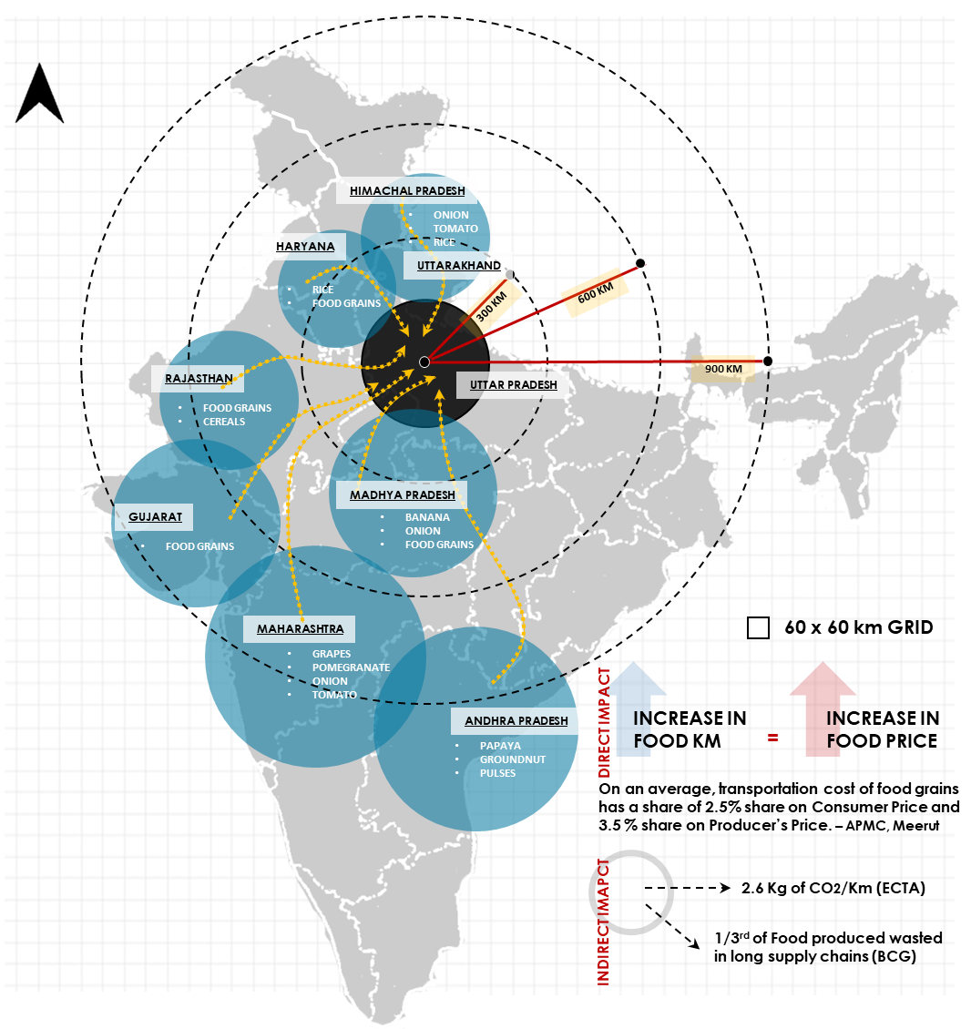
APMC – Agriculture Produce Market Committee | ECTA - European Clean Trucking Alliance |
BCG- Boston Consulting Group
Fig 9: Food Kilometer mapping, Meerut District
(Author generated based on Primary Survey, APMC Experts Interview)
The map in Fig 9 illustrates the concept of food kilometres, which refers to the distance food travels from its production site to the consumer. The goal is to highlight the environmental impact of long supply chains, especially in terms of carbon emissions. The following assumptions were made when drawing the map:
- The distances of 300 km, 600 km, and 900 km represent three different zones of food transportation, emphasizing how transportation distances affect carbon emissions and food wastage.
- It is assumed that 2.6 kg of CO2 is emitted per kilometer of food transport, as per the European Clean Trucking Alliance (ECTA).
- The assumption from the Boston Consulting Group (BCG) is that one-third of the food produced is wasted in long supply chains.

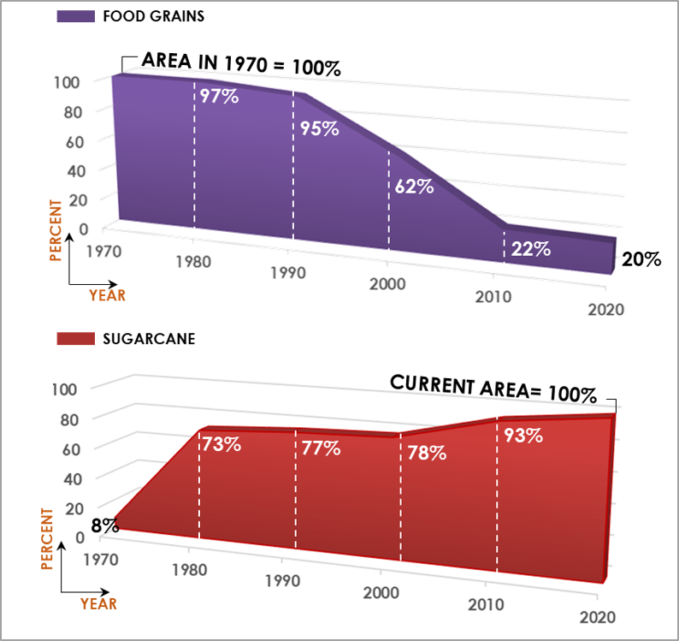
Fig 10: Comparison of Food grains and Sugarcane Crop area (Author generated based on Ministry of Agriculture, Department of Economics, Lucknow, Uttar Pradesh (1970-2020))

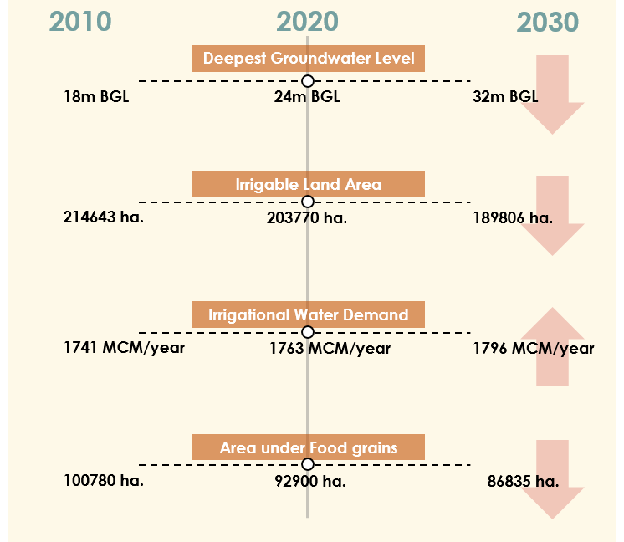
Fig 11: Projected scenarios for 2030 based on arithmetic projections, assuming the continuation of the similar baseline conditions ((Author generated)

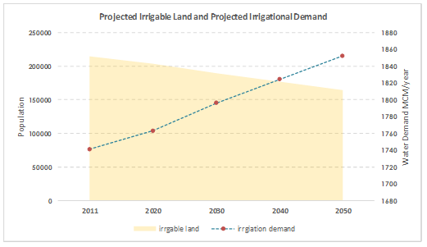
Fig 12: Projected Irrigational Demand v/s Projected Irrigable Land based on arithmetic projections, assuming the continuation of the similar baseline conditions (Author generated)

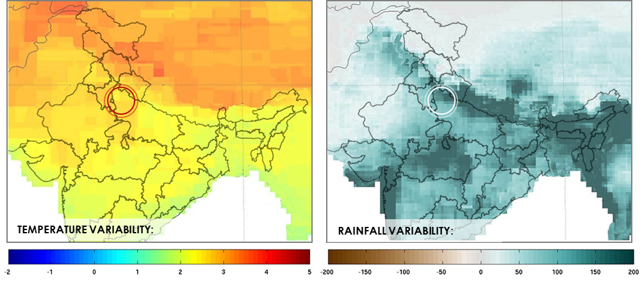
Fig 13: Median changes in annual (left) temperature (oC) and (right) total precipitation (mm) for Meerut and surrounding areas in the 2050s compared with the 1980-2010 historical period (AgMIP Impact Explorer)

