Fig. 1s Globally different methods adopted for seaweed cultivation [134-138]

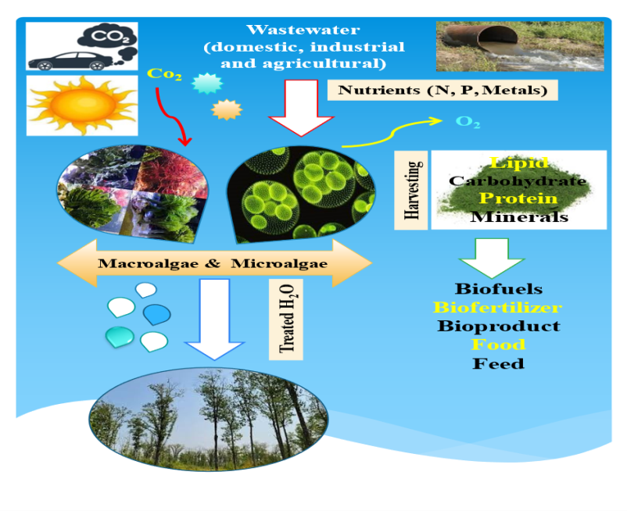
Fig. 2s The function of algae in supporting natural resource management objectives of sustainable development (self-design)

Fig. 3s ES cascade framework the adaptive (4 steps DPSIR) indicator and management cycle (Haines-Young et al.,
[128-129]

