Supporting Information
Rapid Adsorption of Industrial Cationic Dye Pollutant Using Base-Activated Rice Straw Biochar: Performance, Isotherm, Kinetic and Thermodynamic Evaluation
Soumyaranjan Senapatiª, Jyotirmayee Giriª, Laxmidhar Mallickª, Dipankar Singha^{b} Tapan Kumar Bastia^{a,c}, Prasanta Rath^{a,c}, Malay Kumar Rana^{b} and Alok Kumar Panda^{a,c}*

ª.Environmental Science Laboratory, School of Applied Sciences, Kalinga Institute of Industrial Technology, Deemed to be University, Bhubaneswar-751024, Odisha, India. Email -alok.pandafch@kiit.ac.in
^{b}.Indian Institute of Science Education and Research (IISER) Berhampur, Govt. ITI Campus, Engineering School Road, Berhampur, Ganjam, Odisha - 760010.
^{c}.Centre for Water Research and Climate Change, Kalinga Institute of Industrial Technology, Deemed to be University, Bhubaneswar-751024, Odisha.

Fig. S1. Calibration plot of methylene blue (MB) dye at different pH

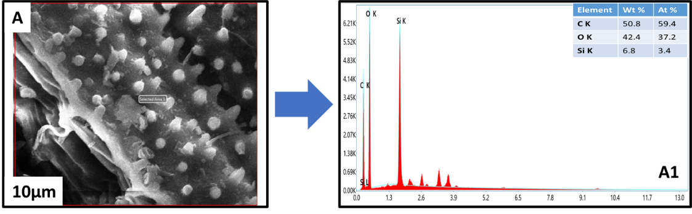
EDAX-Area
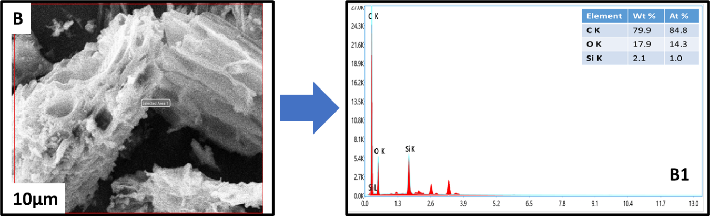
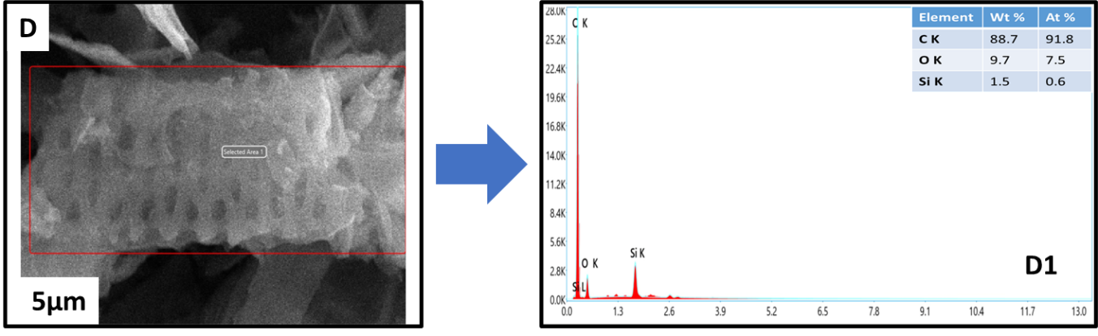
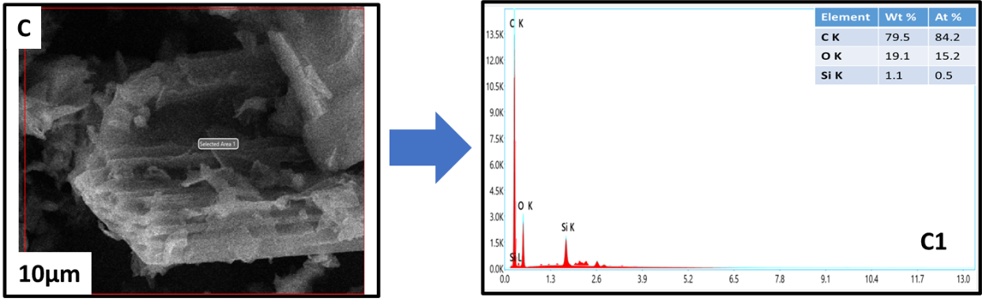
Fig. S2. SEM morphology and elemental composition by EDAX analysis (Area) of (A) DR, (B) non-activated biocharDBCNa0, (C) base-activated biocharDBCNa5, (D) DBCNa10.
Fig. S3. Raman spectra curve fitting of (A) non-activated biochar DBCNa0; (B) base-activated biochar DBCNa5; (C) DBCNa10.

Fig. S4. XPS spectra of non-activated biochar DBCNa0 (A) full spectrum, (B) C1s, (C) O1s, and (D) N1s.
Fig. S5. XPS spectra of base-activated biochar DBCNa5 (A) full spectrum, (B) C1s, (C) O1s, and (D) N1s.
Fig. S6. XPS spectra of base-activated biochar DBCNa10 (A) full spectrum, (B) C1s, (C) O1s, and (D) N1s.

Fig. S7. Point zero charges (pH_{pzc}) of non-activated and base-activated rice straw biochar.

Fig. S8. Non-linear adsorption isotherm of MB dye molecule with different pH variations (pH=2 -10) and different dye concentration variations (C_{o}= 2 - 18mg/L), at 25ºC, with biochar adsorbent dose of 2.5mg with a reaction volume of 20 mL. The dot symbols represent the experimental data, and the solid line shows the Langmuir (A, C, E, G, I) and Freundlich isotherm (B, D, F, H, J) fit.

Fig. S9. Effect of pH and pH_{PZC} on MB dye molecule adsorption and biochar maximum adsorption capacity (q_{m}).

Fig. S10. Langmuir adsorption isotherm separation factor rice straw biochar materials at pH 10.

Fig. S11. Kinetics of MB dye molecule adsorption onto the base-activated and non-activated rice straw biochar adsorbent at 25ºC (MB dye concentration = 10mg/L, biochar adsorbent dose 0.125 mg/mL, pH = 10. Dot symbols represent the experimental data, and the solid line shows the fitting of models (A) Weber model and (B) Boyd model.

Fig. S14. Kinetic of methylene blue dye molecule adsorption onto the base-activated and non-activated rice straw biochar adsorbent at 20-40 °C (MB dye concentration = 10mg.L⁻¹, activated biochar adsorbent dosages 0.125 mg.mL⁻¹, pH = 10. Dot/spot shape symbols represent the experimental data, and the solid line shows the mathematical pseudo second order kinetic model.

Table S1. Properties of organic dye methylene blue
Organic dye | Molecular formula | Molecular structure | Molecular weight (g/mol) | Size (L & B. Å) | Estimated diameter (Å) | Ref.
Methylene blue | C₁₆H₁₈N₃ClS |  | 319.85 | 14.34 × 4.98 | 13.95 | (Yang et al., 2024)

Table S2. List of FTIR peaks of non-activated and base-activated biochar materials
Sl No. | Wavenumber (CM⁻¹) | Functional groups | References
1 | 3350 | -OH (Stretching) | (Guo et al., 2020)
2 | 2930 | -C-H (Stretching) | (Reza et al., 2020)
3 | 2850 | -C-H (Stretching) | (Reza et al., 2020)
4 | 1910-2360 | -C=O (Stretching, Ketene) | (Reza et al., 2020)
5 | 1610 | -C=C (Stretching) | (Reza et al., 2020)
6 | 1570 | -C=C (Stretching) | (Reza et al., 2020)
7 | 1079 | -C-O (Stretching) | (Reza et al., 2020)
8 | 790 | C=C (Aromatic stretching) | (Reza et al., 2020)
9 | 467 | Si-O-Si (Bending) | (Liu et al., 2019)

Table S3. List of Raman peak/band and their description of non-activated and base-activated biochar materials
Peak No. | Band name | Band position (cm⁻¹) | Description | Bond type | Area
 |  |  |  |  | DBCNa0 | DBCNa5 | DBCNa10
1 | G_{L} | 1700 | Carbonyl group C=O | sp² | 331077.68 | NA | 53001.10 (
2 | G | 1590 | Graphite E²_{2g}; aromatic ring quadrant breathing; alkene C=C | sp² | 653786.45 | 130941.66 | 449847.61
3 | G_{R} | 1540 | Aromatics with 3–5 rings; amorphous carbon structures | sp² | 529602.38 | 125783.58 | 80809.73
4 | V_{L} | 1465 | Methylene or methyl; semi-circle breathing of aromatic rings; amorphous carbon structures | sp² sp³ | 574898.14 | 141108.81 | 268293.89
5 | V_{R} | 1380 | Methyl group; semi-circle breathing of aromatic rings; amorphous carbon structures | sp² sp³ | 860799.24 | 148564.54 | 201517.97
6 | D | 1300 | D band on highly ordered carbonaceous materials; C–C between aromatic rings and aromatics with not less than 6 rings | sp² | 195373.90 | 141019.34 | 412980.75
7 | S_{L} | 1230 | Aryl–alkyl ether; para-aromatics | sp², sp³ | 197608.62 | 109529.68 | NA
8 | S | 1185 | C _{aromatic} – C _{alkyl}; aromatic (aliphatic) ethers; C–C on hydroaromatic rings; hexagonal diamond carbon sp3; C–H on aromatic rings | sp² sp³ | 308867.16 | NA | 98079.55
I_{D}/I_{G} |  |  |  |  | 0.29 | 1.07 | 0.92
*NA-Not Available
Table S4. List of XPS peaks/ bands and their description of non-activated and base-activated biochar materials
Elements | Binding energy (eV) | Peak Assign | Description | Area |  |  | References
 |  |  |  | DBCNa0 | DBCNa5 | DBCNa10 | References
C 1s | 284.4/284.5 | C-C, C=C | Represent hydrocarbon and C=C sp² bonds in the graphitic and aromatic network | 2566.37 | 6411.18 | 5225.19 | (Golsheikh et al., 2015; González-Hourcade et al., 2022; Li et al., 2017)
C 1s | 286.5 | C-O | Represent C-O connected to ether or phenolic group | NA | 1135.45 | NA | (Andersson et al., 2002; González-Hourcade et al., 2022)
C 1s | 288.6 | COOH | Represent C=O groups like the Carboxylic group (HO-C=O), C=O | NA | 1266.24 | 7993.89 | (Chahinez et al., 2020; Ghosh et al., 2022; Kumar et al., 2021)
N 1s | 399.4 | Amine | Represent C-N-C, C-N-H | NA | 151.43 | 140.16 | (González-Hourcade et al., 2022; Meng et al., 2016)
N 1s | 400 | C-NH₂ | Represent stronger C-N bond linked to C atoms with sp³ bonds | NA | 142.14 | 157.90 | (Auciello et al.)
N 1s | 400.6 | Pyridonic / Pyrrolic N | Represent nitrogen-containing rings | NA | 166.13 | 251.54 | (González-Hourcade et al., 2022; Meng et al., 2016)
N 1s | 402.4 | Oxidised N | Represent a weak C-N or N-N bonds linked to C atoms with sp² bonds | NA | NA | 57.80 | (Auciello et al.; González-Hourcade et al., 2022)
O 1s | 531.4 | C=O | Represent carbonyl, lactone and carboxylic groups | NA | 2017.03 | 276.91 | (Ghosh et al., 2022; Smith et al., 2016)
O 1s | 532.3 | O-H | Represent hydroxyl group | NA | NA | 4294.42 | (Kumar et al., 2021)
O 1s | 532.8 | C-O | Represent aliphatic C-O. Also, oxygen singly bonded to carbon in aromatic rings, phenols, and ethers. | NA | 2144.54 | NA | (Simoes dos Reis et al., 2022; Smith et al., 2016)
O 1s | 533.1 | C=O | Represent ether and hydroxyl groups bonded to aromatics. Also, ester, anhydride, aromatic C=O | NA | 2307.98 | 2422.72 | (Fan et al., 2018; Smith et al., 2016)
O 1s | 534.9 | C-OOH | Represent carboxylic group | NA | 1762.55 | NA | (Qian and Chen, 2014)
*NA- Not Available

Table S5. Elemental analysis of rice straw waste of non-activated and base-activated biochar materials
Name | N Area | C Area | H Area | S Area | N [%] | C [%] | H [%] | S [%] | C/N ratio | H/C ratio
DR | 1373 | 62821 | 30503 | 87 | 0.58 | 35.28 | 5.1 | 0.12 | 60.84 | 0.14
DBCNa0 | 1699 | 97981 | 10908 | 268 | 0.67 | 52.22 | 1.76 | 0.35 | 77.43 | 0.03
DBCNa5 | 4306 | 96484 | 11168 | 93 | 1.82 | 56.2 | 1.97 | 0.13 | 30.94 | 0.03
DBCNa10 | 5392 | 96104 | 10168 | 87 | 1.94 | 52.2 | 1.69 | 0.12 | 26.90 | 0.03

Table S6. Different stages of weight loss of raw, non-activated, and base-activated rice straw biochar.
Mass loss components | volatile organic moisture components (V-O-M) (%) | Hemicellulose (H-C) (%) | Cellulose (C) (%) | lignin (L) (%) | Remaining mass (%)
Temp. range (ºC) | 30-220 | 220-315 | 315-400 | 400-895 | >895
DR | 10.54 | 24.38 | 22.21 | 10.87 | 32
DBCNa0 | 5.39 | 1.41 | 1.22 | 7.72 | 84.26
DBCNa5 | 7.78 | 2.75 | 3.07 | 14.28 | 72.12
DBCNa10 | 9.86 | 2.68 | 2.16 | 8.89 | 76.41

Table S7. Surface area and pore size analysis of of non-activated and base-activated biochar materials
Adsorbent | BJH-Surface Area (m².g⁻¹) | BJH-Pore Volume (cm³.g⁻¹) | BJH-average pore diameter (nm)
DBCNa0 | 2.23 | 0.01 | 25.14
DBCNa5 | 31.34 | 0.079 | 10.20
DBCNa10 | 109.70 | 0.26 | 9.55

Table S8. Adsorption kinetic diffusion model data/mass transfer model data for adsorption of MB dye molecule onto the solid-liquid solution of base-activated and non-activated rice straw biochar
pH | Adsorbent | Intraparticle diffusion |  |  |  |  |  |  |  |  | Liquid film diffusion
pH | Adsorbent | $$k_{{(WM)}_{1}}$$  (mg/g.min^{1/2}) | C (mg/g) (Intercept) | R² | $$k_{{(WM)}_{2}}$$  (mg/g.min^{1/2}) | C (mg/g) (Intercept) | R² | $$k_{{(WM)}_{3}}$$  (mg/g.min^{1/2}) | C (mg/g) (Intercept) | R² | $k_{b}$ (1/min) | C (Intercept) | R²
10 | DBCNa0 | 2.85 | 8.25 | 0.99 | 0.60 | 12.09 | 0.97 | 0.41 | 12.99 | 0.94 | 0.35 | 0.93 | 0.90
10 | DBCNa5 | 10.46 | 29.12 | 0.99 | 5.03 | 39.42 | 0.97 | 2.28 | 48.26 | 0.94 | 0.34 | 0.47 | 0.85
10 | DBCNa10 | 10.90 | 33.78 | 0.98 | 4.45 | 46.98 | 0.95 | 0.64 | 60.78 | 0.89 | 0.33 | 0.59 | 0.87

Table S9. Thermodynamic and activation energy details of MB dye adsorption onto of non-activated and base-activated biochar materials
Adsorbent | pH | Temperature (K) | ΔGº(kJ/mol) | ΔHº(kJ/mol) | ΔSº(J/K.mol) | R² | E_{a} (kJ/mol) | R²
DBCNa0 | 10 | 293 | -1.88 | -25.62 | -99.63 | 0.94 | 20.10 | 0.74
DBCNa0 | 10 | 298 | -1.83
DBCNa0 | 10 | 303 | -0.88
DBCNa0 | 10 | 308 | -0.47
DBCNa0 | 10 | 313 | -0.07
DBCNa5 | 10 | 293 | -7.60 | -14.12 | -21.0 | 0.91 | 19.91 | 0.88
DBCNa5 | 10 | 298 | -7.58
DBCNa5 | 10 | 303 | -7.55
DBCNa5 | 10 | 308 | -7.49
DBCNa5 | 10 | 313 | -7.11
DBCNa10 | 10 | 293 | -8.02 | -10.20 | -7.0 | 0.98 | 12.91 | 0.89
DBCNa10 | 10 | 298 | -7.91
DBCNa10 | 10 | 303 | -7.89
DBCNa10 | 10 | 308 | -7.85
DBCNa10 | 10 | 313 | -7.84

References:
Andersson, A., Abraham, D., Haasch, R., MacLaren, S., Liu, J. & Amine, K.: 2002, 'Surface characterization of electrodes from high power lithium-ion batteries', Journal of The Electrochemical Society 149, A1358.
Auciello, O., Veyan, J.-F. & Arellano-Jimenez, M. J.: 'Comparative X-ray Photoelectron Spectroscopy Analysis of Nitrogen Atoms Implanted in Graphite and Diamond', Frontiers in Carbon 2, 1279356.
Chahinez, H.-O., Abdelkader, O., Leila, Y. & Tran, H. N.: 2020, 'One-stage preparation of palm petiole-derived biochar: Characterization and application for adsorption of crystal violet dye in water', Environmental Technology & Innovation 19, 100872.
Fan, Q., Sun, J., Chu, L., Cui, L., Quan, G., Yan, J., Hussain, Q. & Iqbal, M.: 2018, 'Effects of chemical oxidation on surface oxygen-containing functional groups and adsorption behavior of biochar', Chemosphere 207, 33-40.
Ghosh, T., Elo, T., Parihar, V. S., Maiti, P. & Layek, R.: 2022, 'Poly (itaconic acid) functionalized lignin/polyvinyl acetate composite resin with improved sustainability and wood adhesion strength', Industrial Crops and Products 187, 115299.
Golsheikh, A. M., Lim, H., Zakaria, R. & Huang, N.: 2015, 'Sonochemical synthesis of reduced graphene oxide uniformly decorated with hierarchical ZnS nanospheres and its enhanced photocatalytic activities', Rsc Advances 5, 12726-12735.
González-Hourcade, M., dos Reis, G. S., Grimm, A., Lima, E. C., Larsson, S. H. & Gentili, F. G.: 2022, 'Microalgae biomass as a sustainable precursor to produce nitrogen-doped biochar for efficient removal of emerging pollutants from aqueous media', Journal of Cleaner Production 348, 131280.
Guo, C., Zou, J., Yang, J., Wang, K. & Song, S.: 2020, 'Surface characterization of maize-straw-derived biochar and their sorption mechanism for Pb2+ and methylene blue', PLoS One 15, e0238105.
Kumar, N. S., Shaikh, H. M., Asif, M. & Al-Ghurabi, E. H.: 2021, 'Engineered biochar from wood apple shell waste for high-efficient removal of toxic phenolic compounds in wastewater', Scientific reports 11, 2586.
Li, Y., Li, S., Wang, Y., Wang, J., Liu, H., Liu, X., Wang, L., Liu, X., Xue, W. & Ma, N.: 2017, 'Electrochemical synthesis of phosphorus-doped graphene quantum dots for free radical scavenging', Physical Chemistry Chemical Physics 19, 11631-11638.
Liu, X., Liao, J., Song, H., Yang, Y., Guan, C. & Zhang, Z.: 2019, 'A biochar-based route for environmentally friendly controlled release of nitrogen: urea-loaded biochar and bentonite composite', Scientific reports 9, 9548.
Meng, M., Yan, H., Jiao, Y., Wu, A., Zhang, X., Wang, R. & Tian, C.: 2016, 'A “1-methylimidazole-fixation” route to anchor small-sized nitrides on carbon supports as non-Pt catalysts for the hydrogen evolution reaction', RSC advances 6, 29303-29307.
Qian, L. & Chen, B.: 2014, 'Interactions of aluminum with biochars and oxidized biochars: implications for the biochar aging process', Journal of agricultural and food chemistry 62, 373-380.
Reza, M. S., Afroze, S., Bakar, M. S., Saidur, R., Aslfattahi, N., Taweekun, J. & Azad, A. K.: 2020, 'Biochar characterization of invasive Pennisetum purpureum grass: effect of pyrolysis temperature', Biochar 2, 239-251.
Simoes dos Reis, G., Mayandi Subramaniyam, C., Cárdenas, A. D., Larsson, S. H., Thyrel, M., Lassi, U. & Garcia-Alvarado, F.: 2022, 'Facile synthesis of sustainable activated biochars with different pore structures as efficient additive-carbon-free anodes for lithium-and sodium-ion batteries', ACS omega 7, 42570-42581.
Smith, M., Scudiero, L., Espinal, J., McEwen, J.-S. & Garcia-Perez, M.: 2016, 'Improving the deconvolution and interpretation of XPS spectra from chars by ab initio calculations', Carbon 110, 155-171.
Yang, P., Lu, Y., Zhang, H., Li, R., Hu, X., Shahab, A., Elnaggar, A. Y., Alrefaei, A. F., AlmutairiI, M. H. & Ali, E.: 2024, 'Effective removal of methylene blue and crystal violet by low-cost biomass derived from eucalyptus: Characterization, experiments, and mechanism investigation', Environmental Technology & Innovation 33, 103459.

