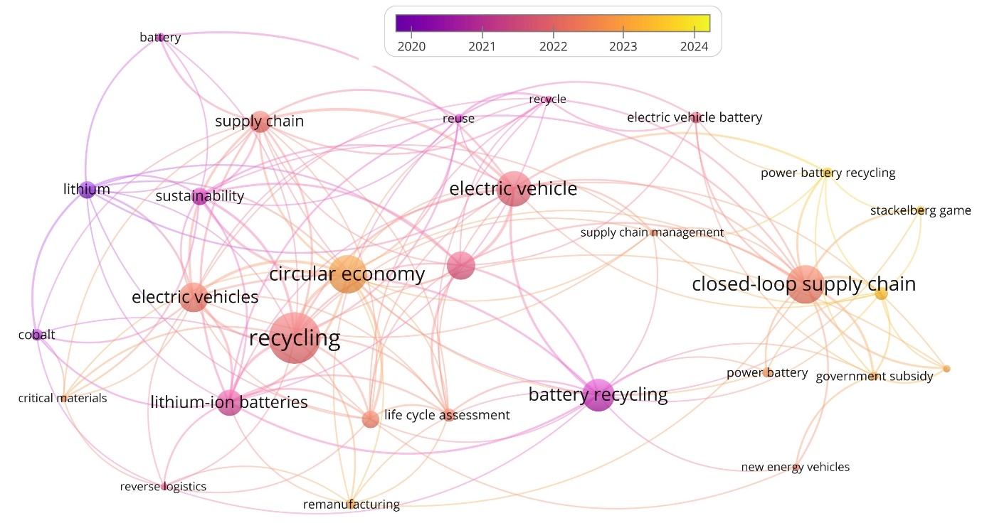
Supplementary Figure 1Trends in the electric vehicle (EV) supply chain

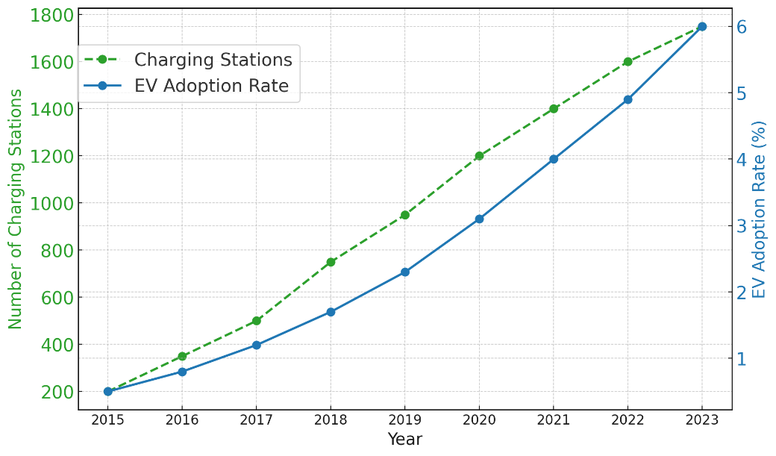
Supplementary Figure 2 Growth of Charging Infrastructure vs. EV Adoption in India 2015-2023
Supplementary Figure 3 Growth of Charging Stations vs. EV Adoption Rates in India 2015-2023

