Life Cycle Assessment for Construction Materials of an Industrial Building Using Web-Based Software “OneClick LCA”.
Berlant Arab, Mohamed Abdel Raouf, Amir Hany, Mariam Mostafa, Mohamed Nagib AbouZeid

Berlant Arab, Graduate Student and Full-Time Teaching Assistant,
Dept. of Construction Engineering, The American University in Cairo (AUC), Egypt.
berlantarab@aucegypt.edu
Corresponding author: Berlant Arab

Mohamed Abdel Raouf, Assistant Professor, Dept. of Construction Management and Interior Design, Ball State University, Muncie, IN 47306, USA.
maraouf@bsu.edu

Amir Rahal, Graduate Student, Dept. of Sustainable Development, The American University in Cairo (AUC), Egypt.
amirrahal@aucegypt.edu

Mariam Mostafa, Graduate Student, Dept. of Sustainable Development, The American University in Cairo (AUC), Egypt.
mariamadelabdelaziz@aucegypt.edu

Mohamed Nagib AbouZeid, Professor, Dept. of Construction Engineering,
The American University in Cairo (AUC), Egypt.
mnagiba@aucegypt.edu

Abstract: Life cycle assessment (LCA) is crucial for evaluating the environmental impacts of construction buildings and materials throughout their lifespan. The present study seeks to bridge the gap between assessing the LCA and quantifying their environmental impacts through using an existing web-based environmental software. Specifically, the research identifies a gap in the availability of environmental data for Egyptian construction materials, the absence of a standardized LCA framework, and the limited adoption of LCA software in early design decision-making. As a practical example, this study aims to assess the environmental impacts of an industrial building in Cairo, Egypt, with an emphasis on determining the social carbon cost, and identifying opportunities for emission reductions. Additionally, this study involves preparing the required data for compatibility with OneClick software and proposing a procedure for entering these data to the web-based software to assess the environmental impact of the industrial building. The findings reveal that concrete and steel in the baseline scenario have significant environmental impacts, with high embodied carbon (29,122 tons CO₂e; 132.98 kg CO₂e per m² per year) and substantial effects on global warming, ozone depletion, and other environmental aspects (a social carbon cost of 1,456,090 €). The study recommends using alternative materials with a detailed comparative analysis to reduce the embodied carbon footprint and social cost of carbon of the industrial building by approximately 16%. Implementing these alternatives can significantly mitigate environmental impacts and promote more sustainable building practices. These findings underscore the importance of integrating LCA using software into the early design and material selection phases for more environmentally responsible construction decision-making.

Keywords: Green buildings; Carbon footprint; LCA; OneClick; Sustainable materials; Industrial building; Environmental impact; Sustainability.

1. Introduction
The buildings and construction sectors stand out as the leading contributors to greenhouse gas (GHG) emissions, comprising a remarkable 37% of global emissions [1]. The manufacture and utilization of materials like cement, steel, and aluminum play a substantial role in generating carbon emissions. There are several assessments in evaluating the emissions of buildings to minimize the environmental impact across the entire building life cycle. These assessments include life cycle assessment (LCA), the carbon footprint assessment, energy performance assessment, greenhouse gas inventory, and building performance benchmarking and standards [2]. For example, the American Society of Heating, Refrigerating and Air-Conditioning Engineers (ASHRAE) and the International Code Council (ICC) are proposing and developing standards and a framework to evaluate the greenhouse gas impacts of building materials, systems, and energy use over a building’s lifecycle. ASHRAE and ICC are supporting the decarbonization of the built environment and helping professionals understand the environmental impact of design choices [3,4].
The LCA or Life Cycle Sustainability Assessment (LCSA) concept was introduced at the World Summit on Sustainable Development in Johannesburg in 2002 [5]. Since then, the LCA has become widely used and acknowledged in the construction sector as a methodology to assess resource use, energy, waste generation, and other environmental aspects throughout a project’s lifespan. In other words, LCA aids in quantifying the environmental impacts, trade-offs, and opportunities for enhancements across the entire lifespan of buildings, spanning from design to demolishing. The aim of LCA is to assist building owners in making informed decisions concerning sustainability and resilience, to assess design alternatives by offering insights into material selections and their environmental ramifications, aid in evaluating the environmental advantages of new products or policies, assert that a system or product is more environmentally advantageous than another for comparison, and measure against benchmarks to assess a building's performance.
The social cost of carbon (SCC) can be defined as the monetary value caused by emitting one metric ton of carbon dioxide (CO₂) into the atmosphere and leads to climatic damage. Therefore, SCC can be integrated into LCA to quantify the economic cost of carbon emissions throughout a product's life cycle. By incorporating the SCC into LCA, it is possible to account for the monetary value of the damages caused by carbon emissions, providing a more comprehensive assessment of a product's environmental impact [6]. The SCC represents the economic cost or damages associated with emitting one additional ton of CO₂ into the atmosphere, quantifying the harm caused by that extra ton of CO₂ in monetary terms. When a ton of CO₂ is released, it lingers in the atmosphere, contributing to global warming and affecting various outcomes such as changes in climate, agricultural productivity, sea level rise, and human health. Calculating the SCC involves considering both climate impacts and their economic consequences, including how CO₂ emissions alter the climate system (e.g., temperature rise, extreme weather events) and the resulting economic outcomes, such as damages to agriculture, health, labor productivity, and infrastructure [6]. The SCC sums up the full global cost of the damage caused by that extra ton of CO₂ over its entire time in the atmosphere. Policymakers use the SCC to evaluate climate-related policies, guiding decisions on emissions reduction, adaptation, and mitigation, effectively serving as a cosmic price tag on carbon emissions to balance the costs of damage against the benefits of emission reduction.
The LCA is crucial to analyze the most used building's materials, notably concrete and steel, as it is revealed that these materials have a high negative environmental impact and produce significant carbon emissions [7]. Concrete, widely used in construction due to its robustness and longevity, emerges as a significant contributor to the elevated carbon footprint identified in this investigation. The production of concrete entails the emission of substantial quantities of CO₂, chiefly attributed to the calcination of limestone and the energy-intensive processes involved in cement manufacturing. According to the National Ready Mixed Concrete Association, 1 pound of concrete releases 0.93 pounds of CO₂ [8], making concrete responsible for 8 percent of global carbon emissions, with 90 percent of these emissions coming from clinker production, the primary strength-contributing ingredient of concrete [9]. Similarly, steel, recognized for its structural strength in building construction, also plays a substantial role in the observed carbon emissions. The manufacturing of steel involves energy-intensive procedures such as iron ore extraction, smelting, and refining, resulting in notable CO₂ and greenhouse gas emissions. In addition, the carbon footprint of steel is 1.4 tons per produced ton of steel [10]. Despite ongoing efforts to develop alternative materials with lower carbon footprints, addressing the emissions linked with concrete and steel remains crucial for fostering sustainable construction practices. Thus, this study assesses the life cycle of a building with these two environmentally significant materials.
Building construction causes 10% of energy-related emissions [9], taking into consideration that materials manufacturing account for 80–90% of the total building embodied emissions [11]. Embodied carbon refers to carbon emissions throughout a building's life, from material extraction to disposal. Key stages include Product (A1-A3: raw materials, transport, manufacturing), Construction (A4-A5: transport, construction), Use (B1-B7: use, maintenance, repair, replacement, refurbishment, energy, and water use), End-of-Life (C1-C4: deconstruction, transport, waste processing, disposal), and beyond building life cycle (D: recycling and reuse benefits). Since calculations are performed by computers, simplifying the calculations is less important than simplifying the tool interface and usability. Data acquisition is the most prominent problem since buildings contain a huge number of different materials and the availability of quality-assured production data is restricted [12]. When the aim is to simplify the LCA process, it is important to identify the most important data for a particular life cycle stage. Communication of clear and useful results is also a very important question since this is the key to increasing demand for LCA.
There has been a dedicated focus on reducing operational carbon emissions; yet to effectively reduce the emissions from the building sector, embodied carbon needs to be considered to reduce emissions across the entire life cycle of buildings. The level of emissions varies by building type and kind of construction building; according to the Center for Climate and Energy Solutions, approximately 30% of greenhouse gas emissions in the United States originate from the industrial sector [13]. Industrial structures play a crucial role in the global economy, acting as central hubs for manufacturing, production, and processing activities across diverse sectors. However, alongside their economic significance, industrial buildings also exert a notable influence on environmental pollution, particularly through greenhouse gas emissions.
The LCA and sustainable materials are of essence these days since the construction industry is on urge to limit its environmental impact. Importantly, LCA software tools play a pivotal role in addressing building emissions by providing a holistic evaluation of environmental impacts across the entire lifespan of a structure. LCA enables a meticulous analysis of different phases, and this comprehensive approach offers valuable insights into a building’s carbon footprint, helping to identify key areas where emissions can be minimized. During the design phase, LCA tools empower professionals, such as architects, engineers, and policymakers, to make informed decisions by evaluating the environmental implications of material choices and construction methods. For instance, LCA can highlight opportunities to specify alternative materials with lower environmental impacts, optimize energy consumption, and improve waste management strategies. By integrating these insights, stakeholders can adopt more sustainable practices that reduce the overall environmental burden of a building. However, there is sacristy of data regarding real-life applications to quantify these environmental impacts of the construction materials in different projects. This study is an attempt and a step toward the closure of the existing gap between research studies and applications for practitioners. Most of the previous studies were concerned about life cycle assessment methods, procedures, guidelines, and policies and other studies were focusing on the environmental impact of specific construction materials. A summary for previous studies will be mentioned later. Therefore, there is a research gap between the life cycle assessment as a research topic and as an application that can be used by the construction industry practitioners during early design stage of the project to quantify the environmental impact of different materials and assessing on the effect of changing these materials.

This study is an attempt to address the following hypotheses and questions. First, the opportunity of using an environmental web-based software tool, such as OneClick, as a decision tool in selecting construction materials during the design phase. Second, the degree of the availability of the environmental information and data of construction materials in the international databases. Third, the possibility of quantifying the effect of environmental impact of different construction materials, such as concrete and steel, existing in the Egyptian market. In this study, the assessed environmental impacts and emissions include global warming, biogenic carbon storage, ozone depletion, acidification, eutrophication, formation of lower atmospheric ozone, abiotic depletion potential (ADP-elements) for non-fossil resources, and abiotic depletion potential (ADP-fossil fuels) for fossil resources. This study addresses the gap in sustainable construction practices by using LCA tools to quantify the environmental impacts of concrete and steel, which have significant environmental footprints. Through OneClick LCA software, the study identifies the substantial embodied emissions and social cost of carbon associated with these materials. By applying LCA to an industrial building in Cairo, the research emphasizes the importance of material selection in reducing environmental impact and promotes more sustainable construction practices.
In summary, the specific objectives of this study were to: (1) conduct a literature review to utter the gap analysis about the research trends concerning LCA and the implementation of technological tools in quantifying environmental impacts, specifically in Egypt, (2) propose a simplified and sequential methodology and procedure to be used in OneClick to assess the environmental impact of construction materials utilized as structural elements for an industrial building, (3) assess the environmental impact of construction materials for an industrial building in 10th of Ramadan city, Egypt as a case study, (4) propose sustainable alternatives for enhancement and lowering of environmental impact of construction materials, and (5) analyze and report the social cost of carbon emissions for different sustainable alternatives.

2. Literature Review

2.1 LCA and Decision Making
LCA can support engineers, designers, and decision makers as it provides environmental impacts at the early stages [13]. The LCA can allow the contractor to reduce the environmental impacts by using alternate construction materials if LCA is performed before the start of construction activity [14]. In other words, it is well known that LCA can be used for decision making as it inherently considers global, national, and regional impacts on social and environmental problems such as human health, resource depletion, and ecosystem quality. However, this is difficult to achieve since a precise, inclusive and holistic model is usually challenging to develop [15].
Since 2010, LCA practitioners have minimal straightforward guidance for deciding on a modeling approach; this leads to sole decision-making approach of selection based on the best available data and information [16]. There are different methods in LCA that are under the development phase and more research is required in developing reliable databases. Therefore, this leads to the variability within the research area of the procedure and methodology to quantify the environmental and social impact of the construction industry [17].
This study starts with a systematic desktop literature review on life cycle assessments utilizing software tools conducted in Egypt to identify the gap-analysis for further research. Different LCA tools have been introduced in the last four decades to help carry out studies more quickly and easily in addition to comparing various design ideas, materials, and different situations based on costs and environmental performance. As per Table 1. shown below, these are the different technological tools being established and used in LCA since 1990 [18]. Most of these technological tools are web-based tools to quantify the environmental impacts of projects and products. Importantly, some of these technological tools are backed with adequate databases that report the environmental impacts for different construction materials and operational processes that made it possible to have precise LCA reports and studies. In summary, the following assessments can be made for these software tools. First, SimaPro and GaBi are well developed and advanced software tools for LCAs with comprehensive and extensive databases across diverse industries, but they have higher costs, require more learning times, and less user-friendly. Second, Athena simplifies LCA for construction materials but lacks flexibility for broader applications while Umberto excels in process modeling and industry-specific analyses but requires significant expertise. Third, OpenLCA is a flexible, open-source tool suitable for detailed LCAs, though it demands technical proficiency and lacks the user-friendly interface of OneClick LCA. The choice of tool depends on the project's complexity, industry focus, and user expertise, with OneClick LCA being the most accessible for construction professionals. Fourth, OneClick LCA is a cloud-based, user-friendly, and tailored for construction industry and that offers fast and cost-effective LCAs with strong BIM integration, making it ideal for green building certifications. However, its scope is limited to construction, and it lacks the depth of databases and customization for complex, industry-specific analyses.
Table 1. Summary of the most used LCA tools.
Tool Name | Website | Year | Developer | Scope
SimaPRO¹ | www.pre.nl | 1990 | Pre-Sustainability | Detailed LCA
GaBi² | www.sphera.com | 1992 | Sphero | Database and LCA
Athena³ | www.athenasmi.ca | 1997 | Athena Sustainable Materials Institute | Simplified LCA
Umberto² | www.ifu.com/umberto | 2003 | Institut fur Umweltinformatik | Simplified LCA
OpenLCA² | www.openlca.org | 2007 | Green delta | Detailed LCA
OneClick LCA⁴ | www.oneclicklca.com | 2011 | OneClick LCA | Simplified LCA
1 Netherlands, 2 Deutschland, 3 Canada, 4 Finland

The concept of applying the LCA methods in the construction industry to reduce the negative environmental impacts has been developing and booming since long time ago. However, the development of software tools to quantify these environmental and social impacts has been lagging this momentum of movement towards sustainable construction. Specifically, there is a sacristy of data concerned about the real-life applications of utilization of different software tools and quantification of environmental and social impacts in the construction industry. Importantly, the main rationale and driving motive behind this study is providing a quantitative analysis for the environmental and social cost of carbon footprint for a real-life project. Therefore, the OneClick tool was used in this study due to many folds. First, this LCA tool has an adequate database for different construction materials. In addition, many of the products and materials have Environmental Product Declarations (EPDs) and can be accessed and hence compared. Second, this tool can be used to determine the environmental impacts and social cost of carbon within different stages of project, design and material selection, construction, operation, and end of life. Third, most of the environmental impacts are included and calculated, so the comparison between different scenarios in design and materials can be assessed on different impacts and corresponding decisions can be made.

2.2 LCA and ISO Standards
Based on literature review, it has been claimed that ISO 14040/44, that is the standard and guideline to perform LCA, has failed since it is being interpreted differently for same products [14, 19]. For example, there are different Product Category Rules (PCRs) for the same product. The significance of PCRs is important since they are used to formulate and calculate EPD, generally and in construction industry. The usage of EPDs in construction is crucial since the EPDs are a detailed quantitative method to declare the environmental impact of producing and manufacturing of any product from start to cradle or gate. Therefore, the presence of these EPDs for different construction materials is of an essence to the movement toward sustainable development in the construction industry. For example, the certification of Leadership in Energy and Environmental Design (LEED) specifies additional points to be granted for projects that are using products declared and verified with EPDs [14, 20].

2.3 LCA and Constrains
To perform LCA, there are different databases owned by different companies and hence treated as classified information. This leads to discrepancies between analysis if performed on the same building [14]. Hence, there are gaps and overlaps in the construction industry that are leading to issues of compatibility, comparability, preciseness, and quality. In other words, there is scarcity of data regarding benchmarking and limits.
Also, there is another obstacle within existing LCA tools in the construction industry which is the availability of information regarding construction materials. The variability in construction materials makes it difficult to collect all of them in one database. Importantly, the environmental impacts of construction materials are not measured and calculated based on standardized methods and procedures to evaluate and measure impact of environment. The establishment and development of EPDs make it possible to compare between different materials and towards better sustainability of buildings.
In addition, barriers to LCA implementation in building work include prejudices about the complexity, arbitrary results, accuracy, problems regarding interpretation of results and the high costs of performing an LCA. Hence, the European ENSLIC Building Project has drawn up practical guidelines to promote increased use of LCA in building design [21].

2.4 LCA in Egypt
Life Cycle Assessment studies and tools are being widely used by many organizations. When looking at the number of published studies on the use of LCA as a tool for environmental sustainability in Egypt, it is still limited compared to other countries. From 2006 till 2023, only 43 studies about implementing LCA in Egypt were published focusing on seven main areas such as building and construction materials, aquaculture farming, energy, industrial manufacturing, transportation, water treatment, and waste handling. As per Table 2 shown below, only 21 of the studies about LCA in Egypt were focusing on the building and construction materials field. It may be concluded that there is scarcity of data and research work concerned about the utilization of technological software in LCA assessments.
Based on Table 2, it may be concluded that there is a research gap in the quantification of the environmental impact of commonly used construction materials in the Egyptian market. Specifically, many findings and conclusions could be made that are not limited to but listed as the following. First, there is scarcity of information and data regarding environmental impacts of construction materials in Egypt. Second, there is no known or approved software tool being used as a LCA tool for practitioners in the construction industry in Egypt. Third, there is no standardized framework and procedures to conduct and implement LCA for residential buildings. Fourth, the main obstacle in using LCA as a decision-aiding tool in the design stage is the lack of quantification of the environmental impact of different construction materials.
Table 2. Summary of the local LCA studies related to construction materials in Egypt.
Name of study/Year | University | Publication | Results
Life Cycle assessment tools for maintenance management and resource conservation.  2007 [22] | Tanta University | Assiut University Bulletin for Environmental Research | For parking lot paving materials, both Asphalt with GSB88 Seal-Bind maintenance and 20% Fly ash cement have the same performance in overall evaluation, although they recorded different values in economic and environmental performance separately. For transformer oils, Bio Trans transformer oil records the best overall maintenance amongst the selected types.
Environmental impacts assessment of the Egyptian brick types using life cycle assessment tool.  2014 [23] | Egypt-Japan University of Science  and Technology | The 4th international [avniR] Conference Life Cycle in practice at: "Nouveau Siècle", Lille, France  Volume: 4 | The study found that among four common Egyptian brick types, straw/raw, sand, clay, and cement-clay bricks had the most significant adverse environmental impact, while straw/raw bricks were the most environmentally friendly.
Framework for Application of Life Cycle Assessment Approach on Egyptian Residential Building Case Study: New Assiut City, Egypt.  2014 [24] | Egypt-Japan University of Science  and Technology | ICIME 2014: International conference in integrated management of environment At: Hammamet - Tunisia | The study proposes a framework for applying Life Cycle Assessment (LCA) to Egyptian residential buildings, using existing structures in New Assiut City as a case study. The result highlighted the challenge of limited local Life Cycle Inventory data, suggesting mechanisms to synthesize missing information from international databases.
Environmental impact assessment of the Egyptian cement industry based on a life-cycle assessment approach: a comparative study between Egyptian and Swiss plants. 2014 [25] | Egypt-Japan University of Science  and Technology | The Asian Conference on Sustainability, Energy & the Environment 2014 At: Osaka, Japan  Volume: 4 | The study conducts a life-cycle assessment comparing Egyptian and Swiss cement plants. The results revealed that the hypothetical Egyptian plant using coal as fuel exhibits higher impacts on respiratory inorganics, aquatic acidification, and global warming. However, the Swiss plant, despite advanced technology, still showed significant adverse impacts on global warming and respiratory inorganics due to its energy sources.
Estimating Carbon Emissions from Industrial Process by using Life Cycle Assessment Tool. 2014 [26] | Egypt-Japan University of Science  and Technology | IAC2014: International conference on Industry Academia Collaboration  At: Cairo  Volume: 1 | The study results show that; the building materials of vernacular building can achieve 78.68% reduction of carbon emissions compared to modern buildings. Therefore, it is recommended to establish a code for carbon emissions from LCA of modern buildings.
Moving towards an Egyptian national life cycle inventory database.  2014 [27] | Egypt-Japan University of Science  and Technology | The International Journal of Life Cycle Assessment 19 (8) | The development of a Life cycle inventory (LCI) database specific to Egypt is difficult because Egypt has various technical and organizational challenges, but a roadmap of actions to be taken to move ahead is provided.
Towards an integrated tool to estimate carbon emissions from life cycle assessment of building materials in Egypt.  2014 [28] | Egypt-Japan University of Science  and Technology | International Journal of Research in Engineering and Technology, 2 (3) | The study addressed the absence of a localized tool for assessing carbon emissions in Egyptian building materials. It proposes the development of an integrated Life Cycle Assessment (LCA) tool tailored to Egypt's construction industry, aiming to accurately estimate carbon emissions throughout the life cycle of residential buildings.
Environmental life cycle assessment of residential building in Egypt: a case study. 2015 [29] | Egypt-Japan University of Science  and Technology | The 8th International Conference INTER-ENG 2014 Interdisciplinarity in Engineering | On a life cycle basis, the main improvement opportunities in the housing sector lied in the reduction of the impacts in the operation and maintenance phase of the building. Whilst people behavior plays a big role, the greatest improvement opportunities are in the design stage of the house.
Life Cycle Assessment as a Decision Making for Window Performance Comparison in Green Building Design. 2015 [30] | Egypt-Japan University of Science  and Technology | International Journal of Architectural and Environmental Engineering  Vol:9, No:9 | The results showed that wood products that had been installed and were used in an appropriate way tend to have a favorable environmental profile compared aluminum products.
Practical case study for life cycle assessment of the Egyptian brick industry: A comparative analysis of the Japanese industry.  2017 [31] | Egypt-Japan University of Science  and Technology | Science Direct | The results showed that cement bricks (CEB) generally had higher environmental impacts across most categories, exceeding 60% of the total impact in several areas.
Life Cycle Assessment of Dredged Materials Placement Strategies: Case Study, Damietta Port, Egypt.  2017 [32] | Egypt-Japan University of Science  and Technology | 10th International Conference Interdisciplinarity in Engineering, INTER-ENG 2016 | The results showed that: the associated impact for upland placement has little impacts for up to 20% compared to transportation to a damped area. The transportation process was the main contributor to ecological impacts in addition to high fuel consumption.
Life Cycle Assessment for Sidewalk Pavement Types, Case Study: Extension of New Borg El-Arab City. 2017 [33] | Egypt-Japan University of Science  and Technology | 10th International Conference Interdisciplinarity in Engineering, INTER-ENG 2016 | The results of the LCA for each pavement type indicated that the interlocking concrete tile has the minimum diverse impact on the environment.
Global warming potential impact due to pile foundation construction using life cycle assessment. 2015 [34] | Egypt-Japan University of Science  and Technology | Electronic Journal of Geotechnical Engineering, 20 (12) | This study focused on a typical building with area of about 1300 m². Because of data constraints, CO₂ and N₂O emissions shall be considered and the category which taken into account is global warming potential. Two different stages are considered and compared during this LCA study; the construction processes and the transportation phase.
Analyzing sustainability in low-income housing projects using system dynamics.  2017 [35] | Cairo University | Energy and Buildings,  Volume 134 | The results revealed that the operation costs of most green materials are much less than the conventional materials. Using conventional building materials raises the total cost of the building by a greater value than the use of green materials with an increase in the negative effects on the environment.
Life Cycle Assessment for Construction of Asphalt Pavements in Egypt.  2016 [36] | Menoufia University | Journal of Earth Sciences and Geotechnical Engineering,  vol.6, no. 4 | The calculation of emissions and energy consumption from pavement construction in Egypt from LCA view were more difficult because Egypt does not have any LCA tool/program to estimate emissions from road construction.
Life cycle assessment of a residential building in Egypt: A case study.  2020 [37] | The British University in Egypt | 13th International Conference on Civil and Architecture Engineering (ICCAE-13) | The result showed that two life cycle phases concerning, manufacturing and operation, were significant in their environmental impact.  It showed that building structure and flooring result in most of the environmental loads. In terms of the sensitivity analysis, it was found the structural concrete had the largest impact, dominating all selected impact categories except ODP.
Application of comparative life cycle assessment to a proposed building for reduced environmental impacts: Assiut University Hospital Clinic as a case study.  2022 [38] | Assiut University | Journal of Architecture, Arts and Humanistic Sciences - Volume 7 - Issue 31 | The results have revealed that the significant harmful environmental impacts are respiratory inorganics, global warming potential, and non-renewable energy as the midpoint method and human health and resource depletion as an endpoint method.
The future of green building materials in Egypt: A framework for action.  2018 [39] | Housing and Building National Research Center, Giza, Egypt | Vol. 1 Issue 1 (2018): ARCHCAIRO 7 - Architecture, Urbanism and Sustainable Development | This framework describes procedures required for the system development of for collecting online data for green building materials.  Also, a digital library for accessible and reliable information on green building materials is needed to enable building designers, constructors and developers to make reasoned choices based upon the health & environmental impacts.
Applying LCA-BIM integration for a sustainable management process. 2020 [40] | The British University in Egypt | 36th Annual ARCOM Conference, 7-8 September 2020, UK, Association of  Researchers in Construction Management, 416-424 | The result outlines that most of the environmental impacts occur during the operation and manufacturing phase.  It also shows that slabs and beams result in most of the environmental loads. In terms of the material analysis, it was found the steel reinforcement had the largest impact.
Toward a National Life Cycle Assessment Tool: Generative Design for Early Decision Support.  2022 [41] | Port Said University | Energy and Buildings, Volume 267, 112144 | A suggested implementation design method was developed as a tool focusing only on residential building exterior walls to aid the design process and promote sustainable development.
Parametric BIM-based life cycle assessment framework for optimal sustainable design.  2023 [42] | Cairo University | Journal of Building Engineering, 75 | While the circular approach reduces operating emissions, it increases embodied emissions due to materials with higher heat transmittance.  The framework aids decision-making by optimizing material selection using LCA, DEA, and the NSGA-II algorithm.

3. Methodology
The methodology followed in this paper were divided into two phases. The first phase was composed of a systematic desktop literature review to summarize the previous studies conducted in Egypt concerning life cycle assessment in the green buildings sector. The second phase was composed of different procedures required for the preparation of the input data for the case study into the OneClick software according to EN15804 +A1 and corresponding output results for the baseline scenario and alterative sustainable scenarios.

3.1. Systematic Desktop Literature Review
A comprehensive and systematic desktop literature review was conducted using major and reputable scientific database, specifically Scopus, to obtain insight into available publications and author contributions in the life cycle assessment in Egypt. A few keywords that were used in the different search engines were "life cycle assessment," "social carbon footprint," and "industrial buildings." After that, the discovered papers were filtered according to parameters such as subject matter, journals, and date range.

3.2. OneClick Methodology
The methodology implemented in this study facilitates a comprehensive life cycle assessment for the construction materials in the industrial building. The flowchart below outlines the steps involved prior to generating the OneClick model, as illustrated in Figure 1. The process begun by defining the project scope, including site location, area, number of floors, and their heights. This building was classified as an industrial building since it compromised the construction of plastic production plant. The building's land area was approximately 13,600 m², with the structure itself covering 8,760 m² for each ground and first floor, 3,137 m² for basement, and 2,189 m² for mezzanine. The building comprised four levels: a basement, a ground floor, a mezzanine, and a first floor with different floor heights 5m, 7.25m, 3.7m and 5.65m respectively. The structural elements included isolated footings, tie beams, structural walls for the basement, elevators and stairs, structural columns, structural beams, and floors with slabs and drop panels.
Based on this, 2D AutoCAD for both architectural and structural plans were created. These plans were then converted into a 3D Revit model, which facilitated data coordination and enabled the generation of the BOQ for the required materials. The BOQ provided detailed material quantities, which were used in the OneClick LCA tool to assess the environmental impacts of construction materials.

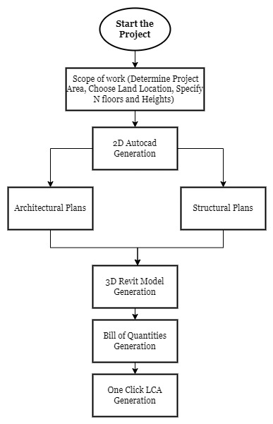
Figure 1. Flowchart showing the process of the project development.

3.2.1. AutoCAD Generation:
The model development process began with the generation of AutoCAD files for architectural and structural aspects, which included detailed plans for multiple levels (basement, ground, first floor, and mezzanine), along with elevations and sections covering the plans in both directions. Figure 2(a) presents the architectural plan for the ground floor, encompassing various key areas such as the factory management zone, which includes spaces for technicians and supervisors, the production area, men's locker and sterilization facilities, storage section, recycling area, air compressor partition, and several other sections integral to the production process. Figure 2(b) illustrates the structural elements of the ground floor ceiling, detailing the placement of columns, marginal beams, flat slabs with drop panels, shear walls, and stairs excluding the front administration building.

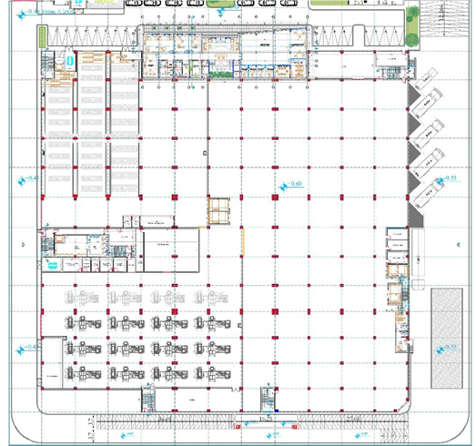 | 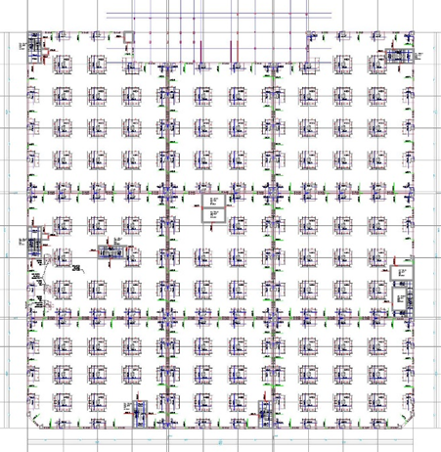
(a) | (b)
Figure 2. (a) Architectural plan for ground floor; (b) Structural plan for ground floor.
Figure 3(a) presents the architectural plan for the first floor. This floor is designed to accommodate both the service and facility needs of the employees and visiting experts. It features small rooms designated for visitors, a restaurant for the employees, a fully equipped kitchen, an entertainment area, and a large warehouse for product storage. Figure 3(b) illustrates the structural plan for the first floor, which includes all the structural elements like those on the ground floor. This plan details the placement of columns, beams, slabs, and other key structural components.
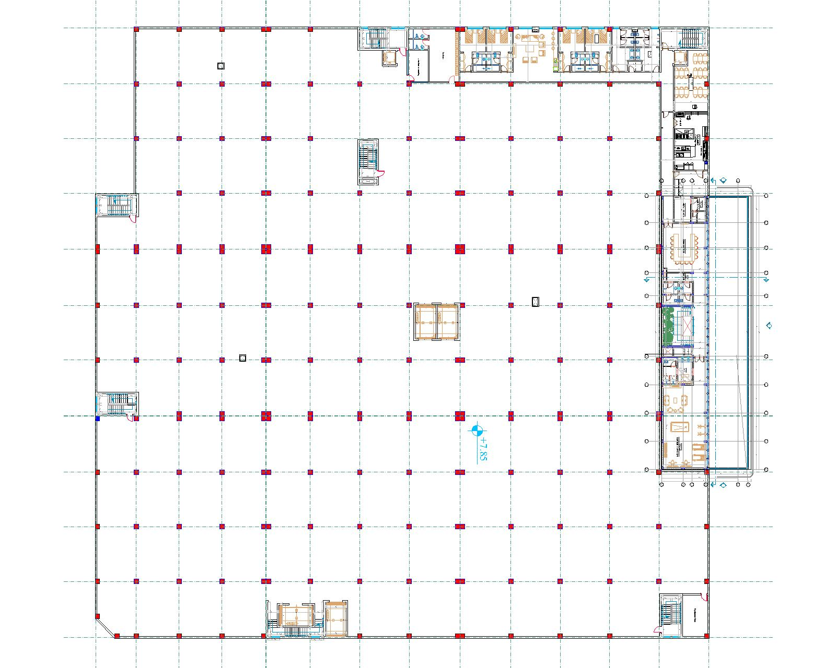
(a) | (b)
Figure 3. (a) Architectural plan for first floor; (b) Structural plan for first floor.

3.2.2. REVIT Model Generation:
As the focus was on studying the LCA of structural elements, the next step involved creating a REVIT model (as shown in Figure 4) specifically to represent the concrete and steel components. This 3D model provided a comprehensive visualization of all structural elements for the factory, including isolated footings with tie beams, columns, drop panels, exterior panels, flat slabs, cores, and retaining walls in the basement floor. The 3D model effectively showcased the reinforcement details as well when taking a section at specific structural element. For instance, Figure 5 illustrates the reinforcement specifics for the column, drop panel, and crane support.

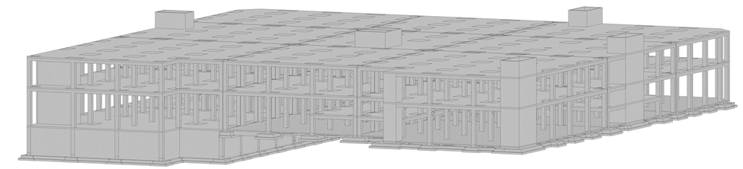
Figure 4. 3D Model of the industrial building.
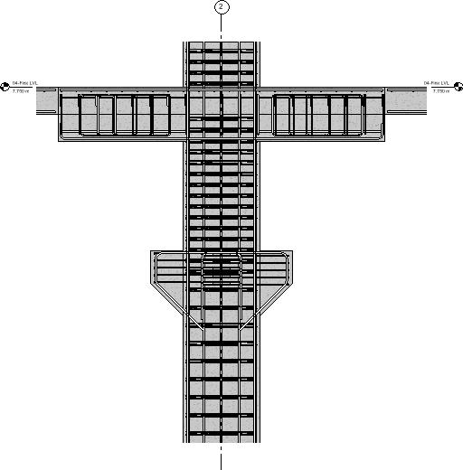
Figure 5. Section showing the reinforcement details of the slab system.

3.2.3. BoQ Generation:
Subsequently, the Bill of Quantities (BoQ) using REVIT software was determined for structural elements, specifically Portland cement concrete and steel. The BoQ was segmented into various categories such as foundations, tie beams, structural walls, columns, beams, slabs, and drop panels, with meticulous quantification of concrete in cubic meters (m³) and steel in kilograms (kg). The inputs of the structural elements in OneClick will be according to this BoQ segmentation to be easier during analysis to specify and categorize them according to their environmental impacts.

3.2.4. OneClick LCA Generation:
The OneClick Model initiation process, shown in Figure 6, involves the following key steps:
- Model Initiation: Start by creating a new project file and inputting basic information like the project name.
- Construction Stage: Select the construction stage, in this case, "5-Construction-Hiring the Contractor," to align the model's scope with this phase’s activities and materials.
- Design Tool: Choose the Level(s) life-cycle assessment tool (EN15804 +A1) for standardized environmental impact analysis.
- Project Type: Set the project as "new construction, whole building" to include all structural and elements.
- Frame Type: Specify "concrete frame," ensuring material-specific modeling for accurate embodied carbon calculations.
- Included Parts: Select elements like foundations, structure, and enclosure to focus the LCA on key building components.
Each step in this flowchart refines the model’s setup, ensuring a comprehensive and standardized life-cycle assessment tailored to the project.
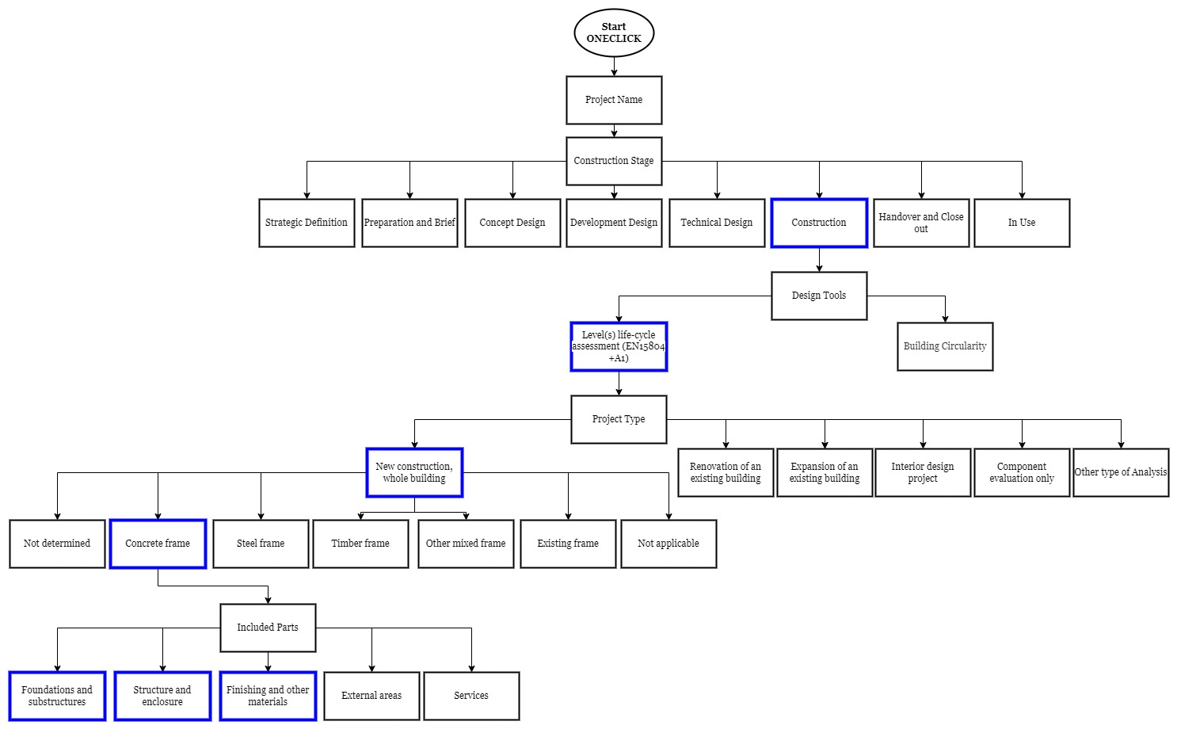

Figure 6. Flowchart of OneClick model initiation.
Subsequently, the project commences with the initiation of an input data window, which encompasses various parameters such as building materials, annual energy consumption, annual water consumption, construction site operations, calculation period, emissions removals, and building area. Figure 7 illustrates the comprehensive input data incorporated for the project.
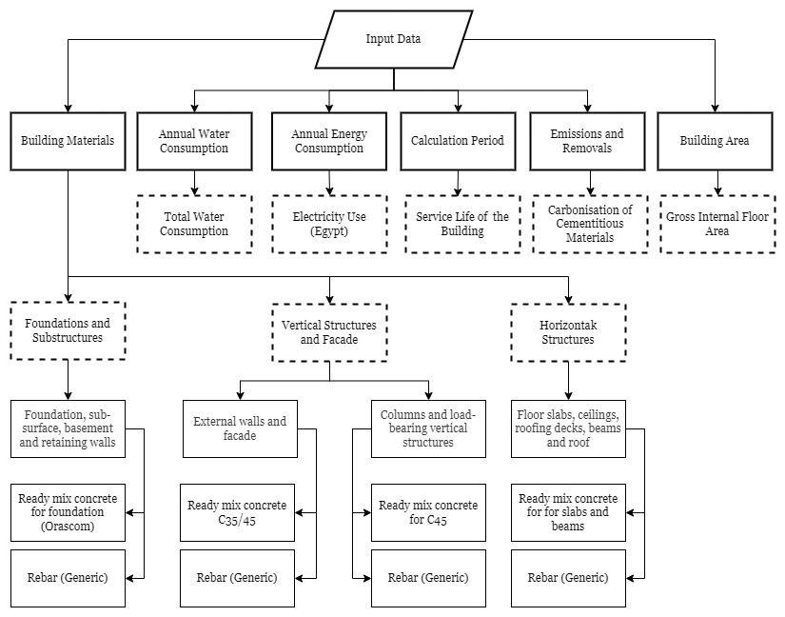
Figure 7. Flowchart of OneClick input data for this study.
Although not all input data is mandatory, the project focuses primarily on the emission of structural elements. Hence, significant attention is devoted to accurately inputting the quantity of building materials. To achieve this, a detailed BoQ for all structural elements is prepared to accommodate with OneClick input data, as summarized in Table 3 shown hereafter. This includes precise measurements of concrete volume in cubic meters (m³) and the weight of reinforcement, calculated and added for various rebar diameters, inputted in kilograms.
Table 3. Quantities of materials to be inserted in OneClick LCA
Structural Element | Ready Mix Concrete (m³) | Reinforcement Steel (kg)
Foundations and Substructure | 4,441 | 254,755
External Walls | 1,216 | 137,908
Columns | 1,429 | 150,060
Horizontal Structures | 6,435 | 743,458

The ready-mix concrete used in this project contains 0% recycled binders and is tailored to meet the specific compressive strength requirements of the assigned structural elements. Similarly, the rebars are of a generic type with 0% recycled content. OneClick offers a wide variety of construction materials, encompassing different products from various countries, each with unique characteristics and environmental profiles. These materials include concrete mixtures with varying percentages of recycled content, advanced composite materials, and high-strength steel rebars. Many of these products are Environmental Product Declaration (EPD) certified, providing transparent data on their environmental impact throughout their lifecycle. The availability of diverse materials with specific properties allows for the selection of the most suitable and sustainable options based on the project's location, performance requirements, and environmental goals.
It is crucial to note here that carbonization was the sole consideration due to concrete and steel being the primary material in the project. Concrete can act as a carbon sink through carbonization (or carbonation), a chemical process where CO₂ from the atmosphere reacts with calcium hydroxide (Ca(OH)₂) and other compounds in cementitious materials to form calcium carbonate (CaCO₃). Over time, this process can result in a net removal of CO₂, with concrete structures absorbing approximately 10-20% of the CO₂ emitted during cement production over their lifetime. For example, over a 50-year period, 13,522 m³ of concrete could absorb around 1,352.2 metric tons of CO₂, assuming a conservative absorption rate of 100 kg of CO₂ per m³ of concrete, highlighting the dual role of concrete as both a source of emissions during production and a potential carbon sink through carbonation.
Energy consumption emerged as the dominant factor for carbon emissions and global warming. OneClick requires two quantities for energy consumption: the annual energy consumed, and the energy consumed on site during construction from generators and similar sources. Following this, an annual electricity consumption rate of 100 kWh/m² was assumed, given that the project area measured approximately 8,800 m². Consequently, the estimated electricity consumption during the operational phase amounted to 880,000 kWh/year. This conservative assumption is closely aligned with reality, especially considering the nature of the studied project, a plastic factory known for its substantial annual electricity usage.
The water consumption was estimated at a minimal quantity, considering that plastic factories typically do not utilize significant amounts of water in their production processes. Additionally, the calculation period section necessitated specifying the service life of the building, which was assumed to be 25 years. This duration falls within the common range for concrete structures, typically spanning between 20 to 50 years, ensuring a realistic assessment of the project's lifespan. In the emissions and removals assessment, omitting the aspects of vegetation and refrigerant leakages was justified as there were no green areas surrounding the industrial building. Lastly, the building area, including the gross internal floor area, was a mandatory input data point with 8,760 m².

4. Results and Analysis

4.1 Results and Discussions:
It is important to note that the scope of this study focused solely on the structural system of the industrial building. Therefore, architectural components such as the facade, finishes, and cladding systems were excluded from the analysis. After conducting the LCA using OneClick, the results reveal that the total carbon dioxide equivalent emissions from the project amount to 29,122 tons CO₂e, with 132.98 kg CO₂e per m² per year, and a social carbon cost of 1,456,090 €. This underscores the significant impact of building materials on the overall carbon footprint.
Figure 7 illustrates the Embodied Carbon Benchmark for the studied project and it is automatically calculated for a period of 60 years, regardless of the set calculation period. Also, this benchmark accounts for embodied impacts relating to all assigned building parts. The results show a total of 1,037 kg CO₂e/m² at level G which represents at the highest embodied carbon emissions compared to level A which represents the lowest embodied carbon emissions.

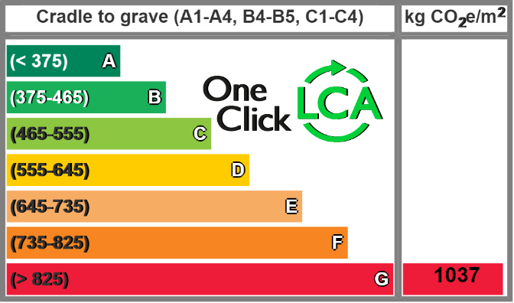
Figure 7. Embodied carbon benchmark.
The studied project shows that A1-A3 emissions from materials represent the highest percentage of embodied carbon at 94%, while material and waste transportation and disposal contribute minimally, not exceeding 10% of the embodied carbon as shown in Figure 8. The embodied carbon footprint during A1-A3 stages is high and represent most emissions as per literature review since this stage is includes the extraction, transportation, manufacturing and production of concrete and steel materials.

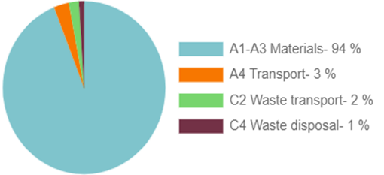
Figure 8. Embodied carbon by lifecycle stage.
According to American Concrete Institute (ACI 318-05) for special moment frames and special structural walls using Grade 60 or 80 reinforcement, the minimum concrete strength (fc′) should be at least 21 MPa. For special structural walls using Grade 100 reinforcement, the minimum concrete strength should be at least 35 MPa. For other structures, the minimum concrete strength should be at least 17 MPa.
Consequently, horizontal structures—beams, floors, and roofs—resulted in the highest percentage of embodied carbon, followed by foundations and substructures. The quantities of concrete and steel used in horizontal structures, beams, floors, and roofs are significantly higher than those used in other structures. Specifically, foundations and substructures used 4,441 m³ of concrete and 254,755 kg of steel, compared to vertical structures and facades with 2,645 m³ of concrete and 287,968 kg of steel. Horizontal structures, beams, floors, and roofs utilized 6,435 m³ of concrete and 743,458 kg of steel. Therefore, the increase in embodied carbon is primarily due to the high quantities used rather than the type of concrete.
Horizontal structures, beams, floors, and roofs have the highest embodied carbon and contribute the most to global warming, ozone depletion, acidification, eutrophication, and abiotic depletion. According to the analysis of construction materials, foundations and vertical structures have significantly less impact compared to horizontal structures, beams, floors, and roofs as shown in Figure 9, except for their impact on abiotic depletion.
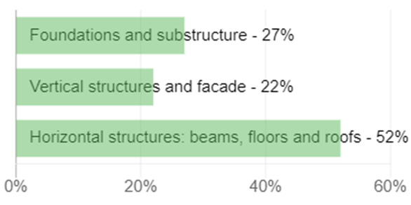
Figure 9. Embodied carbon by structure A1-A3.
Table 4 breaks down the environmental impact of different building material categories used in construction, focusing on their contributions to global warming (measured in kg CO₂e), biogenic carbon storage, ozone depletion (kg CFC11e), acidification (kg SO₂e), eutrophication (kg PO₄e), formation of lower atmosphere ozone (kg Ethene), abiotic depletion potential (ADP) for non-fossil resources (kg Sb), and ADP for fossil fuels (MJ). The percentages represent the share of each construction section's impact. Foundations, substructures, basements, and retaining walls contribute 26.74% to global warming, 29.11% to Ozone depletion, and varying percentages to other environmental impacts. External walls and facades have a smaller share, while columns and load-bearing structures have moderate impacts. Horizontal structures like floor slabs, ceilings, roofing decks, and beams dominate the environmental impact, especially in global warming, formation of ozone of lower atmosphere, and Eutrophication.
Table 4. Level(s) life-cycle assessment (EN15804 +A1): Construction Materials
Construction | Resource | User input | Global warming kg CO₂e | Biogenic carbon storage kg CO₂e  bio | Ozone Depletion  kg CFC11e | Acidification  kg SO₂e | Eutrophication  kg PO₄e | Formation of ozone of lower atmosphere kg Ethenee | Abiotic depletion potential (ADP- elements) for non-fossil resources  kg Sbe | Abiotic depletion potential (ADP- fossil fuels) for fossil resources  MJ
Building materials > Foundations and substructure > Foundation, sub-surface, basement and retaining walls
 |  | Section share | 26,74 % |  | 29,11 % | 26,84 % | 24,31 % | 22,82 % | 54,4 % | 30,82 %
Building materials > Vertical structures and facade > External walls and facade
 |  | Section share | 8,85 % |  | 8,85 % | 8,22 % | 9,11 % | 9,82 % | 14,11 % | 9,04 %
Building materials > Vertical structures and facade > Columns and load-bearing vertical structures
 |  | Section share | 12,7 % |  | 13,1 % | 12,81 % | 12,01 % | 12,04 % | 22,34 % | 12,04 %
Building materials > Horizontal structures: beams, floors and roofs > Floor slabs, ceilings, roofing decks, beams and roof
 |  | Section share | 51,71 % |  | 48,94 % | 52,13 % | 54,57 % | 55,32 % | 9,15 % | 48,1 %

The OneClick assessment focuses on identifying and evaluating the impact of construction materials, namely concrete and steel. However, to fully understand the carbon emissions from the entire construction phase, other factors such as energy and water consumption must also be considered. The available data is limited to quantities of materials used, but when minimum estimates for energy consumption were included, the results varied significantly. As shown in Figure 7 and Figure 8, incorporating energy consumption into the design results in markedly different outcomes compared to considering only construction materials.
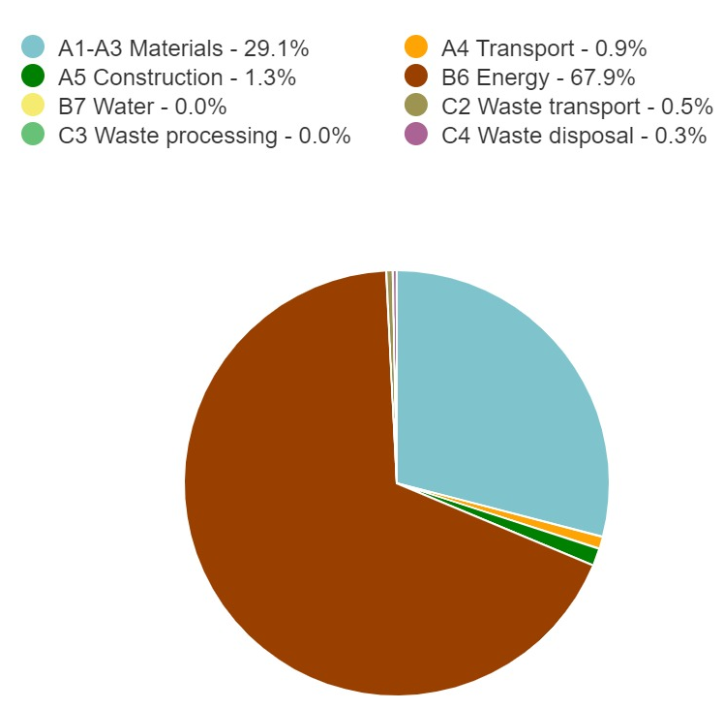
Figure 7. Global warming kg CO₂₋ Life Cycle-Stages.
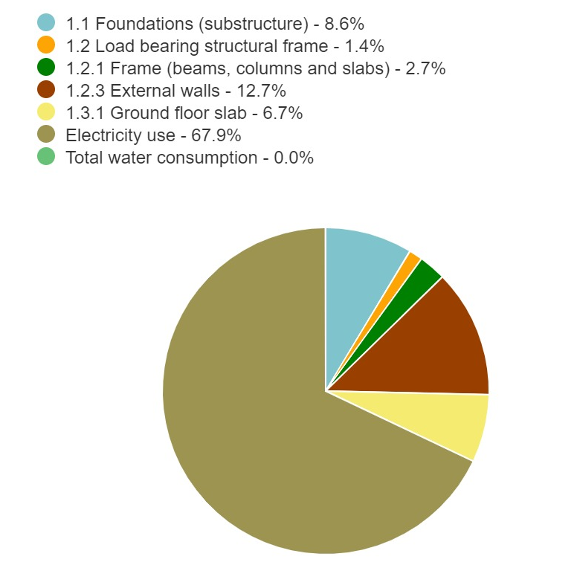
Figure 8. Global warming kg CO₂₋ classifications.
Upon inspecting the most contributing materials, it was found that the steel rebars have the highest cradle to gate impacts (A1-A3), followed by ready-mix concrete for slabs and beams and other types of concrete used for the different structures, as shown in Table 5.
Table 5. Most contributing materials (Global Warming)
Resource | Cradle to gate impacts (A1-A3)
Reinforcement steel (rebar), generic, 0% recycled content | 3,204 tonnes CO₂e
Ready-mix concrete for slabs and beams, C40, 2407.5 kg/m³ | 2,587 tonnes CO₂e
Ready-mix concrete for foundation and piles, 2373.5 kg/m³ | 1,661 tonnes CO₂e
Ready-mix concrete, C45, 2446.5 kg/m³ | 716 tonnes CO₂e
Ready-mix concrete, normal strength, generic, C35/45 (5000/6500 PSI) with CEM I, 0% recycled binders (340 kg/m³; 21.2 lbs/ft³ total cement) | 416 tonnes CO₂e

4.2 Sustainable Alternatives
As mentioned in the results, the analysis revealed that the total carbon dioxide equivalent emissions from the project is 29,122 tons CO₂e, with 133 kg CO₂e per m² per year. Many alternatives have been made to decrease CO₂ emissions during construction. Four different alternatives will be discussed, three of them involve changing the materials to more sustainable ones while keeping the design/plans for both architecture and structural the same with no alterations. It is important to clarify that the recycled materials used in the study were directly included in the LCA without incorporating any secondary materials or secondary fuels associated with the collection or transportation of the recycled structural elements. In line with the cut-off rules, we ensured that the environmental impacts were only attributed to the recycling processes themselves, and no benefits or burdens from external processes, such as the recovery or transport of recycled materials, were considered. This approach was used to maintain the integrity of the LCA while adhering to the principles of the cut-off model. Thus, only the direct impacts of the recycled content in the materials were included in the analysis, avoiding the inclusion of additional, potentially misleading burdens.

4.2.1. First alternative
This one entailed replacing the 0% recycled ready mixed concrete in all the structural elements with a mix containing 40-55% recycled binders in cement. This resulted in a reduction in CO₂e to 122 kg CO₂e / m² / year, approximately an 8.5% reduction, leading the results to upgrade to level F in the Embodied Carbon Benchmark (Figure 9).
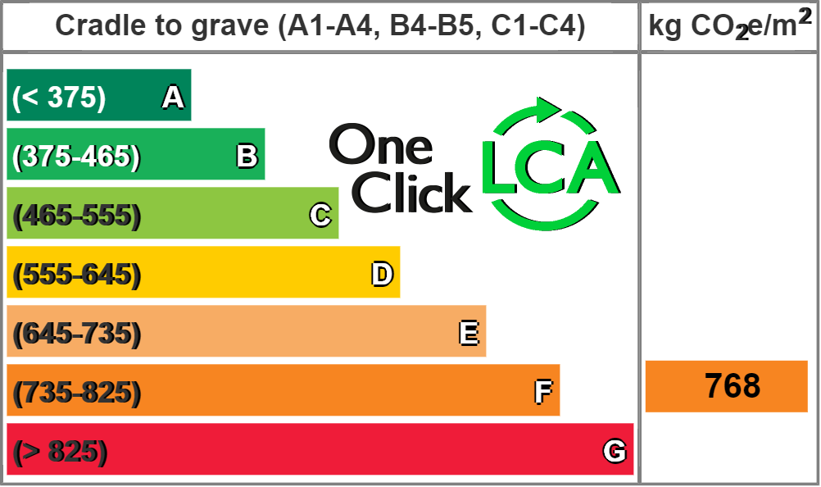
Figure 9. Embodied carbon benchmark for recycled concrete replacement.
4.2.2. Second alternative
This recommended alternative suggested replacing the 0% recycled rebar with 97% recycled rebar. This change reflects in the results with a reduction in CO₂e to 123 kg CO₂e / m² / year, a figure like the change observed with the recycled binders in ready-mix concrete (Figure 10).
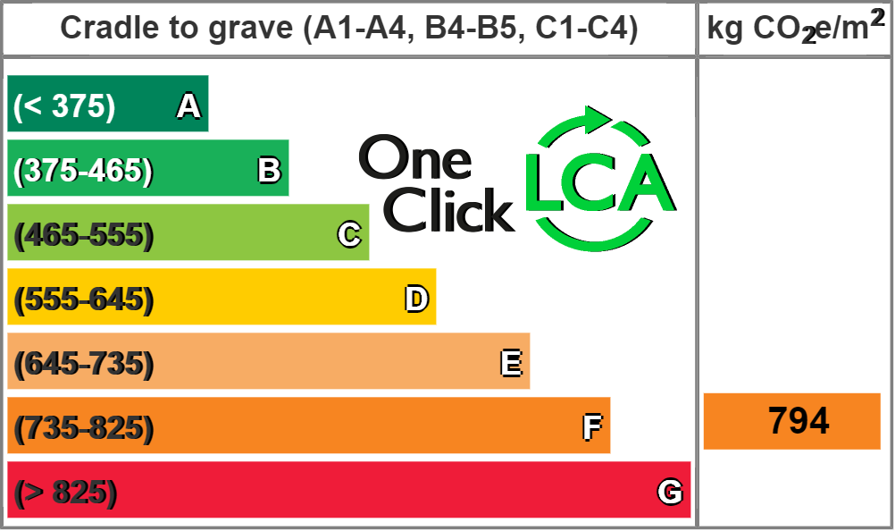
Figure 10. Embodied carbon benchmark for recycled rebar replacement.
4.2.3. Third alternative
The proposal that could improve the results further involved replacing both the 0% recycled binder of the ready-mix concrete and the 0% recycled rebars with the suggested materials above (Ready mix concrete with 40-55% recycled binders in cement and 97% recycled rebar). This would lead to a reduction in CO₂e equivalent to 112 kg CO₂e / m² / year, around a 16% reduction from the original results, and to upgrade to level C in the Embodied Carbon Benchmark as shown in Figure 11.

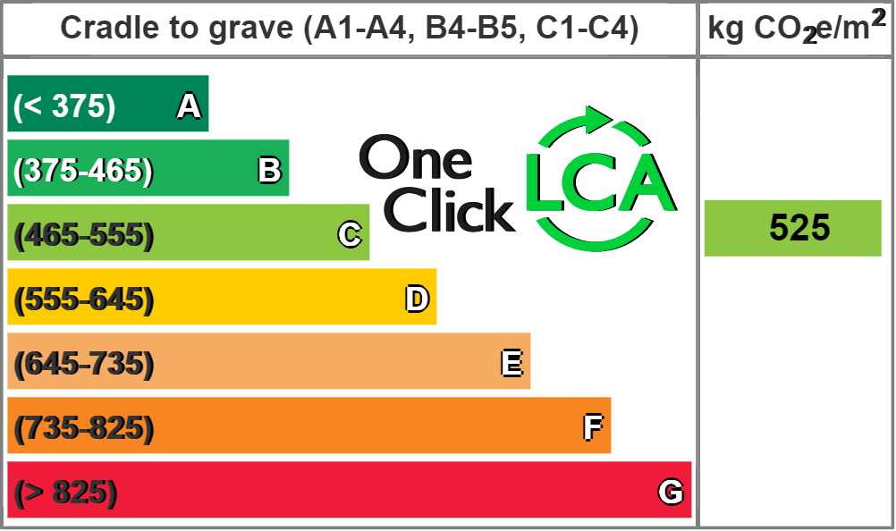
Figure 11. Embodied carbon benchmark for recycled rebar and recycled concrete replacement.
4.3.4. Fourth alternative
The final suggestion entailed a shift in the construction approach from a concrete frame to steel construction. Instead of erecting a multi-story building entirely composed of concrete and reinforced steel with extensive reinforcement, the proposed solution advocated for expanding the land area and constructing a single-story building using steel construction methods. This alternative design was focused mainly on changing the main frame from concrete structure to steel structure but does not necessitate the whole replacement of concrete elements, such as facade. This solution effectively addressed the issue of CO₂ emissions stemming from the substantial volume of concrete required, which amounted to 13,522 m³, while also reducing the quantity of steel utilized in the concrete. Although the shift from concrete to steel framing reduced concrete usage significantly, it did not eliminate it entirely. Concrete remained necessary for certain structural components, most notably the foundation, and was treated as a secondary material. The recommendation to utilize steel frame primarily served as guidance for future industrial projects, where early adoption of steel framing may support lower embodied carbon outcomes.
Expanding the land area at the time of land acquisition emerged as the optimal solution, given the relatively low cost of land per square meter during that period. The land was obtainable at a nominal price, nearly devoid of any significant cost, particularly considering the stipulation of commencing construction promptly.
Table 6 presents a comparison of the recommended designs alongside the existing design, focusing on CO₂ emissions and the social cost of carbon. The Existing Design uses 0% recycled content in both concrete and reinforcement rebars, leading to the highest CO₂ emissions (29,122 tons) and social cost (€1,456,090). In contrast, Recommended Designs 1 to 3 incorporate recycled binders (40-55%) and recycled rebars (up to 97%), showing a steady reduction in emissions and costs. Recommended Design 3, with both recycled binders and rebars, achieves the lowest emissions (24,435 tons) and social cost (€1,221,749). Recommended Design 4 suggests a switch to steel construction and expanding the land area but lacks specific emissions data.
Table 6. Comparison of CO₂ emissions and social cost of carbon for different designs
Design Option | Description | CO₂e Tonnes | Kg Co₂e/m²/year | Social Cost of Carbon (€)
Existing Design | All structural elements are made of Ready-mix concrete (0% Recycled binders) and Reinforcement rebars (0% recycled content) | 29,122 | 132.98 | 1,456,090
Recommended Design 1 | All structural elements are made of Ready-mix concrete (40-55% Recycled binders) and Reinforcement rebars (0% recycled content) | 26,669 | 121.78 | 1,333,473
Recommended Design 2 | All structural elements are made of Ready-mix concrete (0% Recycled binders) and Reinforcement rebars (97% recycled content) | 26,887 | 122.77 | 1,344,367
Recommended Design 3 | All structural elements are made of Ready-mix concrete (40-55% Recycled binders) and Reinforcement rebars (97% recycled content) | 24,435 | 111.58 | 1,221,749
Recommended Design 4 | switching from a concrete frame to steel construction, expanding the land area, and building a single-story structure | _ | _ | _

5. Conclusions
In conclusion, the significance of building materials in mitigating emissions within the construction sector cannot be overstated. Embracing sustainable and low-carbon materials profoundly impacts the environmental footprint of buildings, reducing their energy consumption and emissions throughout their lifecycle. The objective of this project was to verify and demonstrate the contribution of building materials to building emissions, focusing on the impact of concrete and steel, through using environmental software tools. In other words, this study aimed to contribute to the development of more sustainable construction practices, particularly in regions where industrial buildings play a significant role in economic and environmental landscapes.
After conducting and evaluating the life cycle assessment study by the environmental software OneClick, many conclusions and recommendations may be drawn as follows:
- Nowadays, the environmental software is a crucial tool to quantify the life cycle assessment and environmental impacts of construction materials for all projects and specifically for an industrial building. Importantly, quantitative analysis of the environmental impacts made it possible to make different recommendations and scenarios to study their effects and compare them to look for opportunities to lower emissions.
- This study confirmed that environmental software tools, for example OneClick LCA, plays a crucial role and valuable insights during early design stages in measuring and quantifying emissions and the social cost of these carbon emissions. By providing detailed insights during the design stage and before construction, OneClick allows for informed decision-making, helping to identify and implement strategies to reduce carbon emissions effectively. This proactive approach not only improves the environmental performance of buildings but also contributes to long-term sustainability goals.
- Incorporating recycled materials, such as recycled concrete or recycled rebar, significantly decreases the amount of embodied carbon. Notably, the combined use of both recycled concrete and recycled rebar has the most substantial impact on reducing embodied carbon compared to using recycled materials in just one type alone. Also, it is worth noting to emphasize on using certified and approved recycled concrete and rebars to guarantee the quality and performance of these materials and that there will be no trade off the durability and functionality of the structure.
- Many environmental and technical datasheets for different international and Egyptian materials are already existing within different databases used in these environmental software tools. Specifically, this study found that OneClick includes comprehensive environmental datasets for many construction materials, including those commonly used in Egypt. This broad data availability ensures that such tools are practical for local applications, although continued efforts are needed to enrich regional datasets for more accurate assessments.
- The LCA showed that materials like ready-mix concrete and reinforcement steel, when used with recycled content, can significantly reduce carbon emissions. The most substantial reductions were achieved when both recycled concrete binders and recycled steel rebars were used together. However, it is crucial to ensure that all recycled materials are certified and tested for structural reliability.
- More research investigations need to be conducted for better quantification of LCA studies and environmental impacts.
- Additionally, future efforts to reduce embodied carbon by focusing on other areas, such as energy and water usage, will further diminish the environmental impact of industrial building construction projects, making them more sustainable.

6. Recommendations
More research is needed to quantify the life cycle assessments and environmental impacts of the construction industry. The aim of these studies is to investigate the different existing LCA tools to assess and validate the environmental impacts of the construction industry quantitively for better implementation of sustainable development concepts. Importantly, it is paramount for the construction industry to adopt of the usage of existing LCA tools during the design development stage as a decision aiding tool for better enhancement of sustainability of construction industry. It is important for future research to include other variables and parameters that impact the sustainability of construction such as transportation and maintenance. Further recommendations include expanding research into the development of international standards and procedures for better usage of LCA tools in quantifying the sustainability of the construction industry. It is of essence, nowadays, to further investigate means and incentives needed to encourage different stakeholders to promote sustainability in the construction industry. Also, it is crucial to encourage the use of alternative sustainable materials and innovative construction techniques and then to assess their economic and social impacts. Continuous advancements in material science and construction technology should be integrated into building practices. Additionally, the development of industry-wide standards and regulations promoting the use of low-carbon and recycled materials would significantly enhance the overall sustainability of the construction sector. Collaboration between stakeholders, including architects, engineers, policymakers, and material suppliers, is essential to drive the adoption of these sustainable practices and achieve long-term environmental benefits. Recommendations on alternative materials and design could be improved by adding considerations on availability and costs of alternative materials in Egypt and economic and social impacts.

Funding: This research received no external funding.

Declaration of Competing Interest
All authors declare that there are no known competing conflicts of interest, financial or non-financial, related to influence the work reported in these publications.

Ethics declarations
The authors declare that they have not used any type of generative artificial intelligence for the writing of this manuscript, nor for the creation of images, graphics, tables, or their corresponding captions.

Ethics approval and consent to participate
Not applicable.

Publish declaration
The authors consent for the publication of this manuscript.

Clinical trial declaration
Not applicable.

Author Contributions
Berlant Arab: conceptualization, methodology, formal analysis, investigation, writing-original draft preparation, writing-review and editing. Mohamed Abdel Raouf: conceptualization, methodology, formal analysis, writing-original draft preparation, writing-review and editing, supervision. Amir Hany: investigation, writing-original draft preparation, writing-review and editing. Mariam Mostafa: investigation, writing-original draft preparation, writing-review and editing. Mohamed Nagib AbouZeid: supervision.

Corresponding author
Berlant Arab, berlantarab@aucegypt.edu

References

[1] Building Materials and the climate: Constructing a new future. (2023, September 12). UNEP - UN Environment Programme. https://www.unep.org/resources/report/building-materials-and-climate-constructing-new future#:~:text=The%20buildings%20and%20construction%20sector,have%20a%20%20significant%20%20carbon%20%20footprint

[2] Amarnath, N. (2024, February 2). ASHRAE, ICC unveil draft standard for GHG emission assessment in buildings. Facilities Dive. https://www.facilitiesdive.com/news/ashrae-icc-draft-standard-greenhouse-gas-emission-assessment-buildings/706441/

[3] International Code Council (ICC). (n.d.). 2021 International Building Code (IBC). https://codes.iccsafe.org/content/IBC2021P2

[4] ASHRAE. (2022). ASHRAE Handbook—HVAC Systems and Equipment. American Society of Heating, Refrigerating and Air-Conditioning Engineers.

[5] Guinée, J. (2015). Life cycle sustainability Assessment: What is it and what are its challenges? In Springer eBooks (pp. 45–68). https://doi.org/10.1007/978-3-319-20571-7_3

[6] Van Den Bijgaart, I., Gerlagh, R., & Liski, M. (2016). A simple formula for the social cost of carbon. Journal of Environmental Economics and Management, 77, 75–94. https://doi.org/10.1016/j.jeem.2016.01.005

[7] Bribián, I. Z., Capilla, A. V., & Usón, A. A. (2010). Life cycle assessment of building materials: Comparative analysis of energy and environmental impacts and evaluation of the eco-efficiency improvement potential. Building and Environment, 46(5), 1133–1140. https://doi.org/10.1016/j.buildenv.2010.12.002

[8] Ramsden, K. (2020, November 3). Cement and Concrete: The Environmental Impact — PSCI. PSCI. https://psci.princeton.edu/tips/2020/11/3/cement-and-concrete-the-environmental-impact

[9] Skinner, B., & Lalit, R. (2023). Concrete: 8% of Global Emissions and Rising. Which Innovations Can Achieve Net Zero by 2050? Energy Post. https://energypost.eu/concrete-8-of-global-emissions-and-rising-which-innovations-can-achieve-net-zero-by-2050/

[10] Doedee, V. (2023, October 17). What is the carbon footprint of steel? — Sustainable Ships. Sustainable Ships. https://www.sustainable-ships.org/stories/2022/carbon-footprint-steel

[11] Zhang, X., & Wang, F. (2016). Assessment of embodied carbon emissions for building construction in China: Comparative case studies using alternative methods. Energy and Buildings, 130, 330–340. https://doi.org/10.1016/j.enbuild.2016.08.080

[12] PEEB Working Paper. (2021). Embodied carbon – a hidden heavyweight for the climate: How financing and policy can reduce the carbon footprint of building materials and construction. PEEB. https://www.peeb.build/imglib/downloads/PEEB_Building_Materials_Embodied_Carbon.pdf

[13] Center for Climate and Energy Solutions. (2022, December 7). Controlling Industrial Greenhouse Gas Emissions - Center for Climate and Energy Solutions. https://www.c2es.org/content/regulating-industrial-sector-carbon-emissions/

[14] Dossche, C., Boel, V., & De Corte, W. (2017). Use of life cycle assessments in the construction sector: Critical review. Procedia Engineering, 171, 302–311. https://doi.org/10.1016/j.proeng.2017.01.338

[15] Pamu, Y., Kumar, V., Shakir, M. A., & Ubbana, H. (2021). Life Cycle Assessment of a building using Open-LCA software. Materials Today Proceedings, 52, 1968–1978. https://doi.org/10.1016/j.matpr.2021.11.621

[16] Bilec, M. M., Ries, R. J., & Matthews, H. S. (2009). Life-Cycle Assessment Modeling of construction processes for buildings. Journal of Infrastructure Systems, 16(3), 199–205. https://doi.org/10.1061/(asce)is.1943-555x.0000022

[17] Singh, A., Berghorn, G., Joshi, S., & Syal, M. (2010). Review of Life-Cycle Assessment Applications in Building Construction. Journal of Architectural Engineering, 17(1), 15–23. https://doi.org/10.1061/(asce)ae.1943-5568.0000026

[18] Talpur, B. D., Liuzzi, S., Rubino, C., Cannavale, A., & Martellotta, F. (2023). Life cycle assessment and circular building design in South Asian Countries: A review of the current state of the art and research potentials. Buildings, 13(12), 3045. https://doi.org/10.3390/buildings13123045

[19] ISO. (2006). ISO 14040:2006(en) - Environmental management - Life cycle assessment - Principles and framework. International Organization for Standardization. https://www.iso.org/standard/37456.html

[20] U.S. Green Building Council. (2025). LEED v5 Reference Guide for Building Design and Construction, April 2025 Launch Edition. U.S. Green Building Council. Retrieved from https://www.usgbc.org/resources/leed-v5-reference-guide-building-design-and-construction-april-2025-launch-edition

[21] Malmqvist, T., Glaumann, M., Scarpellini, S., Zabalza, I., Aranda, A., Llera, E., & Díaz, S. (2010). Life cycle assessment in buildings: The ENSLIC simplified method and guidelines. Energy, 36(4), 1900–1907. https://doi.org/10.1016/j.energy.2010.03.026

[22] Elmawgoud, M., & Elghaffar, A. (2007). Life-Cycle Assessment Tools for Maintenance Management and Resource Conservation. Assiut University Bulletin for Environmental Research, 10.1(10.1), 73–83. https://doi.org/10.21608/auber.2007.150218

[23] Ali, A., & Negm, A. (2014). Environmental Impacts Assessment of the Egyptian Brick Types Using Life Cycle Assessment Tool. Research Gate. https://doi.org/10.13140/2.1.1333.4085

[24] Ali, A., Negm, A., Bady, M., & Ibrahim, M. (Eds.). (2014a). Framework for Application of Life Cycle Assessment Approach on Egyptian Residential Building: Case Study: New Assiut City, Egypt. Research Gate. https://www.researchgate.net/publication/269393627_Framework_for_Application_of_Life_Cycle_Assessment_Approach_on_Egyptian_Residential_Building_Case_Study_New_Assiut_City_Egypt

[25] Ali, A. a. M., Negm, A. M., Bady, M. F., Ibrahim, M. G. E., & Suzuki, M. (2014). Environmental impact assessment of the Egyptian cement industry based on a life-cycle assessment approach: a comparative study between Egyptian and Swiss plants. Clean Technologies and Environmental Policy, 18(4), 1053–1068. https://doi.org/10.1007/s10098-016-1096-0

[26] Ali, A., Negm, A., & Bady, M. (2014). Estimating Carbon Emissions from Industrial Process by using Life Cycle Assessment Tool. Research Gate. https://doi.org/10.13140/2.1.1857.6965

[27] Ali, A. a. M., Negm, A. M., Bady, M. F., & Ibrahim, M. G. E. (2014). Moving towards an Egyptian national life cycle inventory database. The International Journal of Life Cycle Assessment, 19(8), 1551–1558. https://doi.org/10.1007/s11367-014-0760-z

[28] Ali, A., Negm, A., Bady, M., & Ibrahim, M. (2014b). Towards an Integrated Tool to Estimate Carbon Emissions from Life Cycle Assessment of Building Materials in Egypt. Research Gate. https://www.researchgate.net/publication/269393690

[29] Ali, A. a. M. M., Negm, A. M., Bady, M. F., & Ibrahim, M. G. (2015). Environmental life cycle assessment of a residential building in Egypt: a case study. Procedia Technology, 19, 349–356. https://doi.org/10.1016/j.protcy.2015.02.050

[30] Elshafei, G., & Negm, A. (2015). Life cycle assessment as a decision making for window performance comparison in green building design. World Academy of Science, Engineering and Technology, International Journal of Civil, Environmental, Structural, Construction and Architectural Engineering, 9(9), 1147–1155. https://doi.org/10.5281/zenodo.1108284

[31] Ibrahim M., and Ali, A.A.M. 2017. Practical case study for life cycle assessment of the Egyptian brick industry: A comparative analysis of the Japanese industry. https://scholar.google.com/citations?view_op=view_citation&hl=en&user=5Ng0zOMAAAAJ&cstart=20&pagesize=80&citation_for_view=5Ng0zOMAAAAJ:roLk4NBRz8UC

[32] Sharaan, M., & Negm, A. (2017). Life Cycle Assessment of Dredged Materials Placement Strategies: Case Study, Damietta Port, Egypt. Procedia Engineering, 181, 102–108. https://doi.org/10.1016/j.proeng.2017.02.375

[33] Elboshy, B., Negm, A., Gamaleldin, M., & Abdel-Fattah, S. (2017). Life cycle assessment for sidewalk pavement types, Case study: Extension of New Borg El-Arab City. Procedia Engineering, 181, 370–377. https://doi.org/10.1016/j.proeng.2017.02.403

[34] Ayeldeen, Mohamed & Negm, Abdelazim. (2015). Global warming potential impact due to pile foundation construction using life cycle assessment. 20. 4413-4421. https://scholar.google.com/citations?view_op=view_citation&hl=en&user=SCUFtZkAAAAJ&cstart=100&pagesize=100&citation_for_view=SCUFtZkAAAAJ:rJyh6hJnyfgC

[35] Marzouk, M., & Azab, S. (2016). Analyzing sustainability in low-income housing projects using system dynamics. Energy and Buildings, 134, 143–153. https://doi.org/10.1016/j.enbuild.2016.10.034

[36] Younes, M., Huang, Y., & Hashim, I. (2014). Towards an Integrated Tool of a Life Cycle Assessment for Construction of Asphalt Pavements in Egypt. Journal of Earth Sciences and Geotechnical Engineering, 6(4), 377–388. https://www.scienpress.com/Upload/GEO/Vol%206_4_23.pdf

[37] Morsi, D. M., Ismaeel, W. S., & El-Hamed, A. E. A. (2020). Life cycle assessment of a residential building in Egypt: A case study. IOP Conference Series Materials Science and Engineering, 974(1), 012028. https://doi.org/10.1088/1757-899x/974/1/012028

[38] Ali, A. (2022). Application of comparative life cycle assessment to a proposed building for reduced environmental impacts: Assiut University Hospital Clinic as a case study. Journal of Architecture, Arts and Humanistic Sciences, 7(31), 0. https://doi.org/10.21608/mjaf.2020.41904.1847

[39] Azouz, M. (2018). The Future of Green Building Materials in Egypt: A Framework for Action. Resourceedings, 1(1). https://doi.org/10.21625/resourceedings.v1i1.180

[40] Morsi, D., Ismaeel, W. S., Dr, A. E. a. E. H., & Othman, A. A. (n.d.) (2020). Applying LCA-BIM integration for a sustainable management process. BUE Scholar. https://buescholar.bue.edu.eg/arch_eng/111/

[41] Hassan, S. R., Megahed, N. A., Eleinen, O. M. A., & Hassan, A. M. (2022). Toward a national life cycle assessment tool: Generative design for early decision support. Energy and Buildings, 267, 112144. https://doi.org/10.1016/j.enbuild.2022.112144

[42] Mowafy, N., Zayat, M. E., & Marzouk, M. (2023). Parametric BIM-based life cycle assessment framework for optimal sustainable design. Journal of Building Engineering, 75, 106898. https://doi.org/10.1016/j.jobe.2023.106898

