Figure 1:
The 17 SDG icons
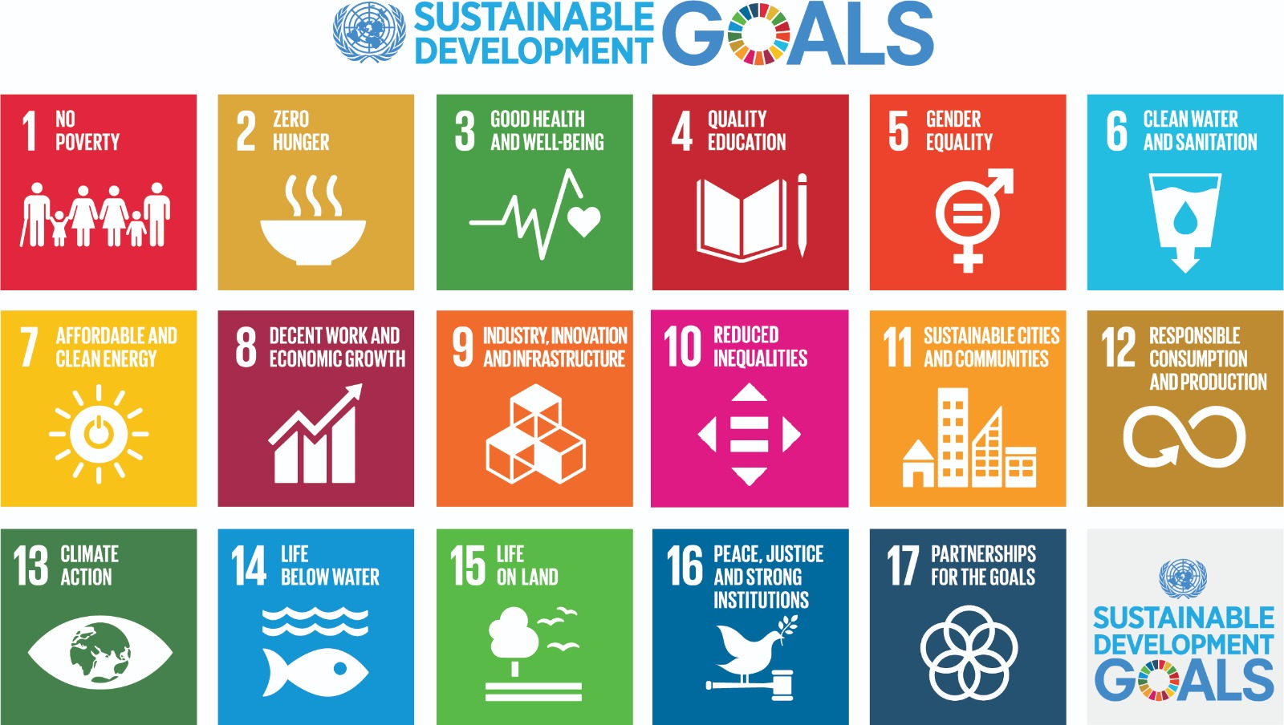

Figure 2:
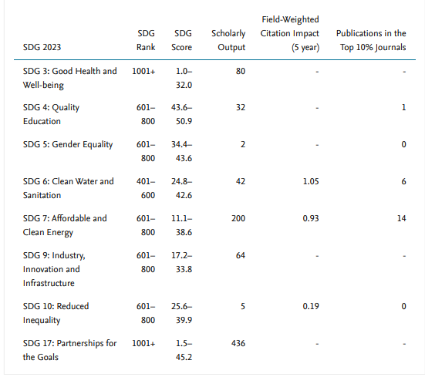
Ranking of Hassan first University in the program” impact ranking 2023” by SDG

Figure 3:
Evolution of Hassan first's overall score and rank (impact ranking
) 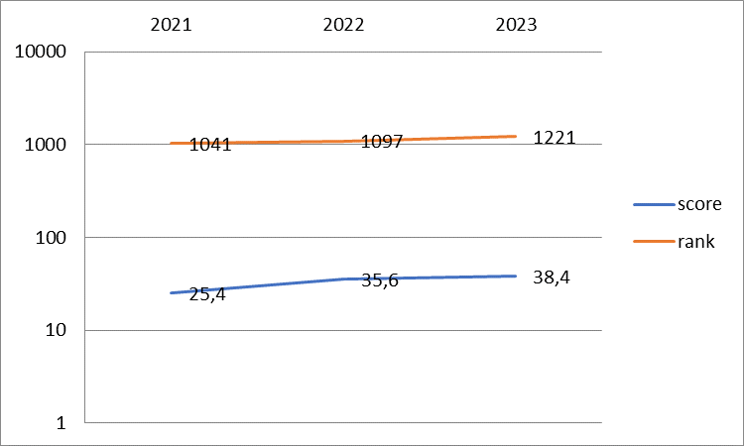

Figure 4:
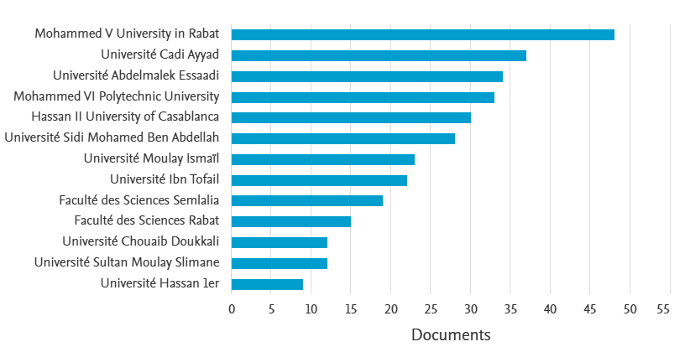
Ranking of Moroccan universities by number of documents produced related directly to SDG’s

Figure 5:
Publications by Subject Area
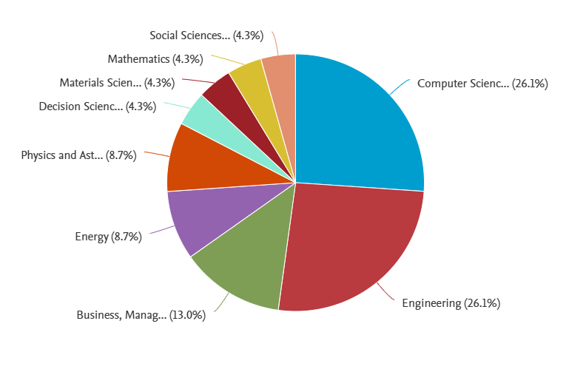
Figure 6:
Number of publications indirectly related to SDG between 2018-2023 by SDG and FWCI:
