Supplementary Materials —Linking Green Entrepreneurial Orientation and Green Market Orientation to Firm Sustainability Performance: A Three-Level Meta-analysis
R Codes (S1)
## Install and Load Necessary Packages
if (!require("metafor")) install.packages("metafor", dependencies = TRUE)
if (!require("dplyr")) install.packages("dplyr", dependencies = TRUE)
if (!require("readxl")) install.packages("readxl", dependencies = TRUE)
if (!require("ggplot2")) install.packages("ggplot2l", dependencies = TRUE)
if (!require("readxl")) install.packages("readxl", dependencies = TRUE)

## Libraries
library(metafor)
library(dplyr)
library(readxl)
library(ggplot2)
library(dmetar)
library(writexl)

### Set Working Directory
setwd("path/to/data/folder") # masked for blind review

## Read Data from CSV File
data <- read.csv("Overall_GEO_MM.csv")
View(data)

# Calculate sampling variance (vi) and store it in the dataset
data$vi <- (1 - data$yi)^2 / (data$n - 1)

# View the updated dataset
head(data)

### fit multilevel model
res.geo <- rma.mv(yi, vi, random = ~ 1 | study/esid, data = data)
res.geo

### Extract coefficients
coef_table <- data.frame(
Term = rownames(summary(res.geo)$b),
Estimate = as.vector(summary(res.geo)$b),
SE = summary(res.geo)$se,
Zval = summary(res.geo)$zval,
Pval = summary(res.geo)$pval,
CI_lb = summary(res.geo)$ci.lb,
CI_ub = summary(res.geo)$ci.ub
)

### Extract model statistics
model_stats <- data.frame(
Statistic = c("k", "Q", "df", "Q_pval"),
Value = c(
res.geo$k, # Number of studies
res.geo$QE, # Q-statistic
res.geo$k - 1, # Degrees of freedom (df)
res.geo$QEp # p-value for Q-statistic
)
)

### Save both tables to an Excel file
write_xlsx(
list(
Coefficients = coef_table,
Model_Statistics = model_stats
),
file_path <- "C:/path/to/res.geo_results.xlsx" # masked for blind review
)

### LRTs for the variance components
res.geo0 <- rma.mv(yi, vi, random = ~ 1 | study/esid, data=data, sigma2=c(0,NA))
anova(res.geo0, res.geo)

## Compute distribution of variance across levels
i2.geo <- var.comp(res.geo)
summary(i2.geo)

## Plot distribution of variance across levels
plot(i2.geo)

### Examine moderating effect of Global Sustainability Competitive Index
meta_regression.geo.gsci <- rma.mv(yi, vi, mods = ~ GSCI, random = ~ 1 | study/esid, data=data)
summary(meta_regression.geo.gsci)

### Extract coefficients from the model
coef_table <- data.frame(
Term = rownames(summary(meta_regression.geo.gsci)$b),
Estimate = as.vector(summary(meta_regression.geo.gsci)$b),
SE = summary(meta_regression.geo.gsci)$se,
Zval = summary(meta_regression.geo.gsci)$zval,
Pval = summary(meta_regression.geo.gsci)$pval,
CI_lb = summary(meta_regression.geo.gsci)$ci.lb,
CI_ub = summary(meta_regression.geo.gsci)$ci.ub
)

# Extract model statistics
model_stats <- data.frame(
Statistic = c("k", "Q", "df", "Q_pval"),
Value = c(
meta_regression.geo.gsci$k, # Number of studies
meta_regression.geo.gsci$QE, # Q-statistic
meta_regression.geo.gsci$k - 1, # Degrees of freedom (df)
meta_regression.geo.gsci$QEp # p-value for Q-statistic
)
)

# Save results to Excel
write_xlsx(
list(
Coefficients = coef_table,
Model_Statistics = model_stats
),
file_path <- "C:/path/to/meta_regression.geo.gsci_results.xlsx" # masked for blind review
)

### Examine moderating effect of research design
meta_regression.geo.design <- rma.mv(yi, vi, mods = ~ design, random = ~ 1 | study/esid, data=data)
summary(meta_regression.geo.design)

### Extract coefficients from the model
coef_table <- data.frame(
Term = rownames(summary(meta_regression.geo.design)$b),
Estimate = as.vector(summary(meta_regression.geo.design)$b),
SE = summary(meta_regression.geo.design)$se,
Zval = summary(meta_regression.geo.design)$zval,
Pval = summary(meta_regression.geo.design)$pval,
CI_lb = summary(meta_regression.geo.design)$ci.lb,
CI_ub = summary(meta_regression.geo.design)$ci.ub
)

### Extract model statistics
model_stats <- data.frame(
Statistic = c("k", "Q", "df", "Q_pval"),
Value = c(
meta_regression.geo.design$k, # Number of studies
meta_regression.geo.design$QE, # Q-statistic
meta_regression.geo.design$k - 1, # Degrees of freedom (df)
meta_regression.geo.design$QEp # p-value for Q-statistic
)
)

### Save results to Excel
write_xlsx(
list(
Coefficients = coef_table,
Model_Statistics = model_stats
),
file_path <- "C:/path/to/meta_regression.geo.design_results.xlsx" # masked for blind review
)

## Test for Publication Bias with Funnel Plot
funnel(res.geo)

R Codes (S2)
## Install and Load Necessary Packages
if (!require("metafor")) install.packages("metafor", dependencies = TRUE)
if (!require("dplyr")) install.packages("dplyr", dependencies = TRUE)
if (!require("readxl")) install.packages("readxl", dependencies = TRUE)
if (!require("ggplot2")) install.packages("ggplot2l", dependencies = TRUE)
if (!require("readxl")) install.packages("readxl", dependencies = TRUE)

## Libraries
library(metafor)
library(dplyr)
library(readxl)
library(ggplot2)
library(dmetar)
library(writexl)

### Set Working Directory
setwd("path/to/data/folder") # masked for blind review

## Read Data from CSV File
data <- read.csv("Overall_GMO_MM.csv")
View(data)

# Calculate sampling variance (vi) and store it in the dataset
data$vi <- (1 - data$yi)^2 / (data$n - 1)

# View the updated dataset
head(data)

### fit multilevel model
res.gmo <- rma.mv(yi., vi, random = ~ 1 | study/esid, data = data)
res.gmo

### Extract coefficients
coef_table <- data.frame(
Term = rownames(summary(res.gmo)$b),
Estimate = as.vector(summary(res.gmo)$b),
SE = summary(res.gmo)$se,
Zval = summary(res.gmo)$zval,
Pval = summary(res.gmo)$pval,
CI_lb = summary(res.gmo)$ci.lb,
CI_ub = summary(res.gmo)$ci.ub
)

### Extract model statistics
model_stats <- data.frame(
Statistic = c("k", "Q", "df", "Q_pval"),
Value = c(
res.gmo$k, # Number of studies
res.gmo$QE, # Q-statistic
res.gmo$k - 1, # Degrees of freedom (df)
res.gmo$QEp # p-value for Q-statistic
)
)

### Save both tables to an Excel file
write_xlsx(
list(
Coefficients = coef_table,
Model_Statistics = model_stats
),
file_path <- "C:/path/to/res.gmo_results.xlsx" # masked for peer review
)

### LRTs for the variance components
res.gmo0 <- rma.mv(yi., vi, random = ~ 1 | study/esid, data=data, sigma2=c(0,NA))
anova(res.gmo0, res.gmo)

## Compute distribution of variance across levels
i2.gmo <- var.comp(res.gmo)
summary(i2.gmo)

## Plot distribution of variance across levels
plot(i2.gmo)

### Examine moderating effect of Global Sustainability Competitive Index
meta_regression.gmo.gsci <- rma.mv(yi., vi, mods = ~ GSCI, random = ~ 1 | study/esid, data=data)
summary(meta_regression.gmo.gsci)

### Extract coefficients from the model
coef_table <- data.frame(
Term = rownames(summary(meta_regression.gmo.gsci)$b),
Estimate = as.vector(summary(meta_regression.gmo.gsci)$b),
SE = summary(meta_regression.gmo.gsci)$se,
Zval = summary(meta_regression.gmo.gsci)$zval,
Pval = summary(meta_regression.gmo.gsci)$pval,
CI_lb = summary(meta_regression.gmo.gsci)$ci.lb,
CI_ub = summary(meta_regression.gmo.gsci)$ci.ub
)

### Extract model statistics
model_stats <- data.frame(
Statistic = c("k", "Q", "df", "Q_pval"),
Value = c(
meta_regression.gmo.gsci$k, # Number of studies
meta_regression.gmo.gsci$QE, # Q-statistic
meta_regression.gmo.gsci$k - 1, # Degrees of freedom (df)
meta_regression.gmo.gsci$QEp # p-value for Q-statistic
)
)

### Save results to Excel
write_xlsx(
list(
Coefficients = coef_table,
Model_Statistics = model_stats
),
file_path <- "C:/path/to/meta_regression.gmo.gsci_results.xlsx" # masked for peer review
)

### Examine moderating effect of research design
meta_regression.gmo.design <- rma.mv(yi., vi, mods = ~ design, random = ~ 1 | study/esid, data=data)
summary(meta_regression.gmo.design)

### Extract coefficients from the model
coef_table <- data.frame(
Term = rownames(summary(meta_regression.gmo.design)$b),
Estimate = as.vector(summary(meta_regression.gmo.design)$b),
SE = summary(meta_regression.gmo.design)$se,
Zval = summary(meta_regression.gmo.design)$zval,
Pval = summary(meta_regression.gmo.design)$pval,
CI_lb = summary(meta_regression.gmo.design)$ci.lb,
CI_ub = summary(meta_regression.gmo.design)$ci.ub
)

### Extract model statistics
model_stats <- data.frame(
Statistic = c("k", "Q", "df", "Q_pval"),
Value = c(
meta_regression.gmo.design$k, # Number of studies
meta_regression.gmo.design$QE, # Q-statistic
meta_regression.gmo.design$k - 1, # Degrees of freedom (df)
meta_regression.gmo.design$QEp # p-value for Q-statistic
)
)

### Save results to Excel
write_xlsx(
list(
Coefficients = coef_table,
Model_Statistics = model_stats
),
file_path <- "C:/path/to/meta_regression.gmo.design_results.xlsx") # masked for peer review

## Test for Publication Bias with Funnel Plot
funnel(res.gmo)

Plot of variance across levels for green entrepreneurial orientation (S3)
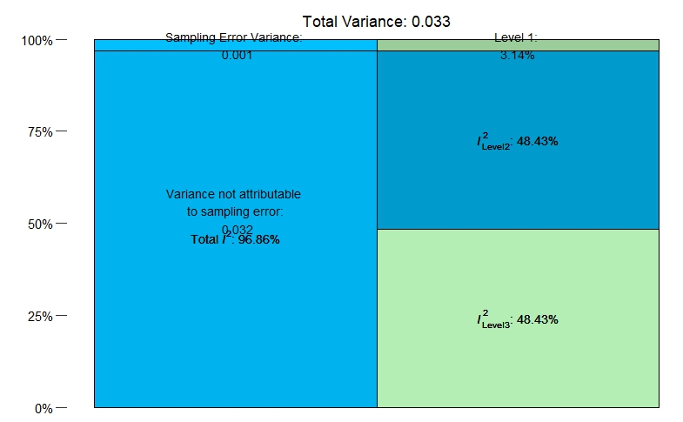

Plot of variance across levels for green market orientation (S4)
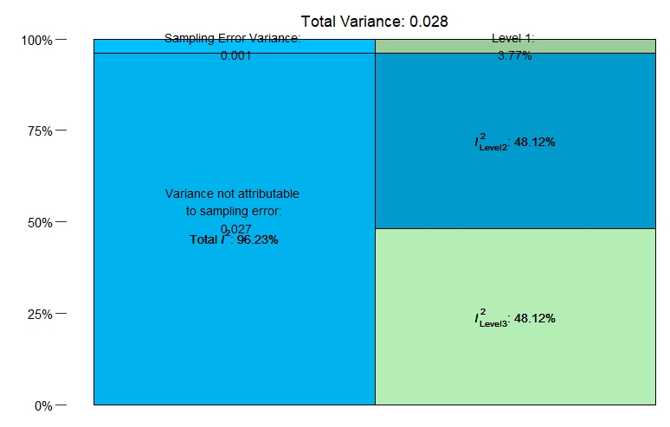

Funnel Plot for green entrepreneurial orientation (S5)
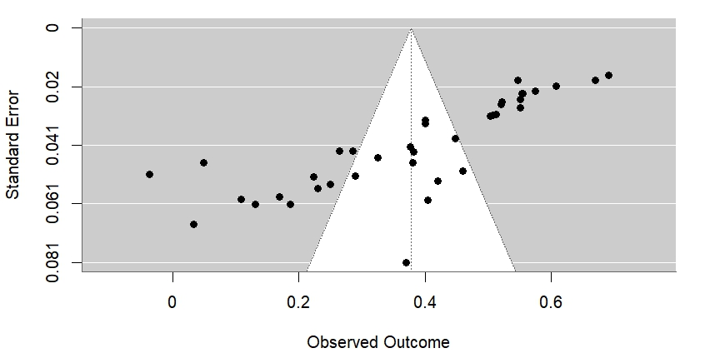
Funnel Plot for green market orientation (S6)
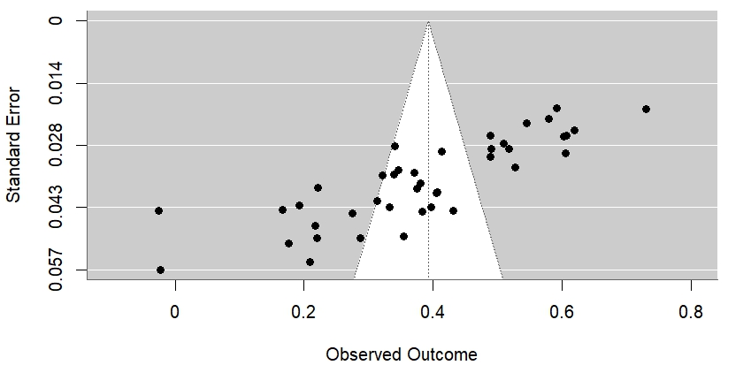

PRISMA (S7)

