Annexure- I
Bibliometric Analysis

The growing interest in climate change is further reflected in the bibliometric analysis of "Climate Change" research, which mapped out key themes and emerging areas within this field over the last two decades [13]. While these studies collectively address various aspects of climate change and its environmental, economic, and societal implications, there is a need for a more integrated approach that synthesizes these findings to build a stronger case for why additional research is required. A deeper understanding of climate variability, extreme weather, and long-term environmental changes, along with advancements in predictive models, enhances our ability to mitigate climate change impacts on ecosystems, economies, and communities. The figure illustrates key themes and emerging research trends in sustainability studies.
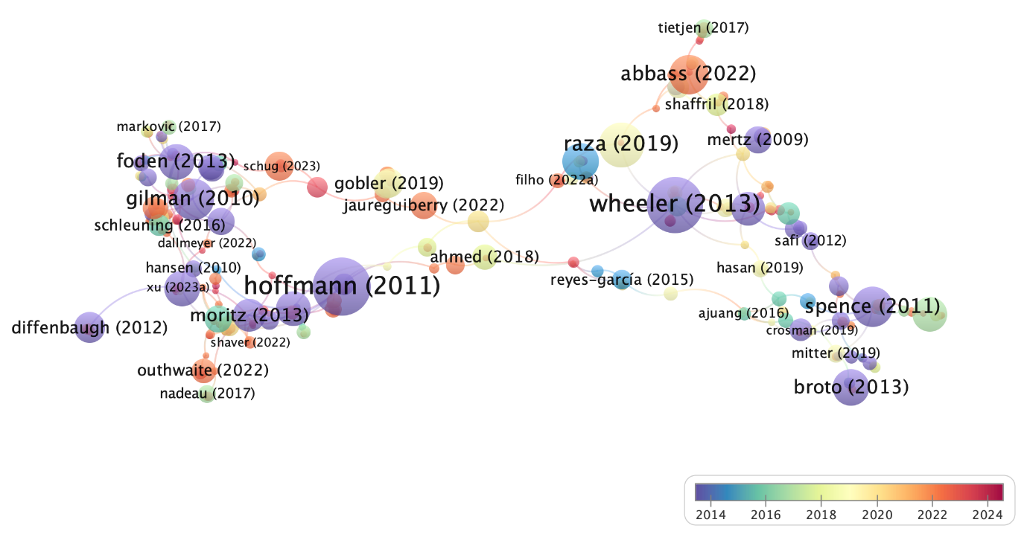
Fig. Bibliometric analysis based on similar studies.

