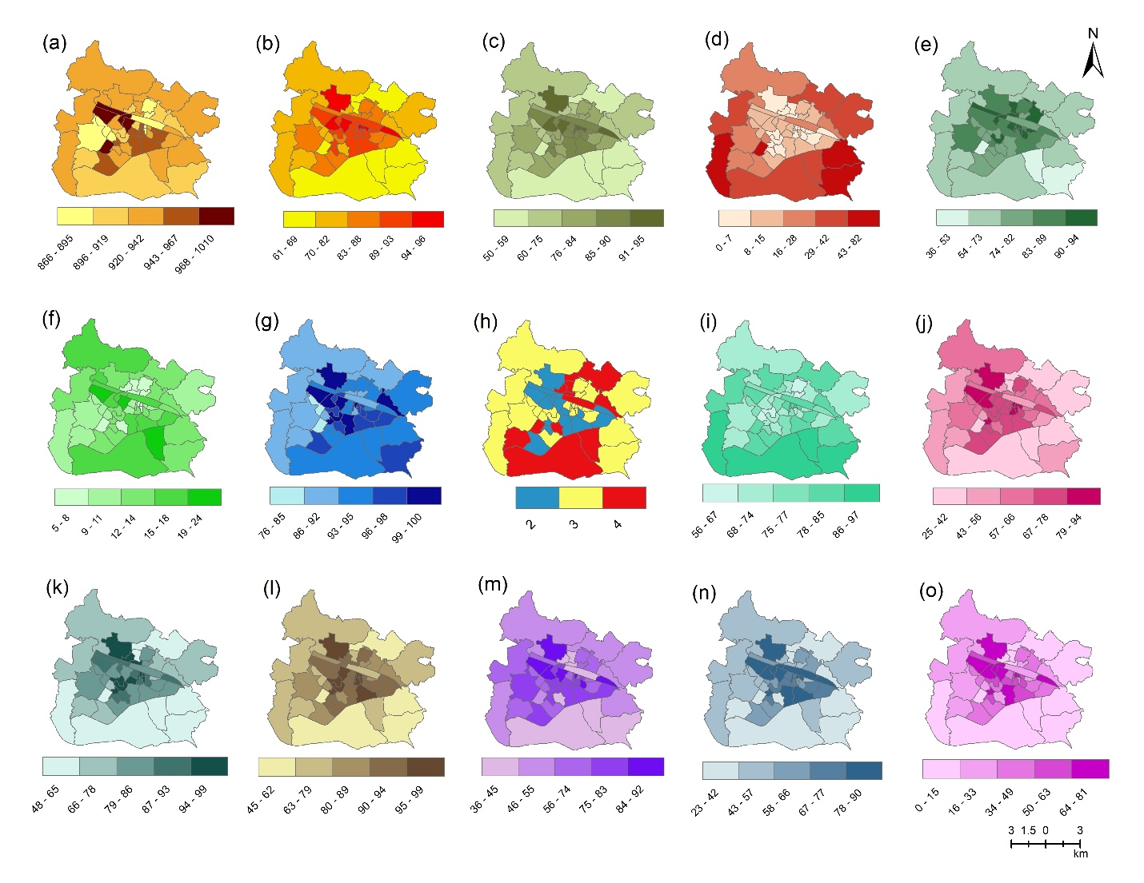

SF 1: Spatial distribution maps of selected indicators across the Asansol municipality ward-wise (a) Sex Ratio, (b) Literacy, (c) Female literacy, (d) % of marginalized population, (e) % of main workers, (f) % of female main workers, (g) % of household have either good or livable condition, (h) No of person living per room, (i) % of household own by self, (j) % of household having concrete roof, (k) % of household having concreated and brick wall, (l) % of household having cement floor, (m) % of household have access to safe drinking water, (n) % of household having sources of drinking water within and near premises, (o) % of household having access to electricity.

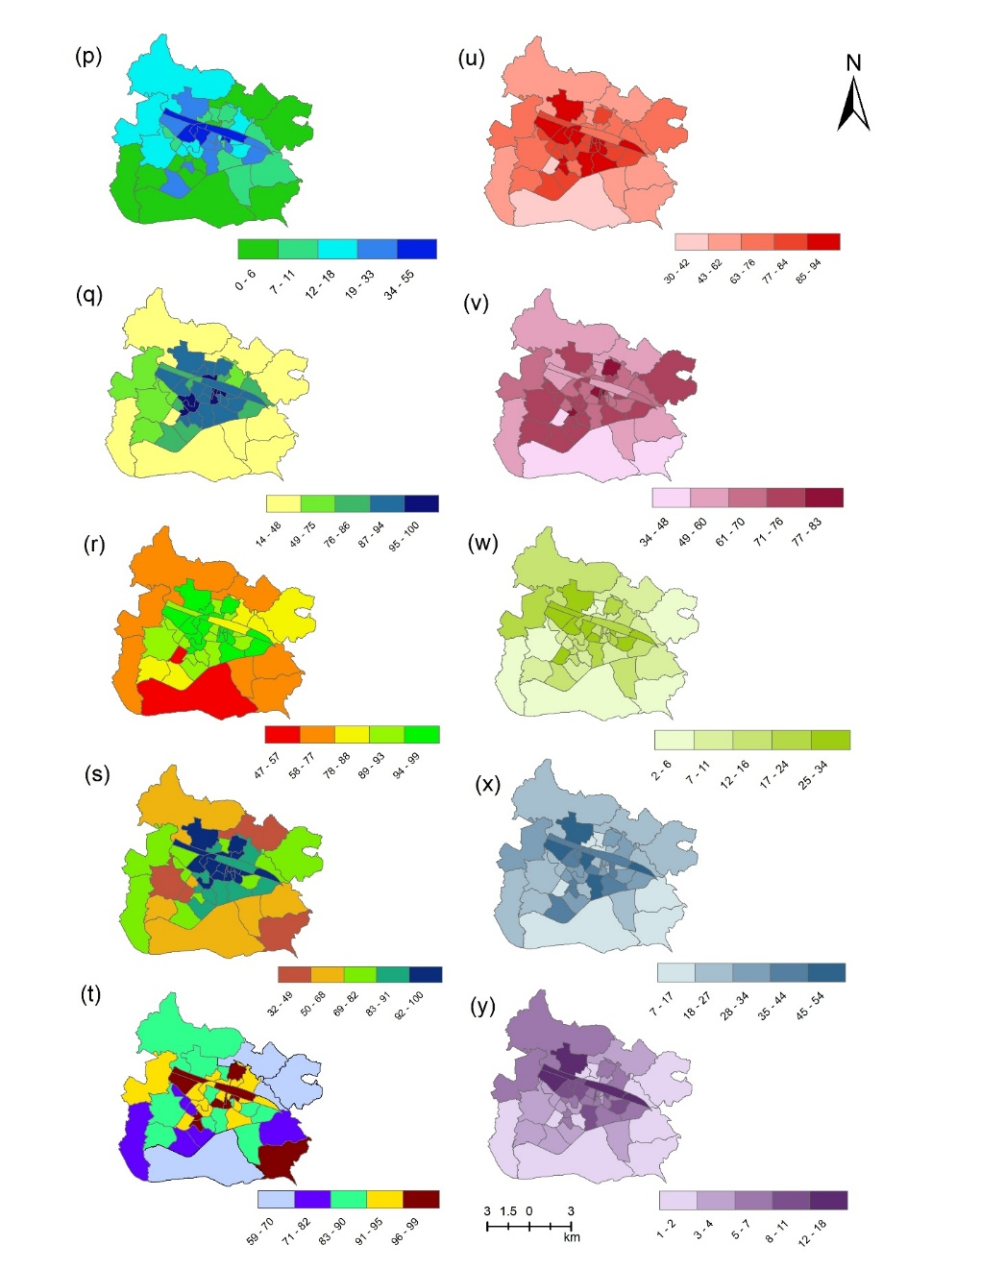

SF 2: Spatial distribution maps of selected indicators across the Asansol municipality ward-wise (p) % of households having latrine facilities, (q) % of households having closed drainage waste water disposal facilities, (r) % of households using clean cooking fuel, (s) % of households having a separate kitchen, (t) % of households having banking facilities, (u) % of household having television, (v) % of household having mobile, (w) % of household having computer or laptop, (x) % of household having two-wheeler, (y) % of household having four-wheeler

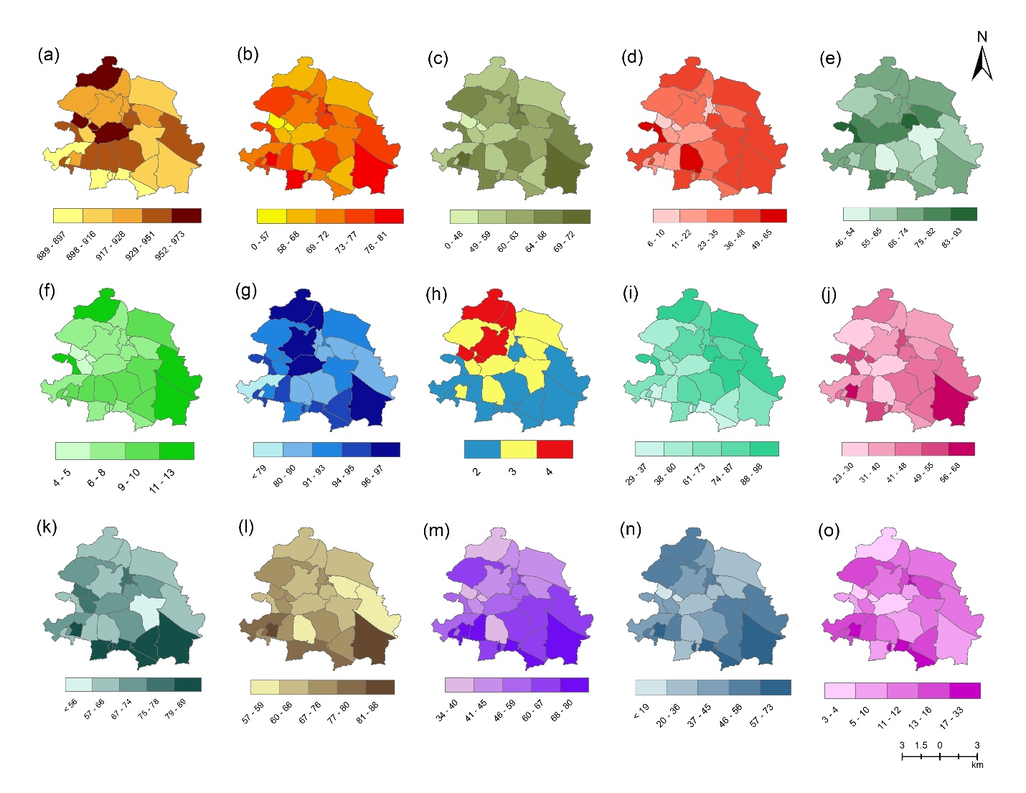

SF 3: Spatial distribution maps of selected indicators across the Jamuria municipality ward-wise (a) Sex Ratio, (b) Literacy, (c) Female literacy, (d) % of marginalized population, (e) % of main workers, (f) % of female main workers, (g) % of household have either good or livable condition, (h) No of person living per room, (i) % of household own by self, (j) % of household having concrete roof, (k) % of household having concreated and brick wall, (l) % of household having cement floor, (m) % of household have access to safe drinking water, (n) % of household having sources of drinking water within and near premises, (o) % of household having access to electricity.

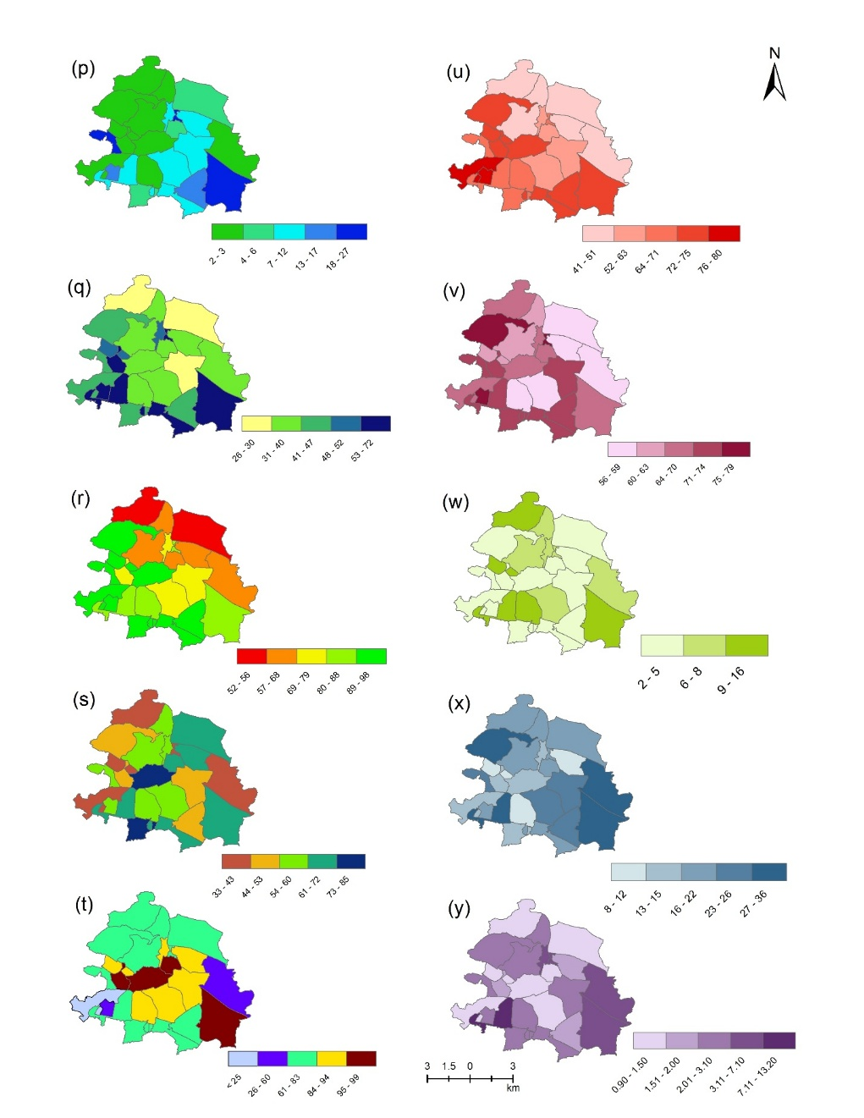

SF 4: Spatial distribution maps of selected indicators across the Jamuria municipality ward-wise (p) % of households having latrine facilities, (q) % of households having closed drainage waste water disposal facilities, (r) % of households using clean cooking fuel, (s) % of households having a separate kitchen, (t) % of households having banking facilities, (u) % of household having television, (v) % of household having mobile, (w) % of household having computer or laptop, (x) % of household having two-wheeler, (y) % of household having four-wheeler

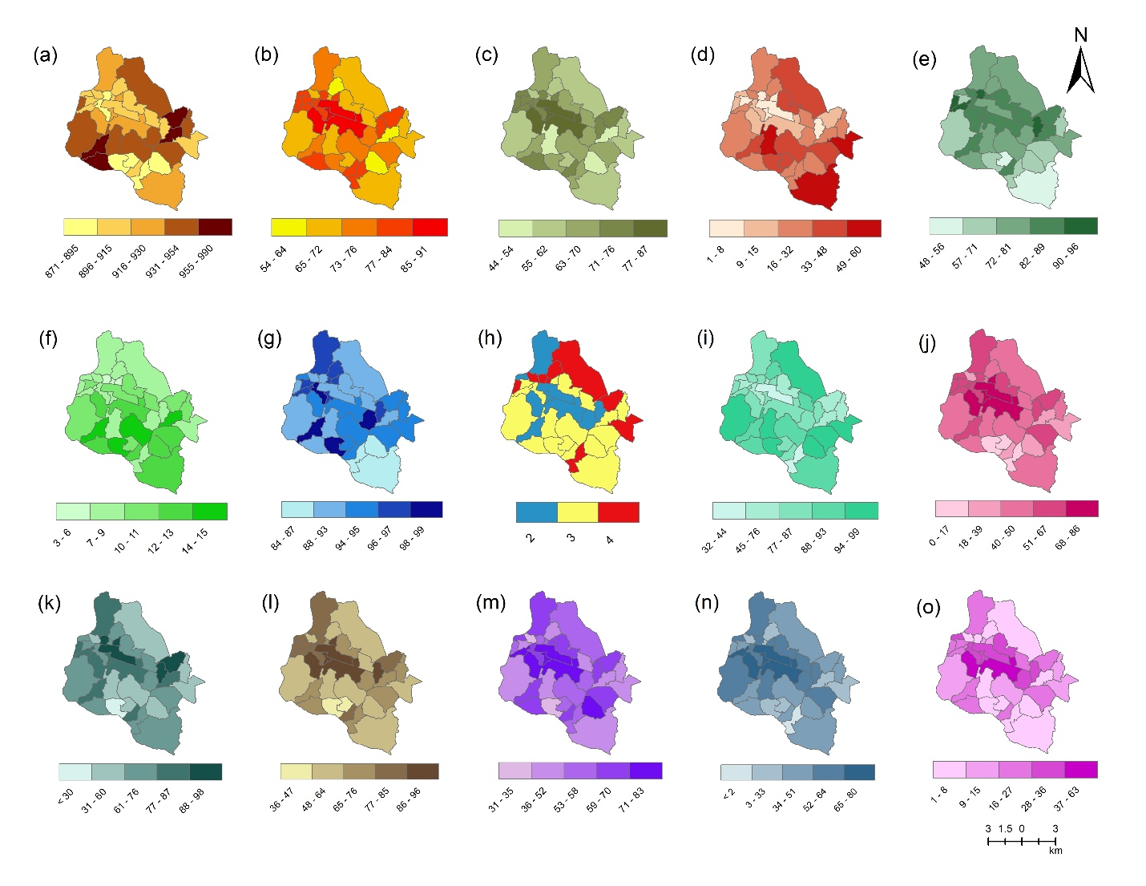

SF 5: Spatial distribution maps of selected indicators across the Kulti municipality ward-wise (a) Sex Ratio, (b) Literacy, (c) Female literacy, (d) % of marginalized population, (e) % of main workers, (f) % of female main workers, (g) % of household have either good or livable condition, (h) No of person living per room, (i) % of household own by self, (j) % of household having concrete roof, (k) % of household having concreated and brick wall, (l) % of household having cement floor, (m) % of household have access to safe drinking water, (n) % of household having sources of drinking water within and near premises, (o) % of household having access to electricity.

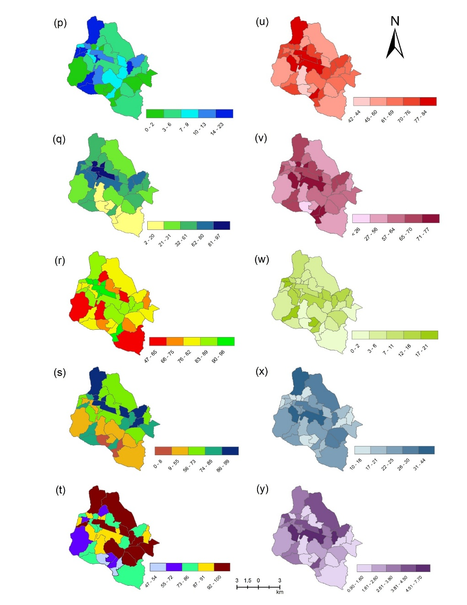

SF 6: Spatial distribution maps of selected indicators across the Kulti municipality ward-wise (p) % of households having latrine facilities, (q) % of households having closed drainage waste water disposal facilities, (r) % of households using clean cooking fuel, (s) % of households having a separate kitchen, (t) % of households having banking facilities, (u) % of household having television, (v) % of household having mobile, (w) % of household having computer or laptop, (x) % of household having two-wheeler, (y) % of household having four-wheeler

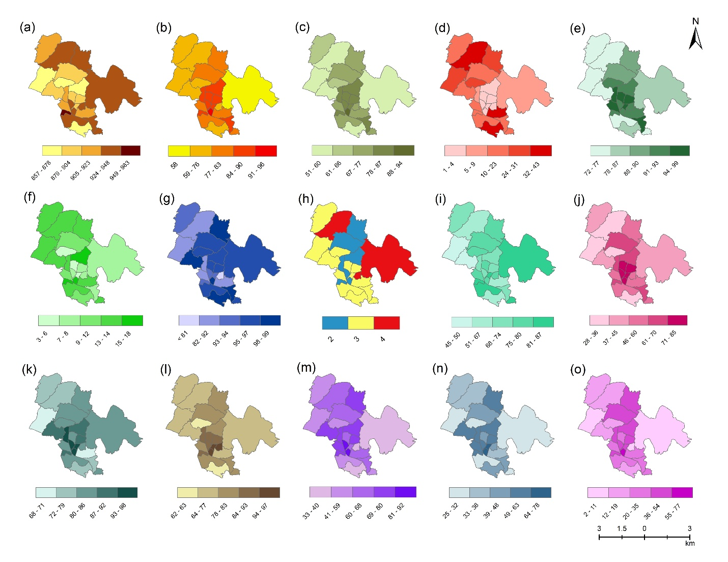

SF 7: Spatial distribution maps of selected indicators across the Raniganj municipality ward-wise (a) Sex Ratio, (b) Literacy, (c) Female literacy, (d) % of marginalized population, (e) % of main workers, (f) % of female main workers, (g) % of household have either good or livable condition, (h) No of person living per room, (i) % of household own by self, (j) % of household having concrete roof, (k) % of household having concreated and brick wall, (l) % of household having cement floor, (m) % of household have access to safe drinking water, (n) % of household having sources of drinking water within and near premises, (o) % of household having access to electricity.

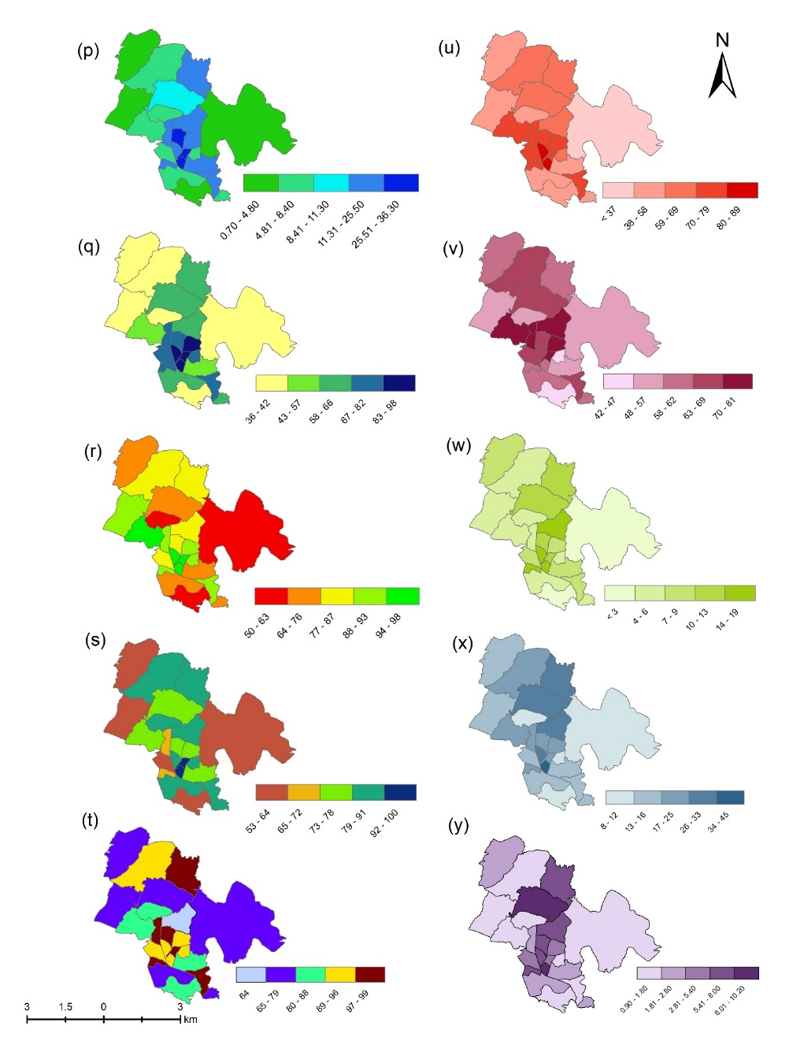

SF 8: Spatial distribution maps of selected indicators across the Raniganj municipality ward-wise (p) % of households having latrine facilities, (q) % of households having closed drainage waste water disposal facilities, (r) % of households using clean cooking fuel, (s) % of households having a separate kitchen, (t) % of households having banking facilities, (u) % of household having television, (v) % of household having mobile, (w) % of household having computer or laptop, (x) % of household having two-wheeler, (y) % of household having four-wheeler

