Supplementary Materials:
Fig 1
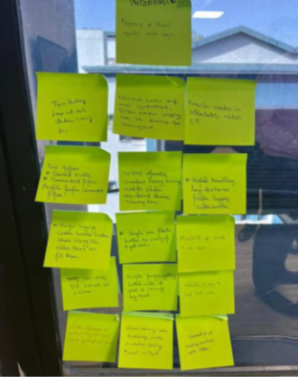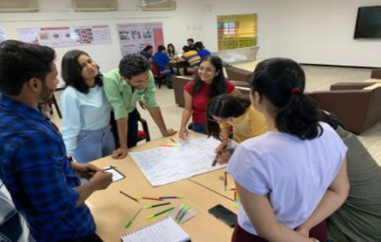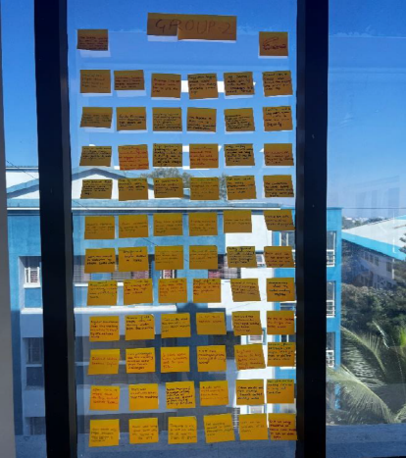
Define Phase: Data on Post-it for deriving clusters. (Refer 4.2 Define Phase: Derive clusters and the Theoretical framework
Figure 2 User Persona- Exercise 5- Point of View (POV)
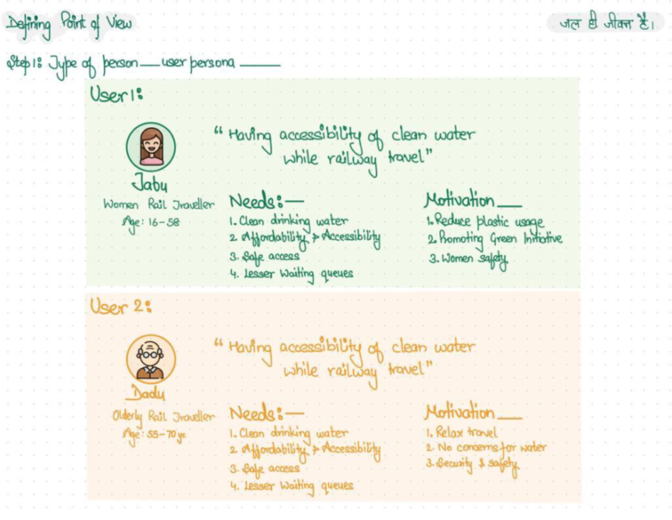
Figure 5 Problem Statement: POV
