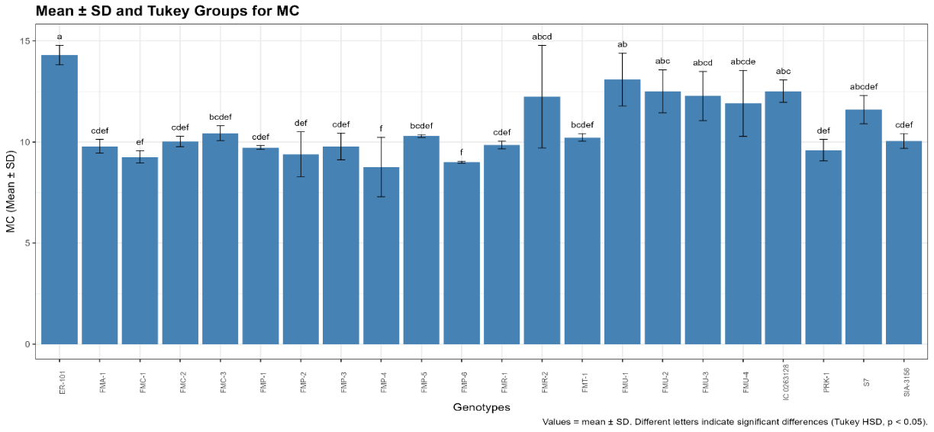
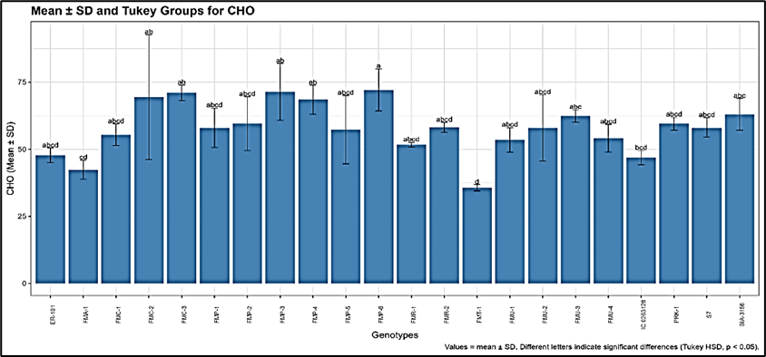
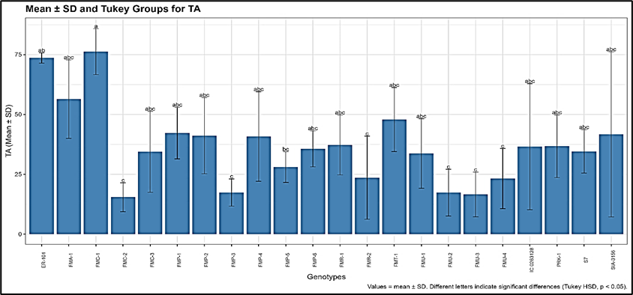
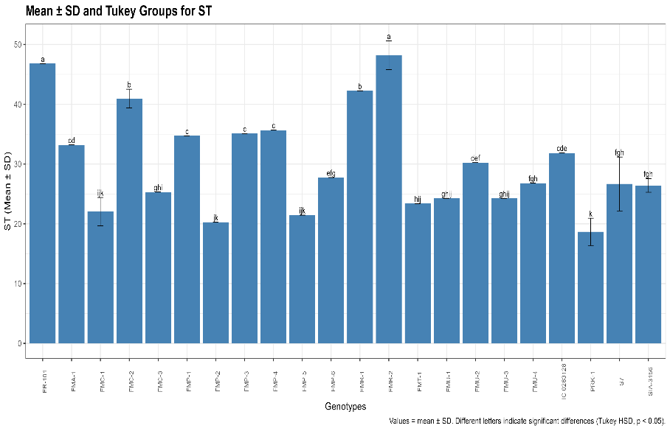
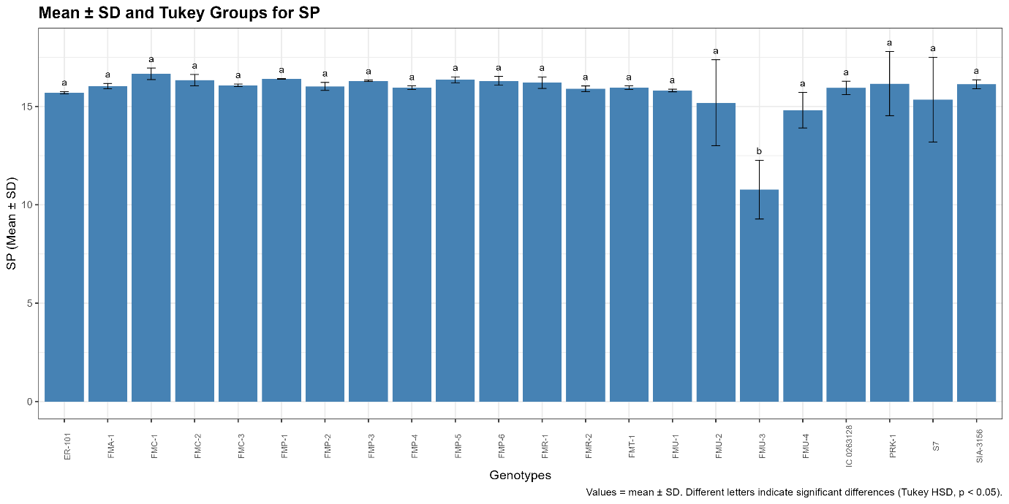
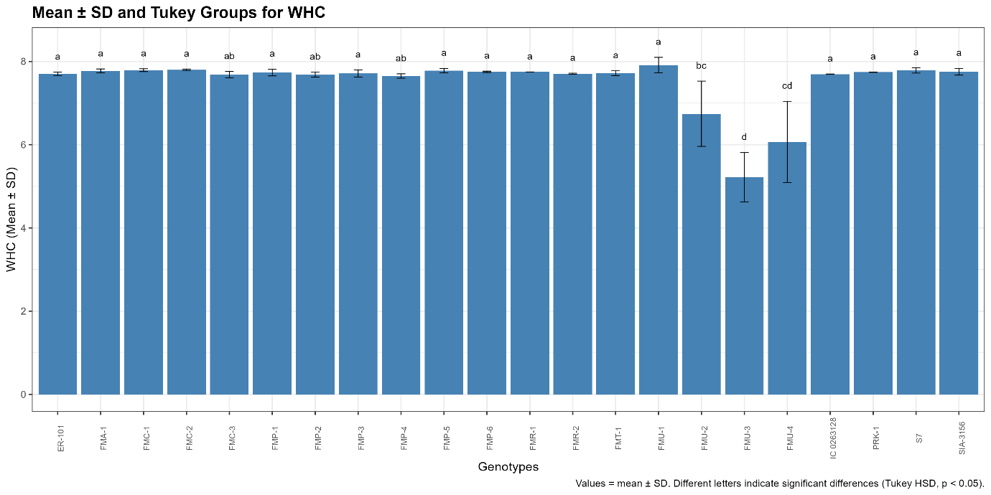
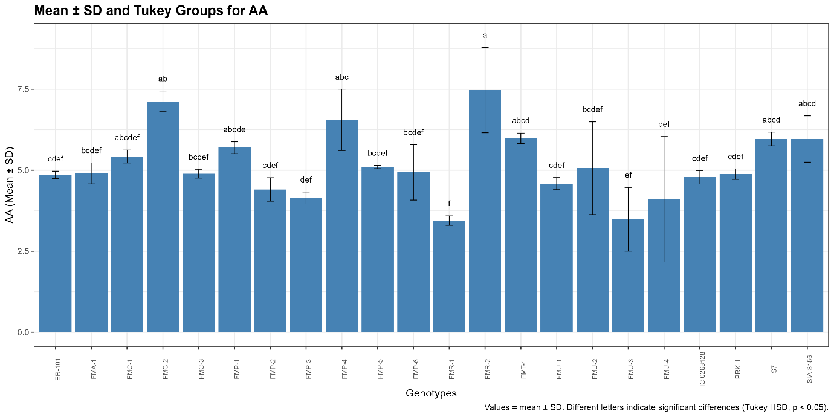
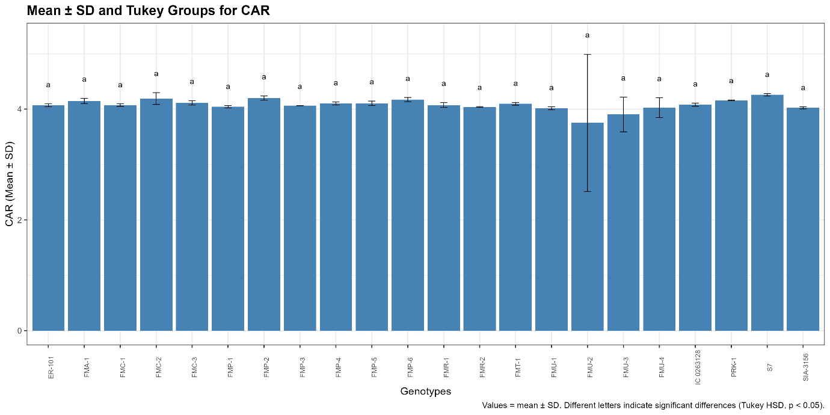
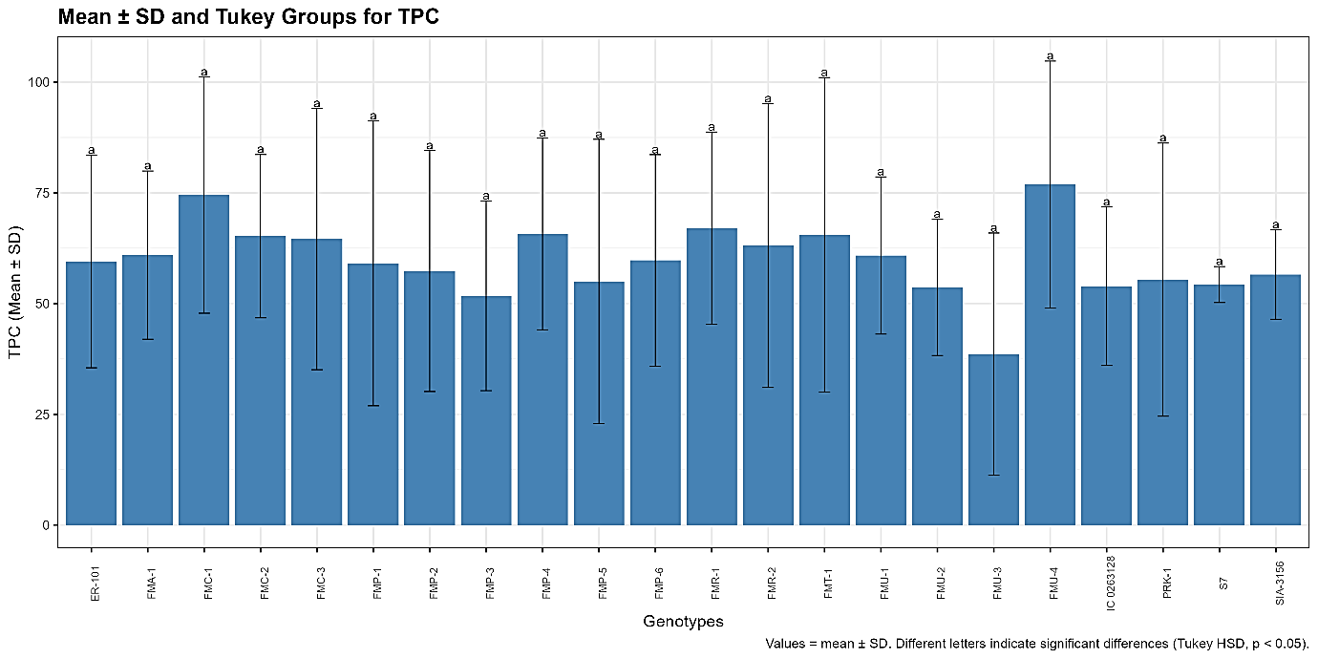
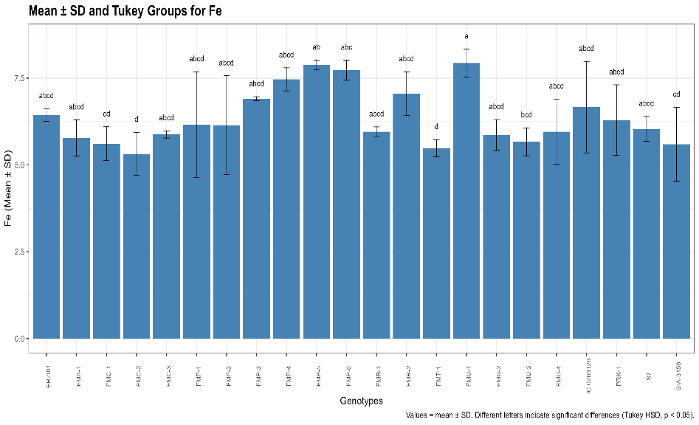
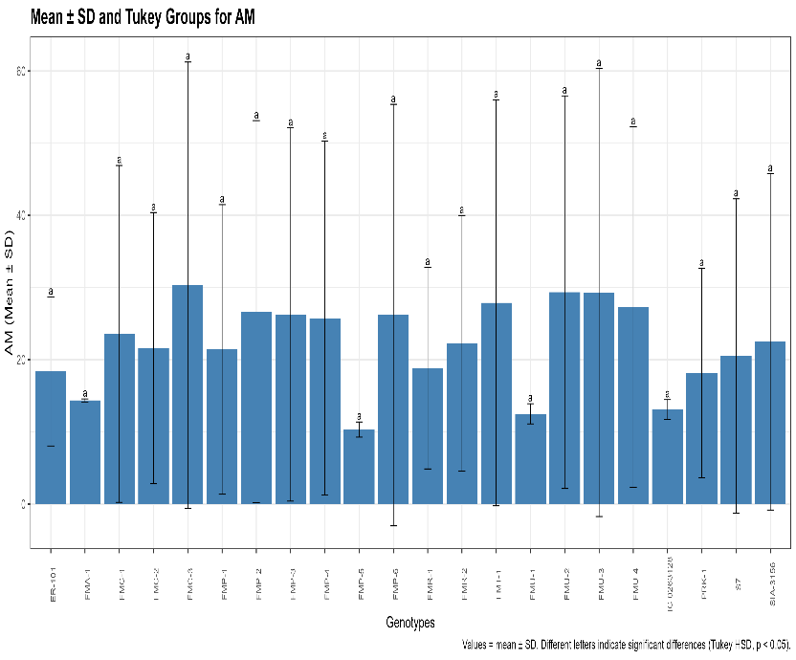
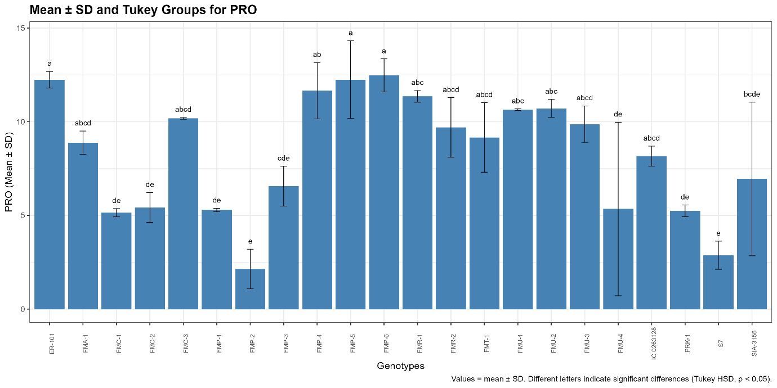
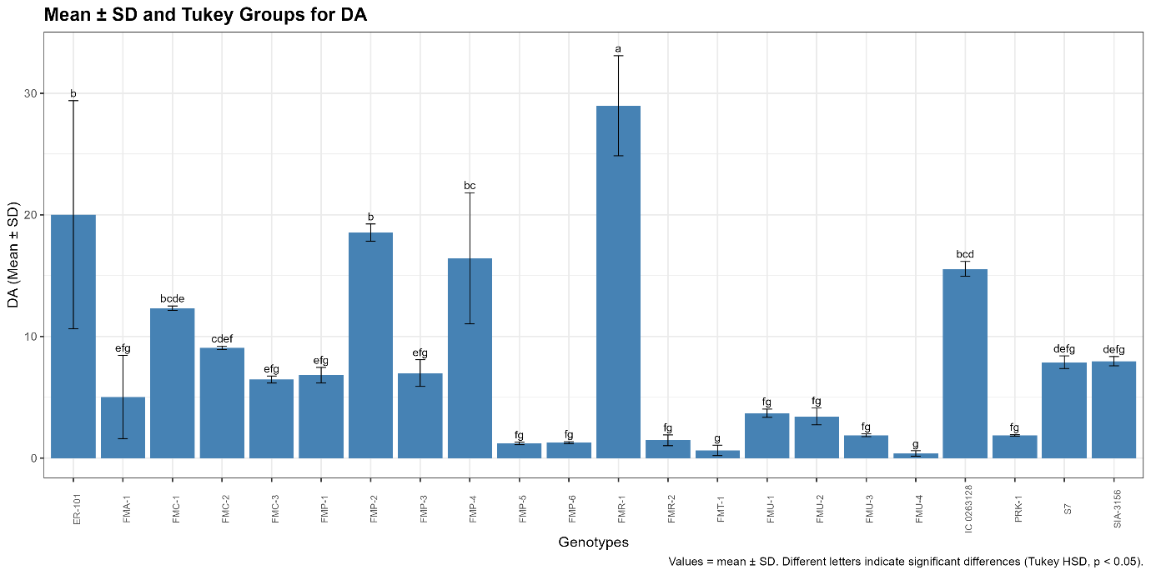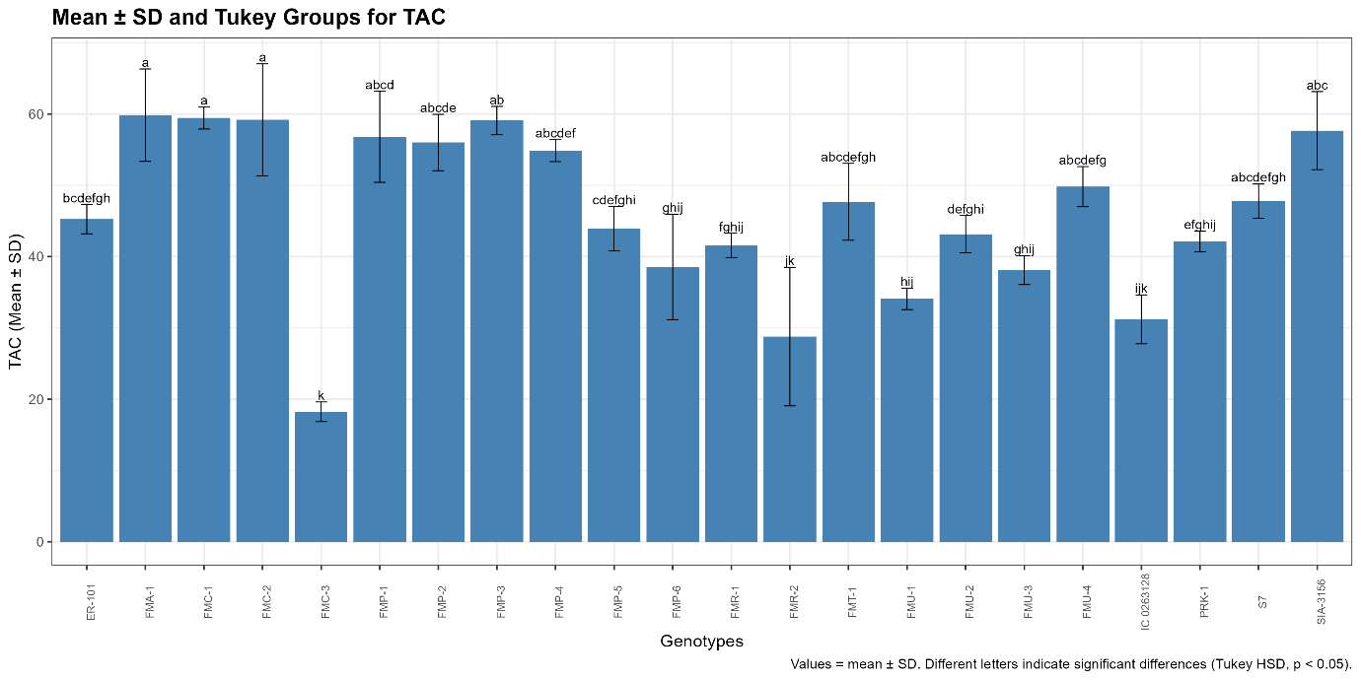
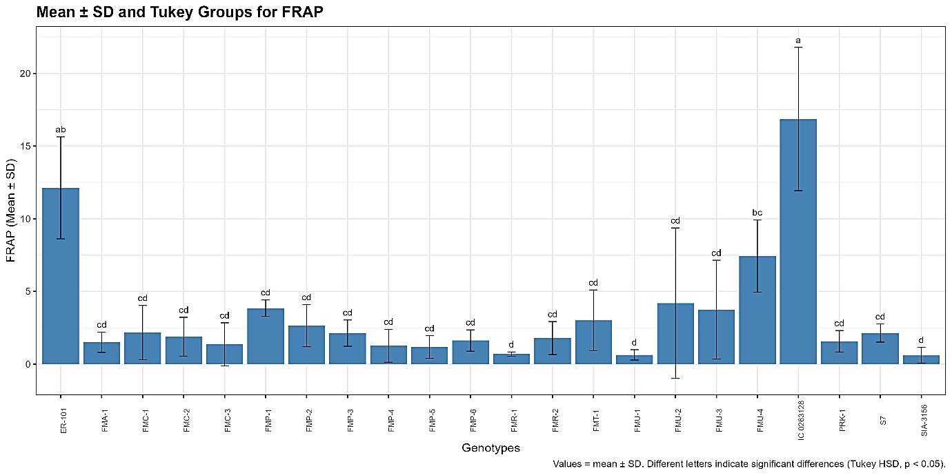
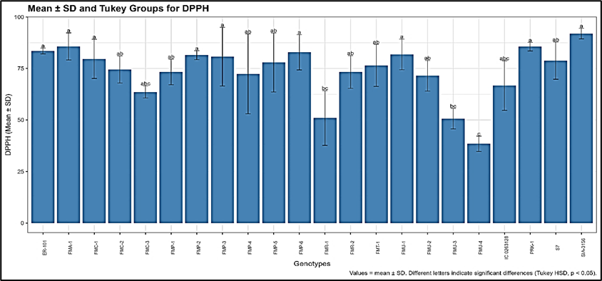

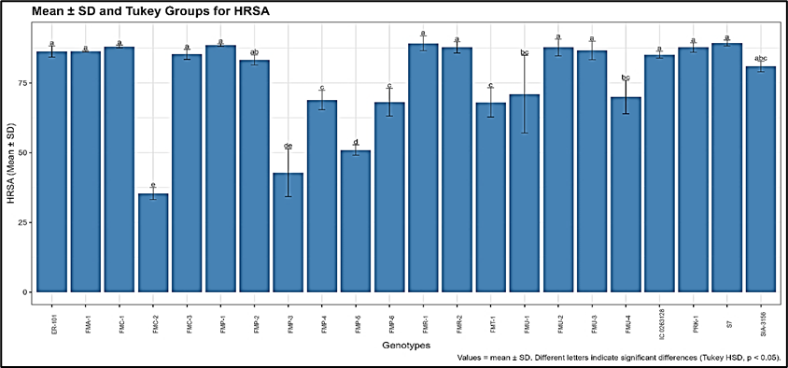
Figure S1. The figure showed mean ± SD values for all the studied parameters among genotypes based on the Tukey HSD.

Table S1. Pearson correlation coefficient among the nutrient content of foxtail millet germplasm

 | MC | SP | WHC | CHO | PRO | AM | ST | Fe | AA | TPC | TAC | DA | DPPH | FRAP | HRSA | TA
MC | 1 | -0.424 | -0.344 | -0.35 | 0.241 | -0.183 | 0.267 | 0.061 | -0.132 | -0.232 | -0.462 | -0.065 | -0.224 | 0.581 | 0.242 | -0.086
SP | -0.424 | 1 | 0.898 | -0.015 | -0.092 | -0.326 | 0.139 | 0.21 | 0.378 | 0.533 | 0.209 | 0.232 | 0.517 | -0.136 | -0.207 | 0.349
WHC | -0.344 | 0.898 | 1 | -0.049 | -0.038 | -0.463 | 0.162 | 0.272 | 0.423 | 0.291 | 0.111 | 0.294 | 0.686 | -0.182 | -0.128 | 0.412
CHO | -0.35 | -0.015 | -0.049 | 1 | -0.051 | 0.4 | -0.012 | 0.221 | 0.106 | -0.167 | -0.029 | -0.089 | 0.023 | -0.39 | -0.352 | -0.471
PRO | 0.241 | -0.092 | -0.038 | -0.051 | 1 | -0.129 | 0.301 | 0.478 | -0.102 | -0.071 | -0.476 | -0.003 | -0.09 | 0.028 | -0.05 | 0.005
AM | -0.183 | -0.326 | -0.463 | 0.4 | -0.129 | 1 | -0.098 | -0.393 | -0.01 | 0.053 | 0.02 | -0.141 | -0.311 | -0.173 | 0.032 | -0.225
ST | 0.267 | 0.139 | 0.162 | -0.012 | 0.301 | -0.098 | 1 | 0.036 | 0.308 | 0.147 | -0.003 | 0.397 | -0.1 | 0.224 | -0.047 | -0.006
Fe | 0.061 | 0.21 | 0.272 | 0.221 | 0.478 | -0.393 | 0.036 | 1 | -0.001 | -0.106 | -0.3 | -0.113 | 0.206 | -0.046 | -0.263 | -0.13
AA | -0.132 | 0.378 | 0.423 | 0.106 | -0.102 | -0.01 | 0.308 | -0.001 | 1 | 0.256 | 0.142 | -0.182 | 0.397 | -0.182 | -0.175 | 0.03
TPC | -0.232 | 0.533 | 0.291 | -0.167 | -0.071 | 0.053 | 0.147 | -0.106 | 0.256 | 1 | 0.151 | 0.167 | -0.177 | -0.088 | -0.07 | 0.364
TAC | -0.462 | 0.209 | 0.111 | -0.029 | -0.476 | 0.02 | -0.003 | -0.3 | 0.142 | 0.151 | 1 | 0.156 | 0.306 | -0.186 | -0.296 | 0.247
DA | -0.065 | 0.232 | 0.294 | -0.089 | -0.003 | -0.141 | 0.397 | -0.113 | -0.182 | 0.167 | 0.156 | 1 | -0.067 | 0.242 | 0.217 | 0.398
DPPH | -0.224 | 0.517 | 0.686 | 0.023 | -0.09 | -0.311 | -0.1 | 0.206 | 0.397 | -0.177 | 0.306 | -0.067 | 1 | -0.232 | -0.087 | 0.394
FRAP | 0.581 | -0.136 | -0.182 | -0.39 | 0.028 | -0.173 | 0.224 | -0.046 | -0.182 | -0.088 | -0.186 | 0.242 | -0.232 | 1 | 0.187 | 0.178
HRSA | 0.242 | -0.207 | -0.128 | -0.352 | -0.05 | 0.032 | -0.047 | -0.263 | -0.175 | -0.07 | -0.296 | 0.217 | -0.087 | 0.187 | 1 | 0.417
TA | -0.086 | 0.349 | 0.412 | -0.471 | 0.005 | -0.225 | -0.006 | -0.13 | 0.03 | 0.364 | 0.247 | 0.398 | 0.394 | 0.178 | 0.417 | 1
Abbreviations: MC -Moisture content (%), SP-Swelling power, WHC- Water holding capacity (%), CHO-Carbohydrates (g/100g), PRO- Protein (g/100g), AM-Amylose (%), ST-Starch (g/100g), Fe- Iron (mg/100g), AA- Ascorbic acid (mg/100g), TPC-Total phenolic content (mg GAE/100g), TAC- Total antioxidant content (mg AAE/100g), DA- Dehydrogenase activity (OD g⁻¹mL⁻¹), DPPH – DPPH radical scavenging activity(%), FRAP- Ferric reducing antioxidant properties (%), HRSA- OH radical scavenging activity (%), TA- Tannic acid(mg/100g)

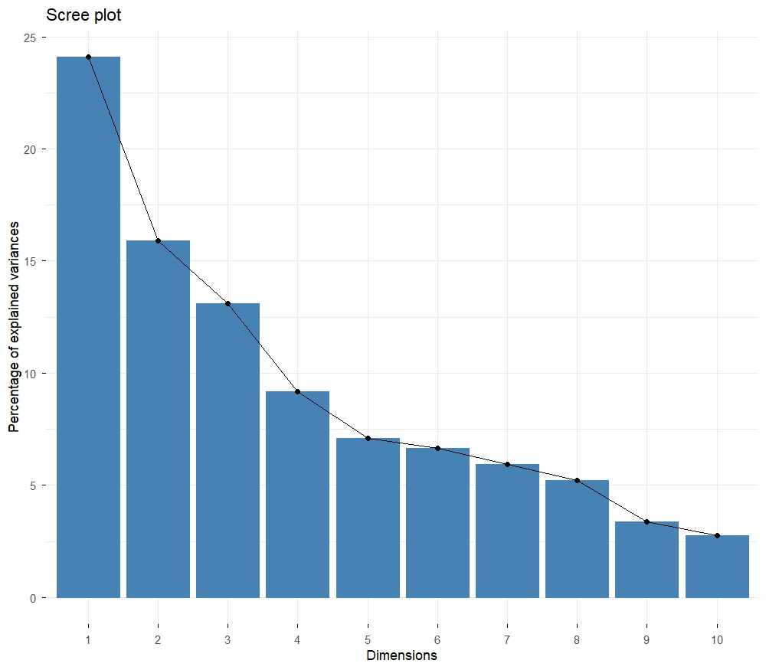
Figure S2: Screen plot showing percentage of variance explained by PC for nutrient composition in foxtail millet
The total variation explained by the different PC was showed in the scree plot. The proportion of the total variation explained by the PC1 is 23.1% indicating to capture the largest amount of information. The proportion of the total variation explained by the second and PC is 16.9% and 13%, respectively. However, the sum of the proportions of the total variation explained by PC1 to PC3 was more than 50%. In this case, the proportion of the total variation explained by the next components is declining. In this case, the proportion of the total variation explained by the fourth component is approximately 9%. Therefore, the proportion of the total variation explained by the next five components is declining. Therefore, the proportion of the total variation explained by the next five components is small.

