Heteroscedasticity test

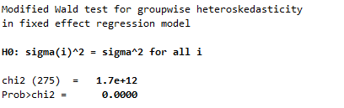

Table 3 Descriptive Statistic and Sample distribution
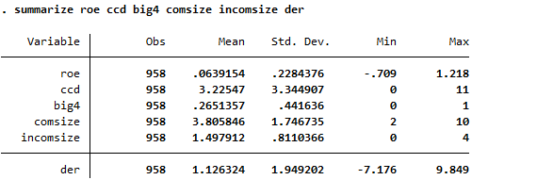
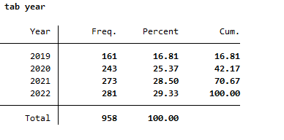
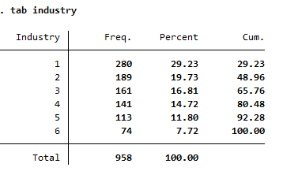

Table 5 Regression Results

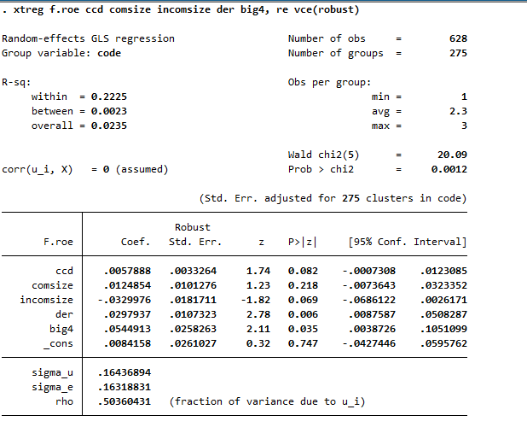

Table 6 Robustness Analysis using the Heckman Two-Stage Model

1stage
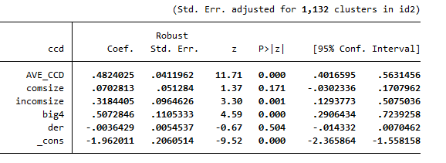
2stage

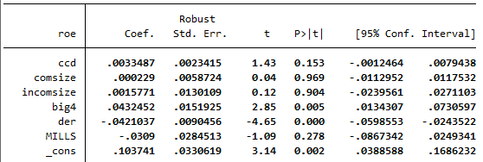

Table 7 Robustness Test Monotonic Relationship between CCD and ROE_{t+1}

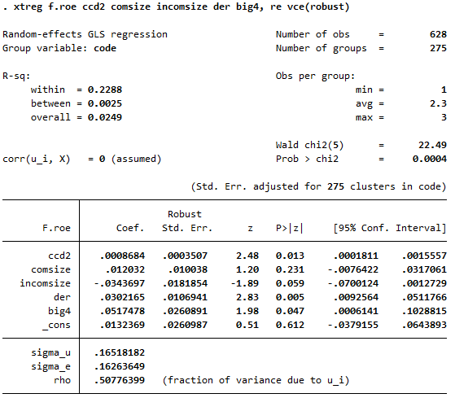

Table 8 Robustness Checks for Alternative Measurement
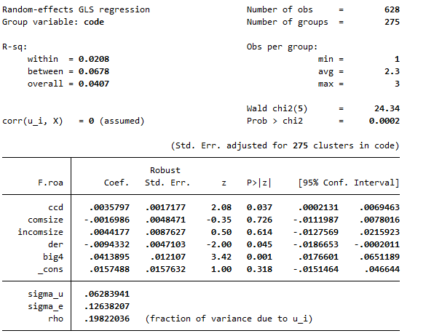

Table 9 Robustness Checks for TCFD Dimenssion

Governance Dimenssion
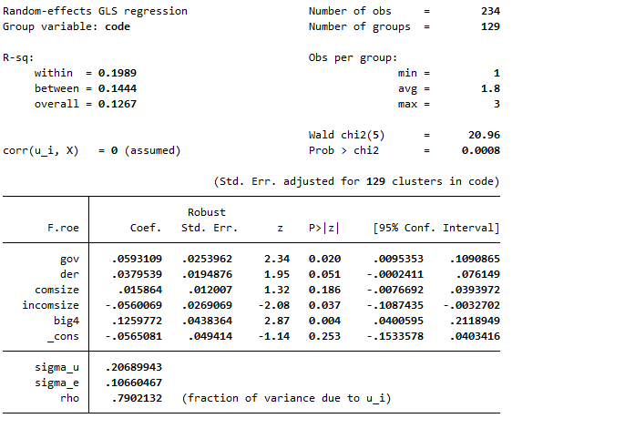

Strategy Dimenssion
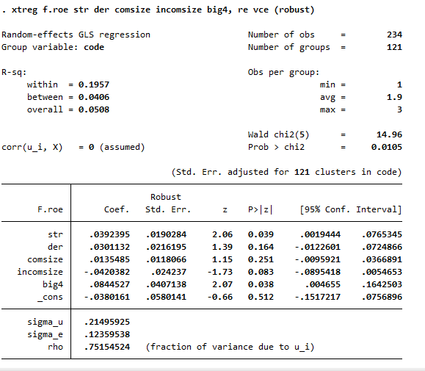

Risk Management Dimenssion
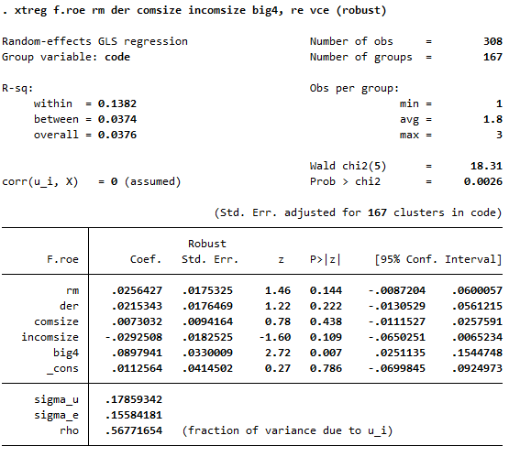

Metrics and Target Dimenssion
