Appendix B
A Systematic Scoping Review on Definitions, Models, Measures, and Related Constructs of Sustainable Careers
Angela Russo, Jaroslaw Grobelny, Paola Magnano, Andrea Zammitti, Giuseppe Santisi

Methods (detailed)
This review follows the scoping review methodology in accordance with the PRISMA (Preferred Reporting Items for Systematic Reviews and Meta-Analyses) guidelines, and the PRISMA-ScR (Scoping Reviews) Checklist will guide the reporting of results. The review process comprised five sequential stages: (1) a systematic database search to identify relevant records, (2) a two-step screening of titles/abstracts and full texts against predefined eligibility criteria, (3) critical appraisal of methodological quality using JBI checklists, (4) structured data extraction aligned with the SPIDER framework, and (5) data charting and synthesis to address the review questions.

Stage 1: Search Strategy
The review strategy encompasses a comprehensive search for relevant literature in the databases of Scopus and Web of Science (WoS). Only peer-reviewed papers were considered for inclusion.
The query strings used to retrieve relevant articles were “(Sustainable OR sustainability) AND (career* OR work)”. The population was excluded from the query strings to avoid excluding conceptual articles on career and to ensure a comprehensive analysis of the relevant literature. The search was conducted in May 2023, and no year delimitation was included. Moreover, we decided to exclude the term “employment” due to the conceptual distinction from “career”: employment refers to a service performed for pay or wages under a contract of hire (Black et al., 2009), therefore focusing on the short-term and immediate economic needs, while a career encompasses a long-term professional journey characterized by a series of jobs that a person has throughout his or her working life (Heery & Noon, 2017).
The first phase results in 1424 articles identified on Scopus and 1439 on WoS. When full-text articles were not accessible, the corresponding authors were contacted via email, with a follow-up request sent after two weeks when necessary.

Inclusion and Exclusion Criteria
Following the SPIDER framework, specific inclusion and exclusion criteria were applied to identify studies eligible for further review, as detailed below:
- it pertained to employed [permanent workers; temporary workers; gig workers - defined as “labor contracted and compensated on a short-term basis to organizations or to individual clients through an external labor market” (Cropanzano et al., 2023, p. 9)], unemployed, volunteers, and student populations (Sample);
- the concept of sustainable career or career sustainability was defined based on the models proposed by De Vos et al. (2020), Newman (2011), or Heslin (2020). Additionally, studies that adopted a psychological, social, or work-related perspective on sustainable careers were incorporated in the analysis. Both sustainable and non-sustainable careers were considered (Phenomenon of interest);
- qualitative, quantitative, and mixed methods papers and conceptual, theoretical, and methodological contributions, such as frameworks, and research agendas (Design);
- studies were selected if they provided descriptions of sustainable career definitions, models, measures, or examined constructs that authors declared as being related to sustainable career (Evaluation).
On the other hand, exclusion criteria were applied to ensure the selection of appropriate studies:
- studies involving older adults in retirement age (70 years or older; Sample);
- studies that solely analyzed the concept of sustainable career from an environmental, consumerist, or productivism perspective, or a United Nations sustainable development perspective, without considering the psychological, social, or work-related perspective (Phenomenon of interest);
- review articles (Design);
- studies not written in English, Polish, or Italian, as well as those that were not peer-reviewed (Research type).

Search Validation
As a search validation procedure, we conducted a benchmark check using a set of well-established and highly cited studies on sustainable careers, selected to represent different methodological approaches. The articles were as follows: conceptual papers (Newman, 2011; Van der Heijden & De Vos, 2015; Heslin et al., 2020), measurement papers (Chin et al., 2022), quasi-experimental intervention study (Bozionelos et al., 2020), quantitative studies (Straub et al., 2020; Hirschi et al., 2020; Kelly et al., 2020; Barthauer et al., 2020), qualitative studies (Kossek and Ollier-Malattere, 2020; Chudzikowski et al., 2020), multi-method research design (Richardson & McKenna, 2020). These studies were used to verify whether the search strategy was able to retrieve key contributions in the field. As all benchmark articles were successfully identified, no further refinement of the search string was required.

Stage 2: Screening
The screening process consisted of two phases —title and abstract screening and full text screening —conducted by two independent reviewers. Throughout the process, all citation details, including authors, date, title, journal, volume, issue, and pages, were visible to the reviewers. Data management and sharing were facilitated through the use of a Zotero group library, which included the search and screening results. After each stage, the screeners contacted each other to check for agreement, which was facilitated by CADIMA software. Any disagreements in the screening process were resolved through discussion and consensus among the screeners, with the involvement of a third author.
In the first phase, titles and abstracts of articles were evaluated for their relevance to sustainable careers, resulting in 140 articles screened on Scopus and 140 on WoS.

Agreement during the title and abstract screening phase was 99.43% for Scopus and 99.51% for Web of Science. Inter-rater reliability was assessed using Cohen’s kappa, which estimates agreement between reviewers beyond chance, yielding κ = .97 for both databases prior to third-author mediation and indicating almost perfect agreement. Deduplication was performed at the end of this phase, using Zotero group library’s automatic duplicate detection, followed by manual rechecking, resulting in 222 unique records. In the second phase, full texts were assessed against the inclusion and exclusion criteria, leading to 95 studies eligible for critical appraisal (detailed screening records are provided in the OSF repository). Inter-rater reliability for full-text screening was 98.42% (Cohen’s κ = .97), again reflecting almost perfect agreement between reviewers. See Figure 1 for the PRISMA flow chart.
Figure 1. PRISMA flow chart
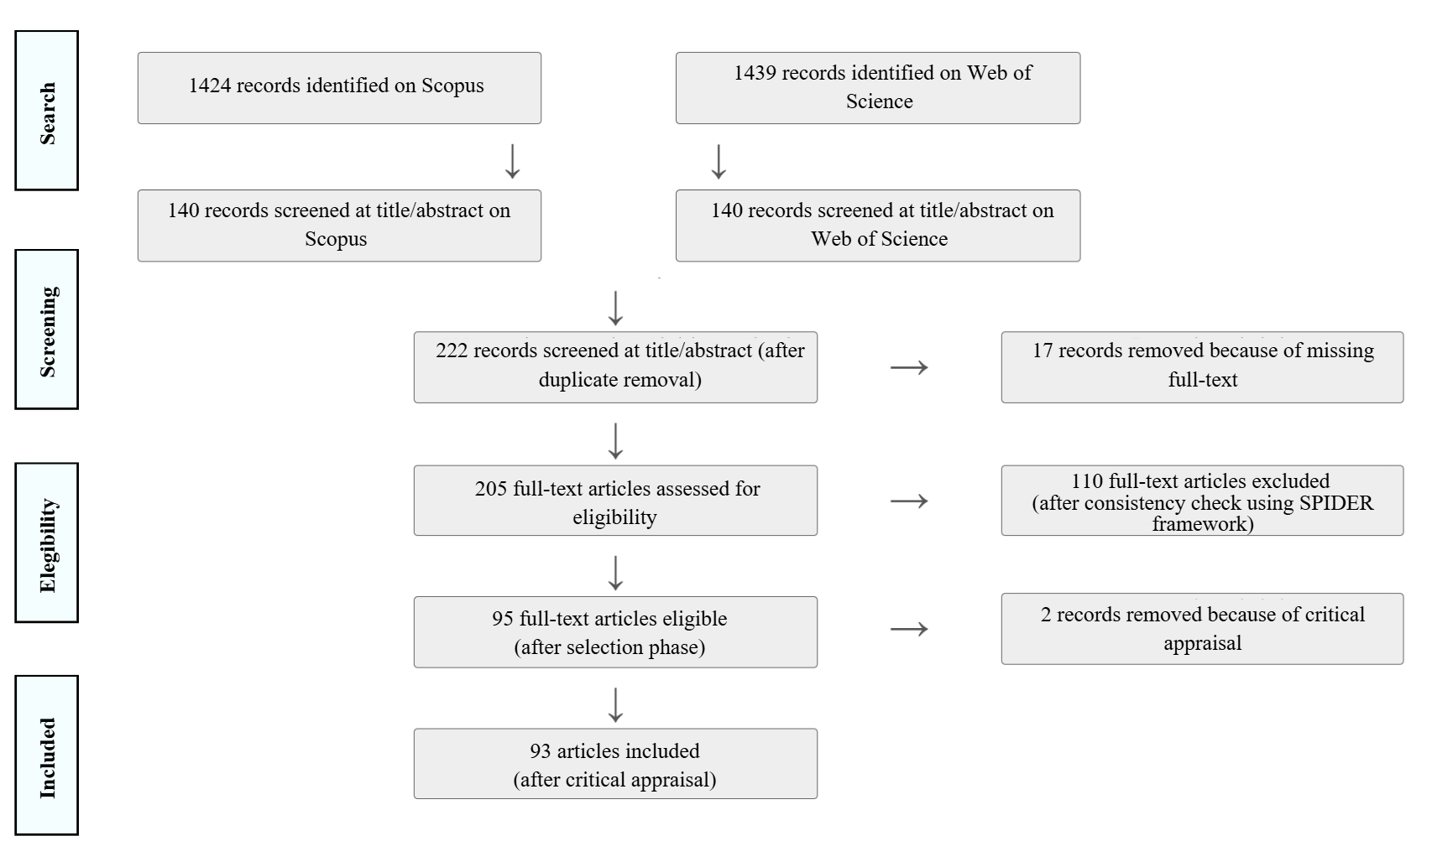

Stage 3: Quality Assessment
Quality assessment was conducted through critical appraisal to evaluate and weight the methodological quality of the included studies. Two authors independently assessed study quality using the Joanna Briggs Institute (JBI) Critical Appraisal Checklists (accessed 2023).
Specifically, for purely quantitative cross-sectional, longitudinal, and quasi-experimental studies, we used the respective JBI checklists with 8 and 9 questions. To evaluate longitudinal studies, the JBI analytical cross-sectional checklist was applied, consistent with prior research (Liu et al., 2022; Barroso et al., 2021). For qualitative cross-sectional, longitudinal, and quasi-experimental studies, the JBI qualitative checklist was applied. Mixed-methods studies were assessed using both JBI checklists. Additionally, conceptual framework studies were assessed using the JBI text and opinions checklist, which contains 6 questions. A detailed description of the JBI appraisal criteria and study-level outcomes is provided in the OSF repository. Disagreements were resolved through discussions.
Cross-sectional, longitudinal, qualitative and quasi-experimental studies that met 5 or more criteria and conceptual frameworks that met 4 or more criteria were retained. Inter-reliability was 100%.

Stage 4: Extraction
The extraction process involved several stages: a training stage, an actual extraction stage, a reliability verification stage, and a final extraction stage. In the training stage, the extractor was trained on the procedures to ensure consistency and accuracy. In the actual extraction stage, relevant information was manually extracted from the selected studies using CADIMA software; no AI-based extraction methods were employed. Reliability was verified by a second extractor who reviewed a subset of the data to clarify criteria and resolve ambiguities. The remaining data were then extracted using the agreed-upon procedures.
Each entity was specifically aligned with the search queries, following the SPIDER model. The entities extracted were citations details, definition of the study as empirical or conceptual, year of the study conduction, research design, research method, research setting, definition (the entire main definition used inside the paper, including the references) model and dimensions (the entire main features of the model used inside the paper, including its reference, was extracted; if unclear, we stated “unclear or unspecified”. Moreover, if the paper was conceptual, we deepened the dimension of the model; if the paper was empirical, we discussed the studied dimensions), measurement used by the authors of the studies to assess career sustainability (including document analysis—e.g., organizational policies, employment contracts, or other materials—questionnaires, rating scales, checklists, structured interviews, semi-structured interviews, focus group, naturalistic observation, participant observation, or objective indicators—e.g., absenteeism rates, staff turnover, or performance data), and correlated constructs (a list of all the variables that have been studied along with career sustainability).
Additionally, the research setting entity was further divided to include the following details:
- the main sample’s features identified, as sample size, generation cohort following Robinson et al. (2017), and gender. For sample size extraction, the analytic sample size reported in each study was manually extracted from the full text. When a total sample size was explicitly reported, this value was recorded. For studies reporting experimental/control groups or other independent study groups contributing to the same analysis, group sizes were summed. Gender, age-group, or other within-sample subgroup breakdowns were not treated as independent sample sizes. For dyadic or multi-actor designs, the total number of participants across the relevant parties was recorded when both contributed to the analysis. For multi-study or multi-stage papers, the sample size corresponding to the focal empirical analysis on career sustainability was recorded; when multiple relevant empirical stages contributed to the findings, this was documented in the extraction notes.
- the inclusion of people at risk of occupational vulnerability (for declared physical, social, economic, and environmental reasons) in the study. We define occupational vulnerability risk as people with low socio-economic status (Landsbergis et al., 2014), people with health issues (Schuring et al., 2013), or people with non-standard forms of employment (Rubery et al., 2018);
- employment status (i.e., employed, unemployed, trainee, volunteer, and student);
- status at work​, following the International Classification of Status in Employment (ICSE-18-A; International Labour Organization, 2023) according to the type of authority, as it was suitable for various types of labour market analysis and it is considered the most suitable hierarchy for use as an input variable in the compilation of statistics classified by socio-economic status. We divide workers in independent (e.g., employers, independent workers without employees as owner-operators of corporations or freelancers/self-employed/independent workers in the own-use provision of goods or services without employees) and dependent (e.g., dependent contractors, employees, contributing family workers);
- the inclusion of gig workers in study;
- type of work contract (i.e., permanent workers, fixed-term workers, temporary or short-term workers);
- presence of remote work (i.e., onsite, remote, mixed);
- contest/country of the study.
Data management and sharing adhered to the FAIR (Findable, Accessible, Interoperable, and Reusable), using a structured Microsoft Excel file deposited in the OSF Storage.

Stage 5: Data Charting Process
Data charting was conducted to address the qualitative research questions, with one author performing the charting and a second author reviewing the process. Any disagreements were solved through discussion.
First, regarding definitions of career sustainability, we used an inductive approach (Woo et al., 2017). The qualitative data fragments extracted were carefully examined and categorized providing an initial basis for clustering papers according to their main definition provided. After that, we identified categories about the underlying themes. Instead of approaching the articles with a predetermined categorization scheme, our inductive approach allowed the themes to emerge organically through immersion in the corpus of work (for similar approaches, see Bankins et al., 2023; Conz & Magnani, 2020). Consequently, we further refined the first-order concepts into overarching second-order themes. Second, regarding models and measure, we reported them for each article (see Table 1). Third, regarding constructs related to career sustainability, a topic modelling analysis was performed to identify and analyze patterns within the coded data, amalgamating objective data analysis and subjective data labelling processes (Hwang & Cho, 2021). The topic modelling provides a set of words that frequently co-occur with each topic, and a topic represents a recurring pattern or latent variables in which a set of words frequently co-occur (Blei, 2012; Yin & Yuan, 2022). Specifically, we choose Latent Dirichlet Allocation (LDA) as a powerful method for generating a probabilistic model to discover a topic from the corpus (Blei, 2012; Yin & Yuan, 2022).
The analysis was conducted in R (version 4.3.1, using quanteda 3.3.1, topicmodels 0.2.16). Before conducting LDA, to discover a topic from the corpus using the R language, first we manually proceed with three pre-processing steps: stop words removal (e.g., pronouns, conjunctions, and prepositions), stemming (e.g., the term “meaningfulness of work” is transformed into “meaningful work”; Yin & Yuan, 2022) and tokenization to break down the text into phrases. Second, to determine the optimal number of topics (k) - defined as the solution that maximized model fit while preserving topic interpretability - we performed perplexity analysis using a ldatuning package in R (1.0.2), which provides model fitness scores for the given topics (Nikita, 2020). The number of topics was evaluated from k = 2 to k = 15, using four standard metrics at once (“Griffiths2004”, “CaoJuan2009”, “Arun2010”, “Deveaud2014”). Because fit-based topic-number metrics do not necessarily align with human interpretability, UMass coherence was also computed, with higher values indicating better coherence (Mimno et al., 2011). Then, we determine the name of each topic using: (a) LDA using Gibbs sampling with a fixed random seed (seed = 77) to ensure reproducibility, (b) top 15 characteristic words, (c) top five representative articles. In the final model, the document-topic prior was α = 8.33, the topic-word prior was β = 0.10 (reported as delta in topicmodels), the number of iterations was 2000, and the burn-in period was 0. This process helped us understand the narratives of each topic (e.g., research purpose and findings) and determine the research topic name. The full syntax for the LDA topic modelling is available in the OSF repository.
Moreover, regarding the main sample’s features, we proceed with: a) data management where multiple studies or phases are mentioned in a single study; b) calculating descriptive statistics; c) categorizing data into groups to clearly synthesize them.
Finally, the second-order themes were mapped onto the converging LDA topics to identify their shared conceptual core, integrating the qualitative and computational results into a single synthesis. All the findings were interpreted within the context of the research question and objectives.

