Supplementary Information
Contributors to Output Uncertainty in Prospective Life Cycle Assessment of Emerging Artificial Photosynthesis Technologies
Lukas Lazar ª
ª Institute for Technology Assessment and System Analysis (ITAS), Karlsruhe Institute of Technology (KIT),
Karlstrasse 11, 76133 Karlsruhe, lukas.lazar@kit.edu, https://orcid.org/0000-0001-8200-0722

Contents
Life Cyle Inventory & Life Cycle Assessment Model 3
Model Input Variables 3
H₂+CO 3
H₂O₂&CH₄ 4
Premise IAM scenarios 4
Additional Result Visualizations 5
H₂+CO 5
H₂O₂&CH₄ 8

Life Cyle Inventory & Life Cycle Assessment Model
- Archived: https://zenodo.org/records/20845327
- Actively maintained: https://codeberg.org/ljlazar/leaf

Model Input Variables

H₂+CO
Table S1 Model input variables with default, minimum, maximum and distribution types for H₂+CO
name | default | min | max | distrib
Au_TiO2_heat | 1343.333333 | 1.53623 | 1343.33 | triangle
avoided_burden | 1
C3N4_catalyst_switch | Ni
CO2_switch | cementdirectseparation
IAM_switch | remindSSP1NPi2030
WO3_electricity | 86.38755128 | 41.9421 | 86.3876 | triangle
WO3_heat | 46285.71429 | 2463.44 | 46285.7 | triangle
biogas_avoided_burden_switch | biogas
biogas_heat_switch | fresnelheat
biogas_switch | manure
concentration_ratio_parabolic | 64 | 1 | 70 | triangle
conversion_rate | 0.6 | 0.1 | 1 | triangle
density_AuTiO2 | 4332.63061 | 4332.63 | 19300 | triangle
density_C3N4_Ni | 2336 | 2336 | 8900.06 | triangle
density_C3N4_Rh_Cr2O3 | 2336 | 2336 | 12399.9 | triangle
density_photocatalyst_switch | AuTiO2 | 0 | 2
direct_normal_irradiation | 1095.5 | 776 | 3512 | triangle
economic_allocation | 1
efficiency_furnace | 0.258 | 0.204 | 0.312 | triangle
hydrogen_switch | market
lab_scaling | 1 | 0.01 | 1 | linear
lifetime_photocatalyst | 10 | 1 | 50 | triangle
lifetime_system_PC | 30 | 1 | 50 | triangle
photocatalyst_layer_thickness | 5.00E-06 | 4.00E-06 | 1.00E-05 | triangle
photocatalyst_switch | AuTiO2
solar_to_chemical_efficiency_PC | 0.0054 | 0.001 | 0.178 | triangle
weight_side_reaction_switch | reactionweight1

H₂O₂&CH₄
Table S2 Model input variables with default, minimum, maximum and distribution types for H₂O₂&CH₄
name | default | min | max | distrib
CO2_switch | cementdirectseparation
FTO_electricity_variability | 1 | 0.0403412 | 1 | linear
IAM_switch | remindSSP1NPi2030
PEC_storage_scaling | 1 | 0 | 100 | linear
efficiency_furnace | 0.258 | 0.204 | 0.312 | triangle
global_horizontal_irradiation | 1351.3 | 802 | 2645 | triangle
lifetime_electrodes_PEC | 10 | 1 | 50 | triangle
lifetime_system_PEC | 30 | 1 | 50 | triangle
methanizer_volume_flow | 0.09025848 | 0 | 0.180517 | triangle
mount_type_switch | ground
photoreactioncell_scaling | 1 | 0.01 | 1 | linear
solar_to_chemical_efficiency_PEC | 0.0058 | 0.001 | 0.283 | triangle

Premise IAM scenarios
The following premise integrated assessment model scenarios were used, generated for the year 2030 and 2050 (thus in total 32 background model scenarios used):
Table S3 Climate mitigation pathways and their corresponding climate-change temperature targets, used as the basis for the prospective background databases. Derived from integrated assessment models (IAMs) implemented in premise.

Additional Result Visualizations

H₂+CO
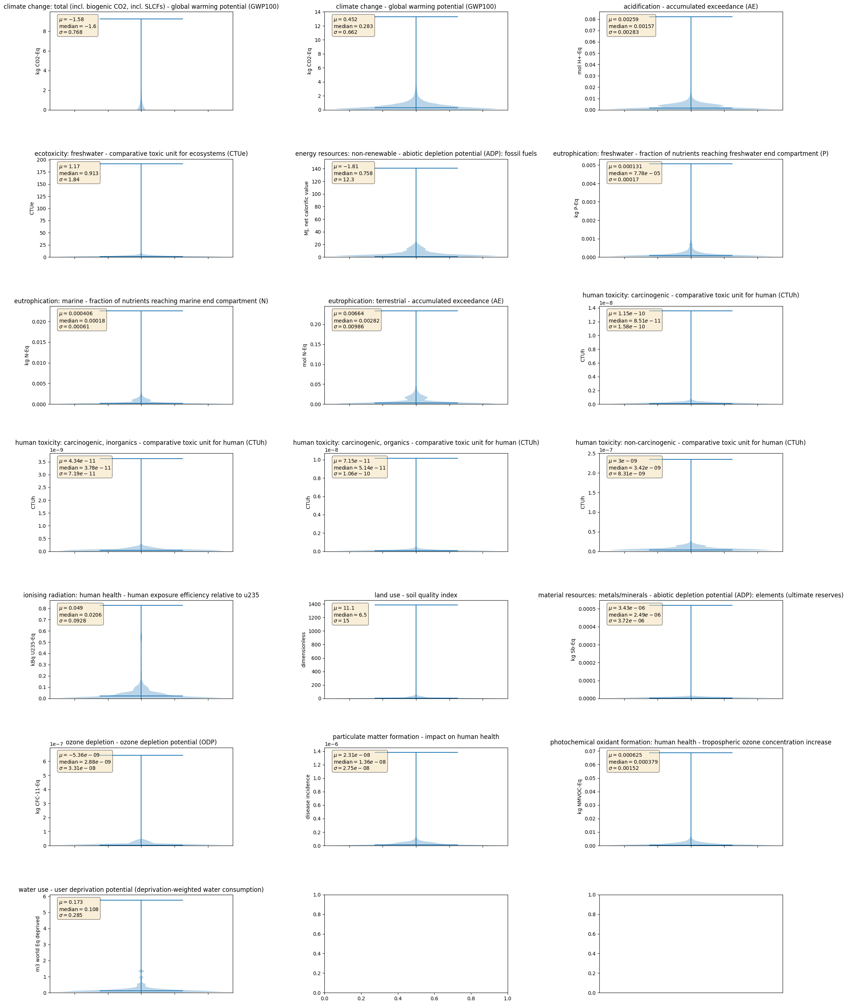
Fig S1 Violin Plots of H₂+CO uncertainty quantification. Violin plots have not been modified to represent negative values thus only positive values are displayed.

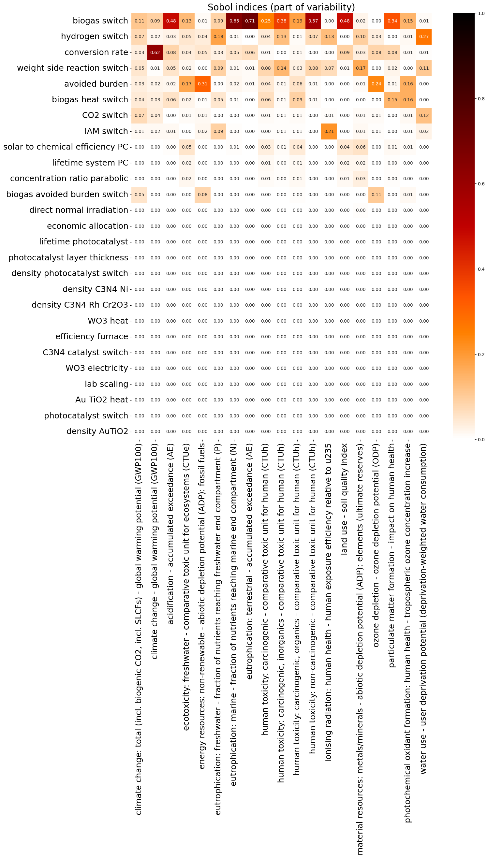
Fig S2 Uncertainty apportioning showing the first-order Sobol’ indices for H₂+CO. Horizontal entries represent the input variables, while vertical entries correspond to the impact categories.
Table S4 Uncertainty quantification and apportioning for H₂+CO.

H₂O₂&CH₄
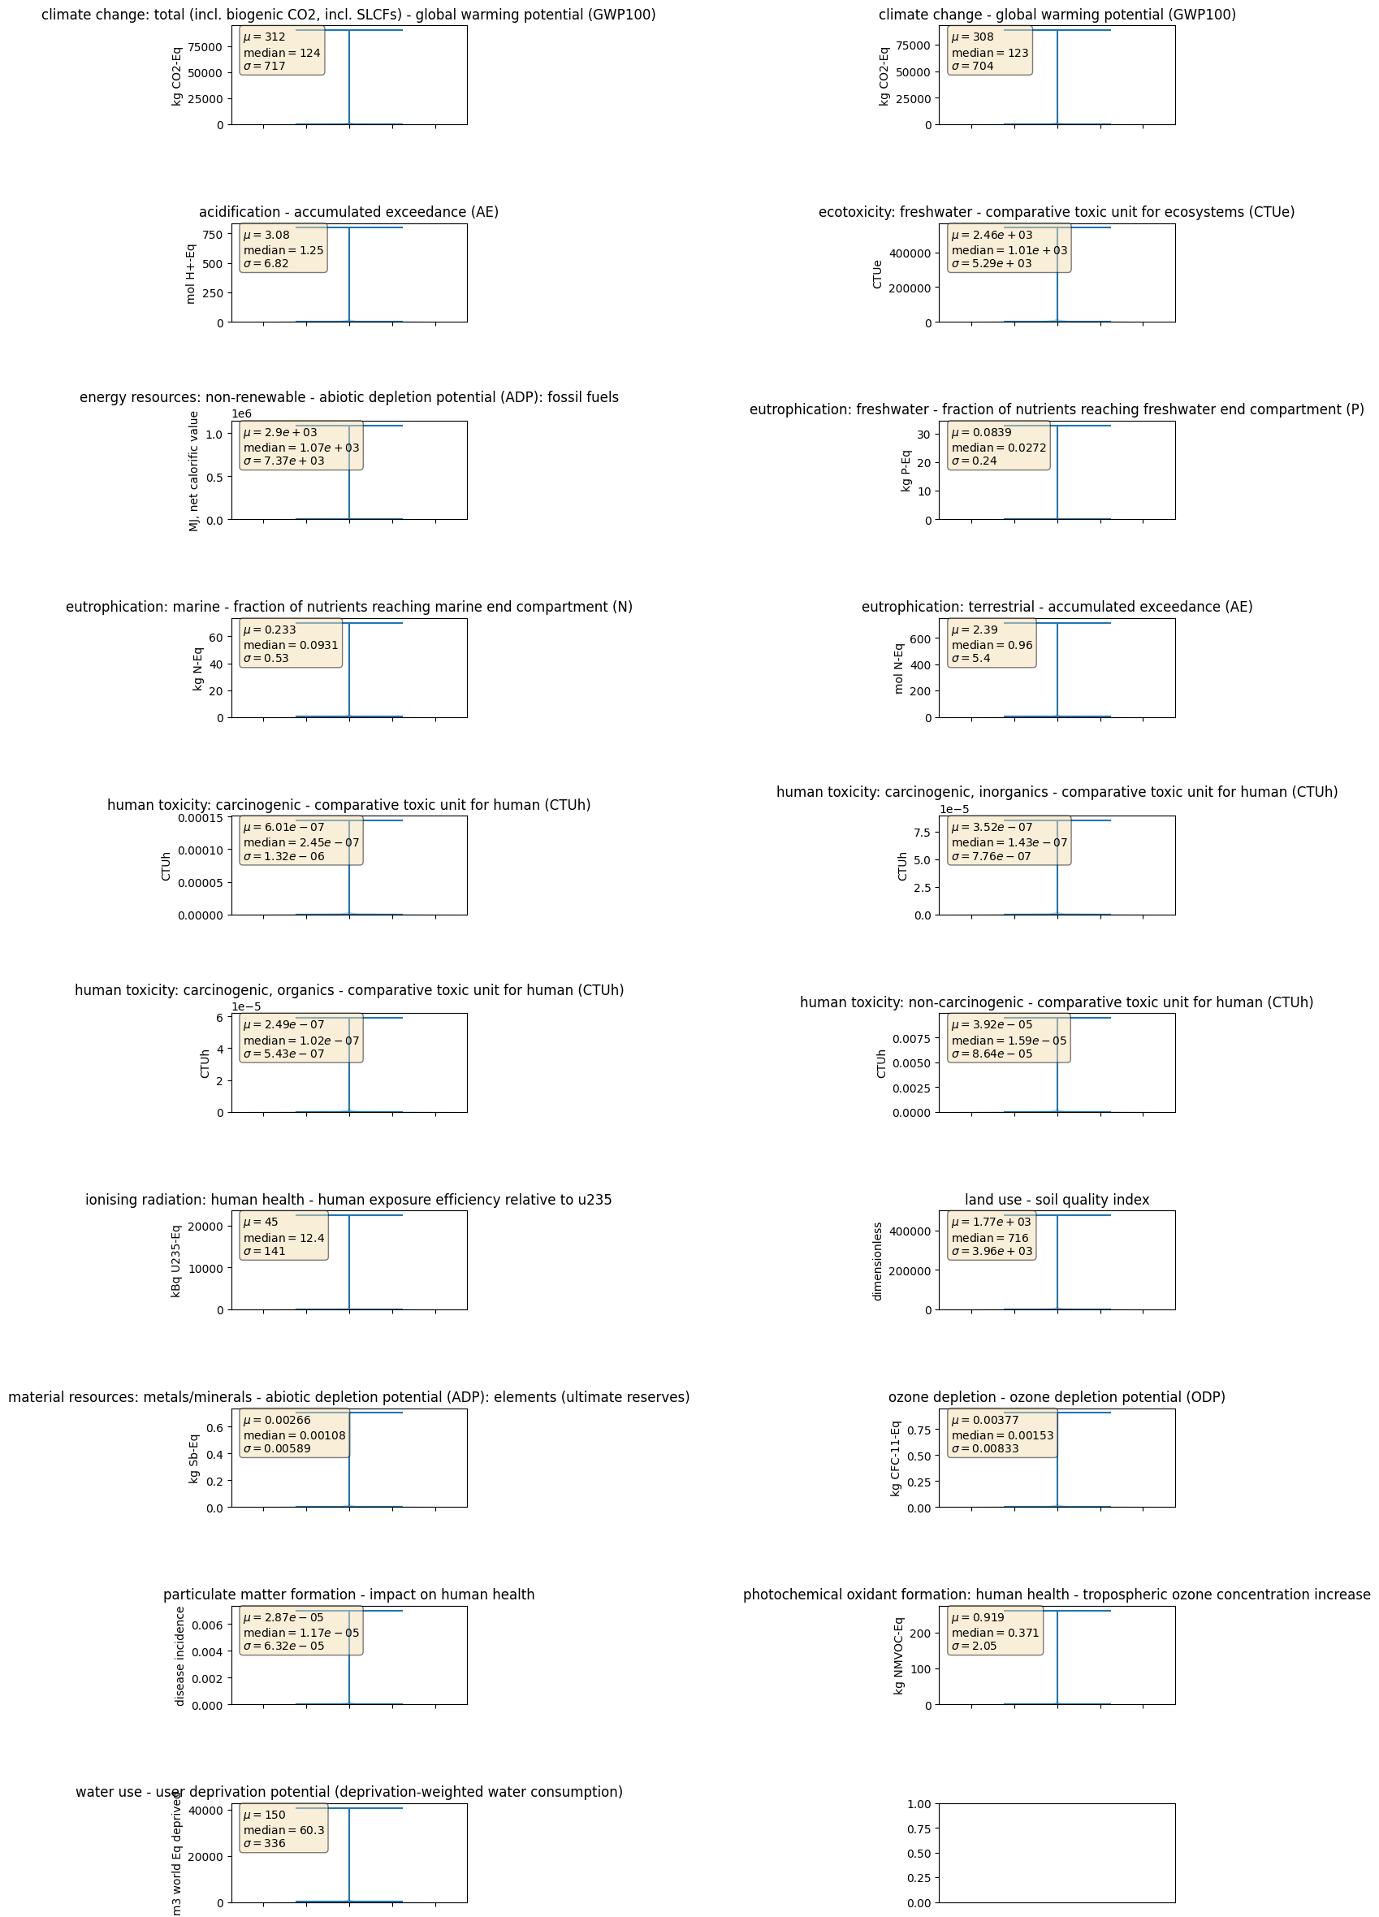
Fig S3 Violin Plots of H₂O₂&CH₄ uncertainty quantification. Violin plots have not been modified to represent negative values thus only positive values are displayed.
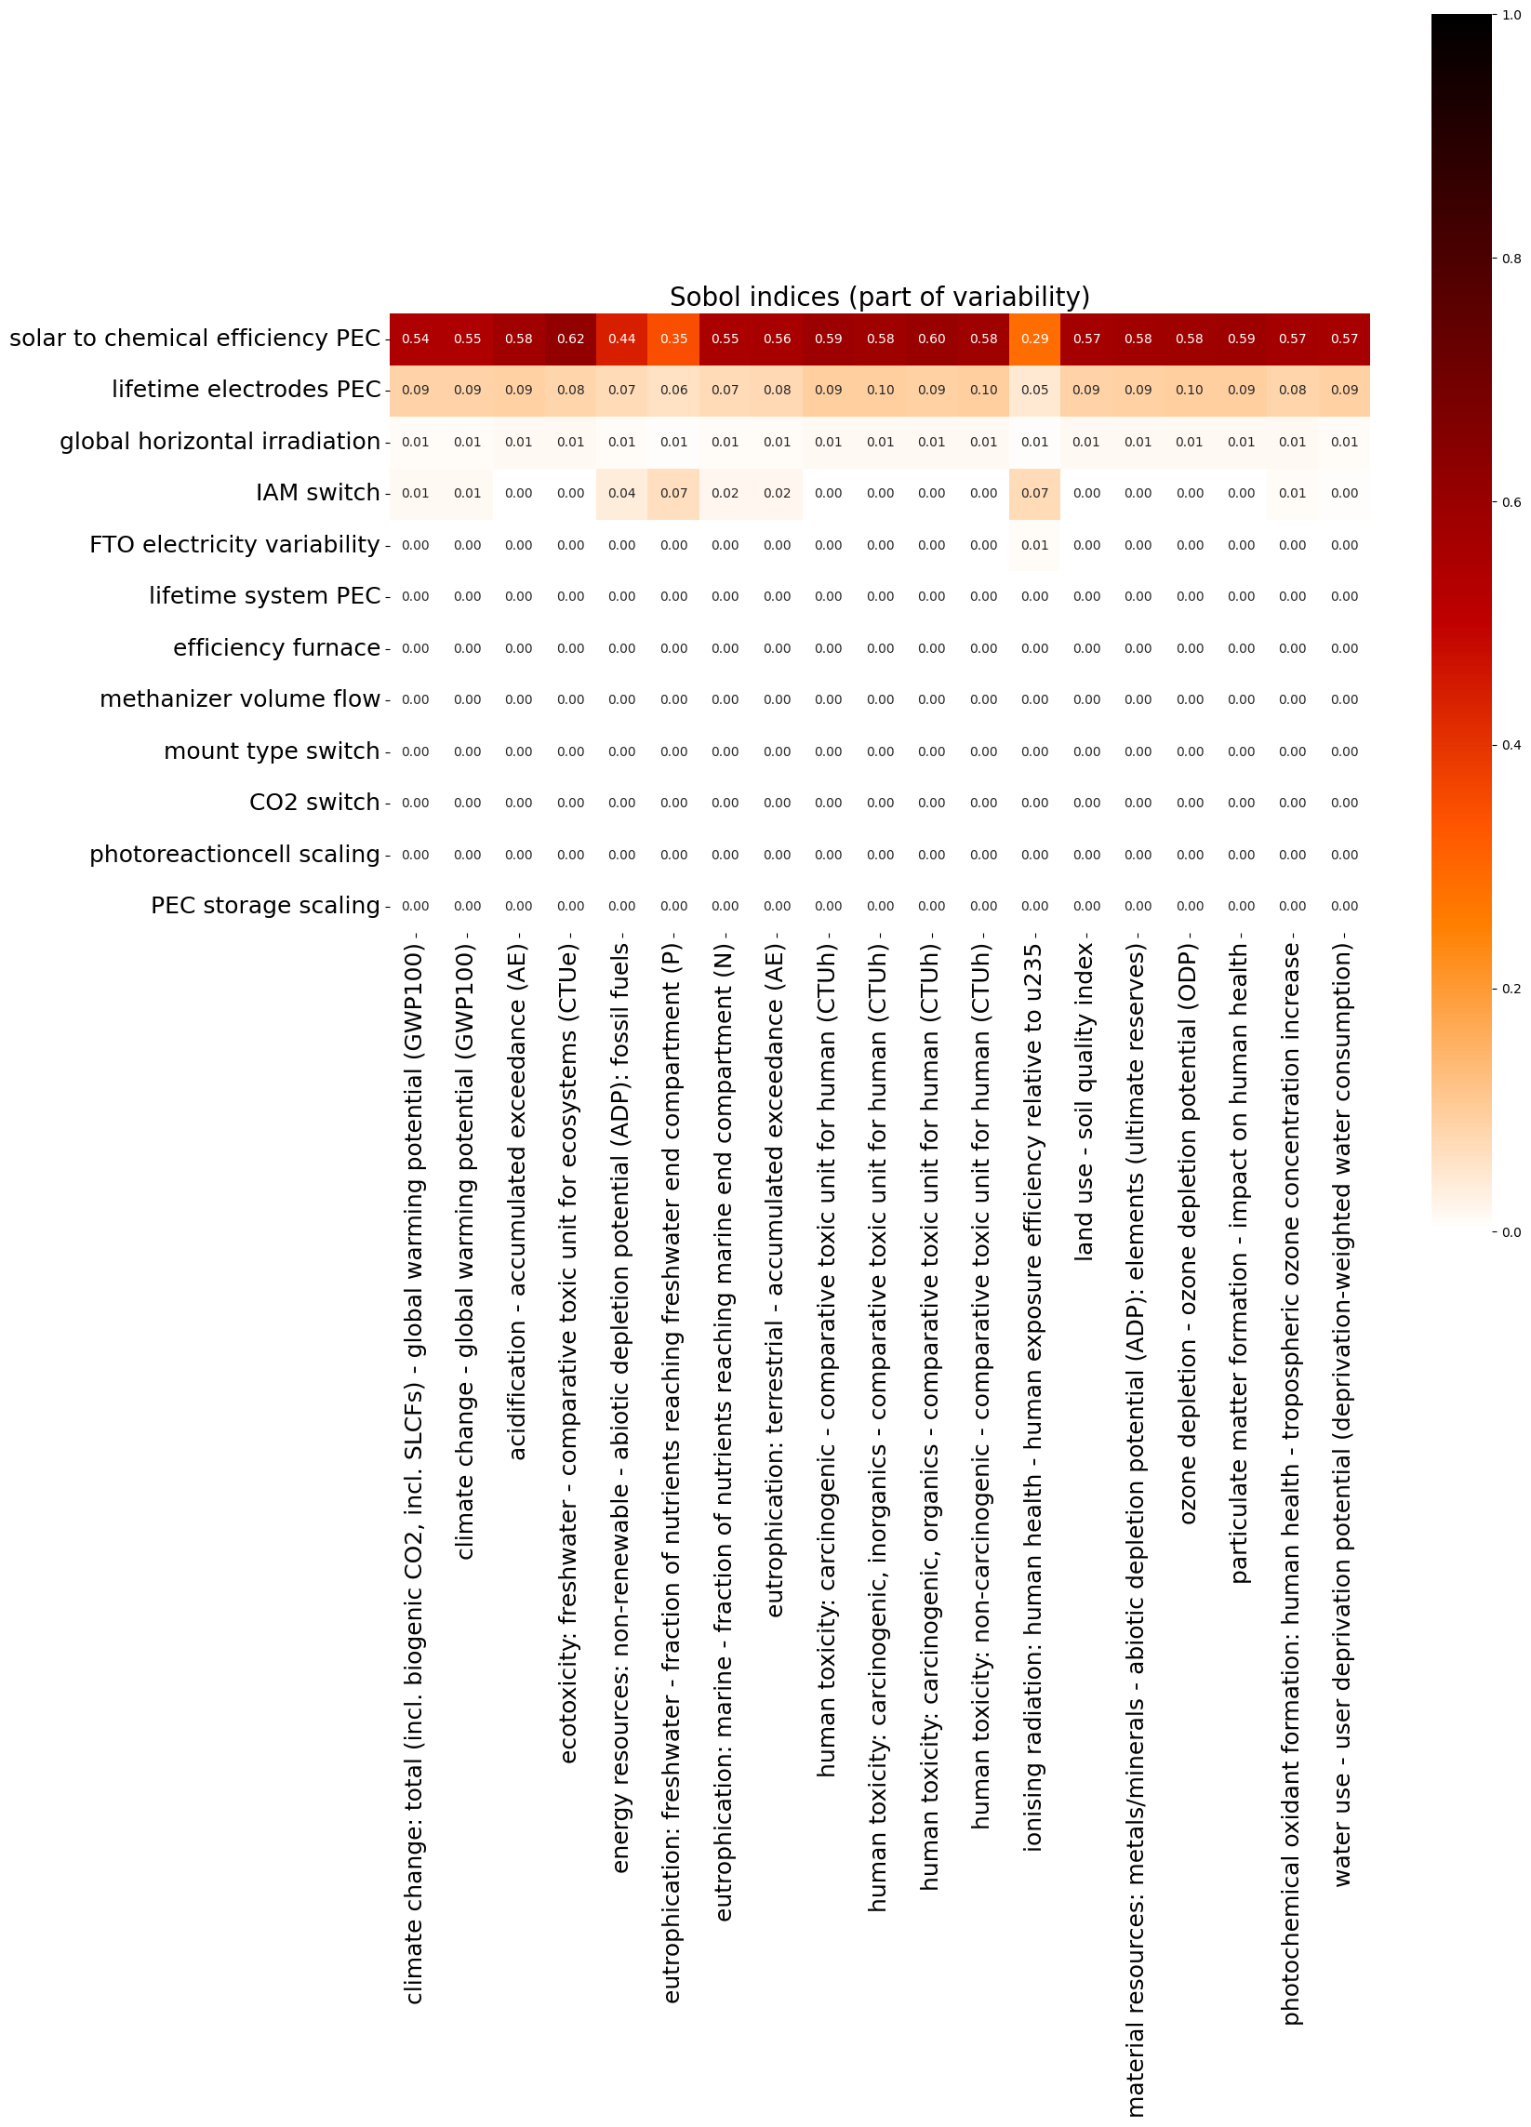
Fig S4 Uncertainty apportioning showing the first-order Sobol’ indices for H₂O₂&CH₄. Horizontal entries represent the input variables, while vertical entries correspond to the impact categories.
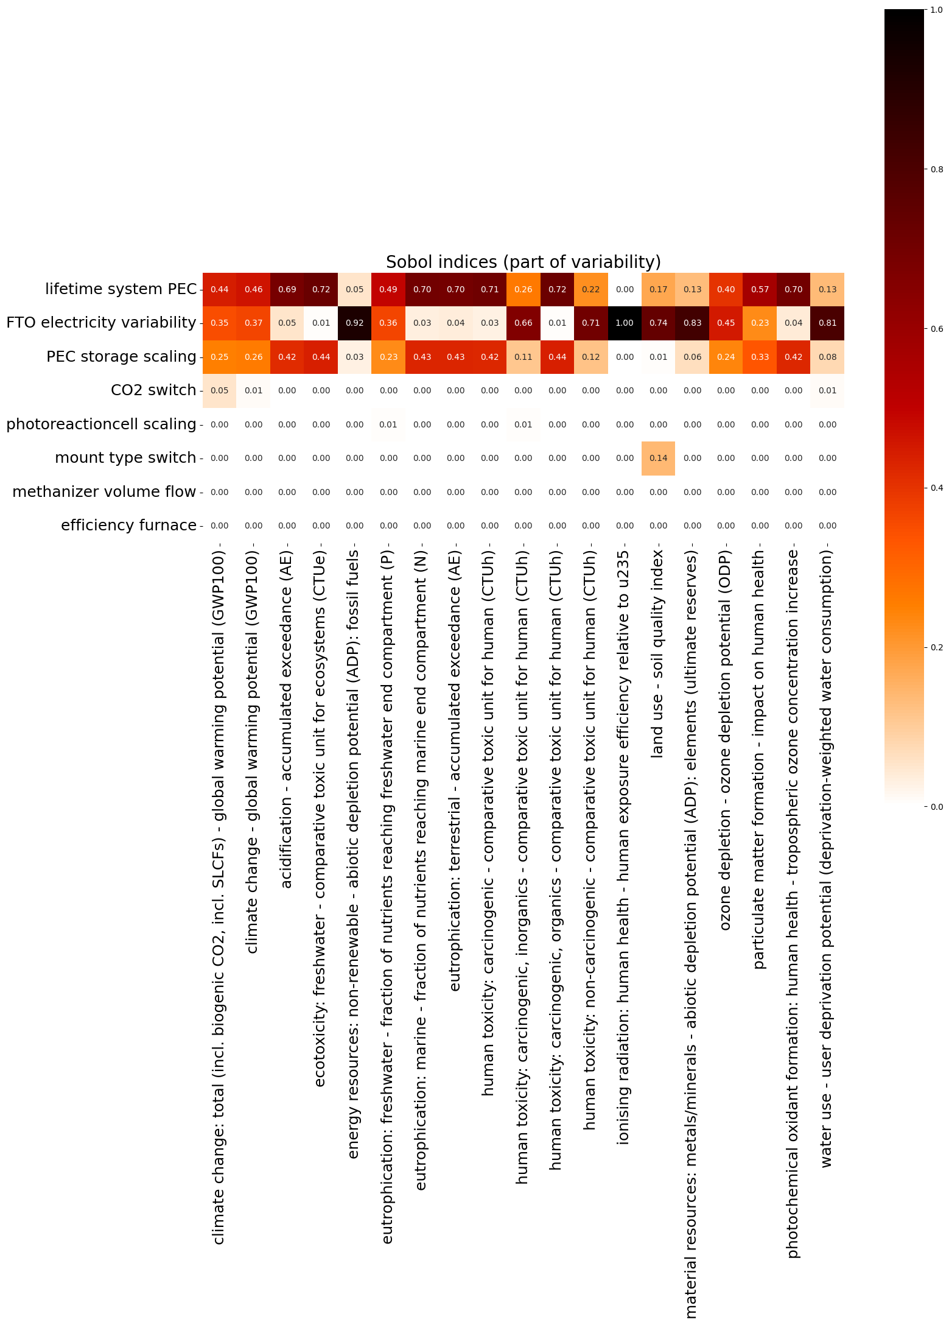

Fig S5 Uncertainty apportioning showing the total-order Sobol’ indices for H₂O₂&CH₄. The highly influential input variables (solar-to-chemical efficiency, electrode lifetime, and global horizontal irradiation) were excluded to highlight the contributions of the remaining input variables to output uncertainty. Horizontal entries represent the input variables, while vertical entries correspond to the impact categories.

Table S5 Uncertainty quantification and apportioning results for H₂O₂&CH₄.

