Supporting Information
Developing Hydrophobic Patterned Composite Membranes for Synchronous Water and Heat Recovery to Reduce CO₂ Capture Energy Demand
Te Tuª, Zuozhuo Caoª, Wei Gao^{b,}*, Fengyi Liª, Zida Wangª, Yunfei Gaoª, Xiaowen Chengª, Mengjun Liangª, Shaofu Wangª, Tiezhou Wuª
ªHubei Key Laboratory for High-efficiency Utilization of Solar Energy and Operation Control of Energy Storage System, Hubei University of Technology, Wuhan 430068, PR China
^{b}College of Advanced Agricultural Sciences, Yulin University, Yulin 719000, PR China
*Corresponding author:
E-mail address: gw89@foxmail.com

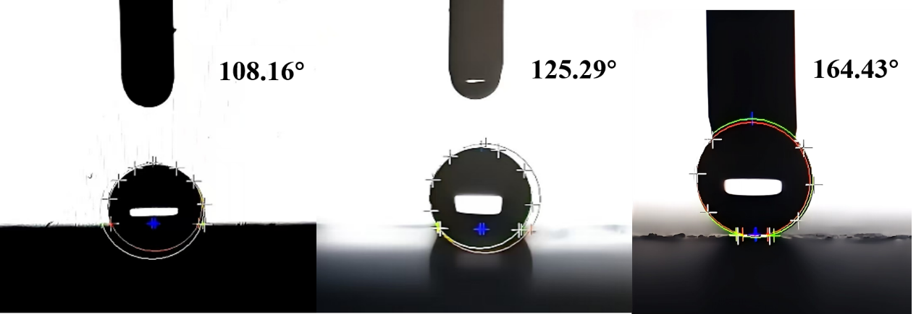
Fig. S1. Water contact angle measurement results of the three-segment wettability gradient of Mode‑A‑Ⅲ.
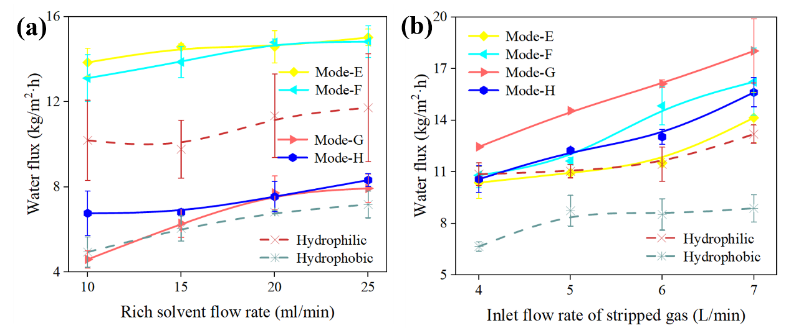
Fig. S2. Effects of flow rate of (a) rich solvent and (b) stripped gas on water transfer flux in Group II (Mode-E, F, G, H).
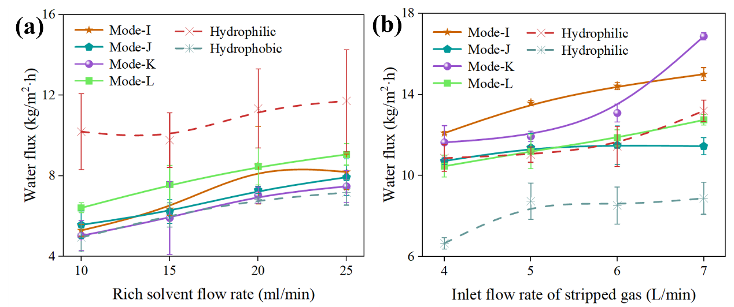
Fig. S3. Effects of flow rate of (a) rich solvent and (b) stripped gas on water transfer flux in Group III (Mode-I, J, K, L).

