Supplementary Materials
for “Domestic and Imported Embodied Energy in Grain Consumption Across High- and Low-Income Countries: An MRIO Analysis”
These supplementary materials provide additional descriptive results and an exploratory principal component analysis (PCA) of agricultural input structures. The PCA-based regressions are supplementary to the main multi-regional input–output (MRIO) analysis. Because the income-specific samples are small, the regression estimates are interpreted as descriptive associations rather than causal effects and are not used to test the main hypotheses.

Supplementary Descriptive Tables and Figures
Table S1. Correlation matrix of agricultural inputs: high-income group
 | Fertilizer N | Fertilizer P₂O₅ | Fertilizer K₂O | Pesticides | Capital stock | Irrigation
Fertilizer N | 1
Fertilizer P₂O₅ | 0.0393 | 1
Fertilizer K₂O | 0.6098 | 0.4846 | 1
Pesticides | 0.0913 | 0.4269 | 0.6070 | 1
Capital stock | 0.0477 | 0.1155 | 0.2074 | 0.2442 | 1
Irrigation | -0.2553 | 0.2587 | 0.1767 | 0.5895 | 0.0967 | 1

Table S2. Correlation matrix of agricultural inputs: low-income group
 | Fertilizer N | Fertilizer P₂O₅ | Fertilizer K₂O | Pesticides | Capital stock | Irrigation
Fertilizer N | 1
Fertilizer P₂O₅ | 0.8915 | 1
Fertilizer K₂O | 0.2802 | 0.3746 | 1
Pesticides | 0.3528 | 0.3373 | 0.3109 | 1
Capital stock | 0.4322 | 0.4378 | 0.0899 | 0.3457 | 1
Irrigation | 0.5456 | 0.5413 | -0.0580 | 0.0047 | 0.4567 | 1

Table S3. Eigenvalues and explained variance: high-income group
 | Eigenvalue | Difference | Proportion | Cumulative
PC1 | 2.4469 | 0.977421 | 0.4078 | 0.4078
PC2 | 1.46948 | 0.542185 | 0.2449 | 0.6527
PC3 | 0.927294 | 0.227319 | 0.1545 | 0.8073
PC4 | 0.699974 | 0.398001 | 0.1167 | 0.9239
PC5 | 0.301974 | 0.147594 | 0.0503 | 0.9743
PC6 | 0.15438 |  | 0.0257 | 1.0000

Table S4. Eigenvalues and explained variance: low-income group
 | Eigenvalue | Difference | Proportion | Cumulative
PC1 | 2.94145 | 1.69376 | 0.4902 | 0.4902
PC2 | 1.24768 | 0.419187 | 0.2079 | 0.6982
PC3 | 0.828496 | 0.285746 | 0.1381 | 0.8363
PC4 | 0.54275 | 0.204313 | 0.0905 | 0.9267
PC5 | 0.338437 | 0.237251 | 0.0564 | 0.9831
PC6 | 0.101186 |  | 0.0169 | 1.0000

Table S5. Countries included in the analysis
No. | High-income group | Low-income group
1 | Luxembourg | Kenya
2 | Singapore | Pakistan
3 | Ireland | Nigeria
4 | Qatar | Republic of the Congo
5 | Norway | Cameroon
6 | Switzerland | Nepal
7 | Brunei Darussalam | Tajikistan
8 | United States | Zimbabwe
9 | Denmark | Senegal
10 | Netherlands | Benin
11 | Iceland | Guinea
12 | United Arab Emirates | Zambia
13 | Taiwan Province of China | United Republic of Tanzania
14 | Austria | Ethiopia
15 | Hong Kong SAR | Comoros
16 | Belgium | Rwanda
17 | Sweden | Uganda
18 | Germany | Sudan
19 | Malta | Haiti
20 | Australia | Togo
21 | France | Mali
22 | Finland | Chad
23 | Bahrain | Burkina Faso
24 | Canada | Afghanistan
25 | Saudi Arabia | Madagascar
26 | United Kingdom | Niger
27 | Republic of Korea | Democratic Republic of the Congo
28 | Italy | Malawi
29 | Cyprus | Mozambique
30 | Czech Republic | Central African Republic

Note: The labels “high-income” and “low-income” refer to the top and bottom 30 countries in the sample ranked by 2017 GDP per capita; they do not correspond to official income classifications.

Figure S1. Distribution of energy-intensity components by income group
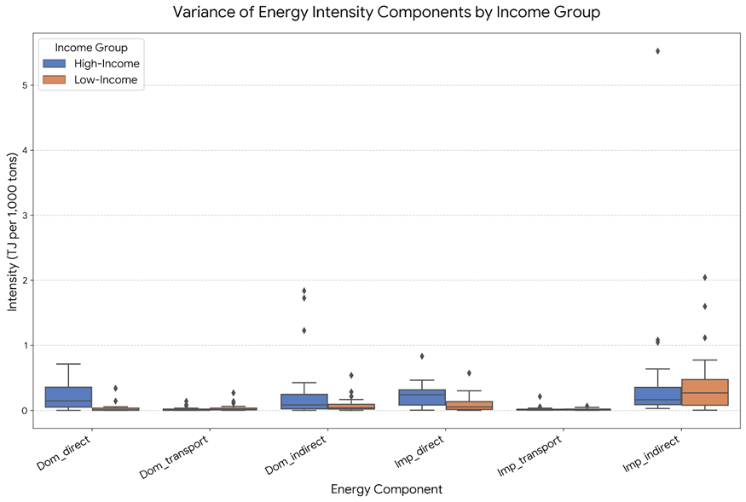
Source: Authors’ calculations.
Note: The box plots summarize cross-country variation in the six energy-intensity components. Outliers are retained because they reflect observed country-level differences.

Figure S2. Energy-intensity components of grain consumption in 60 countries
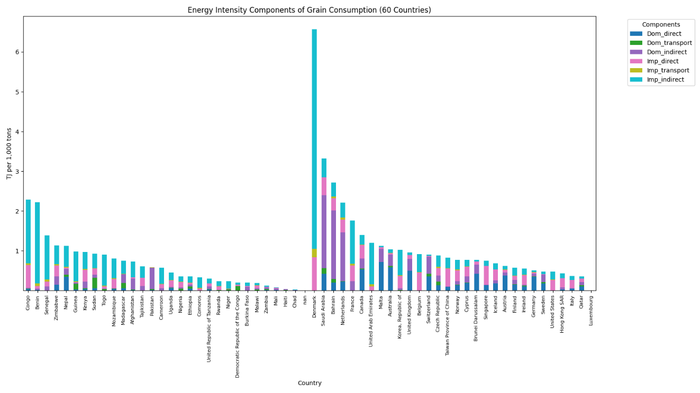
Source: Authors’ calculations.

S1. Exploratory PCA Methodology
The supplementary PCA examines associations between agricultural input structures and domestic grain energy intensity. It is conducted separately for the high-income and low-income groups because the correlation structure and economic interpretation of the input variables differ across the two samples. The complete-case regression samples contain 25 high-income countries and 28 low-income countries.

S1.1 Variables and Standardization
The analysis uses six agricultural input indicators obtained from FAOSTAT (2025):
- Fertilizer nitrogen (N), measured in kilograms per hectare;
- Fertilizer phosphate (P₂O₅), measured in kilograms per hectare;
- Fertilizer potash (K₂O), measured in kilograms per hectare;
- Pesticide use, measured in kilograms per hectare;
- Agricultural capital stock, measured in U.S. dollars per hectare; and
- Irrigated area, measured as a percentage of cropland.
All variables are standardized within each income group before PCA:
zᵢⱼ = (xᵢⱼ − x̄ⱼ) / sⱼ (S1)
where xᵢⱼ is the value of variable j for country i, x̄ⱼ is the group mean, and sⱼ is the group standard deviation.

S1.2 Principal Component Extraction and Retention
PCA is applied to the correlation matrix of the standardized variables. Let Z denote the standardized country-by-variable matrix and R its correlation matrix:
R = (1 / (n − 1)) ZᵀZ (S2)
Rvₖ = λₖvₖ (S3)
The score for component k is calculated as:
PCₖ = Zvₖ (S4)
Only PC1 and PC2 have eigenvalues greater than one in both income groups. PC3 is nevertheless retained because it raises cumulative explained variance above 80% and provides a distinct, interpretable capital- and irrigation-related dimension. The first three components explain 80.73% of the variance in the high-income group and 83.63% in the low-income group. This retention rule is pragmatic and exploratory rather than a strict application of the Kaiser criterion.

S1.3 Exploratory Regression Specification
The dependent variable is the domestic component of grain energy intensity, measured in TJ per 1,000 tons and calculated using the MRIO framework described in the main manuscript. The baseline cross-sectional specification is:
EIᵢᴰ = α + β₁PC1ᵢ + β₂PC2ᵢ + β₃PC3ᵢ + γ′Rᵢ + εᵢ (S5)
where EIᵢᴰ denotes domestic grain energy intensity, PC1ᵢ–PC3ᵢ are the retained component scores, and Rᵢ contains regional indicator variables. The reported models use alternative regional-dummy specifications to assess whether the signs and magnitudes of the principal-component coefficients are sensitive to regional controls. Robust standard errors are reported because the residual diagnostics indicate heteroskedasticity. Given the limited sample sizes, the coefficients are interpreted as conditional associations rather than causal effects.

S2. Principal Component Results

S2.1 High-Income Group
PC1 explains 40.78% of the standardized input variation and loads most strongly on pesticides, potash, and phosphate. It is therefore interpreted as a chemical-input-intensity dimension. PC2 explains 24.49% and contrasts nitrogen use with irrigation, indicating alternative input strategies. PC3 explains 15.45% and is dominated by agricultural capital stock, representing a capital-intensity dimension. The sign of a PCA loading is directional and can be reversed without changing the substantive component; interpretation therefore focuses on the relative magnitudes and contrasts among loadings.
Table S6. Principal-component loadings: high-income group
 | PC1 | PC2 | PC3 | PC4 | PC5 | PC6
Irrigation | 0.3425 | -0.5660 | -0.1145 | 0.4032 | 0.6188 | -0.0614
Fertilizer N | 0.2222 | 0.7122 | -0.0580 | 0.2732 | 0.3860 | 0.4652
Fertilizer P₂O₅ | 0.4292 | -0.0845 | -0.2359 | -0.8181 | 0.1957 | 0.2130
Fertilizer K₂O | 0.5425 | 0.3493 | -0.0953 | 0.0553 | -0.1087 | -0.7481
Pesticides | 0.5474 | -0.2070 | -0.0360 | 0.2754 | -0.6370 | 0.4178
Capital stock | 0.2347 | -0.0183 | 0.9579 | -0.1209 | 0.1107 | 0.0145

Note: All variables are standardized within the income group. PC1–PC3 are retained for the exploratory regressions.

S2.2 Low-Income Group
PC1 explains 49.02% of the standardized input variation and has positive loadings on phosphate, potash, nitrogen, and irrigation. It is interpreted as a broad fertilizer-and-water-input dimension. PC2 explains 20.79% and contrasts pesticide use and capital stock with nitrogen use. PC3 explains 13.81% and contrasts irrigation and capital stock with pesticide use. Because these loading patterns differ from those in the high-income group, coefficients on similarly numbered components should not be treated as representing identical economic constructs across the two samples.
Table S7. Principal-component loadings: low-income group
 | PC1 | PC2 | PC3 | PC4 | PC5 | PC6
Fertilizer N | 0.3819 | -0.5492 | -0.0957 | 0.1266 | 0.7259 | 0.0204
Fertilizer P₂O₅ | 0.5260 | -0.0485 | -0.2260 | -0.3407 | -0.3029 | 0.6797
Fertilizer K₂O | 0.5323 | -0.0007 | -0.2871 | -0.1992 | -0.2633 | -0.7247
Pesticides | 0.2327 | 0.6454 | -0.4085 | 0.5539 | 0.2126 | 0.1026
Capital stock | 0.2958 | 0.5032 | 0.5870 | -0.4148 | 0.3759 | -0.0383
Irrigation | 0.3904 | -0.1622 | 0.5882 | 0.5910 | -0.3543 | 0.0202

Note: All variables are standardized within the income group. PC1–PC3 are retained for the exploratory regressions.

S3. Exploratory Regression Results
Tables S8 and S9 report the PCA-based regressions. Model (1) includes only the three component scores. Models (2)–(5) add alternative sets of regional indicators. The regional coefficients are included as controls and are not the primary focus of the analysis.

S3.1 High-Income Group
PC1 is positive in all specifications and statistically distinguishable from zero in Models (1), (3), (4), and (5), but not in Model (2). This pattern suggests a positive association between chemical-input intensity and domestic grain energy intensity, although the estimate is sensitive to the regional controls. PC2 is negative and statistically distinguishable from zero in several specifications, while PC3 is negative and statistically distinguishable from zero only in the more parsimonious regional specifications. These coefficients should not be interpreted as evidence that capital investment or irrigation causally improves energy efficiency; they reflect conditional cross-country associations in a small sample.

S3.2 Low-Income Group
PC1 is positive and statistically distinguishable from zero across all specifications. PC2 and PC3 are negative across all specifications, with PC2 generally significant at the 10% level and PC3 at the 5% level. The stability of these signs indicates that the association between the input-structure components and domestic grain energy intensity is less sensitive to the alternative regional controls in this sample. Nevertheless, the regressions do not identify causal effects, and the negative coefficients cannot by themselves establish that capital investment, irrigation, or pesticide use reduces energy intensity.

Table S8. Exploratory PCA regressions: high-income group
Variable | (1) Coef. | S.E. | (2) Coef. | S.E. | (3) Coef. | S.E. | (4) Coef. | S.E. | (5) Coef. | S.E.
PC1 | 0.1805** | 0.0827 | 0.0409 | 0.1104 | 0.1929** | 0.0872 | 0.2157*** | 0.0709 | 0.2212*** | 0.0746
PC2 | -0.0999 | 0.1067 | -0.1890* | 0.1049 | -0.1268 | 0.1175 | -0.2607** | 0.1045 | -0.2541** | 0.1090
PC3 | -0.2139 | 0.1343 | -0.2004 | 0.1223 | -0.2022 | 0.1393 | -0.3075** | 0.1169 | -0.2989** | 0.1228
Constant | 0.6152*** | 0.1267 | 0.6088*** | 0.1443 | 0.6197*** | 0.1431 | 0.7864*** | 0.1203 | 0.7713*** | 0.1323
North America dummy | — | — | 0.1452 | 0.4000 | 0.3487 | 0.5059 | — | — | 0.1380 | 0.4356
East Asia dummy | — | — | 1.3193* | 0.6331 | — | — | — | — | — | —
Middle East dummy | — | — | -0.8696* | 0.4803 | — | — | -1.3623*** | 0.4449 | -1.3378** | 0.4623
Oceania dummy | — | — | -0.5159 | 0.4323 | -0.4059 | 0.5166 | -0.7785* | 0.4356 | -0.7513 | 0.4544
R-squared | 0.2804 |  | 0.6337 |  | 0.5552 |  | 0.5375 |  | 0.5401
Adjusted R-squared | 0.1776 |  | 0.4828 |  | 0.4381 |  | 0.4158 |  | 0.3867
Prob. > F | 0.0698 |  | 0.0074 |  | 0.0056 |  | 0.0078 |  | 0.0175
Observations | 25 |  | 25 |  | 25 |  | 25 |  | 25

Note: Robust standard errors are reported. ***, **, and * denote statistical significance at the 1%, 5%, and 10% levels. In this group, PC1 primarily reflects chemical-input intensity, PC2 contrasts nitrogen use with irrigation, and PC3 primarily reflects capital stock. Europe is the reference region when the full set of regional indicators is included.
Table S9. Exploratory PCA regressions: low-income group
Variable | (1) Coef. | S.E. | (2) Coef. | S.E. | (3) Coef. | S.E. | (4) Coef. | S.E. | (5) Coef. | S.E.
PC1 | 0.0645*** | 0.0106 | 0.0718*** | 0.0167 | 0.0625*** | 0.0125 | 0.0732*** | 0.0160 | 0.0731*** | 0.0159
PC2 | -0.0322* | 0.0163 | -0.0448* | 0.0231 | -0.0319* | 0.0173 | -0.0449* | 0.0226 | -0.0436* | 0.0224
PC3 | -0.0486** | 0.0200 | -0.0468** | 0.0211 | -0.0483** | 0.0208 | -0.0471** | 0.0206 | -0.0472** | 0.0206
Constant | 0.1327*** | 0.0179 | 0.1531*** | 0.0314 | 0.1396*** | 0.0269 | 0.1450*** | 0.0242 | 0.1474*** | 0.0265
West Africa dummy | — | — | -0.0189 | 0.0457 | -0.0145 | 0.0451 | — | — | -0.0127 | 0.0413
Central Africa dummy | — | — | -0.0220 | 0.0617 | -0.0154 | 0.0608 | -0.0121 | 0.0559 | — | —
Non-Africa dummy | — | — | -0.0780 | 0.0919 | — | — | -0.0737 | 0.0896 | -0.0739 | 0.0894
R-squared | 0.66 |  | 0.67 |  | 0.66 |  | 0.67 |  | 0.67
Adjusted R-squared | 0.62 |  | 0.58 |  | 0.59 |  | 0.60 |  | 0.60
Prob. > F | 0.00 |  | 0.00 |  | 0.00 |  | 0.00 |  | 0.00
Observations | 28 |  | 28 |  | 28 |  | 28 |  | 28

Note: Robust standard errors are reported. ***, **, and * denote statistical significance at the 1%, 5%, and 10% levels. In this group, PC1 reflects a broad fertilizer-and-water-input dimension, PC2 contrasts pesticide use and capital stock with nitrogen use, and PC3 contrasts irrigation and capital stock with pesticide use. The included regional indicators and omitted reference categories vary across Models (2)–(5) as shown in the table.

S4. Regression Diagnostics and Interpretation Limits
The Breusch–Pagan diagnostics indicate heteroskedasticity in the high-income regression (p = 0.0012) and borderline evidence of heteroskedasticity in the low-income regression (p = 0.0513). Robust standard errors are therefore reported in Tables S8 and S9. Cook’s distance was also inspected to identify potentially influential observations. The signs of the main component coefficients are broadly similar across the alternative regional specifications, although the statistical precision of the high-income estimates varies.
Figure S3. Residual-versus-fitted plot for the low-income regression
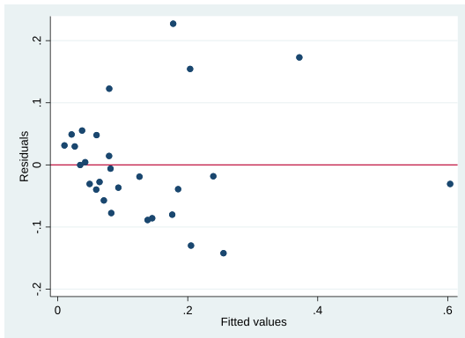
Source: Authors’ calculations.
Note: The residual plot is consistent with the borderline Breusch–Pagan result for the low-income sample. Robust standard errors are used in the reported regressions.

S5. Scope and Limitations of the Supplementary Analysis
The PCA-based regressions are exploratory for four reasons. First, the complete-case samples are small (25 high-income and 28 low-income countries), limiting statistical power and the stability of regional coefficients. Second, the analysis is cross-sectional and may be affected by omitted variables such as crop composition, land quality, farm size, climate, energy prices, and agricultural productivity. Third, the principal components have group-specific meanings, so coefficients cannot be compared mechanically across the two income groups. Fourth, the regressions establish associations rather than causal effects.
Accordingly, this supplementary analysis is not used to validate the main MRIO estimates or to make claims about energy-price shocks, food-price pass-through, transport-cost transmission, or the effects of grain self-sufficiency. Its purpose is limited to documenting whether broad agricultural input structures are associated with the domestic component of grain energy intensity.

References
FAO (Food and Agriculture Organization of the United Nations). (2025). FAOSTAT Database. Rome: FAO.
Hotelling, H. (1933). Analysis of a complex of statistical variables into principal components. Journal of Educational Psychology, 24(6), 417–441.
Kaiser, H. F. (1960). The application of electronic computers to factor analysis. Educational and Psychological Measurement, 20, 141–151.

