SF 1: A brief overview of the Eco-environmental quality and standard of Urbanities zones in the study area.

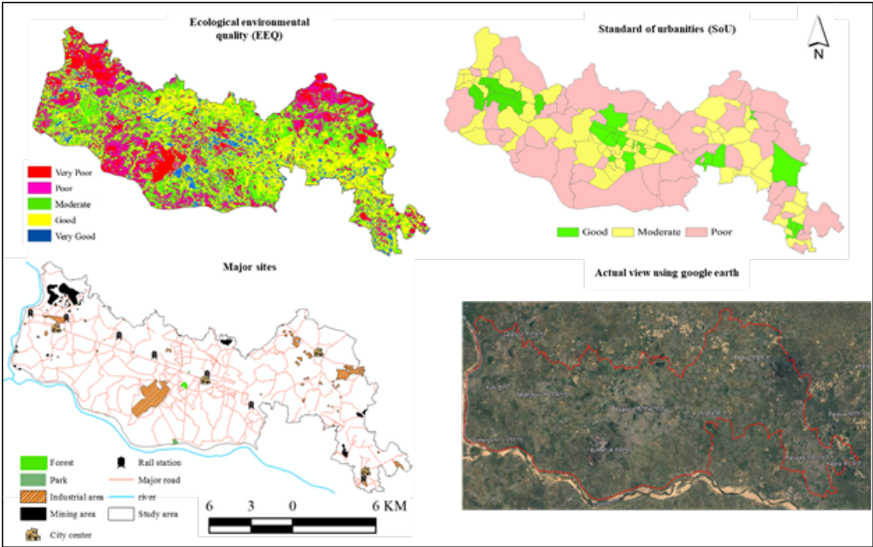

SF 2: Weight calculation of Housing Quality Domain

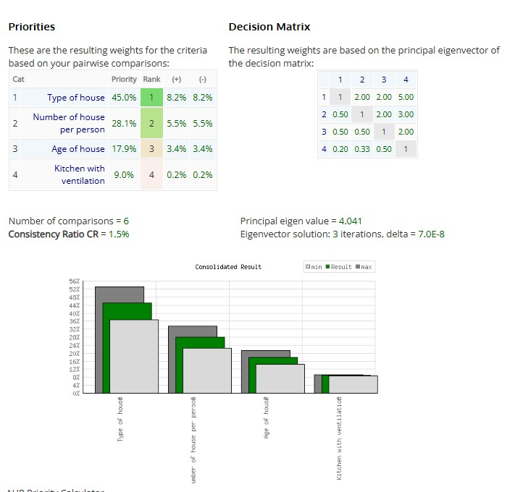

SF 3: Weight calculation of WASH & Drainage Domain

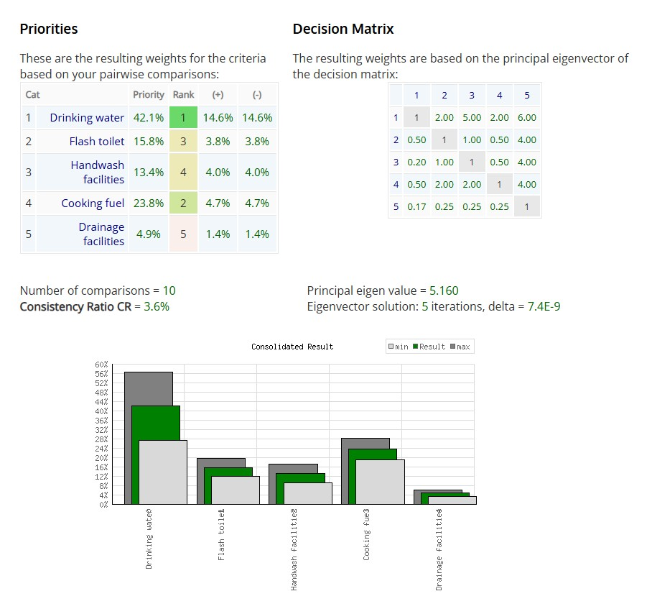

SF 4: Weight calculation of Neighborhoods Infrastructure Domain

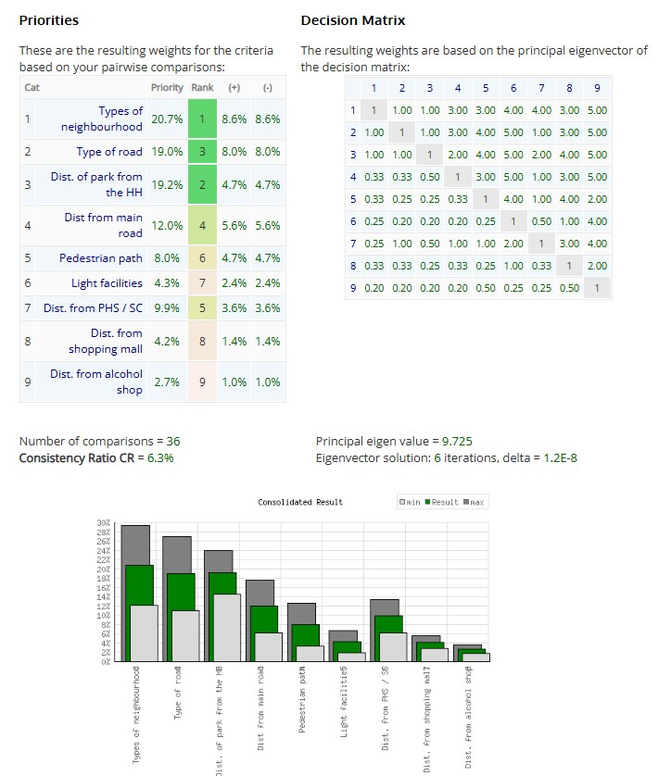

SF 5: Weight calculation of Level of Pollution Domain
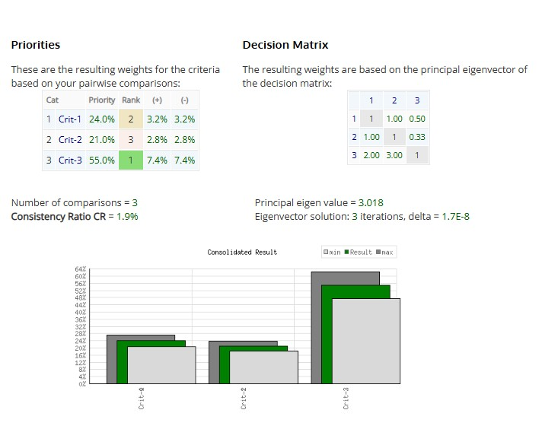

SF 6: Weight calculation for Neighborhoods built Environment (NBE)

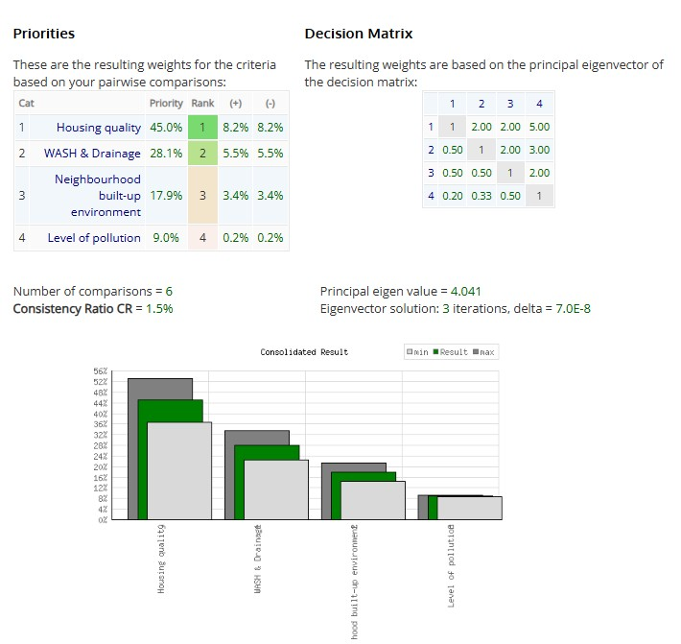

ST 1: Multicollinearity assessment of different indicators

Domain | Indicator | VIF | Tolerance
Housing quality | Types of houses | 2.18 | 0.459
Housing quality | Number of available rooms per person | 2.43 | 0.412
Housing quality | Age of the house | 1.76 | 0.568
Housing quality | Separate kitchen with ventilation | 2.31 | 0.433
WASH & Drainage | Access to improved drinking water | 2.67 | 0.375
WASH & Drainage | Access to a flush toilet | 2.84 | 0.352
WASH & Drainage | Handwashing facility | 2.25 | 0.444
WASH & Drainage | Clean cooking fuel | 2.91 | 0.344
WASH & Drainage | Covered drainage facility | 2.48 | 0.403
Neighborhood infrastructure | Types of neighborhoods | 1.94 | 0.515
Neighborhood infrastructure | Types of roads | 2.36 | 0.424
Neighborhood infrastructure | Distance of park/open space from household | 1.83 | 0.546
Neighborhood infrastructure | Distance from the main road | 2.12 | 0.472
Neighborhood infrastructure | Pedestrian path availability | 2.57 | 0.389
Neighborhood infrastructure | Street-light facilities | 2.29 | 0.437
Neighborhood infrastructure | Distance from PHS/SC | 1.71 | 0.585
Neighborhood infrastructure | Distance from shopping complex | 1.88 | 0.532
Neighborhood infrastructure | Distance from alcohol shop | 1.65 | 0.606
Level of pollution | Noise pollution | 2.73 | 0.366
Level of pollution | Air pollution | 3.12 | 0.321
Level of pollution | Dust pollution | 2.86 | 0.35

