Supplementary Materials
We re-estimated the multinomial logit model using alternative base outcomes representing key transition points in the adoption process, specifically “aware non-adopters” (capturing barriers to entry) and “new adopters” (capturing initial engagement), to assess whether results are sensitive to model normalization.
Table S 1: Multinomial logit estimates of factors associated with regenerative agriculture adoption states.
 | (1) | (3) | (4) | (5) | (6) | (7)
Variables | Not aware | Disadopted users | Trailing adopters | New adopters | Plateau adopters | Intensifying adopters
Age | 0.009 | 0.030 | 0.031*** | 0.026*** | 0.068*** | 0.025**
 | (0.009) | (0.019) | (0.011) | (0.010) | (0.020) | (0.010)
Sex | -0.013 | -0.976** | -0.048 | -0.643** | -0.817 | -0.209
 | (0.236) | (0.479) | (0.294) | (0.273) | (0.497) | (0.286)
Education | -0.194 | -0.514 | -0.142 | 0.104 | 1.293** | -0.097
 | (0.235) | (0.427) | (0.299) | (0.266) | (0.509) | (0.281)
Married | -0.241 | 0.473 | 0.378 | 0.200 | 1.154 | 0.417
 | (0.269) | (0.565) | (0.370) | (0.316) | (0.767) | (0.332)
HH size | 0.039 | 0.005 | 0.024 | 0.122* | 0.236** | -0.002
 | (0.063) | (0.102) | (0.079) | (0.069) | (0.104) | (0.076)
Farm size | 0.115 | 0.315*** | 0.191** | 0.082 | -0.379 | 0.094
 | (0.076) | (0.103) | (0.090) | (0.096) | (0.245) | (0.093)
Land tenure | 0.491** | -0.448 | -0.082 | 0.238 | 0.427 | 0.862***
 | (0.232) | (0.452) | (0.303) | (0.265) | (0.584) | (0.273)
Farm income | 0.091 | -0.186 | -0.021 | 0.153 | 0.071 | 0.139
 | (0.109) | (0.269) | (0.125) | (0.106) | (0.131) | (0.108)
Off farm income | -0.262 | -0.750 | -0.269 | -0.396*** | -1.204 | -0.848**
 | (0.182) | (0.572) | (0.208) | (0.149) | (0.961) | (0.335)
Credit access | 0.131 | 1.154** | 0.999*** | 1.308*** | 0.665 | 0.737**
 | (0.236) | (0.538) | (0.355) | (0.310) | (0.632) | (0.311)
County | -1.080*** | -1.766*** | -2.066*** | -1.872*** | -0.353 | -1.246***
 | (0.322) | (0.582) | (0.406) | (0.352) | (0.710) | (0.377)
Constant | 0.819 | -2.698** | -1.863** | -1.566** | -7.449*** | -1.574**
 | (0.620) | (1.240) | (0.780) | (0.728) | (1.445) | (0.793)
Observations | 949 | 949 | 949 | 949 | 949 | 949
Coefficients are log-odds relative to the reference category (“Aware non-adopters”), with robust standard errors in parentheses. Significance levels: *** p < 0.01, ** p < 0.05, * p < 0.1. Binary variables are coded as education (1 = secondary or higher), sex (1 = male), county (1 = Makueni), and marital status (1 = married). Income is reported in Ksh’00,000
Table S 2: Multinomial logit estimates of factors associated with regenerative agriculture adoption states.
 | (1) | (2) | (3) | (4) | (6) | (7)
Variables | Not aware | Aware non-adopters | Disadopted users | Trailing adopters | Plateau adopters | Intensifying adopters
Age | -0.017** | -0.026*** | 0.005 | 0.005 | 0.042** | -0.001
 | (0.008) | (0.010) | (0.018) | (0.010) | (0.019) | (0.009)
Sex | 0.630*** | 0.643** | -0.334 | 0.594** | -0.174 | 0.433*
 | (0.217) | (0.273) | (0.467) | (0.268) | (0.486) | (0.256)
Education | -0.299 | -0.104 | -0.618 | -0.247 | 1.188** | -0.201
 | (0.210) | (0.266) | (0.407) | (0.267) | (0.492) | (0.246)
Married | -0.441* | -0.200 | 0.273 | 0.178 | 0.954 | 0.217
 | (0.239) | (0.316) | (0.550) | (0.328) | (0.756) | (0.291)
HH size | -0.084 | -0.122* | -0.118 | -0.099 | 0.114 | -0.124*
 | (0.055) | (0.069) | (0.097) | (0.070) | (0.098) | (0.067)
Farm size | 0.033 | -0.082 | 0.233** | 0.109 | -0.461* | 0.012
 | (0.081) | (0.096) | (0.102) | (0.088) | (0.245) | (0.093)
Land tenure | 0.253 | -0.238 | -0.686 | -0.320 | 0.189 | 0.624***
 | (0.202) | (0.265) | (0.430) | (0.264) | (0.569) | (0.239)
Farm income | -0.062 | -0.153 | -0.339 | -0.173** | -0.082 | -0.013
 | (0.051) | (0.106) | (0.250) | (0.072) | (0.086) | (0.048)
Off farm income | 0.134 | 0.396*** | -0.355 | 0.126 | -0.808 | -0.452
 | (0.179) | (0.149) | (0.573) | (0.228) | (0.959) | (0.332)
Credit access | -1.176*** | -1.308*** | -0.153 | -0.308 | -0.643 | -0.570*
 | (0.275) | (0.310) | (0.553) | (0.378) | (0.640) | (0.341)
County | 0.792*** | 1.872*** | 0.106 | -0.195 | 1.519** | 0.625*
 | (0.265) | (0.352) | (0.551) | (0.355) | (0.686) | (0.325)
Constant | 2.384*** | 1.566** | -1.132 | -0.297 | -5.883*** | -0.008
 | (0.580) | (0.728) | (1.202) | (0.730) | (1.419) | (0.735)
Observations | 949 | 949 | 949 | 949 | 949 | 949
Coefficients are log-odds relative to the reference category (“New adopters”), with robust standard errors in parentheses. Significance levels: *** p < 0.01, ** p < 0.05, * p < 0.1. Binary variables are coded as education (1 = secondary or higher), sex (1 = male), county (1 = Makueni), and marital status (1 = married). Income is reported in Ksh’00,000
To further assess robustness, we collapsed the seven adoption states into three broader categories reflecting levels of engagement:(1) non-engagement: not aware, aware non-adopters, disadopted users; (2) early engagement: trailing adopters, new adopters;(3) advanced engagement: plateau adopters, intensifying adopters. We then re-estimated a multinomial logit model using this reduced classification
Table S 3: Multinomial logit estimates of factors associated with regenerative agriculture collapsed adoption categories.
 | (1) | (2) | (3)
Variables | Non-engagement | Early adoption | Advanced adoption
Age |  | 0.019*** | 0.022***
 |  | (0.006) | (0.007)
Sex |  | -0.339* | -0.188
 |  | (0.174) | (0.214)
Education |  | 0.202 | 0.233
 |  | (0.171) | (0.207)
Married |  | 0.394* | 0.617**
 |  | (0.204) | (0.248)
HH size |  | 0.059 | 0.013
 |  | (0.044) | (0.053)
Farm size |  | 0.016 | -0.059
 |  | (0.057) | (0.071)
Land tenure |  | -0.197 | 0.503**
 |  | (0.169) | (0.198)
Farm income |  | 0.036 | 0.052
 |  | (0.047) | (0.047)
Off farm income |  | -0.146 | -0.663**
 |  | (0.127) | (0.306)
Credit access |  | 1.030*** | 0.580**
 |  | (0.216) | (0.249)
County |  | -1.065*** | -0.288
 |  | (0.216) | (0.268)
Constant |  | -2.199*** | -3.144***
 |  | (0.449) | (0.596)
Observations | 949 | 949 | 949
Coefficients are log-odds relative to the reference category (“non-engagement category”), with robust standard errors in parentheses. Significance levels: *** p < 0.01, ** p < 0.05, * p < 0.1. Binary variables are coded as education (1 = secondary or higher), sex (1 = male), county (1 = Makueni), and marital status (1 = married). Income is reported in Ksh’00,000
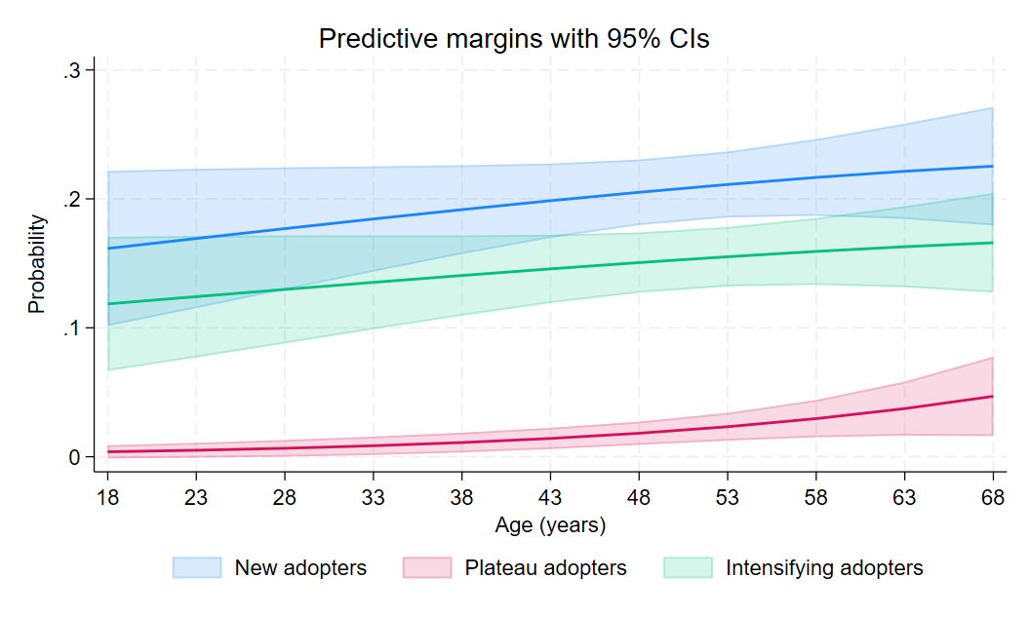
Figure S 1: Predicted probabilities across age; new, plateau and intensifying regenerative agriculture adopters. CIs is short for confidence intervals.

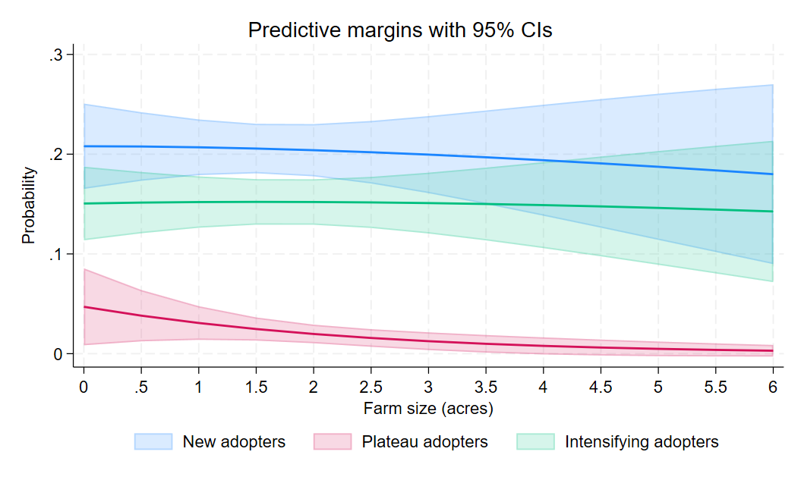
Figure S 2: Predicted probabilities across farm size; new, plateau and intensifying regenerative agriculture adopters. CIs are short for confidence intervals.
Table S 4: Variance inflation factors (VIF) for explanatory variables.
Variable | VIF
Age | 1.27
Sex | 1.19
Education | 1.22
Married | 1.14
HH size | 1.24
Farm size | 1.42
Land tenure | 1.13
Farm income | 1.30
Off farm income | 1.04
Credit access | 1.29
County | 2.00
Mean VIF | 1.29
VIFs are computed based on an auxiliary ordinary lest squares (OLS) specification. All values are low, indicating no evidence of problematic multicollinearity.
Table S 5: Hausman and Small–Hsiao tests of the independence of irrelevant alternatives (IIA) assumption for the multinomial logistic regression model of regenerative agriculture adoption states.
Outcome Omitted | Hausman Χ² | Df | P-Value | Small–Hsiao Χ² | Df | P-Value | Interpretation
Not aware | 4.558 | 58 | 1.000 | 40.854 | 60 | 0.972 | No evidence against IIA
Aware non-adopters | −2.205 | 57 | — | 40.780 | 60 | 0.973 | Hausman invalid; Small–Hsiao supports IIA
Disadopted users | 0.169 | 57 | 1.000 | 46.933 | 60 | 0.891 | No evidence against IIA
Trailing adopters | 0.467 | 57 | 1.000 | 46.381 | 60 | 0.901 | No evidence against IIA
New adopters | −0.358 | 58 | — | 41.535 | 60 | 0.967 | Hausman invalid; Small–Hsiao supports IIA
Plateau adopters | 0.529 | 58 | 1.000 | 42.298 | 60 | 0.960 | No evidence against IIA
Intensifying adopters | −7.541 | 57 | — | 47.994 | 60 | 0.868 | Hausman invalid; Small–Hsiao supports IIA

Table S 6: Adjusted predicted probabilities and average marginal effects of credit access on regenerative agriculture engagement-state membership.
state | No credit, predicted probability | Credit access, predicted probability | AME of credit access | 95% CI for AME | p-value
Not aware | 44.8% | 30.5% | −14.3 pp | −22.4 to −6.2 | 0.001
Aware non-adopter | 18.3% | 11.6% | −6.7 pp | −11.9 to −1.4 | 0.014
Disadopter | 2.2% | 4.1% | +1.8 pp | −0.7 to +4.4 | 0.160
Trailing adopter | 7.9% | 12.1% | +4.2 pp | −0.5 to +9.0 | 0.082
New adopter | 11.3% | 23.3% | +12 pp | +6.5 to +17.6 | <0.001
Plateau adopter | 1.9% | 2.1% | +0.2 pp | −2.0 to +2.4 | 0.860
Intensifying adopter | 13.6% | 16.3% | +2.7 pp | −3.5 to +8.8 | 0.395

Table S7: Multinomial logit estimates of factors associated with regenerative agriculture adoption states with access to extension included as part of the covariates.
 | (2) | (3) | (4) | (5) | (6) | (7)
Variables | Aware non-adopters | Disadopted users | Trailing adopters | New adopters | Plateau adopters | Intensifying adopters
Age | -0.012 | 0.021 | 0.023** | 0.018* | 0.068*** | 0.016
 | (0.011) | (0.019) | (0.011) | (0.011) | (0.022) | (0.011)
Sex | 0.069 | -1.036** | -0.066 | -0.658** | -0.876 | -0.219
 | (0.297) | (0.493) | (0.285) | (0.272) | (0.543) | (0.290)
Education | -0.044 | -0.565 | -0.163 | 0.059 | 1.305** | -0.161
 | (0.307) | (0.442) | (0.303) | (0.278) | (0.513) | (0.292)
Married | 0.410 | 0.941 | 0.802** | 0.631** | 1.678** | 0.862***
 | (0.351) | (0.578) | (0.338) | (0.291) | (0.801) | (0.315)
HH size | -0.100 | -0.092 | -0.057 | 0.038 | 0.166 | -0.087
 | (0.070) | (0.100) | (0.066) | (0.059) | (0.107) | (0.067)
Farm size | -0.151* | 0.190** | 0.055 | -0.067 | -0.561** | -0.047
 | (0.080) | (0.097) | (0.073) | (0.088) | (0.236) | (0.082)
Land tenure | -0.958*** | -1.320*** | -0.904*** | -0.633** | -0.607 | -0.035
 | (0.297) | (0.457) | (0.298) | (0.272) | (0.602) | (0.281)
Farm income | -0.266 | -0.397 | -0.196** | -0.003 | -0.089 | -0.013
 | (0.172) | (0.280) | (0.087) | (0.063) | (0.102) | (0.066)
Off farm income | 0.531 | -0.418 | 0.232 | 0.060 | -1.025 | -0.500
 | (0.394) | (0.803) | (0.313) | (0.414) | (1.092) | (0.488)
Extension access | 5.482*** | 5.368*** | 3.517*** | 5.167*** | 16.976*** | 5.780***
 | (0.619) | (1.145) | (0.459) | (0.603) | (0.435) | (0.804)
Credit access | -0.335 | 0.795 | 0.708** | 0.973*** | 0.251 | 0.441
 | (0.302) | (0.569) | (0.361) | (0.319) | (0.649) | (0.342)
County | 2.331*** | 0.586 | 0.140 | 0.529 | 2.097*** | 1.183***
 | (0.455) | (0.619) | (0.432) | (0.369) | (0.702) | (0.395)
Constant | -4.469*** | -7.276*** | -4.863*** | -6.150*** | -24.125*** | -6.740***
 | (1.064) | (1.691) | (0.876) | (0.876) | (1.637) | (1.119)
Observations | 949 | 949 | 949 | 949 | 949 | 949
Coefficients are log-odds relative to the reference category (“Not aware”), with robust standard errors in parentheses. Significance levels: *** p < 0.01, ** p < 0.05, * p < 0.1. Binary variables are coded as education (1 = secondary or higher), sex (1 = male), county (1 = Makueni), and marital status (1 = married). Income is reported in Ksh’00,000.

