Online resource 2: Solar radiation, Tropic and Arctic
Title: Violet-blue light exposure of the skin: is there need for protection?
Journal: Photochemical Photobiological Sciences
Authors: Terje Christensen,^{a,b} Bjørn J. Johnsen ^{b} and Ellen M. Bruzell ^{c}
Affiliations: ªUniversity of South-Eastern Norway.
^{b}Norwegian Radiation and Nuclear Safety Authority
^{c}Nordic Institute of Dental Materials (NIOM)
Corresponding author e-mail: terje.christensen222@gmail.com
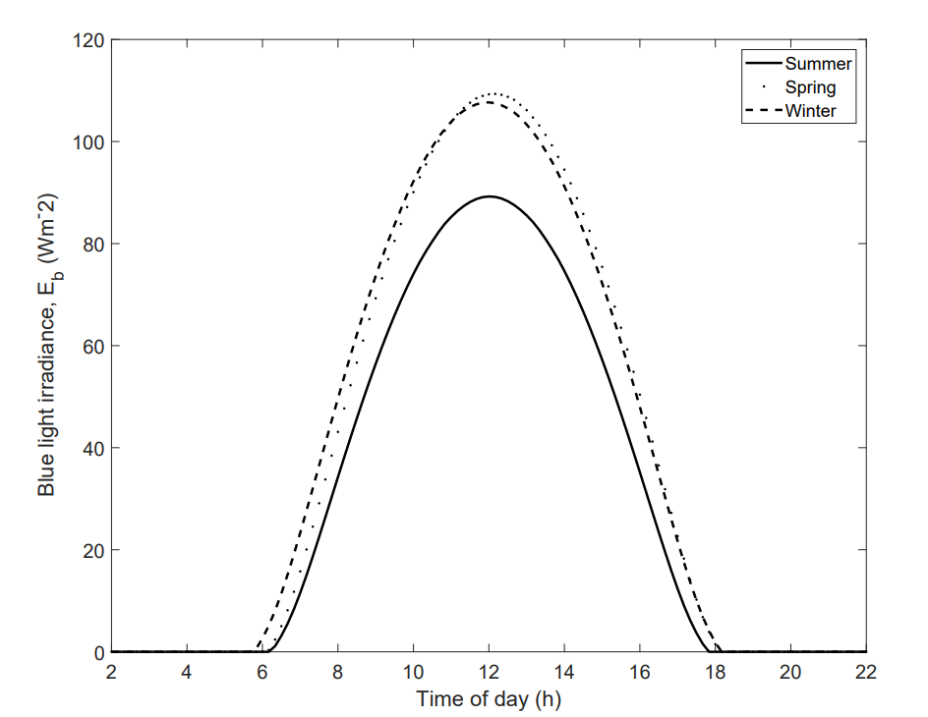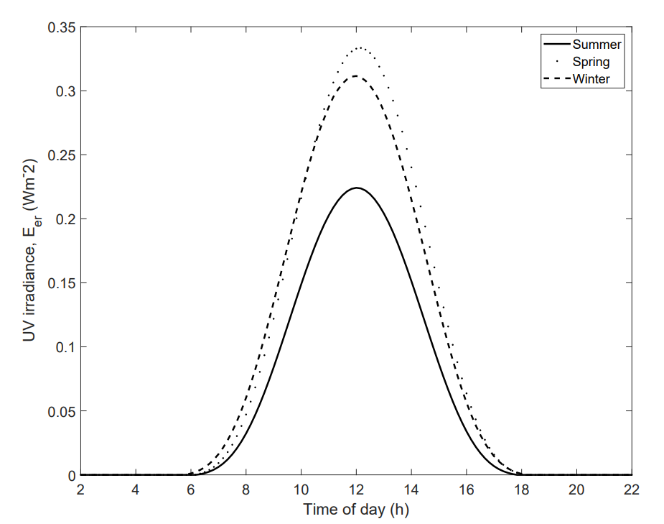
Dar es Salaam, E_{b} and E_{er} values
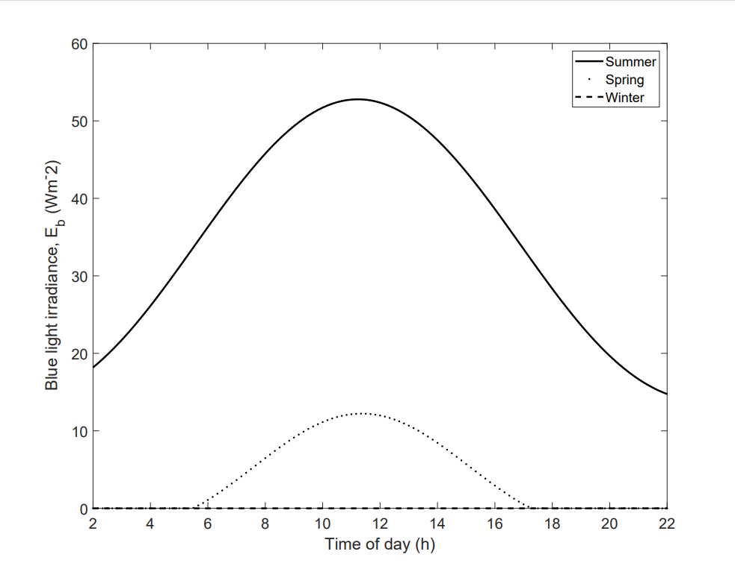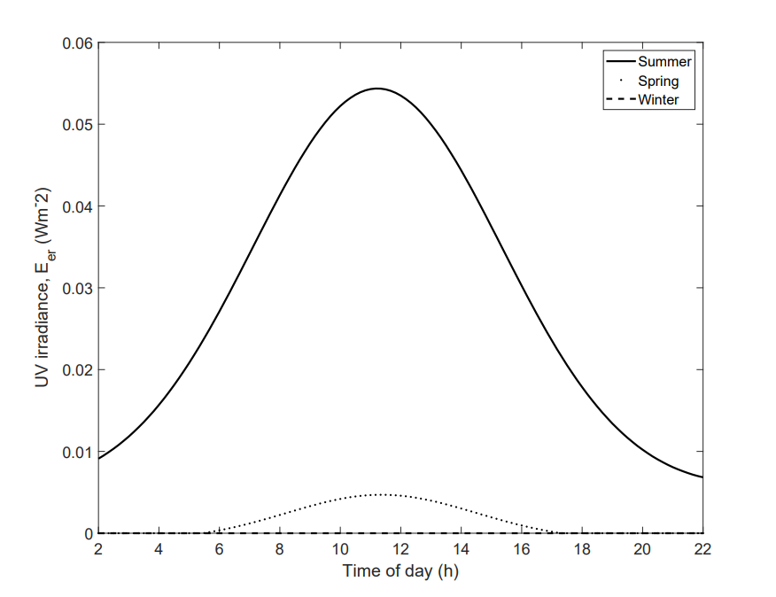
Ny Ålesund, E_{b} and E_{er} values

