Online resource 3: Ratio E_{b}/E₄₀₀₋₅₀₀
Title: Violet-blue light exposure of the skin: is there need for protection?
Journal: Photochemical Photobiological Sciences
Authors: Terje Christensen,^{a,b} Bjørn J. Johnsen ^{b} and Ellen M. Bruzell ^{c}
Affiliations: ªUniversity of South-Eastern Norway.
^{b}Norwegian Radiation and Nuclear Safety Authority
^{c}Nordic Institute of Dental Materials (NIOM)
Corresponding author e-mail: terje.christensen222@gmail.com 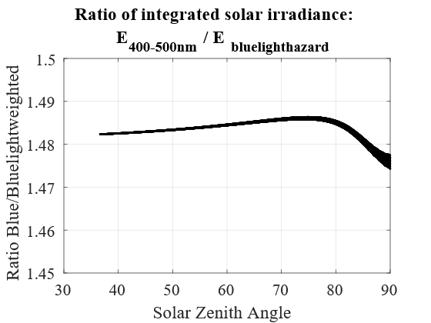
The ratio between un-weighted global irradiance between 400 and 500 nm, E₄₀₀₋₅₀₀, and irradiance weighted with the blue light hazard weighting function, E_{b} as a function of the solar zenith angle.

