Supporting Information
Photoredox Catalysis Powered by Triplet Fusion Upconversion: Arylation of Heteroarenes

Jorge Castellanos-Soriano, Daniel Álvarez-Gutiérrez, M. Consuelo Jiménez and Raúl Pérez-Ruiz*
Departamento de Química, Universitat Politècnica de València, Camino de Vera s/n, 46022, Valencia, Spain.
Email: raupreru@qim.upv.es

Table of contents

This page………………………………………………………………….………….… | 1
Figure S1 and Equations S1-S2…………………………………………..………... | 2
Figures S2 & S3…………………...…………………………………………………… | 3
Figure S4………………………………………………………………………………… | 4
Table S1…………………………………………………………………………………. | 5
Figure S5………………………………………………………………………………… | 6
Figure S6………………………………………………………………………………… | 7
Figure S7………………………………………………………………………………… | 8
Compound characterization…………………………………………………………. | 9
NMR copies……………………………………………………………………………... | 18
GC copies….....……………………………………………………………………........ | 41
HRMS copies…………………………………………………………………………… | 46

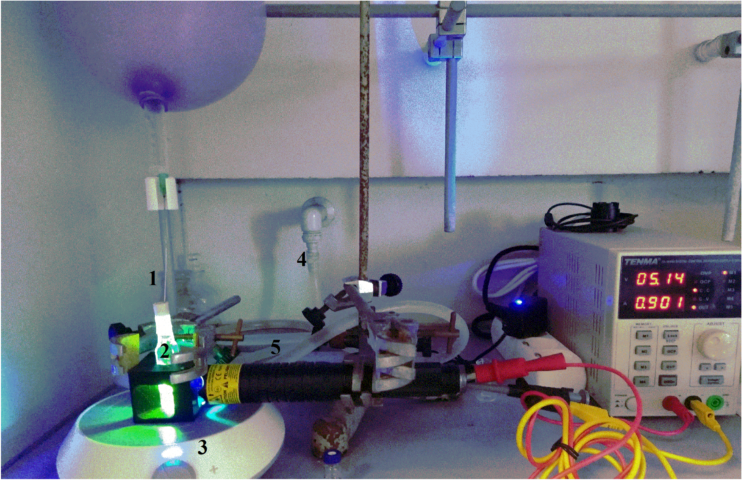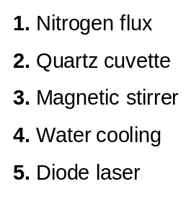
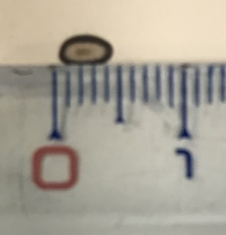
Figure S1. Set-up for the photochemical reaction. Photograph of the photocatalytic coupling reaction by TFU methodology in batch process. Constant reaction temperature was ensured using a water-cooling. The blue diode laser pointer with a real power of 2000 mW (λ_{exc} = 445 ± 10 nm, beam diameter of 5 mm x 3 mm, intensity of 1.64 mJ/cm²) has been purchased from ®TorLaser.

Equations for the Stern-Volmer analysis:
ϕ₀/ ϕ = 1 + K_{SV} ∙[quencher] eq S1
K_{SV} = τ_{F} ∙k_{q}(S₁) eq S2

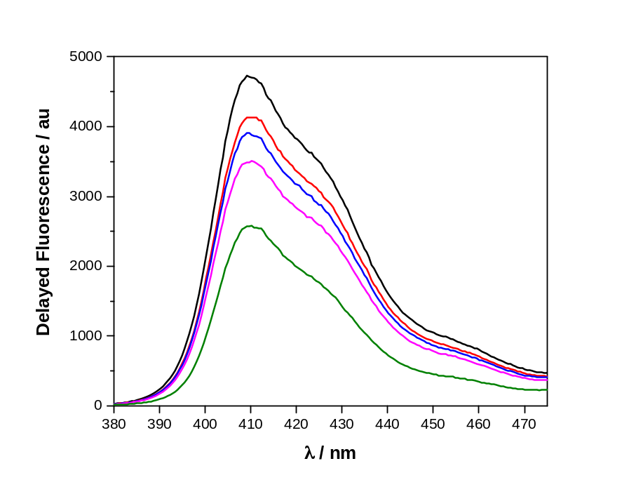
Figure S2. Delayed fluorescence spectra of a mixture of BOPHY (0.1 mM) and DPA (1 mM) in degassed ACN/DMA (4/1 v/v) after excitation with a pulsed laser (λ_{exc} = 485 nm) recorded 1 μs after the laser pulse in the presence of increasing amounts of 4-bromoacetophenone 1a (0 mM black, 2.7 mM red, 5 mM blue, 10 mM magenta and 17 mM green).
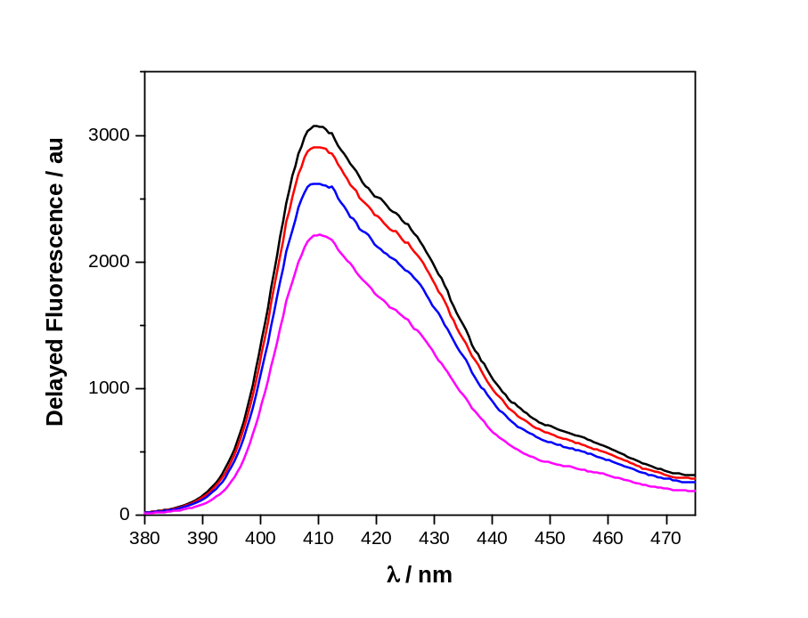
Figure S3. Delayed fluorescence spectra of a mixture of BOPHY (0.1 mM) and DPA (1 mM) in degassed ACN/DMA (4/1 v/v) after excitation with a pulsed laser (λ_{exc} = 485 nm) recorded 1 μs after the laser pulse in the presence of increasing amounts of 4-bromobenzonitrile 1c (0 mM black, 1.7 mM red, 10 mM blue, 20 mM magenta).

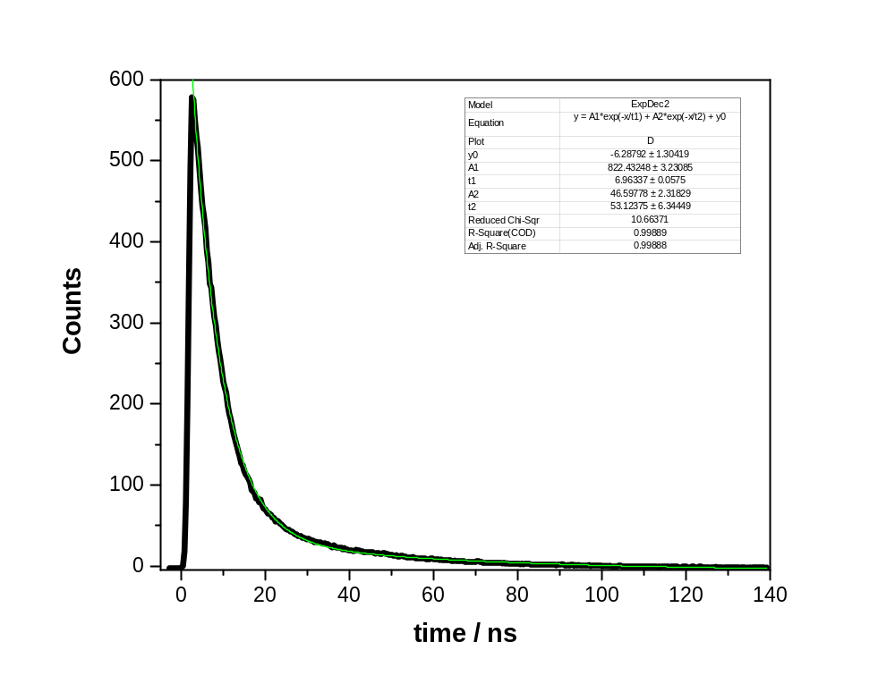
Figure S4. Fluorescence decay trace of 0.01 mM DPA (λ_{exc} = 372 nm) in ACN/DMA 4/1 v/v. The green line indicates the goodness of the lifetime measurement.

Table S1. Thermodynamic (ΔG) and kinetic (ΔG≠) data for the ET and BET processes based on DFT calculations. Collected data from reference 10e of the main text.
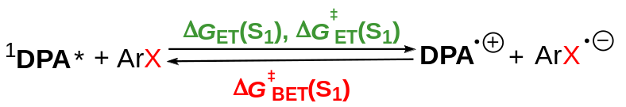
Substrate | E_{red} (V) SCEª | ΔG_{ET}(S₁) kJ/mol^{b} | ΔG_{ET}(T₁) kJ/mol^{b} | λ kJ/mol | ΔG≠_{ET} (S₁) kJ/mol | ΔG≠_{BET} (S₁) kJ/mol^{c}
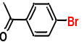 | 1.51 | −16.6 | 102.84 | 24.27 | 0.69 | 16.66
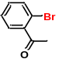 | 1.57 | −10.9 | 108.57 | 35.29 | 4.36 | 14.83
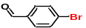 | 1.36 | −0.25 | 88.53 | 22.32 | 0.61 | 30.31
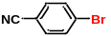 | 1.76 | 7.33 | 126.80 | 17.95 | 8.69 | 1.66
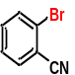 | 1.69 | 0.76 | 120.24 | 21.03 | 5.63 | 4.90
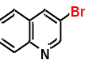 | 1.62 | −5.84 | 113.63 | 12.47 | 0.94 | 6.55
ªReduction potentials of the substrates according to DFT calculations; ^{b}values of free energy changes (ΔG) obtained by DFT calculations taking into account E_{red}^{(DPA)} = −1.38 V vs SCE; E_{S} = 3.0564 eV; E_{T} = 1.8119 eV.

Conversion and product formation over laser pointer power
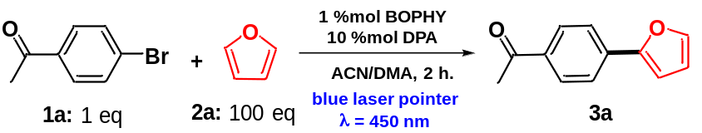
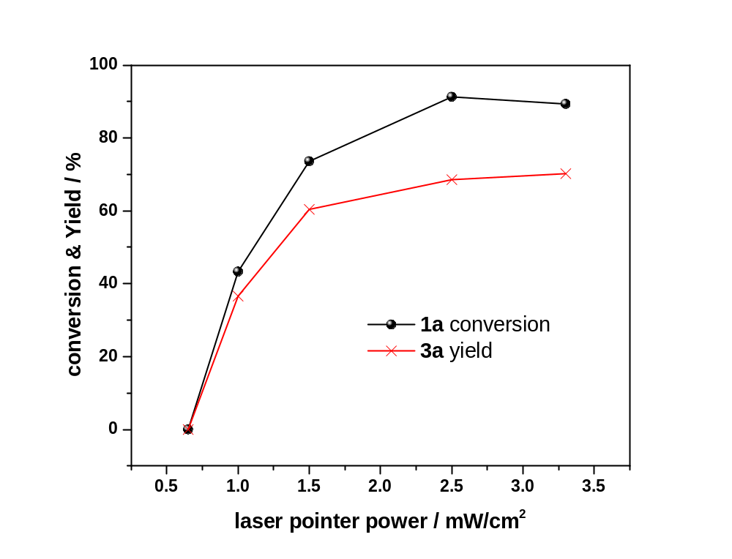
Figure S5. Relationship between 1a conversion or 3a yield versus laser pointer power.

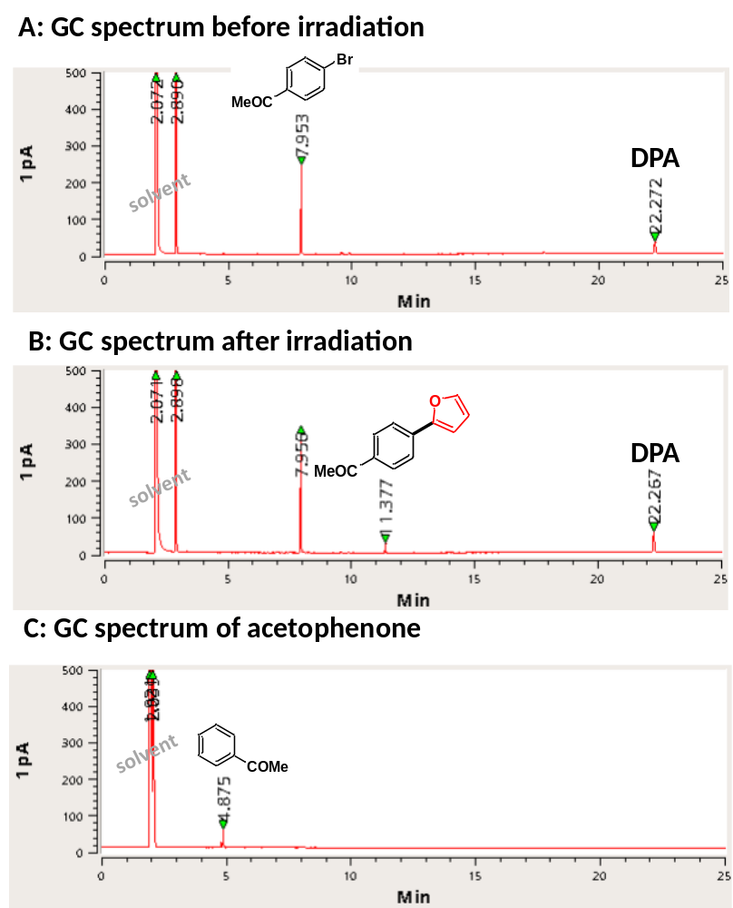

Figure S6. GC spectra of the gram-scale irradiation of 4-bromoacetophenone and furan in the presence of catalytic amounts of TFU system (BOPHY/DPA) under continuous-flow setting. A: before irradiation; B: after irradiation; C: GC spectrum of the photoreduced by-product acetophenone

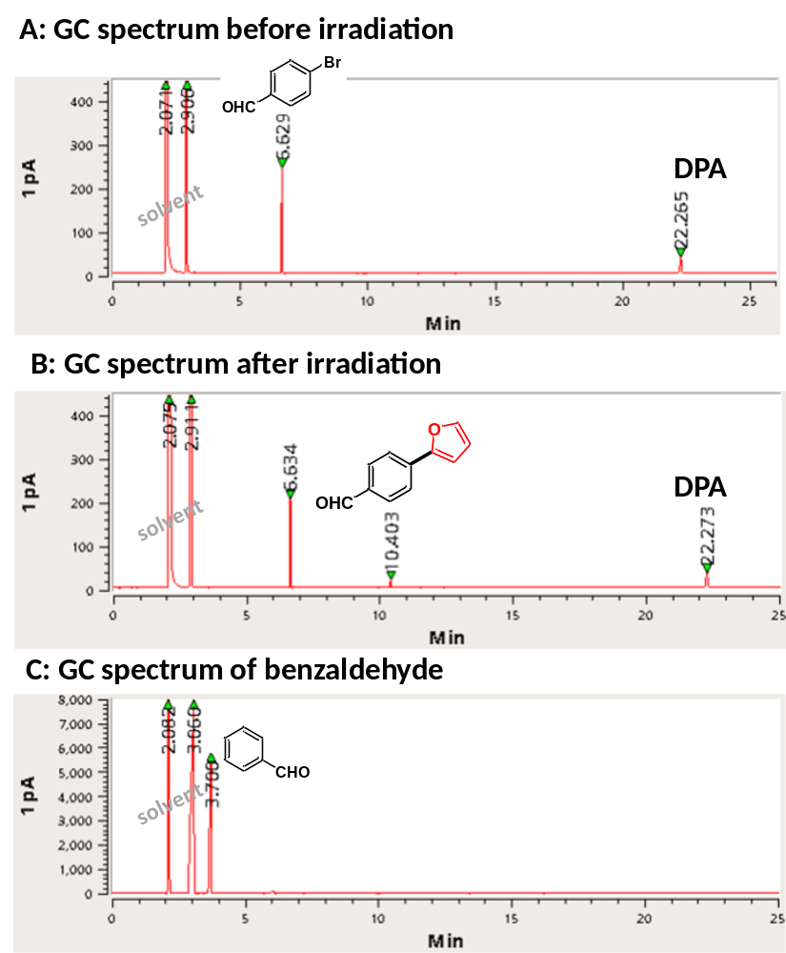

Figure S7. GC spectra of the gram-scale irradiation of 4-bromoacetophenone and furan in the presence of catalytic amounts of TFU system (BOPHY/DPA) under continuous-flow setting. A: before irradiation; B: after irradiation; C: GC spectrum of the photoreduced by-product benzaldehyde.

Compound characterization
1-[4-(Furan-2-yl)phenyl]ethanone (3a)
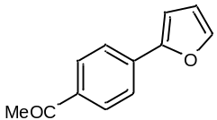The compound was prepared according to the general procedure described in the main text using 4-bromoacetophenone 1a (5.6 mg, 30 µmol, 1.0 equiv.) as aryl halide and furan 2a (220 µL, 3 mmol, 100 equiv.) as trapping agent. The reaction mixture was irradiated for 2 hours, obtaining 70% of GC yield and 55% of isolated yield. Conversion of 1a was 90% with a 78% selectivity.
¹H NMR (CDCl₃, 400 MHz): δ 7.97 (d, 2H, J=8.4 Hz), 7.76 (d, 2H, J=8.4 Hz), 7.53 (d, 1H, J=1.7 Hz), 6.80 (d, 1H, J=3.4 Hz), 6.52 (dd, 1H, J=1.7, 3.4 Hz), 2.61 (3H, s); ¹³C NMR (CDCl₃, 101 MHz): δ 197.3, 152.8, 143.2, 135.5, 134.8, 128.9, 123.5, 112.0, 107.4, 26.5 ppm; HRMS (EI): m/z (M+H)⁺ = calcd. for C₁₂H₁₁O₂: 187.0759; found: 187.0755.
This compound was already described, and spectral data were consistent with literature (see for instance: Eur. J. Org. Chem. 2015, 8, 1727–1734)

Scaling-up procedure: Reagent 4-bromoacetophenone 1a (1 g, 5 mmol, 1.0 equiv.), furan 2a (36 mL, 500 mmol, 100 equiv.), DPA (165 mg, 0.5 mmol, 0.1 equiv.), BOPHY (29.5 mg, 0.05 mmol, 0.01 equiv.) and 50 mL of ACN/DMA (4/1 v/v) were placed in a 100 mL sealed flask with a magnetic bar. The tap flask contains four connection ports that allowed the reaction being carried out under constant N₂ atmosphere and driving the mixture to a continuous flux. The reaction mixture was irradiated for 15 hours with an external diode laser pointer (λ_{exc} = 445 nm ± 10) through one face of the cuvette. For isolation purposes, water (25 mL) was added, and the aqueous phase was extracted with ethyl acetate (3×25 mL). The combined organic phases were washed with brine (25 mL), dried over magnesium sulphate, filtered from the drying agent, and concentrated in vacuum. The crude product was purified by silica gel chromatography using hexane:ethyl acetate (from 99/01 to 80/20 v/v) as eluent, obtaining 228 mg of 3a as a yellow-pale solid.

4-(Furan-2-yl)benzaldehyde (3b)
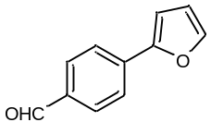The compound was prepared according to the general procedure described in the main text using 4-bromobenzaldehyde 1b (5.6 mg, 30 µmol, 1.0 equiv.) as aryl halide and furan (220 µL, 3 mmol, 100 equiv.) as trapping agent. The reaction mixture was irradiated for 2 hours, obtaining 75% of GC yield and 60% isolated yield. Conversion of 1b was 92% with 82% selectivity.
¹H NMR (CD₃CN, 400 MHz): δ 9.90 (s, 1H), 7.94-7.92 (d, J=8.3Hz, 2H), 7.89-7.87 (d, J=8.3Hz, 2H), 7.66 (m, 1H), 7.00 (m, 1H), 6.61-6.60 (m, 1H); ¹³C NMR (CDCl₃, 101 MHz): δ 191.6, 152.6, 143.6, 136.1, 134.9, 130.4, 123.9, 112.2, 108.1.
This compound was already described, and spectral data were consistent with literature (see for instance: J. Org. Chem. 2009, 74, 973–980).

Scaling-up procedure: Reagent 4-bromobenzaldehyde 1b (1 g, 5.4 mmol, 1.0 equiv.), furan 2a (39 mL, 540 mmol, 100 equiv.), DPA (178 mg, 0.54 mmol, 0.1 equiv.) and BOPHY (21.8 mg, 0.054 mmol, 0.01 equiv.) were dissolved in 50 mL of ACN/DMA (4/1 v/v) and placed in a 100 mL sealed flask with a magnet. The tap flask had four connection ports that allowed the reaction being carried out under constant N₂ atmosphere and driving the mixture to a continuous flux. The reaction mixture was irradiated for 15 hours with an external diode laser pointer (λ_{exc} = 445 nm ± 10) through one face of the cuvette. For isolation purposes, water (25 mL) was added, and the aqueous phase was extracted with ethyl acetate (3×25 mL). The combined organic phases were washed with brine (25 mL), dried over magnesium sulphate, filtered from the drying agent, and concentrated in vacuum. The crude product was purified by silica gel chromatography using hexane:ethyl acetate (from 99/01 to 80/20 v/v) as eluent. Thus, 285 mg of 3g as a yellow-pale solid were obtained.

4-(Furan-2-yl)benzonitrile (3c)
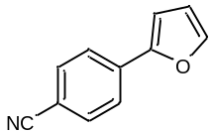The compound was prepared according to the general procedure described in the main text using 4-bromobenzonitrile 1c (5.5 mg, 30 µmol, 1.0 equiv.) as aryl halide and furan (220 µL, 3 mmol, 100 equiv.) as trapping agent. The reaction mixture was irradiated for 2 hours, obtaining 25% of GC yield. Conversion of 1c was 25% with 100% selectivity.
¹H NMR (CDCl₃, 400 MHz): δ 6.53 (1 H, dd, J=3.4, 1.7 Hz), 6.81 (1 H, d, J = 3.6 Hz,), 7.54 (1 H, d, J = 3.6 Hz), 7.67 (2 H, d, J = 8.2 Hz), 7.74 (2 H, d, J = 8.2 Hz); ¹³C NMR (101 MHz, CDCl3): δ 151.9, 143.6, 134.5, 132.5, 123.8, 118.9, 112.2, 110.1, 108.1 ppm; HRMS (EI): m/z (M+H)⁺ = calcd. for C₁₁H₈NO: 170.0606; found: 170.0608.

1-(2-(Furan-2-yl)phenyl)ethanone (3d)
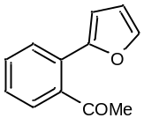The compound was prepared according to the general procedure described in the main text using 2-bromoacetophenone (5.6 mg, 30 µmol, 1.0 equiv.) as aryl halide and furan (220 µL, 3 mmol, 100 equiv.) as trapping agent. The reaction mixture was irradiated for 2 hours, obtaining 22% of GC yield and 15% isolated yield. Conversion of 2-bromoacetophenone was 60% with 37% selectivity.
¹H NMR (CDCl₃, 400 MHz): δ 7.59-7.55 (d, J=7.6. Hz, 1H), 7.52-7.35 (m, 4H), 6.59 (d, J = 3.4 Hz, 1H), 6.51 (dd, J = 3.4, 1.8 Hz, 1H), 2.26 (s, 3H). ¹³C NMR (101 MHz, CDCl₃): δ 204.83, 152.50, 143.30, 130.45, 128.23, 127.81, 127.27, 112.11, 108.55, 29.98 ppm; HRMS (EI): m/z (M+H)⁺ = calcd. for C₁₂H₁₀O₂: 187.0754; found: 187.0751.

2-(Furan-2-yl)benzaldehyde (3e)
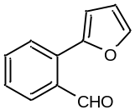The compound was prepared according to the general procedure described in the main text using 2-bromobenzaldehyde (5.6 mg, 30 µmol, 1.0 equiv.) as aryl halide and furane (220 µL, 3 mmol, 100 equiv.) as trapping agent. The reaction mixture was irradiated for 2 hours, obtaining 66% of GC yield. Conversion of 2-bromoabenzaldehyde was 79% with 84% selectivity. Compound purification for characterization was carried out by HPLC.
¹H NMR (CDCl₃, 400 MHz); δ 10.26 (s, 1H), 7.84 (dd, J = 7.9, 1.4 Hz, 1H), 7.71 – 7.55 (m, 3H), 7.42 (t, J = 7.5 Hz, 1H), 6.71 (d, J = 3.4 Hz, 1H), 6.55 (dd, J = 3.4, 1.8 Hz, 1H). ¹³C (101 MHz, CDCl₃): δ 192.7, 151.6, 145.1, 134.3, 133.7, 133.6, 129.0, 128.8, 128.3, 117.9, 112.6, 111.9. HRMS (EI): m/z (M+H)⁺ = calcd. for C₁₁H₈O₂: 173.0597; found: 173.0587.

2-(Furan-2-yl)benzonitrile (3f)
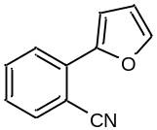The compound was prepared according to the general procedure described in the main text using 2-bromobenzonitrile (5.5 mg, 30 µmol, 1.0 equiv.) as aryl halide and furan (220 µL, 3 mmol, 100 equiv.) as trapping agent. The reaction mixture was irradiated for 3 hours, obtaining 47% of GC yield. Conversion of 2-bromobenzonitrile was 47% with 100% selectivity. Compound purification for characterization was carried out by HPLC.
¹H NMR (CDCl₃, 400 MHz); δ 7.91-7.89 (1H), 7.71-7.69 (1H), 7.64-7.60 (1H), 7.57 (1H), 7.35-7.32 (1H), 6.56 (1H).
This product is commercially available and spectral data were consistent with literature data (see for instance: J. Chem. Soc., Perkin Trans. 2, 1994, 247-252).

2-(4-Acetylphenyl)furan-5-carbonitrile (3g)
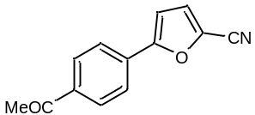The compound was prepared according to the general procedure described in the main text using 4-bromoacetophenone 1a (5.6 mg, 30 µmol, 1.0 equiv.) as aryl halide and 2-furanitrile (258 µL, 3 mmol, 100 equiv.) as trapping agent. The reaction mixture was irradiated for 2 hours, obtaining 32% of GC yield and 25% of isolated yield. Conversion of 1a was 84% with a 36% selectivity.
¹H NMR (CDCl₃, 400 MHz): δ 8.03 (2 H, d, J = 8.2 Hz), 7.81 (2 H, d, J = 8.2 Hz), 7.21 (1 H, d, J = 3.6 Hz), 6.87 (1 H, d, J = 3.6 Hz), 2.64 (3 H, s).
This compound was already described, and spectral data were consistent with literature (see for instance: New J. Chem. 2015, 39, 5171-5179).

Methyl 5-(4-acetylphenyl)furan-2-carboxylate (3h).
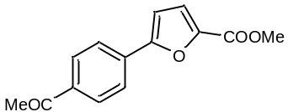The compound was prepared according to the general procedure described in the main text using 4-bromoacetophenone 1a (5.6 mg, 30 µmol, 1.0 equiv.) as aryl halide and methyl furan-2-carboxylate (320 µL, 3 mmol, 100 equiv.) as trapping agent. The reaction mixture was irradiated for 2 hours, obtaining 47% of GC yield. Conversion of 1a was 83% with a 57% selectivity. Compound purification for characterization was carried out by HPLC.
¹H NMR (CDCl₃, 400 MHz): δ 8.0 (d, J = 8.4 Hz, 2H), 7.88 (d, J = 8.4 Hz, 2H), 7.27 (d, J = 3.9 Hz, 1H), 6.88 (d, J = 3.9 Hz, 1H), 3.94 (s, 3H), 2.63 (s, 3 H). ¹³C NMR (CD₃CN, 101 MHz): δ 186.08, 166.02, 155.76, 155.74, 151.99, 132.73, 129.73, 124.23, 118.81, 108.79, 51.9, 25.62; HRMS (EI): m/z (M+H)⁺ = calcd. for C₁₄H₁₂O₄: 245.0808; found: 245.0805.

1-(4-(5-Acetylfuran-2-yl)phenyl)ethanone (3i)
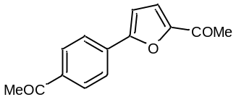The compound was prepared according to the general procedure described in the main text using 4-bromoacetophenone 1a (5.6 mg, 30 µmol, 1.0 equiv.) as aryl halide and 2-acetylfuran (300 µL, 3 mmol, 100 equiv.) as trapping agent. The reaction mixture was irradiated for 2 hours, obtaining 50% of GC yield. Conversion of 1a was 83% with a 57% selectivity. Compound purification for characterization was carried out by HPLC.
¹H NMR (CDCl₃, 400 MHz): δ 7.98 (d, J = 8.9 Hz, 2H), 7.84 (d, J = 8.9 Hz, 2H), 7.24 (d, J = 3.6 Hz, 1H), 6.88 (d, J = 3.9 Hz, 1H), 2.60 (s, 3H), 2.52 (s, 3 H). ¹³C NMR (CDCl₃, 101 MHz): δ 197.3, 186.5, 156.1, 152.5, 136.9, 133.3, 128.9, 124.9, 119.3, 109.4, 26.7, 26.1 ppm; HRMS (EI): m/z (M+H)⁺ = calcd. for C₁₄H₁₃O₃: 229.0859; found: 229.0854.
This compound was already described, and spectral data were consistent with literature (see for instance: Org. Lett. 2012, 14, 21, 5534–5537).

1-(4-(5-Ethylfuran-2-yl)phenyl)ethanone (3j)
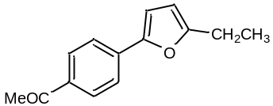The compound was prepared according to the general procedure described in the main text using 4-bromoacetophenone 1a (5.6 mg, 30 µmol, 1.0 equiv.) as aryl halide and 2-ethylfuran (316 µL, 3 mmol, 100 equiv.) as trapping agent. The reaction mixture was irradiated for 2 hours, obtaining 50% of GC yield and 45% isolated yield. Conversion of 1a was 81% with a 62% selectivity.
¹H NMR (CD₃CN, 400 MHz): δ 7.98 (d, J = 8.9 Hz, 2H), 7.75 (d, J = 8.9 Hz, 2H), 6.85 (d, J = 3.6 Hz, 1H), 6.20 (d, J = 3.9 Hz, 1H), 2.76-2.70 (q, J=7.5 Hz, 2H), 2.55 (s, 3H), 1.29-1.25 (t, J=7.6Hz, 3 H). ¹³C NMR (CD₃CN, 101 MHz): δ 198.1, 148.9, 145.6, 136.2, 135.9, 129.9, 123.8, 109.8, 107.9, 26.9, 22.1, 12.4; HRMS (EI): m/z (M+H)⁺ = calcd. for C₁₄H₁₄O₃: 215.1067; found: 215.1062.

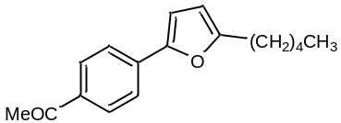1-(4-(5-Pentylfuran-2-yl)phenyl)ethanone (3k)
The compound was prepared according to the general procedure described in the main text using 4-bromoacetophenone 1a (5.6 mg, 30 µmol, 1.0 equiv.) as aryl halide and 2-pentylfuran (467 µL, 3 mmol, 100 equiv.) as trapping agent. The reaction mixture was irradiated for 2 hours, obtaining 38% of GC yield. Conversion of 1a was 73% with a 53% selectivity. Compound purification for characterization was carried out by HPLC.
¹H NMR (CDCl₃, 400 MHz): δ 7.96 (d, J = 8.7 Hz, 2H), 7.70 (d, J = 8.7 Hz, 2H), 6.70 (d, J = 3.3 Hz, 1H), 6.11 (d, J = 3.0 Hz, 1H), 2.69 (t, J =7.5 Hz, 2H), 2.60 (s, 3H), 1.70 (p, J = 2.5 Hz, 2H), 1.37 (p., J = 3.7 Hz, 4H), 0.91 (m, 3H). ¹³C NMR (CD₃CN, 101 MHz): δ 198.1, 159.1, 149.8, 136.2, 129.9, 123.8, 122.1, 109.8, 108.7, 32.0, 28.6, 28.4, 26.7, 23.0, 14.2. HRMS (EI): m/z (M+H)⁺ = calcd. for C₁₇H₂₀O₂: 257.1532; found: 257.1544.

4-(5-Pentylfuran-2-yl)benzonitrile (3l)
The compound was prepared according to the general procedure described in the main text using 4-bromobenzonitrile 1c (5.5 mg, 30 µmol, 1.0 equiv.) as aryl halide and 2-pentylfuran (467 µL, 3 mmol, 100 equiv.) as trapping agent. The reaction mixture was irradiated for 2 hours, obtaining 20% of GC yield.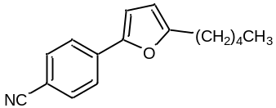 Conversion of 1c was 20% with 100% selectivity. Compound purification for characterization was carried out by HPLC.
¹H NMR (CDCl3, 400 MHz); δ 7.62 (d, J = 8.3 Hz, 2H), 7.55 (d, J = 8.3 Hz, 2H), 6.64 (d, J = 3.3 Hz, 1H), 6.05 (d, J = 3.4 Hz, 1H), 2.62 (t, J = 7.6 Hz, 2H), 1.70 – 1.56 (m, 2H), 1.49 – 1.20 (m, 4H), 0.83 (m, 3H); HRMS (EI): m/z (M+H)⁺ = calcd. for C₁₆H₁₇NO: 240.1383, found: 240.1384.

1-(2-(5-Acetylfuran-2-yl)phenyl)ethanone (3m)
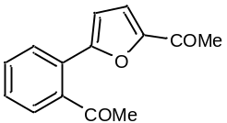The compound was prepared according to the general procedure described in the main text using 2-bromoacetophenone (5.6 mg, 30 µmol, 1.0 equiv.) as aryl halide and 2-acetylfuran (300 µL, 3 mmol, 100 equiv.) as trapping agent. The reaction mixture was irradiated for 3 hours, obtaining 23% of GC yield. Conversion of 2-bromoacetophenone was 50% with 46% selectivity. Compound purification for characterization was carried out by HPLC.
¹H NMR (CDCl₃, 400 MHz): δ 7.74-7.72 (d, J=8.1 Hz, 1H), 7.60-7.54 (m, 3H), 7.33 (d, J = 3.8 Hz, 1H), 6.84 (d, J = 3.8 Hz, 1H), 2.41 (s, 3H), 2.38 (s, 3H). ¹³C (101 MHz, CDCl₃): δ 197.42, 186.97, 156.31, 153.54, 131.46, 130.39, 129.38, 128.22, 124.76, 122.52, 120.07, 111.29, 30.40, 29.99 ppm; HRMS (EI): m/z (M+H)⁺ = calcd. for C₁₄H₁₂O₃: 229.0859; found: 229.0855.

5-(2-Cyanophenyl)furan-2-carbonitrile (3n)
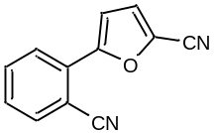The compound was prepared according to the general procedure described in the main text using 2-bromobenzonitrile (5.5 mg, 30 µmol, 1.0 equiv.) as aryl halide and 2-furonitrile (258 µL, 3 mmol, 100 equiv.) as trapping agent. The reaction mixture was irradiated for 3 hours, obtaining 23% of GC yield. Conversion of 2-bromobenzonitrile was 23% with 100% selectivity. Compound purification for characterization was carried out by HPLC.
¹H NMR (CD₃CN, 400 MHz): δ 7.96 (d, J = 1.2 Hz, 1H), 7.86 (d, J = 1.1 Hz, 1H), 7.78 (t, J = 7.6 Hz, 3H), 7.58 (t, J = 7.7 Hz, 2H), 7.44 (d, J = 3.8 Hz, 2H), 7.33 (d, J = 3.8 Hz, 2H).
This compound was already described, and spectral data were consistent with literature data (see for instance: Green Chem. 2009, 11, 1832-1846).

3-(Furan-2-yl)quinoline (3o)
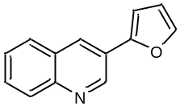The compound was prepared according to the general procedure described in the main text using 3-bromoquinoline (4.2 µL, 30 µmol, 1.0 equiv.) as aryl halide and furan (220 µL, 3 mmol, 100 equiv.) as trapping agent. The reaction mixture was irradiated for 2 hours, obtaining 35% of GC yield. Conversion of 3-bromoquinoline was 44% with 80% selectivity. Compound purification for characterization was carried out by HPLC.
¹H NMR (CDCl₃, 400 MHz): δ 9.23 (s, 1H), 8.38 (s, 1H), 8.08 (d, J = 8.2 Hz, 1H), 7.87 (d, J = 8.3 Hz, 1H), 7.71–7.69 (m, 2H), 7.56–7.53 (m, 1H), 6.89 (d, J = 3.4 Hz, 1H), 6.57–6.55 (m, 1H).
This compound was already described, and spectral data were consistent with literature data (see for instance: Adv. Synth. Catal., 2010, 18, 3255-3266).

2-(Furan-2-yl)quinoline (3p)
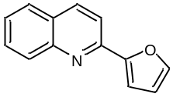The compound was prepared according to the general procedure described in the main text using 2-bromoquinoline (4.2 µL, 30 µmol, 1.0 equiv.) as aryl halide and furan (220 µL, 3 mmol, 100 equiv.) as trapping agent. The reaction mixture was irradiated for 2 hours, obtaining 30% of GC yield. Conversion of 2-bromoquinoline was 38% with 80% selectivity. Compound purification for characterization was carried out by HPLC.
¹H NMR (CD₃CN, 400 MHz): δ 8.31 (d, J = 8.6 Hz, 1H), 8.00 (d, J = 8.5 Hz, 1H), 7.93 – 7.87 (m, J = 8.6 Hz, 2H), 7.74 (m, 2H), 7.55 (t, J = 7.5 Hz, 1H), 7.25 (d, J = 3.5 Hz, 1H), 6.72 – 6.61 (m, 1H).
This compound was already described, and spectral data were consistent with literature data (see for instance: J. Org. Chem. 2008, 73, 9778–9780).

1-(4-Thiophen-2-yl-phenyl)ethanone (5a)
The compound was prepared according to the general procedure described in the main text using 4-bromoacetophenone 1a (5.6 mg, 30 µmol, 1.0 equiv.) as aryl halide and thiophene (284 µL, 3.2 mmol, 120 equiv.) as trapping agent. The reaction mixture was irradiated for 3 hours, obtaining 47% of GC yield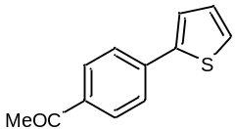. Conversion of 1a was 61% with 47% selectivity. Compound purification for characterization was carried out by HPLC.
¹H NMR (CDCl₃, 400 MHz): δ 7.96 (d, 2H, J=8.3 Hz), 7.69 (d, 2H, J=8.3 Hz), 7.42 (d, 1H, J=3.6 Hz), 7.37 (d, 1H, J=4.8 Hz), 7.12 (dd, 1H, J=4.8, 3.6 Hz), 2.60 (3H, s); ¹³C NMR (CDCl₃, 101 MHz): δ 197.5, 143.1, 138.9, 135.9, 129.3, 128.5, 126.6, 125.8, 124.8, 26.7 ppm; HRMS (EI): m/z (M+H)⁺ = calcd. For C₁₂H₁₁OS: 203.0531; found: 203.0533.

4-(Thiophen-2-yl)benzaldehyde (5b)
The compound was prepared according to the general procedure described in the main text using 4-bromobenzaldehyde 1b (5.6 mg, 30 µmol, 1.0 equiv.) as aryl halide and thiophene (284 µL, 3.2 mmol, 120 equiv.) as trapping agent. The reaction mixture was irradiated for 3 hours, obtaining 37% of GC yield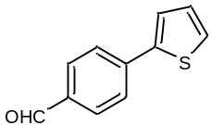 of pale-yellow product. Conversion of 1b was 80% with 47% selectivity. Compound purification for characterization was carried out by HPLC.
¹H NMR (CD₃CN, 400 MHz): δ 9.99 (s, 1H), 7.92 (d, J = 8.6 Hz, 2H), 7.86 (d, J = 8.6 Hz, 2H), 7.59 (dd, J = 3.7 Hz, 1.5 Hz 1H), 7.53 (d, J = 5.1 Hz, 1.5Hz, 1H), 7.21 – 7.14 (m, 1H).
This compound was already described, and spectral data were consistent with literature data (see for instance: Eur. J. Inorg. Chem, 2010, 19, 2998-3004).

4-(Thiophen-2-yl)benzonitrile (5c)
The compound was prepared according to the general procedure described in the main text using 4-bromobenzonitrile 1c (5.6 mg, 30 µmol, 1.0 equiv.) as aryl halide and thiophene (284 µL, 3.2 mmol, 120 equiv.) as trapping agent. The reaction mixture was irradiated for 3 hours, obtaining 26% of GC yield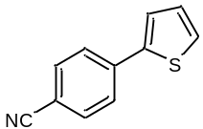. Conversion of 1c was 26% with 100% selectivity. Compound purification for characterization was carried out by HPLC.
¹H NMR (CD₃CN, 400 MHz): δ 7.81 (d, J = 8.4 Hz, 1H), 7.74 (d, J = 8.5 Hz, 1H), 7.57 (d, J = 3.7 Hz, 1H), 7.53 (d, J = 5.0 Hz, 1H), 7.17 (m, 1H).
This compound was already described, and spectral data were consistent with literature data (see for instance: Chem. Comm., 2011, 47, 1872–1874).

1-(2-(Thiophen-2-yl)phenyl)ethanone (5d)
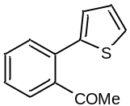The compound was prepared according to the general procedure described in the main text using 2-bromoacetophenone (4.13 µL, 30 µmol, 1.0 equiv.) as aryl halide and thiophene (284 µL, 3.2 mmol, 120 equiv.) as trapping agent. The reaction mixture was irradiated for 3 hours, obtaining 23% of GC yield. Conversion of 2-bromoacetophenone was 92% with 25% selectivity. Compound purification for characterization was carried out by HPLC.
¹H NMR (CDCl₃, 400 MHz): δ 7.48-7.47 (m, 3H,), 7.39-7.42 (m, 2H), 7.09-7.07 (m, 1H), 7.0-7.01 (m, 1H), 2.14 (s, 3H). HRMS (EI): m/z (M+H)⁺ = calcd. for C₁₂H₁₀OS: 203.0525, found: 203.0526.

2-(Thiophen-2-yl)benzaldehyde (5e)
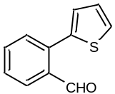The compound was prepared according to the general procedure described in the main text using 2-bromobenzaldehyde (5.6 mg, 30 µmol, 1.0 equiv.) as aryl halide and thiophene (284 µL, 3.2 mmol, 120 equiv.) as trapping agent. The reaction mixture was irradiated for 3 hours, obtaining 40% of GC yield. Conversion of 2-bromoacetophenone was 92% with 44% selectivity. Compound purification for characterization was carried out by HPLC.
¹H NMR (CD₃CN, 400 MHz): δ 10.19 (s, 1H), 8.01 (d, J = 7.8 Hz, 1H), 7.67 – 7.45 (m, 3H), 7.17 (s, 1H), 7.08 (d, J = 3.0 Hz, 1H).
This compound was already described, and spectral data were consistent with literature data (see for instance: Org. Lett. 2011, 13, 5020-5023).

2-(Thiophen-2-yl)benzonitrile (5f)
The compound was prepared according to the general procedure described in the main text using 4-bromobenzonitrile (5.6 mg, 30 µmol, 1.0 equiv.) as aryl halide and thiophene (284 µL, 3.2 mmol, 120 equiv.) as trapping agent. The reaction mixture was irradiated for 3 hours, obtaining 32% of GC yield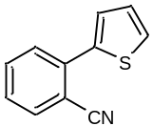. Conversion of 2-bromobenzonitrile was 40% with 80% selectivity. Compound purification for characterization was carried out by HPLC.
¹H NMR (CD₃CN, 400 MHz): δ 7.82 (dt, J = 7.8, 1.0 Hz, 1H), 7.69 (d, J = 4.2 Hz, 2H), 7.59 (dd, J = 4.2, 2.8 Hz, 2H), 7.49 (dt, J = 7.8, 4.4 Hz, 1H), 7.21 (dd, J = 5.1, 3.7 Hz, 1H).
This compound was already described, and spectral data were consistent with literature data (see for instance: Angew. Chem. Int. 2009, 48, 6731-6734).

1-(4-(5-Methylthiophen-2-yl)phenyl)ethanone (5g)
The compound was prepared according to the general procedure described in the main text using 4-bromoacetophenone 1a (5.6 mg, 30 µmol, 1.0 equiv.) as aryl halide and 2-methylthiophene (363 µL, 3.2 mmol, 120 equiv.) as trapping agent. The reaction mixture was irradiated for 3 hours, obtaining 28% of GC yield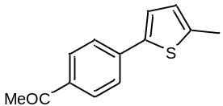. Conversion of 1a was 73% with 39% selectivity. Compound purification for characterization was carried out by HPLC
¹H NMR (CD₃CN, 400 MHz): δ 7.94 (d, J = 8.4 Hz, 2H), 7.62 (d, J = 8.4 Hz, 2H), 7.23 (d, J = 0.7 Hz, 1H), 6.95 – 6.68 (m, 1H), 2.60 (s, 3H), 2.53 (s, 3H).
This compound was already described, and spectral data were consistent with literature data (see for instance: Angew. Chem. Int. Ed. 2009, 48, 3644-3647).

1-(3-(4-Acetylphenyl)thiophen-2-yl)ethanone (5h)
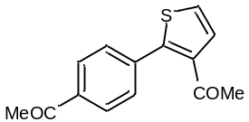The compound was prepared according to the general procedure described in the main text using 4-bromoacetophenone 1a (5.6 mg, 30 µmol, 1.0 equiv.) as aryl halide and 3-acetylthiophene (454mg, 3.2 mmol, 120 equiv.) as trapping agent. The reaction mixture was irradiated for 3 hours, obtaining 46% of yield. Conversion of 1a was 74% with 63% selectivity. Compound purification for characterization was carried out by HPLC.
¹H NMR (CD₃CN, 400 MHz): δ 7.99 (d, J = 8.2 Hz, 2H), 7.58 (d, J = 8.2 Hz, 2H), 7.51 (d, J = 5.4 Hz, 1H), 7.48 (d, J = 5.4 Hz, 1H), 2.60 (s, 3H), 2.34 (s, 3H)); ¹³C NMR (CD₃CN, 101 MHz): δ 198.43, 195.25, 148.16, 139.33, 137.97, 130.83, 130.60, 129.10, 126.77, 30.32, 27.06. HRMS (EI): m/z (M+H)⁺ = calcd. for C₁₄H₁₂O₂S: 245.0631; found: 245.0633.

4-(2-Acetylthiophen-3-yl)benzaldehyde (5i)
The compound was prepared according to the general procedure described in the main text using 4-bromobenzaldehyde 1b (5.6 mg, 30 µmol, 1.0 equiv.) as aryl halide and 3-acetylthiophene (454mg, 3.2 mmol, 120 equiv.) as trapping agent. The reaction mixture was irradiated for 3 hours, obtaining 43% of GC yield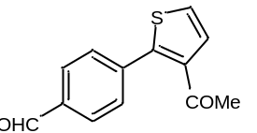. Conversion of 1b was 74% with 63% selectivity. Compound purification for characterization was carried out by HPLC.
¹H NMR (CD₃CN, 400 MHz): δ 9.97 (s, 1H), 7.85 (d, J = 8.1 Hz, 2H), 7.58 (d, J = 8.1 Hz, 2H), 7.44 (d, J = 5.3 Hz, 1H), 7.42 (d, J = 5.4 Hz, 1H). HRMS (EI): m/z (M+H)⁺ = calcd. for C₁₃H₁₀O₂S: 231.0474, found: 231.0477.

4-(2-Acetylthiophen-3-yl)benzonitrile (5j)
The compound was prepared according to the general procedure described in the main text using 4-bromobenzonitrile 1c (5.6 mg, 30 µmol, 1.0 equiv.) as aryl halide and 3-acetylthiophene (454mg, 3.2 mmol, 120 equiv.) as trapping agent. The reaction mixture was irradiated for 3 hours, obtaining 18% of GC yield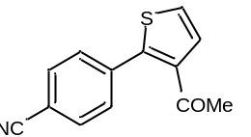. Conversion of 1c was 18% with 100% selectivity. Compound purification for characterization was carried out by HPLC.
¹H NMR (CD₃Cl, 400 MHz): δ 7.70 (d, J = 8.2 Hz, 3H), 7.58 (d, J = 8.3 Hz, 2H), 7.47 (d, J = 5.4 Hz, 1H), 7.38 (d, J = 5.5 Hz, 1H), 2.54 (s, 5H). HRMS (EI): m/z (M+H)⁺ = calcd. for C₁₃H₉NOS: 228.0478, found: 228.0476.

1-(2-(2-Acetylphenyl)thiophen-3-yl)ethanone (5k)
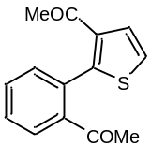The compound was prepared according to the general procedure described in the main text using 2-bromoacetophenone (4.13 µL, 30 µmol, 1.0 equiv.) as aryl halide and 3-acetylthiophene (454mg, 3.2 mmol, 120 equiv.) as trapping agent. The reaction mixture was irradiated for 3 hours, obtaining 17% of GC yield. Conversion of 2-bromoacetophenone was 78% with 22% selectivity. Compound purification for characterization was carried out by HPLC.
¹H NMR (CD₃CN, 400 MHz): δ 8.04 (dd, J = 2.7, 1.0 Hz, 1H), 7.82 – 7.63 (m, 1H), 7.37 – 7.30 (m, 2H), 7.18 (dd, J = 2.9, 1.3 Hz, 1H), 7.12 – 7.05 (m, 1H), 2.35 (s, 3H), 2.24 (s, 3H). HRMS (EI): m/z (M+H)⁺ = calcd. for C₁₄H₁₂O₂S: 245.0631, found: 245.0635.

5-(4-Acetylphenyl)thiophene-2-carbonitrile (5l) 3-(4-acetylphenyl)thiophene-2-carbonitrile (5l’)
The compound was prepared according to the general procedure described in the main text using 4-bromoacetophenone 1a (5.6 mg, 30 µmol, 1.0 equiv.) as aryl halide and 2-cyanothiophene (333 µL, 3.2 mmol, 120 equiv.) as trapping agent. The reaction mixture was irradiated for 3 hours, obtaining 41% of GC yield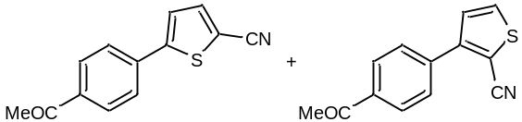. Conversion of 1a was 57% with 41% selectivity. Compound purification for characterization was carried out by HPLC.
¹H NMR (CD₃CN, 400 MHz): (5c) δ 8.08 (d, J = 8.2 Hz, 2H), 7.80 (d, J = 8.1 Hz, 2H), 7.66 (d, J = 5.1 Hz, 1H), 7.34 (d, J = 5.2 Hz, 1H), 2.65 (s, 3H); (5c’) δ 8.02 (d, J = 8.2 Hz, 2H), 7.70 (d, J = 8.3 Hz, 2H), 7.63 (d, J = 4.1 Hz, 1H), 7.39 (d, J = 4.1 Hz, 1H), 2.63 (s, 3H). ¹³C NMR (CD₃CN, 101 MHz): δ (5c) 201.8, 151.2, 140.9, 138.0, 137.4, 129.2, 128.2, 124.5, 116.0, 112.5, 29.9; (5c’) 200.3, 151.2, 138.6, 136.8, 136.5, 129.5, 126.6, 124.7, 113.9, 110.8, 29.9. HRMS (EI): m/z (M+H)⁺ = calcd. for C₁₃H₉NOS: 228.0478; found: 228.0479.
These compounds were already described, and spectral data were consistent with literature data (see for instance: Chem. Sus. Chem. 2008, 1, 404-407).

3-(Thiophen-2-yl)quinoline (5m)
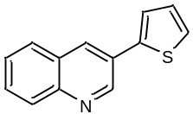The compound was prepared according to the general procedure described in the main text using 3-bromoquinoline (4.13 µL, 30 µmol, 1.0 equiv.) as aryl halide and 3-acetylthiophene (454mg, 3.2 mmol, 120 equiv.) as trapping agent. The reaction mixture was irradiated for 3 hours, obtaining 31% of GC yield. Conversion of 3-bromoquinoline was 50% with 62% selectivity. Compound purification for characterization was carried out by HPLC.
¹H NMR (CD₃CN, 400 MHz): δ 9.24 (s, 1H), 8.46 (s, 1H), 8.05 (d, J = 8.4 Hz, 1H), 7.95 (d, J = 8.2 Hz, 1H), 7.77 – 7.68 (m, 1H), 7.68 – 7.58 (m, 2H), 7.53 (d, J = 5.1 Hz, 1H), 7.22 (dd, J = 5.1, 3.6 Hz, 1H).
This compound was already described, and spectral data were consistent with literature data (see for instance: Tetrahedron, 2011, 67, 7090–7095).

2-(Thiophen-2-yl)quinoline (5n)
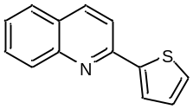 The compound was prepared according to the general procedure described in the main text using 2-bromoquinoline (4.13 µL, 30 µmol, 1.0 equiv.) as aryl halide and 3-acetylthiophene (454mg, 3.2 mmol, 120 equiv.) as trapping agent. The reaction mixture was irradiated for 3 hours, obtaining 29% of GC yield. Conversion of 3-bromoquinoline was 44% with 66% selectivity. Compound purification for characterization was carried out by HPLC.
¹H NMR (CD₃CN, 400 MHz): δ 8.29 (d, J = 8.7 Hz, 1H), 7.96 (dd, J = 8.7, 4.9 Hz, 2H), 7.89 (d, J = 8.1 Hz, 1H), 7.84 (d, J = 3.5 Hz, 1H), 7.74 (t, J = 7.7 Hz, 1H), 7.62 – 7.51 (m, 2H), 7.27 – 7.15 (m, 1H).
This compound was already described, and spectral data were consistent with literature data (see for instance: J. Am. Chem. Soc. 2006, 128, 4592-4593).

NMR copies
¹H NMR (CDCl₃, 400 MHz)
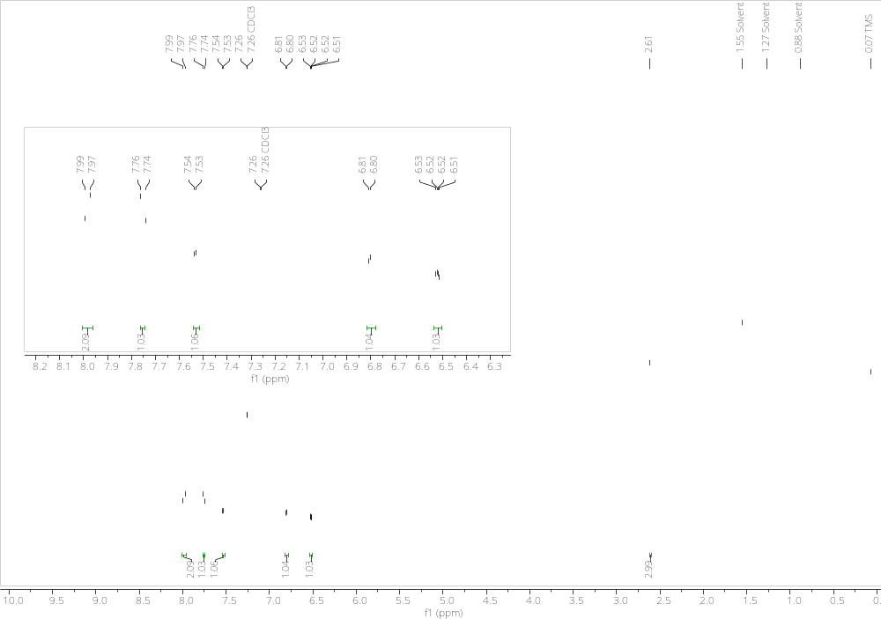
¹³C NMR (CDCl₃, 101 MHz)
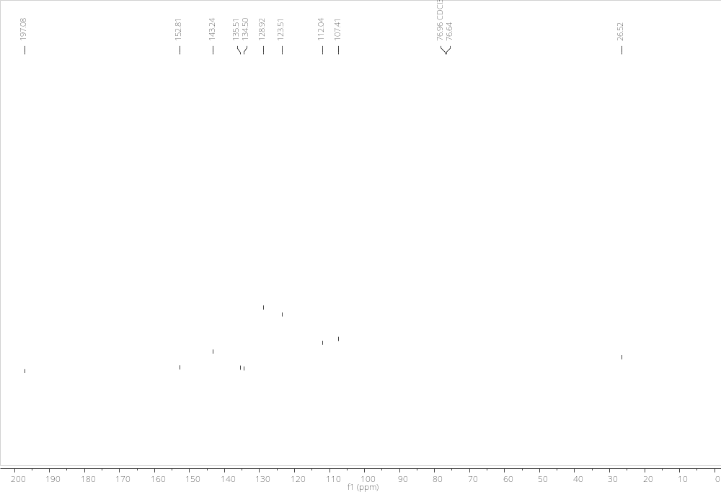

¹H NMR (CDCl₃, 400 MHz)
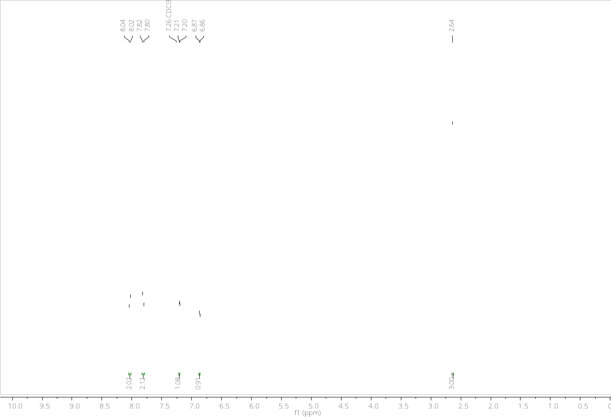

¹H NMR (CD₃CN, 400 MHz)
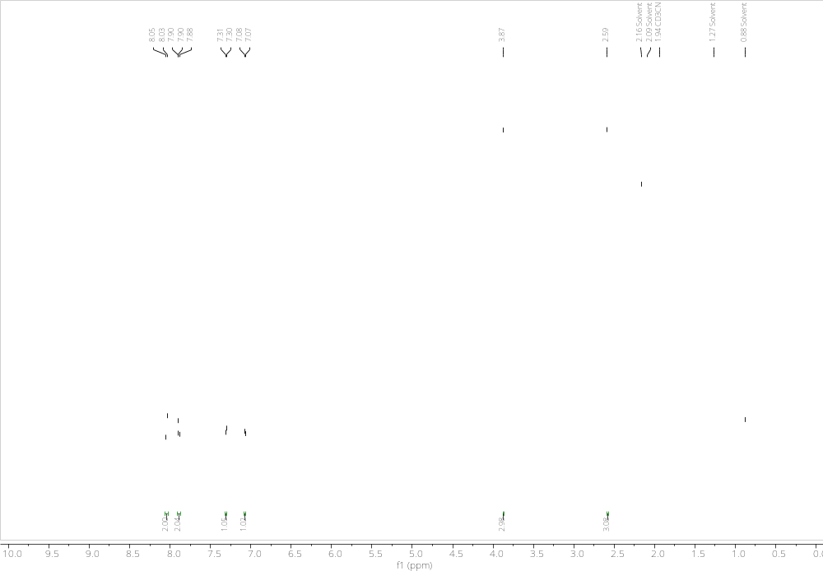

¹³C NMR (CDCl₃, 101 MHz)

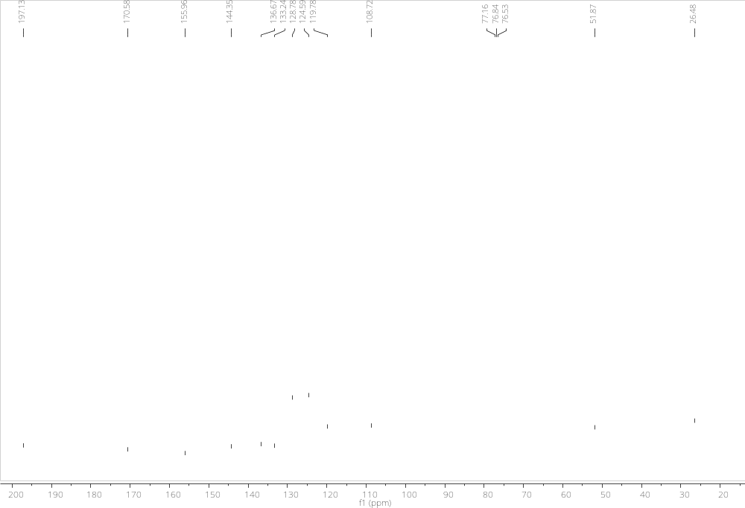

¹H NMR (CDCl₃, 400 MHz)
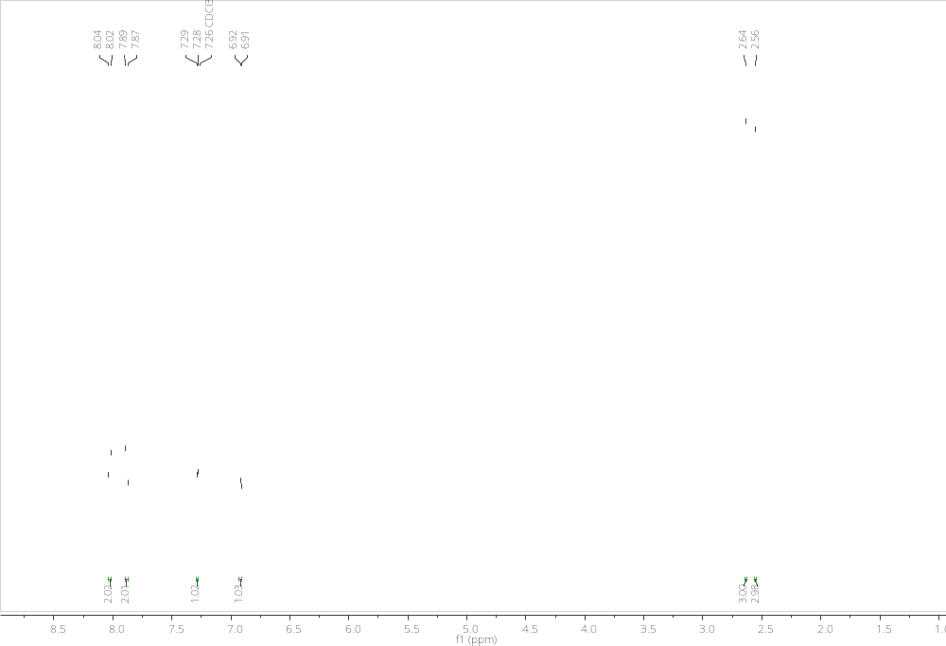
¹³C NMR (CDCl₃, 101 MHz)
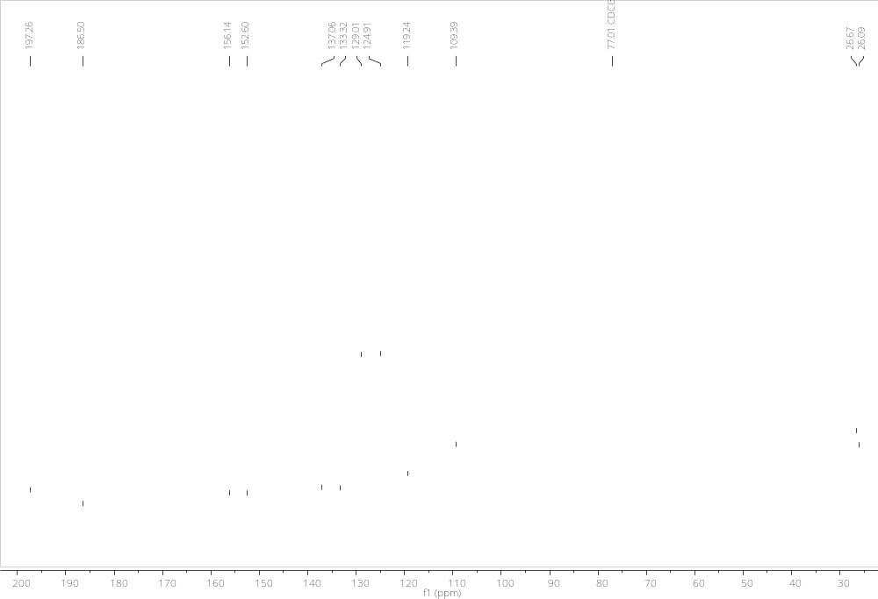

¹H NMR (CD₃CN, 400 MHz)
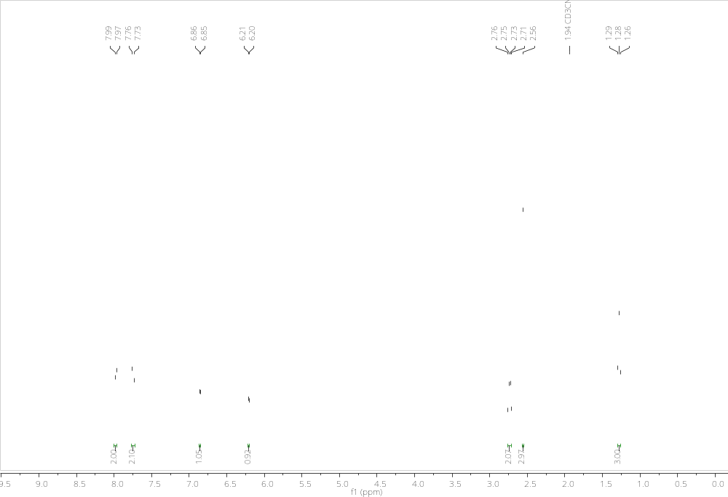

¹³C NMR (CD₃CN, 101 MHz)
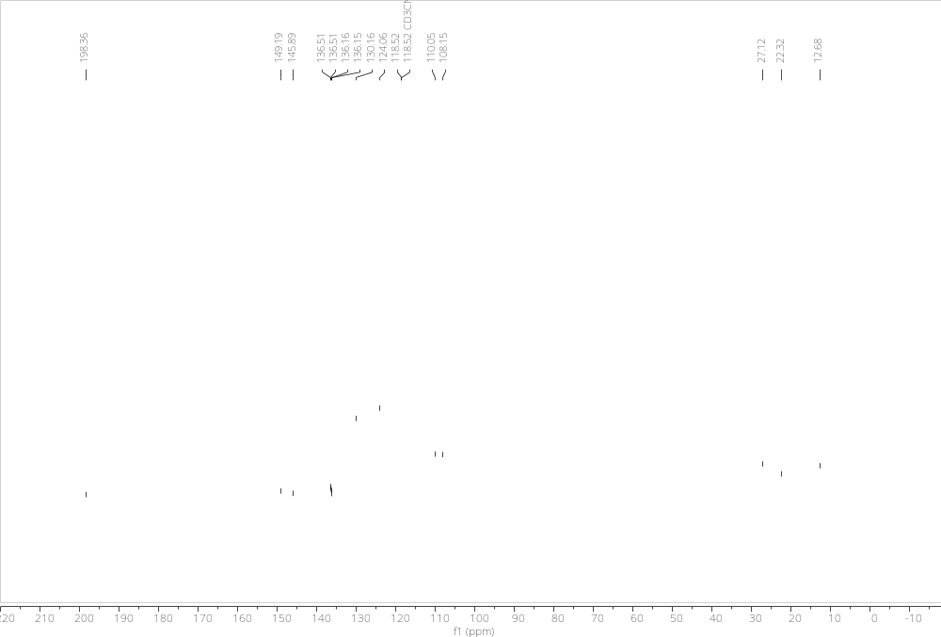

¹H NMR (CD₃CN, 400 MHz)
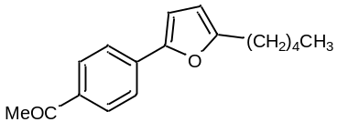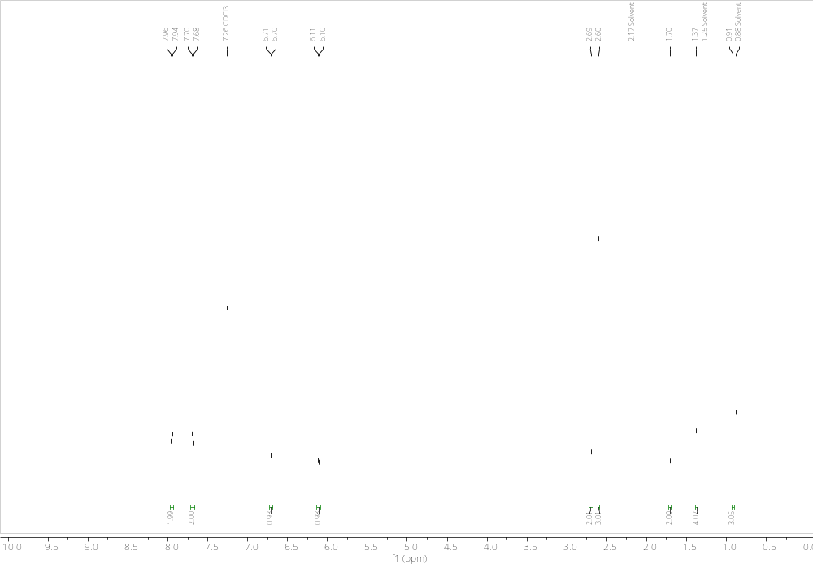

¹³C NMR (CD₃CN, 101 MHz)
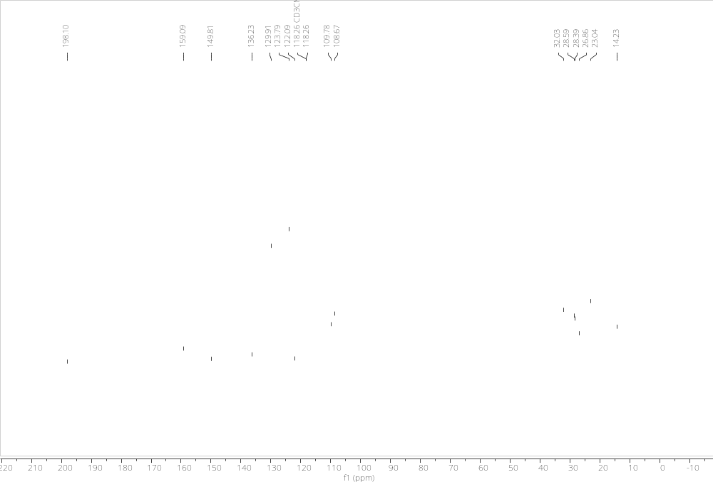

¹H NMR (CD₃CN, 400 MHz)
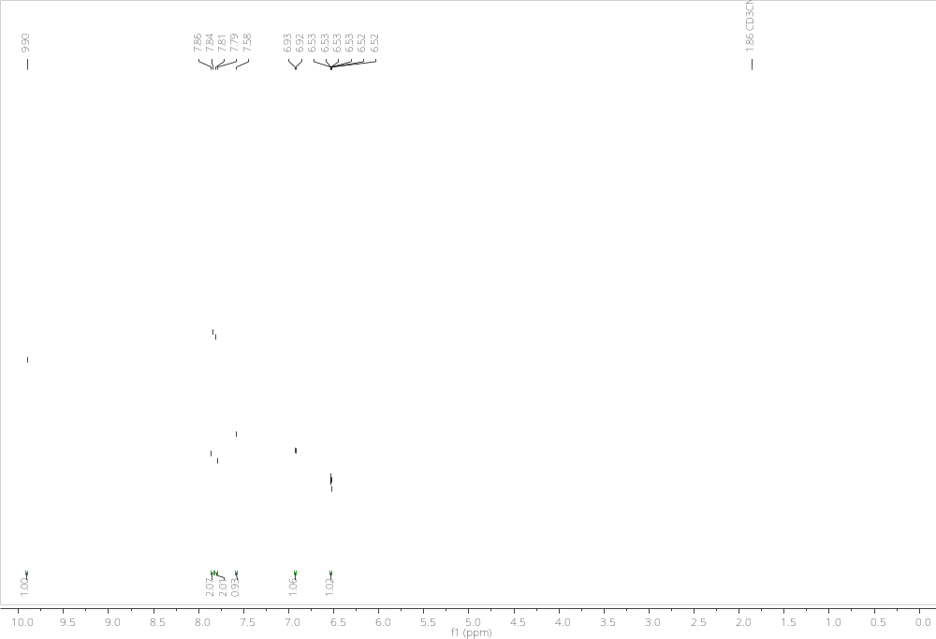
¹³C NMR (CDCl₃, 101 MHz)
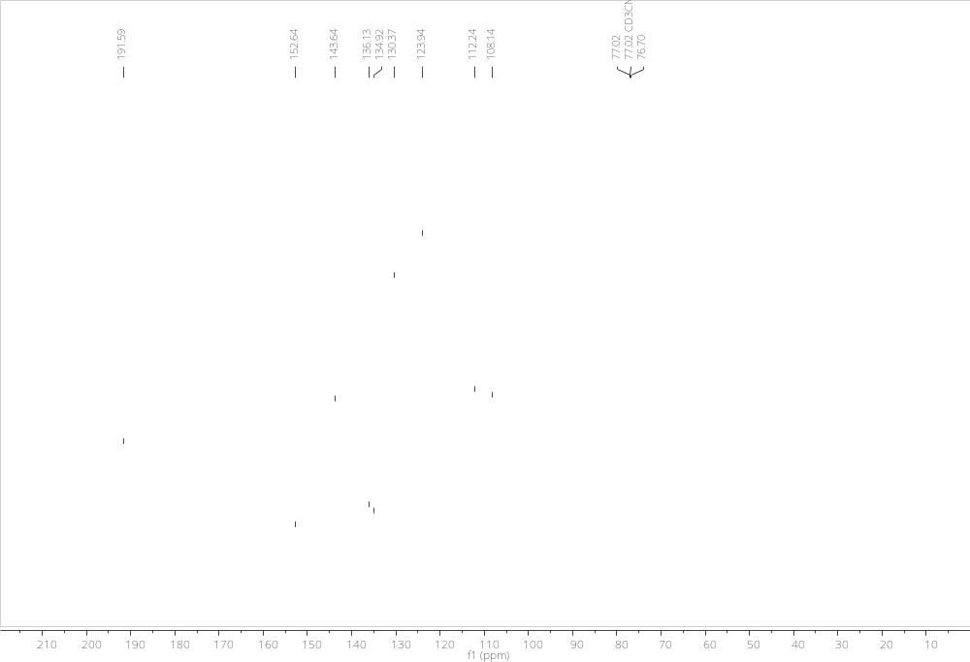

¹H NMR (CDCl₃, 400 MHz)
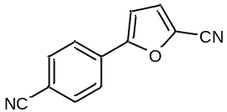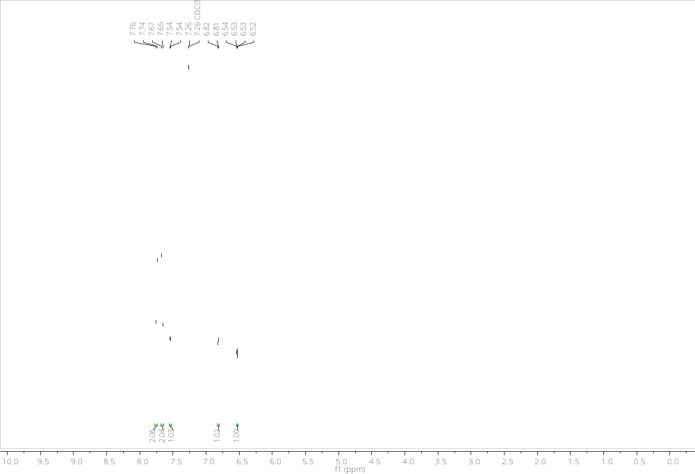

¹³C NMR (CDCl₃, 101 MHz)
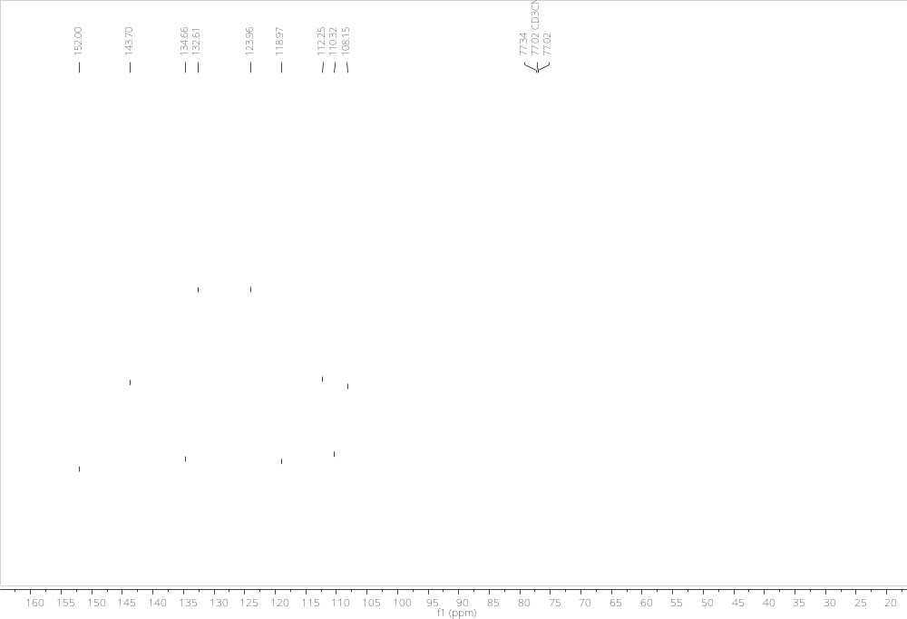

¹H NMR (CDCl₃, 400 MHz)
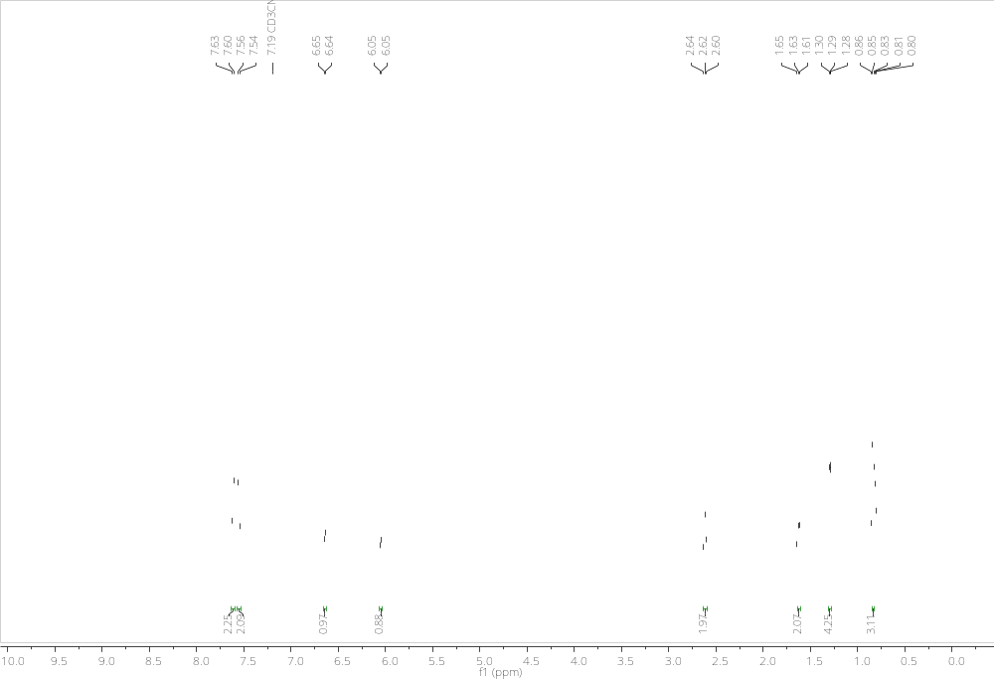

¹H NMR (CDCl₃, 400 MHz)
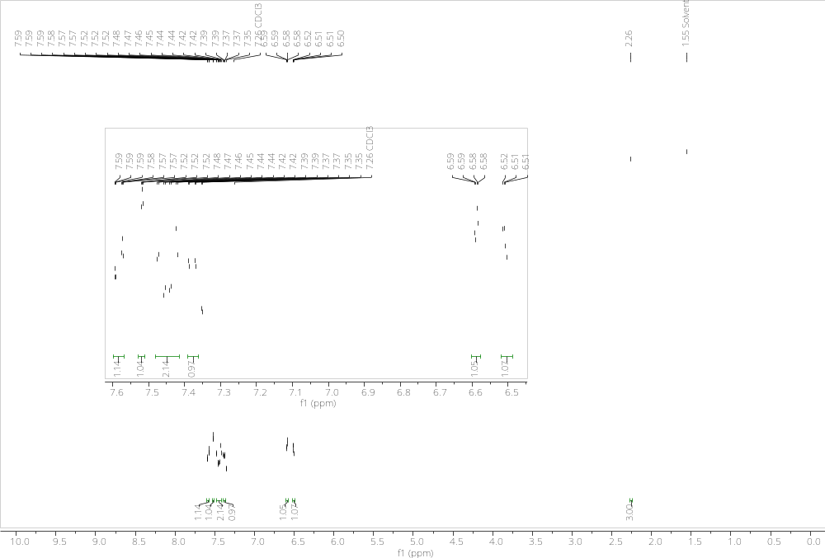

¹³C NMR (CDCl₃, 101 MHz)
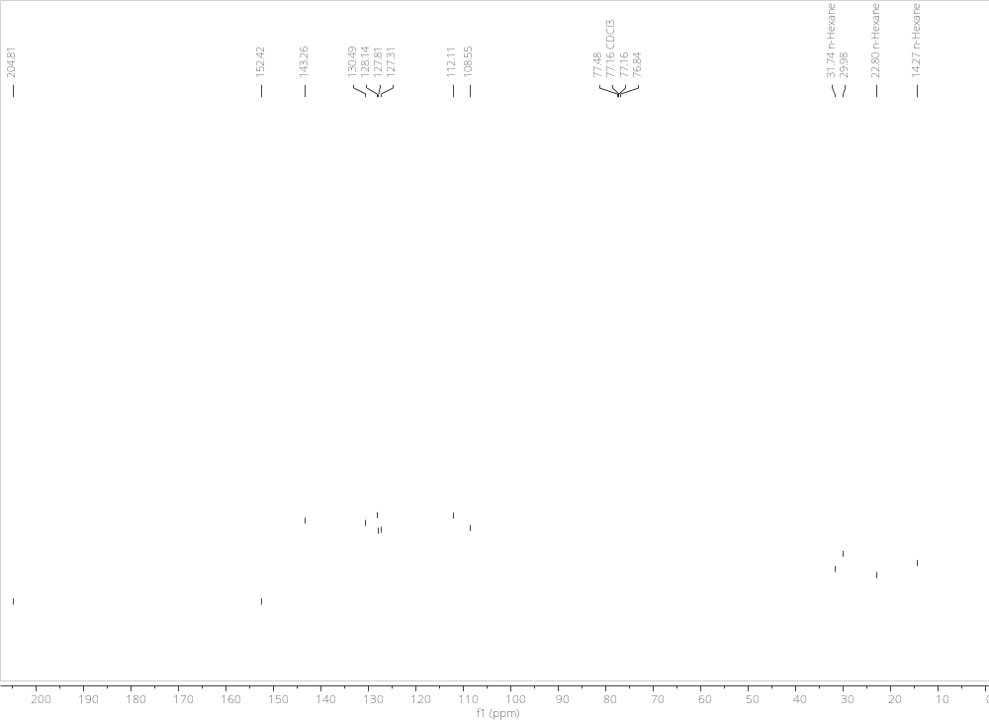

¹H NMR (CD₃CN, 400 MHz)
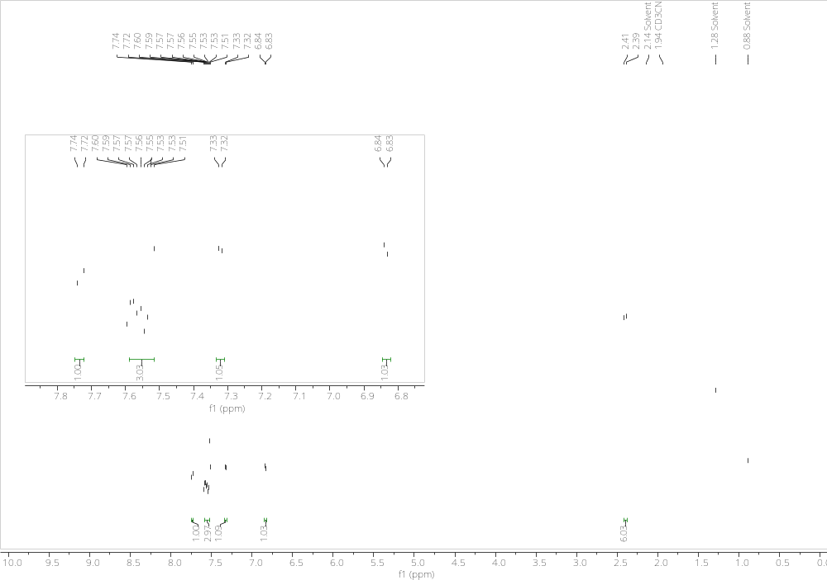

¹³C NMR (CD₃CN, 101 MHz)
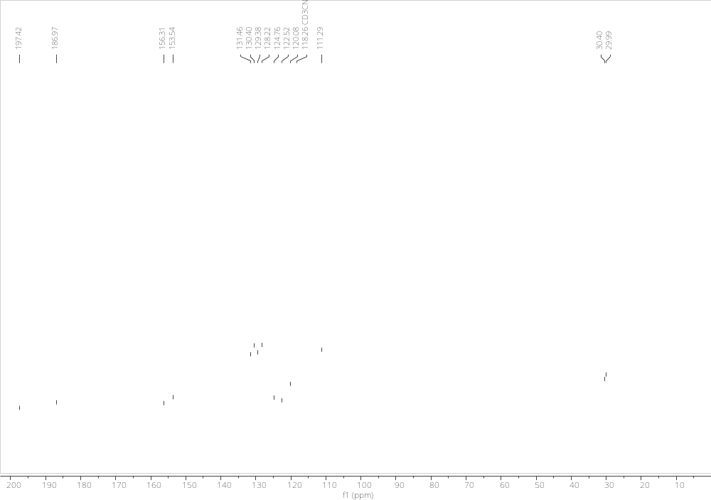

¹H NMR (CDCl₃, 400 MHz)
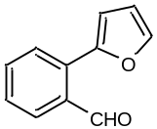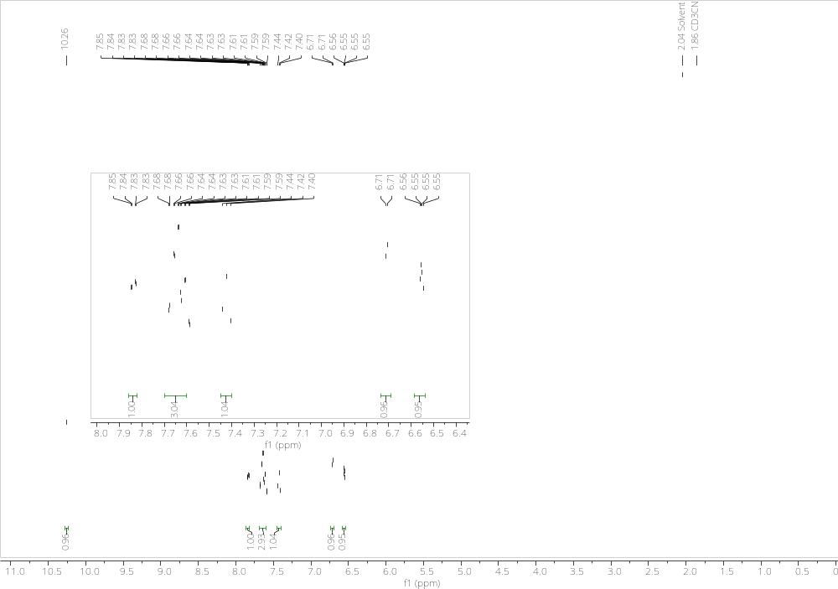

¹³C NMR (CDCl₃, 101 MHz)
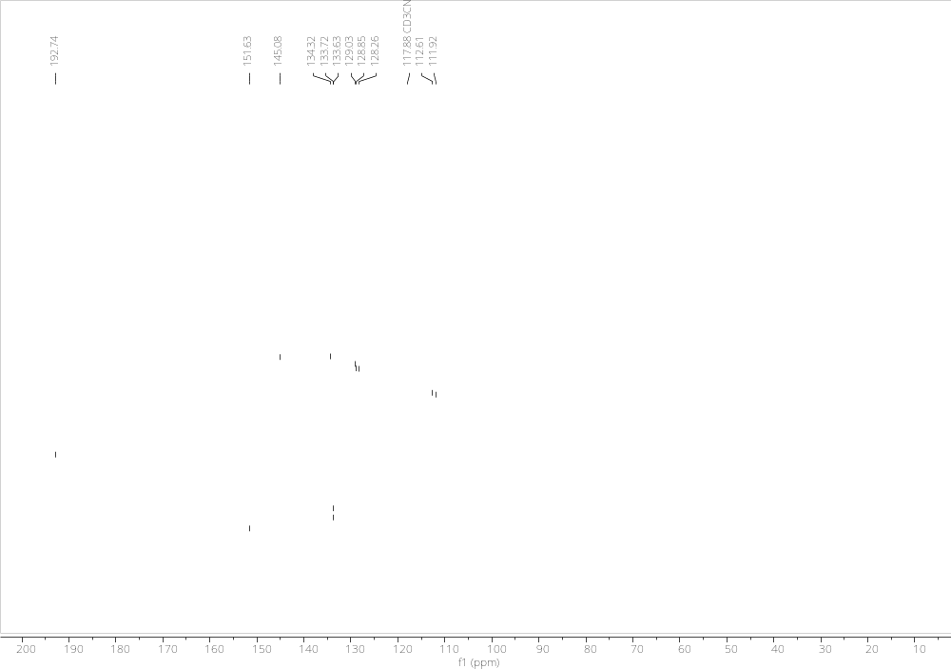

¹H NMR (CDCl₃, 400 MHz)
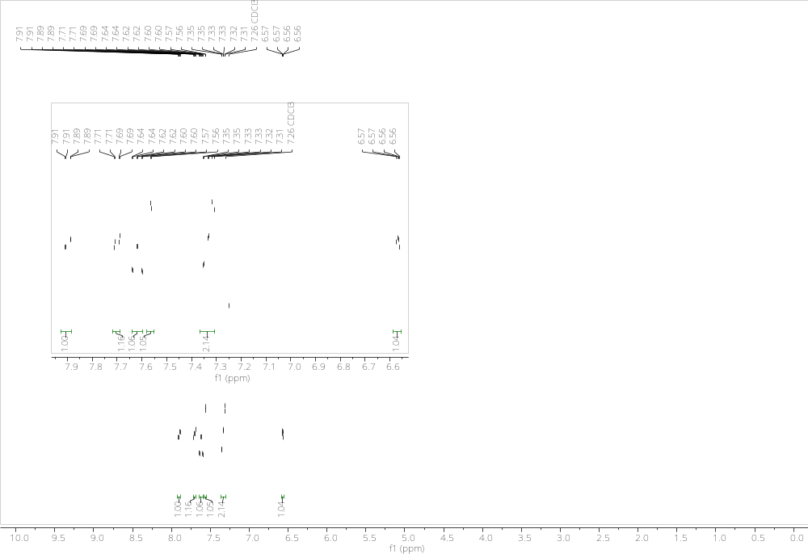

¹H NMR (CD₃CN, 400 MHz)
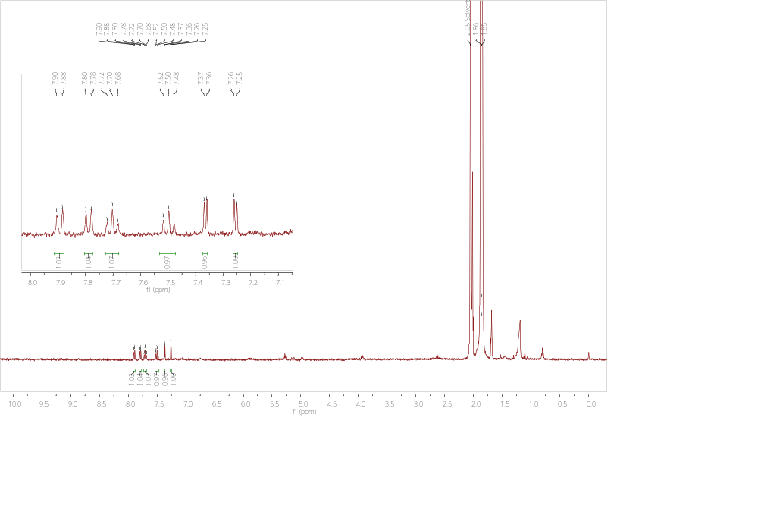

¹H NMR (CDCl₃, 400 MHz)
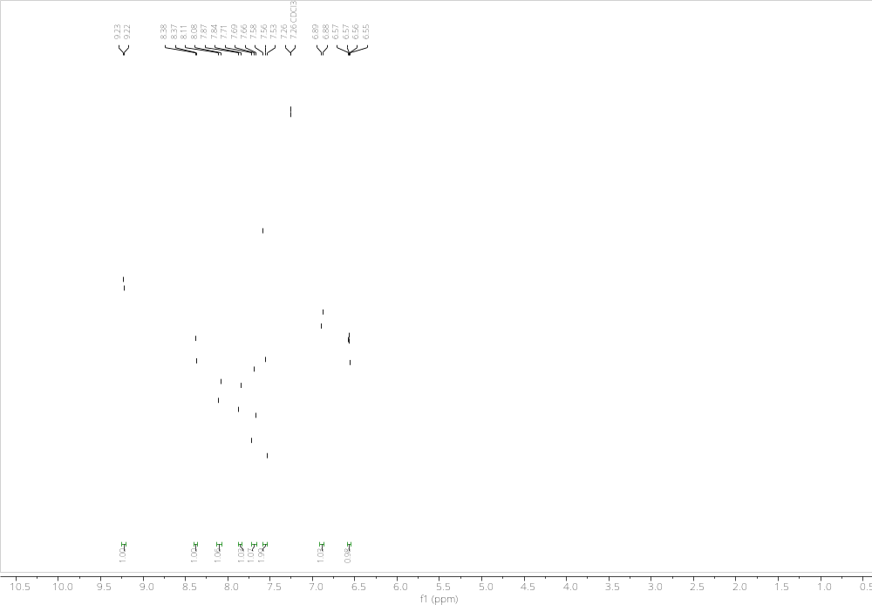

¹H NMR (CD₃CN, 400 MHz)
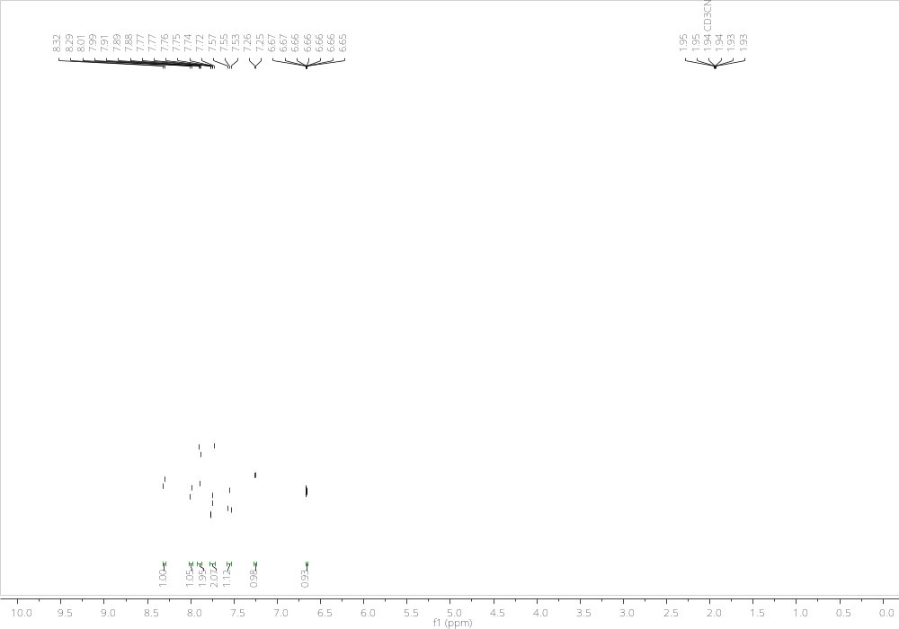

¹H NMR (CDCl₃, 400 MHz)
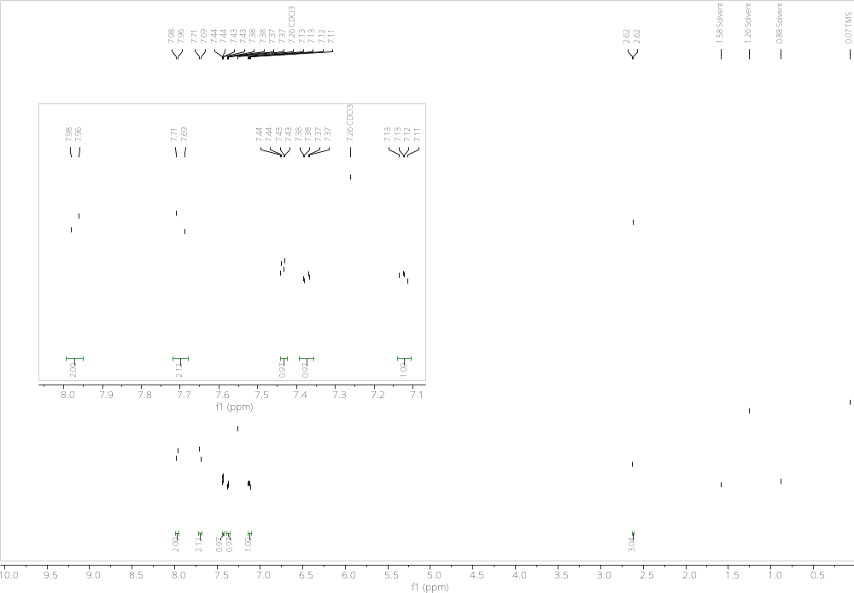
¹³C NMR (CDCl₃, 101 MHz)
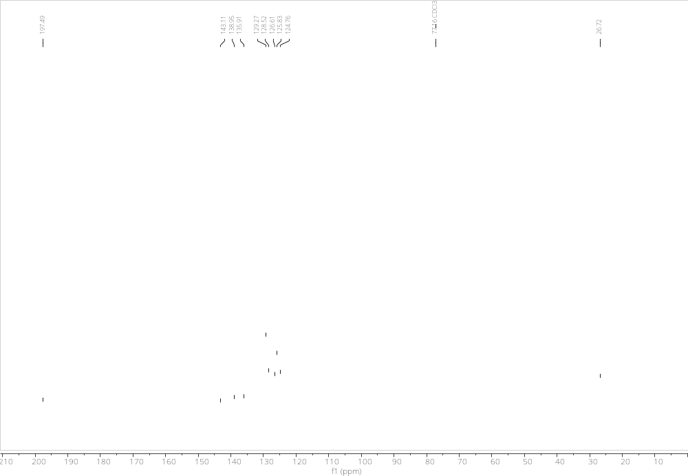

¹H NMR (CDCl₃, 400 MHz)
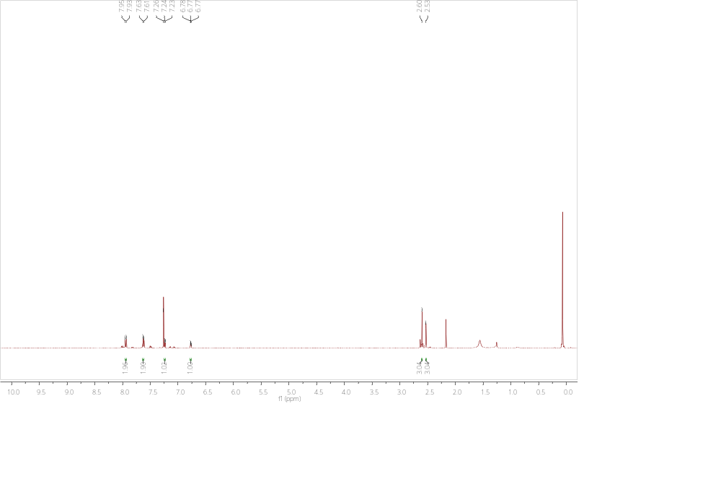
¹H NMR (CDCl₃, 400 MHz)
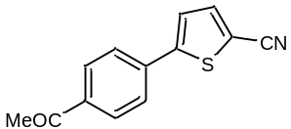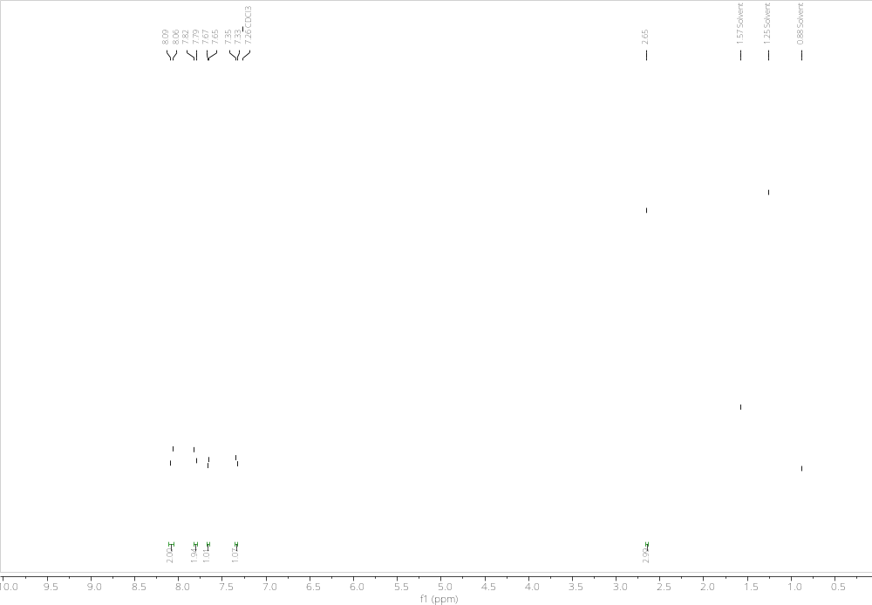

¹³C NMR (CDCl₃, 101 MHz)
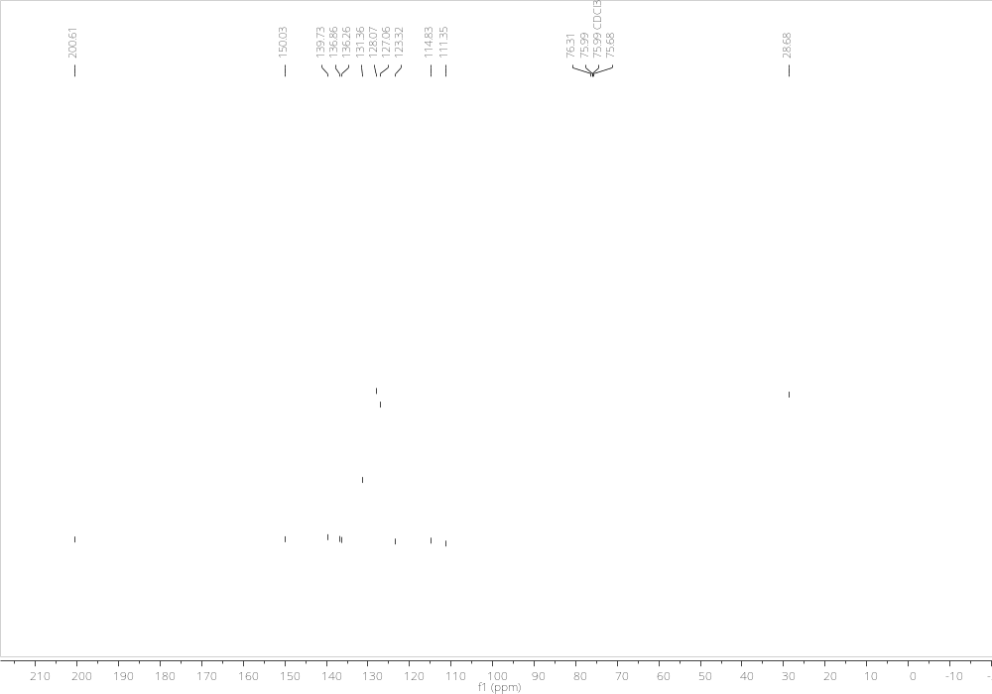

¹H NMR (CDCl₃, 400 MHz)
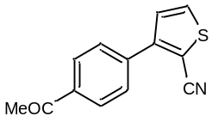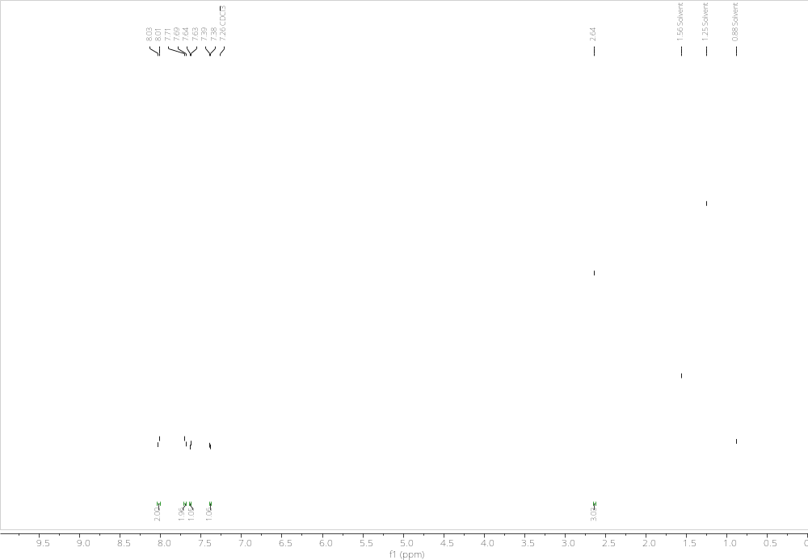

¹³C NMR (CDCl₃, 101 MHz)
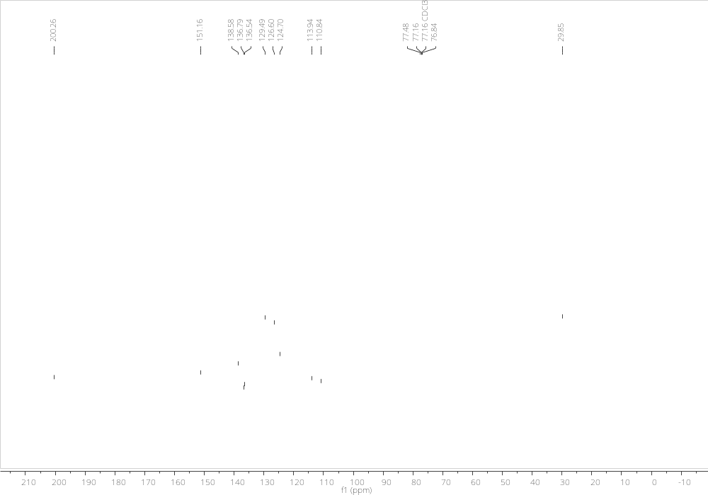

¹H NMR (CD₃CN, 400 MHz)
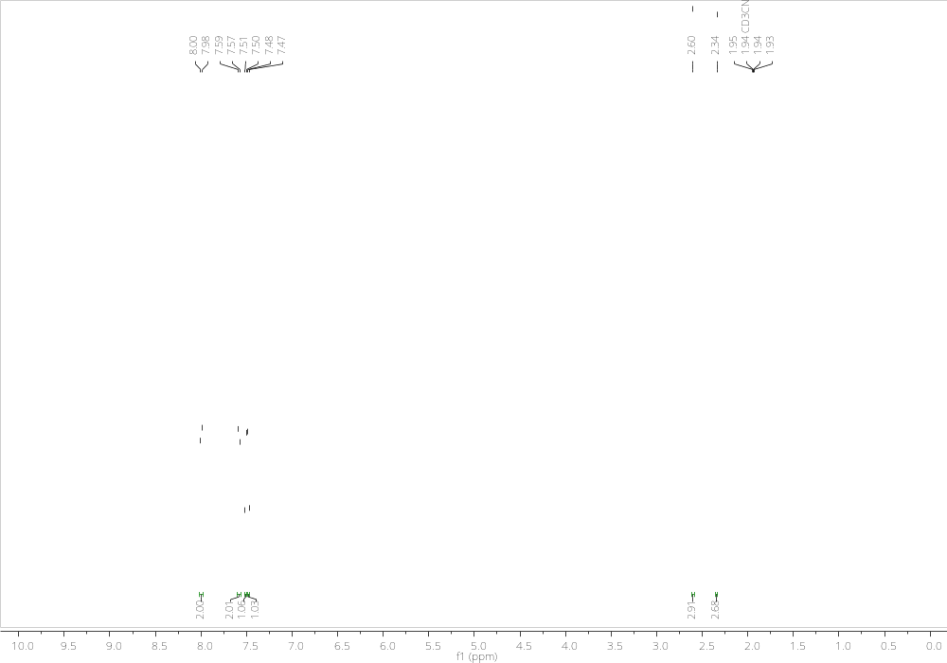

¹³C NMR (CD₃CN, 101 MHz)
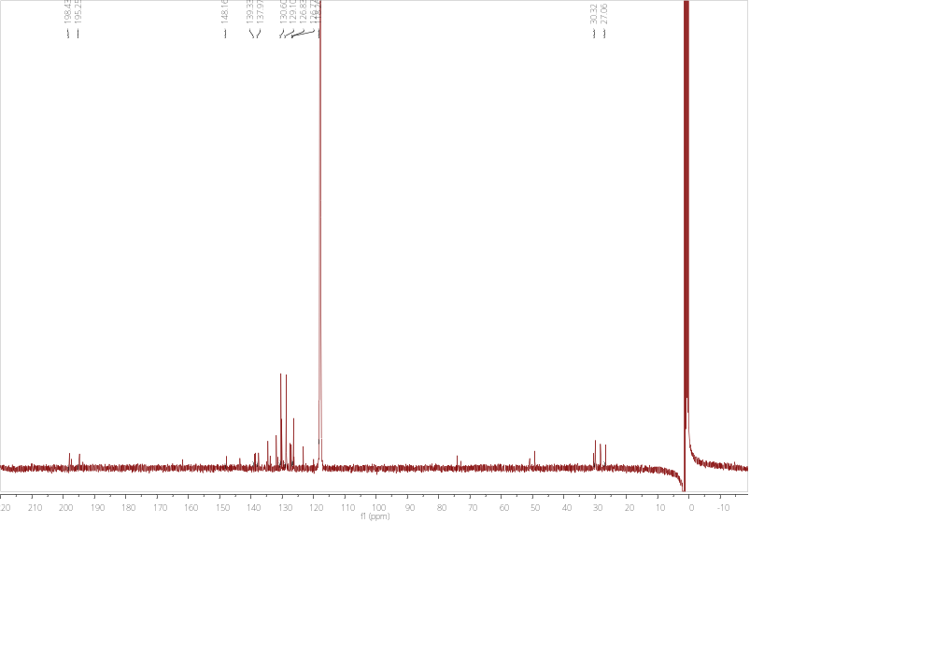

¹H NMR (CD₃CN, 400 MHz)
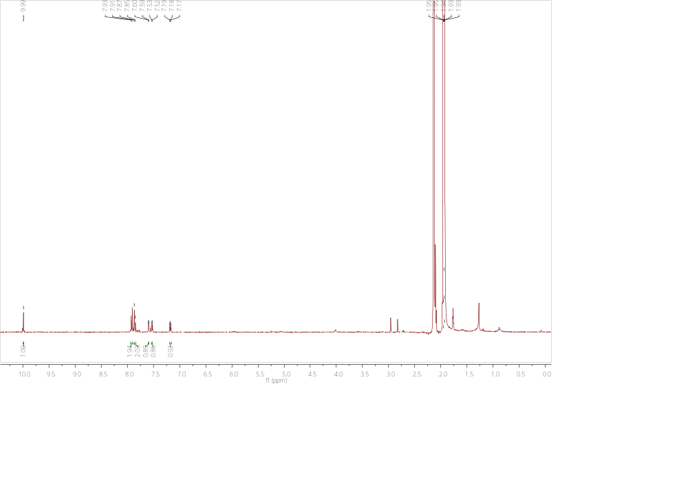

¹H NMR (CD₃CN, 400 MHz)
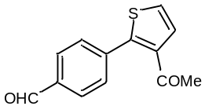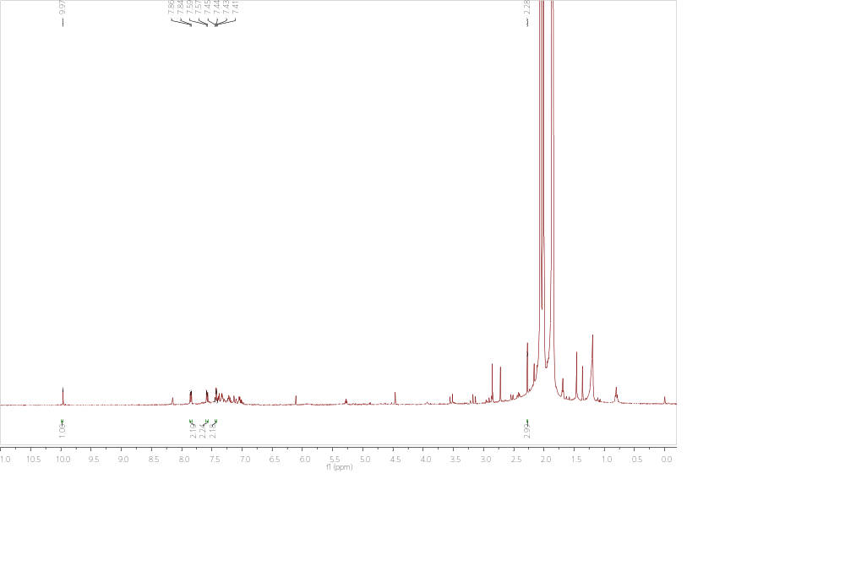

¹H NMR (CD₃CN, 400 MHz)
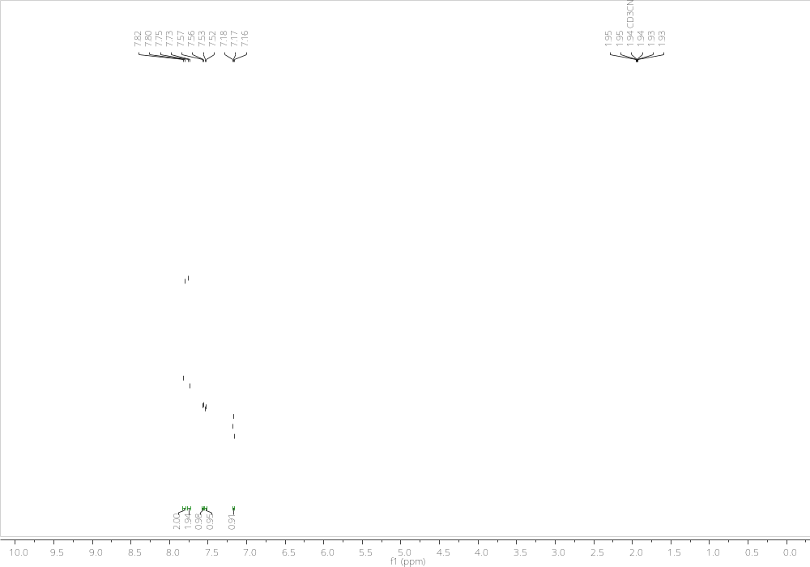

¹H NMR (CD₃CN, 400 MHz)
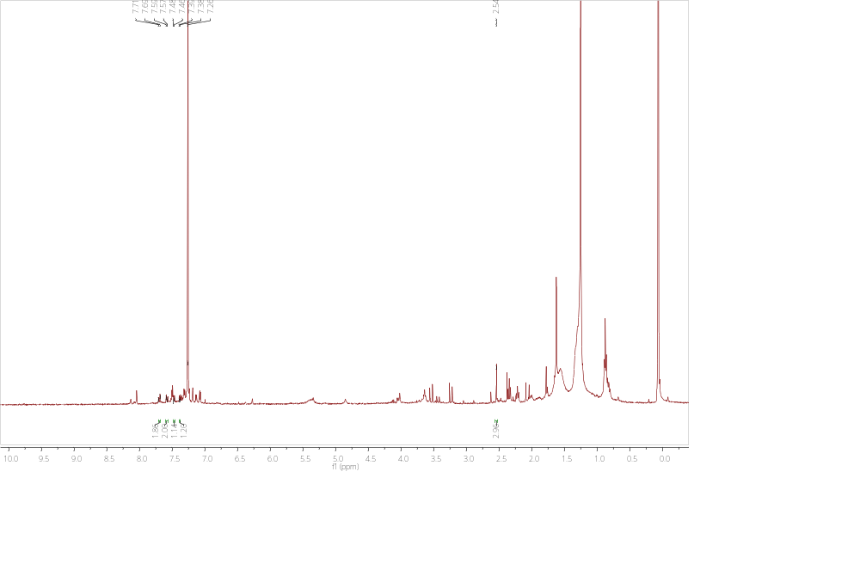

¹H NMR (CDCl₃, 400 MHz)
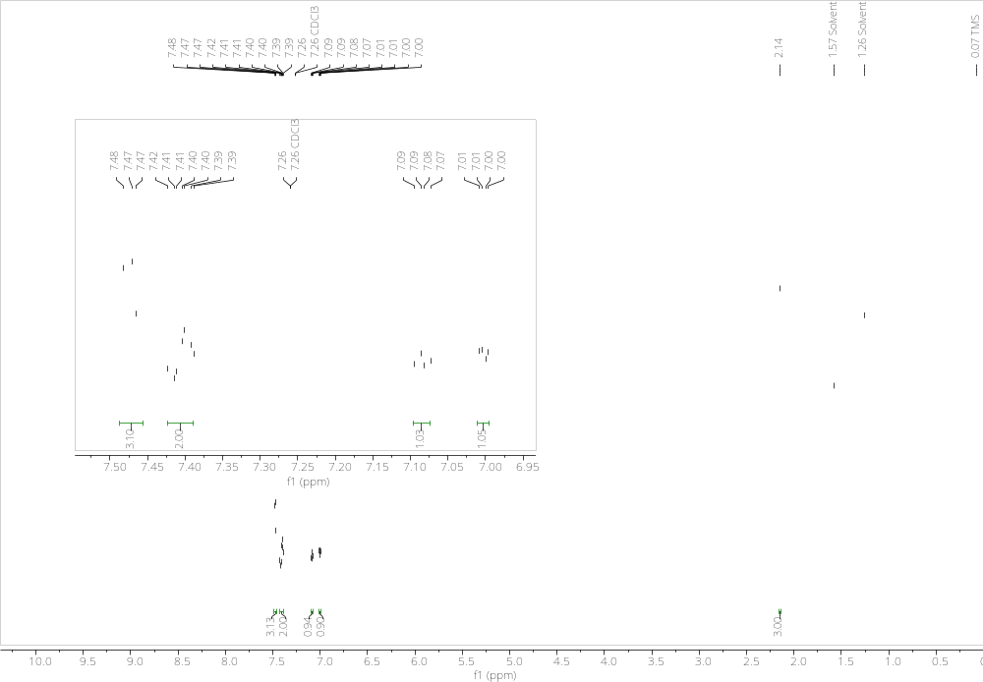

¹H NMR (CDCl₃, 400 MHz)
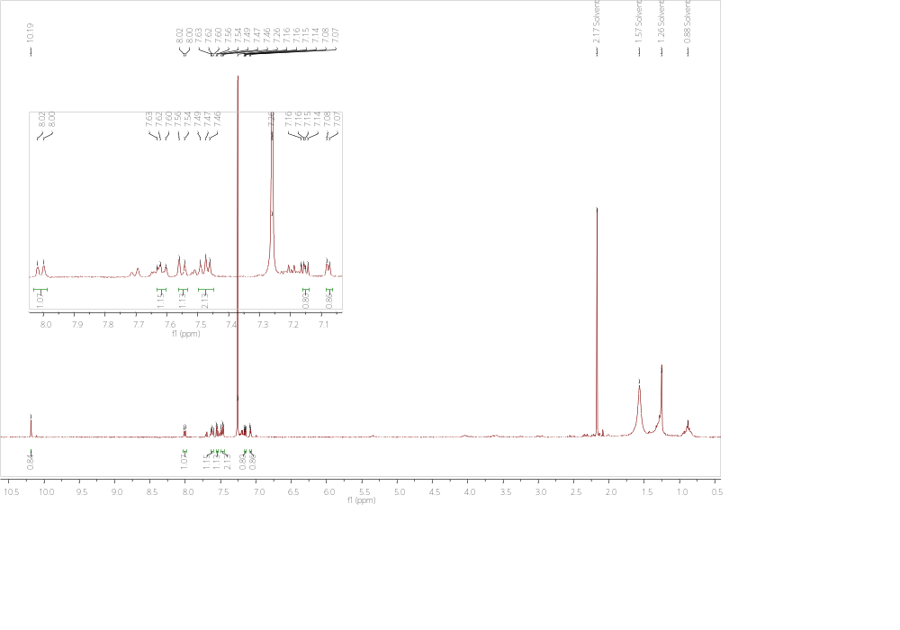

¹H NMR (CD₃CN, 400 MHz)
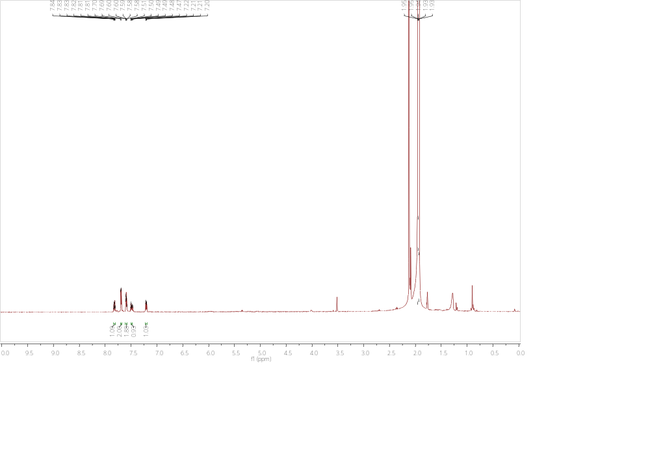

¹H NMR (CD₃CN, 400 MHz)
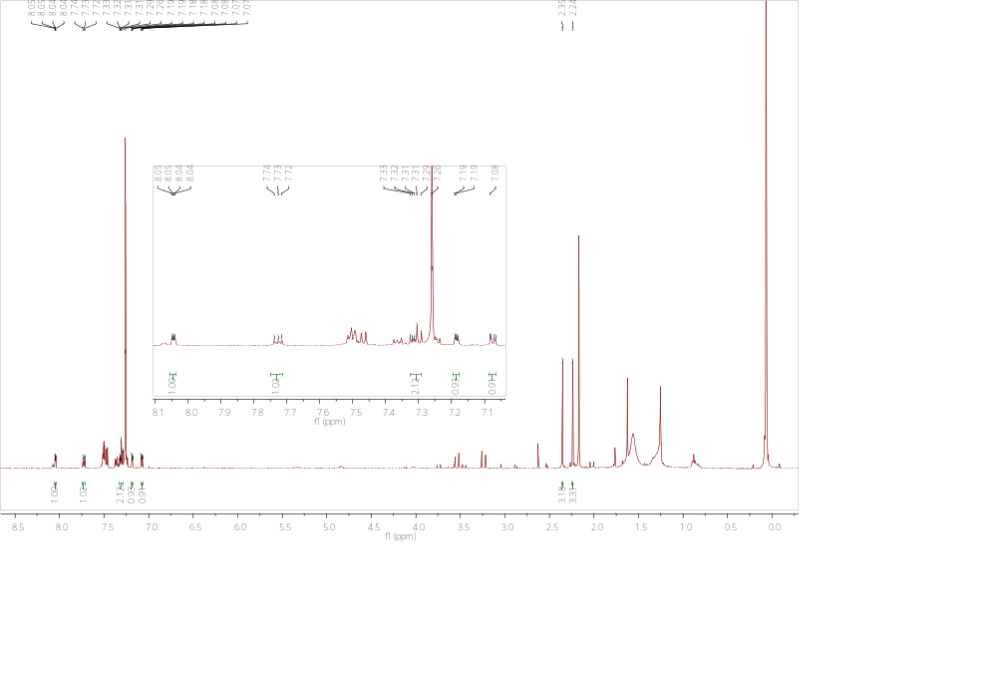

¹H NMR (CD₃CN, 400 MHz)
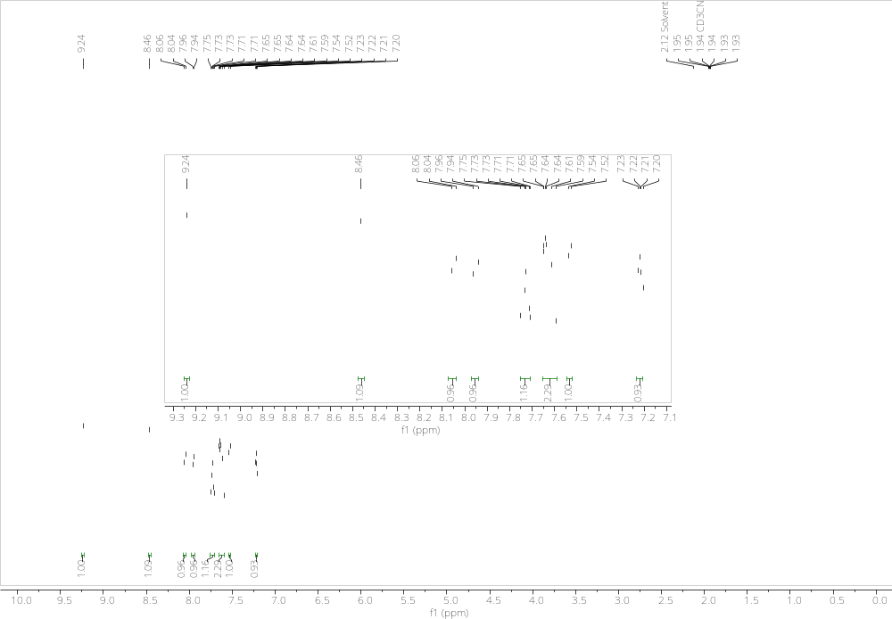

¹H NMR (CD₃CN, 400 MHz)
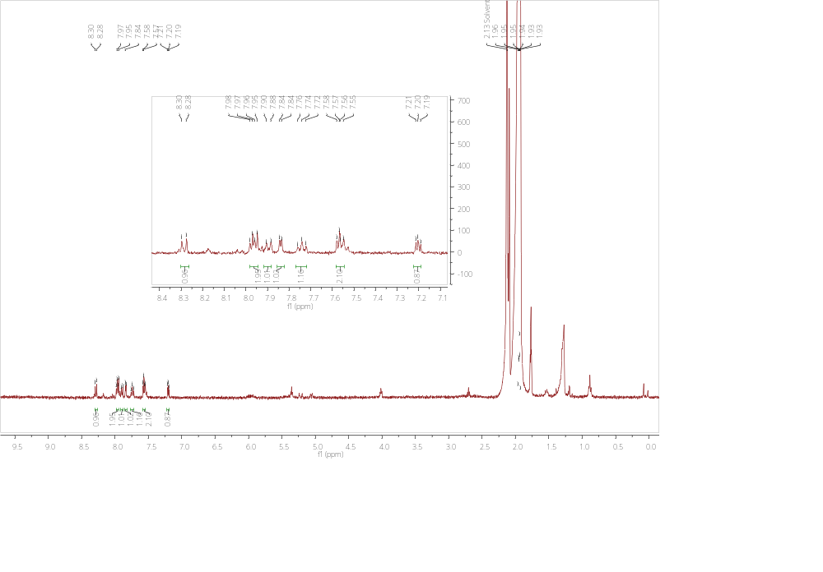

GC copies before (left) and after (right) irradiation. Retention time of dodecanenitrile (internal standard) is 9.7 min.
1-[4-(Furan-2-yl)phenyl]ethanone
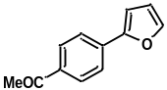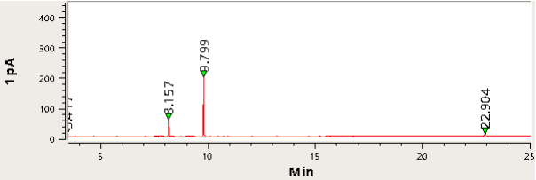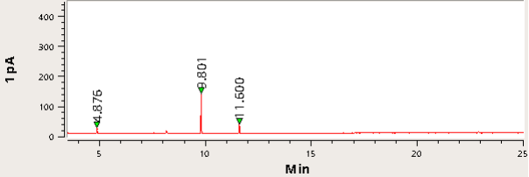
2-(4-Acetylphenyl)furan-5-carbonitrile
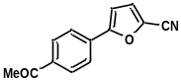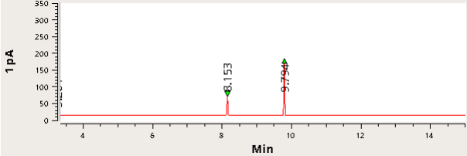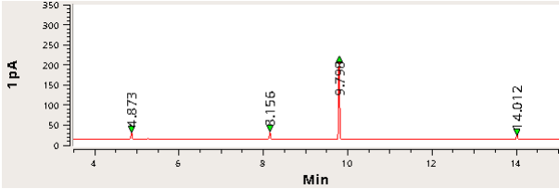
Methyl 5-(4-acetylphenyl)furan-2-carboxylate
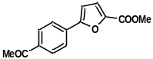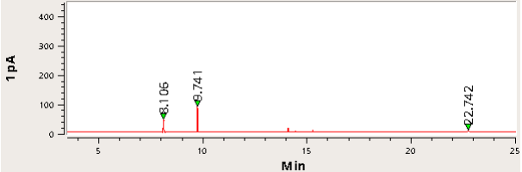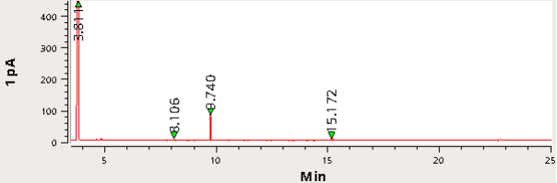

1-(4-(5-Acetylfuran-2-yl)phenyl)ethanone
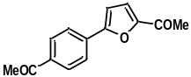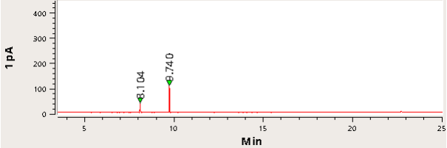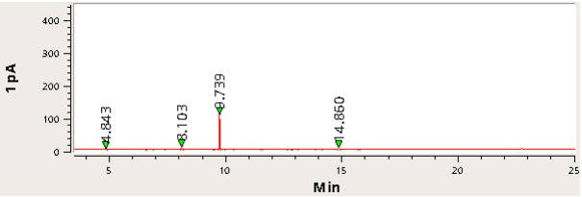
1-(4-(5-Ethylfuran-2-yl)phenyl)ethanone
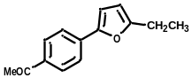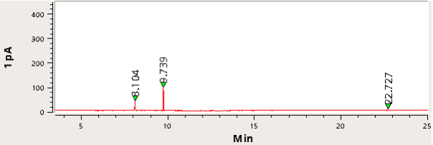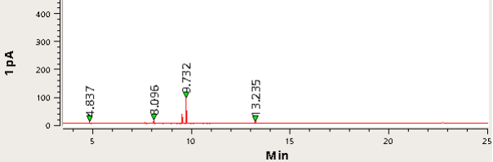
1-(4-(5-Pentylfuran-2-yl)phenyl)ethanone
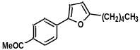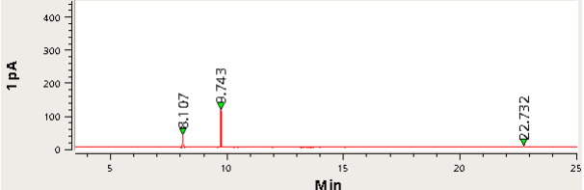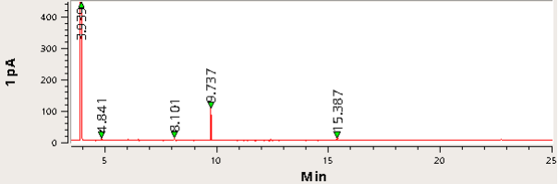

4-(Furan-2-yl)benzaldehyde
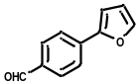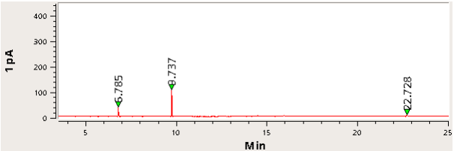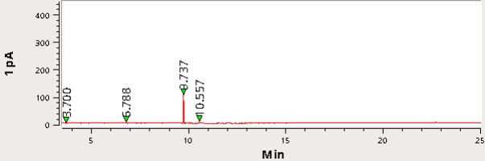
4-(Furan-2-yl)benzonitrile
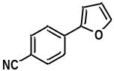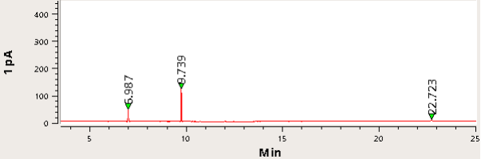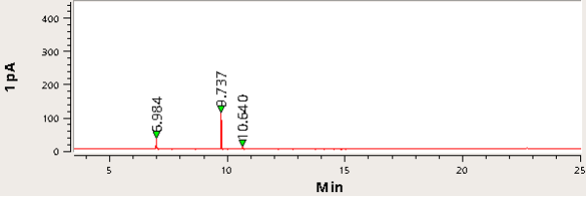
4-(5-Pentylfuran-2-yl)benzonitrile
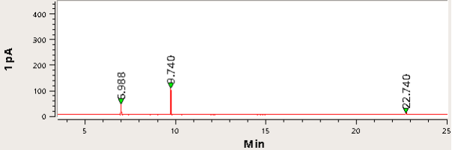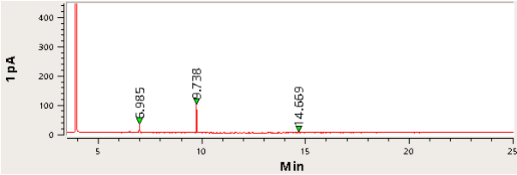
1-(2-(furan-2-yl)phenyl)ethanone
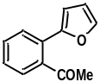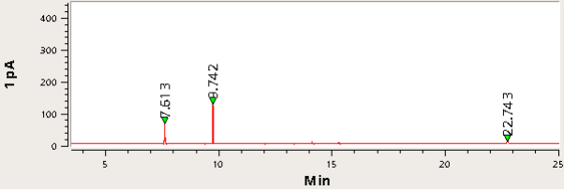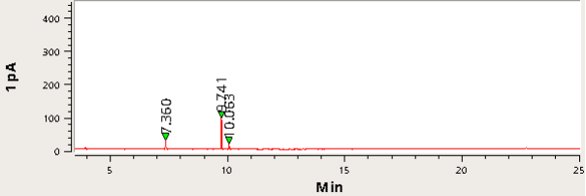
1-(2-(5-Acetylfuran-2-yl)phenyl)ethanone
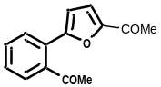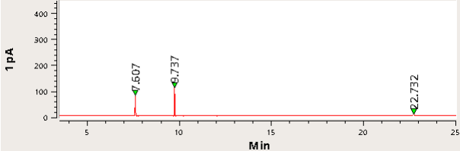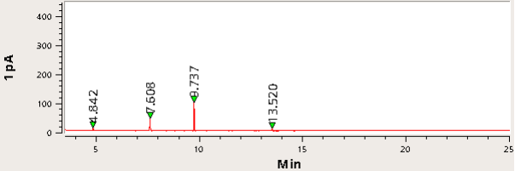
2-(Furan-2-yl)benzaldehyde
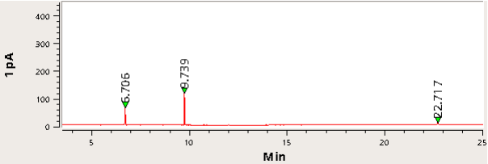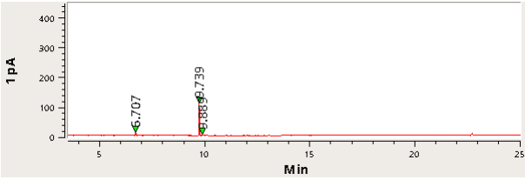

2-(Furan-2-yl)benzonitrile
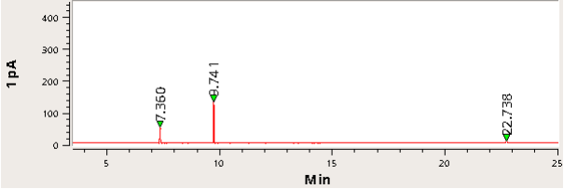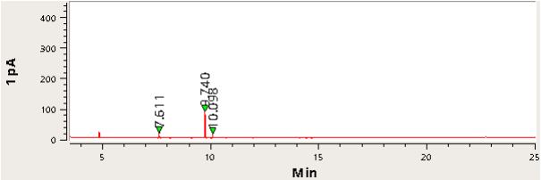
5-(2-Cyanophenyl)furan-2-carbonitrile
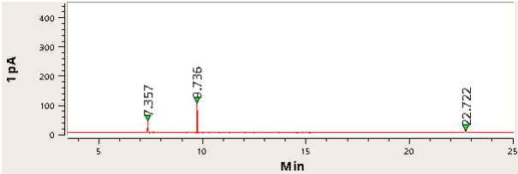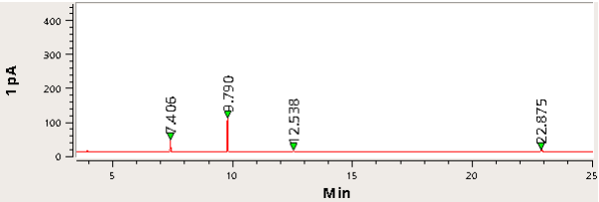
3-(Furan-2-yl)quinoline
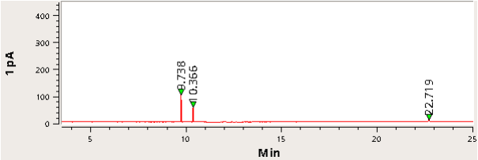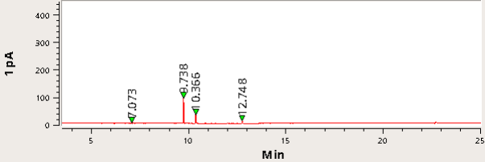
2-(Furan-2-yl)quinoline
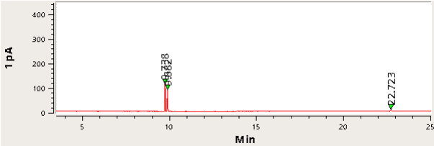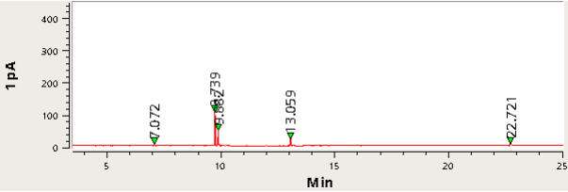
1-(4-Thiophen-2-yl-phenyl)ethanone
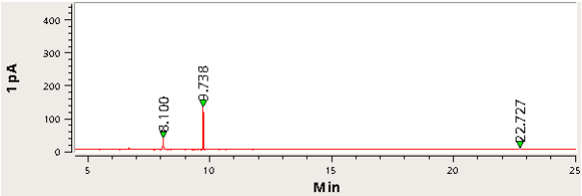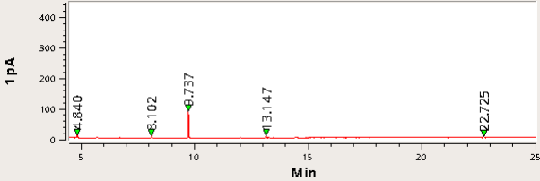
1-(4-(5-Methylthiophen-2-yl)phenyl)ethanone
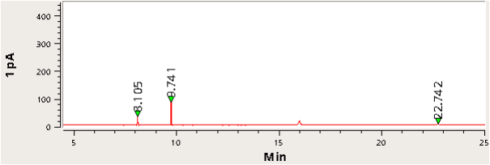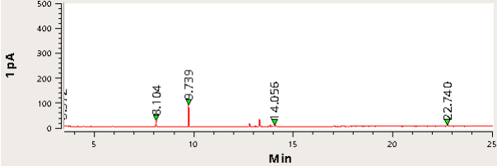

5-(4-Acetylphenyl)thiophene-2-carbonitrile and 3-(4-acetylphenyl)thiophene-2-carbonitrile
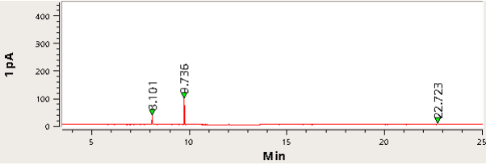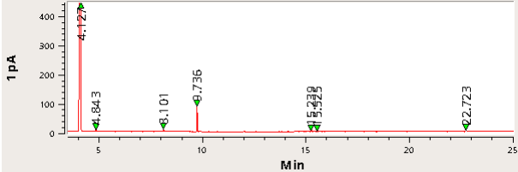
1-(3-(4-Acetylphenyl)thiophen-2-yl)ethanone
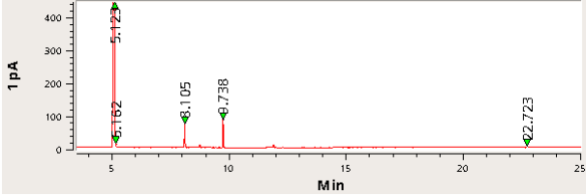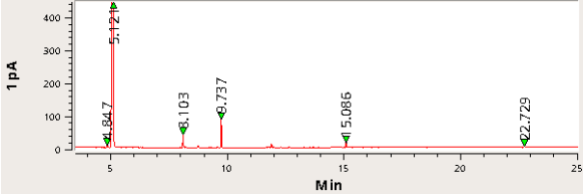
4-(Thiophen-2-yl)benzaldehyde
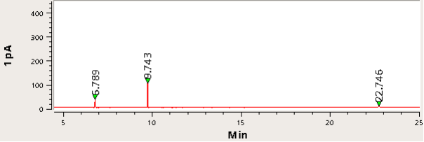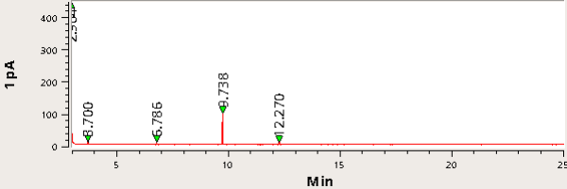
4-(2-Acetylthiophen-3-yl)benzaldehyde
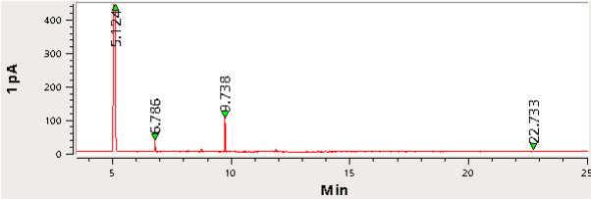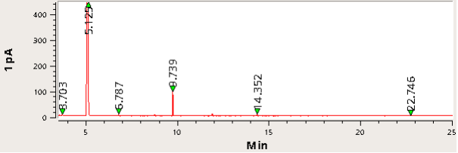
4-(Thiophen-2-yl)benzonitrile
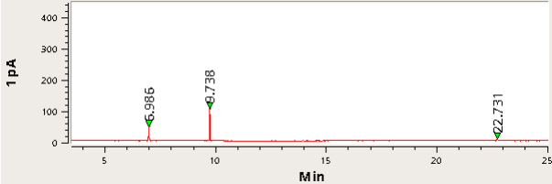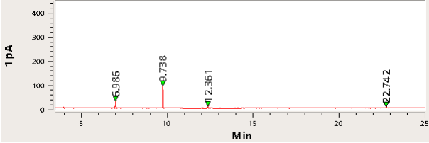
4-(2-Acetylthiophen-3-yl)benzonitrile
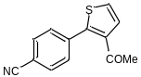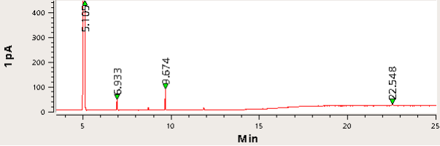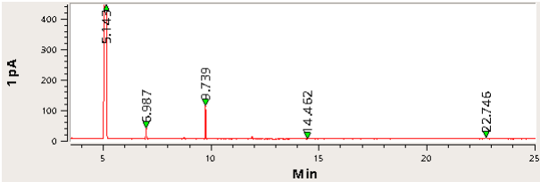

1-(2-(Thiophen-2-yl)phenyl)ethanone
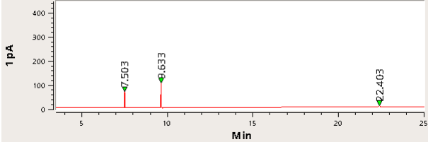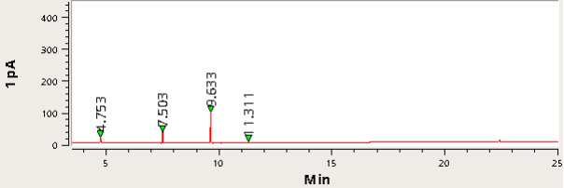
2-(Thiophen-2-yl)benzaldehyde
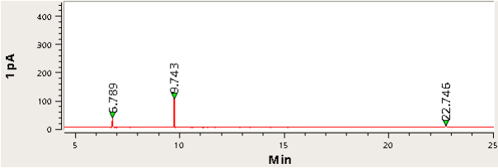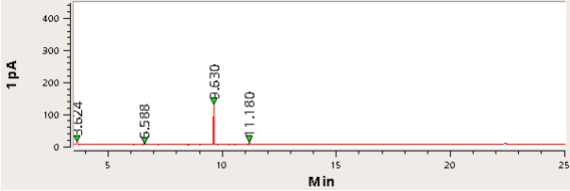
2-(Thiophen-2-yl)benzonitrile
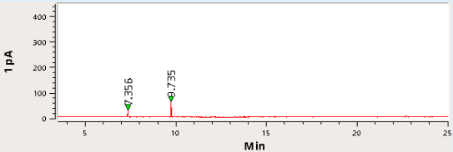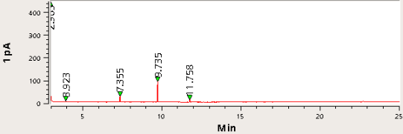
1-(2-(2-Acetylphenyl)thiophen-3-yl)ethanone
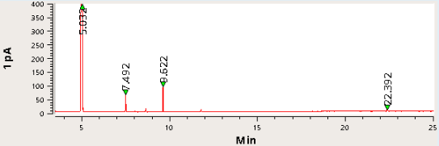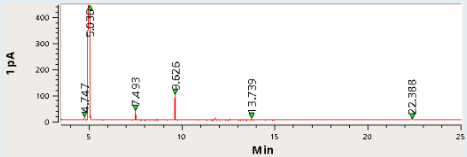
3-(Thiophen-2-yl)quinoline
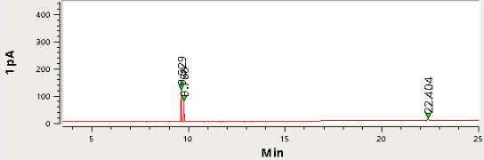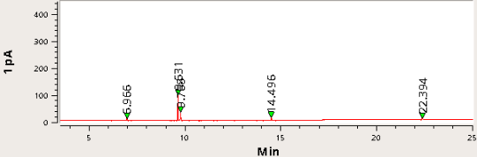
2-(Thiophen-2-yl)quinoline
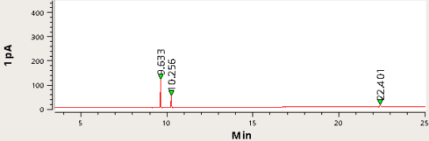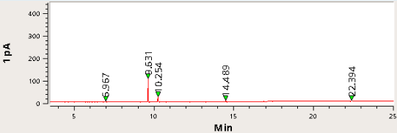

HRMS copies

Compound 3a
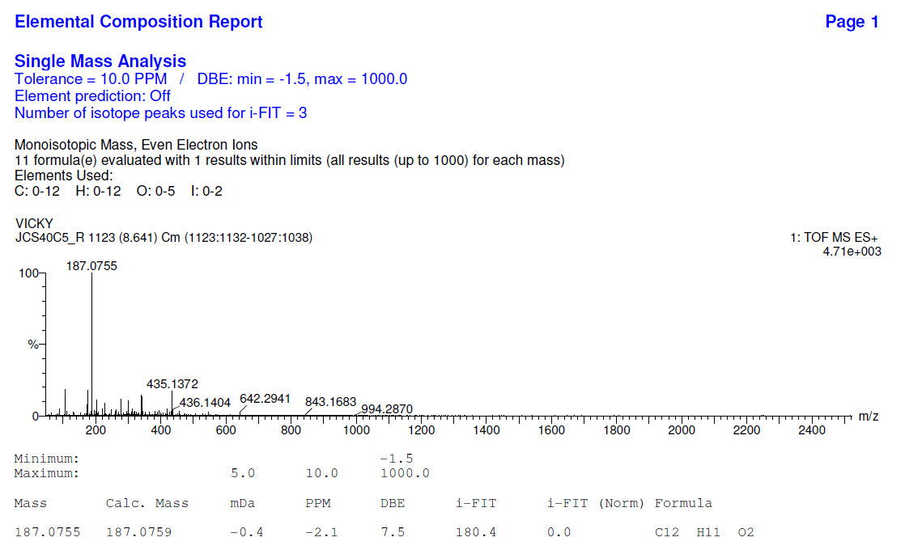

Compound 3c
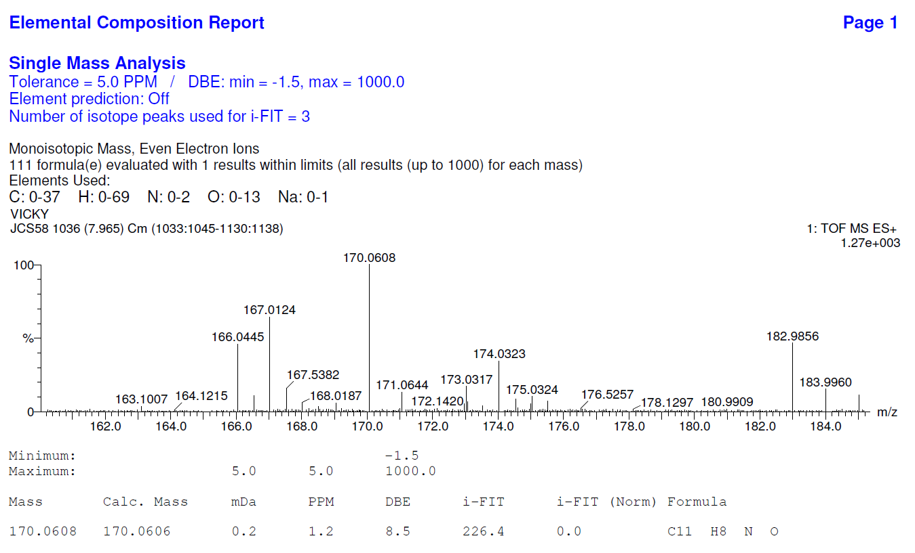

Compound 3d
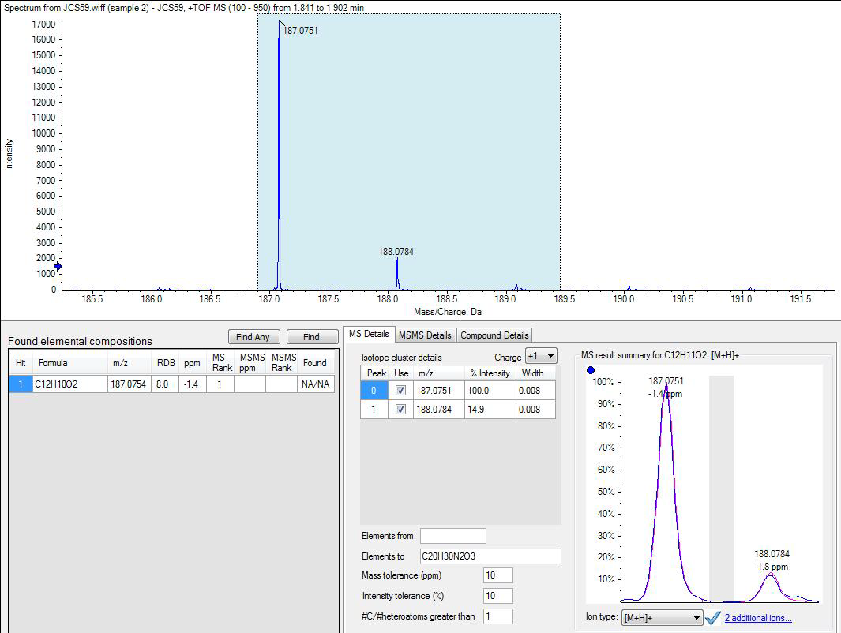

Compound 3h
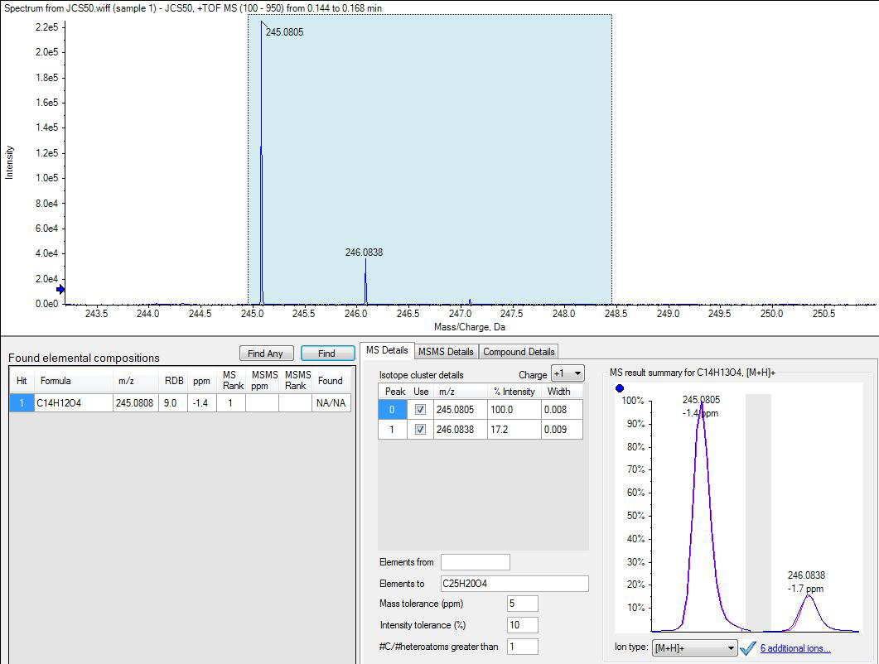

Compound 3i
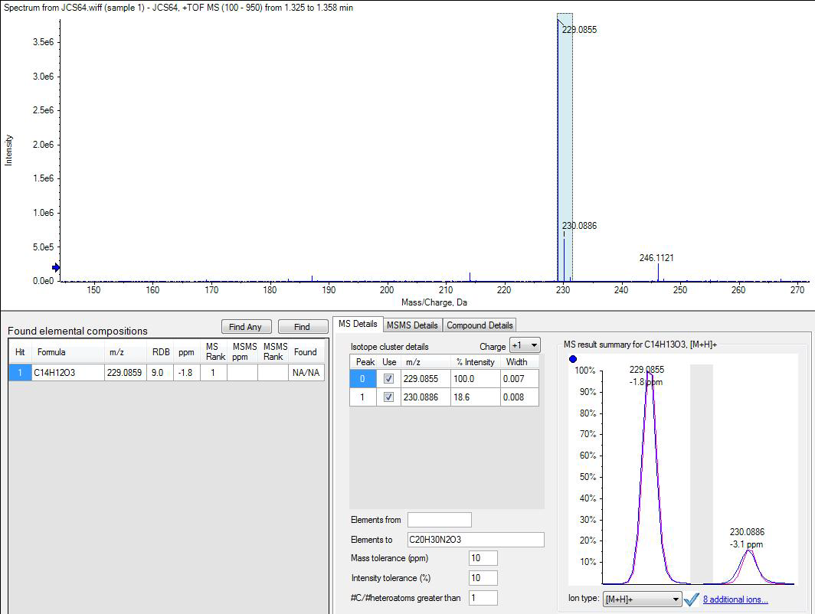

Compound 3j
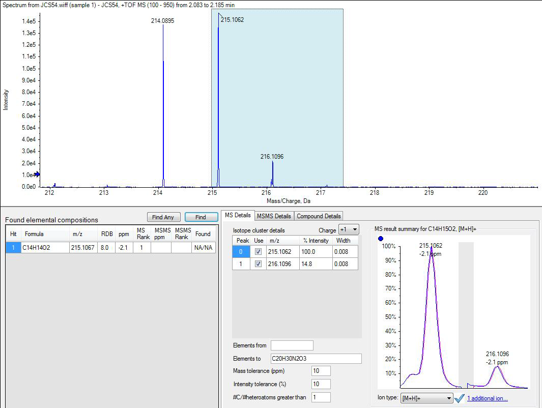

Compound 3k
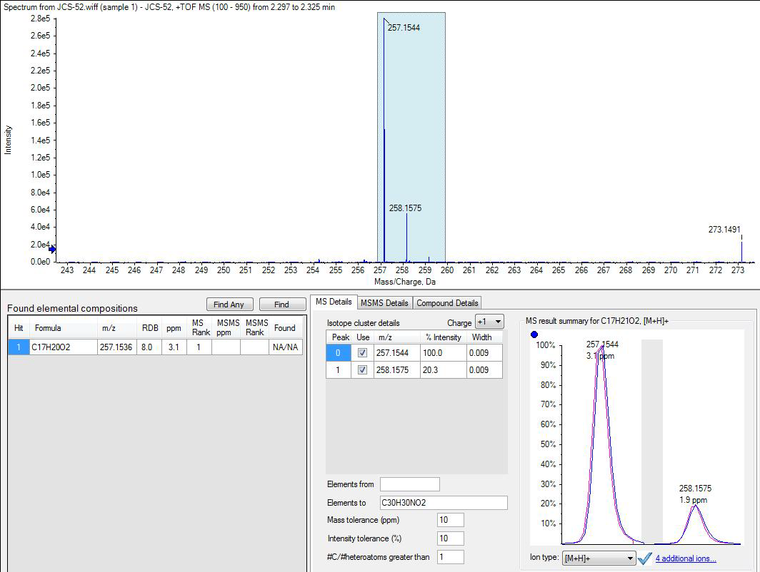

Compound 3l
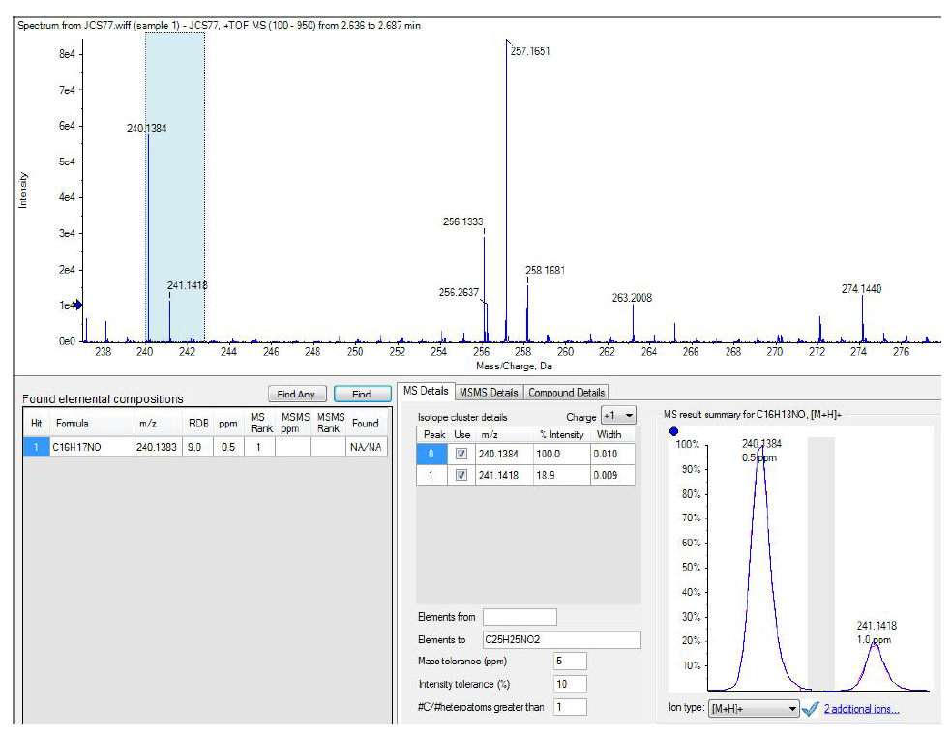

Compound 3m
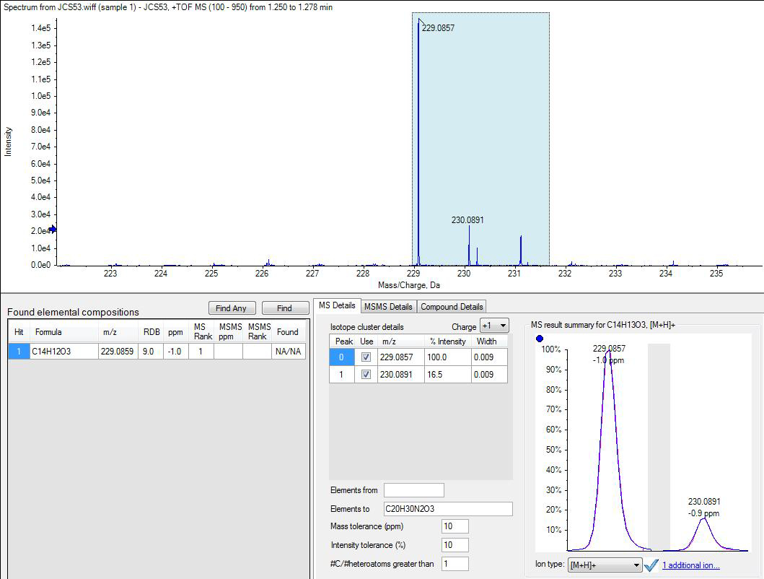

Compound 3n
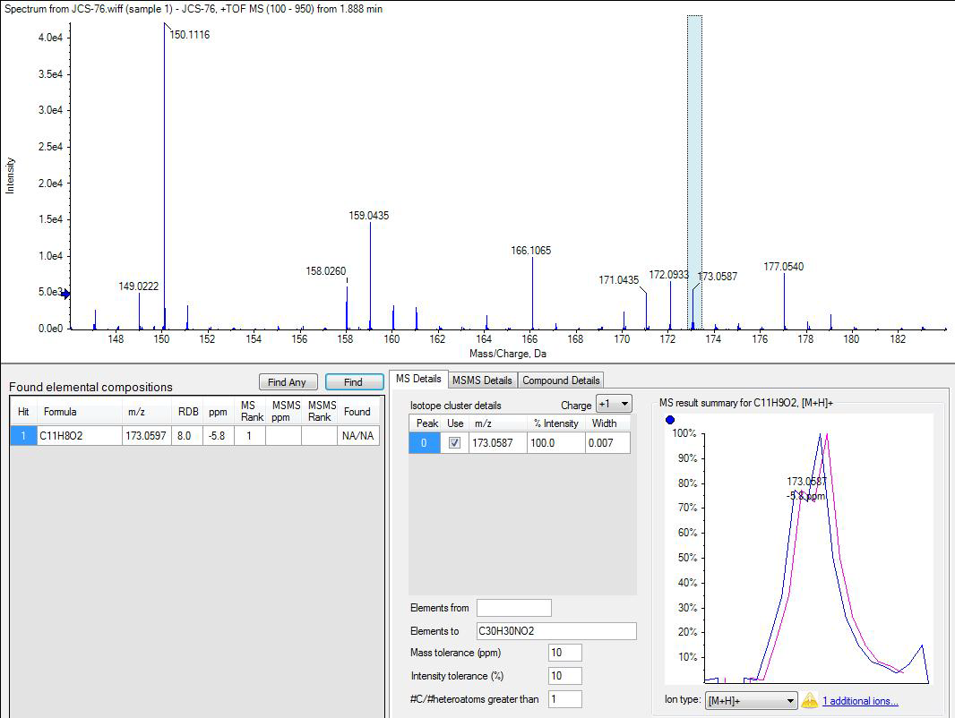

Compound 5a
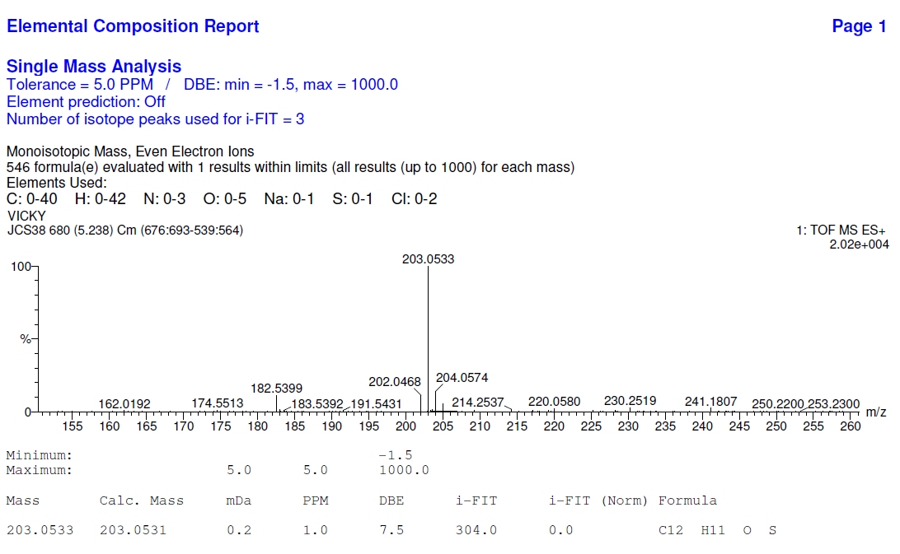

Compound 5d
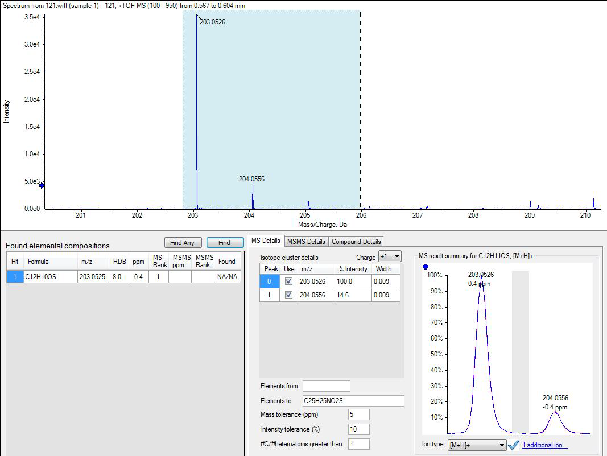

Compound 5h
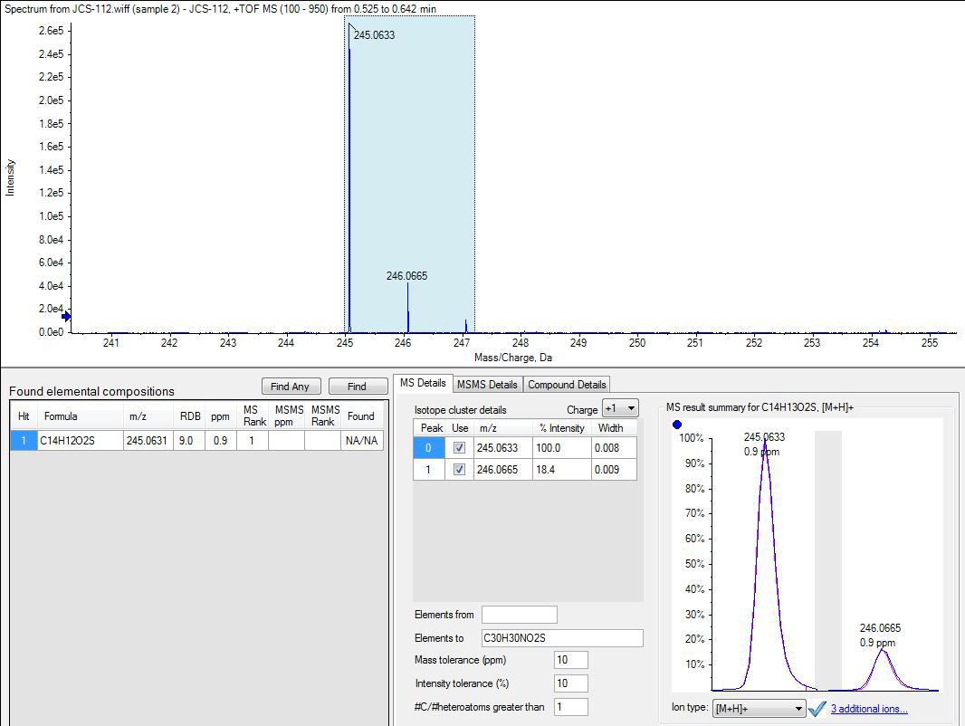

Compound 5i
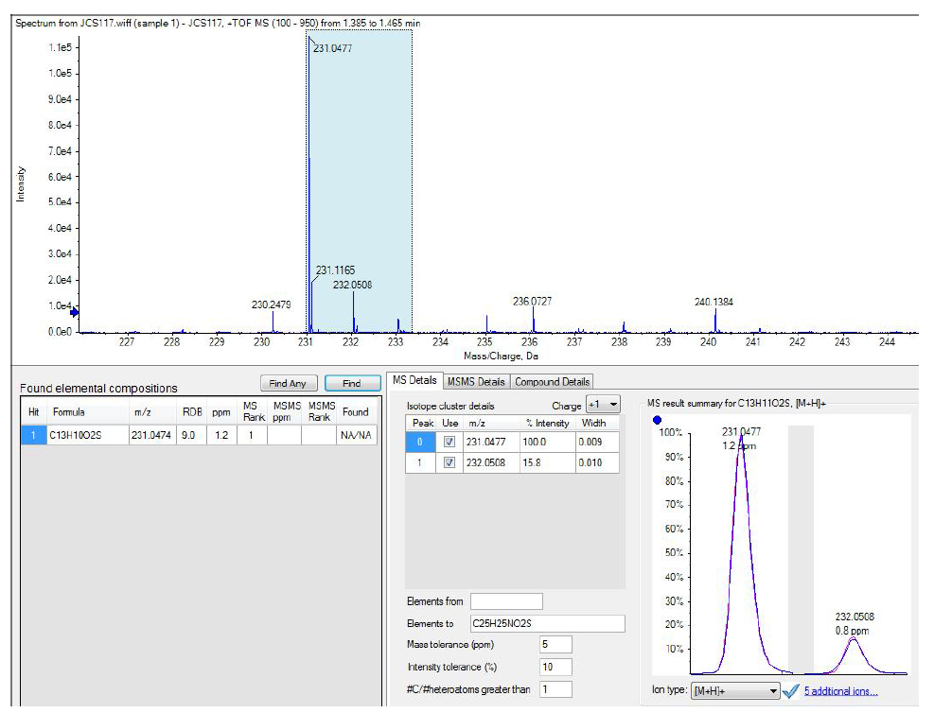

Compound 5j
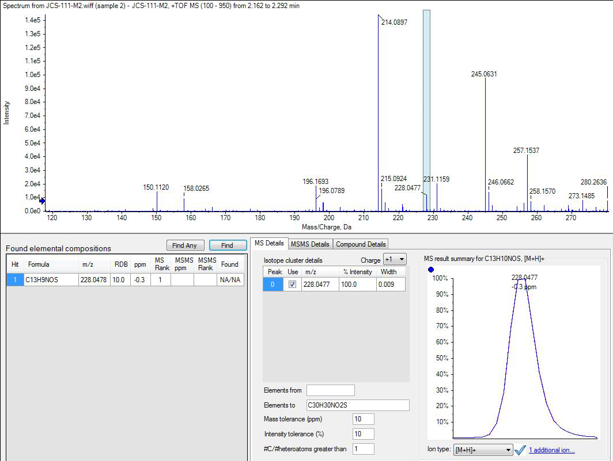

Compound 5k
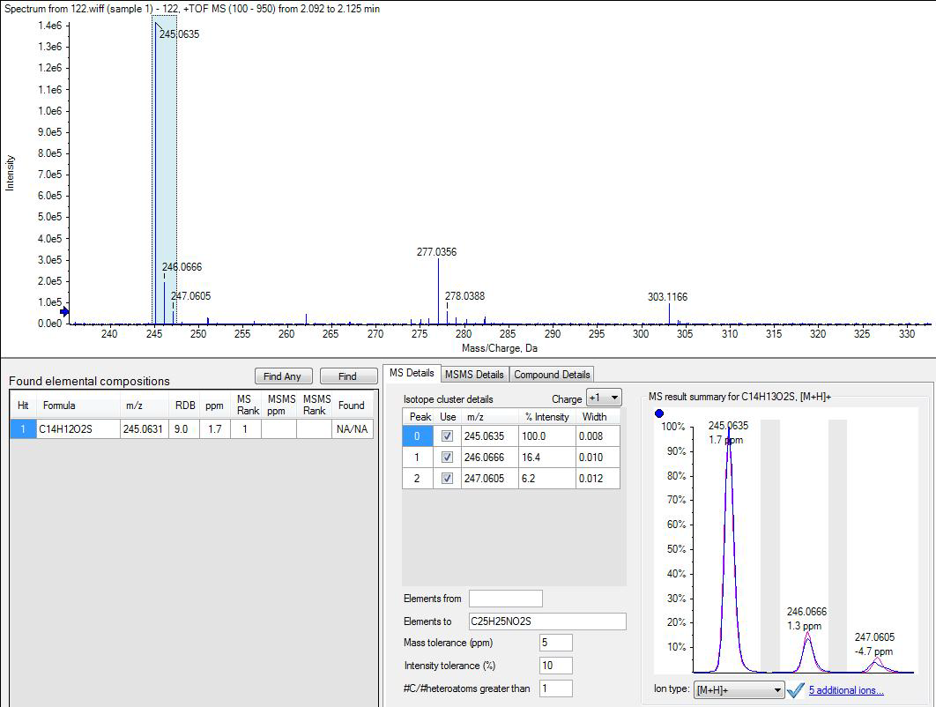

Compound 5l
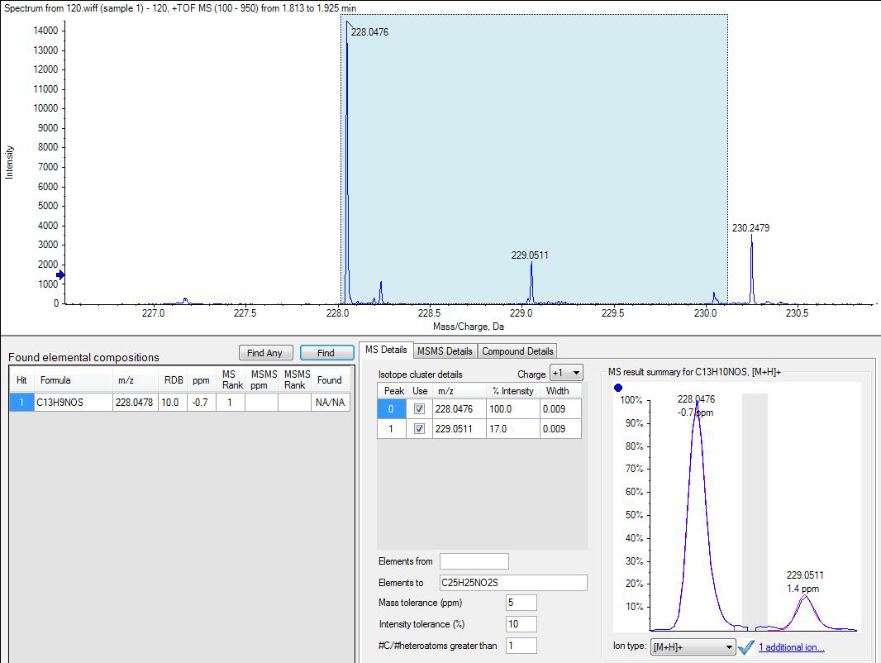

Compound 5l’
