Application of Fe(III)-EDDS Complexes and Soybean Peroxidase in Photo-Fenton Processes for Organic Pollutant Removal: Insights into Possible Synergistic Effects
Silvia Bertolotti^{1,2}, Marco Minella*³, Enzo Laurenti³, Marcello Brigante⁴, Gilles Mailhot⁴, Alessandra Bianco Prevot³
¹ Department of Life Sciences and System Biology, University of Turin, via Accademia Albertina 13, 10123 Turin, Italy
²ALPSTREAM – Alpine Stream Research Center, 102030 Ostana, Italy
³Department of Chemistry, University of Turin, via P. Giuria 7, 10125 Turin, Italy
⁴ Université Clermont Auvergne, CNRS, Institut de Chimie de Clermont-Ferrand, 63000 Clermont–Ferrand, France.
* marco.minella@unito.it

Supplementary Information

Material and methods

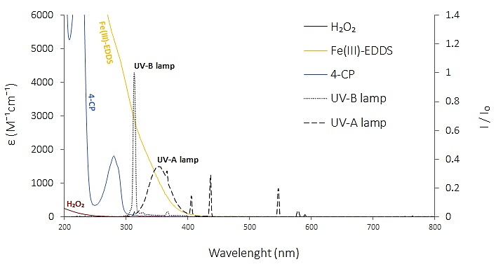
Fig. S1 Absorptivity of the reagents (Fe(III)-EDDS 0.1 mM, H₂O₂ 1.0 mM, 4-CP 0.1 mM,) vs emission spectra of the two lamps (UV-A and UV-B) used for the irradiation.

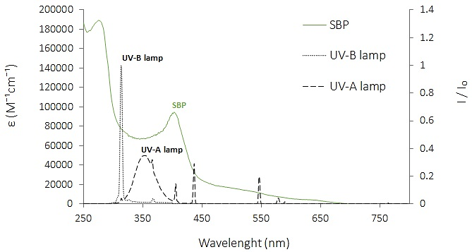
Fig. S2 Specific absorptivity of SBP and emission spectra of the two lamps (UV-A and UV-B) used for the irradiation.

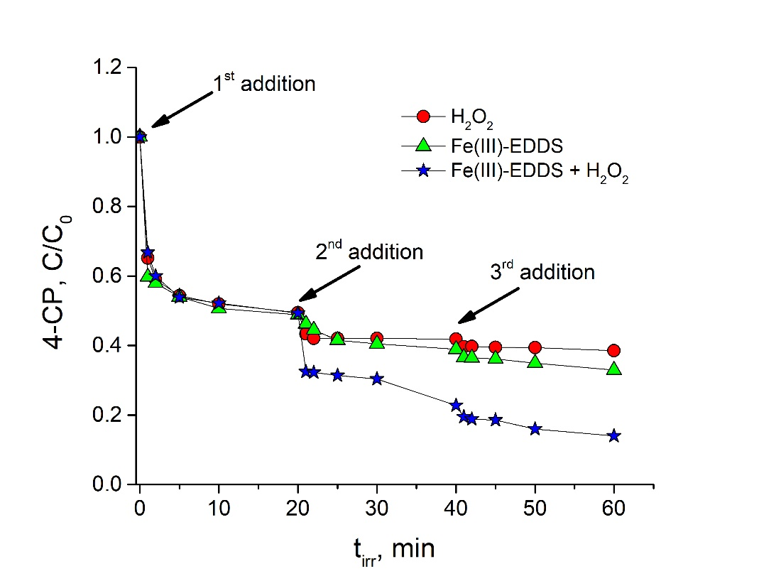
Fig. S3 4-CP degradation as a consequence of 3 consecutive additions (every 20 minutes) of (i) H₂O₂ 0.1 mM, (ii) Fe(III)-EDDS 0.1 mM and (iii) H₂O₂ 0.1 mM + Fe(III)-EDDS 0.1 mM

Results and discussion

Effect of initial pH value
The pH of the solution is a key parameter for the photo-Fenton processes. At different pH the speciation in solution changes and consequently not only the stability of the iron complex, but also the redox properties of the transient species generated change affecting the overall efficiency of the degradation process. For this reason, the 4-CP degradation was investigated (in the presence of Fe(III)-EDDS 0.1 mM and H₂O₂ 0.2 mM) in the pH interval 3-8.
Fig. S4a shows the concentration of 4-CP as a function of the irradiation time at different pH. In all the investigated pH we observed the usual behavior with an effective 4-CP degradation limited to the first part of the experiments (t_{irr} < 20 minutes). The only difference was observed at pH 8, in this case the process had a clear double kinetic regime, a rapid decrease in the first 10 minutes of treatment followed by a monotonic and linear decrease of the concentration from 10 to 120 minutes. Fig. S4b shows the % removal after 120 minutes as a function of the pH. The highest removal was observed at the extreme investigated pH (3 and 8). It is not easy to rationalize this experimental evidence due to numerous consequences that the change of the pH could have on the overall processes. Three possible points to be considered and that can partially justify the observed trends are:
- at acidic pH the concentration of the free Fe³⁺ in solution increases (i.e. the conditional constant of Fe(III)-EDDS decreases as a consequence of the protonation of EDDS) and at pH 3 it has been reported that the photo-Fenton process in the absence of ligands reaches its maximum of efficiency;
- the acid/base speciation of the hydroperoxyl radical (HO₂•/O₂•⁻, pK_{a} = 4.88 [1]) affects significantly its reductant properties toward Fe(III) (see reaction R6-9), the kinetic constant for the reaction between superoxide radical anion and Fe³⁺ and hydroperoxyl radical and Fe³⁺ are 5×10⁷ M⁻¹ s⁻¹ and <1.0×10³ M⁻¹ s⁻1, respectively [2,3,4]. As a consequence, only at pH higher than 4.88 Fe(III) can be easily reduced by O₂•⁻ to give Fe(II) that can react with H₂O₂ to give hydroxyl radical (note that the role of this reaction in the photo-Fenton processes is mitigated by the photochemical reduction of Fe(III)).
- at pH > 8 is has been reported the formation of hydroxylated complex (e.g. Fe(OH)-EDDS^{2–}) that could have peculiar properties from the point of view of their photochemical properties [5].
Fe²⁺ + HO₂• → [Fe(III)(HO₂)]²⁺ k_{Fe(II),HO₂˙} = 1.2×10⁶ M⁻¹ s⁻¹ (R6)
Fe³⁺ + HO₂• → Fe²⁺ + O₂ + H⁺ k_{Fe(III),HO₂˙} < 1.0×10³ M⁻¹ s⁻¹ (R7)
Fe²⁺ + O₂•⁻ + H₂O → [Fe(III)(HO₂)]²⁺ + HO⁻ k_{Fe(II),O₂˙⁻} = 1.0×10⁷ M⁻¹ s⁻¹ (R8)
Fe³⁺ + O₂•⁻ + H₂O → Fe²⁺ + O₂ k_{Fe(III),O₂˙⁻} = 5.0×10⁷ M⁻¹ s⁻¹ (R9)

Fig. S4.(a) Photodegradation of 4-CP at different pH; (b) % removal of 4-CP after 120 min of irradiation. Conditions: [4-CP]₀ = 0.1 mM, [Fe(III)-EDDS] = 0.1 mM, [H₂O₂] = 0.2 mM.

Effect of oxygen in the absence of H₂O₂
The role of the dissolved oxygen in the absence of any additional oxidants (i.e. H₂O₂) was explored. Fig. S5a shows the profiles of 4-CP concentration obtained with tested solutions equilibrated in air, saturated with oxygen and deoxygenated with nitrogen, respectively. After 120 minutes of irradiation the % removal showed the order N₂ < air < O₂ (see Fig. S5b). Different kinetics were observed in the presence and absence of oxygen. With oxygen saturated solutions the 4-CP concentration profile showed the usual initial step and the following plateau (the profiles in air and pure oxygen overlapped). In the absence of oxygen, the behaviour was different and a zero-order kinetics (constant rate in the whole irradiation time explored) was observed. The initial rate of 4-CP transformation was at least 6 times higher in the presence of oxygen than in anoxic conditions. Wu et al. [6,7] observed a similar decrease in the degradation of 4-tertbutylphenol in the absence of dissolved oxygen.
The observed experimental evidences can be interpreted considering the reaction between the radical EDDS• (formed from the photolysis of Fe(III)-EDDS complex) with oxygen that promotes the formation of HO₂•/O₂•⁻ able not only to reduce Fe(III) (especially at pH > 4.88, see above), but also to dismutate to give H₂O₂. Furthermore, the dissolved oxygen reacts with the radical species generated from the oxidation of 4-CP (4-CPOH• produced for addition of the hydroxyl radical to the 4-CP aromatic ring or 4-CP^{• +} formed through the monoelectronic direct oxidation of the aromatic substrate) to give the related hydroquinone or benzoquinone promoting its degradation. Furthermore, the degradation of 4-CP also in anoxic condition suggests that other reactive species different from •OH (generated through the reactions R1-R5 only in the presence of dissolved oxygen) can be operative in this conditions, as an example the production of non-radical iron-based reactive species has been often proposed in the presence of Fenton and Fenton-like processes alternatively to •OH [8,9,10,11].
Fig. S5. (a) Concentration of 4-CP as a function of the irradiation time in air equilibrated, oxygen saturated and N₂ stripped solutions; (b) % removal of 4-CP after 120 min of irradiation in the different tested conditions. Conditions: [4-CP]₀ = 0.1 mM, [Fe(III)-EDDS] = 0.1 mM, no [H₂O₂], initial pH = 5.5.

References

[1] Bielski, B. H. J., Cabelli, D. E., Arudi, R. L., & Ross, A. B. (1985). Reactivity of HO₂/O⁻₂ Radicals in Aqueous Solution. Journal of Physical and Chemical Reference Data, 14(4), 1041– https://doi.org/10.1063/1.555739
[2] Rush, J. D., & Bielski, B. H. J. (1985). Pulse radiolytic studies of the reaction of HO₂/O₂⁻ with Fe (II)/Fe(III) ions. The reactivity of HO₂/O₂⁻ with ferric ions and its implication on the occurrence of the Haber-Weiss reaction. The Journal of Physical Chemistry, 89(23), 5062–5066. https://doi.org/10.1021/j100269a035
[3] Rothschild, W. G., & Allen, A. O. (1958). Studies in the Radiolysis of Ferrous Sulfate Solutions: III. Air-Free Solutions at Higher pH. Radiation Research, 8(2), 101–110 . https://doi.org/10.2307/3570600
[4] Jayson, G. G., Parsons, B. J., & Swallow, A. J. (1973). Oxidation of ferrous ions by perhydroxyl radicals. Journal of the Chemical Society, Faraday Transactions 1: Physical Chemistry in Condensed Phases, 69, 236–242. https://doi.org/10.1039/F19736900236
[5] Orama, M., Hyvönen, H., Saarinen, H., & Aksela, R. (2002). Complexation of [S,S] and mixed stereoisomers of N,N′-ethylenediaminedisuccinic acid (EDDS) with Fe(III), Cu(II), Zn(II) and Mn(II) ions in aqueous solution. Journal of the Chemical Society. Dalton Transactions, 24, 4644–4648. https://doi.org/10.1039/B207777A
[6] Wu, Y., Brigante, M., Dong, W., de Sainte-Claire, P., & Mailhot, G. (2014). Toward a Better Understanding of Fe(III)–EDDS Photochemistry: Theoretical Stability Calculation and Experimental Investigation of 4- tert -Butylphenol Degradation. The Journal of Physical Chemistry A, 118(2), 396–403. https://doi.org/10.1021/jp409043e
[7] Wu, Y., Passananti, M., Brigante, M., Dong, W., & Mailhot, G. (2014). Fe(III)–EDDS complex in Fenton and photo-Fenton processes: from the radical formation to the degradation of a target compound. Environmental Science and Pollution Research, 21, 12154–12162. https://doi.org/10.1007/s11356-014-2945-1
[8] Ghosh, A., Mitchell, D. A., Chanda, A., Ryabov, A. D., Popescu, D. L., Upham, E. C., Collins, G. J., & Collins, T. J. (2008). Catalase−Peroxidase Activity of Iron(III)−TAML Activators of Hydrogen Peroxide. Journal of the American Chemical Society, 130(45), 5116–15126. https://doi.org/10.1021/ja8043689
[9] De Oliveira, F. T., Chanda, A., Banerjee, D., Shan, X., Mondal, S., Que JR., L., Bominaar, E. L., Münck, E., & Collins. T. J. (2007). Chemical and Spectroscopic Evidence for an Fe^{V}-Oxo Complex. Science, 315(5813), 835–838. https://doi.org/10.1126/science.1133417
[10] Minero, C., Lucchiari, M., Maurino, V., & Vione, D. (2013). A quantitative assessment of the production of •OH and additional oxidants in the dark Fenton reaction: Fenton degradation of aromatic amines. RSC Advances, 3(48), 26443–26450. https://doi.org/10.1039/c3ra44585b
[11] Farinelli, G., Minella, M., Sordello, F., Vione, D., & Tiraferri, A. (2019). Metabisulfite as an Unconventional Reagent for Green Oxidation of Emerging Contaminants Using an Iron-Based Catalyst. ACS Omega, 4(24), 20732–20741. https://doi.org/10.1021/acsomega.9b03088

