SUPPLEMENTARY INFORMATION

- General information
S1. UPLC-QqTOF-MS analysis for water samples
A liquid chromatography-quadrupole time-of-flight mass spectrometry (UPLC-QqTOF-MS) system was used in order to identify and quantify the pharmaceutical compounds selected in this study. Specifically, LC separation was achieved using an ACQUITY I-Class UPLC system (Waters Corporation, Milford, MA, USA) coupled with an ACQUITY BEH C18 (100 mm x 2.1 mm, 1.7 µm) column. Mobile phases were 0.1% formic acid in MilliQ water (solvent A) and 0.1 % MeOH (solvent B). The gradient used ranged from 5% to 95% of solvent B: Initially was increased from 5% to 25% in 1.50 min, after increased from 25% to 80%, kept at 80% during 1 min, increased in 8 min and from 80% to 95% in 1 min and finally returned to its initial conditions in 4 min. The total analysis run time was 15.50 min. The flow rate was adjusted at 0.25 mL/min and 10 µL of sample was injected. The LC system was connected to a Bruker Daltonics, maXis q-TOF mass spectrometer equipped with an electrospray ion source (Bruker Daltonics, Bremen, Germany). The ion source settings were as follows: nitrogen was used as nebulizer, drying and collision gas; the nebulizer pressure was 2 bars, the drying gas flow was 8 L/min, the dry gas temperature was 200 ºC and the capillary voltage was 4500 V. The system worked via TOF MS survey scan (resolving power ≥ 55000 FWHM). The target pharmaceuticals were identified and reported from accurate-mass scan data using the software Target Analysis (1.3) and Data Analysis (4.2) from Bruker. In order to simplify, all analysis was performed in positive ionization mode.

S2. Solid-phase extraction (SPE) protocol
SPE was performed with commercial Oasis® HLB (200 mg, 6 cm³) using a Visiprep vacuum manifold. Before use, the cartridges were conditioned with 4 ml of methanol and 4 ml of Milli-Q water (pH adjusted to 8, same pH as the real water samples, in order not to alter their composition). Samples (100 ml) were passed through the cartridges at a flow rate of 1 ml/min. The cartridges were then rinsed with 4 ml of ultrapure water and vacuum dried for 10 min to remove excess of water. Finally, the retained compounds were eluted with 8 ml MeOH (4 + 4). The extracts were evaporated to dryness under a gentle nitrogen stream and reconstituted with 1 ml of H₂O/MeOH (95:5, v/v) containing 0.1% formic acid. Final extracts were filtered through a 0.22 μm PTFE filter.

S3. Pathogenic viruses and protozoa analytical procedure
Levels of somatic coliphages were quantified by the double-layer agar (DAL) plaque assay technique using as the host strain E. coli C (ATCC 13706) and E. coli WG5 (ATCC 700078). One or five millilitres per concentrate per samples were treated with (10%) of chloroform to disrupt all the bacteria cells. All samples were centrifuged at 2500 ×g for 5 min at 4 °C and the supernatant was filtered. For the lower and upper layers in the double agar test, tryptone-yeast- extract glucose (TYG) agar and TYG semisolid agar. Plates were incubated at 37 °C for 24 h and the levels of total coliphages were expressed in plaque forming units per 100 mL (PFU/100 mL) as described ISO 10705-2. In addition, DAL plaque assay was used to quantify of total coliphages was applied after the concentration of 100 mL water samples (Méndez et al., 2004), as recommended ISO 10705-3.
For the analysis of Clostridium perfringens spores, one millilitre of this thioglycollate culture was inoculated in sporulation broth and incubated at 37 C for 72 h in anaerobic conditions. After the incubation, the spores were recovered by centrifugation (10,000 rpm, 15 min). The cultures were washed and the suspension of spores was prepares as described ISO 14189.

- Tables
Table S1. Physico-chemical properties of selected pharmaceutical compounds
 | Drug type | Formula | Molecular Weight  (g/mol) | Log Kow | pKa
Acetaminophen  (ACT) | Analgesic | C₃₇H₆₇NO₁₃ | 151.16 | 3.06 | 8.9
Amoxicillin  (AMX) | Antibacterial | C₁₆H₁₉N₃O₅S | 365.4 | 0.87 | 2.6
Carbamazepine  (CBZ) | Anticonvulsant | C₁₅H₁₂N₂O | 236.3 | 2.45 | 15.9, -3.8
Chloroquine  (CHL) | Antimalarial | C₁₈H₂₆ClN₃ | 319.9 | 4.63 | 10.1
Diclofenac  (DCF) | Anti-inflammatory | C₁₄H₁₁C_{l2}NO₂ | 296.1 | 4.51 | 3.9
Erythromycin  (ERY) | Antibacterial | C₃₇H₆₇NO₁₃ | 733.9 | 3.06 | 8.8
Haloperidol  (HLP) | Antipsychotic | C₂₁H₂₃ClFNO₂ | 375.9 | 4.30 | 8.65
Ketoprofen  (KTP) | Anti-inflammatory | C₁₆H₁₄O₃ | 254.3 | - | 3.98
Naproxen  (NPX) | Anti-inflammatory | C₁₄H₁₄O₃ | 230.26 | 3.18 | 4.18
Sulfamethoxazole  (SMX) | Anticonvulsant | C₁₀H₁₁N₃O₃S | 253.28 | 0.89 | pKa1 = 1.6 pKa2 = 5.7
Tetracycline  (TCL) | Antibacterial | C₂₂H₂₄N₂O₈ | 444.4 | -1.37 | 7.68, 3.3
Trazodone  (TRZ) | Antidepressant | C₁₉H₂₂ClN₅O | 371.9 | 3.21 | 6.79
*Data from PubChem (https://pubchem.ncbi.nlm.nih.gov/) and Network of reference laboratories, research centres and related organisations for monitoring of emerging environmental substances (https://www.norman-network.net/)

Table S2. SPE recovery test for selected pharmaceuticals.
Compound | Recovery (%)
ACT | 88 ± 4
AMX | 71 ± 8
CBZ | 97 ± 2
CHL | 82 ± 5
DCF | 78 ± 6
ERY | 84 ± 7
HLP | 81 ± 6
KTP | 95 ± 3
NPX | 92 ± 4
SMX | 91 ± 5
TCL | 85 ± 7
TRZ | 79 ± 6
*Values based on triplicate spiked samples analysis

Table S3. Properties of commercial ceramic microfiltration membranes tested.
 | Membrane types
 | M1 | M2 | M3 | M4
Membrane surface area (m²) | 0.24 | 0.5 | 0.76 (0.38 each) | 0.86 (0.43 each)
Pore size (µm) | 0.4 | 0.1 | 0.1 | 0.1
Outside diameter (mm) | 25 | 25 | 25 | 41
Number of channels | 19 | 61 | 19 | 19
Chanel diameter (mm) | 3.5 | 2.2 | 2.8 | 6
Length specific membrane area (m²/m) | 0.20 | - | - | 0.358
Total length (mm) | 1178 | 1178 | 1178 | 1200
Maximum flow (L/h) | 3600 | - | - | 9670
Hydraulic flow (mm) | - | 2.2 | 2.8 | 3.87

- Figures
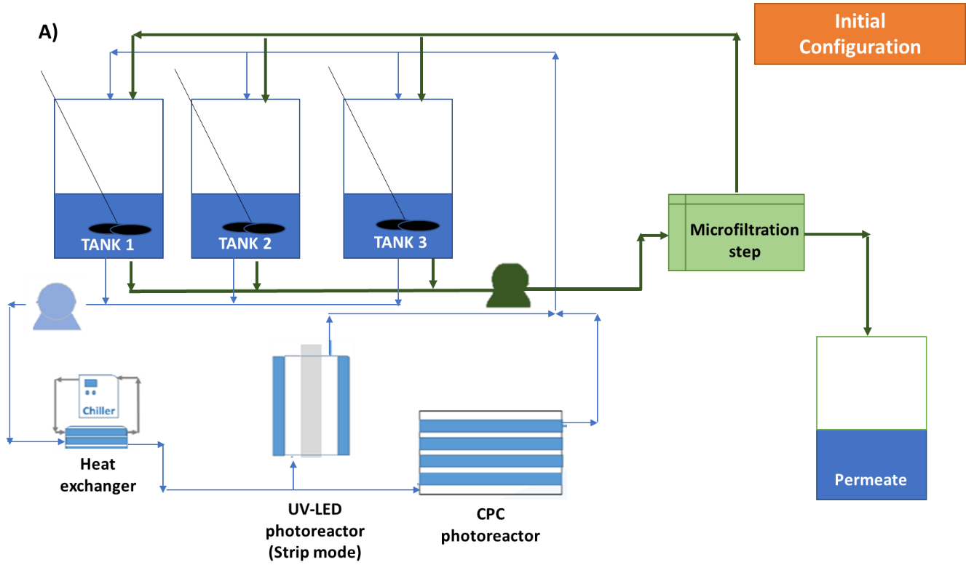

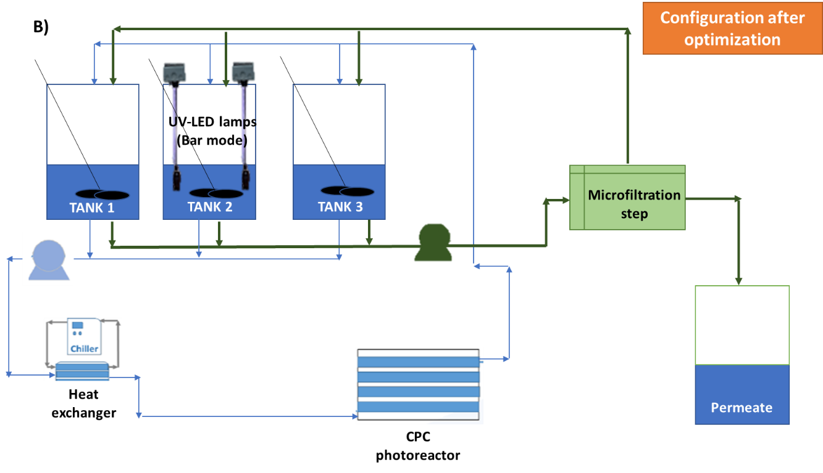

Fig. S1. Hydraulic scheme of the proposed tertiary treatment: a) initial configuration; b) configuration after optimization.

A)
B)
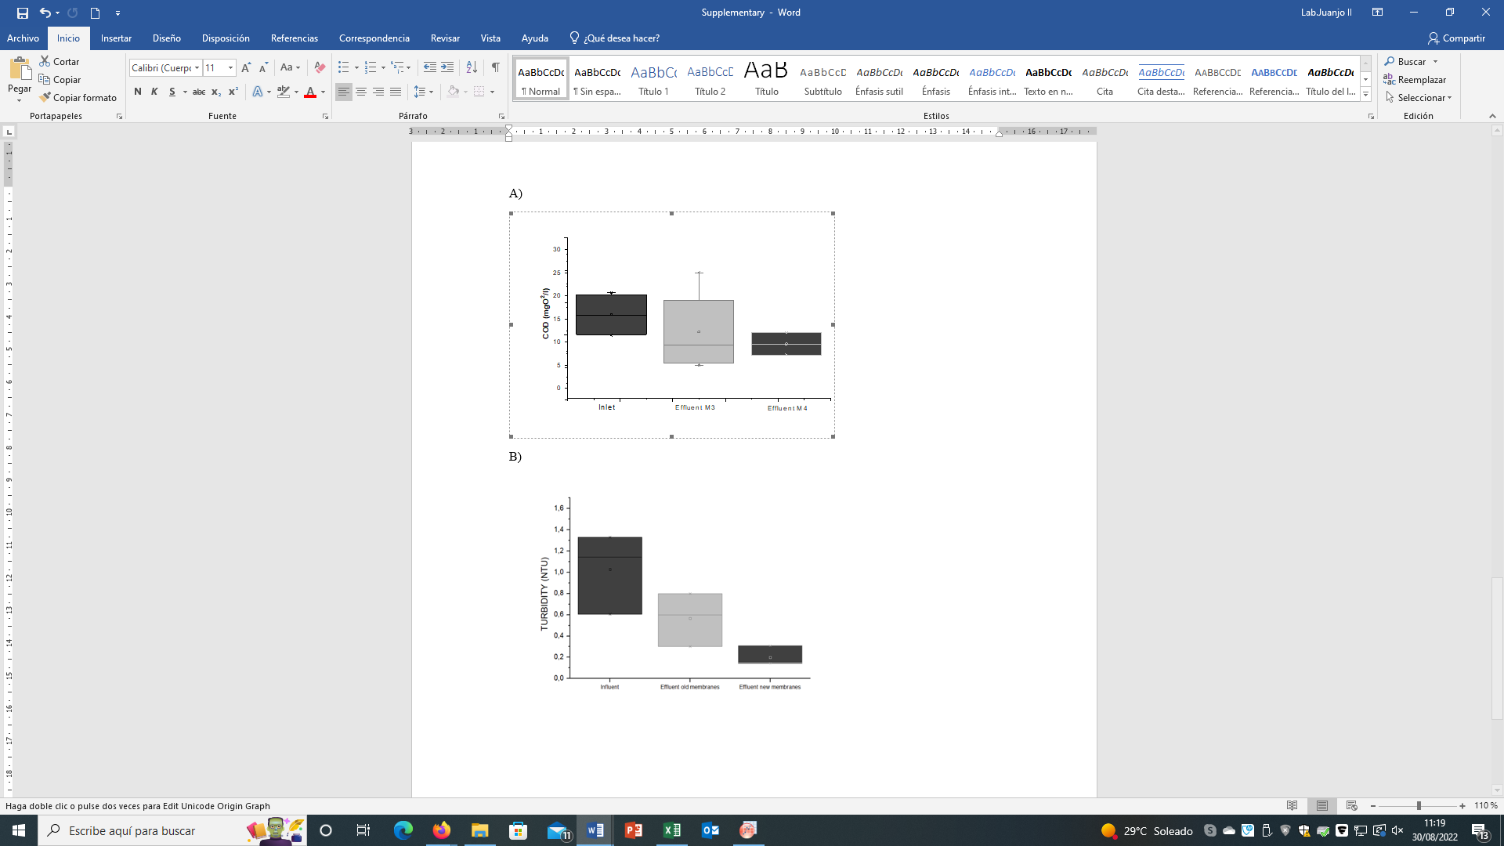
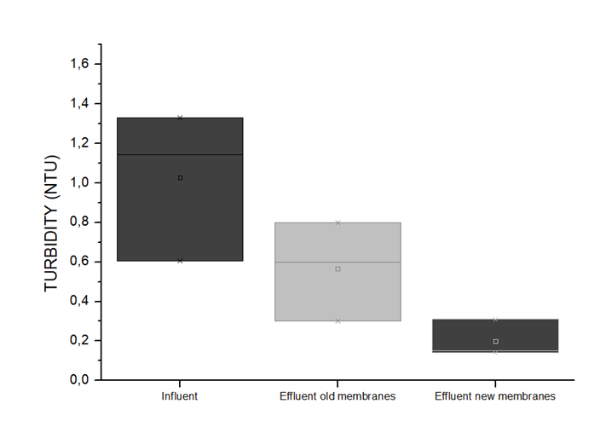

Fig. S2. COD and Turbidity removal efficiencies using M3 and M4 as a final filtration step.

