Verjk31012023
Supplementary Information
Photocatalytic degradation of gaseous pollutants on nanostructured TiO₂ films of various thickness and surface area

Michal Baudys¹, Eleonore Berthet¹, Jan M. Macak^{2,3}, Miloslav Lhotka¹ Josef Krysa¹

1 Department of Inorganic Technology, University of Chemistry and Technology Prague, Czech Republic. krysaj@vscht.cz
2 Center of Materials and Nanotechnologies, University of Pardubice, Czech Republic.
3 Central European Institute of Technology, Brno University of Technology, Brno, Czech Republic.

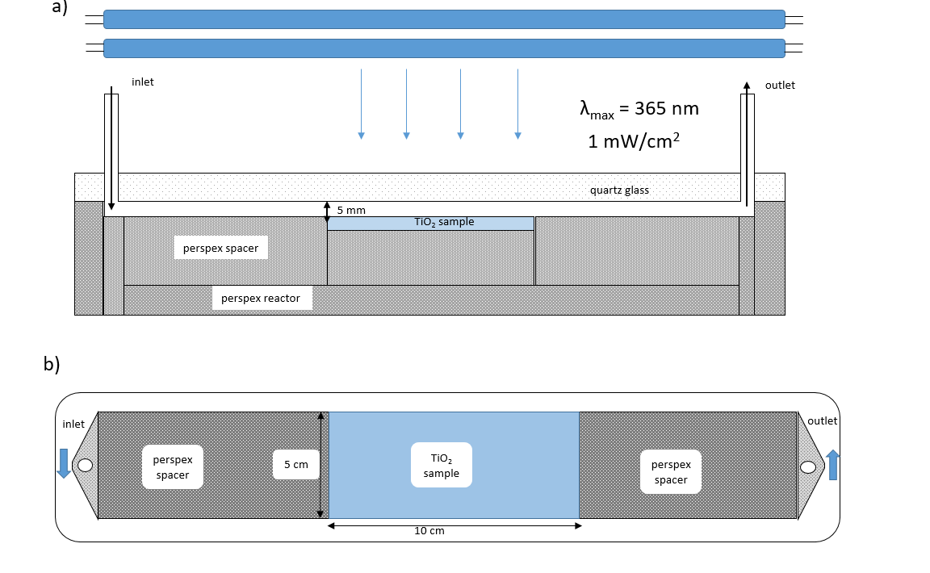

Fig. S1. Scheme of the geometry of the ISO flow-through photoreactor. a) side view, b) top view.

The photoreactor was made of Perspex plates; only the upper part was a fused silica plate. Glass substrates with a TiO₂ layer (5 cm × 10 cm) were irradiated by UV A light (2 fluorescent tubes with an emission maximum of 365 nm). The UV irradiance of 1 mW/cm² was set by changing the distance between the UV light source and the photoreactor. Test gas was introduced into the photoreactor using Swagelock connectors. Perspex spacers were put on both sides of the sample in order to maintain a constant cross section throughout the reactor. The cross-section area between the fused silica plate and the substrate covered with the TiO₂ layer was 0.5 × 5 cm, i.e. 2.5 cm². A flow rate of 1 dm³/min (16.7 cm³/s) thus corresponded to a flow velocity of 6.7 cm/s.

Table S1. Properties of studied commercial TiO₂ powders.
Powder | Producer | Phase Composition XRD | Crystal size (nm)  XRD | S_{BET} (m²/g) | Chlorides (XRF) w% | Sulphates  (XRF) w%
CG 300 | Precheza | 100% anatase | 5 | 300 | ≤0.03 | 0.7
P25 | Evonik | 71% anatase | 22 | 46 | 0.17 | ≤0.03
P25 | Evonik | 29% rutile | 41 | 46 | 0.17 | ≤0.03
P90 | Evonik | 77% anatase | 13 | 109 | 0.30 | ≤0.03
P90 | Evonik | 23% rutile | 15 | 109 | 0.30 | ≤0.03

Fig. S2. X-ray diffraction patterns of studied TiO₂ powders red - P25, green – P90, black – CG300

Fig. S3. Nitrogen adsorption isotherm of a) P90 powder, b) P25 powder and c) CG300 powder.

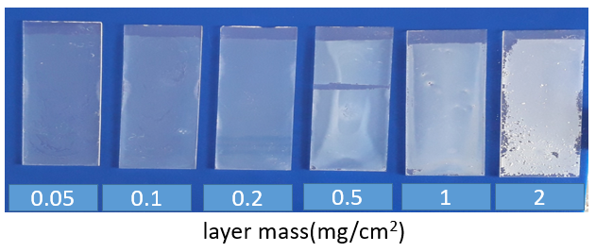
Fig S4. Photographs showing TiO₂ layers of different layer mass prepared by drop casting from a P90 powder suspension.

Table S2. Thickness of TiO₂ drop-cast layers and their calculated porosity and effective TiO₂ thickness.
Powder | Layer mass (mg/cm²) | Layer thickness  (μm) | Porosity  (%) | effective TiO₂ thickness (μm)
P90 | 0.05 | 0.53 ± 0.06 | 75 | 0.132
P90 | 0.15 | 0.98 ± 0.18 | 60 | 0.392
P90 | 0.27 | 1.37 ± 0.15 | 51 | 0.671
P90 | 0.67 | 3.41 ± 0.56 | 50 | 1.70
P90 | 1.05 | 4.54 ± 0.18 | 41 | 2.68
P90 | 2.32 | 9.42 ±0.37 | 37 | 5.93
P25 | 0.05 | 0.63±0,1 | 60 | 0.252
P25 | 0.1 | 0.80±0.1 | 67 | 0.264
P25 | 0.2 | 1.6 ± 0.2 | 69 | 0.496
P25 | 0.48 | 3.8 ± 0.2 | 69 | 1.18
P25 | 1.01 | 6.5±0.2 | 60 | 2.68
P25 | 2.0 | 13.5±0.3 | 62 | 5.13
CG300 | 0.32 | 1.7±0.4 | 52 | 0.816
CG300 | 0.5 | 3.0±0.5 | 58 | 1.26

Fig S5. Typical profilometric trace of a step – glass/TiO₂_P25 layer (layer mass 0.5 mg/cm²)

Fig S6. Nitrogen adsorption isotherms a) and Krypton adsorption isotherms (b) of P90 layers with different layer mass (mg/cm²).

1

Fig. S7. Nitrogen adsorption isotherms a) and Krypton adsorption isotherms (b) of P25 layers with different layer mass (mg/cm²)

Fig. S8. Comparison of the photocatalytic activity of P25 in hexane and acetaldehyde decomposition.

Fig S9a. First use of a layer made with P25 (layer mass 0.5 mg/cm²).

Fig. S9b. Second use of the layer made with P25 (layer mass 0.5 mg/cm²)

Fig S10. Conversion of a mixture containing acetaldehyde, acetone, heptane and toluene for studied TiO₂ layers.

