Supplementary Material for

Fluctuation-mediated orbital rotation of microparticles in non-coaxially counter-propagating optical tweezers
Kenji Setouraª, Takayasu kakimoto^{b}, Hiroshi Miyasaka*^{b}, and Syoji Ito* ^{b,c}
ª Department of Mechanical Engineering, Kobe City College of Technology, Kobe, Hyogo 651-2194, Japan
^{b} Division of Frontier Materials Science and Center for Promotion of Advanced Interdisciplinary Research, Graduate School of Engineering Science, Osaka University, Toyonaka, Osaka 560-8531, Japan.
^{c} Research Institute for Light-induced Acceleration System (RILACS), Osaka Metropolitan University, 1-2, Gakuen-cho, Naka-ku, Sakai, Osaka 599-8570, Japan

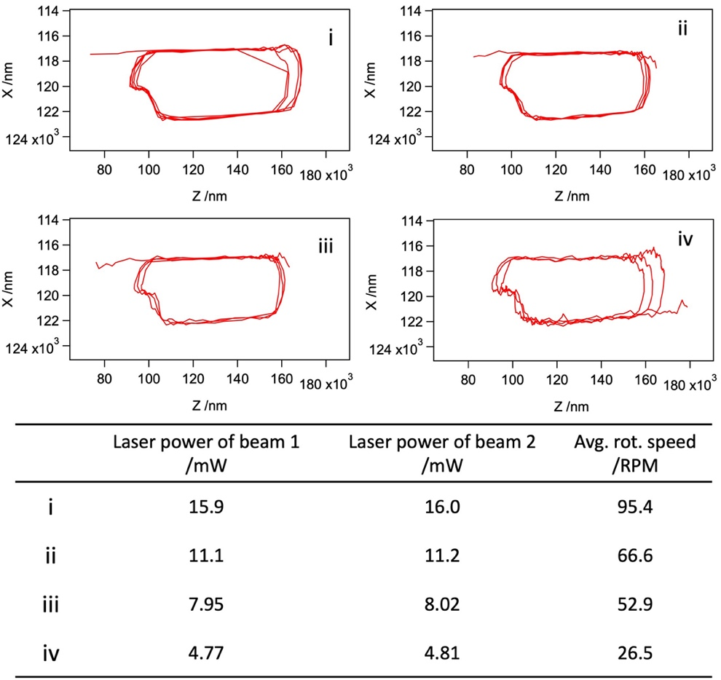

Fig. SM1. Trajectories of the single 1-µm polystyrene particles under different incident laser powers. The incident powers of the beam 1 and 2 for the trajectories i - iv and corresponding averaged rotational speed of the microparticles are listed in the table.

