Supplementary Information

Selective, broad-spectrum antiviral photodynamic disinfection with dicationic imidazolyl chlorin photosensitizers

Zoe A. Arnaut ª, Sara M. A. Pinto ª, Rafael T. Aroso ª, Anita S. Amorim ª, Catarina S. Lobo ^{b}, Fabio A. Schaberle ª, Dina Pereira ^{c,d}, Jisette Núñez ^{c,d}, Sandra C. C. Nunes ª, Alberto A. C. C. Pais ª, Paulo Rodrigues-Santos ^{c,d,e}, Luis Pereira de Almeida ^{c,d}, Mariette M. Pereira ^{a,*} and Luis G. Arnaut ^{a,*}

ª CQC-IMS, Chemistry Department, University of Coimbra 3004-535 Coimbra, Portugal
^{b} LaserLeap Technologies, R. Col. Júlio Veiga Simão, CTCV, Ed. B, 3025-307 Coimbra, Portugal
^{c} Center for Neuroscience and Cell Biology (CNC), University of Coimbra, 3004-517 Coimbra, Portugal
^{d} Center for Innovation in Biomedicine and Biotechnology (CIBB), University of Coimbra, Coimbra, Portugal
^{e} Laboratory of Immunology and Oncology, Center for Neuroscience and Cell Biology (CNC), University of Coimbra, Coimbra, Portugal

Table S1. Optimization of the reduction of IP-H using NH₂NH₂.H₂O
Figure S1. Electronic density maps of atropisomers of di-cationic imidazolyl chlorins with the larger substituents on opposite side of the macrocycle, without counterions, from total SCF density mapped with ESP, isovalue=0.0004 at B3LYP/6-31G(d,p) level.
Figure S2. Structures of lower-energy conformers of 5,15-bis(1-methyl-3-ethylimidazol-2-yl)chlorin (IC-H-Et²⁺) and 5,15-bis(1-methyl-3-(1,1,1-trifluoroethyl)imidazol-2-yl)chlorin (IC-H-FEt²⁺) optimized at the B3LYP/6-31G(d,p) level.
Figure S3. ¹H NMR of 5,15-bis(1-methylimidazol-2-yl)porphyrin IP-H in deuterated acetone.
Figure S4. ¹H NMR of 5,15-bis(1,3-dimethylimidazol-2-yl)porphyrin diiodide IP-H-Me²⁺ in deuterated DMSO.
Figure S5. ESI-TOF Mass spectra of 5,15-bis(1,3-dimethylimidazol-2-yl)porphyrin diiodide IP-H-Me²⁺.
Figure S6. ¹H NMR of 5,15-bis(1-methyl-3-ethylimidazol-2-yl)porphyrin diiodide IP-H-Et²⁺ in deuterated DMSO.
Figure S7. ESI-TOF Mass spectra of 5,15-bis(1-methyl-3-ethylimidazol-2-yl)porphyrin diiodide IP-H-Et²⁺.
Figure S8. ¹H NMR of 5,15-bis(1-methyl-3-(1,1,1-trifluoropropyl)imidazol-2-yl)porphyrin diiodide IP-H-FPr²⁺ in deuterated methanol.
Figure S9. ¹⁹F NMR of 5,15-bis(1-methyl-3-(1,1,1-trifluoropropyl)imidazol-2-yl)porphyrin diiodide IP-H-FPr²⁺ in deuterated methanol.
Figure S10. ESI-TOF Mass spectra of 5,15-bis(1-methyl-3-(1,1,1-trifluoropropyl)imidazol-2-yl)porphyrin diiodide IP-H-FPr²⁺.
Figure S11. ¹H NMR of 75:25 mixture of 5,15-bis(1-methylimidazol-2-yl)chlorin IC-H and 5,15-bis(1-methylimidazol-2-yl)porphyrin IP-H, respectively, in deuterated acetone.
Figure S12. ESI-TOF Mass spectra of 5,15-bis(1-methylimidazol-2-yl)chlorin IC-H.
Figure S13. ¹H NMR of 5,15-bis(1,3-dimethylimidazol-2-yl)chlorin diiodide IC-H-Me²⁺ in deuterated methanol.
Figure S14. ESI-TOF Mass spectra of 5,15-bis(1,3-dimethylimidazol-2-yl)chlorin diiodide IC-H-Me²⁺.
Figure S15. HPLC of 5,15-bis(1,3-dimethylimidazol-2-yl)chlorin diiodide IC-H-Me²⁺ with detection at 385 nm (upper panel) or at 405 nm (lower panel). C18 reversed-phase packing column (Luna® 5 μm C18(2) 100 Å, 150 × 4.6 mm, RP) and methanol:buffer solution of ammonium acetate (85:15, v:v), adjusted to pH 8.5 with ammonium hydroxide solution, as mobile phase. The elution was achieved under isocratic elution conditions with a flow rate of 1.500 mL/min at 30 °C.
Figure S16. Changes in absorption spectra observed with prolonged illumination of the porphyrins and chlorins in their lowest energy absorption bands.
Figure S17. Steady-state phosphorescence emission of singlet oxygen observed after excitation of porphyrins, chlorins or the reference methylene blue (MB) in ethanol. Excitation of porphyrins and chlorins were at 625 nm and 650 nm, respectively
Figure S18. Toxicity of IC-H-Me²⁺ towards HEK-293T or HEK-293T-hACE2 cells. A) Cytotoxicity in the dark towards HEK-293T cells after 12 h of incubation. B) Phototoxicity at 4 J cm^{–2} towards HEK-293T cells after 12 h of incubation. C) Phototoxicity at 4 J cm^{–2} HEK-293T-hACE2 cells after 12 h of incubation.
Figure S19. Typical RT-qPCR calibration curve used to determine the efficiency, linear range, and reproducibility of a qPCR assay.

Table S1. Optimization of IP-H reduction using NH₂NH₂.H₂O. ª

Entry | Solvent | Catalyst | NH₂NH₂.H₂O equiv. | Chlorin^{b} | Bacteriochlorin^{b}
1 | DMF | -- | 10 + 10 | ++ | +
2 | DMF^{c} | -- | 40 | +++ | ++
3 | Xylene | -- | 10 + 10 | +++ | +++
4 | Xylene^{c} | -- | 40 | +++ | +++
5 | Xylene | Pd/C | 40 | +++ | +++
6 | DMF | Pd/C | 40 | +++++ | +
ª Reaction conditions: time = 2 h; temperature = 70 ºC, aerobic open vessel conditions.
^{b} Qualitative assessment based on relative intensity of UV-vis absorption bands at 550 and 650 nm.
^{c} Reaction performed under inert atmosphere.

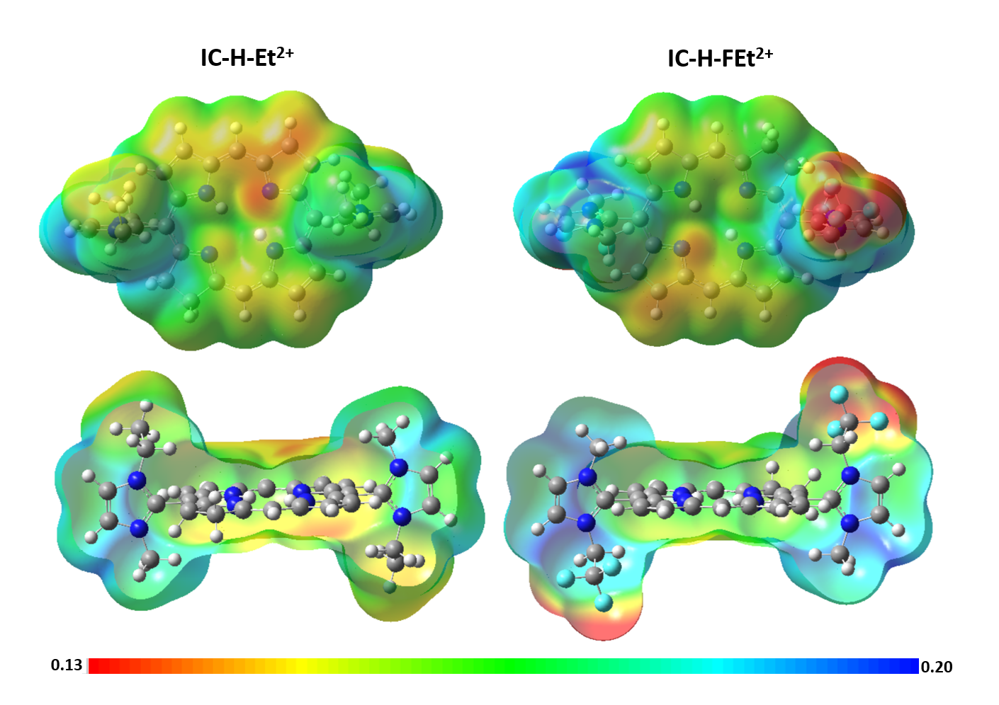
Figure S1. Electronic density maps of atropisomers of di-cationic imidazolyl chlorins with the larger substituents on opposite side of the macrocycle, without counterions, from total SCF density mapped with ESP, isovalue=0.0004 at B3LYP/6-31G(d,p) level, in atomic units(e/a₀³). IC-H-Et²⁺: 5,15-bis(1-methyl-3-ethylimidazol-2-yl)chlorin; IC-H-FEt²⁺: 5,15-bis(1-methyl-3-(1,1,1-trifluoroethyl)imidazol-2-yl)chlorin.

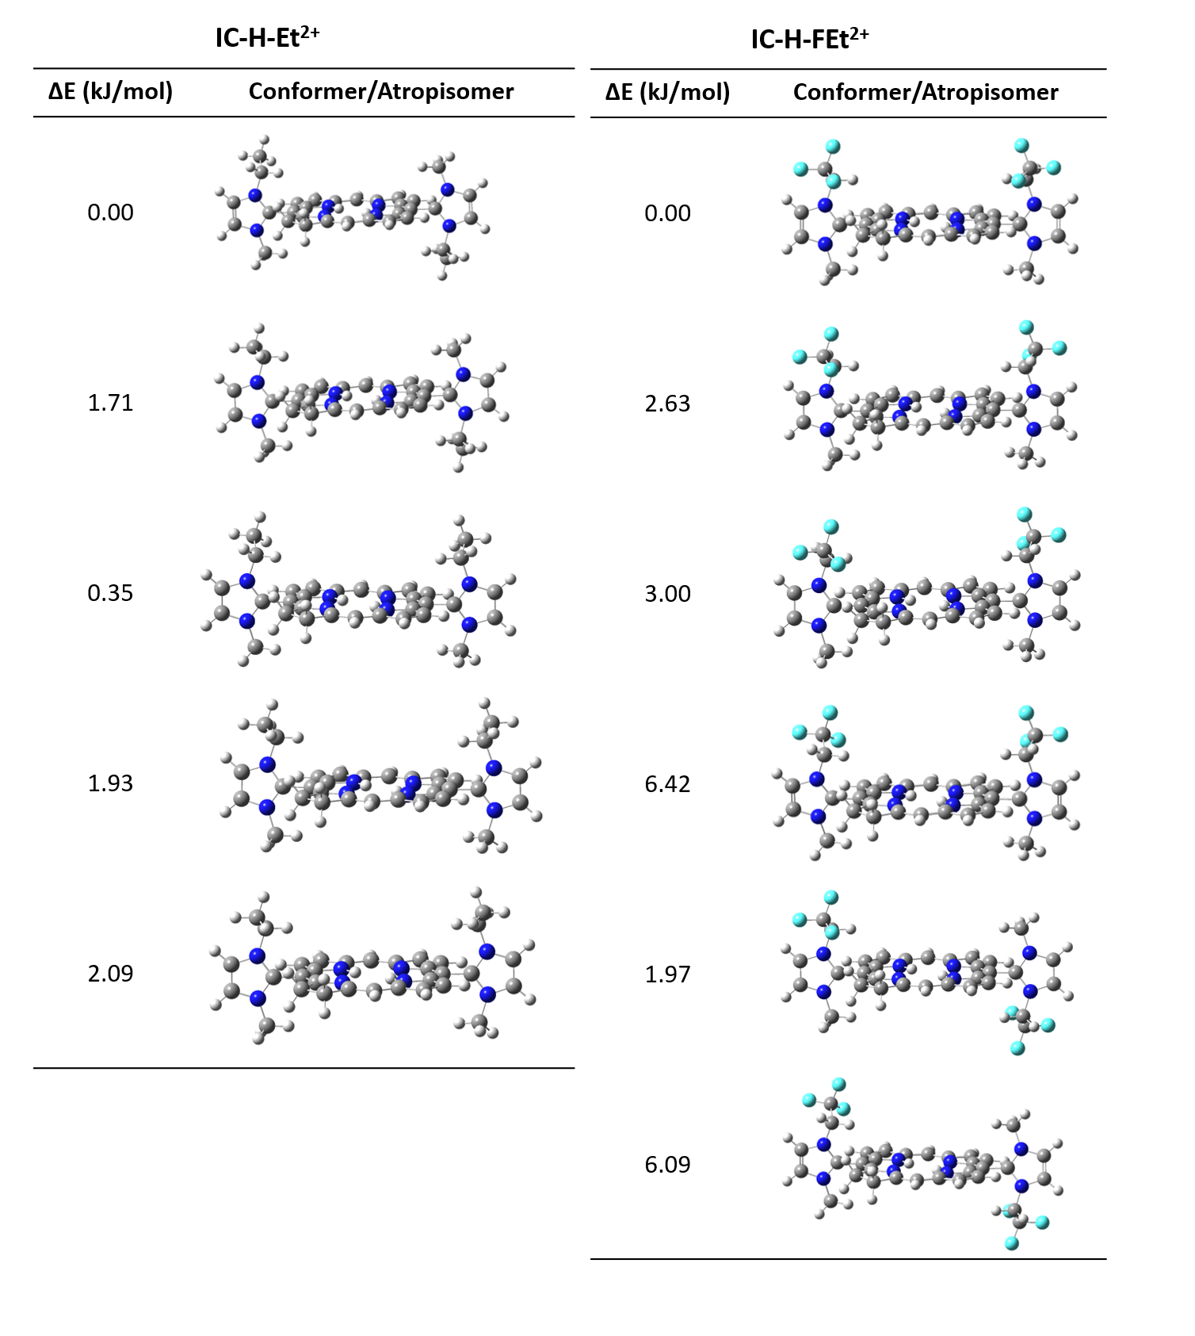
Figure S2. Structures of lower-energy conformers of 5,15-bis(1-methyl-3-ethylimidazol-2-yl)chlorin (IC-H-Et²⁺) and 5,15-bis(1-methyl-3-(1,1,1-trifluoroethyl)imidazol-2-yl)chlorin (IC-H-FEt²⁺) optimized at the B3LYP/6-31G(d,p) level. Two atropisomers are present in each chlorin. The lowest energy atropisomer of IC-H-Et²⁺ has the two ethyl groups in opposite sides of the macrocycle whereas the lowers energy atropisomer of IC-H-FEt²⁺ has the two trifluoroethyl groups on the same side of the macrocycle and the fluorine atoms pointing towards each other. Color code: blue stands for nitrogen, white for hydrogen, gray for carbon and light blue for the fluorine atoms.

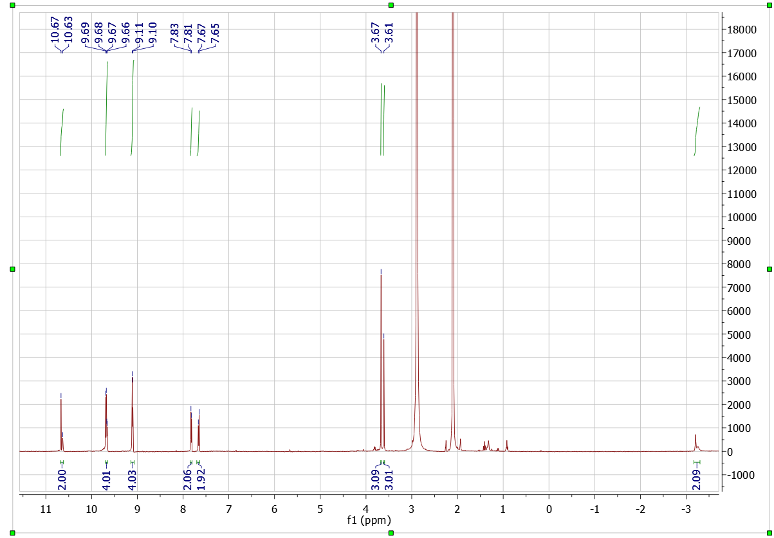
IP-H
H₂O
acetone

Figure S3. ¹H NMR of 5,15-bis(1-methylimidazol-2-yl)porphyrin IP-H in deuterated acetone.

IP-H-Me²⁺
IP-H-Me²⁺
Figure S4. ¹H NMR of 5,15-bis(1,3-dimethylimidazol-2-yl) porphyrin diiodide IP-H-Me²⁺ in deuterated DMSO.

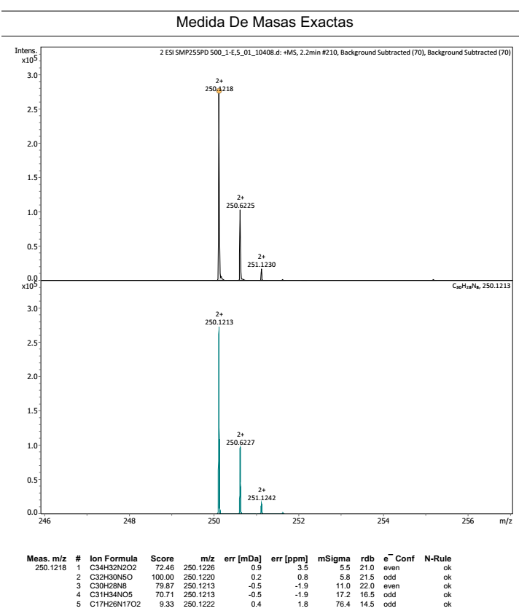
IP-H-Me²⁺

Figure S5. ESI-TOF Mass spectra of 5,15-bis(1,3-dimethylimidazol-2-yl)porphyrin diiodide IP-H-Me²⁺.

IP-H-Et²⁺

Figure S6. ¹H NMR of 5,15-bis(1-methyl-3-ethylimidazol-2-yl)porphyrin diiodide IP-H-Et²⁺ in deuterated DMSO.

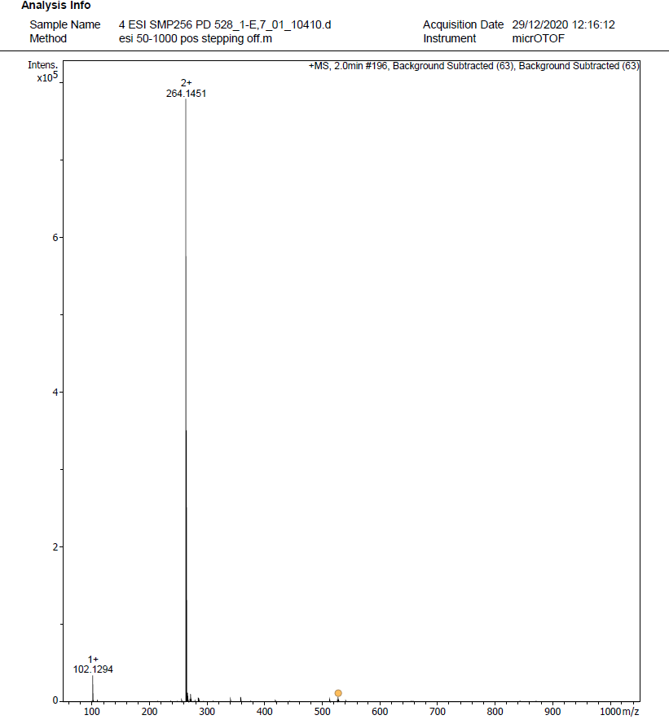
IP-H-Et²⁺

Figure S7. ESI-TOF Mass spectra of 5,15-bis(1-methyl-3-ethylimidazol-2-yl)porphyrin diiodide IP-H-Et²⁺.

H₂O
MeOH
IP-H-FPr²⁺

Figure S8. ¹H NMR of 5,15-bis(1-methyl-3-(1,1,1-trifluoropropyl)imidazol-2-yl)porphyrin diiodide IP-H-FPr²⁺ in deuterated methanol.

Figure S9. ¹⁹F NMR of 5,15-bis(1-methyl-3-(1,1,1-trifluoropropyl)imidazol-2-yl)porphyrin diiodide IP-H-FPr²⁺ in deuterated methanol.

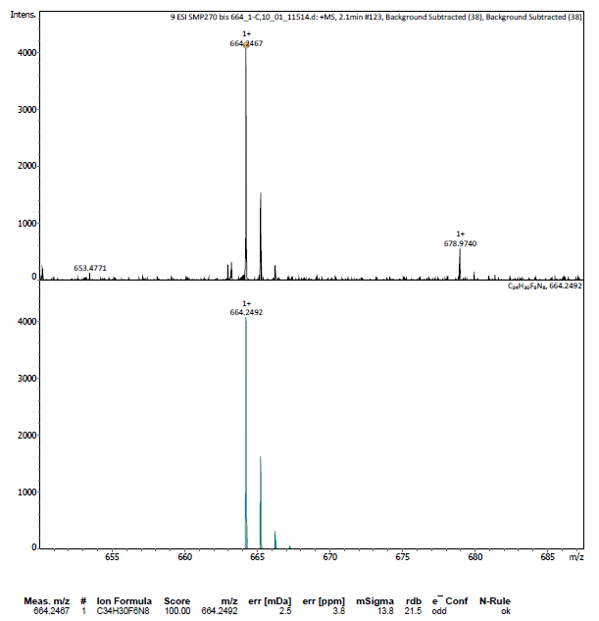
IP-H-FPr²⁺

Figure S10. ESI-TOF Mass spectra of 5,15-bis(1-methyl-3-(1,1,1-trifluoropropyl)imidazol-2-yl)porphyrin diiodide IP-H-FPr²⁺.

IP-H
IC-H
Grease
Acetone
IC-H-Me= 6.00
IP-H-Me= 2.00

IC-H-Me= 4.00
IP-H-Me= 1.49
IC-H-Me= 2.00
IP-H-Me= 1.33
H₂O

Figure S11. ¹H NMR of 75:25 mixture of 5,15-bis(1-methylimidazol-2-yl)chlorin IC-H and 5,15-bis(1-methylimidazol-2-yl)porphyrin IP-H, respectively, in deuterated acetone.

IC-H

Figure S12. ESI-TOF Mass spectra of 5,15-bis(1-methylimidazol-2-yl)chlorin IC-H.

IC-H-Me²⁺
H₂O
MeOH
DMF
DMF

Figure S13. ¹H NMR of 5,15-bis(1,3-dimethylimidazol-2-yl)chlorin diiodide IC-H-Me²⁺ in deuterated methanol.

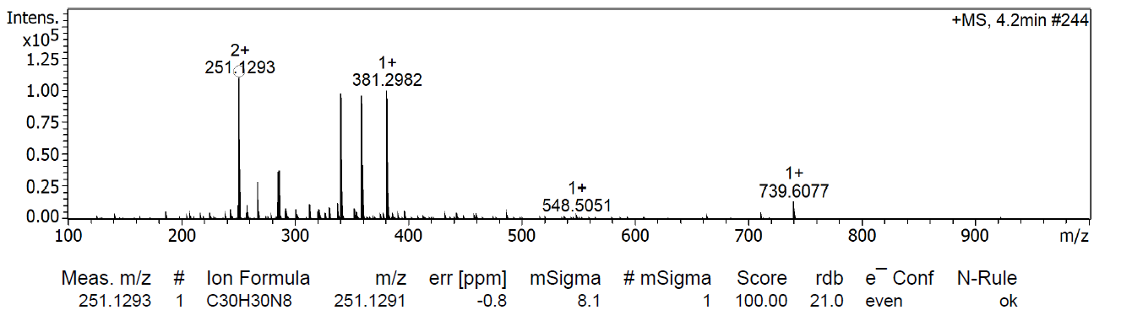

Figure S14. ESI-TOF Mass spectra of 5,15-bis(1,3-dimethylimidazol-2-yl)chlorin diiodide IC-H-Me²⁺.

Figure S15. HPLC of 5,15-bis(1,3-dimethylimidazol-2-yl)chlorin diiodide IC-H-Me²⁺ with detection at 385 nm (upper panel) or at 405 nm (lower panel). C18 reversed-phase packing column (Luna® 5 μm C18(2) 100 Å, 150 × 4.6 mm, RP) and methanol:buffer solution of ammonium acetate (85:15, v:v), adjusted to pH 8.5 with ammonium hydroxide solution, as mobile phase. The elution was achieved under isocratic elution conditions with a flow rate of 1.500 mL/min at 30 °C.

IP-H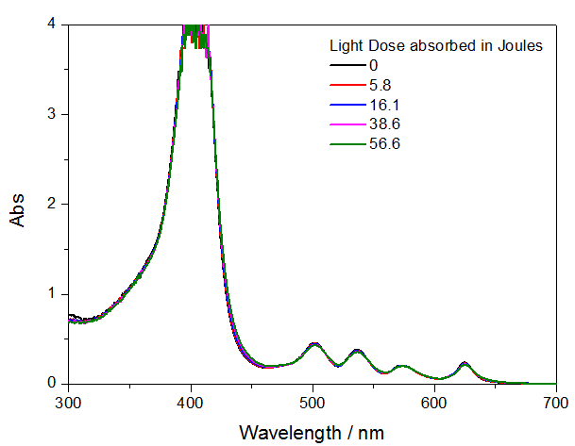IP-H-Me²⁺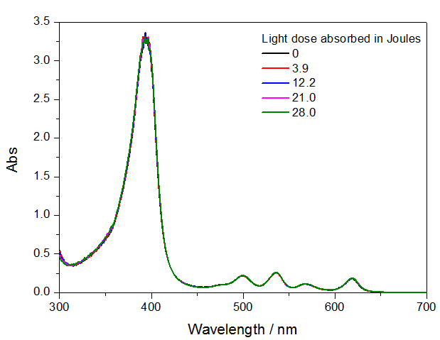

IC-H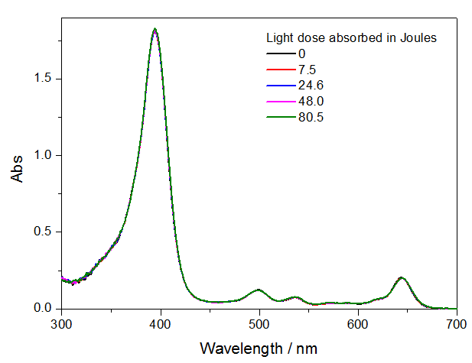IC-H-Me²⁺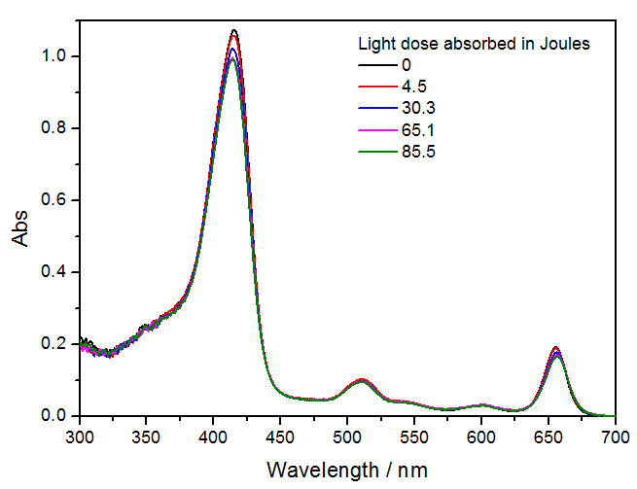

Figure S16. Changes in absorption spectra observed with prolonged illumination of the porphyrins and chlorins in their lowest energy absorption bands. IP-H, IC-H, IP-H-Me²⁺ and IC-H-Me²⁺ in DMSO:water (2:30, v:v).

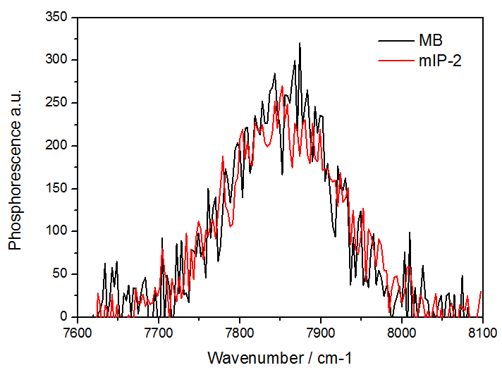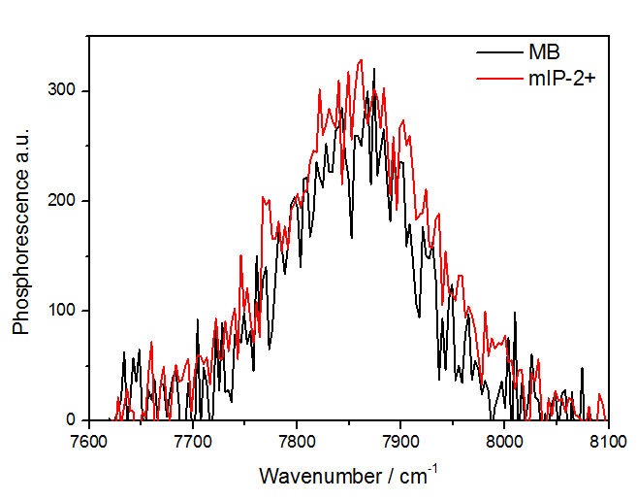
MB
IP-H-Me²⁺
MB
IP-H
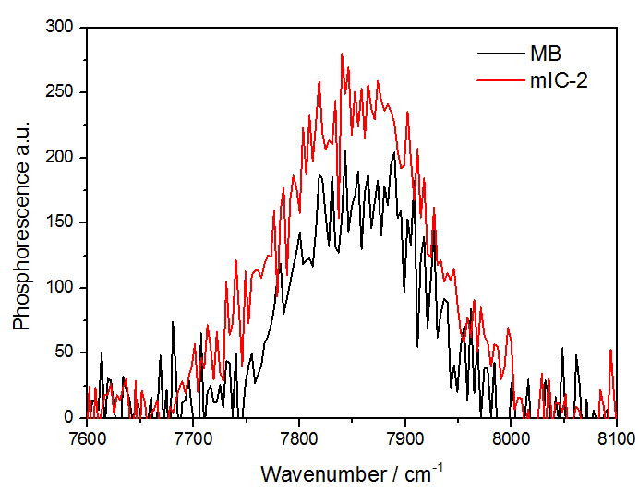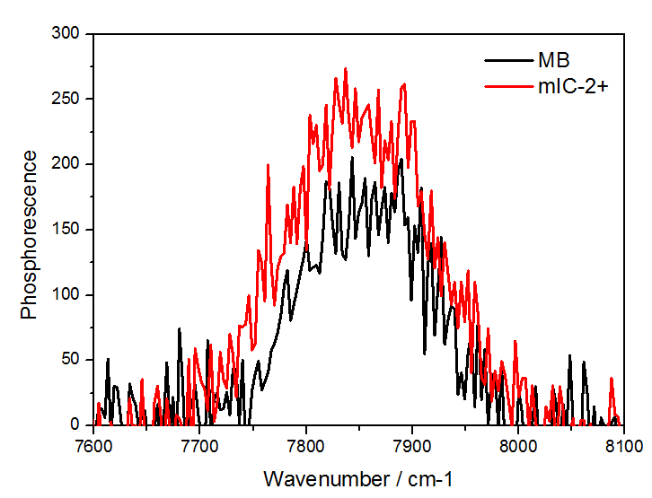
MB
IC-H-Me²⁺
MB
IC-H

Figure S17. Steady-state phosphorescence emission of singlet oxygen observed after excitation of porphyrins, chlorins or the reference methylene blue (MB) in ethanol. Excitation of porphyrins and chlorins were at 625 nm and 650 nm, respectively.

Figure S18. Toxicity of IC-H-Me²⁺ towards HEK-293T or HEK-293T-hACE2 cells. A) Cytotoxicity in the dark towards HEK-293T cells after 12 h of incubation. B) Phototoxicity at 4 J cm^{–2} towards HEK-293T cells after 12 h of incubation. C) Phototoxicity at 4 J cm^{–2} HEK-293T-hACE2 cells after 12 h of incubation.

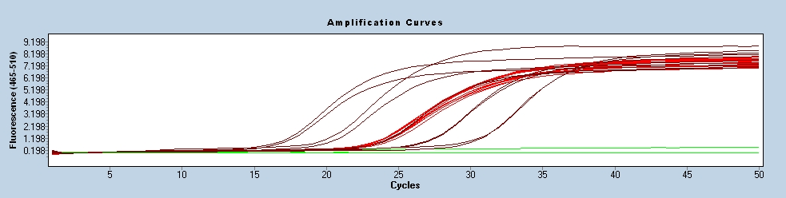
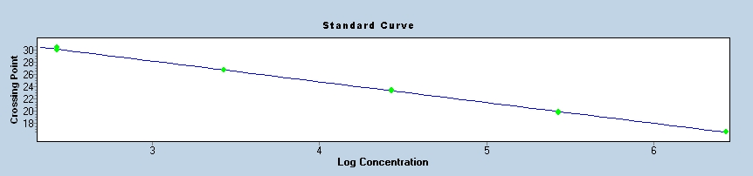

Figure S19. Typical RT-qPCR calibration curve used to determine the efficiency, linear range, and reproducibility of a qPCR assay.

