Supporting Information

Morphology Control of Dynamic Optical Matter of Gold Nanoparticles Fabricated by Optical Trapping in Printed Microchannels

Pin-Hsun Huang¹, Mu-En Li ¹, Chi-Shan Lu², Chih-Hao Huang¹, Hsin-Ni Wu², Peng-Chin Tsai², Jim Jui-Kai Chen³, Boris Lous³, Roger Bresoli-Obach^{3,4}, Suzanna Rocha³, Johan Hofkens^{3,5}, Henryk Witek*¹, Ming-Chia Li*², Hiroshi Masuhara*¹

¹Department of Applied Chemistry and Center for Emergent Functional Matter Science, National Yang Ming Chiao Tung University, Hsinchu 300093, Taiwan.
² Department of Biological Science and Technology, Institute of Molecular Medicine and Bioengineering, College of Engineering Bioscience, and Center for Intelligent Drug Systems and Smart Bio-devices (IDS2B), National Yang Ming Chiao Tung University, Hsinchu 300093, Taiwan.
³Laboratory for Photochemistry and Spectroscopy, Division for Molecular Imaging and Photonics, Department of Chemistry, Katholieke Universiteit Leuven, Leuven 3000, Belgium.
⁴AppLightChem, Institut Químic de Sarrià, Universitat Ramon Llull, Barcelona 08017, Spain.
⁵Max Planck Institute for Polymer Research, Mainz 55128, Germany.

*corresponding authors
masuhara@nycu.edu.tw; mingchiali@nycu.edu.tw; hwitek@nycu.edu.tw

Fig. S1
Various PCL micropatterns prepared by the MESW method.
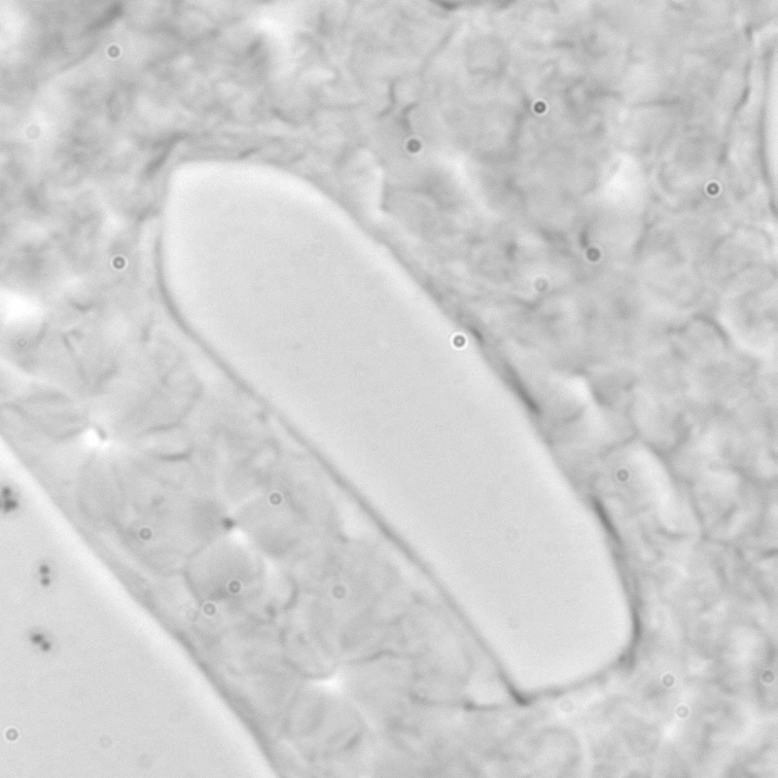
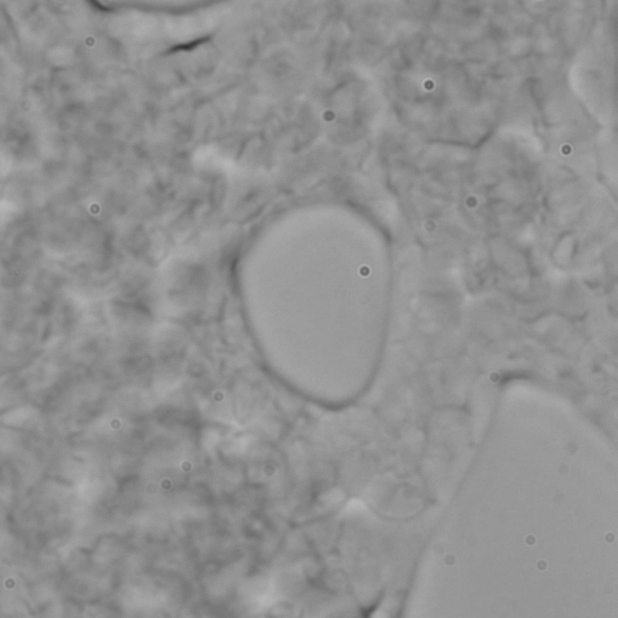
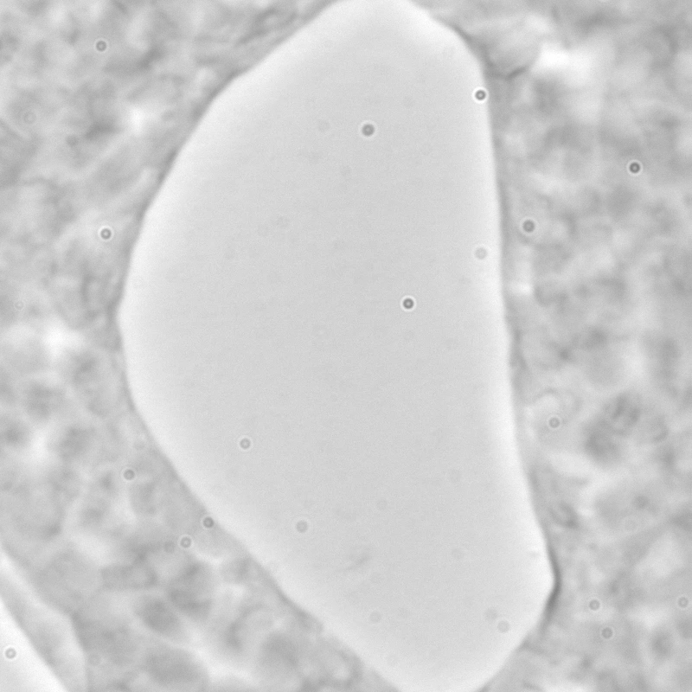
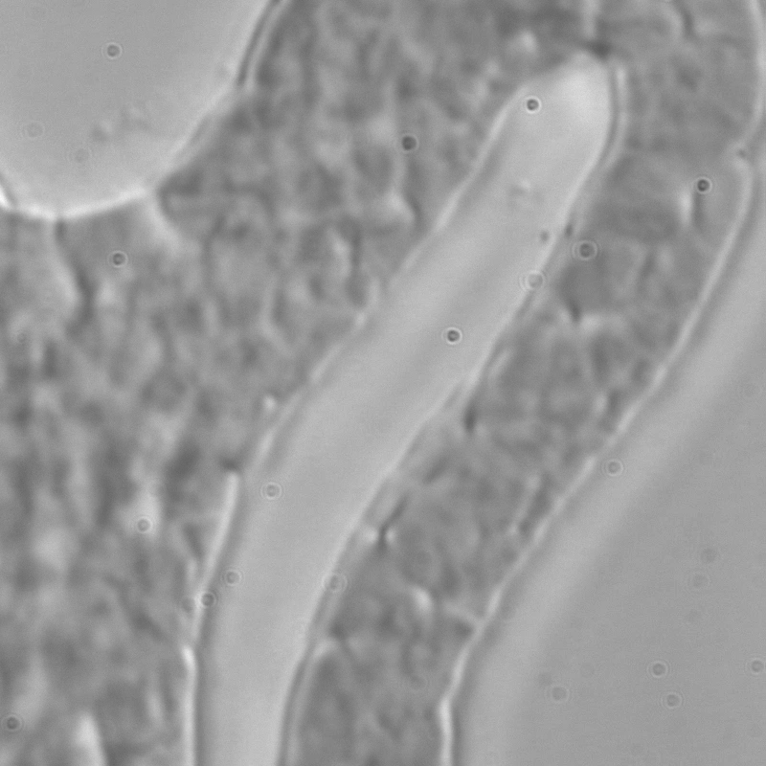
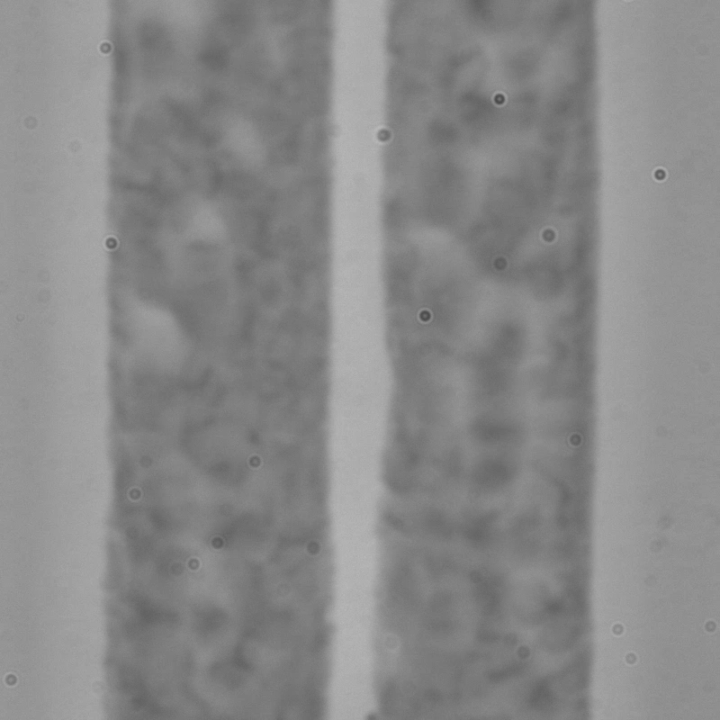
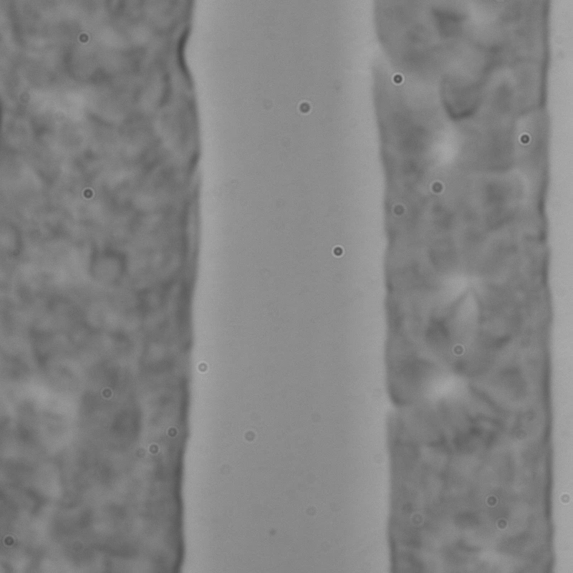
10 µm

Fig. S2
One representative example of the cross section of the plastic microchannel by scanning electron microscopy (SEM) image. The scale bar is 20 µm. The width of the PCL microchannel (yellow), the height of the PCL microchannel (blue), and the distance between the channels (red).

3.27 micrometer
6.96 micrometer
16.13 micrometer

Fig. S3
(A) Transmission image of the strapping and swarming of the 400 nm gold nanoparticle swarming within the microchannel distance of 2.4 µm, where the estimated length of the swarming was about 18 µm. (B) The transmission intensity is converted to scattering image, assuming absorption is negligible compared to scattering. (C) The scattering intensity in the marked top and bottom areas of (B) is plotted against the irradiation time. The trapping irradiation starts at 10 s.

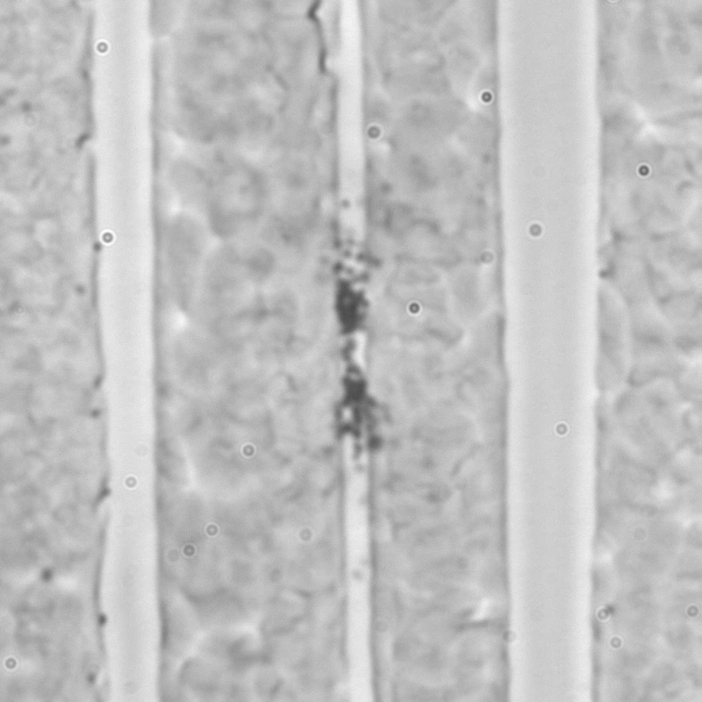
17.76 µm
5 µm
A.
C.
B.
10 µm

Text S1. The effective diameter of the focus is experimentally determined by using the knife-edge method [39]

We prepared a sample with a sharp edge by spin-coated gold on a glass substrate, and placed it on to the sample stage. Just like how we conduct the trapping experiment, the gold film was placed at the upper interface, facing the incoming laser beam. The edge was slowly moved into the beam by the 100 nm-precision stage (100 nm/1s). Since the gold film strongly scatter the 1064 nm laser, the intensity of the reflection pattern on the camera get stronger as more gold film enters the beam. We repeated this process and then analyzed the data as follows:
1. Calculate the average of light intensity of the airy disk that we obtain each frame.
2. (Optional) The working procedure of the stage is based on a pulse mode, which means that the stage moves 100 nm instantly per second instead of continuously moving within 1 second. Therefore, if the acquisition rate of the camera is longer than 1s, we should take the average of the frames that we have within 1second, so that we do not go against how the stage works.
3. After we obtain the averaged intensity of the airy disk, we plot the intensity against the displacement.
4. The beam waist is retrieved by fitting the averaged intensity to an error function (see Ref.39). The only one parameter we fit is the beam waist.
We measured the beam waist in a single X or Y direction, so we obtained the information of the beam waist in one dimension.
Here we get a plot of 2D intensity distribution by obtaining the beam waist in X and Y directions, and then apply the Gaussian distribution to it for calculating the distribution in 2D.
The formula here is 2D, and σ is the beam waist.
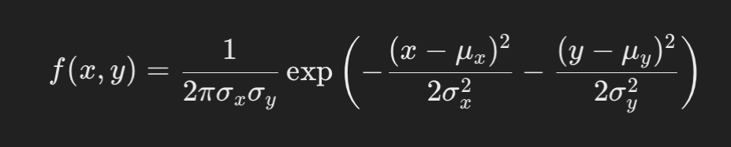

**If the Dropbox links do not work, please use the Google Drive links.

Video 1
Dropbox: https://www.dropbox.com/scl/fi/shu0nh9ugipl78ukl3fww/VideoSI1.mp4?rlkey=3ot6gcelo94uubcgr4ll0upek&st=yvsjz9uv&dl=0
Google Drive: https://drive.google.com/file/d/1sgc3s0gzc0GtZl2LuyDWTuRY6cdhX7cN/view?usp=sharing

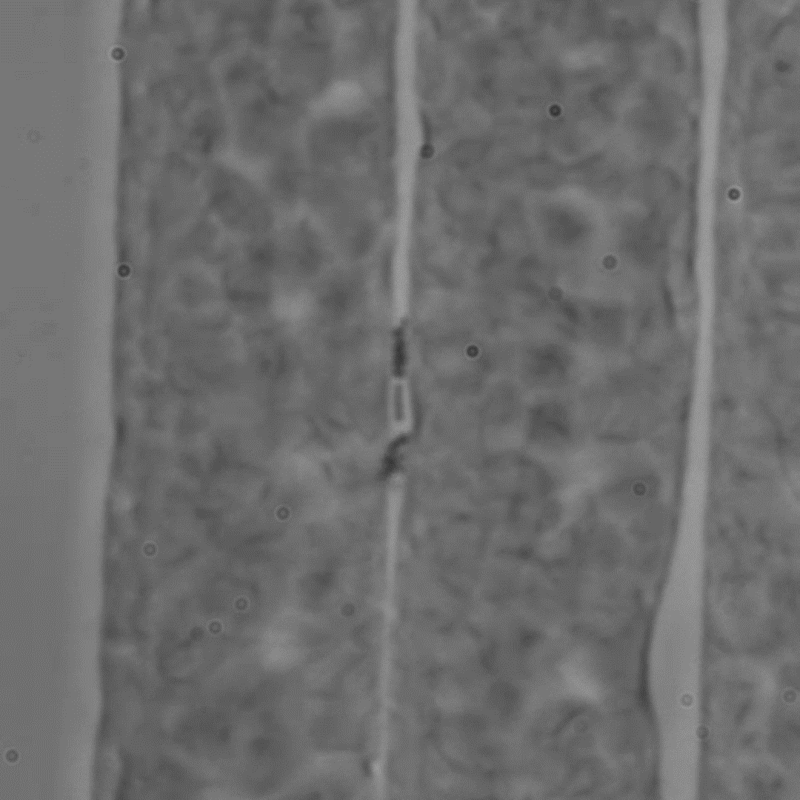
10 µm

Video 2
Dropbox:
https://www.dropbox.com/scl/fi/ceamfz1a4sreu76sjh7ys/VideoSI2.mp4?rlkey=fy1ppx9tu5t3fieuc7qt6tqun&st=g7po0pp9&dl=0
Google drive:
https://drive.google.com/file/d/1QE7NGoE5LSy0G4CWErn-VcymjmyzjLVm/view?usp=drive_link

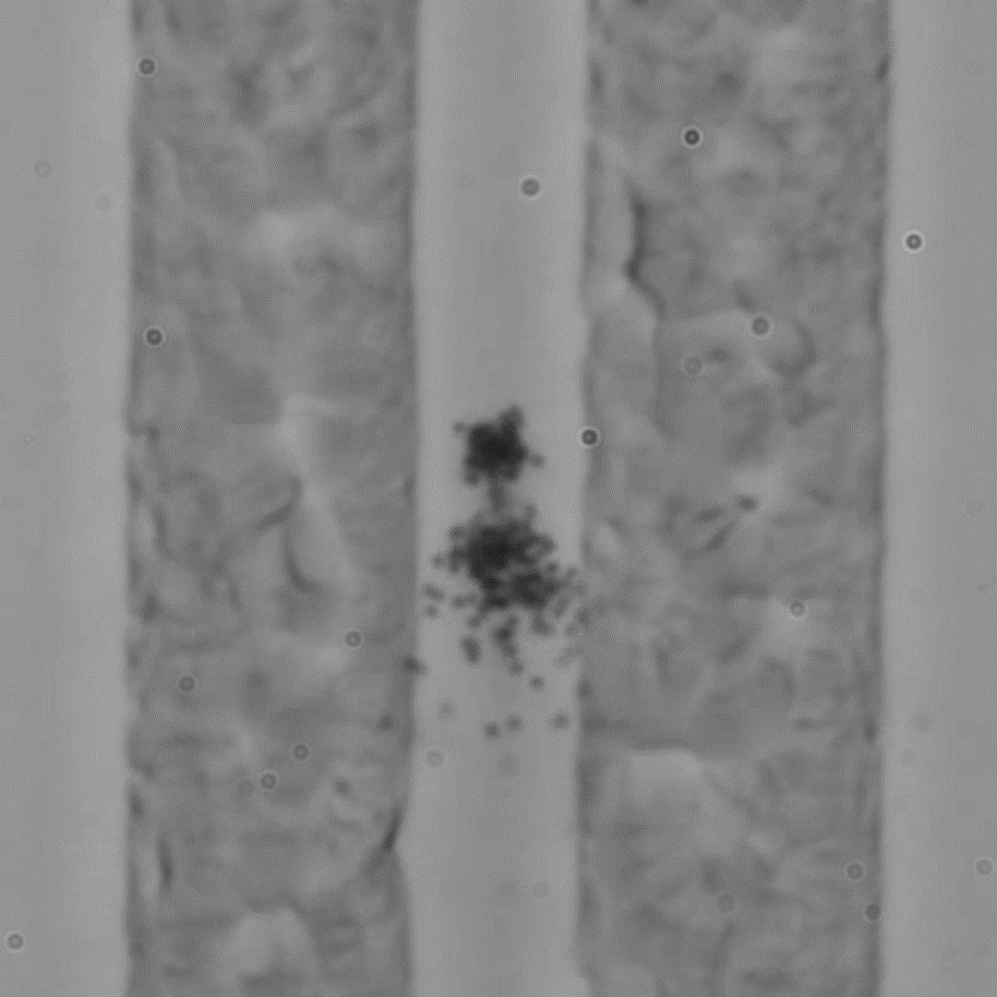

Video 3
Dropbox:
https://www.dropbox.com/scl/fi/aiq3m2vvv9lncnuebyiil/VideoSI3.mp4?rlkey=4lgcr4cur178ore1f72fzhjzl&st=5tqev5b1&dl=0
Google drive:
https://drive.google.com/file/d/1vl64H8B-XQRDwub05TY2J71jXWIb2DaY/view?usp=drive_link

