SUPPLEMENTARY MATERIAL

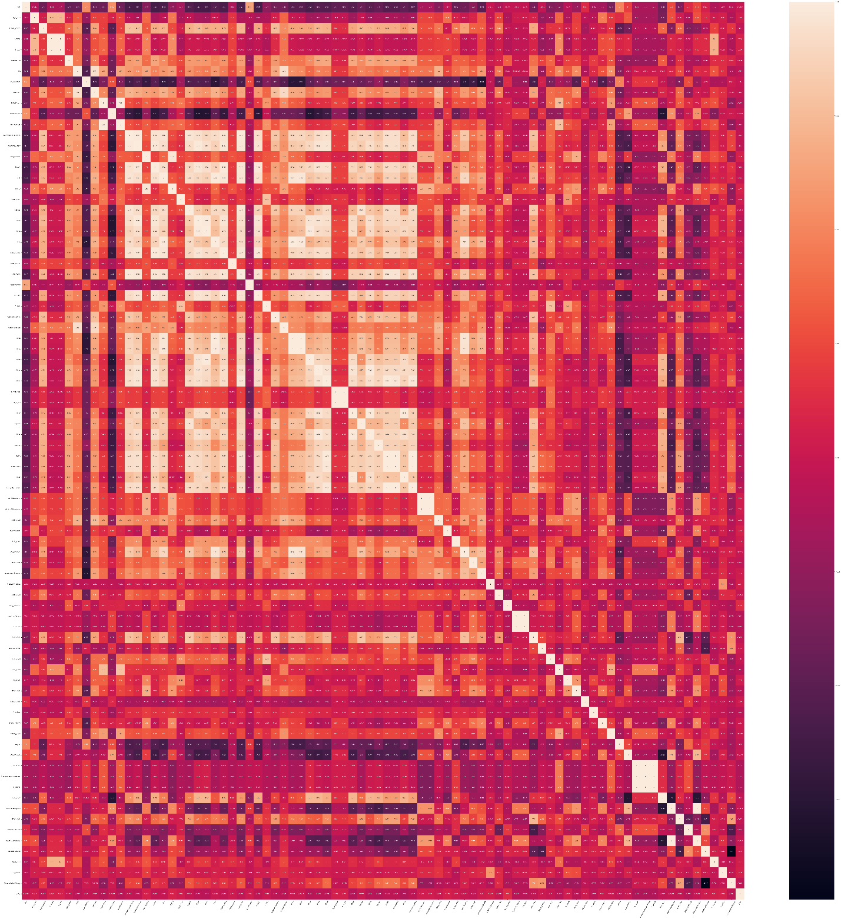
Fig1. Heatmap of molecular descriptors correlating (r > 0.1) with pIC₅₀

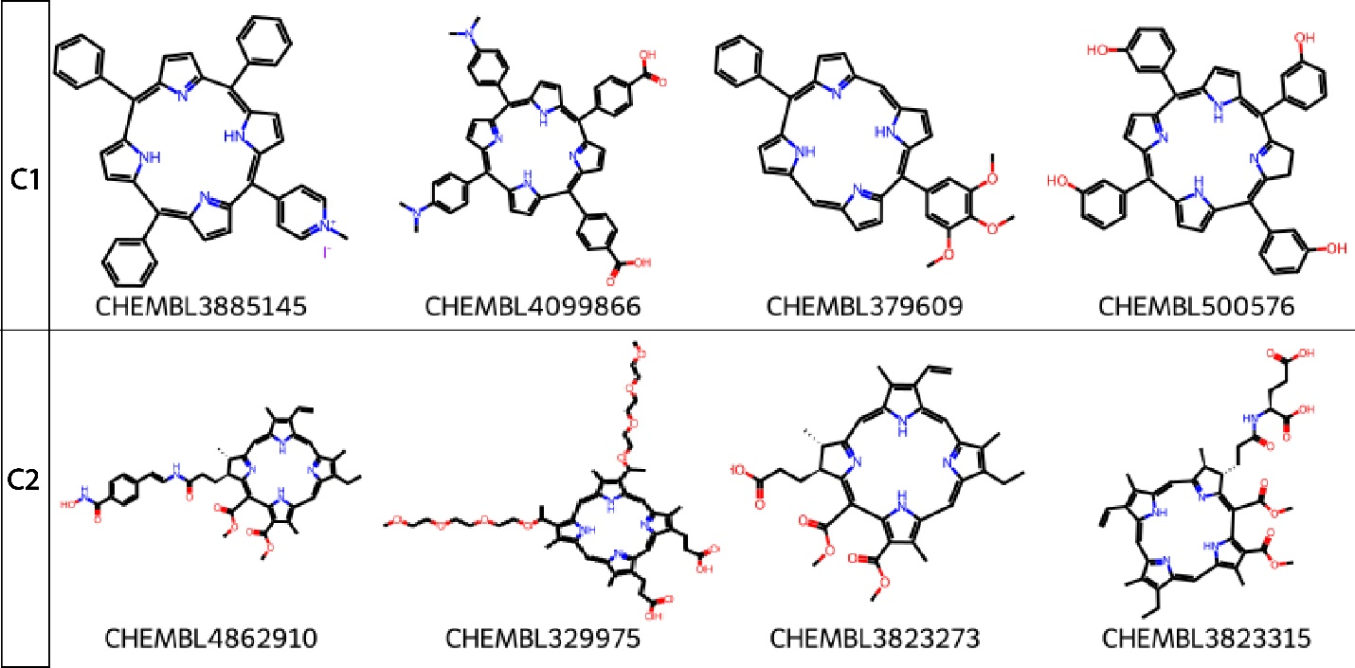

Fig2. Selected five molecules from Cluster C1 (upper row, n=155 samples) and C2 (lower row, n=126 samples)

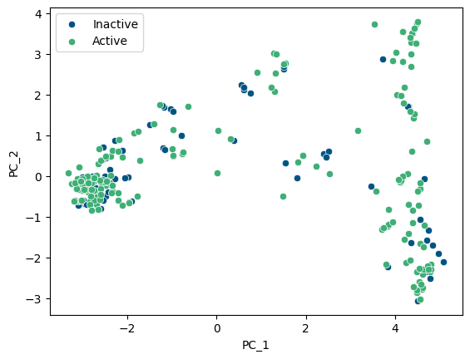
Fig3. Principal component analysis: distribution of Active (green) and Inactive (blue) compounds

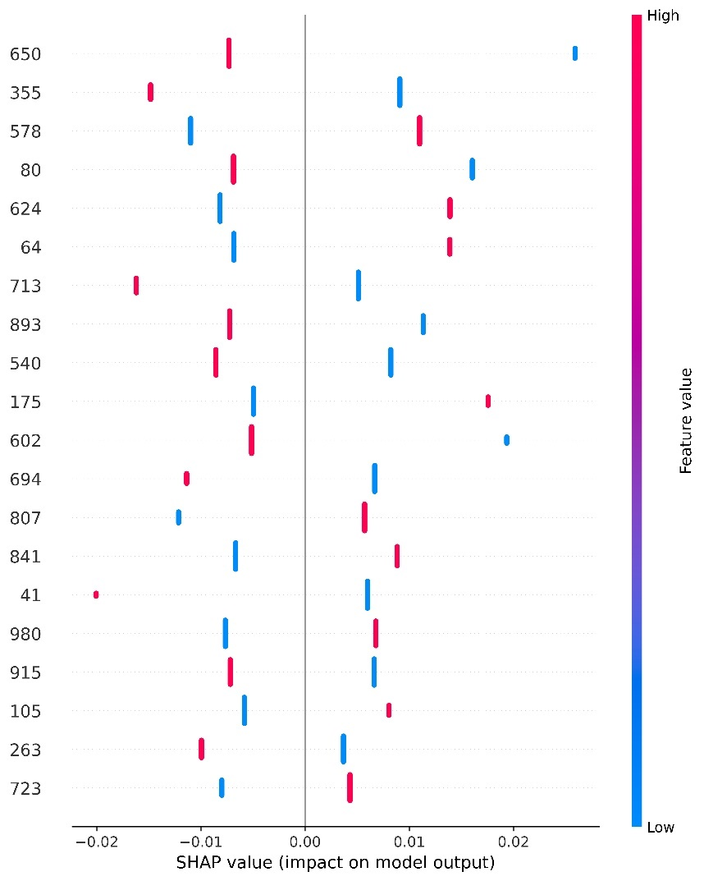
Fig.4. SHAP summary plot of Morgan fingerprint features contributing to machine learning

