SUPPLEMENTAL INFORMATION for Rockwell & Lagarias, “Circular dichroism spectroscopy reveals multiple phytochrome photoproducts in equilibrium”

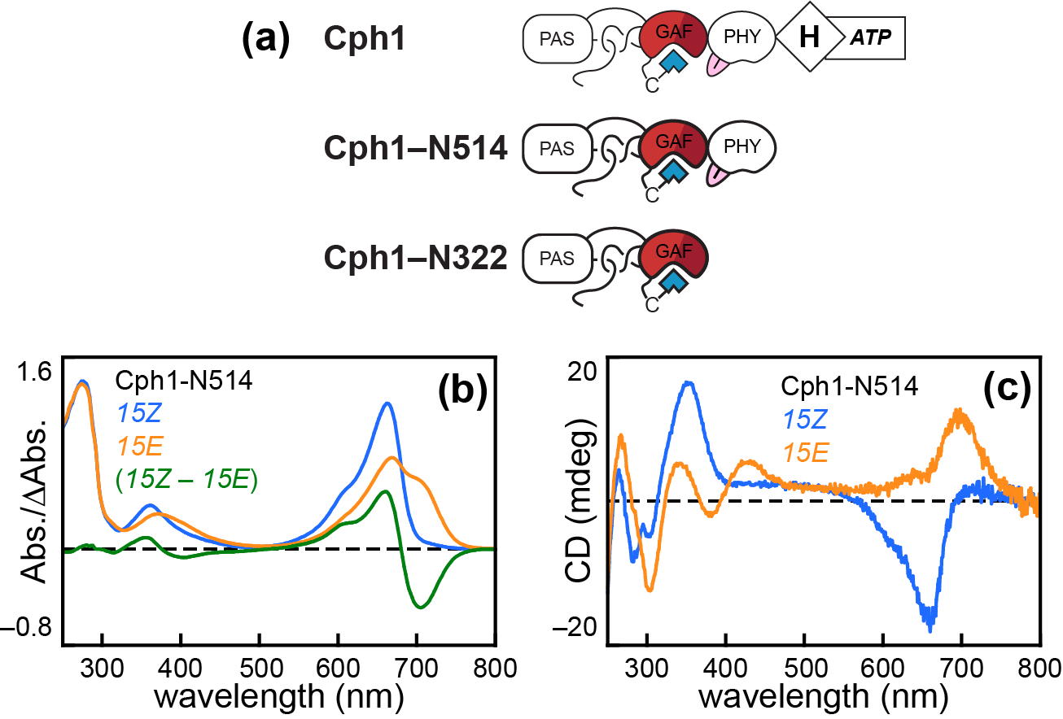

Figure S1. Photoconversion of model cyanobacterial phytochrome Cph1. (a) Domain architecture diagrams are shown for full-length Cph1 and for the Cph1-N514 and Cph1-322 truncations used in this work. (b) Absorption spectra are shown for Cph1-N514 in the 15Z P_{r} (blue) and 15E P_{fr} (orange) states, with the (15Z – 15E) difference spectrum shown in green. (c) CD spectra are shown for the same sample as in panel (b), using the same color scheme. No difference CD spectrum is shown.

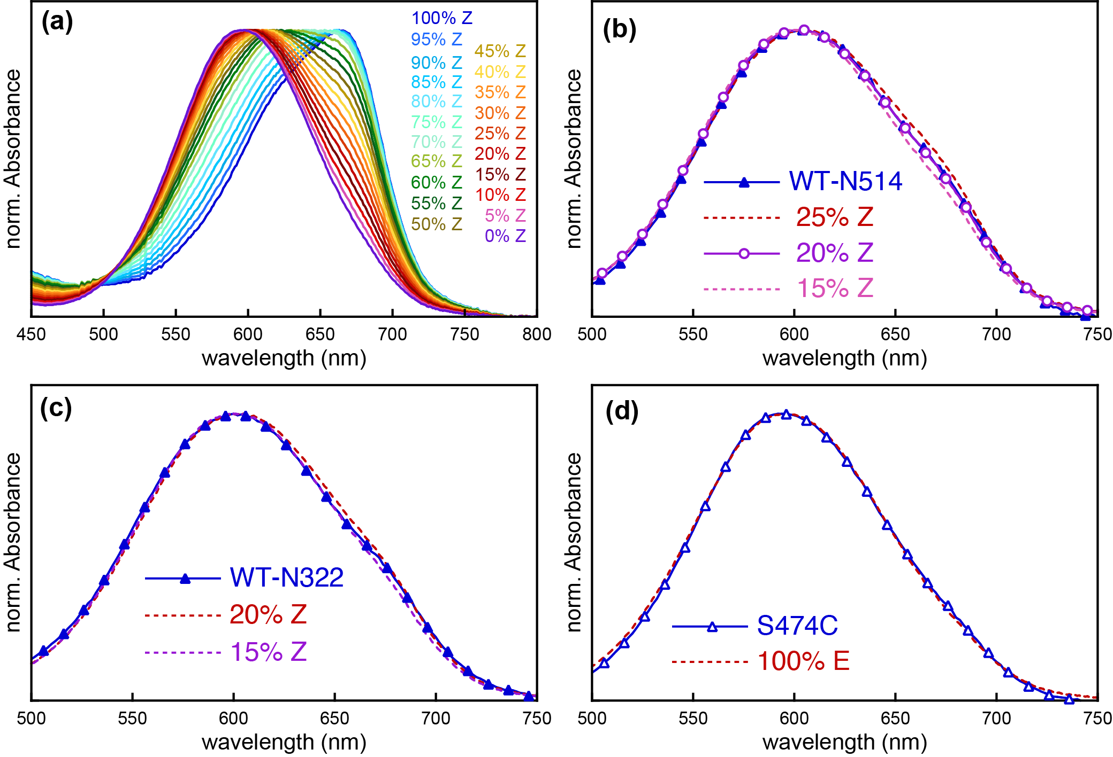

Figure S2. Estimation of photoisomerization using an acid denaturation assay. (a) Effectively complete 15Z and 15E samples of RcaE were used to calculate spectra at the indicated levels of photoconversion under acidic denaturing conditions, providing an approximate standard curve. (b) The absorption spectrum of denatured 15E wild-type Cph1-N514 (blue line and filled triangles; spectrum from Fig. 1D) is compared to calculated reference curves for 25% 15Z/75% 15E (dashed red line), 15% 15Z/85% 15E (dashed pink line), and 20% 15Z/80% 15E (solid magenta line and empty circles). (c) The absorption spectrum of denatured 15E wild-type Cph1-N322 (blue line and filled triangles; spectrum from Fig. 1C) is compared to calculated reference curves for 20% 15Z/80% 15E (dashed red line) and 15% 15Z/85% 15E (dashed magenta line). (d) The absorption spectrum of denatured 15E S474C Cph1-N514 (blue line and filled triangles) is compared to the experimental reference for 100% 15E (dashed red line).

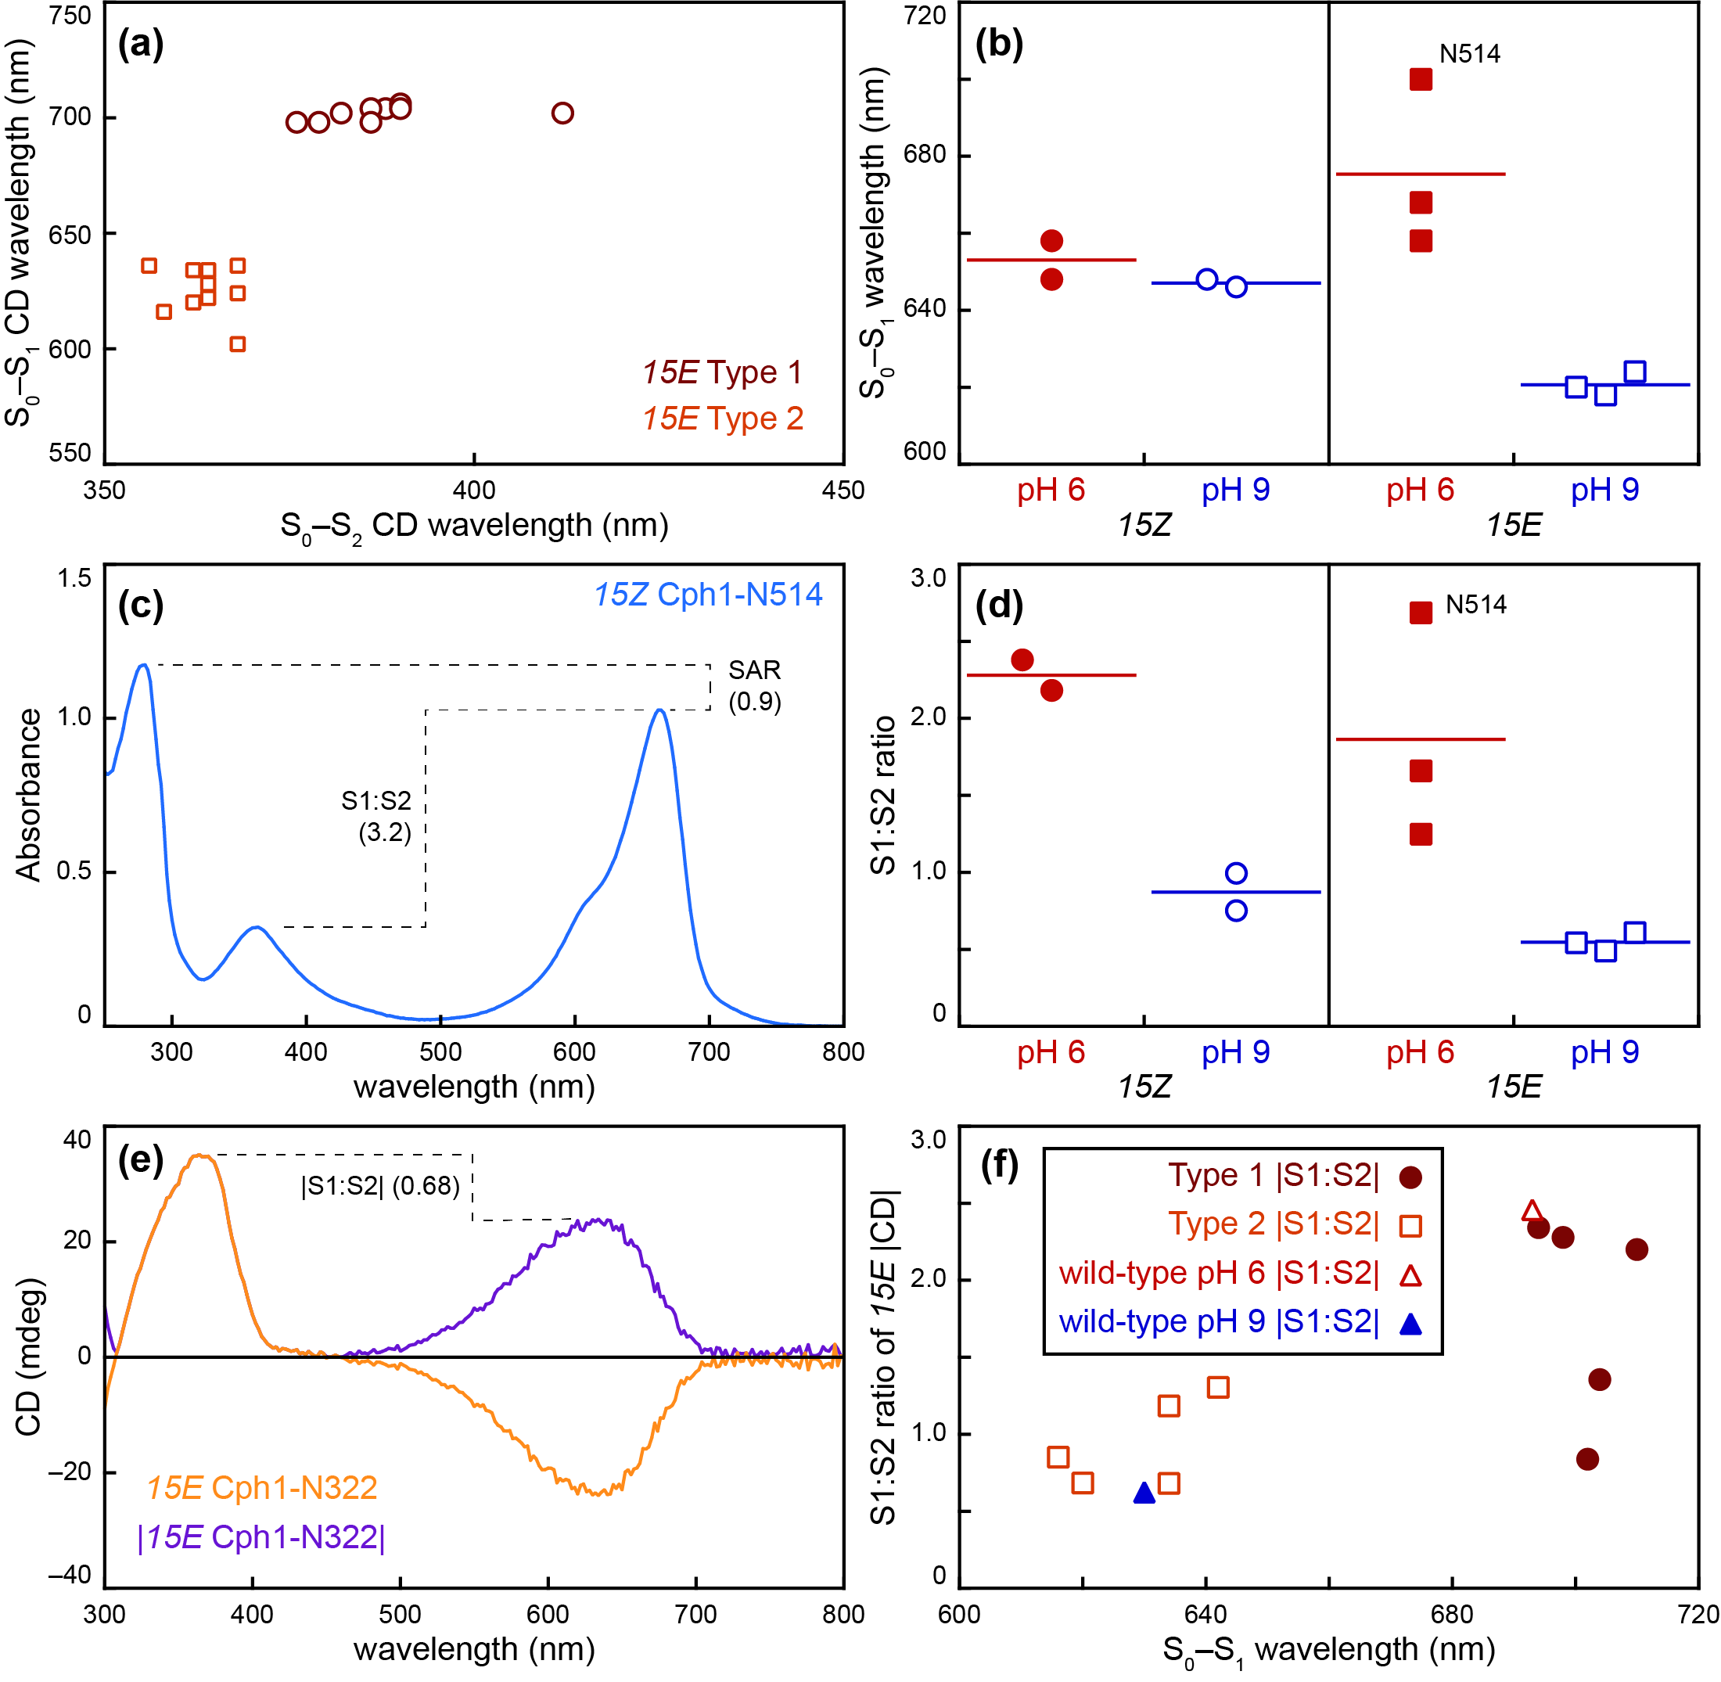

Figure S3. Additional analysis of 15E states of Cph1. (a) Peak wavelengths for maximum observed CD (irrespective of sign) are plotted for the S₀–S₂ (x-axis) and S₀–S₁ (y-axis) transitions for Type 1 (large brick red circles) and Type 2 (small ochre squares) Cph1 variants. (b) Peak wavelengths for the S₀–S₁ transition are plotted for Cph1-N322 (Fig. 7), Cph1-N514 (Fig. 8), and S474C Cph1-N514 (Fig. 9) in the 15Z (left, circles) and 15E (right, squares) states at pH 6 (filled red symbols) and pH 9 (open blue symbols). (c) Definitions are shown for specific absorbance ratio (SAR) and for the ratio of the intensity of the S₀–S₁ transition to that of the S₀–S₂ transition (S1:S2 ratio), using the 15Z spectrum of Cph1-N514 (Fig. S1B). (d) S1:S2 ratios are plotted for Cph1-N322 (Fig. 7), Cph1-N514 (Fig. 8), and S474C Cph1-N514 (Fig. 9) in the 15Z (left, circles) and 15E (right, squares) states at pH 6 (filled red symbols) and pH 9 (open blue symbols). (e) Observed CD (orange) and the absolute value of that trace (dark purple) are shown, using the 15E spectrum of Cph1-N322 (Fig. 1B). (f) The S1:S2 ratio of the absolute value of the 15E CD spectrum is plotted versus S₀–S₁ peak wavelength for Type 1 variants (Figs. S1, 3, and 5; filled brick red circles), Type 2 variants (Figs. 1, 4, and 5; open ochre squares), and for 15E Cph1-N514 at pH 6 (open red triangle) and pH 9 (filled blue triangle). For panels (b) and (d), values for 15E N514 are indicated to facilitate comparison.

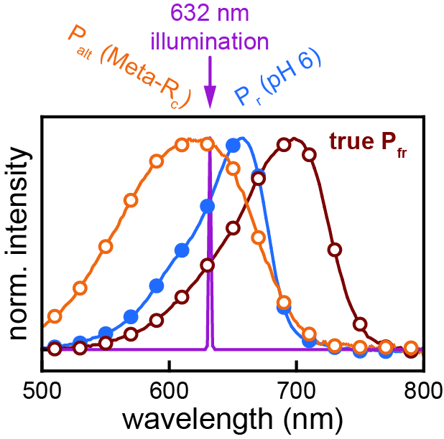

Figure S4. Spectral overlap between 15Z and 15E states of Cph1. Normalized absorption spectra for the 15Z Pr state (blue line and filled circles), 15E far-red-absorbing “true Pfr” species (brick red line and open circles), and deprotonated alternative photoproduct P_{ALT}/Meta-R_{c} (dark orange line and open circles) are compared to the approximate excitation source used in pH dependence studies (632 nm laser pointer; magenta line).

