Study of the Photophysical, Electronic and Electrochemical Properties of Benzimidazoles Derived from a Schiff Base with Ru(III) and La(III) Ions
Damián-Alexander Contreras-Cadena, Bruno Landeros-Rivera, Alejandro Solano-Peralta, Karla P. Salas-Martin, Alejandro Baeza-Reyes, Silvia E. Castillo-Blum*
Facultad de Química, Universidad Nacional Autónoma de México, Ciudad Universitaria, Coyoacán, CDMX 04510, México.

Fig. S1 ATR IR compounds (3) red, (4) green, and (5) blue.
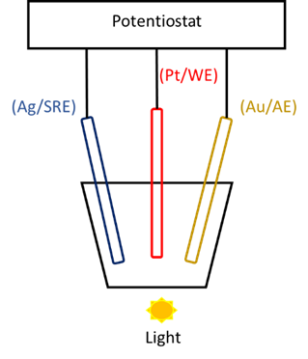
Fig. S2 Electrochemical cell containing 5 mL of 1x10⁻¹ M analyte solution and 1x10⁻² M PTBA. The experiments were conducted at a scan rate of 500 mV/min under dark conditions, followed by illumination with the light source (10 W).

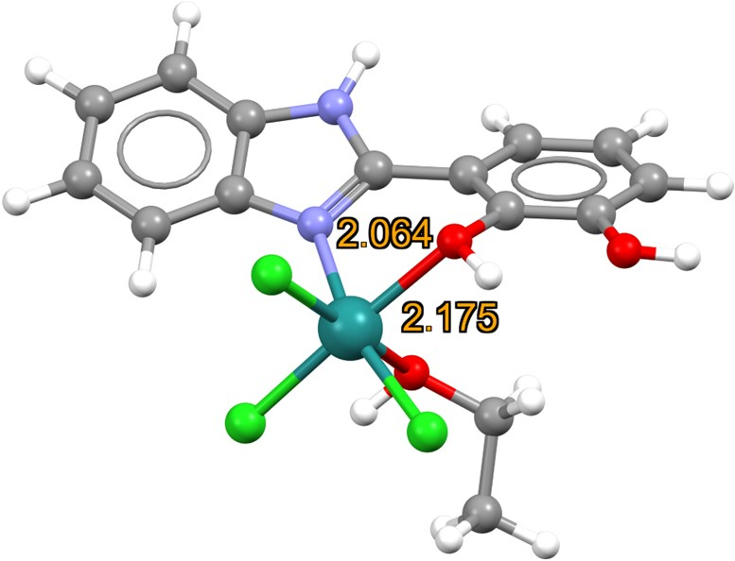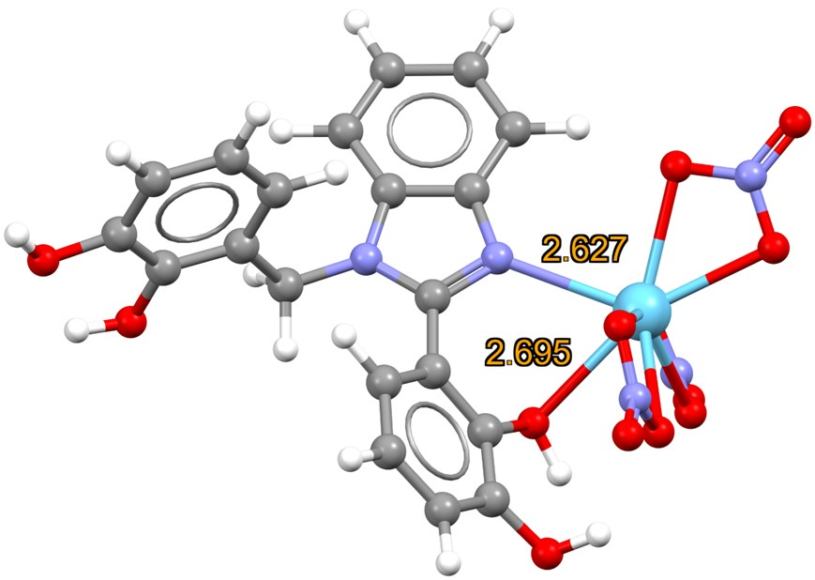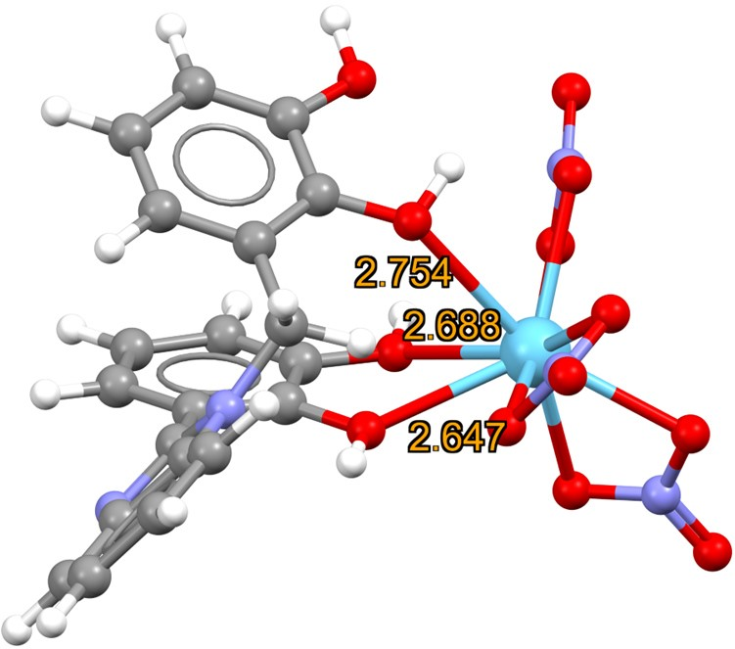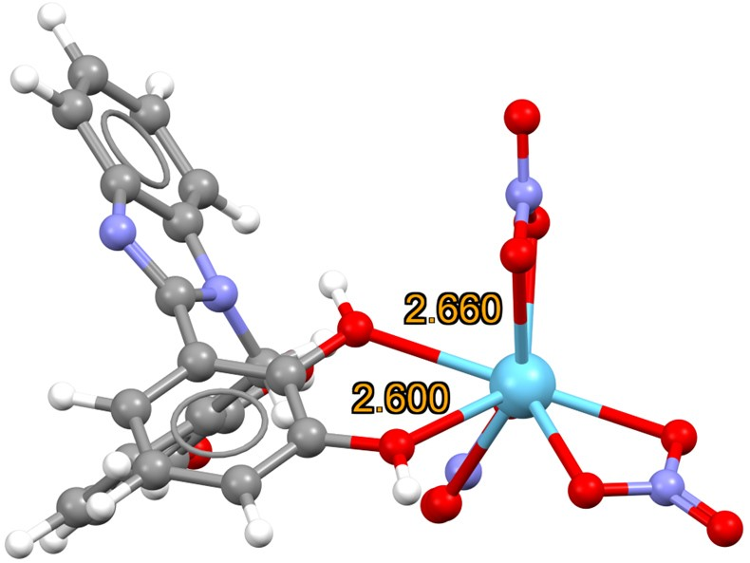

Fig. S3 Optimised structures of the 4 (top left), 5a (top right), 5b (bottom left) and 5c (bottom right).

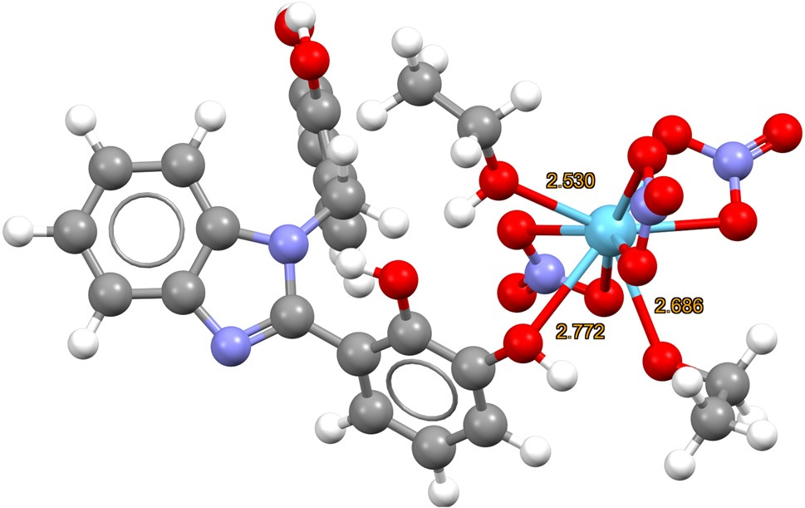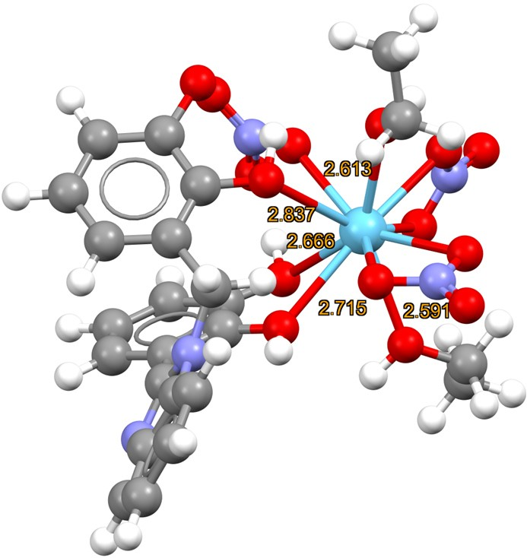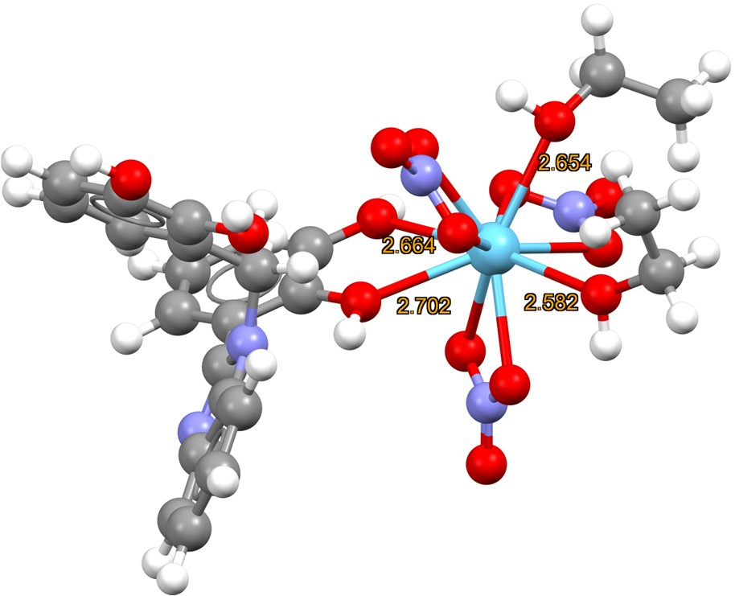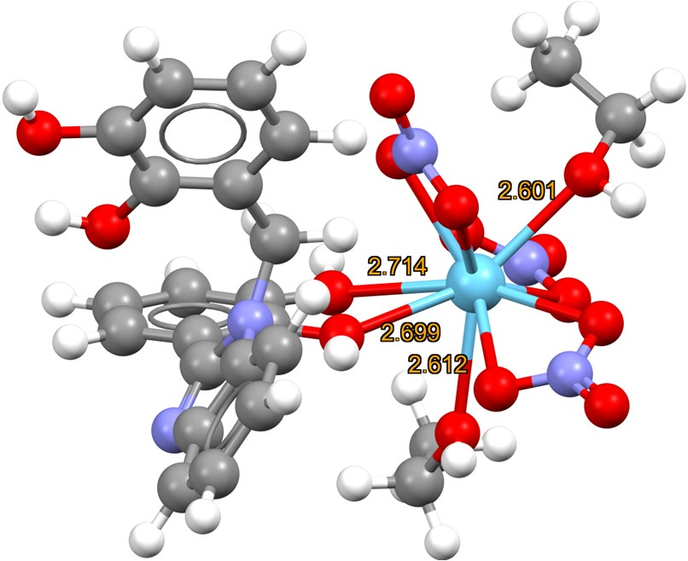

Fig. S4 Ethanol solvated optimised structures with the SMD model. Two ethanol molecules are also coordinated to the lanthanum atom. The top right structure, which has a coordination number of 11, is the most stable one.

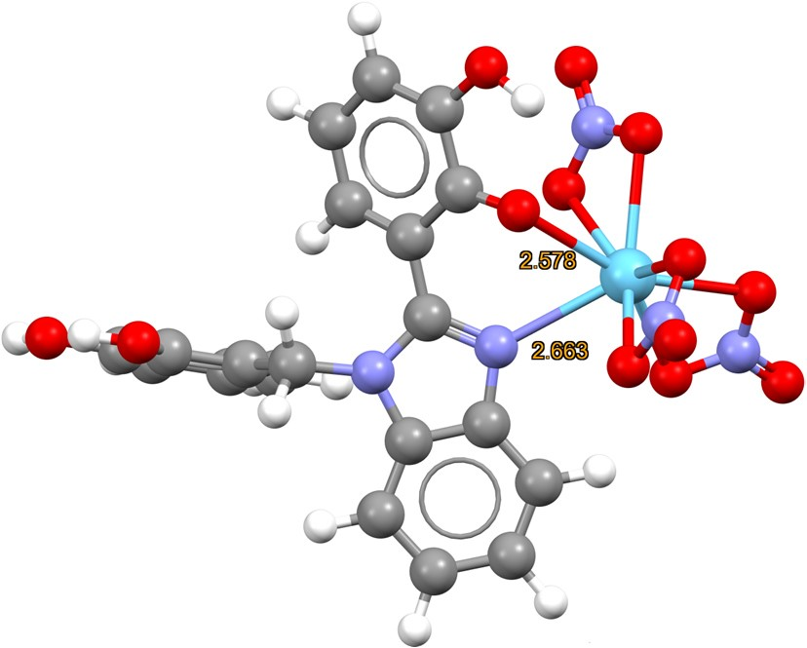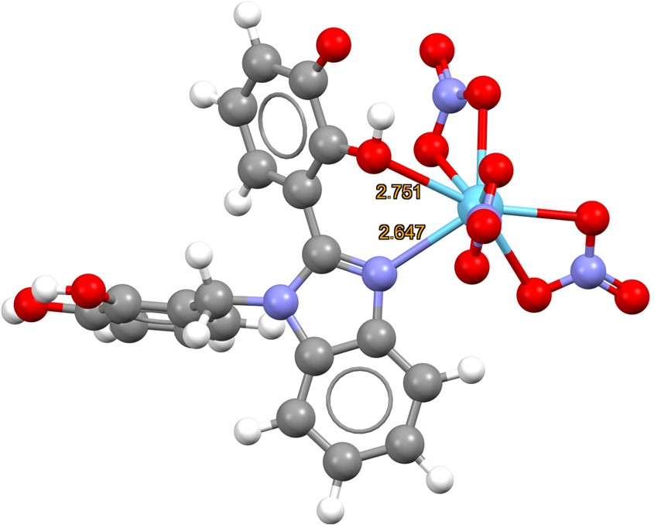

Fig. S5. Optimised structures of 5a1 (left) and 5a2 (right).

Table S1. Electron density (ρ_{B}), electronic energy density (H_{B}), and laplacian of the electron density (²ρ_{B}) at the bond critical points of the ligand-lanthanide interactions (a.u.).
(5a) | p_{B} | H_{B} | ∇²p_{B}
N (middle ring) | 0.0449 | -0.0038 | 0.1203
O (principal ring) | 0.0318 | 0.0008 | 0.1168
O (nitrate) | 0.0452 | -0.0028 | 0.1513
O (nitrate) | 0.0495 | -0.0043 | 0.1615
O (nitrate) | 0.0500 | -0.0043 | 0.1633
O (nitrate) | 0.0446 | -0.0027 | 0.1472
O (nitrate) | 0.0532 | -0.0054 | 0.1718
O (nitrate) | 0.0518 | -0.0051 | 0.1646
(5b) | p_{B} | H_{B} | ∇²p_{B}
O (substitutional ring) | 0.0265 | 0.0017 | 0.1014
O (principal ring) | 0.0310 | 0.0013 | 0.1186
O (principal ring) | 0.0334 | 0.0011 | 0.1287
O (nitrate) | 0.0478 | -0.0038 | 0.1539
O (nitrate) | 0.0414 | -0.0019 | 0.1386
O (nitrate) | 0.0489 | -0.0041 | 0.1574
O (nitrate) | 0.0544 | -0.0059 | 0.1733
O (nitrate) | 0.0494 | -0.0042 | 0.1609
O (nitrate) | 0.0527 | -0.0053 | 0.1689
(5c) | p_{B} | H_{B} | ∇²p_{B}
O (principal ring) | 0.0371 | 0.0005 | 0.1414
O (principal ring) | 0.0329 | 0.0012 | 0.1268
O (nitrate) | 0.0513 | -0.0049 | 0.1650
O (nitrate) | 0.0495 | -0.0042 | 0.1612
O (nitrate) | 0.0539 | -0.0057 | 0.1745
O (nitrate) | 0.0529 | -0.0054 | 0.1690
O (nitrate) | 0.0509 | -0.0048 | 0.1652
O (nitrate) | 0.0513 | -0.0048 | 0.1662
(5a1) | p_{B} | H_{B} | ∇²p_{B}
N (middle ring) | 0.0411 | -0.0027 | 0.1125
O (principal ring) | 0.0394 | -0.0002 | 0.1471
O (nitrate) | 0.0466 | -0.0033 | 0.1534
O (nitrate) | 0.0494 | -0.0042 | 0.1615
O (nitrate) | 0.0597 | -0.0042 | 0.1623
O (nitrate) | 0.0469 | -0.0035 | 0.1528
O (nitrate) | 0.0497 | -0.0042 | 0.1635
O (nitrate) | 0.0513 | -0.0048 | 0.1649
(5a2) | p_{B} | H_{B} | ∇²p_{B}
N (middle ring) | 0.0428 | -0.0032 | 0.1158
O (principal ring) | 0.0270 | 0.0017 | 0.1037
O (nitrate) | 0.0496 | -0.0042 | 0.1618
O (nitrate) | 0.0493 | -0.0042 | 0.1613
O (nitrate) | 0.0502 | -0.0044 | 0.1635
O (nitrate) | 0.0495 | -0.0043 | 0.1695
O (nitrate) | 0.0516 | 0.0516 | 0.1685
O (nitrate) | 0.0518 | -0.0050 | 0.1656

Table S2. Atomic energies (a.u.) of (5a), (5b) and (5c) computed within the QTAIM framework. See Figure S4 for the label references.
Atom | (5a) | (5b) | (5c)
1 (O)  2 (C)  3 (C)  4 (O)  5 (C)  6 (C)  7 (H)  8 (C)  9 (H)  10 (C)  11 (H)  12 (H)  13 (C)  14 (C)  15 (H)  16 (C)  17 (H)  18 (C)  19 (H)  20 (C)  21 (C)  22 (C)  23 (N)  24 (N)  25 (C)  26 (O)  27 (C)  28 (C)  29 (H)  30 (C)  31 (H)  32 (C) | -76.6422397  -38.1599133  -38.2070843  -76.6944107  -38.4746149  -38.4689429  -0.59873846  -38.4563467  -0.60176878  -38.4763464  -0.59068523  -0.59931971  -38.4489067  -38.4500199  -0.60563712  -38.4511435  -0.6043803  -38.4586729  -0.58775092  -38.3085642  -38.325564  -37.8965178  -55.9111711  -56.1081792  -38.2204098  -76.6557475  -38.1804597  -38.4681709  -0.60511521  -38.4535224  -0.60381728  -38.4675439 | -76.6871038  -38.1932221  -38.2038892  -76.6964775  -38.4751711  -38.4565092  -0.59277444  -38.4520605  -0.60233982  -38.462535  -0.5997689  -0.60248588  -38.449562  -38.4497054  -0.60718514  -38.4519397  -0.60813013  -38.4621688  -0.59680281  -38.2994341  -38.3237957  -37.9241355  -55.8760537  -56.0225165  -38.231926  -76.6644546  -38.1728039  -38.4674643  -0.60407811  -38.4562673  -0.60387089  -38.4701273 | -76.6723721  -38.1970897  -38.1895739  -76.687693  -38.478211  -38.4564966  -0.59255132  -38.4522625  -0.60050605  -38.4627566  -0.59961116  -0.59291275  -38.4522698  -38.4505612  -0.60853459  -38.452568  -0.60886827  -38.4615421  -0.59744028  -38.3034814  -38.3301201  -37.9307672  -55.8733636  -56.0288  -38.2382979  -76.6552473  -38.1818456  -38.4671927  -0.60710267  -38.4545904  -0.60653881  -38.4688788

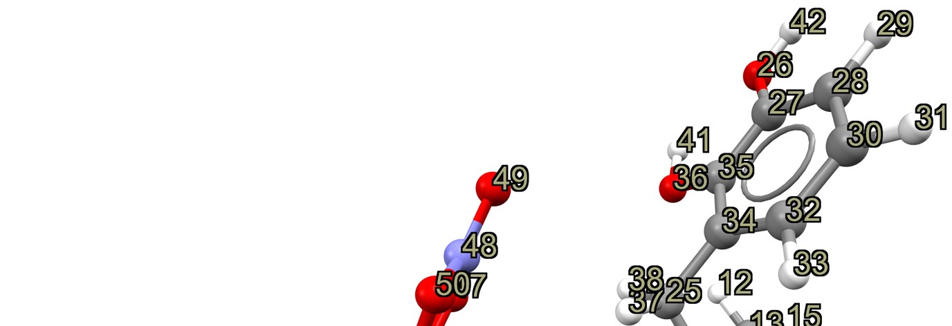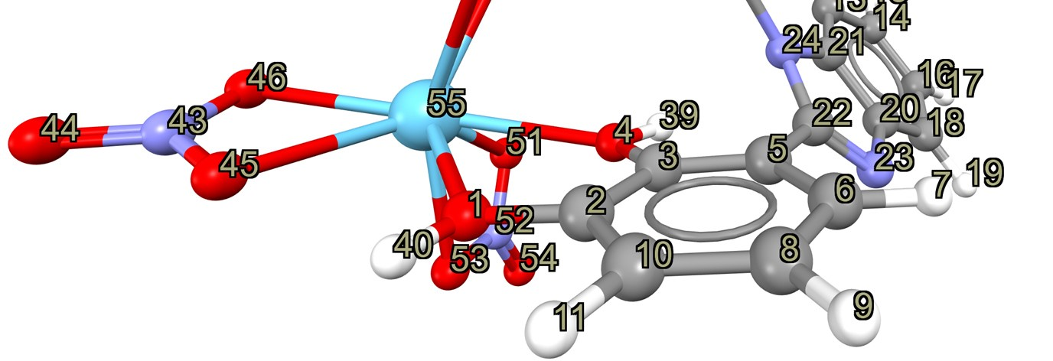
Fig. S6. Label references of (5a). The same labels are used for (5b) and (5c).

