Supplementary material

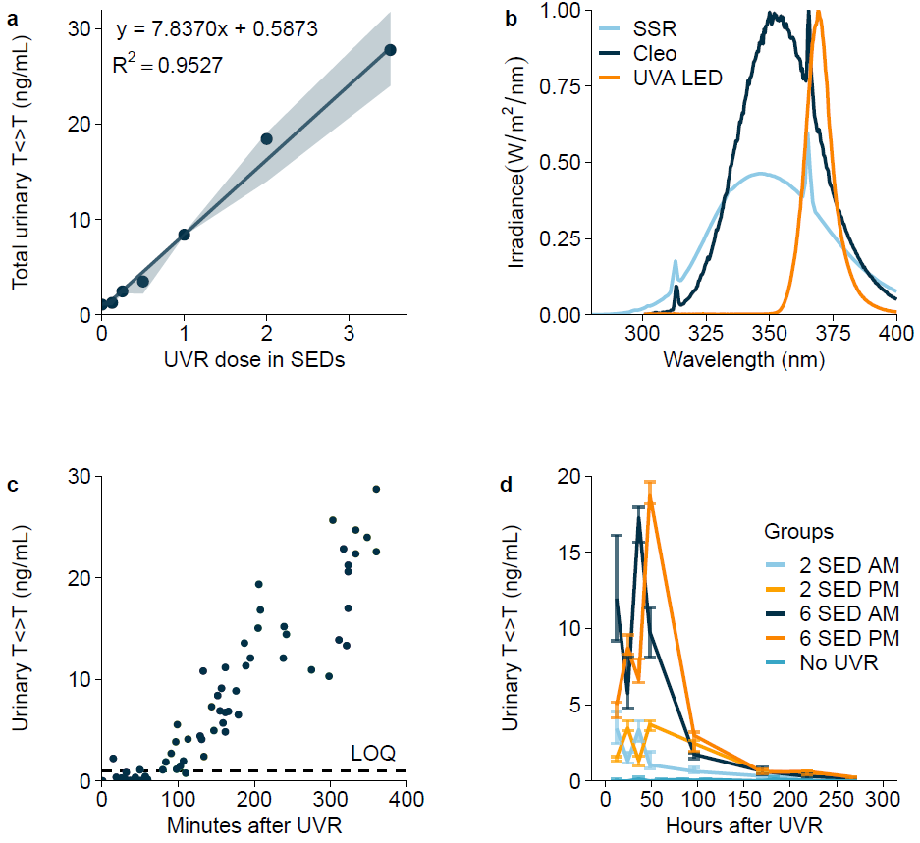
Supplementary Fig. 1: a Linear relation between standard erythema dose (0-3.5 SEDs) and the total T<>T excretion (p < 2.2·10⁻¹⁶) (n = 5 mice). b UV spectra of the solar-simulated radiation (SSR), predominant UVA (Cleo), and pure UVA LED UV sources measured by a Jaz spectroradiometer. c Minutes from UVR exposure and the resulting T<>T concentrations in urine with limit of quantification (LOQ) shown on the plot (n = 50 mice total). d Urinary T<>T concentrations in mice exposed to 2 or 6 SEDs at 5 AM or 5 PM (n = 7 mice). Data are expressed as medians with interquartile ranges (a-b, d) or individual data points (c).

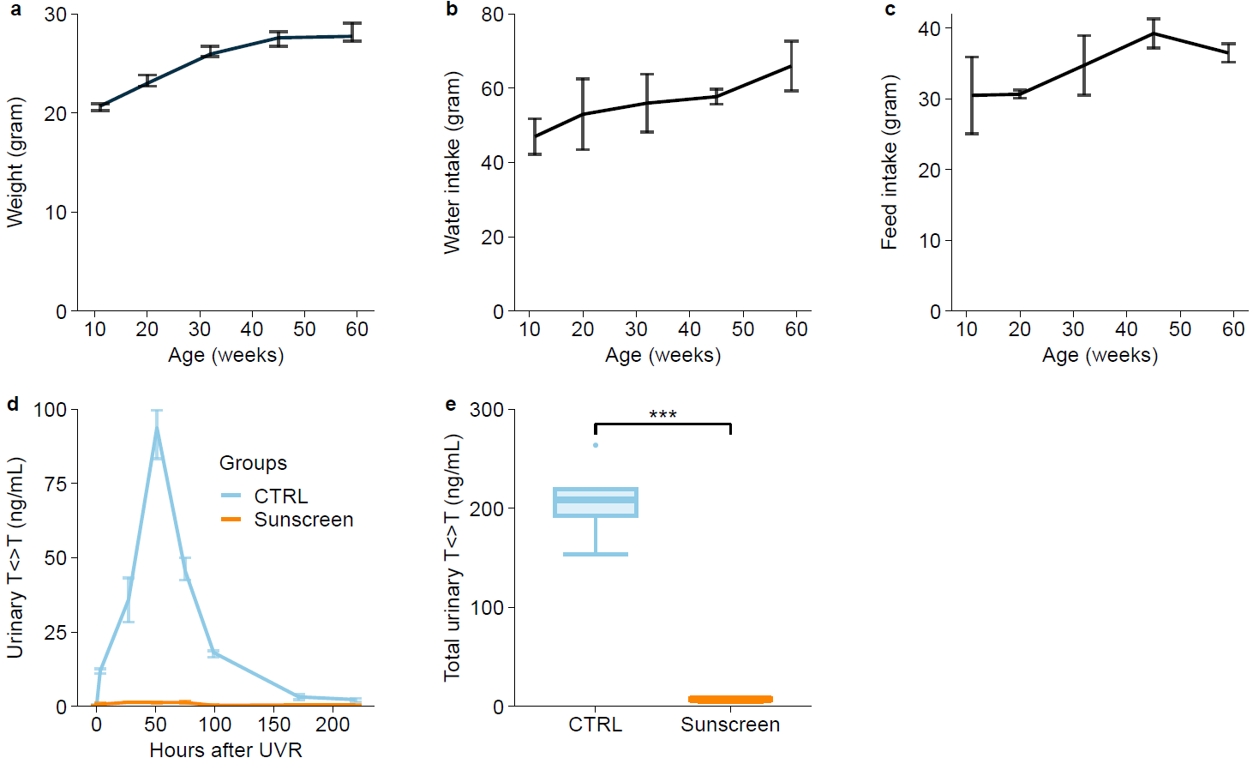
Supplementary Fig. 2: a Weight of the mice in gram during the age study (Fig. 3) (n = 10 mice). b Water and c feed intake in grams from the mice presented in a. d Urinary T<>T concentrations in mice treated with topical sunscreen (sun protection factor 30) twice before exposure to 3.5 SEDs on 3 consecutive days (n = 6 mice). e Total T<>T excretion from d. Data expressed as medians with interquartile ranges (a and d), means with standard deviation (b and c), or boxplots (e). Significance is indicated (***p < 0.001).

