Supplementary Information
Acute lack of sunlight exposure is associated with poorer cognitive test performance
Photochemical & Photobiological Sciences
Andrew Stevenson¹ and Chris Dibben¹
¹ School of Geosciences, University of Edinburgh, Edinburgh, UK
Chris Dibben
chris.dibben@ed.ac.uk

Supplementary Fig. 1. Associations between 2-day ultraviolet-A exposure across UK Local Authorities and predicted cognitive test scores among participants of the UKHLS (aged 16+). Models are adjusted for maximum daily temperature and rainfall. Panels show: (A) General Cognitive Ability, (B) Verbal Fluency, (C) Immediate Word Recall, (D) Delayed Word Recall, and (E) Number Series.

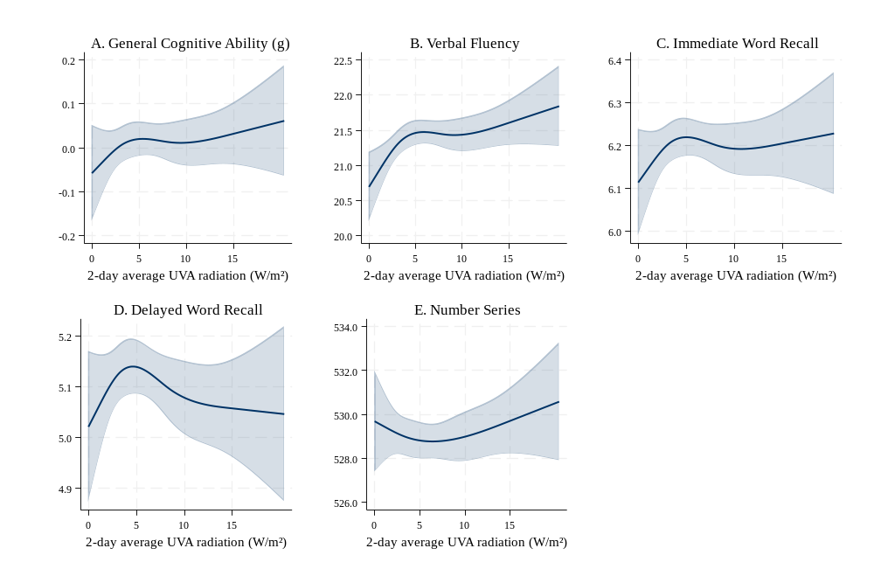

Two-day average UVA irradiance estimates were derived from the Japan Aerospace Exploration Agency (JAXA) MODIS-based satellite product at 0.05° × 0.05° spatial resolution, incorporating cloud cover and aerosol attenuation. Grid cell centroids were spatially joined to Local Authority (LA) boundaries, and daily mean UVA was calculated as the mean across all grid cells within each LA. Using Lower Layer Super Output Area (LSOA) identifiers available under a Special License from Understanding Society, we identified each participant's home LA. As London boroughs are smaller than the 5 km × 5 km satellite grid resolution, some London boroughs were aggregated into a single unit for this analysis. LAs represent various administrative boundaries in the UK, including non-metropolitan districts in England, unitary authorities in England and Wales, London boroughs, metropolitan districts in England, council areas in Scotland, and district council areas in Northern Ireland. Some participants had missing UVA exposure data due to gaps in satellite coverage, particularly in winter.

Supplementary Fig. 2. Nonlinear associations between 2-day average solar radiation (MJ/m²/day) and cognitive test scores among UKHLS participants. Left panel is adjusted for maximum daily temperature and rainfall (minimally adjusted); right panel is adjusted for the minimally adjusted variables plus net personal income, area-level deprivation, age, and sex.
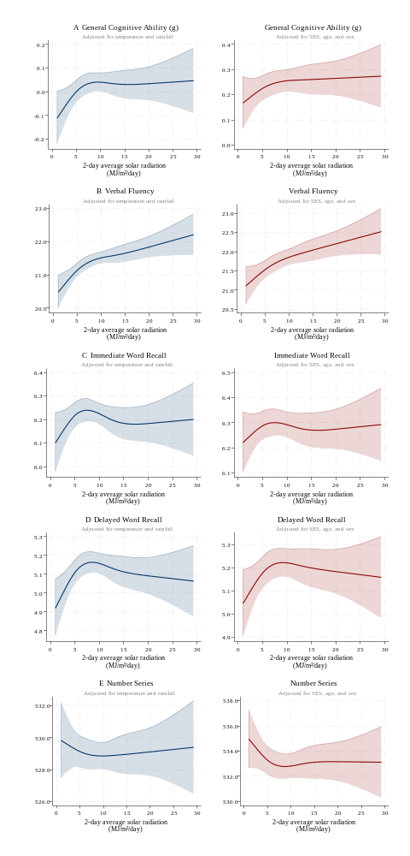
Supplementary Fig. 3. Nonlinear associations between 2-day average solar radiation (MJ/m²/day) and Reading and Mathematics scores among 1958 NCDS participants. Left panel is adjusted for maximum daily temperature and rainfall (minimally adjusted); right panel is adjusted for the minimally adjusted variables plus father’s social class, sex, mother’s usual language and ethnicity.

