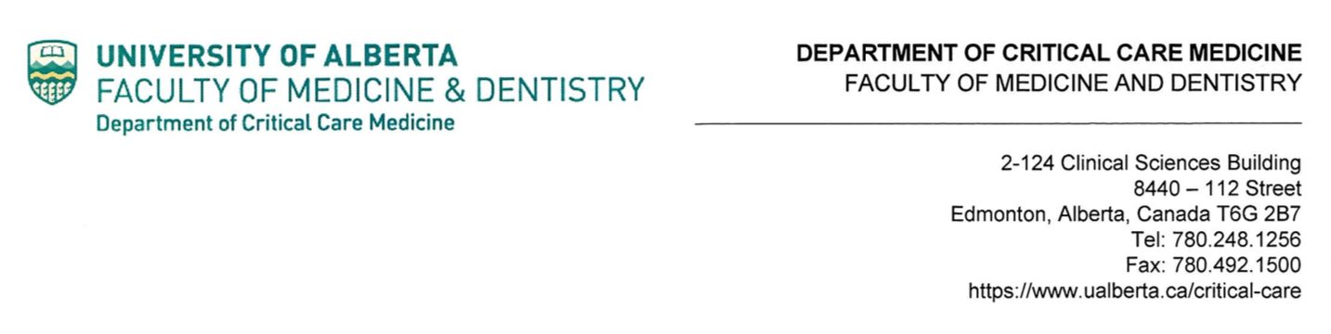
June 25th 2020
Re: Family-centered care document review project
My name is [name and affiliation]. I am contacting you regarding a CanROC-related project about family-centered care in the pre-hospital setting. I am working with Matthew Douma, a CanROC researcher from the University of Alberta in Edmonton.
We are requesting family-related policy and/or procedure documents from CanROC participating sites like yours be emailed to [email address].
Any “clinical governance” type documents related to family presence, visitation and family transport, especially as they relate to cardiac arrest care are relevant. The documents will not be copied or shared and they will be anonymized, extracted, analyzed and deleted. Participating sites will receive a summary of our findings and a template family-centered care policy for prehospital care that is informed by this document review, a related systematic review of literature and an advisory committee of patients and families’ input.
This project has been granted an IRB bypass as it is a quality improvement project that does not involve humans or animal subjects. ARECCI Ethics Screening Tool. Link to bypass: https://drive.google.com/file/d/1_mkwlNyCxVeCywxGyY2USqNNh1bP-a6k/view?usp=sharing
Please scan and email family related documents to me at [email]. If you have any questions about this project, please contact Matthew.
Thank you for your time.
[name]



Matthew J Douma MN RN
Adjunct Associate Professor of Critical Care Medicine
(p) 780 233 9223 (e) douma@ualberta.ca

