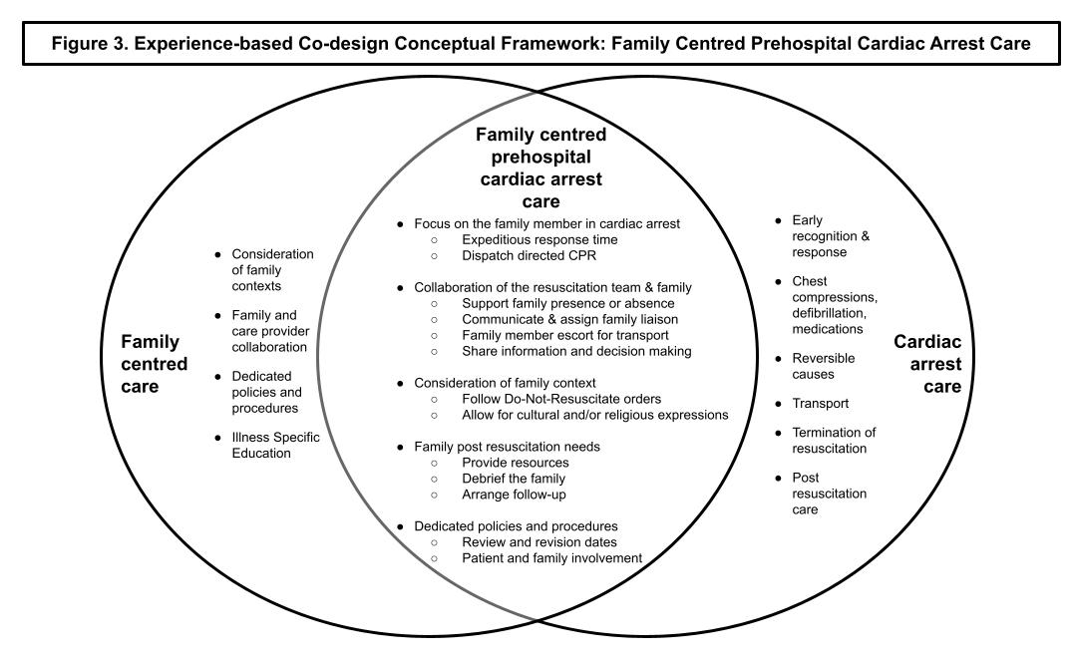
Caption: An output of our co-design workshops was our conceptualization of family centred prehospital cardiac arrest care (figure three) that incorporates content and themes identified in the qualitative document analysis, as well as survivor and family knowledge and experience, and family centredness concepts.

