Supplemental material

Table. S1. Model configuration for heavy rainfall simulations.
Dynamics | Configuration
Initial and lateral boundary condition data | Six-hourly NCEP-GFS at 0.25°×0.25° horizontal resolution
Simulations period | 72 hours
The number of domains, horizontal resolutions, and No. of grid points in X and Y directions | d01: 4.5 km (3.5°N-38.15°N; 62.50°E-96.13°E), 842*572 grid points  d02: 1.5 km (11.5°N-23.7°N; 70.4°E-87.5°E), 858*1014 grid points  d03: 0.5 km (84.72ºE-86.99ºE and 19.27ºN-21.17ºE) 336*384 grid points
Vertical levels | 45
Microphysics | - Ferrier (Ferrier 2000)  - Lin (Lin et al. 1983)  - Thompson (Thompson et al. 2008)  - WSM6 (Hong et al. 2006)
Surface layer physics | Modified MM5 (Jimenez et al., 2012)
Land surface Physics | - Noah (Tewari et al., 2004)  - Noah-MP (Niu et al. 2011, Yang et al. 2011)
PBL | BouLac (Bougeault and Lacarrere, 1989)
Cumulus | - No cumulus  - Kain-Fritsch (Kain 2004)  - Betts-Miller-Janjic (Janjic et al. 1994)  - Multi-Scale Kain-Fritsch (Zheng et al. 2016, Glotfelty et al. 2019)
Radiation physics | Rapid Radiative Transfer Model (Mlawer et al. 1997) for longwave, Goddard (Chou et al. 1994) for shortwave
Urban physics | No Urban physics
LULC | ISRO 2019 30s

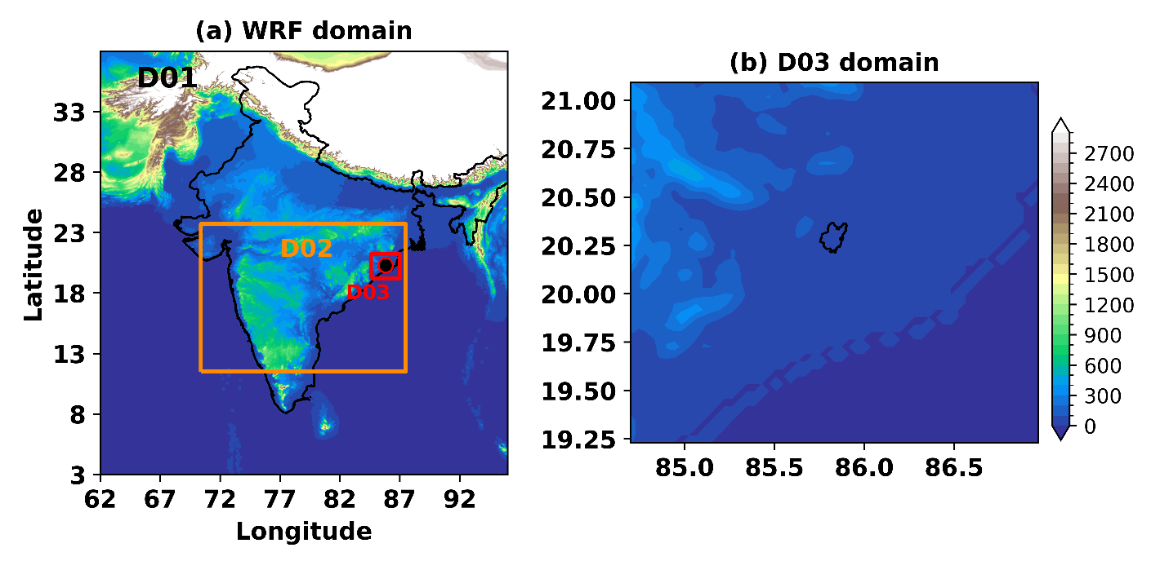
Figure S1. (a) shows the domain configuration. The black, dark-orange, and red boxes represent Domains 1, 2, and 3 (D01, D02, and DO3) which have 4.5, 1.5, and 0.5 km horizontal resolution, respectively. The black dot with a red edge indicates the location of the city of Bhubaneswar. The shaded colors represent the terrain height (m). The black polygon line on the figure on the right (b) displays the city of Bhubaneswar.

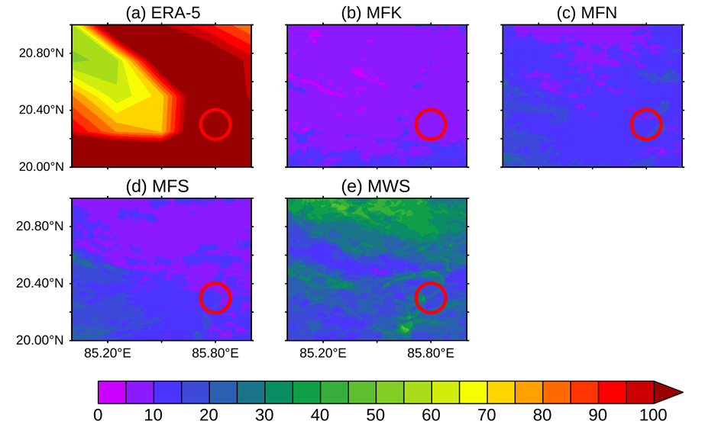
Figure S2. Spatial distribution of convective inhibition (CINE (J/kg)) for the four best model combinations (b-e) and the ERA5 reanalysis dataset (a). The red circle indicates the study region of Bhubaneswar city.

