1 Methodology
1.1 Empirical Basis for Weights
1.1.1 Complementarity Weights
$C_{w\left(f_{o}, f_{d}\right)}=\frac{\left(Trips\left(f_{o}, f_{d}\right)\right)}{max\left(Trips\left(f_{o}\right)\right)}$
Equation 1. Complementarity Weights.
Where:
- $C_{w\left(f_{o}, f_{d}\right)}$ represents the Complementarity Weight for functions pair $fo$ and $fd$.
- $fo​$ and $fd$ represent the origin and destination functions, respectively.
- $Trips(fo​,fd​)$ denotes the number of trips from the origin function $fo$ to the destination function $fd$.
- $max\left(Trips\left(fo​\right)\right)$ is the maximum number of trips originating from $fo$ to any destination, providing a normalization factor that scales each weight by the most active origin.
Table S1. Complementarity Weights.
Origin Function | Destination Function | Trips | Complementarity Weight
Residential | Office | 27925 | 1
Residential | Industrial | 27925 | 1
Residential | Cultural | 16890 | 0.604834378
Residential | Sports | 11753 | 0.42087735
Residential | Commercial | 11408 | 0.408522829
Residential | Green | 9753 | 0.349256938
Residential | Leisure & Hospitality | 5344 | 0.19136974
Residential | Health & Charity | 4624 | 0.165586392
Residential | Residential | 3157 | 0.11305282
Residential | Unique Building | 1706 | 0.061092211
Residential | Parking | 565 | 0.020232766
Office | Residential | 26269 | 1
Office | green | 628 | 0.023906506
Office | Unique Building | 532 | 0.020252008
Office | Office | 427 | 0.016254901
Office | industrial | 427 | 0.016254901
Office | Commercial | 402 | 0.015303209
Office | Leisure & Hospitality | 314 | 0.011953253
Office | Sports | 249 | 0.009478853
Office | Health & Charity | 171 | 0.006509574
Office | Cultural | 110 | 0.004187445
Offices | Parking | 48 | 0.001827249
Unique Building | Residential | 1738 | 1
Unique Building | Unique Building | 475 | 0.273302647
Unique Building | Office | 424 | 0.243958573
Unique Building | Industrial | 424 | 0.243958573
Unique Building | Leisure & Hospitality | 46 | 0.026467204
Unique Building | Commercial | 39 | 0.022439586
Unique Building | Green | 34 | 0.019562716
Unique Building | Sports | 11 | 0.006329114
Unique Building | Parking | 9 | 0.005178366
Unique Building | Health & Charity | 8 | 0.004602992
Unique Building | Cultural | 3 | 0.001726122
Cultural | Residential | 16051 | 1
Cultural | Sports | 275 | 0.017132889
Cultural | Leisure & Hospitality | 245 | 0.015263846
Cultural | Cultural | 203 | 0.012647187
Cultural | Commercial | 89 | 0.005544826
Cultural | Industrial | 80 | 0.004984113
Cultural | Office | 80 | 0.004984113
Cultural | Green | 72 | 0.004485702
Cultural | Health & Charity | 68 | 0.004236496
Cultural | Parking | 39 | 0.002429755
Cultural | Unique Building | 1 | 6.23014E-05
Commercial | Residential | 13042 | 1
Commercial | Commercial | 531 | 0.040714614
Commercial | Leisure & Hospitality | 166 | 0.012728109
Commercial | Sports | 148 | 0.011347953
Commercial | Green | 113 | 0.008664315
Commercial | Industrial | 72 | 0.005520626
Commercial | Office | 72 | 0.005520626
Commercial | Health & Charity | 48 | 0.003680417
Commercial | Parking | 23 | 0.001763533
Commercial | Cultural | 14 | 0.001073455
Commercial | Unique Building | 13 | 0.00099678
Health & Charity | Residential | 4243 | 1
Health & Charity | Commercial | 402 | 0.094744285
Health & Charity | Leisure & Hospitality | 114 | 0.026867782
Health & Charity | Health & Charity | 108 | 0.025453688
Health & Charity | Industrial | 97 | 0.022861183
Health & Charity | Office | 97 | 0.022861183
Health & Charity | Green | 61 | 0.01437662
Health & Charity | Sports | 59 | 0.013905256
Health & Charity | Cultural | 19 | 0.004477964
Health & Charity | Parking | 11 | 0.002592505
Health & Charity | Unique Building | 7 | 0.001649776
Green | Residential | 8881 | 1
Green | Industrial | 1276 | 0.143677514
Green | Office | 1276 | 0.143677514
Green | Green | 823 | 0.092669744
Green | Commercial | 414 | 0.046616372
Green | Sports | 187 | 0.021056187
Green | Leisure & Hospitality | 134 | 0.015088391
Green | Health & Charity | 122 | 0.013737192
Green | Unique Building | 86 | 0.009683594
Green | Cultural | 61 | 0.006868596
Green | Parking | 17 | 0.001914199
Leisure & Hospitality | Residential | 5836 | 1
Leisure & Hospitality | Leisure & Hospitality | 309 | 0.052947224
Leisure & Hospitality | Commercial | 208 | 0.03564085
Leisure & Hospitality | Industrial | 89 | 0.015250171
Leisure & Hospitality | Office | 89 | 0.015250171
Leisure & Hospitality | Sports | 85 | 0.01456477
Leisure & Hospitality | Green | 69 | 0.011823167
Leisure & Hospitality | Cultural | 35 | 0.005997258
Leisure & Hospitality | Health & Charity | 35 | 0.005997258
Leisure & Hospitality | Parking | 14 | 0.002398903
Leisure & Hospitality | Unique Building | 12 | 0.002056203
Sports | Residential | 10427 | 1
Sports | Commercial | 350 | 0.033566702
Sports | Sports | 162 | 0.015536588
Sports | Leisure & Hospitality | 111 | 0.01064544
Sports | Industrial | 93 | 0.008919152
Sports | Office | 93 | 0.008919152
Sports | Green | 31 | 0.002973051
Sports | Health & Charity | 23 | 0.002205812
Sports | Cultural | 17 | 0.001630383
Sports | Unique Building | 6 | 0.000575429
Sports | Parking | 5 | 0.000479524
Industrial | Residential | 26269 | 1
Industrial | Green | 628 | 0.023906506
Industrial | Unique Building | 532 | 0.020252008
Industrial | Industrial | 427 | 0.016254901
Industrial | Office | 427 | 0.016254901
Industrial | Commercial | 402 | 0.015303209
Industrial | Leisure & Hospitality | 314 | 0.011953253
Industrial | Sports | 249 | 0.009478853
Industrial | Health & Charity | 171 | 0.006509574
Industrial | Cultural | 110 | 0.004187445
Industrial | Parking | 48 | 0.001827249
Parking | Residential | 698 | 1
Parking | Industrial | 37 | 0.053008596
Parking | Office | 37 | 0.053008596
Parking | Parking | 33 | 0.047277937
Parking | Leisure & Hospitality | 18 | 0.025787966
Parking | Commercial | 17 | 0.024355301
Parking | Sports | 17 | 0.024355301
Parking | Undeveloped Land | 15 | 0.021489971
Parking | Cultural | 13 | 0.018624642
Parking | Unique Building | 5 | 0.007163324
Parking | Health & Charity | 5 | 0.007163324

3.2.2 Visit Frequency Weights

$VF\left(f\right)= \frac{\sum_{i=1}^{n}{(Frequency Weight(i)⋅Trip Frequency(i))​}}{\sum_{i=1}^{n}{Trip Frequency(i)}}$
Equation 2. Weighted Average Score of Trips to Destination Function.
Where:
- $VF​\left(f\right)$ is the weighted average score of trips to function $f$, which accounts for the frequency of visits.
- $Frequency Weight\left(i\right)$ and $Trip Frequency(i)$ represent the assigned weight and the actual number of trips for the $i$-th frequency type, respectively.
The final step in this analysis involves normalizing these scores to make them comparable across functions. This is done by dividing each function's weighted average score by the highest score obtained among all functions. The normalization formula is:
$VF_{w\left(f\right)}=\frac{VF\left(f\right)}{max\left(VF\right)}$
Equation 3. Visit Frequency Weights.
Where:
- $VF_{w\left(f\right)}$ is the normalized Visit Frequency Weight for function $f$
- $VF\left(f\right)$ represents the actual visit frequency score for function $f$ before normalization.
- $max\left(VF\right)$ is the maximum weighted average score across all functions, which serves as the normalization factor.
Table S2. Visit Frequency Weights.
Function  Destination | Daily | 2-4  /week | <2  /week | Occasional |  | First Time | Weighted Average | $$VF_{w}$$
Residential | 54205 | 17110 | 4972 | 13462 | 593 |  | 3.517 | 0.758
Office & Industrial | 26826 | 2402 | 360 | 854 | 78 |  | 4.485 | 0.967
Unique Building | 865 | 556 | 277 | 1022 | 123 |  | 2.670 | 0.575
Cultural | 15525 | 1356 | 247 | 214 | 23 |  | 4.637 | 1
Commercial | 2786 | 4707 | 2164 | 4058 | 145 |  | 2.924 | 0.630
Health & Charity | 448 | 476 | 479 | 3690 | 119 |  | 2.224 | 0.479
Green | 7436 | 1884 | 528 | 1628 | 123 |  | 3.547 | 0.764
Leisure & Hospitality | 1069 | 1643 | 848 | 3010 | 231 |  | 2.555 | 0.551
Sports | 6031 | 5174 | 603 | 1102 | 36 |  | 3.774 | 0.813
Parking | 296 | 181 | 50 | 211 | 26 |  | 2.915 | 0.628
3.2.2.1 Detailed Visit Frequency Calculation Example:
Although functions like Residential may have a higher total number of trips than Cultural, the Visit Frequency Weight$VF_{w}$does not measure the total volume of visits. Instead, it reflects the average frequency of visits for that function, giving more importance to daily or regular use.
In our data, each trip is recorded individually and assigned a frequency-based weight (daily = 5, first-time = 1). To calculate a function's raw frequency visiting score, two key steps are performed:
- The weights of all individual trips to that function are summed together.
- This total sum is then divided by the total number of trips for that specific function.
This division by the total number of trips is critical because it creates an average score per visit. It effectively neutralizes the raw volume of trips, allowing a high-volume function like 'Residential' to be compared fairly with a lower-volume one like 'Cultural'.
For instance, consider a simplified example:
- Cultural: Has 100 trips, all of them daily (weight 5). Its total weighted sum is (100×5)=500. Its raw score is 500/100​=5.0.
- Residential: Has 500 trips, but a broader mix: 200 are daily (weight 5) and 300 are occasional (weight 2). Its total weighted sum is (200×5)+(300×2)=1600. Its raw score is 1600/500​=3.2.
Even with five times fewer trips, 'Cultural' has a much higher raw intensity score.
The final step is normalization, which makes these raw scores easily comparable on a 0-to-1 scale. After calculating the raw score for every function, the single highest score across all categories is identified (in our example, it's 5.0 from 'Cultural'). The final $VF_{w}$ is then found by dividing each function's raw score by this maximum value. 'Cultural' gets a $VF_{w}$ of 5.0/5.0​=1.0, while 'Residential' gets a VFW of 5.0/3.2​=0.64.
This is why a function like 'Cultural'—with fewer but highly regular trips—can have a higher final $VF_{w}$ than 'Residential', which, despite more visits overall, includes a broader mix of occasional or infrequent users.
1.2 Parcel Complementarity Index PCI
1.2.1 Inter-Parcel Complementarity Score
For each parcel, identified as Parcel A, the Inter-Parcel calculation iterates through each nearby parcel (Parcel B) identified via the KD-tree within the allowable distance. The interactions between Parcel A and Parcel B are evaluated based on the overlap of their urban functions. For each pair of functions $fa$ from Parcel A and $fb$ from Parcel B, the interaction score is computed using the formula to insure accounting all functions in both parcels:
$$Interaction Score=\left(Afa​​+Afb​​\right)×Cw​\left(fa​,fb​\right)×Aw​\left(d\right)×VFw​\left(fb​\right)$$
Equation 4.Inter-Parcel Interaction Score.
Where:
- $Afa$ and $Afb$ denotes the floor area of function $fa$ in parcel A and floor area of function $fb$ in parcel B.
- $Cw\left(fa,fb\right)$ denotes the complementarity weight for the functions pair.
- $Aw​\left(d\right)$ is the distance weight corresponding to the distance $​\left(d\right)$ between the parcels.
- $VFw​\left(fb​\right)$ represents the visit frequency weight for function $fb$.
The total interaction score for Parcel A is the sum of all individual scores with neighbouring parcels B, adjusted for the total interacting area, providing a normalized measure of inter-parcel complementarity:
$Inter-Parcel Score=\frac{∑ Interaction Scores}{Total Interaction Area}$
Equation 5. Inter-Parcel Complementarity Score.
1.2.1.1 Detailed Inter-Parcel PCI Calculation Example:
To provide a comprehensive illustration of the computational process for the Parcel Complementarity Index (PCI), we present a detailed step-by-step example involving three hypothetical parcels: Parcel A, Parcel B, and Parcel C. This example utilizes actual complementarity and visit frequency weights derived from the 2018 Urban Mobility Survey of Madrid and adjacency weights as defined in the main manuscript.
Hypothetical Parcel Data:
- Parcel A (Origin):
  - Functions: Residential: 5000 m2, Office: 2000 m2
  - Parcel Total Functions Area: 7000 m2
  - Coordinates: (0,0) (for distance calculation purposes)
- Parcel B (Neighboring/Destination 1):
  - Functions: Commercial: 1500 m2, Cultural: 700 m2, Sports: 800 m2
  - Parcel Total Functions Area: 3000 m2
  - Coordinates: (250,0) - Distance from Parcel A: 250 meters (falls into 0-400m range)
- Parcel C (Neighboring/Destination 2):
  - Functions: Industrial: 1000 m2, Leisure & Hospitality: 600 m2, Health & Charity: 400 m2, Green: 500 m2
  - Parcel Total Functions Area: 2500 m2
  - Coordinates: (600,0) - Distance from Parcel A: 600 meters (falls into 400-800m range)
Relevant Weights Used (extracted from Supplementary Material Tables S1, S2, and Section 3.2.3 Adjacency Weights):
- Adjacency Weights (Awd​):
  - 0-400 meters: 1.00
  - 400-800 meters: 0.75
  - 800-1200 meters: 0.50
- Visit Frequency Weights (VFwf​):
  - Residential: 0.758
  - Office: 0.967
  - Commercial: 0.630
  - Cultural: 1.000
  - Sports: 0.813
  - Industrial: 0.967
  - Leisure & Hospitality: 0.551
  - Health & Charity: 0.479
  - Green: 0.764
- Complementarity Weights (Cwfo,fd​):
  - Residential-Commercial: 0.408522829
  - Residential-Cultural: 0.604834378
  - Residential-Sports: 0.42087735
  - Residential-Industrial: 1.000
  - Residential-Leisure & Hospitality: 0.19136974
  - Residential-Health & Charity: 0.165586392
  - Residential-Green: 0.349256938
  - Office-Commercial: 0.015303209
  - Office-Cultural: 0.004187445
  - Office-Sports: 0.009478853
  - Office-Industrial: 0.016254901
  - Office-Leisure & Hospitality: 0.011953253
  - Office-Health & Charity: 0.006509574
  - Office-Green: 0.023906506
1.3.1 Inter-Parcel Complementarity Score Calculation for Parcel A
The Inter-Parcel Interaction Score is calculated for each function pair originating from Parcel A (fa​) to functions in neighboring parcels (fb​), using Equation 4:
$$Interaction Score=\left(Afa​​+Afb​​\right)×Cw​\left(fa​,fb​\right)×VFw​\left(fb​\right)×Aw​\left(d\right)$$
The total Inter-Parcel Score for Parcel A is then normalized by the total interacting area (Equation 5 ).
Part 1: Interactions from Parcel A to Parcel B (Distance: 250m, Awd​ = 1.00)
Origin Function (fa​) in Parcel A (Area) | Destination Function (fb​) in Parcel B (Area) | Combined Area (Afa​+Afb​) | Cwfa,fb​ | VFwfb​ | Awd​ | Interaction Score
Residential (5000) | Commercial (1500) | 6500 | 0.408522829 | 0.630 | 1.00 | 6500×0.4085×0.630×1.00=1673.71
Residential (5000) | Cultural (700) | 5700 | 0.604834378 | 1.000 | 1.00 | 5700×0.6048×1.000×1.00=3447.36
Residential (5000) | Sports (800) | 5800 | 0.42087735 | 0.813 | 1.00 | 5800×0.4209×0.813×1.00=1988.66
Office (2000) | Commercial (1500) | 3500 | 0.015303209 | 0.630 | 1.00 | 3500×0.0153×0.630×1.00=33.66
Office (2000) | Cultural (700) | 2700 | 0.004187445 | 1.000 | 1.00 | 2700×0.0042×1.000×1.00=11.34
Office (2000) | Sports (800) | 2800 | 0.009478853 | 0.813 | 1.00 | 2800×0.0095×0.813×1.00=21.68
Sub-Total Interaction Score (Parcel A to Parcel B): 1673.71+3447.36+1988.66+33.66+11.34+21.68=7176.41 Total Interacting Area (Parcel B): 1500(Commercial)+700(Cultural)+800(Sports)=3000m2
Part 2: Interactions from Parcel A to Parcel C (Distance: 600m, Awd​ = 0.75)
Origin Function (fa​) in Parcel A (Area) | Destination Function (fb​) in Parcel C (Area) | Combined Area (Afa​+Afb​) | Cwfa,fb​ | VFwfb​ | Awd​ | Interaction Score
Residential (5000) | Industrial (1000) | 6000 | 1.000 | 0.967 | 0.75 | 6000×1.000×0.967×0.75=4351.5
Residential (5000) | Leisure & Hospitality (600) | 5600 | 0.19136974 | 0.551 | 0.75 | 5600×0.1914×0.551×0.75=442.66
Residential (5000) | Health & Charity (400) | 5400 | 0.165586392 | 0.479 | 0.75 | 5400×0.1656×0.479×0.75=321.36
Residential (5000) | Green (500) | 5500 | 0.349256938 | 0.764 | 0.75 | 5500×0.3493×0.764×0.75=1098.54
Office (2000) | Industrial (1000) | 3000 | 0.016254901 | 0.967 | 0.75 | 3000×0.0163×0.967×0.75=35.42
Office (2000) | Leisure & Hospitality (600) | 2600 | 0.011953253 | 0.551 | 0.75 | 2600×0.0120×0.551×0.75=12.89
Office (2000) | Health & Charity (400) | 2400 | 0.006509574 | 0.479 | 0.75 | 2400×0.0065×0.479×0.75=5.61
Office (2000) | Green (500) | 2500 | 0.023906506 | 0.764 | 0.75 | 2500×0.0239×0.764×0.75=34.30
Sub-Total Interaction Score (Parcel A to Parcel C): 4351.5+442.66+321.36+1098.54+35.42+12.89+5.61+34.30=6302.28 Total Interacting Area (Parcel C): 1000(Industrial)+600(Leisure)+400(Health)+500(Green)=2500m2
Overall Inter-Parcel Complementarity Score for Parcel A:
The inter parcel pci score for Parcel A is the sum of all interaction scores with all interacting parcels, divided by the sum of their total interacting areas.
- Total Sum of Interaction Scores (from Parcel A): 7176.41(to B)+6302.28(to C)=13478.69
- Total Interacting Area (from Parcel B and Parcel C): 3000(Parcel B)+2500(Parcel C)=5500m2
Inter-Parcel Score for Parcel A = 13478.69/5500​≈2.451
This calculation demonstrates how the interaction scores from multiple neighboring parcels are aggregated to compute the overall Inter-Parcel Complementarity Score for a given parcel.
This detailed example demonstrates how individual pair-wise calculations contribute to the overall PCI scores, enhancing the transparency and reproducibility of our methodology. The complete calculation for all 2591 parcels in Tres Cantos, each potentially interacting with numerous neighbors and containing multiple functions, involves millions of such individual calculations, underscoring the necessity of computational tools.
1.2.1.2 Inter-Parcel Complementarity Code:
import pandas as pd
file_path = r"file_path"
parcels_df = pd.read_excel(file_path, sheet_name="parcels")
complementarity_weights_df = pd.read_excel(file_path, sheet_name="complementarity_weights")
visit_frequency_weights_df = pd.read_excel(file_path, sheet_name="visit_frequency_weights")
distance_weights_df = pd.read_excel(file_path, sheet_name="Adjacency_weights")
from scipy.spatial import cKDTree
import numpy as np

def calculate_inter_parcel_pci_with_max_distance(parcels_df, complementarity_weights_df, distance_weights_df, visit_frequency_weights_df, max_distance=1200):
visit_frequency_weights = visit_frequency_weights_df.set_index('function_type')['visit_frequency_weight'].to_dict()

complementarity_weights = complementarity_weights_df.set_index(['function_type_1', 'function_type_2'])['complementarity_weight'].to_dict()

distance_weights = distance_weights_df[['min_distance', 'max_distance', 'weight']].values

coordinates = parcels_df[['longitude', 'latitude']].values
kd_tree = cKDTree(coordinates)

inter_parcel_scores = []
diagnostics = []

for index_a, parcel_a in parcels_df.iterrows():
parcel_a_id = parcel_a['parcel_id']
parcel_a_functions = parcel_a[6:]
parcel_a_total_area = parcel_a['parcel_total_functions_area']
inter_parcel_score = 0
total_interacting_area = 0

distances, indices = kd_tree.query(coordinates[index_a], k=len(parcels_df), distance_upper_bound=max_distance)

for dist, index_b in zip(distances, indices):
if index_a == index_b or np.isinf(dist):
continue

parcel_b = parcels_df.iloc[index_b]
parcel_b_functions = parcel_b[6:]
parcel_b_total_area = parcel_b['parcel_total_functions_area']

distance_weight = next((row[2] for row in distance_weights if row[0] <= dist < row[1]), None)
if distance_weight is None:
diagnostics.append(f"Parcel {parcel_a_id} - Parcel {parcel_b['parcel_id']}: Distance {dist} out of range.")
continue

total_interacting_area += parcel_b_total_area

for func_a, area_a in parcel_a_functions.items():
if area_a <= 0:
continue

for func_b, area_b in parcel_b_functions.items():
if area_b <= 0:
continue

complementarity_weight = complementarity_weights.get((func_a, func_b))
if complementarity_weight is None:
diagnostics.append(f"Missing complementarity weight for {func_a}, {func_b}")
continue

visit_frequency_a = visit_frequency_weights.get(func_a, 1)
visit_frequency_b = visit_frequency_weights.get(func_b, 1)

interaction_score = (area_a + area_b) * complementarity_weight * adjacency_weight * visit_frequency_b

inter_parcel_score += interaction_score

if total_interacting_area > 0:
inter_parcel_scores.append((parcel_a_id, float(inter_parcel_score / total_interacting_area)))
else:
inter_parcel_scores.append((parcel_a_id, 0.0))
diagnostics.append(f"Parcel {parcel_a_id} has no interacting parcels.")

inter_parcel_scores_df = pd.DataFrame(inter_parcel_scores, columns=['parcel_id', 'inter_parcel_pci_score'])

parcels_df = parcels_df.merge(inter_parcel_scores_df, on='parcel_id', how='left')

return parcels_df, diagnostics

parcels_df, diagnostics = calculate_inter_parcel_pci_with_max_distance(
parcels_df, complementarity_weights_df, adjacency_weights_df, visit_frequency_weights_df, max_distance=1200
)

print(parcels_df[['inter_parcel_pci_score']])

1.2.2 Intra-Parcel Complementarity Score
$Interaction Score= (Afa​​+Afb)×Cw​(fa​,fb​)×VFw​(fb​)$
Equation 6. Intra-Parcel Interaction Score.
Where:
- $Afa​​$ and $Afb​$ are the floor areas of functions $fa$ and $fb$ respectively.
- $Cw​(fa​,fb​)$ denotes the complementarity weight for the function pair.
- $VFw​(fa​)$ and $VFw​(fb​)$ represents the visit frequency weight for function $fa$ and $fb$.
The final intra-parcel PCI for each parcel is the sum of all the weighted scores from all function pairs and normalizing this sum by the total functional area of the parcel:
$$Intra-Parcel Score=\frac{\sum{Interaction Scores}}{Total Functions Area}$$
Equation 7. Intra-Parcel Complementarity Score.
1.2.2.1 Detailed Intra-Parcel PCI Calculation Example:
Parcel X Details
Functions and Floor Areas
- Parking: 2668 m²
- Commercial: 1506 m²
- Office: 2342 m²
- Residential: 13372 m²
Visit Frequency Weights $(VFw)$
- Parking: 0.628
- Commercial: 0.630
- Office: 0.967
- Residential: 0.758
Complementarity Weights $(Cw)$
Parking-O & Commercial-D = 0.024
Parking-O & Office-D = 0.053
Parking-O & Residential-D l = 1
Commercial-O & Office-D = 0.005
Commercial-O & Residential-D = 1
Commercial-O & Parking-D = 0.001
Office-O & Residential-D 1
Office-O & Commercial-D =0.01
Office-O & Parking-D = 0.001
Residential-O & Office-D = 1
Residential-O & Commercial-D = 0.408
Residential-O & Parking-D = 0.020

Total Functional Interaction Area
$(FIA total)$​ = 2668 + 1506 + 2342 + 13372 = 19888 m²
$Interaction Score= (Afa​​+Afb​​)×Cw​(fa​,fb​)×VFw​(fb​)$
Calculations for all ordered pairs
- (Parking-O & Commercial-D)
Combined Area: 2668 + 1506 = 4174
Calculation: 4174 × 0.024 × 0.630 ≈ 63.11
- (Parking-O & Office-D)
Combined Area: 2668 + 2342 = 5010
Calculation: 5010 × 0.053 × 0.967 ≈ 256.77
- (Parking-O & Residential-D)
Combined Area: 2668 + 13372 = 16040
Calculation: 16040 × 1.000 × 0.758 ≈ 12,158.32
- (Commercial-O & Office-D)
Combined Area: 1506 + 2342 = 3848
Calculation: 3848 × 0.005 × 0.967 ≈ 18.60
- (Commercial-O & Residential-D)
Combined Area: 1506 + 13372 = 14878
Calculation: 14878 × 1.000 × 0.758 ≈ 11,275.44
- (Commercial-O & Parking-D)
Combined Area: 1506 + 2668 = 4174
Calculation: 4174 × 0.001 × 0.628 ≈ 2.62
- (Office-O & Residential-D)
Combined Area: 2342 + 13372 = 15714
Calculation: 15714 × 1.000 × 0.758 ≈ 11,909.21
- (Office-O & Commercial-D)
Combined Area: 2342 + 1506 = 3848
Calculation: 3848 × 0.010 × 0.630 ≈ 24.24
- (Office-O & Parking-D)
Combined Area: 2342 + 2668 = 5010
Calculation: 5010 × 0.001 × 0.628 ≈ 3.15
- (Residential-O & Office-D)
Combined Area: 13372 + 2342 = 15714
Calculation: 15714 × 1.000 × 0.967 ≈ 15,195.34
- (Residential-O & Commercial-D)
Combined Area: 13372 + 1506 = 14878
Calculation: 14878 × 0.408 × 0.630 ≈ 3,830.34
- (Residential-O & Parking-D)
Combined Area: 13372 + 2668 = 16040
Calculation: 16040 × 0.020 × 0.628 ≈ 201.14
Total Interaction Scores
63.11 + 256.77 + 12158.32 + 18.60 + 11275.44 + 2.62 + 11909.21 + 24.24 + 3.15 + 15195.34 + 3830.34 + 201.14 ≈ 54938.28
Intra-Parcel Score for Parcel X

$$Inter-Parcel Score=\frac{∑ Interaction Scores}{Total Interaction Area}$$
$$\frac{54938.28}{19888} = 2.76$$
1.2.2.2 Intra-Parcel Complementarity Code
def calculate_intra_parcel_pci_with_visit_frequency(parcels_df, complementarity_weights_df, visit_frequency_weights_df):
"""
Calculate the intra-parcel PCI score for each parcel in the DataFrame.
Args:
parcels_df (DataFrame): DataFrame containing parcel data.
complementarity_weights_df (DataFrame): DataFrame containing complementarity weights.
visit_frequency_weights_df (DataFrame): DataFrame containing visit frequency weights.
Returns:
DataFrame: Updated parcels_df with 'intra_parcel_pci_score' column.
"""
visit_frequency_weights = visit_frequency_weights_df.set_index('function_type')['visit_frequency__weight'].to_dict()
parcels_df['intra_parcel_pci_score'] = 0.0
for index, parcel in parcels_df.iterrows():
parcel_id = parcel['parcel_id']
parcel_total_functions_area = parcel['parcel_total_functions_area']
parcel_functions = {col: parcel[col] for col in parcels_df.columns if col not in [
'parcel_id', 'longitude', 'latitude', 'parcel_ground_area', 'ground_coverage_area', 'parcel_total_functions_area', 'free_area_sqm', 'free_area_percentage'
]}
active_functions = {func: area for func, area in parcel_functions.items() if area > 0}
if len(active_functions) < 2 or parcel_total_functions_area == 0:
continue
intra_score = 0.0
for func1, area1 in active_functions.items():
for func2, area2 in active_functions.items():
if func1 != func2:
weight_row = complementarity_weights_df[
(complementarity_weights_df['function_type_1'] == func1) &
(complementarity_weights_df['function_type_2'] == func2)
]
if not weight_row.empty:
complementarity_weight = weight_row['complementarity_weight'].values[0]
visit_frequency_1 = visit_frequency_weights.get(func1, 1)
visit_frequency_2 = visit_frequency_weights.get(func2, 1)
intra_score += ((area1 + area2) * complementarity_weight * visit_frequency_2) / parcel_total_functions_area
parcels_df.at[index, 'intra_parcel_pci_score'] = intra_score
return parcels_df

parcels_df = calculate_intra_parcel_pci_with_visit_frequency(parcels_df, complementarity_weights_df, visit_frequency_weights_df)
print(parcels_df[['parcel_id', 'intra_parcel_pci_score']].head())
3. NSGA-II Configuration
3.2 Illustration of Genetic Algorithm for Optimizing Urban Land Use Configurations
Initialization

- Initial Population Configuration: The genetic algorithm starts with a broad range of configurations, each consisting of several urban parcels designated A, B, C, etc., with diverse mixes of specific functions. For instance:
  - Configuration 1: Parcel A (Residential, Office, Green), Parcel B (Commercial, Cultural, Parking), Parcel C (Office, Green, Parking).
  - Configuration N: Configurations are randomly generated, ensuring extensive genetic diversity across parcels.
Fitness Calculation
- For Configuration 1:
  - Inter-Parcel PCI : Assesses the level of functional complementarity between adjacent parcels. For example, the compatibility of Parcel A’s Residential and Office functions is evaluated in relation to Parcel B’s Commercial and Cultural functions.
  - Intra-Parcel PCI: Measures the complementarity of functions within individual parcels, such as the mix of Office, Green, and Parking in Parcel C, which supports environmental and commercial viability.
Genetic Operations
- Selection: Configurations demonstrating the highest fitness are selected for the next generation.
  - Selected Configurations: For instance, Configuration 1 and Configuration 2 are chosen for their superior fitness scores.
- Crossover: Functions between parcels in selected configurations are swapped, generating novel configurations.
  - Example: Functions from Parcel A in Configuration 1 (Office) are swapped with functions from Parcel B in Configuration 2 (Commercial).
- Mutation: Introduces random changes to enhance genetic diversity.
  - Example: Modify a function in Parcel C from Parking to Cultural in Configuration 1 to enhance accessibility to cultural amenities.
New Generation Creation
- New Configuration Example:
  - After crossover and mutation, a new configuration might result as follows:
    - Parcel A (Residential, Commercial, Green), Parcel B (Office, Cultural, Parking), Parcel C (Office, Cultural, Green)...
Iteration and Convergence
- The genetic algorithm iteratively recalculates the fitness of each new configuration, undergoing successive rounds of selection, crossover, and mutation. This process repeats until the algorithm converges to an optimal configuration, defined by negligible improvements in fitness scores or reaching a predefined number of generations.
Termination
- Optimized Land-Use Configurations: The algorithm concludes with configurations that exhibit maximized PCI scores, indicating highly complementary and diverse functional mixes optimized for urban sustainability.
  - Final Optimized Configuration: For example, an optimal arrangement includes Parcel A (Residential, Commercial, Green), Parcel B (Office, Cultural, Parking), Parcel C (Office, Cultural, Green), representing a balanced urban environment conducive to diverse needs.

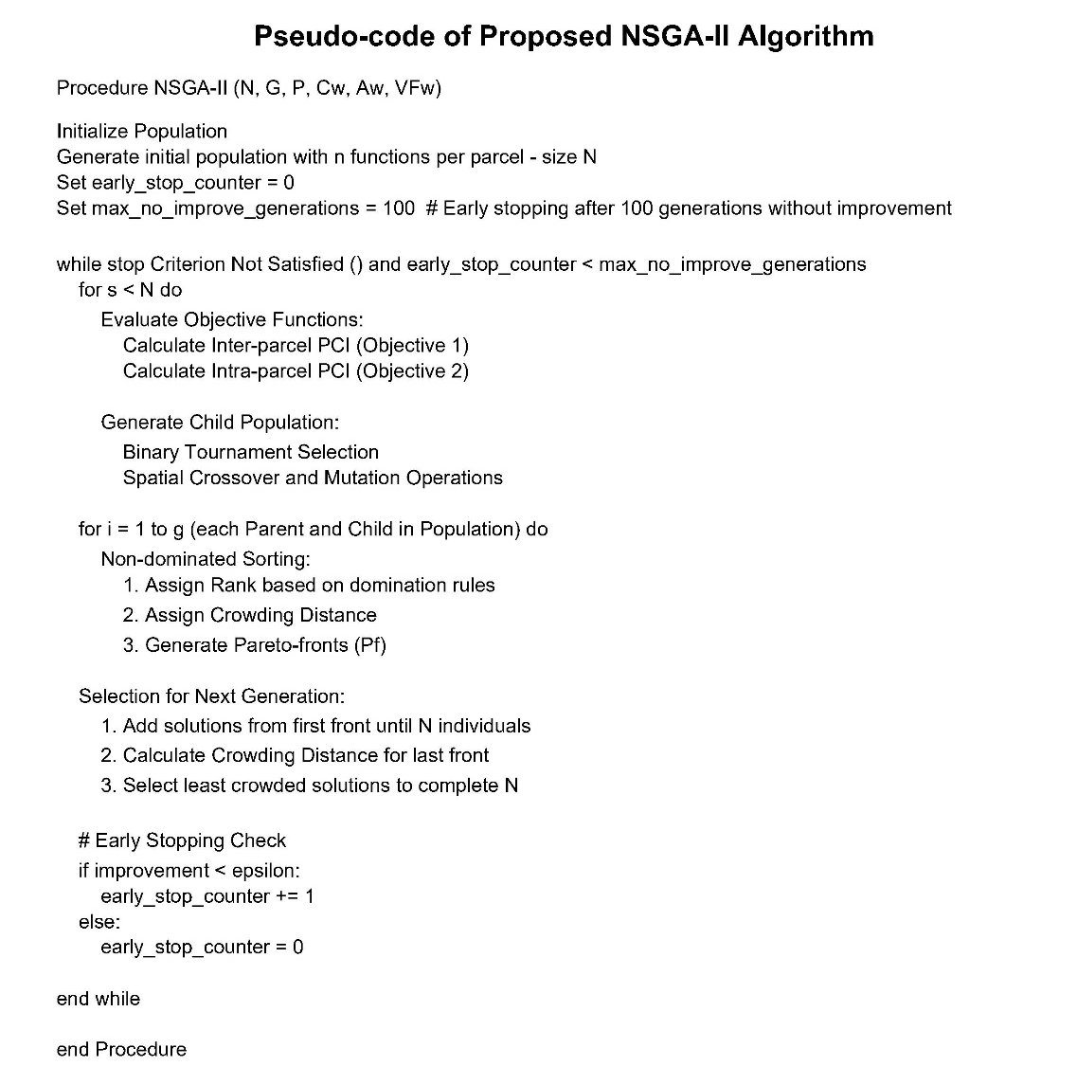
Figure S1. NSGA-II Implementation Pseudo Code.

3.3. Comparison of Extreme Pareto-Front Solutions: Inter- versus Intra-Parcel Prioritisation
To examine how the inclusion of intra-parcel PCI influences planning outcomes, two extreme Pareto-front solutions generated by the NSGA-II algorithm are analysed: (i) an inter-parcel–dominant solution, and (ii) an intra-parcel–dominant solution. These configurations correspond to the boundary solutions of the multi-objective optimisation and represent allocations where one objective is dominant.
3.3.1. Inter-parcel–dominant solution
Figure S2 presents the allocation configuration corresponding to the inter-parcel–dominant Pareto solution. In this extreme, the optimisation assigns single-use configurations to all targeted vacant parcels, producing mono-functional insertions that align with the dominant directional interaction complementarity structure of surrounding parcels. The allocation pattern reinforces existing neighbourhood-scale interaction complementarity rather than introducing internal land-use diversification as multi-use parcels.
The corresponding changes in PCI values are shown in Figure S3. Because no parcel is assigned multiple uses, intra-parcel PCI remains unchanged (Δ Intra = 0 across all parcels). Inter-parcel gains are spatially concentrated in zones where adjacency conditions and empirically derived complementarity and visiting frequency weights allow strong interaction complementarity to be expressed. This configuration therefore maximises neighbourhood-scale interaction complementarity while maintaining single-use internal parcel compositions.

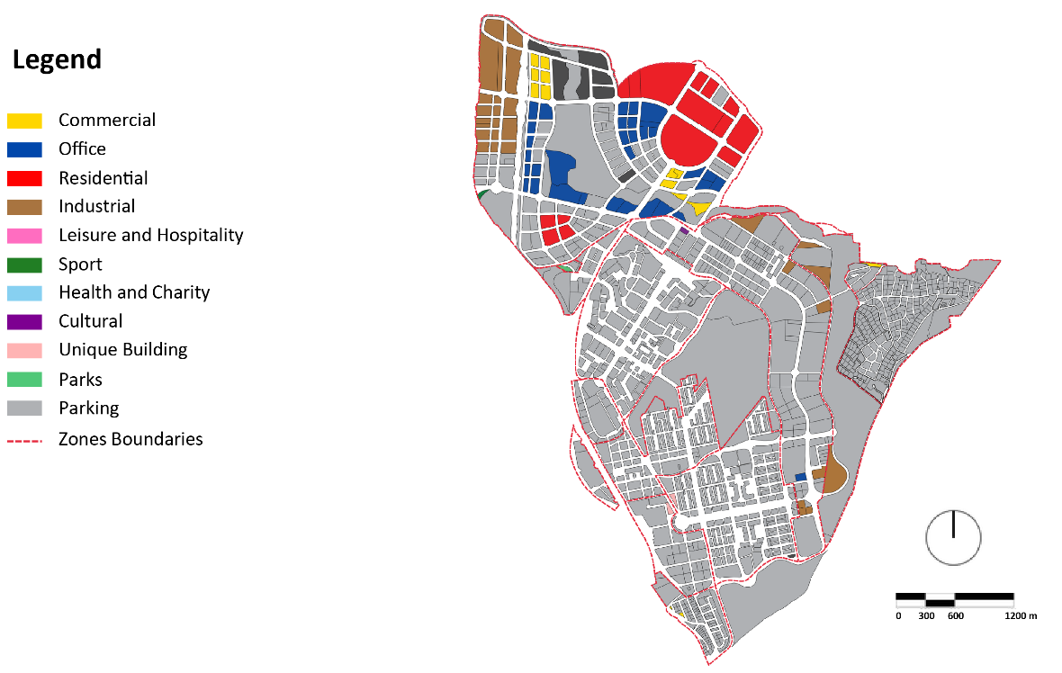
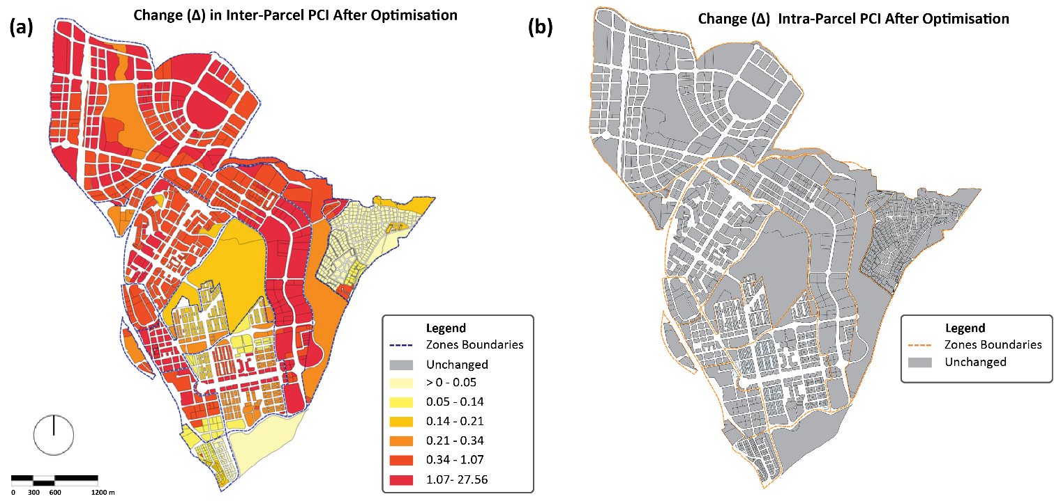
Figure S2. Allocation configuration under the inter-parcel–dominant Pareto solution.
Figure S3. Distribution of Parcel Complementarity Index (PCI) Changes (Optimised − Baseline) under the inter-parcel–dominant Pareto solution: (a) Δ Inter-Parcel PCI, (b) Δ Intra-Parcel PCI.
3.3.2. Intra-parcel–dominant solution
Figure S4 presents the allocation configuration corresponding to the intra-parcel–dominant Pareto solution. In these extreme, targeted vacant parcels are assigned multi-use floor-area shares to maximise internal floor area shares complementarity alignment. The resulting configuration emphasises internal allocation structure, with parcels floor area allocations balanced between uses according to weights rather than exclusively reinforcing neighbourhood-scale interaction complementarity.
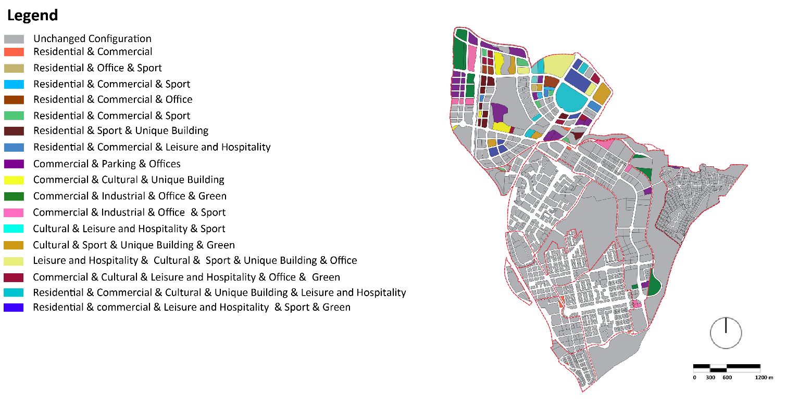
The associated changes in PCI values are shown in Figure S5. This solution produces widespread positive Δ Intra values and a heavier upper tail in the intra-parcel PCI distribution. In contrast, inter-parcel gains become more compressed, with fewer high-magnitude Δ Inter values compared to the inter-parcel–dominant solution. Planning outcomes under this configuration therefore prioritise internal land-use diversification over spatially concentrated reinforcement of neighbourhood-scale interaction complementarity.
Figure S4. Allocation configuration under the intra-parcel–dominant Pareto solution.

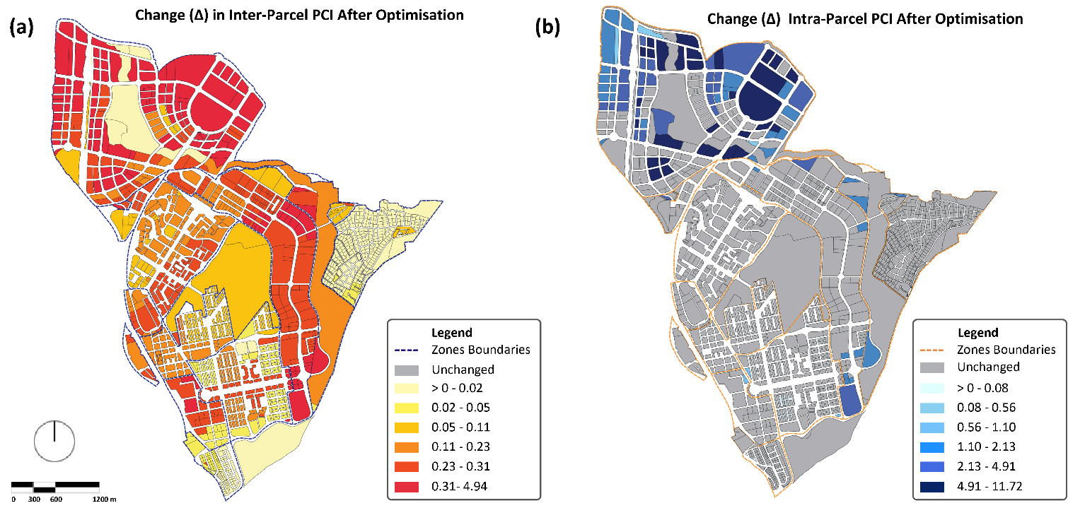
Figure S5. Distribution of Parcel Complementarity Index (PCI) Changes (Optimised − Baseline) under the intra-parcel–dominant Pareto solution: (a) Δ Inter-Parcel PCI, (b) Δ Intra-Parcel PCI.
Table S 3. Examples of Multi-Functional Land Use Allocation in Optimized Parcels.
Parcel ID | longitude | latitude | parcel_ground_area | ground_coverage_area / lot_coverage | parcel_total_functions_area | parking | commercial | cultural | leisure_and_hospitality | industrial | sports | offices | unique_building | residential | health_and_charity | green
8576301VK3987N | 438390.21 | 44974705 | 10709 | 8567 | 59969 | 0 | 0 | 0 | 0 | 5670 | 0 | 21131 | 0 | 0 | 0 | 3881
8577301VK3987S | 438401.52 | 4497568 | 9194 | 7355 | 44130 | 0 | 609 | 0 | 0 | 42007 | 0 | 0 | 0 | 0 | 0 | 83
8580401VK3988S | 438427.74 | 4497860.45 | 65875 | 52700 | 316200 | 0 | 22615 | 0 | 0 | 238998 | 0 | 54587 | 0 | 0 | 0 | 0
8583901VK3988S | 438482.68 | 4498148.71 | 24532 | 19625 | 58875 | 4446 | 11274 | 0 | 0 | 28501 | 0 | 0 | 0 | 0 | 0 | 956
8676301VK3987N | 4384987 | 4497468.97 | 5145 | 4116 | 12348 | 7824 | 926 | 0 | 0 | 0 | 0 | 0 | 0 | 0 | 0 | 0
8677301VK3987N | 438502.73 | 4497558.82 | 3733 | 2986 | 17916 | 0 | 3865 | 0 | 0 | 0 | 0 | 10476 | 0 | 0 | 0 | 0
8873801VK3987S | 438747.88 | 4497072.96 | 4641 | 3712 | 18560 | 0 | 8032 | 0 | 8308 | 0 | 0 | 0 | 0 | 0 | 0 | 0
8976301VK3987N | 438791.98 | 4497496.1 | 11562 | 9249 | 46245 | 23145 | 8488 | 0 | 0 | 0 | 0 | 4680 | 3792 | 0 | 0 | 0
8978201VK3987N | 438811.71 | 4497634.71 | 8356 | 6684 | 40104 | 5005 | 0 | 0 | 0 | 0 | 0 | 14854 | 8965 | 0 | 0 | 0
9066901VK3996N | 438916.41 | 4496448.98 | 16403 | 13122 | 52488 | 0 | 0 | 0 | 33462 | 0 | 13642 | 0 | 5384 | 0 | 0 | 0
9076301VK3997N | 4388903 | 4497479.62 | 13827 | 11061 | 33183 | 2366 | 7959 | 2286 | 0 | 0 | 667 | 3720 | 0 | 16185 | 0 | 0
9166501VK3996N | 439046.27 | 4496489.4 | 11652 | 9321 | 55926 | 18361 | 12285 | 0 | 0 | 0 | 0 | 0 | 1588 | 23692 | 0 | 0
9179101VK3997N | 439016.99 | 4497732.78 | 35756 | 28604 | 114416 | 0 | 15118 | 21736 | 33455 | 0 | 0 | 33333 | 0 | 0 | 0 | 0
9774901VK3997S | 4396284 | 4497256.24 | 7138 | 5710 | 39970 | 0 | 15880 | 2492 | 0 | 0 | 3392 | 2937 | 0 | 819 | 0 | 0
9364204VK3996S | 439060.3 | 4496158.48 | 3672 | 2937 | 8811 | 5995 | 0 | 288 | 1157 | 0 | 0 | 834 | 0 | 537 | 0 | 0
0070301VK4907S | 439890.69 | 4496881.59 | 7764 | 6211 | 31055 | 5429 | 1158 | 0 | 0 | 0 | 0 | 4176 | 0 | 7769 | 0 | 0
0268501VK4906N | 440159.43 | 4496649.9 | 13003 | 10402 | 62412 | 0 | 0 | 0 | 0 | 0 | 8976 | 0 | 5206 | 42930 | 0 | 0
0370501VK4907S | 440262.58 | 4496923.86 | 28666 | 22932 | 160524 | 0 | 82911 | 1429 | 0 | 0 | 0 | 76184 | 0 | 0 | 0 | 0
9078101VK3997N | 438903.6 | 4497620.32 | 10406 | 8324 | 41620 | 0 | 0 | 0 | 0 | 0 | 37450 | 0 | 0 | 4170 | 0 | 0
9079201VK3997N | 438900.41 | 4497745.71 | 7900 | 6320 | 44240 | 11 | 0 | 5567 | 0 | 0 | 0 | 31903 | 6759 | 0 | 0 | 0
9167401VK3996N | 439026.23 | 4496582.78 | 7062 | 5649 | 28245 | 0 | 0 | 5696 | 691 | 0 | 0 | 6626 | 10962 | 0 | 0 | 0
9369201VK3996N | 439212.1 | 4496738.67 | 4979 | 3983 | 27881 | 0 | 3012 | 0 | 0 | 0 | 3823 | 1360 | 8958 | 0 | 0 | 0
9778401VK3997N | 4396429 | 4497676.71 | 19047 | 15237 | 76185 | 0 | 16472 | 0 | 0 | 0 | 1118 | 0 | 15320 | 37268 | 0 | 0
9671601VK3997S | 439538.48 | 4496915.84 | 8896 | 7116 | 42696 | 914 | 18680 | 0 | 38 | 0 | 8186 | 4998 | 0 | 5230 | 0 | 0
9675401VK3997N | 439537.25 | 4497367.45 | 7768 | 6214 | 37284 | 6708 | 0 | 0 | 18395 | 0 | 0 | 0 | 0 | 12181 | 0 | 0
8979301VK3987N | 438812.43 | 4497763.78 | 6635 | 5308 | 15924 | 1175 | 254 | 1982 | 9206 | 0 | 0 | 0 | 0 | 0 | 0 | 0
9568501VK3996N | 439444.59 | 4496676.54 | 12236 | 9788 | 48940 | 10082 | 0 | 3260 | 0 | 0 | 7186 | 14261 | 3180 | 10971 | 0 | 0
0168101VK4906N | 440002.7 | 4496617.33 | 5035 | 4028 | 12084 | 390 | 4927 | 0 | 1586 | 0 | 0 | 502 | 0 | 4679 | 0 | 0
8870901VK3987S | 438735.65 | 4496883.35 | 4787 | 3829 | 15316 | 2246 | 3576 | 0 | 0 | 0 | 0 | 5486 | 0 | 0 | 0 | 356
8970201VK3987S | 438807.3 | 4496879.4 | 10316 | 8252 | 57764 | 0 | 0 | 0 | 0 | 0 | 0 | 0 | 56002 | 1306 | 0 | 0
9773101VK3997S | 439608.96 | 4497101.15 | 6733 | 5386 | 21544 | 868 | 2582 | 0 | 9538 | 0 | 3700 | 0 | 0 | 0 | 0 | 0
0279701VK4907N | 440172.69 | 4497712.69 | 14749 | 11799 | 58995 | 1287 | 3102 | 0 | 22836 | 0 | 2932 | 23816 | 2286 | 0 | 0 | 0
0674401VK4907S | 440535.45 | 4497269.51 | 52165 | 41732 | 166928 | 11640 | 30445 | 0 | 0 | 0 | 0 | 0 | 0 | 83750 | 0 | 0
8874701VK3987S | 438765.43 | 4497236.37 | 5625 | 4500 | 27000 | 0 | 6272 | 0 | 0 | 0 | 0 | 5109 | 8581 | 7038 | 0 | 0
8875601VK3987N | 438781.68 | 44973589 | 7178 | 5742 | 17226 | 1527 | 2785 | 0 | 0 | 0 | 584 | 10341 | 0 | 0 | 0 | 1233
9067901VK3996N | 4388961 | 44965775 | 13708 | 10966 | 43864 | 2941 | 0 | 2236 | 0 | 0 | 3605 | 17293 | 0 | 0 | 0 | 0
9169501VK3996N | 439060.97 | 4496782.18 | 30160 | 24128 | 168896 | 0 | 0 | 54402 | 36764 | 0 | 44619 | 0 | 0 | 0 | 0 | 0
9379801VK3997N | 439223.39 | 44976819 | 21484 | 17187 | 103122 | 0 | 21681 | 22023 | 0 | 0 | 0 | 0 | 0 | 47516 | 0 | 0
9678901VK3997N | 439552.26 | 4497640.69 | 12669 | 10135 | 50675 | 20675 | 0 | 13275 | 0 | 0 | 4080 | 12645 | 0 | 0 | 0 | 0
9968501VK3996N | 439827.42 | 4496622.67 | 13684 | 10947 | 54735 | 0 | 8303 | 0 | 3420 | 0 | 0 | 0 | 0 | 22210 | 0 | 0
0071601VK4907S | 439972.95 | 4496941.86 | 9236 | 7388 | 51716 | 0 | 15701 | 0 | 0 | 0 | 0 | 10409 | 0 | 19054 | 0 | 0
0276501VK4907N | 440177.14 | 4497469.58 | 74464 | 59571 | 357426 | 0 | 83957 | 0 | 34731 | 0 | 83276 | 0 | 0 | 121048 | 34414 | 0
0378601VK4907N | 440262.7 | 4497651.44 | 14936 | 11948 | 83636 | 1872 | 0 | 33775 | 2503 | 0 | 0 | 17320 | 0 | 0 | 0 | 0
0475601VK4907N | 440373.55 | 4497339.12 | 18621 | 14896 | 59584 | 0 | 31461 | 0 | 0 | 0 | 8976 | 0 | 0 | 0 | 0 | 0
8871401VK3987S | 438743.29 | 4496955.66 | 4387 | 3509 | 21054 | 4892 | 2032 | 0 | 6981 | 0 | 0 | 0 | 0 | 7149 | 0 | 0
9080301VK3998S | 438897.38 | 4497861.96 | 7731 | 6184 | 30920 | 523 | 4723 | 2210 | 0 | 0 | 0 | 2459 | 20748 | 0 | 0 | 257
9081501VK3988S | 4388786 | 4497974.2 | 19104 | 15283 | 76415 | 14962 | 0 | 0 | 0 | 0 | 0 | 0 | 71 | 47232 | 0 | 0
9868501VK3996N | 4397174 | 4496624.42 | 15608 | 12486 | 74916 | 1246 | 3379 | 0 | 0 | 0 | 0 | 0 | 6417 | 63874 | 0 | 0
9974301VK3997S | 439796.65 | 4497269.3 | 5652 | 4521 | 27126 | 0 | 0 | 0 | 0 | 0 | 6466 | 0 | 0 | 10439 | 0 | 0
9674601VK3997S | 439553.33 | 4497244.91 | 8077 | 6461 | 32305 | 16572 | 0 | 0 | 0 | 0 | 0 | 4131 | 3241 | 2790 | 0 | 0
9776402VK3997N | 439636.43 | 4497535.82 | 1524 | 1219 | 8533 | 0 | 1171 | 1761 | 0 | 0 | 0 | 5441 | 0 | 0 | 0 | 0
0169401VK4906N | 4400542 | 4496768.7 | 4393 | 3514 | 17570 | 0 | 7160 | 0 | 3811 | 0 | 0 | 1257 | 0 | 0 | 0 | 0
0170901VK4907S | 440027.89 | 44968421 | 10327 | 8261 | 49566 | 9924 | 9305 | 0 | 14358 | 0 | 1611 | 0 | 14368 | 0 | 0 | 0
0572301VK4907S | 440425.26 | 4497089.26 | 21795 | 17436 | 87180 | 0 | 0 | 0 | 0 | 0 | 0 | 8621 | 0 | 0 | 0 | 0
0576401VK4907N | 440443.2 | 4497496.29 | 14287 | 11429 | 57145 | 0 | 4452 | 2820 | 0 | 0 | 0 | 0 | 2010 | 0 | 0 | 0
9380501VK3998S | 439297.5 | 4497886.45 | 27066 | 21652 | 108260 | 0 | 0 | 15120 | 17899 | 0 | 6423 | 0 | 47913 | 20905 | 0 | 0
0173501VK4907S | 440063.93 | 4497201.47 | 136118 | 108894 | 762258 | 23864 | 40050 | 0 | 0 | 0 | 10207 | 0 | 9695 | 366761 | 0 | 0
0271201VK4907S | 440131.26 | 4496945.8 | 9623 | 7698 | 38490 | 0 | 3732 | 0 | 0 | 0 | 5248 | 0 | 0 | 27274 | 0 | 0
8971301VK3987S | 438816 | 4496950.92 | 8018 | 6414 | 44898 | 21775 | 0 | 0 | 4194 | 0 | 0 | 0 | 0 | 18929 | 0 | 0
8980301VK3988S | 438810.75 | 4497883.87 | 7133 | 5706 | 22824 | 13029 | 0 | 0 | 3605 | 0 | 244 | 0 | 3956 | 0 | 0 | 0

