Supporting Information
Potential Toxic Effects Linked to Taurine Interactions with Alkanolamines and Diisopropylamine
Section S1. Analysis of the DO stretch band of D₂O in mixtures containing DIPA and taurine
This section shows a sample fit to the ν(DO) stretch band of D₂O (Fig. S1) and compares this band for replicates of different samples (Fig. S2). It also reports the percent areas under each of the five peaks convolved under this band, in Tables S1-S5.
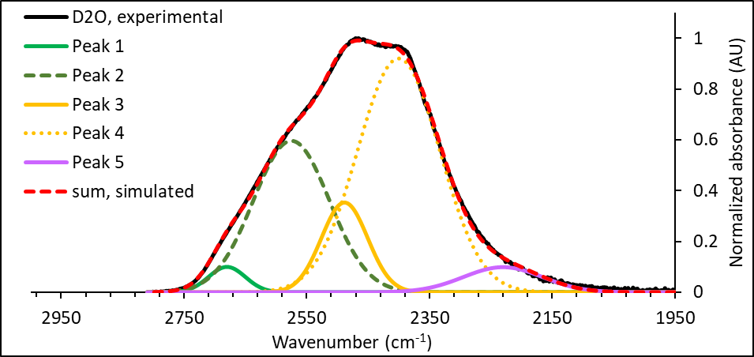
Figure S1 Sample fit to the DO stretch band of D₂O, upon mixing with taurine and DIPA (33wt% taurine, 33wt% water and 33wt% DIPA).

Table S1 Percent area of the peaks convolved under the ν(DO) band of pure D₂O. The peaks are lumped into three groups, at high, intermediate and low wavenumbers, as indicated by the yellow, green and salmon.
D₂O, rep 1 |  | D₂O, rep 2 |  | D₂O, rep 3 |  |  | % area
Center peak (cm⁻¹) | % area | Center peak (cm⁻¹) | % area | Center peak (cm⁻¹) | % area | Center peak range (cm⁻¹) | Average | STDEV
2680.00 | 2.47 | 2664.54 | 5.86 | 2666.01 | 5.30 | 2570-2690 | 33.58 | 1.61
2574.97 | 30.45 | 2567.47 | 27.63 | 2567.11 | 29.04 | 2400-2500 | 61.21 | 2.61
2488.37 | 10.96 | 2487.68 | 6.01 | 2487.22 | 6.08 | 2220-2240 | 5.21 | 0.06
2400.14 | 50.84 | 2406.59 | 55.34 | 2405.63 | 54.40
2230.27 | 5.28 | 2230.27 | 5.16 | 2230.27 | 5.18

Table S2 Percent area of the peaks convolved under the ν(DO) band of 50wt% DIPA in D₂O. The peaks are lumped into three groups, at high, intermediate and low wavenumbers, as indicated by the yellow, green and salmon.
50wt%DIPA, D₂O
rep 1 |  | rep 2 |  | rep 3 |  | rep 4 |  | rep 5 |  |  | % area
Center peak (cm⁻¹) | % area | Center peak (cm⁻¹) | % area | Center peak (cm⁻¹) | % area | Center peak (cm⁻¹) | % area | Center peak (cm⁻¹) | % area | Center peak range (cm⁻¹) | AVG | SD
2688.11 | 1.06 | 2688.70 | 1.18 | 2692.55 | 1.29 | 2691.64 | 1.04 | 2658.53 | 5.52 | 2570-2690 | 26.46 | 2.73
2591.26 | 25.46 | 2595.27 | 23.50 | 2603.33 | 20.80 | 2597.74 | 23.83 | 2567.80 | 28.70 | 2400-2500 | 58.45 | 2.70
2498.15 | 23.25 | 2503.40 | 21.47 | 2509.13 | 23.40 | 2503.61 | 20.70 | 2487.89 | 15.53 | 2220-2240 | 15.08 | 0.59
2404.12 | 35.97 | 2410.52 | 39.59 | 2408.12 | 38.86 | 2408.69 | 39.12 | 2399.45 | 35.15
2241.28 | 14.26 | 2242.48 | 14.27 | 2227.31 | 15.66 | 2233.48 | 15.31 | 2232.52 | 15.10

Table S3 Percent area of the peaks convolved under the ν(DO) band of 33 wt% DIPA in D₂O. The peaks are lumped into three groups, at high, intermediate and low wavenumbers, as indicated by the yellow, green and salmon.
33wt%DIPA, D₂O
rep 1 |  | rep 2 |  | rep 3 |  | rep 4 |  |  | % area
Center peak (cm⁻¹) | % area | Center peak (cm⁻¹) | % area | Center peak (cm⁻¹) | % area | Center peak (cm⁻¹) | % area | Center peak range (cm⁻¹) | AVG | SD
2675.90 | 2.63 | 2673.78 | 2.98 | 2671.23 | 3.38 | 2672.94 | 3.08 | 2570-2690 | 32.05 | 0.56
2575.70 | 29.92 | 2575.37 | 28.93 | 2574.18 | 27.98 | 2574.16 | 29.29 | 2400-2500 | 53.24 | 1.90
2492.45 | 10.24 | 2493.37 | 7.45 | 2493.45 | 6.13 | 2492.76 | 6.96 | 2220-2240 | 14.71 | 0.27
2410.20 | 42.67 | 2415.56 | 45.96 | 2418.49 | 47.41 | 2415.89 | 46.16
2241.39 | 14.54 | 2242.08 | 14.67 | 2237.60 | 15.11 | 2245.94 | 14.51

Table S4 Percent area of the peaks convolved under the ν(DO) band of 33wt% DIPA and 33wt% taurine in D₂O. The peaks are lumped into three groups, at high, intermediate and low wavenumbers, as indicated by the yellow, green and salmon.
33wt%DIPA, 33% taurine, D₂O
rep 1 |  | rep 2 |  | rep 3 |  |  | % area
Center peak (cm⁻¹) | % area | Center peak (cm⁻¹) | % area | Center peak (cm⁻¹) | % area | Center peak range (cm⁻¹) | AVG | SD
2664.58 | 2.18 | 2659.44 | 3.02 | 2658.05 | 3.08 | 2570-2690 | 27.02 | 1.15
2576.08 | 26.32 | 2576.25 | 23.36 | 2575.89 | 23.09 | 2400-2500 | 54.33 | 1.65
2498.63 | 9.75 | 2499.46 | 8.11 | 2499.70 | 7.58 | 2220-2240 | 18.66 | 0.27
2423.64 | 43.40 | 2430.40 | 46.65 | 2433.24 | 47.49
2231.43 | 18.35 | 2227.91 | 18.86 | 2229.59 | 18.77

Table S5 Percent area of the peaks convolved under the ν(DO) band of 50wt% taurine in D₂O. The peaks are lumped into three groups, at high, intermediate and low wavenumbers, as indicated by the yellow, green and salmon.
50% taurine, D₂O
rep 1 |  | rep 2 |  |  | % area
Center peak (cm⁻¹) | % area | Center peak (cm⁻¹) | % area | Center peak range (cm⁻¹) | AVG | SD
2661.84 | 5.43 | 2661.77 | 5.43 | 2570-2690 | 34.32 | 0.03
2563.79 | 28.92 | 2563.97 | 28.85 | 2400-2500 | 59.01 | 0.02
2486.56 | 5.56 | 2486.78 | 5.58 | 2220-2240 | 6.68 | 0.01
2406.67 | 53.41 | 2407.07 | 53.46
2220.13 | 6.67 | 2220.13 | 6.68

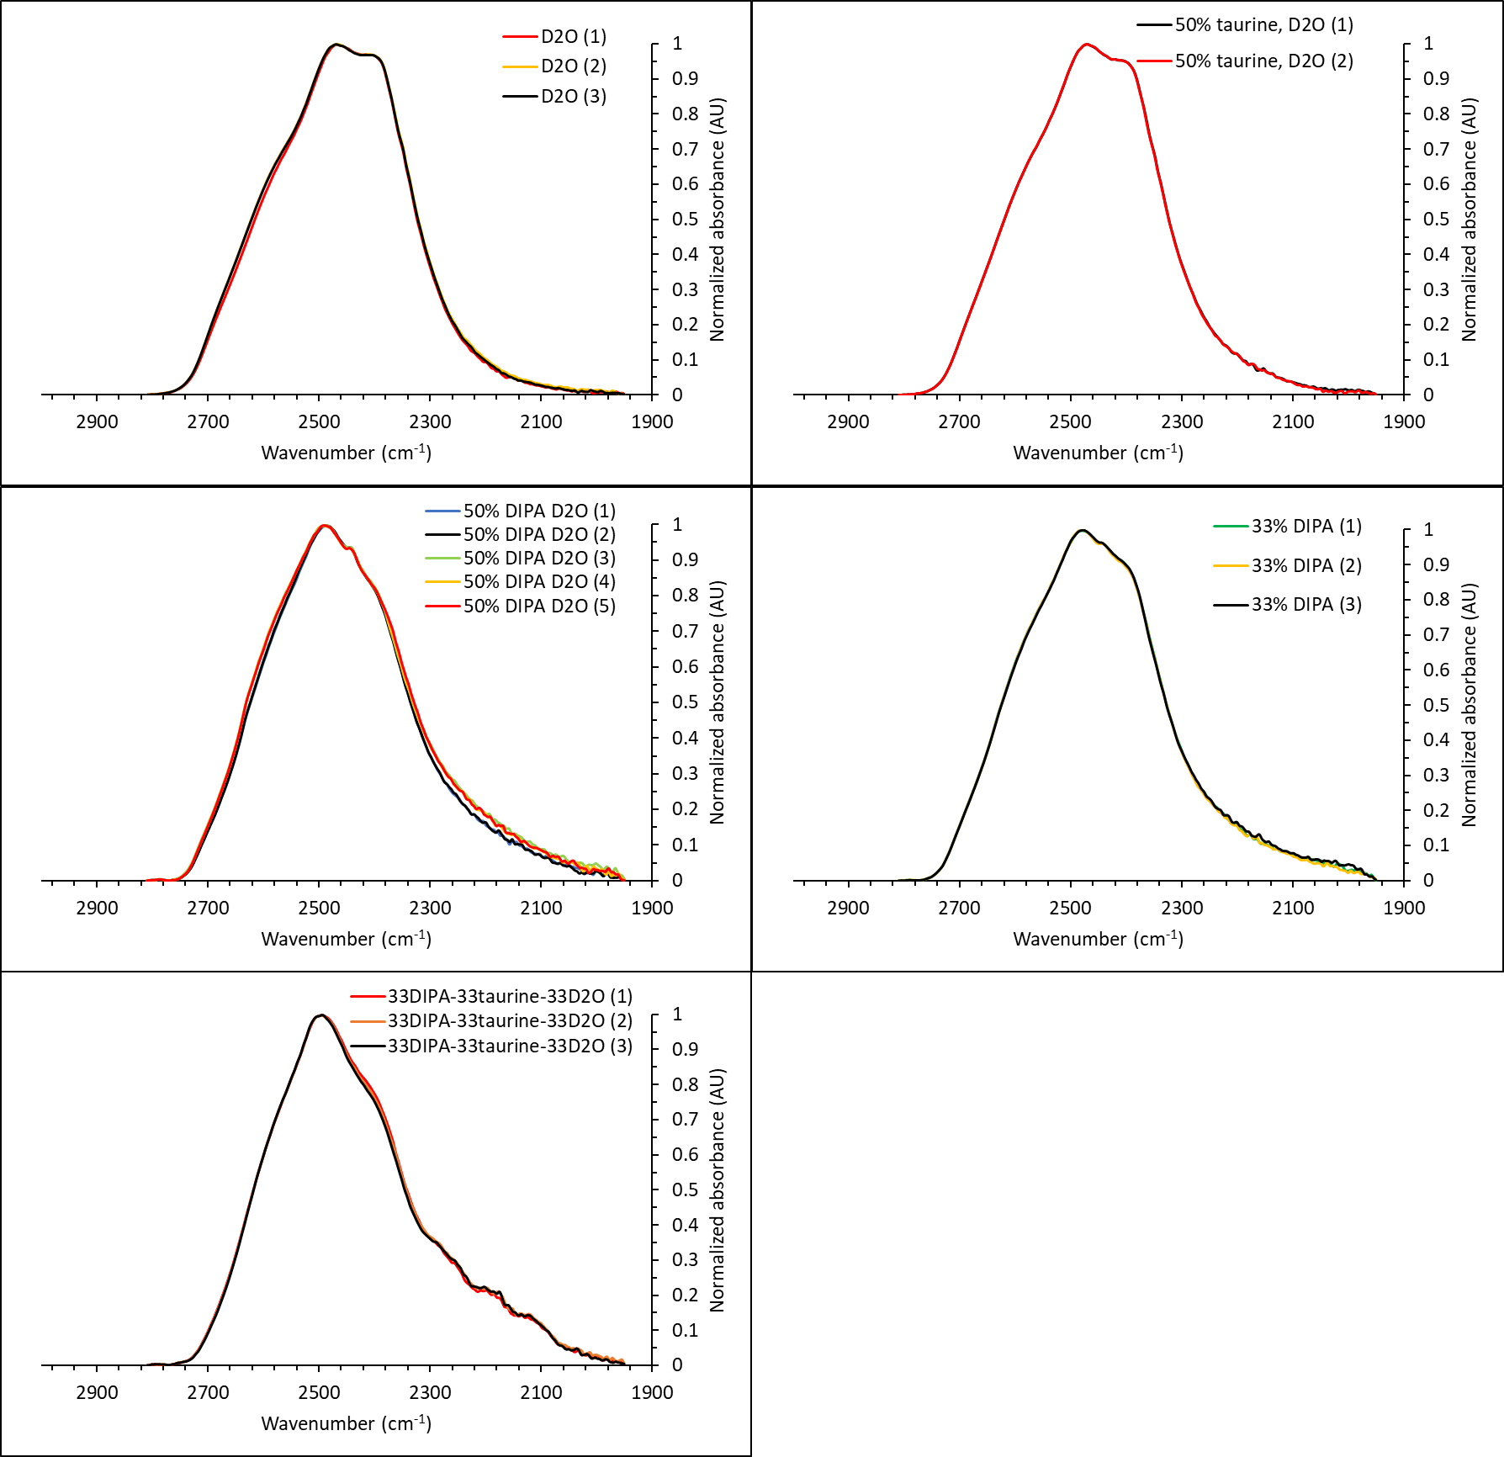
Figure S2 Comparison between the ν(DO) stretch band measured in replicate experiments.

Section S2. ATR-FTIR spectra of amines and their mixtures in the 950-1100⁻¹ region

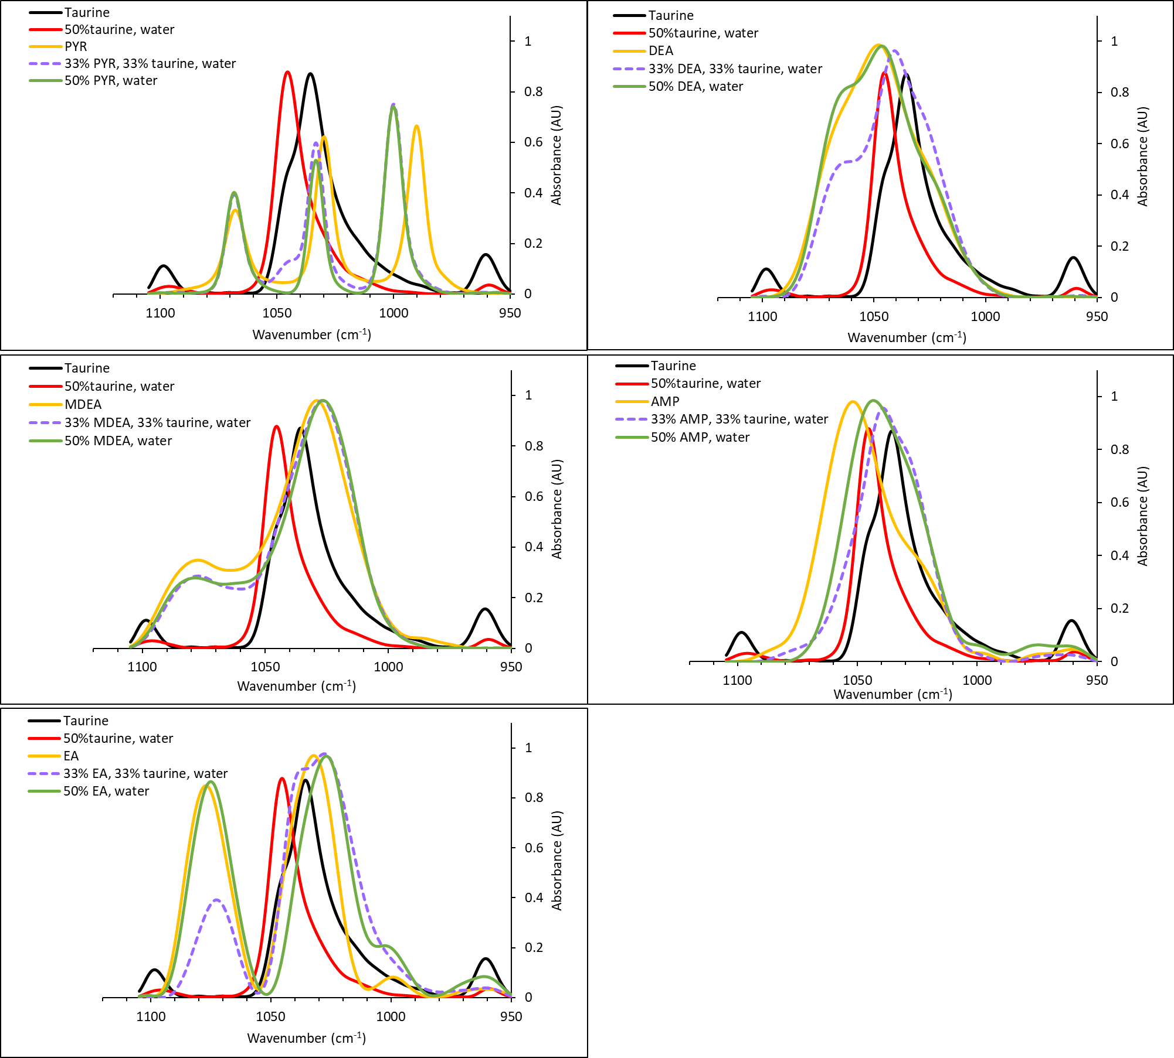
Figure S3 ATR-FTIR spectra of amines and their mixtures in the 950-1100⁻¹ region, for binary mixtures with water (50wt% amine in water), and in ternary mixtures with taurine (at a 1:1:1 wt. ratio of taurine:amine:water). The spectra of taurine and 50% taurine in water are also shown in each panel.

Section S3. DO stretch band of D₂O in mixtures containing alkanolamines and taurine
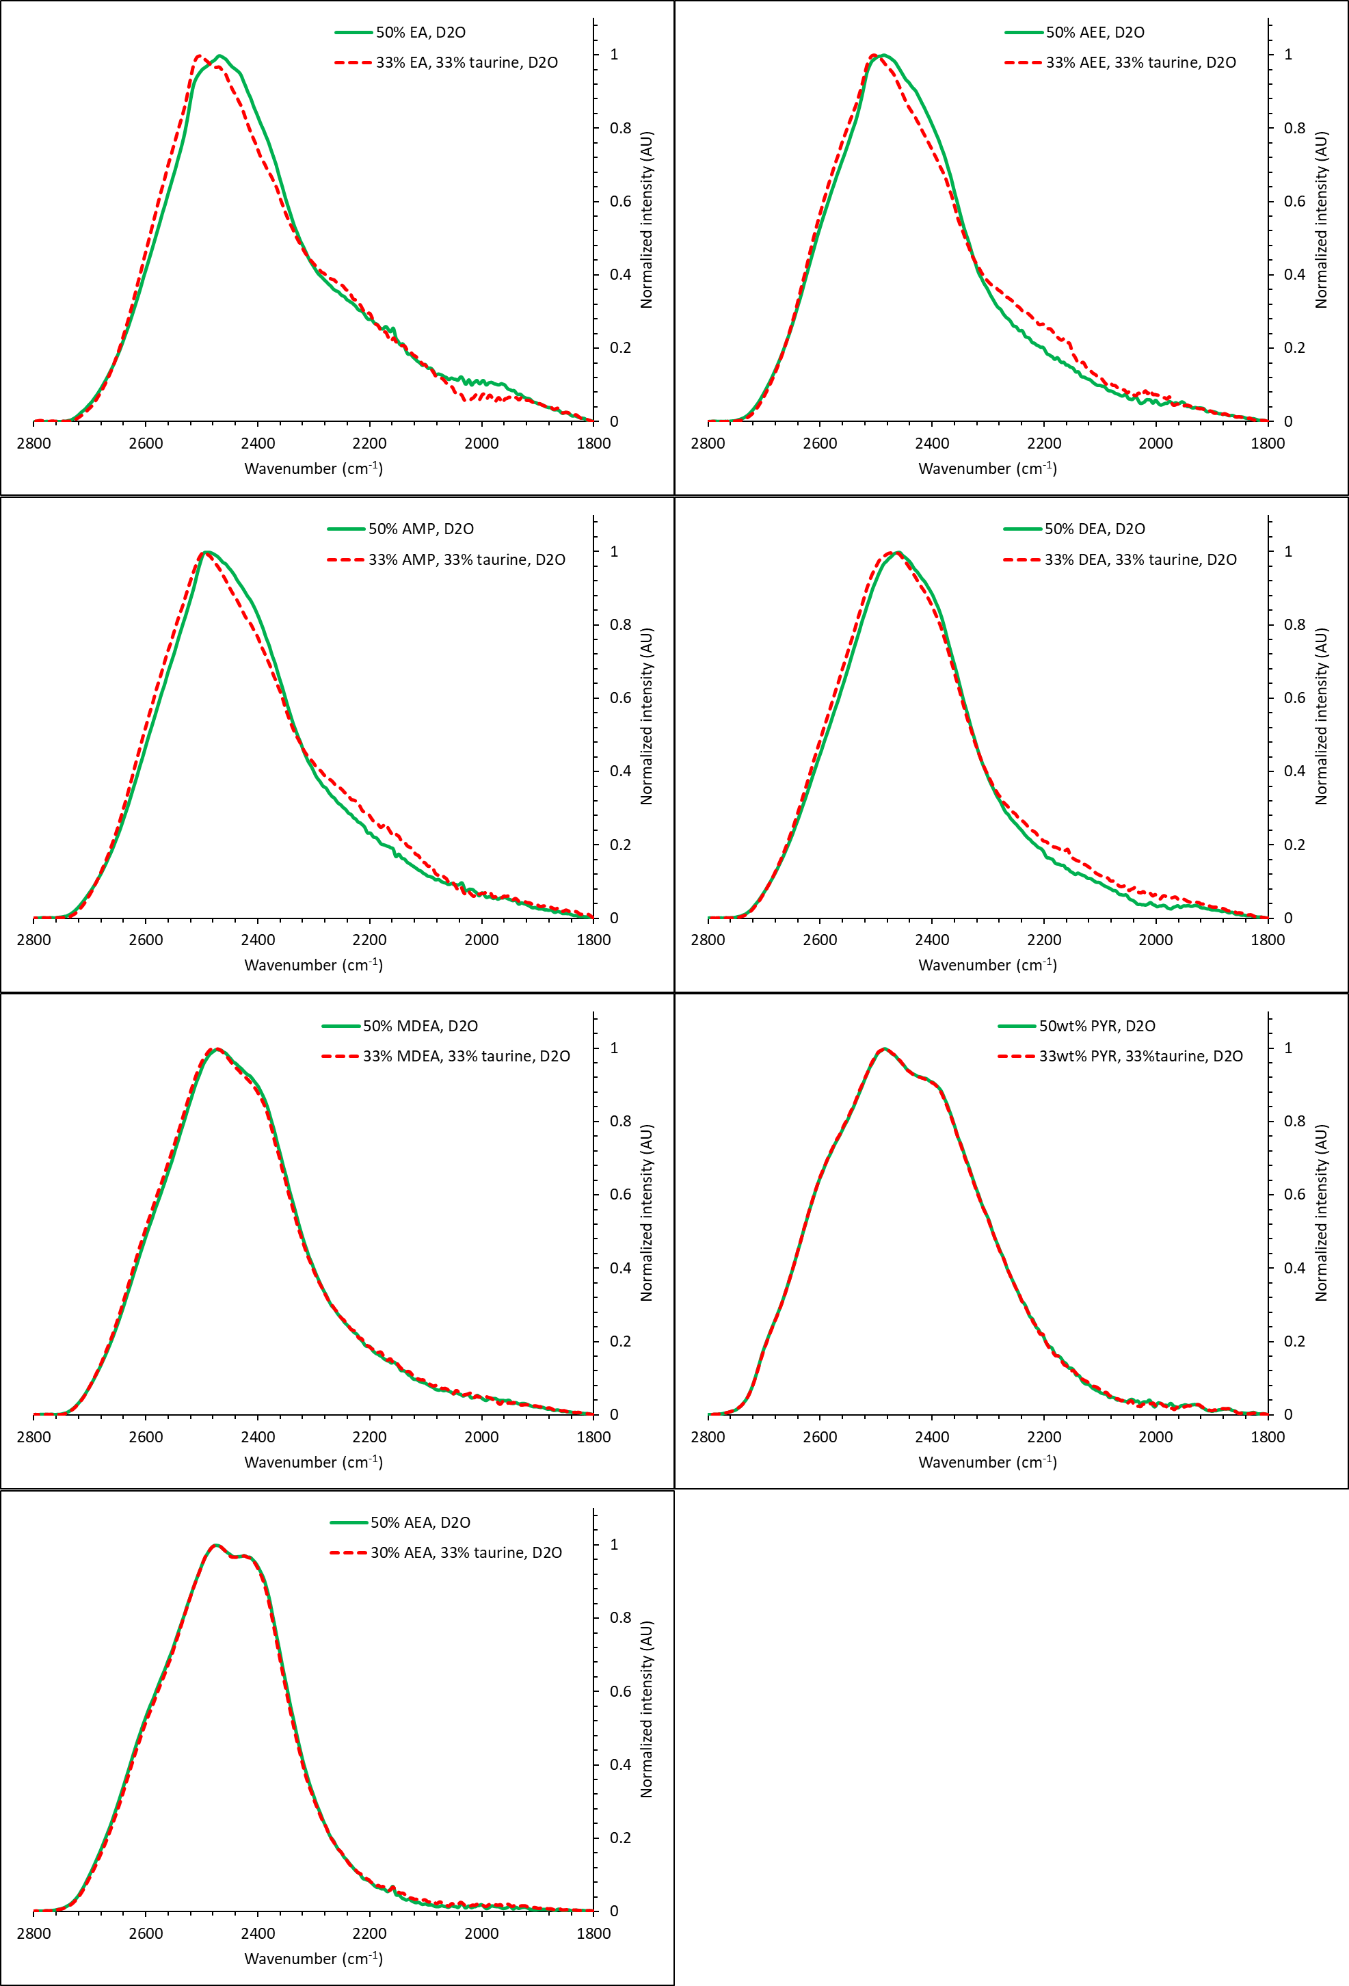
Figure S4 Comparison between the DO stretch band of D₂O with different alkanolamines, with and without taurine.

