Sustainable Adsorptive Removal of Congo Red Using Magnetite@ Zinc Oxide@ Zeolite Composite: A Low-Cost Ceramic-Based Approach

Denga Ramutshatsha-Makhwedzha^{b}*, Pamela Mitah Mnisiª, Mpingana Ndilimeke Akawa^{c}, Mapula Lucey Mavhunguª and Mukuna Patrick Mubiayi^{b}
ªDepartment of Chemical, Metallurgical and Materials Engineering, Tshwane University of Technology, Pretoria West Campus, Private Bag X680, Pretoria, South Africa
^{b}Institute for Nanotechnology and Water Sustainability, College of Science, Engineering and Technology, University of South Africa, Florida Science Campus, Roodepoort 1710, South Africa
^{c}Department of Biology, Chemistry and Physics, Namibia University of Science and Technology, Private Bag 13388, 13 Jackson Kaujeua Street, Windhoek, Namibia

*Corresponding author: Denga Ramutshatsha-Makhwedzha; Email: ramumd@unisa.ac.za

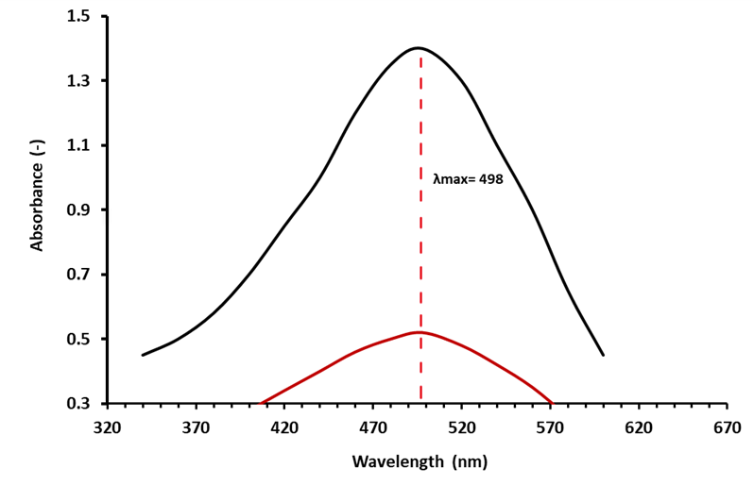

Fig. S1. UV–visible spectra: Wavelength Vs Absorbance plot

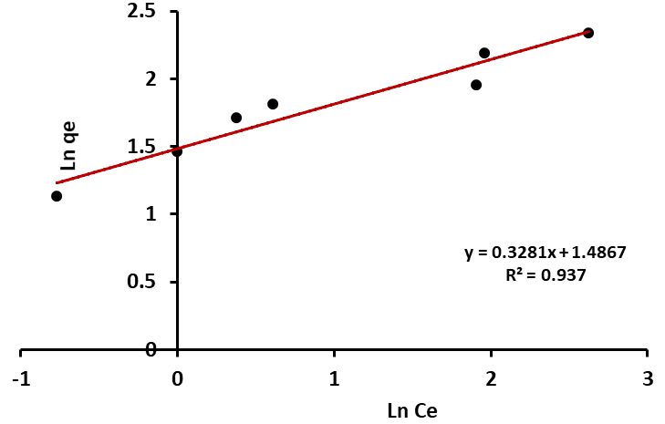
Fig. S2. Freundlich isotherm plot for sorption of CR onto Fe₃O₄@ZnO@Zeolite

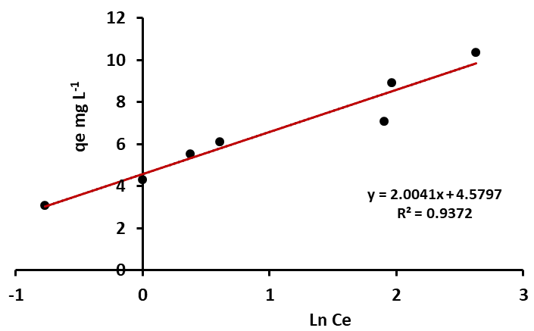
Fig. S3. Temkin isotherm plot for sorption of CR onto Fe₃O₄@ZnO@Zeolite

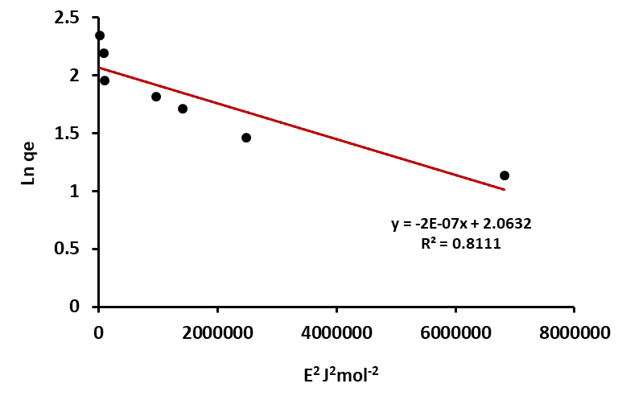
Fig. S4. R-D isotherm plot for sorption of CR onto Fe₃O₄@ZnO@Zeolite

