Supporting Information

Facile Fabrication of Triboelectric Nanogenerators Based on Paper and Natural Rubber as Low-Cost Bio-Derived Materials

K. Paige Williams¹, Noah Hann-Deschaine¹, Div Chamria¹, Hans T. Benze¹, and Ramesh Y. Adhikari¹*
¹Department of Physics & Astronomy, Colgate University, 13 Oak Drive, Hamilton, NY 13346, USA.
*Corresponding author. Email: radhikari@colgate.edu

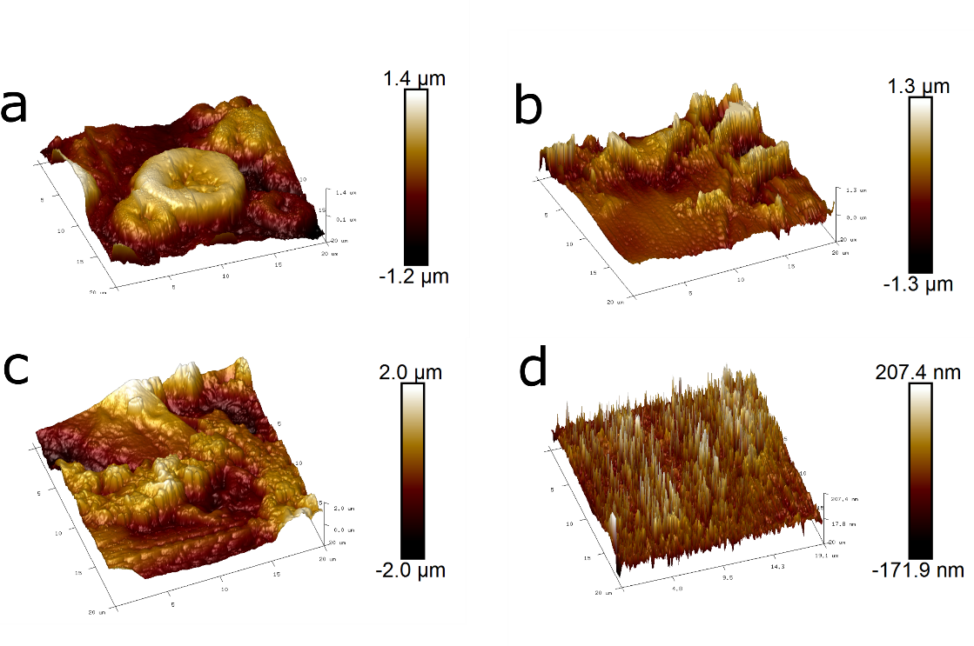
Figure S1. 3D topographical AFM image for a) thick rubber, b) thin rubber, c) PVDF-paper, and d) PI film.

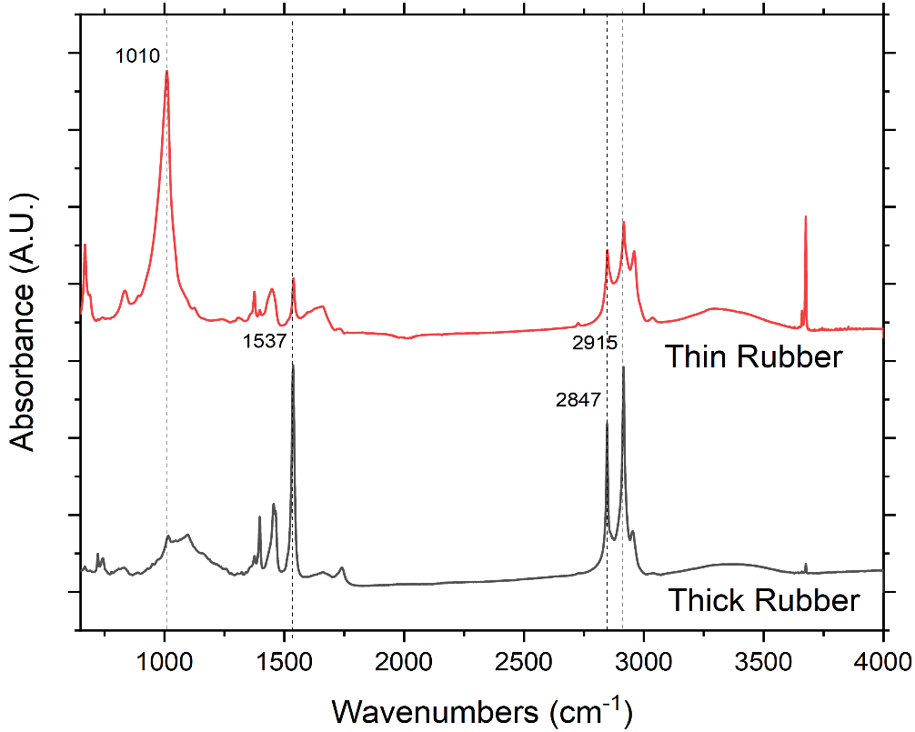

Figure S2. ATR-FTIR spectrum for the thin rubber and thick rubber sheet used in R-TENG.

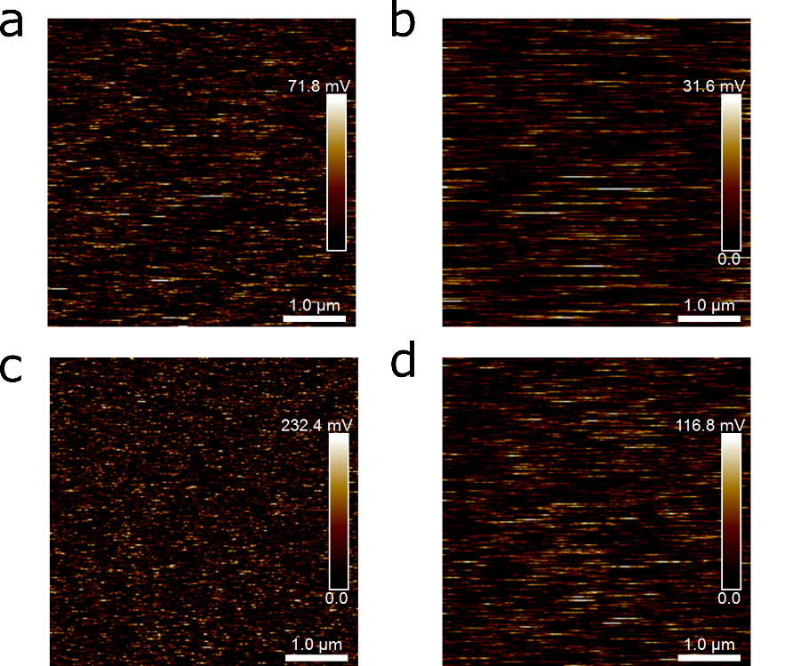

Figure S3. AM-KPFM surface potential image for a) thick rubber, b) thin rubber, c) PVDF-paper, and d) PI film.

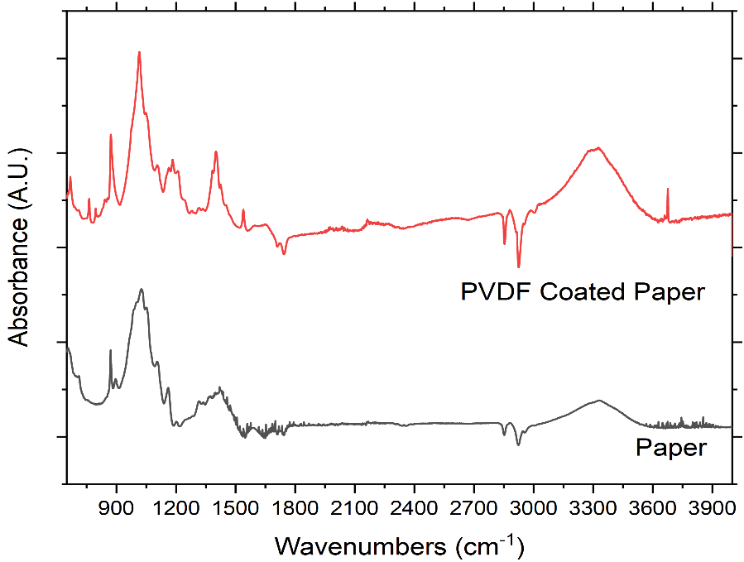
Figure S4. ATR-FTIR spectrum for PVDF treated paper and pristine paper.

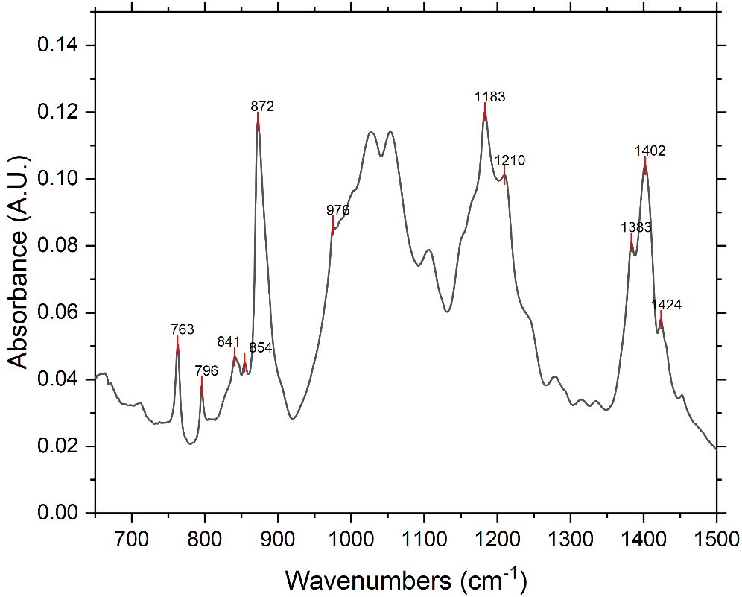

Figure S5. ATR-FTIR spectrum of PVDF paper subtracted from pristine paper in the range from 650 – 1500 cm⁻¹ demonstrates the peaks associated with $α$-phase of PVDF.

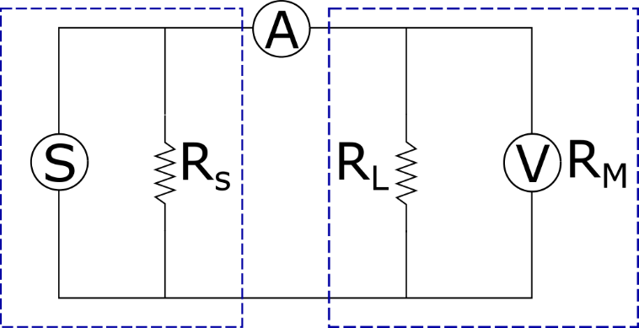

Figure S6. Circuit model for R-TENG where S is the TENG as a current source, R_{s} is the source resistance/internal resistance, R_{L} is the load resistance and R_{M} is the internal resistance of the multimeter used as a voltmeter.

