Supplementary material with Supporting Information

Neural Network Architectures and results
George Psaltakis,¹ Konstantinos Rogdakis^{1,2,*}, Michalis Loizos¹ and Emmanuel Kymakis^{1,2,*}

The utilization of One-vs-One binary classifiers in Spiking Neural Networks (SNN) would allow them to address more complex real-life scenarios. Furthermore, implementing SNN architecture would allow encoding the spike evolution through time, thus offering the benefit of encoding more information. These richer dynamics would raise the accuracy and definition between classes, especially when lower qualities of the input Image are present. For our experiment, we tried resizing the images to 10 by 10 pixels using 2 output neurons for the two classes of each binary classifier. At each simulation step, we implemented a fully connected input layer and two output neurons, where we accumulated the spike responses for the final classification. We used Snntorch [77] and Leaky-Integrate and fire [78]approach. The added complexity of SNNs would make it difficult to effectively tune the weights through light so its not as viable as traditional Neural Networks. The weights are learned using backpropagation and the Adam optimizer. For this approach, we didn't constraint the SNN to only positive weights, but we are able to achieve accuracies up to 90% using the OvO approach with a similar architecture of around 200 synapses. Although these two examples are very different, thus a direct comparison cannot be applied, these results still motivate approaches that can be also implemented with SNN, which with the right tweaking during their implementations could increase the accuracy despite their complexity.
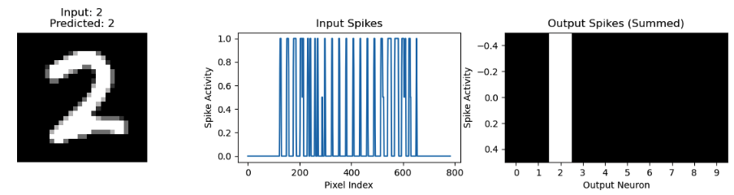

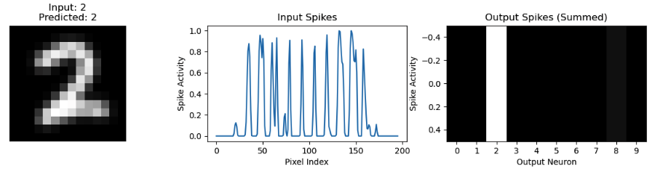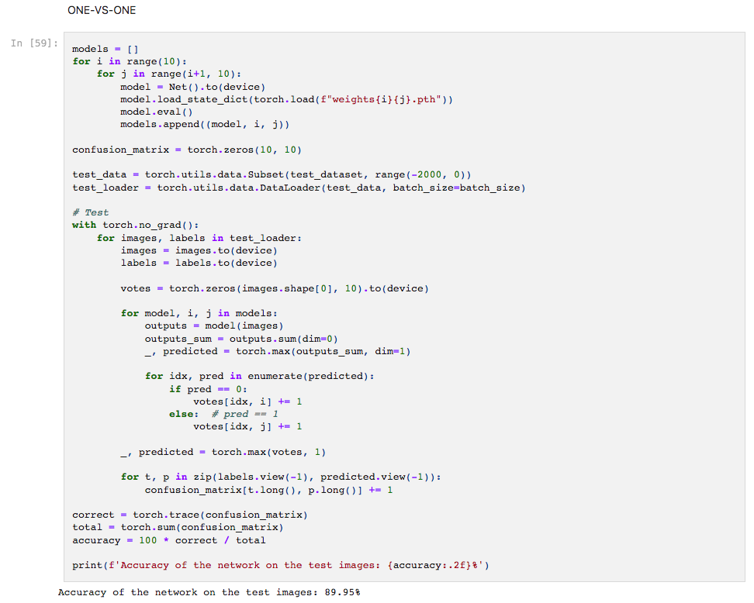

https://github.com/psaltakis/Spiking
For the OvO utilisation in Spiking Neural Networks without learning constraints .

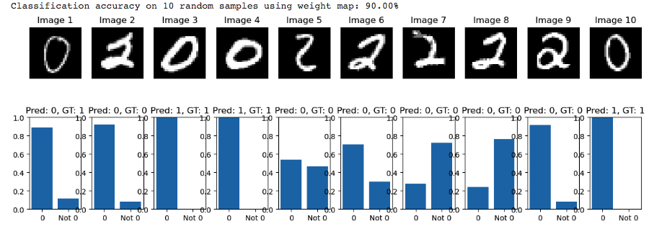
The training process of the binary classifiers for verification.

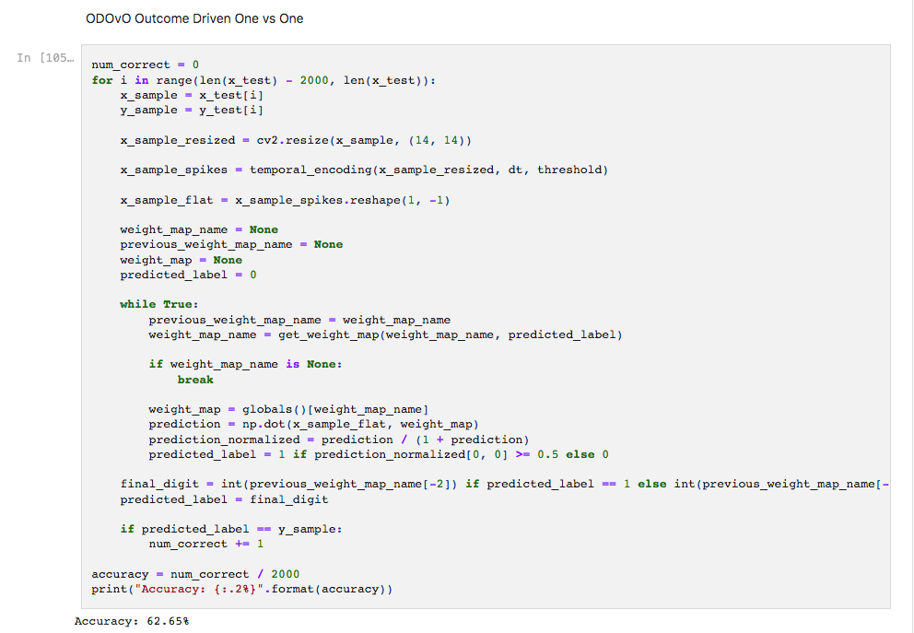
Outcome Driven One vs One Result. 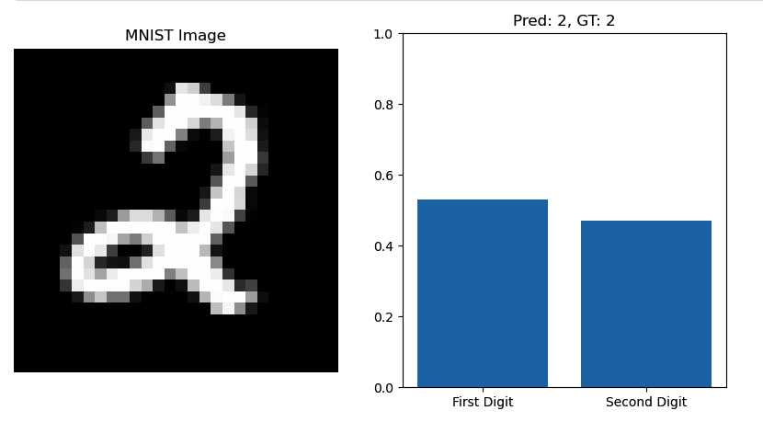
Random Sample from the test to verify the ODOvO Algorithm.

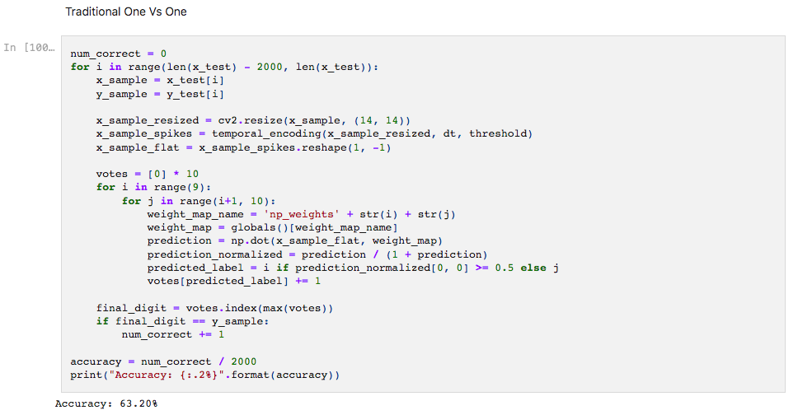

The accuracy of the binary classifiers using the traditional voting system of One-vs-One.

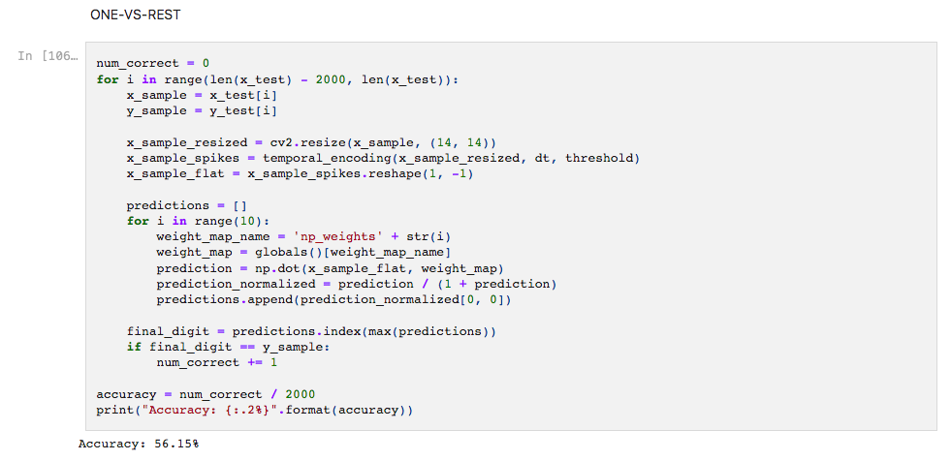
The accuracies of the One-vs-Rest

https://github.com/psaltakis/ODOvA

