A Comparative Study on Arc- and Vacuum Induction-Melting for High Entropy Shape Memory Alloy Production

- Supplementary Information -

Table S1: Phases, lattice parameters and area fraction (by SEM) of the binary pre-alloys compared by the production technique. The 2σ refinement uncertainty (in ‰) is shown in brackets.
Sample/ treatment | Phases (spacegroup) | a, Å | b, Å | c, Å | γ, ° | area, norm. %*
NiTi/  AM | NiTi (Pm-3m)  NiTi (P2₁/m)  NiTi₂(Fd-3m) | 2.954(1)  3.173(2)  11.321(2) | 2.954(1)  5.011(2)  11.321(2) | 2.954(1)  4.600(1)  11.321(2) | 106.54(5) | 94.9
 |  |  |  |  |  | 5.1
NiTi/  VIM | NiTi (Pm-3m)  NiTi (P2₁/m)  NiTi₂(Fd-3m) | 3.159(1)  3.030(1)  11.345(2) | 3.159(1)  4.925(2)  11.345(2) | 3.159(1)  4.605(1)  11.345(2) | 104.88(4) | 98.9
 |  |  |  |  |  | 1.1
CoZr/  AM | CoZr (Pm-3m)  CoZr₂ (I4/mcm)  CoZr₃ (Cmcm) | 3.193(1)  6.384(1)  3.266(1) | 3.193(1)  6.384(1)  10.833(1) | 3.193(1)  5.503(1)  8.955(1) |  | 26.2  66.7  7.1
CoZr/  VIM | CoZr (Pm-3m)  CoZr₂ (I4/mcm)  CoZr₃ (Cmcm) | 3.200(1)  6.380(1)  3.230(1) | 3.200(1)  6.380(1)  10.536(1) | 3.200(1)  5.320(1)  8.974(1) |  | 14.3  85.7  -
CuHf/  AM | CuHf₂ (I4/mmm)  Cu₁₀Hf₇ (Aba2)  Cu₈Hf₃ (Pnma) | 3.196(1)  9.293(1)  7.71(1) | 3.196(1)  9.234(1)  8.31(2) | 11.90(1)  12.579(1)  9.965(1) |  | 19.4  79.0  1.6
CuHf/  VIM | CuHf₂ (I4/mmm)  Cu₁₀Hf₇ (Aba2)  Cu₈Hf₃ (Pnma) | 3.204(2)  9.278(1)  7.682(2) | 3.204(2)  9.233(1)  8.300(1) | 11.860(4)  12.584(1)  9.995(2) |  | 17.8  81.3  0.9
*all area uncertainties are in the order of 0.2 %
Table S2: Overall chemical composition of the senary alloys produced by AM and VIM in as-cast and heat-treated states determined by EDX in norm.-at.-%
Sample/  treatment | Ti | Zr | Hf | Co | Ni | Cu
Nominal | 16.66 | 16.66 | 16.66 | 10 | 20 | 20
AM-AC | 18,76 | 17,33 | 15,74 | 10,13 | 19,22 | 18,82
AM-HT | 18,54 | 16,16 | 16,42 | 11,05 | 19,75 | 18,09
VIM-AC | 22,85 | 18,84 | 14,16 | 8,84 | 16,56 | 18,76
VIM-HT | 20,00 | 18,69 | 14,94 | 9,73 | 18,41 | 18,23

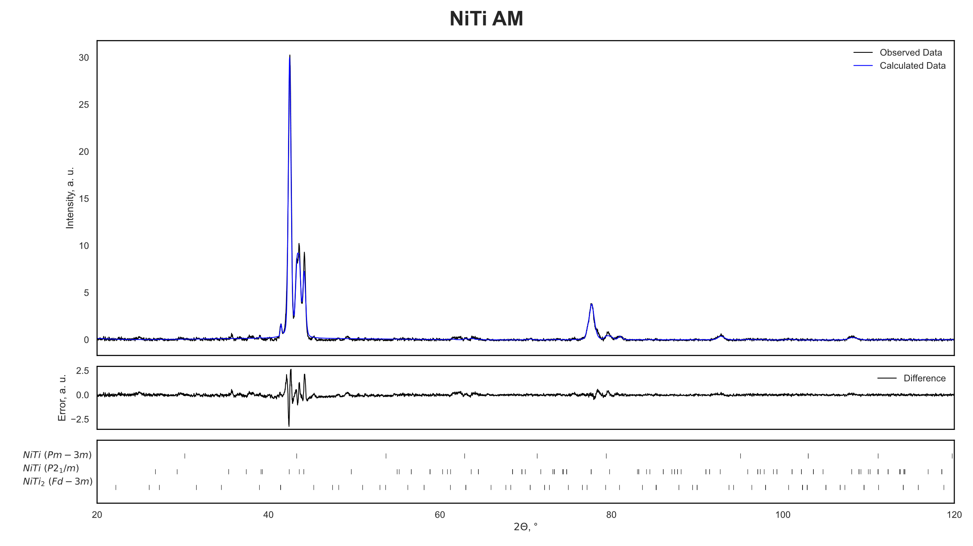
Support Figure S1: Refined XRD plots of NiTi after AM casting with difference between observed and calculated data and indexed phase ticks

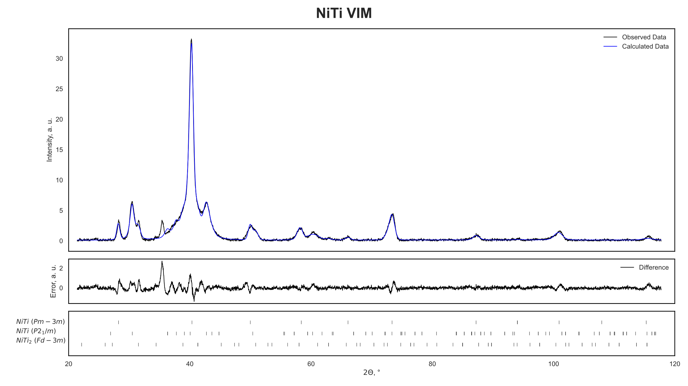
Support Figure S2: Refined XRD plots of NiTi after VIM casting with difference between observed and calculated data and indexed phase ticks
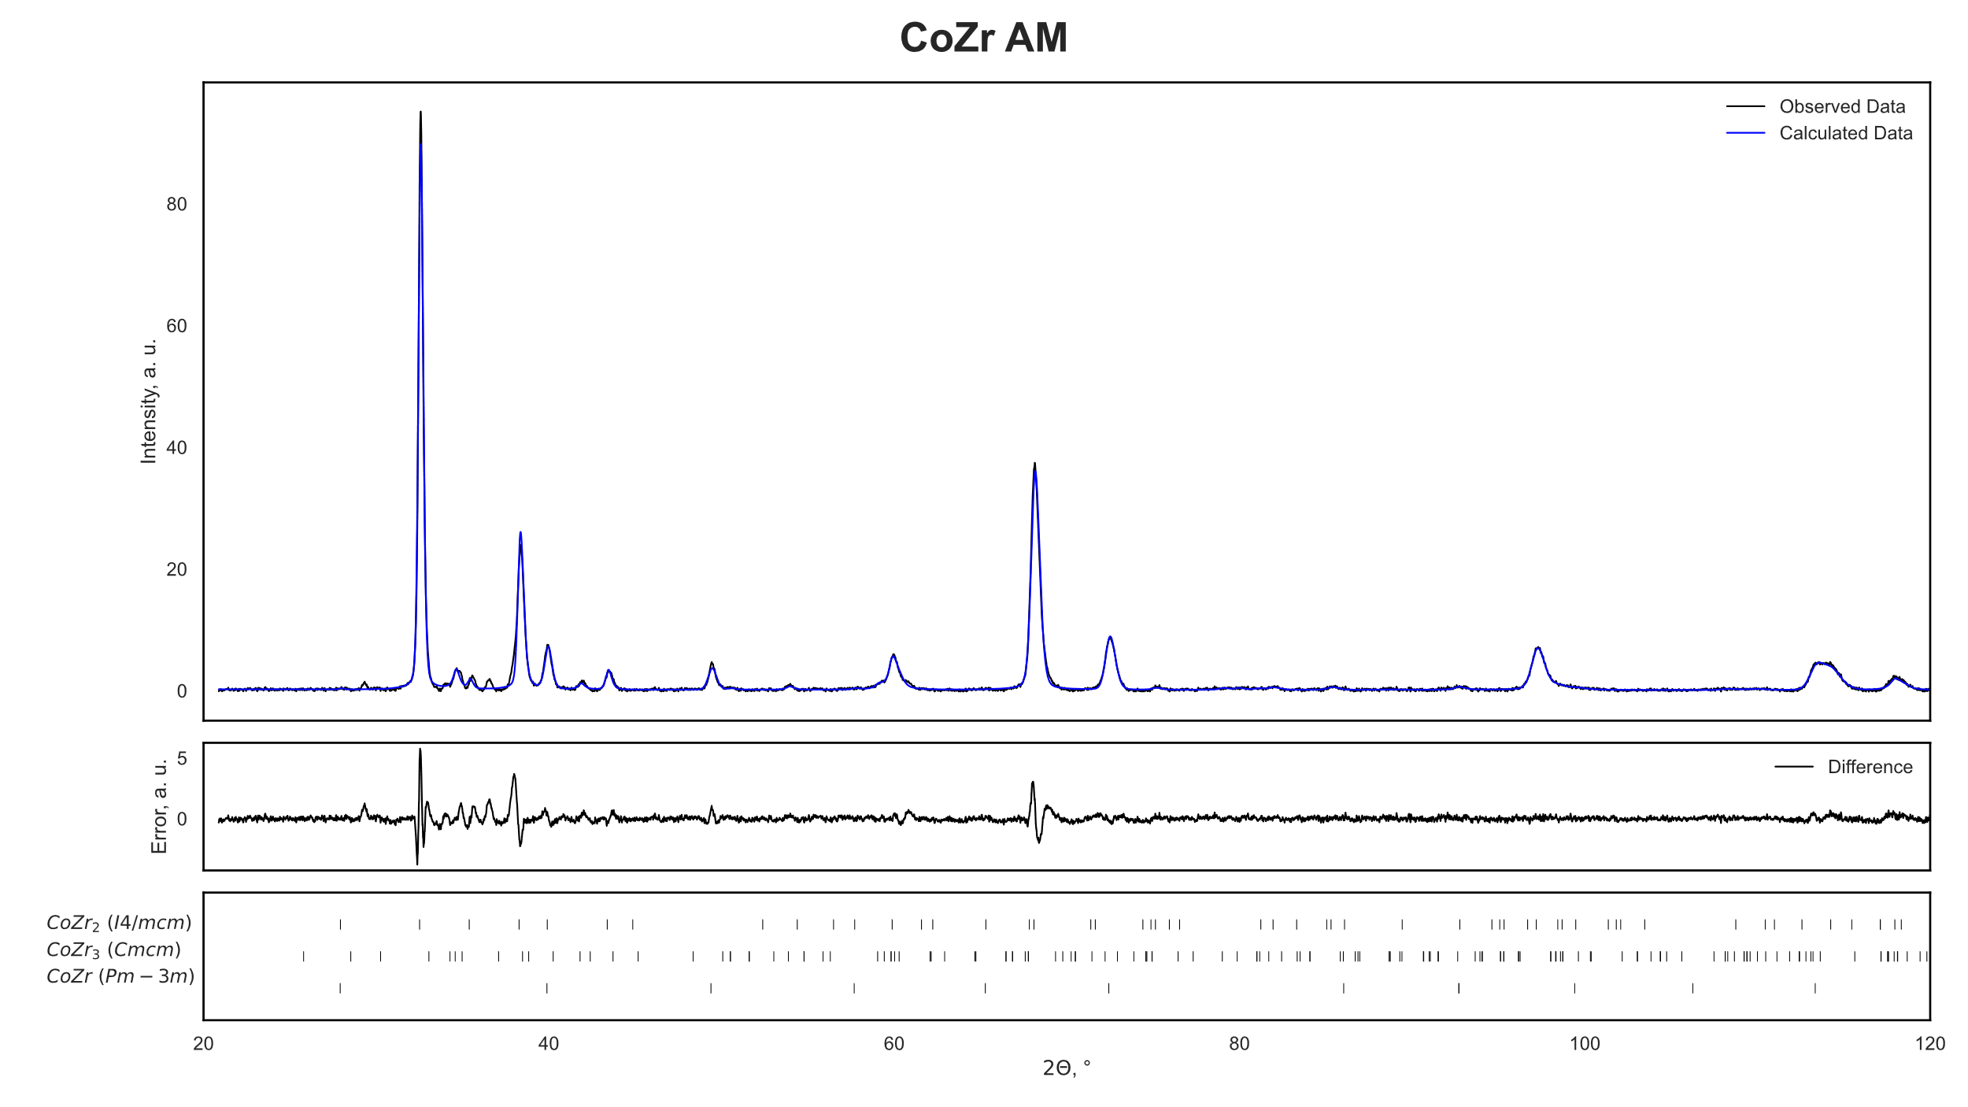
Support Figure S3: Refined XRD plots of CoZr after AM casting with difference between observed and calculated data and indexed phase ticks

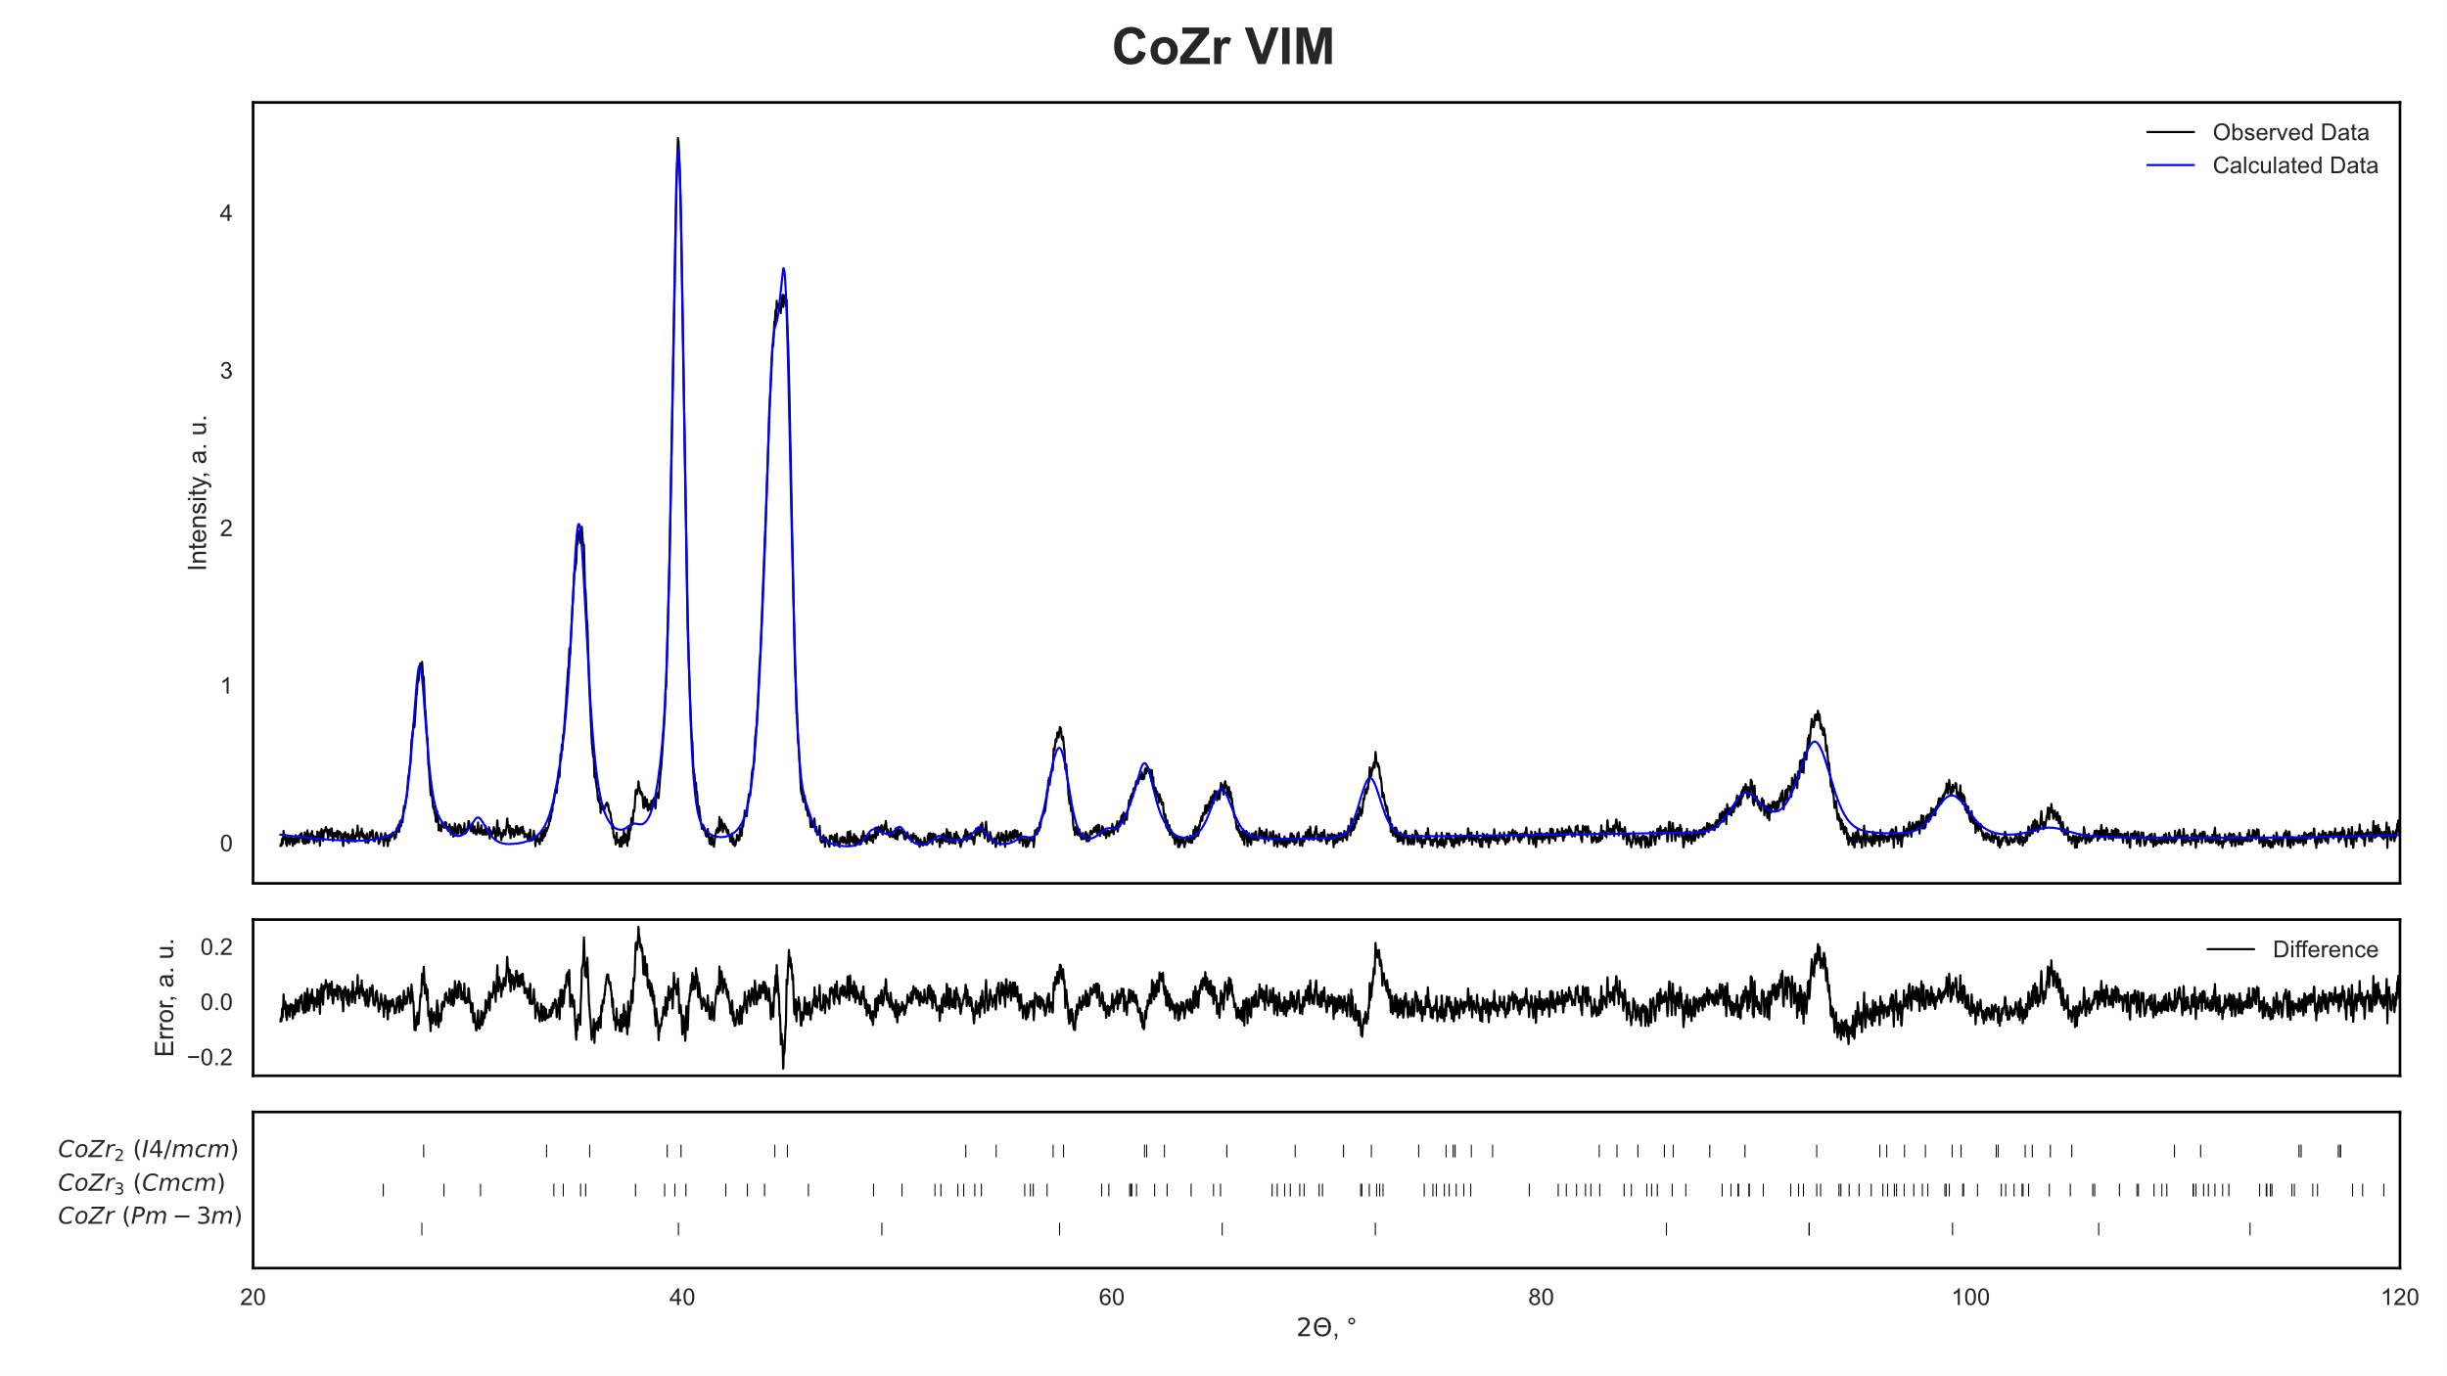
Support Figure S4: Refined XRD plots of CoZr after VIM casting with difference between observed and calculated data and indexed phase ticks

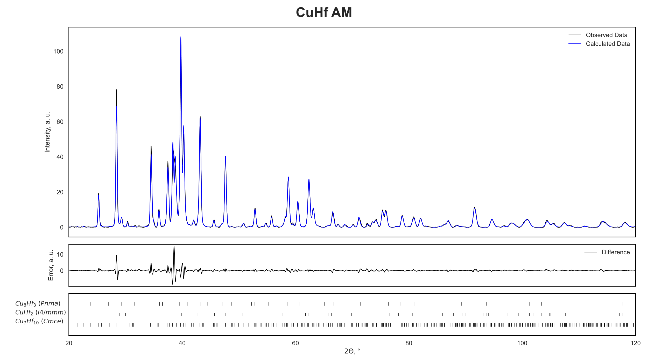
Support Figure S5: Refined XRD plots of CuHf after AM casting with difference between observed and calculated data and indexed phase ticks

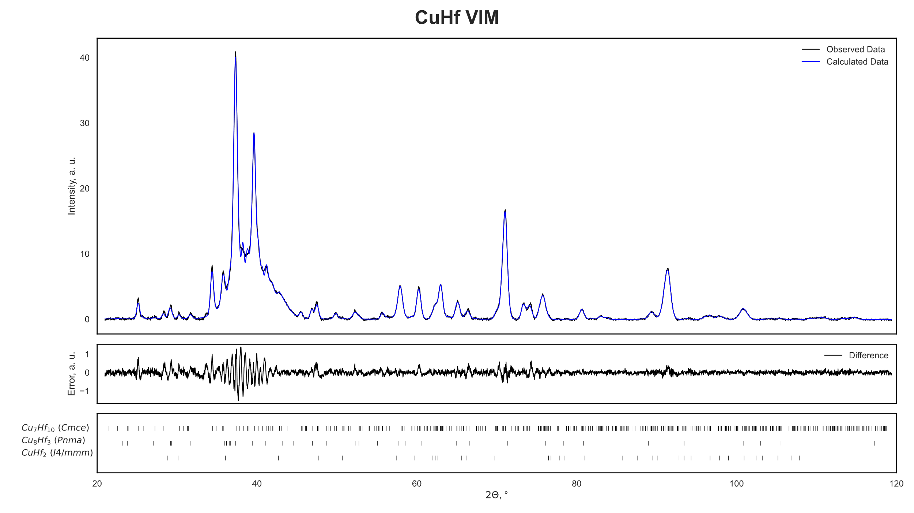
Support Figure S6: Refined XRD plots of CuHf after VIM casting with difference between observed and calculated data and indexed phase ticks

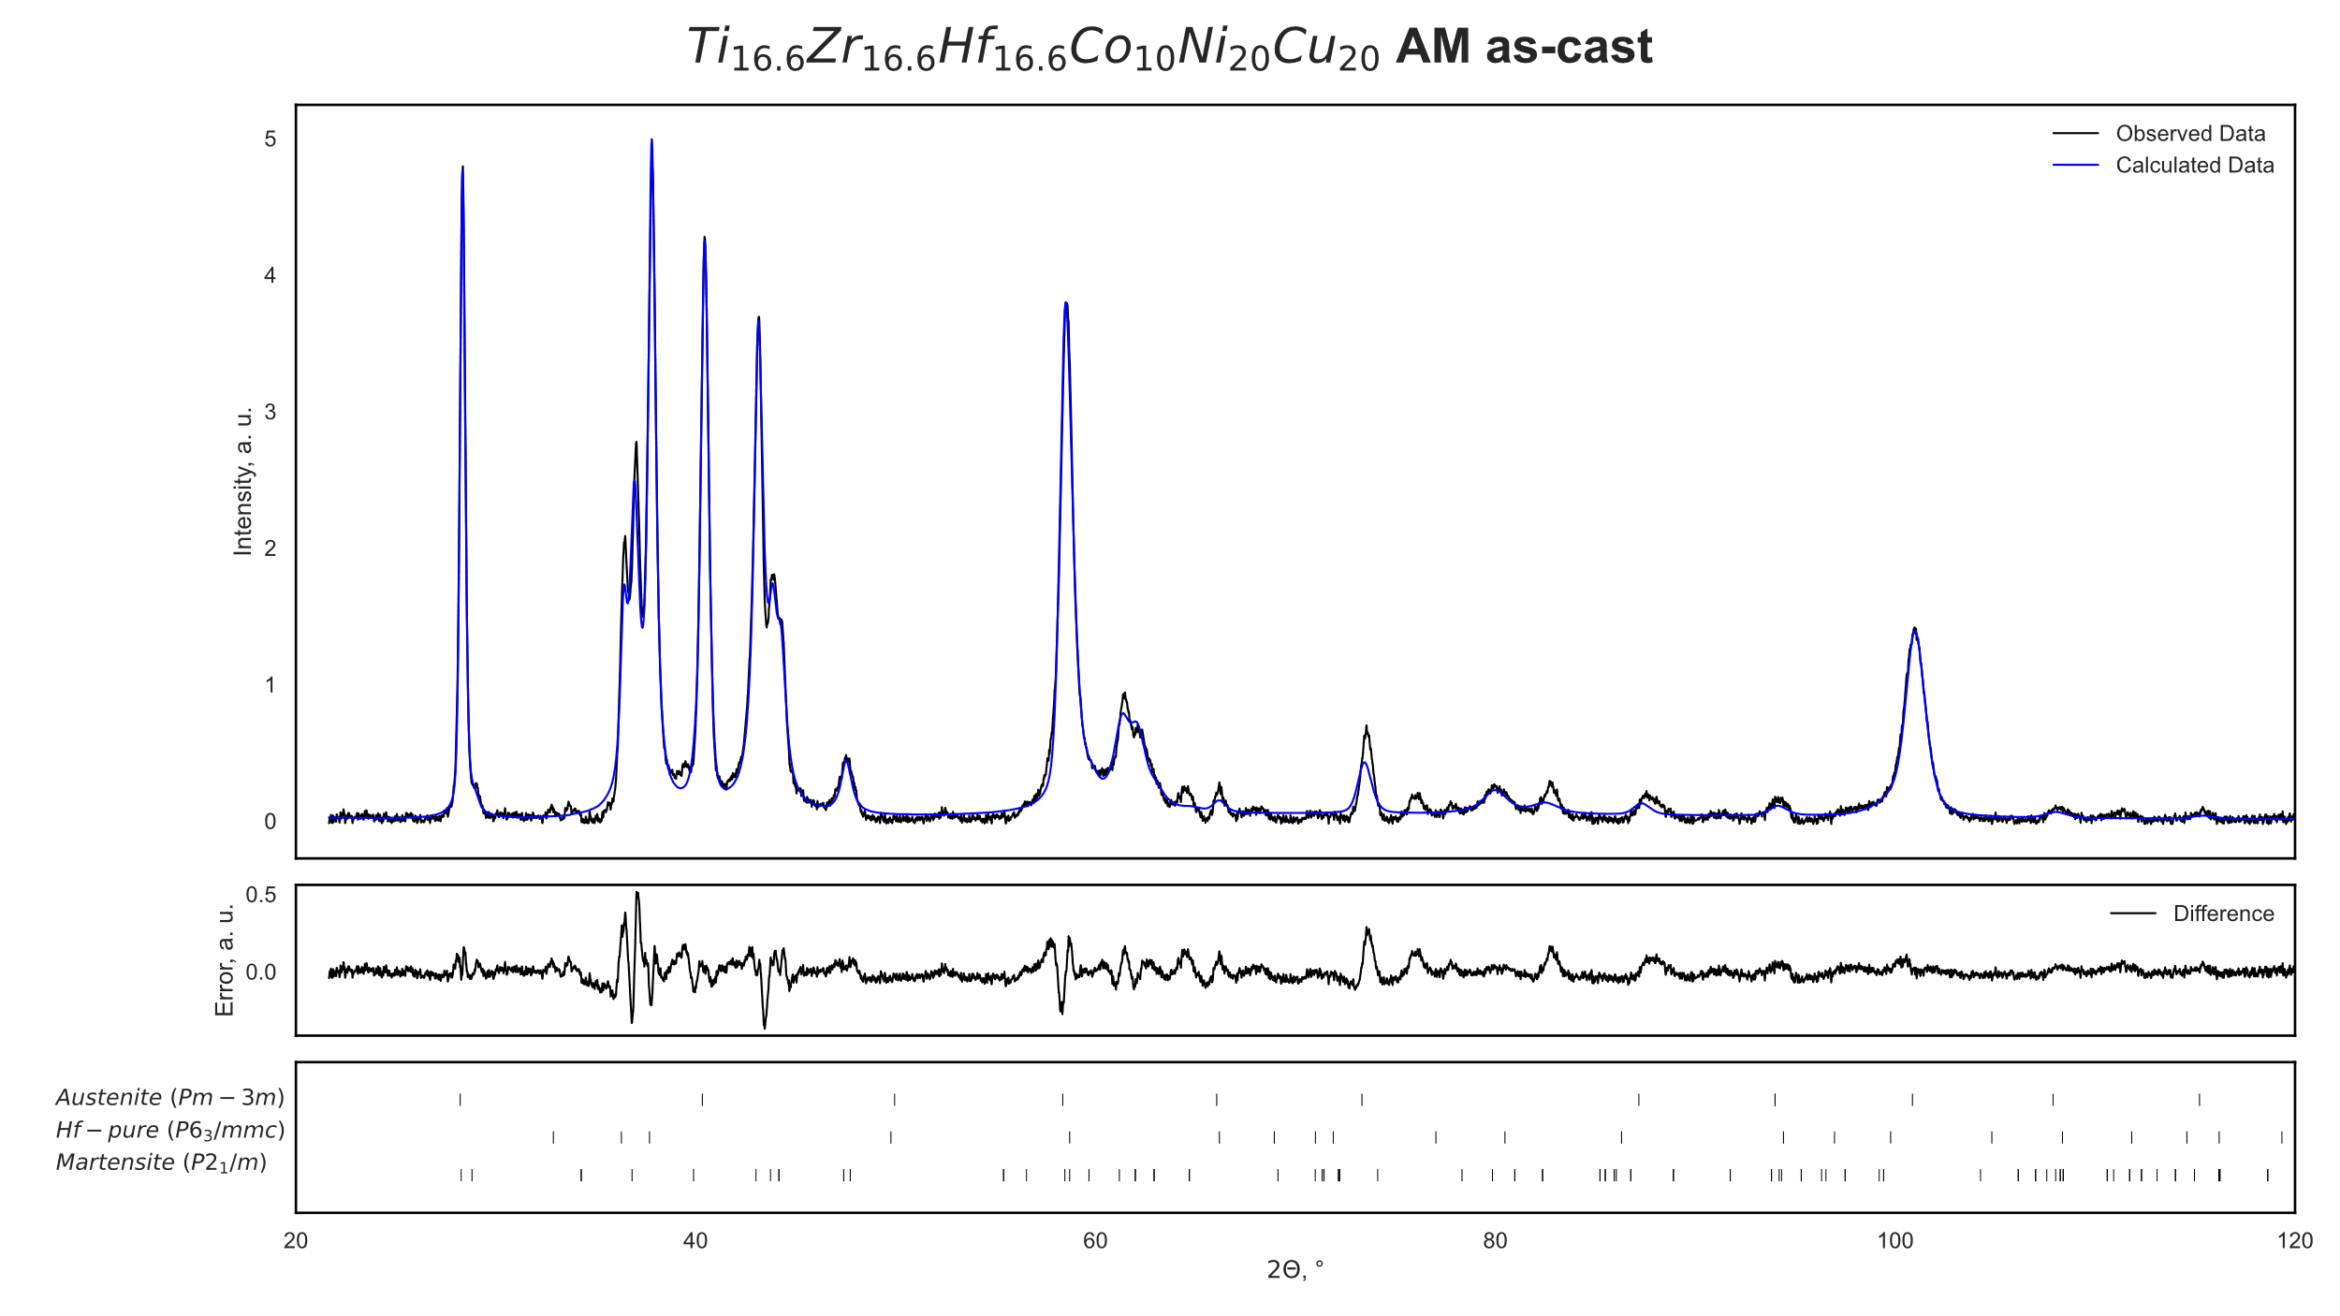
Support Figure S7: Refined XRD plots of Ti_{16.6}Zr_{16.6}Hf_{16.6}Co₁₀Ni₂₀Cu₂₀ after AM casting in as-cast state with difference between observed and calculated data and indexed phase ticks

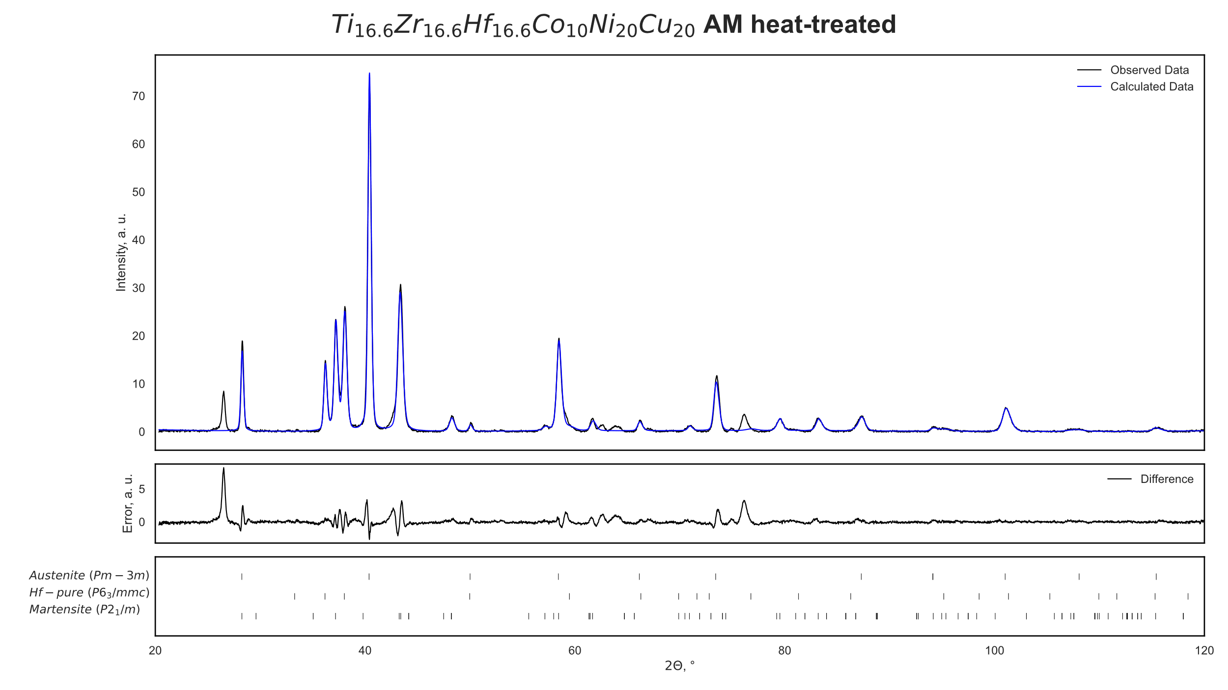
Support Figure S8: Refined XRD plots of Ti_{16.6}Zr_{16.6}Hf_{16.6}Co₁₀Ni₂₀Cu₂₀ after AM casting in heat-treated state with difference between observed and calculated data and indexed phase ticks; (*) signal from embedding
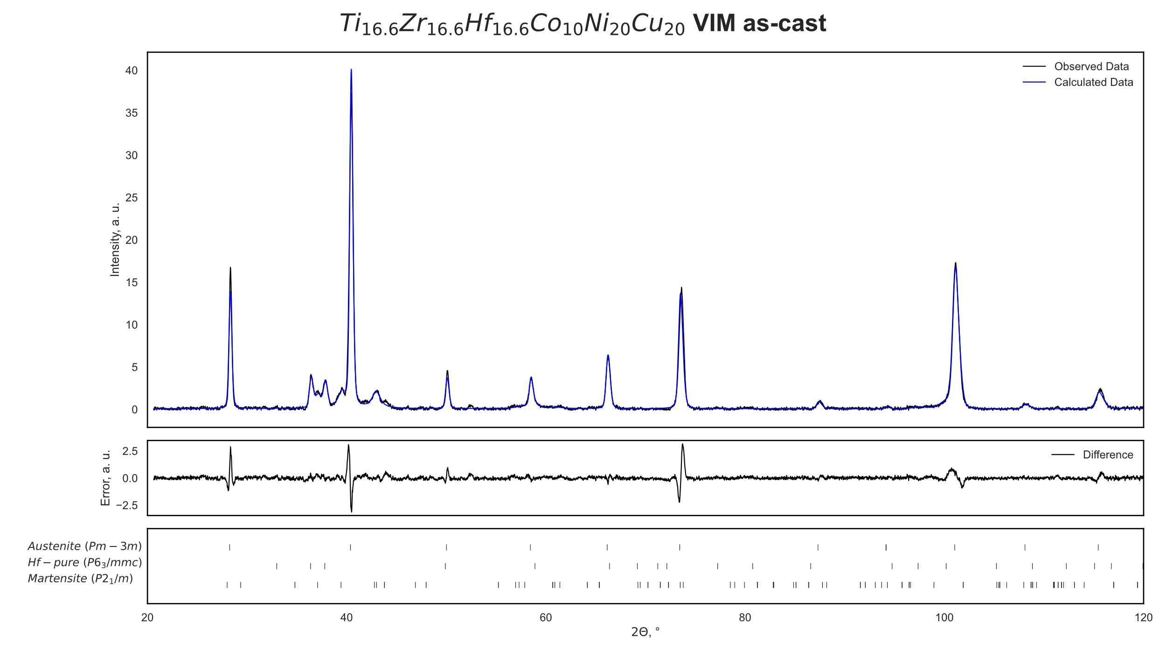
Support Figure S9: Refined XRD plots of Ti_{16.6}Zr_{16.6}Hf_{16.6}Co₁₀Ni₂₀Cu₂₀ after VIM casting in as-cast state with difference between observed and calculated data and indexed phase ticks

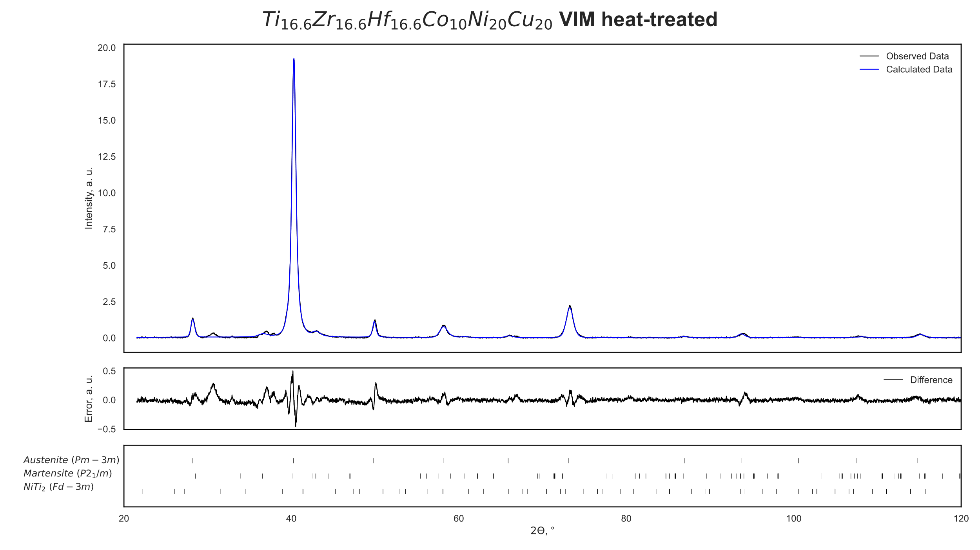
Support Figure S10: Refined XRD plots of Ti_{16.6}Zr_{16.6}Hf_{16.6}Co₁₀Ni₂₀Cu₂₀ after VIM casting in heat-treated state with difference between observed and calculated data and indexed phase ticks

