Mechanically Synthesized S@rGO Nanocomposites for Dye Photodegradation

Karishma Jain¹, Deepika Maan¹, Ashish Kumar¹, Sushil Kumar Jain^{1*}, Balram Tripathi²
¹Department of Physics, Manipal University Jaipur, Jaipur -303007, India
²Department of Physics, S. S. Jain Subodh PG (Auto.) College Jaipur-302004, India
E-mail: *sushilkumar.jain@jaipur.manipal.edu
Supplementary Material
Figures and Tables

XRD Studies

Table S1 Estimated values of 2θ and interlayer spacing of reduced graphene sheet
Sample name | 2θ(°) (hkl) | Interlayer spacing, d (nm)
pristine rGO | 26.62 (002) | 0.335
pristine rGO | 54.68 (004) | 0.168
S@rGO-1 | 26.54 (002) | 0.336
S@rGO-1 | 54.66 (004) | 0.168
S@rGO-2 | 26.46 (002) | 0.337
S@rGO-2 | 54.56 (004) | 0.168
S@rGO-3 | 26.51 (002) | 0.336
S@rGO-3 | 54.62 (004) | 0.168
S@rGO-4 | 26.51 (002) | 0.336
S@rGO-4 | 54.62 (004) | 0.168
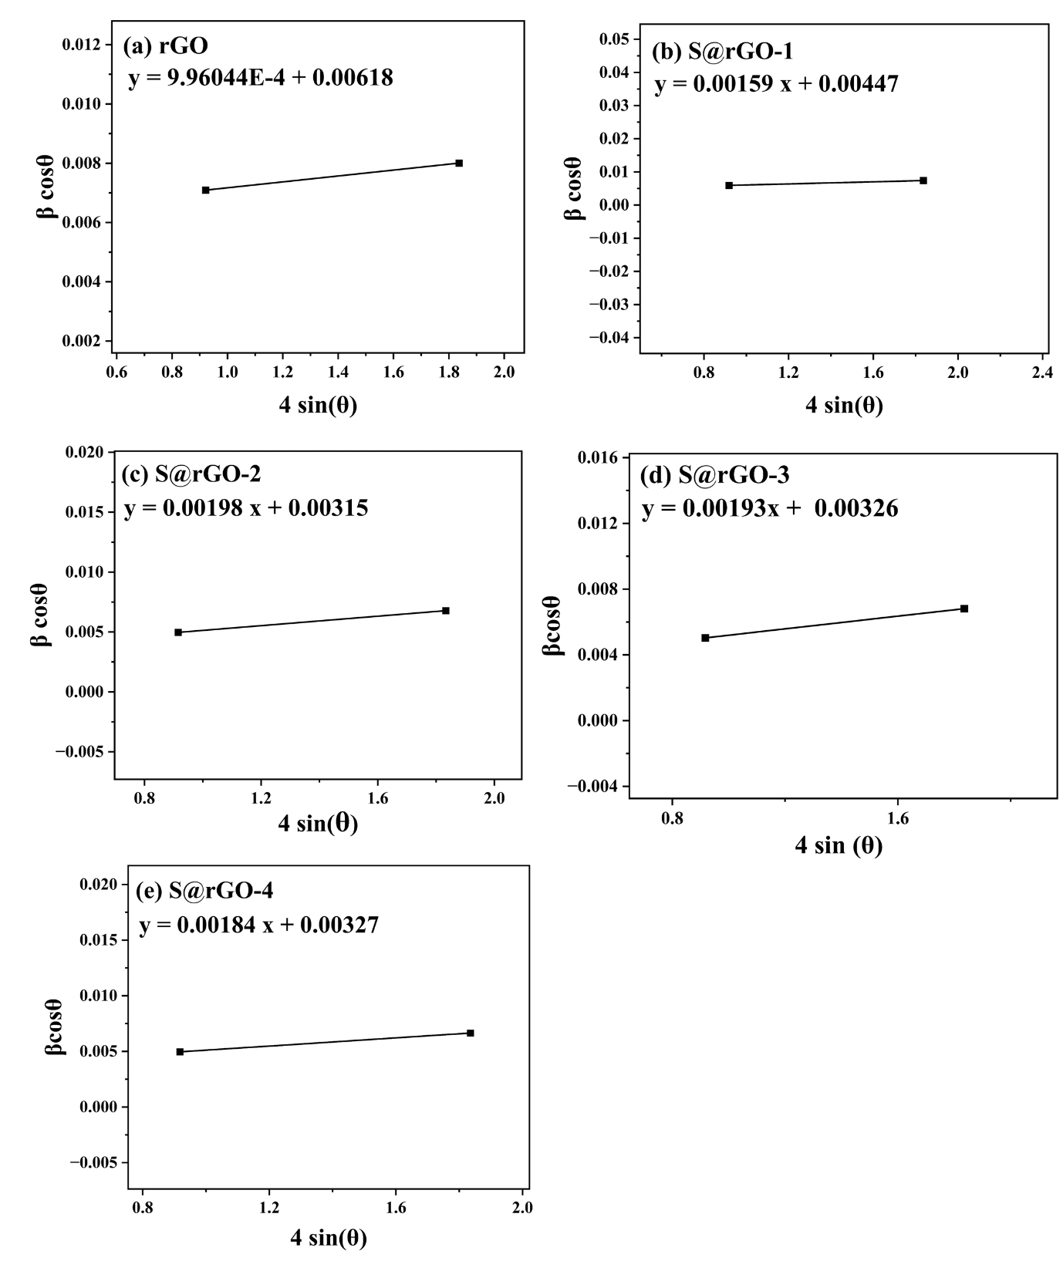
Fig. S1 W-H Plot corresponds to the nanomaterials (a) rGO , (b) S@rGO-1, (c) S@rGO-2 , (d) S@rGO-3 , (e) S@rGO-4.

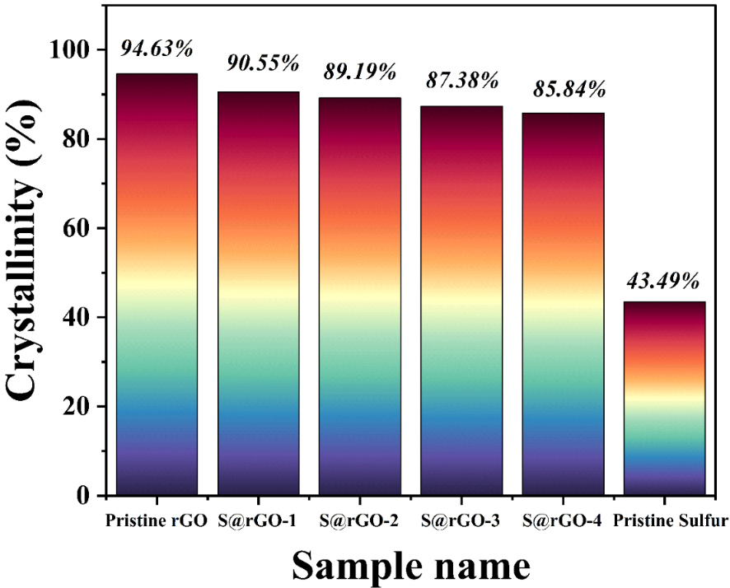
Fig. S2 Column chart depicting crystallinity (in %) of nanocomposites – rGO, S@rGO-1, S@rGO-2 , S@rGO-3 and S@rGO-4

Table S2 Estimated lattice parameter values of nanocomposites

Sample Name | a (Å) | c(Å) | c/a | Volume(Å³)
rGO | 2.354 | 6.689 | 2.842 | 32.100
S@rGO-1 | 2.353 | 6.712 | 2.853 | 32.183
S@rGO-2 | 2.352 | 6.729 | 2.861 | 32.237
S@rGO-3 | 2.352 | 6.719 | 2.857 | 32.189
S@rGO-4 | 2.352 | 6.719 | 2.857 | 32.189

Raman Studies
Fig. S3 Detailed Raman spectra.

Table S3 Raman spectra analysis
Sample name | I_{D}/ I_{G} | I_{2D}/ I_{G}
rGO | 0.336 | 1.875
S@rGO-1 | 0.039 | 1.478
S@rGO-2 | 0.321 | 0.909
S@rGO-3 | 0.045 | 1.603
S@rGO-4 | 0.076 | 1.632

FT-IR Studies
Table S4 Proposed characteristics of the vibrations as well as corresponding wave numbers related to transmittance peaks of (a) pristine sulfur (b) S@rGO-4, (c) S@rGO-3, (d) S@rGO-2, (e) S@rGO-1 and (f) pristine rGO
Sr. No. | Position of Bands (in cm⁻¹) | Assignment of Bands
1. | 568 | C-C=S vibrations [1]
2. | 595 | to C-H [2].
3. | 687 | Stretching of C-S bond [3]
4. | 905 | Ring vibrations due to C-S bond [3]
5. | 1016, 1017 | C-O-C Stretching (epoxy group) [4].
6. | 1024 | C-O Stretching vibration [5].
7. | 1030 | sp³ C-O Stretching[3]
8. | 1114 | Stretching of C-S bond [3]
9. | 1409 | C-H bending bands [6,7]
10. | 1527 | overlapping of triazenes and azo compounds [8]
11. | 1530, 1550, 1533 | aromatic C=C group [9]
12. | 1642, 1639, 1643,1648 | C=C Stretching vibration [10]
13. | 1696 | Stretching vibration at C=O [11]
14. | 2370 | CO₂ bands [7].
15. | 2935, 2925 | C-H Stretching vibration [10].
16. | 3442 | O-H bond (hydroxyl group) of alcohols [4]
17. | 3741, 3744 | O-H Stretching of water molecules[12]

EDX Studies

Fig. S4 EDX spectra for (a) rGO, (b) S@rGO-1, (c) S@rGO-2, (d) S@rGO-3 and (e) S@rGO-4.

Table S5 EDX analysis of (a) S@rGO-1, (b) S@rGO-2, (c) S@rGO-3 and (d) S@rGO-4

Element | Weight% | Atomic% | Error% | O: S  fraction | O/ S  (mole) | C/ O  (mole) | C/ (O+S)  (mole)
(a) S@rGO-1 |  |  |  | 10.25 | 20.5 | 31.05 | 29.611
C | 93.6 | 95.5 | 3.3
O | 5.4 | 4.1 | 18.3
S | 1 | 0.4 | 7
(b) S@rGO-2 |  |  |  | 5.81 | 11.625 | 12.774 | 11.762
C | 84.2 | 89.1 | 7.4
O | 11.7 | 9.3 | 22.4
S | 4.1 | 1.6 | 9.2
(c) S@rGO-3 |  |  |  | 0.9 | 3.77 | 76.392 | 60.4031
C | 95.4 | 97.4 | 4.5
O | 2.2 | 1.7 | 30.4
S | 2.3 | 0.9 | 4
(d) S@rGO-4 |  |  |  | 0.66 | 1.33 | 130 | 74.285
C | 94.9 | 97.5 | 5.8
O | 1.3 | 1 | 49.3
S | 3.8 | 1.5 | 3.7

UV-Vis Studies
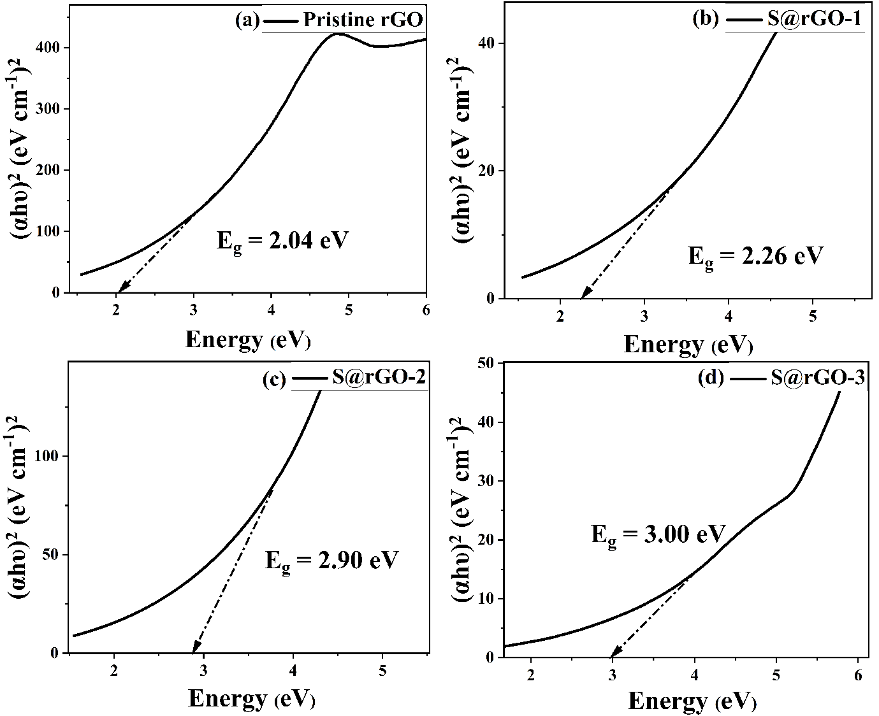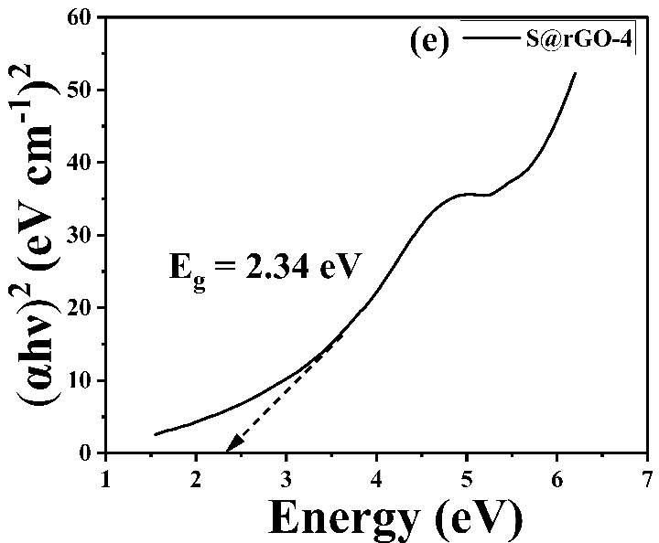
Fig. S5 Tauc Plot: (αhν)² vs hν curves for (a) rGO, (b) S@rGO-1, (c) S@rGO-2, (d) S@rGO-3 and (e) S@rGO-4

Photocatalytic Studies

MB Dye

Fig. S6 Absorption spectra for (a) Blank MB (b) rGO (c) S@rGO-1 (d) S@rGO-2 (e) S@rGO-3 (f) S@rGO-4. Inset graph illustrates zoomed out view of absorption spectra in the wavelength range - 200 nm to 800 nm.

Fig. S7 (a)Concentration vs. Irradiation time (min) plot (b) ln(Co/ C) vs. Irradiation time (min) plot (c) (1/C) vs. Irradiation time (min) plot

Table S6 The values of the pseudo-zero, pseudo - first and pseudo -second-order rate constants, half-lives and the corresponding correlation coefficients for the photocatalytic degradation of MB.
Sr. No. | Sample Name | Rate constant (k₀) (M min⁻¹) | R² | Half | Rate constant (k₁) (min⁻¹) | R² | Half | Rate constant (k₂) (M⁻¹ min⁻¹) | R² | Half
 |  |  |  | Life (C_{o}/2k₀) | Rate constant (k₁) (min⁻¹) | R² | Life | Rate constant (k₂) (M⁻¹ min⁻¹) | R² | Life
 |  |  |  | (min) | Rate constant (k₁) (min⁻¹) | R² | (0.693/k₁) (min) | Rate constant (k₂) (M⁻¹ min⁻¹) | R² | (1/k₂C_{o}) (min)
 |  | Zero Order |  |  | First Order |  |  | Second Order
1. | Blank MB | -0.00178 | 0.96968 | 145.17 | 0.00418 | 0.97713 | 165.55 | 0.00989 | 0.98068 | 195.65
2. | rGO | -0.00362 | 0.98887 | 138.78 | 0.0044 | 0.99337 | 157.5 | 0.00541 | 0.99134 | 183.95
3. | S@rGO-1 | -0.00564 | 0.98458 | 108.80 | 0.00614 | 0.99001 | 112.87 | 0.00684 | 0.98069 | 119.12
4. | S@rGO-2 | -0.00566 | 0.98537 | 108.94 | 0.00637 | 0.99106 | 108.79 | 0.00736 | 0.97628 | 110.17
5. | S@rGO-3 | -0.00722 | 0.99728 | 91.41 | 0.00778 | 0.98562 | 89.07 | 0.00868 | 0.95566 | 87.28
6. | S@rGO-4 | -0.00829 | 0.99101 | 82.71 | 0.00921 | 0.95119 | 75.24 | 0.01084 | 0.87697 | 67.27

Study of Methylene blue Degradation using FTIR

Fig. S8 (a) FT-IR spectra of methylene blue solution before and after photodegradation using rGO catalyst at 0 min, 40 min and 90 min. (b) FT-IR spectra of methylene blue solution before and after photodegradation using S@rGO-2 catalyst at 0 min and 50 min.
In Figure S8 (a), the transmittance peak observed at 3338 cm⁻¹ assigned to –OH hydroxyl groups [13]. The peak at 2923 cm⁻¹ in Figure S8(a) and S8(b) are associated to vibration obtained from CH groups [14]. In Figure 8(a), peak at 1537 cm⁻¹ and in Figure S8(b), peak at 1533 cm⁻¹ is associated to C=C and C=N vibrations of methylene blue [15]. In Figure S8(a), the slight broadness of peak 3338 cm⁻¹ suggests that OH vibrations or water molecules have ameliorated, which substantiates that slight degradation has occurred and water ions have generated.

MO Dye

Fig. S9 Absorption spectra for (a) Blank MO (b) rGO (c) S@rGO-1 (d) S@rGO-2 (e) S@rGO-3 (f) S@rGO-4.
Fig. S10 (a) Concentration vs. Irradiation time (min) plot (b) ln(Co/ C) vs. Irradiation time (min) plot (c) (1/C) vs. Irradiation time (min) plot
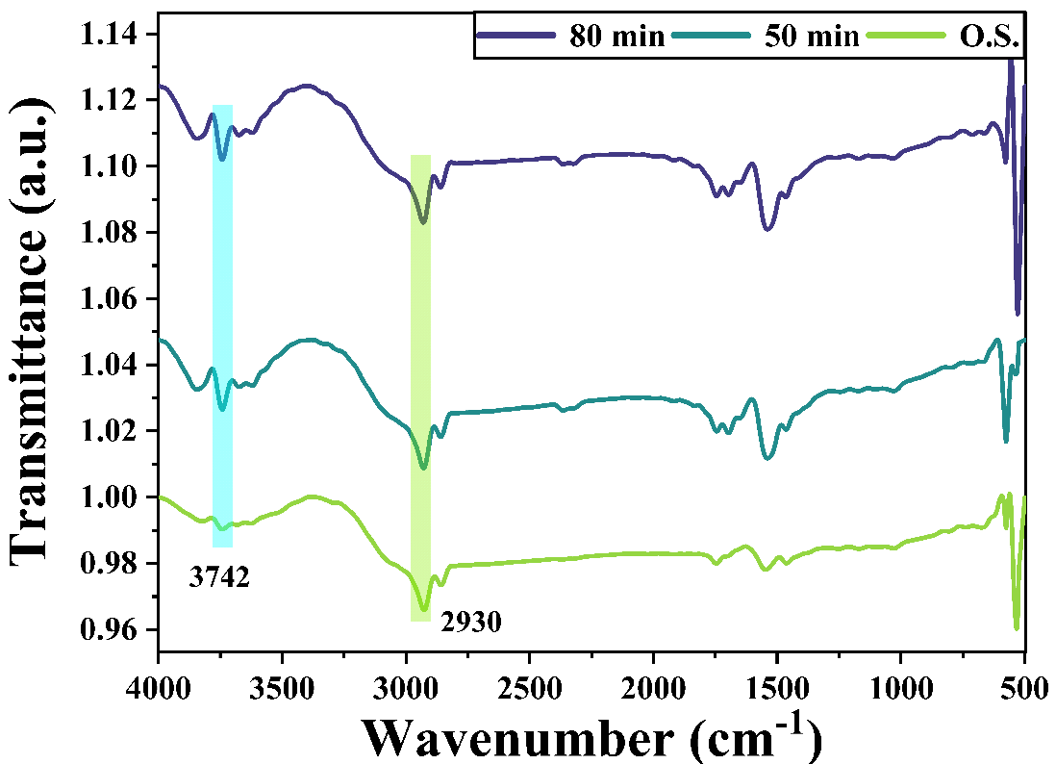
Fig. S11 FT-IR spectra of methyl orange solution before and after photodegradation using S@rGO-2 catalyst at 0 min, 50 min and 80 min.
Methyl orange solution catalyzed using S@rGO-2 catalyst depicts minimal changes in FT-IR spectra, unveiling that degradation is very less (Fig. S11, Supplementary file).
Table S7 The values of the pseudo-zero, pseudo - first and pseudo -second-order rate constants, half-lives and the corresponding correlation coefficients for the photocatalytic degradation of MO.

Sr. No. | Sample Name | Rate constant (k₀) (M min⁻¹) | R² | Half | Rate constant (k₁) (min⁻¹) | R² | Half | Rate constant (K₂) (M⁻¹ min⁻¹) | R² | Half
 |  |  |  | Life (C_{o}/2k₀) | Rate constant (k₁) (min⁻¹) | R² | Life | Rate constant (K₂) (M⁻¹ min⁻¹) | R² | Life
 |  |  |  | (min) | Rate constant (k₁) (min⁻¹) | R² | (0.693/k₁) ( min) | Rate constant (K₂) (M⁻¹ min⁻¹) | R² | (1/k₂C_{o}) (min)
 |  | Zero Order |  |  | First Order |  |  | Second Order
1. | Blank MO | -0.000139273 | 0.99434 | 1846.01 | 0.00027489 | 0.99473 | 2521.01 | 0.000542577 | 0.99508 | 3584.32
2. | rGO | -0.000389636 | 0.96037 | 587.73 | 0.00089831 | 0.96515 | 771.45 | 0.00207 | 0.96945 | 1054.79
3. | S@rGO-1 | -0.000581818 | 0.98314 | 335.16 | 0.00163 | 0.98411 | 425.15 | 0.0046 | 0.98326 | 557.41
4. | S@rGO-2 | -0.000793545 | 0.99184 | 266.53 | 0.00207 | 0.98959 | 334.78 | 0.00543 | 0.98605 | 435.37
5. | S@rGO-3 | -0.00106 | 0.99345 | 215.85 | 0.00265 | 0.98916 | 261.51 | 0.00665 | 0.98206 | 328.62
6. | S@rGO-4 | -0.000730909 | 0.98562 | 219.11 | 0.00262 | 0.97960 | 264.50 | 0.00942 | 0.96958 | 331.43

References
1. Karikalan N, Karthik R, Chen SM, Karuppiah C, Elangovan A. Sonochemical Synthesis of Sulfur Doped Reduced Graphene Oxide Supported CuS Nanoparticles for the Non-Enzymatic Glucose Sensor Applications. Sci Rep. 2017;7(1):2494. https://doi.org/10.1038/s41598-017-02479-5
2. Korucu H, Şimşek B, Kocakerim MM, Karakaş IH. Effective reduction of graphene oxide using sulfur dioxide-containing chemical compounds. Int J Environ Sci Technol. 2019;16(12):8329–42. https://doi.org/10.1007/s13762-019-02419-y
3. Wadekar PH, Ghosh A, Khose R V., Pethsangave DA, Mitra S, Some S. A novel chemical reduction/co-precipitation method to prepare sulfur functionalized reduced graphene oxide for lithium-sulfur batteries. Electrochim Acta. 2020;344:136147. https://doi.org/10.1016/j.electacta.2020.136147
4. Hidayah NMS, Liu WW, Lai CW, Noriman NZ, Khe CS, Hashim U, et al. Comparison on graphite, graphene oxide and reduced graphene oxide: Synthesis and characterization. AIP Conf Proc. American Institute of Physics Inc.; 2017. p. 150002. https://doi.org/10.1063/1.5005764
5. Witjaksono G, Junaid M, Khir MH, Ullah Z, Tansu N, Saheed MSBM, et al. Effect of nitrogen doping on the optical bandgap and electrical conductivity of nitrogen-doped reduced graphene oxide. Molecules. 2021;26(21):6424. https://doi.org/10.3390/molecules26216424
6. Iskandar F, Setiawan B, Mayangsari TR, Maharsi R, Purwanto A, Aimon AH. Electrochemical impedance analysis of polyvinylpyrrolidone-coated sulfur/reduced graphene oxide (S/rGO) electrode. Mater Res Express. 2019;6(2):025514. https://doi.org/10.1088/2053-1591/aaee41
7. Tarimo DJ, Oyedotun KO, Mirghni AA, Manyala N. Sulphur-reduced graphene oxide composite with improved electrochemical performance for supercapacitor applications. Int J Hydrogen Energy. 2020;45(24):13189–201. https://doi.org/10.1016/j.ijhydene.2020.03.059
8. Gunavathi P, Janaki D, Geethanjali S, Balasubramaniam P, Alagesan A. Characterization and identification of elemental sulphur, iron pyrite, mineral gypsum, Phospho gypsum and marine gypsum by using ATR-FTIR. ~ 80 ~ Pharma Innov J. 2021;10(5):80–6.
9. Chen W, Yan L, Bangal PR. Chemical reduction of graphene oxide to graphene by sulfur-containing compounds. J Phys Chem C. 2010;114(47):19885–90. https://doi.org/10.1021/jp107131v
10. Tian Z, Li J, Zhu G, Lu J, Wang Y, Shi Z, et al. Facile synthesis of highly conductive sulfur-doped reduced graphene oxide sheets. Phys Chem Chem Phys. 2015;18(2):1125–30. https://doi.org/10.1039/c5cp05475c
11. Gunaratna TANR, Prajapati PK, de Silva KMN, de Silva WRM. Comparision of traditional and laboratory methods of sulphur processing. J Ayurveda Integr Med. 2023;14(4):100751. https://doi.org/10.1016/j.jaim.2023.100751
12. Manoratne CH, Rosa SRD, Kottegoda IRM. XRD-HTA, UV Visible, FTIR and SEM Interpretation of Reduced Graphene Oxide Synthesized from High Purity Vein Graphite. Mater Sci Res India. 2017;14(1):19–30. https://doi.org/10.13005/msri/140104
13. Ngullie RC, Bhuvaneswari K, Shanmugam P, Boonyuen S, Smith SM, Sathishkumar M. Magnetically Recoverable Biomass-Derived Carbon-Aerogel Supported ZnO (ZnO/MNC) Composites for the Photodegradation of Methylene Blue. Catalysts. 2022;12(9):1073. https://doi.org/10.3390/catal12091073
14. Djellali S, Touati A, Semmeq A, Kebaili M, Badawi M, Bonilla-Petriciolet A. Unravelling the Methylene Blue Adsorption Mechanism on Doped and Nondoped Polyaniline: A Combined Molecular Modeling and Experimental Investigation. Ponnusamy SK, editor. Int J Chem Eng. 2022;2022:1–18. https://doi.org/10.1155/2022/3181963
15. Bartošová A, Blinová L, Sirotiak M, Michalíková A. Usage of FTIR-ATR as Non-Destructive Analysis of Selected Toxic Dyes. Res Pap Fac Mater Sci Technol Slovak Univ Technol. 2017;25(40):103–11. https://doi.org/10.1515/rput-2017-0012

