Supplementary Material
Synthesis of Sulfur based Graphene nanoplatelets composites for efficient Photodegradation of Dyes
Karishma Jain ¹, Deepika Maan ¹, Ashish Kumar ¹, Sushil Kumar Jain ^{1,*} and Balram Tripathi ²
¹ Department of Physics, Manipal University Jaipur, Jaipur 303007, India;
karishma.221051026@muj.manipal.edu (K.J.);
deepika.23fs30sbs00048@muj.manipal.edu (D.M.);
ashish.23fs30sbs00079@muj.manipal.edu (A.K.)
² Department of Physics, S. S. Jain Subodh PG (Auto.) College, Jaipur 302004, India;
balramtripathi1181@gmail.com
* Correspondence: sushilkumar.jain@jaipur.manipal.edu (S.K.J.)
Tel.: +91-9828034055 (S.K.J.)

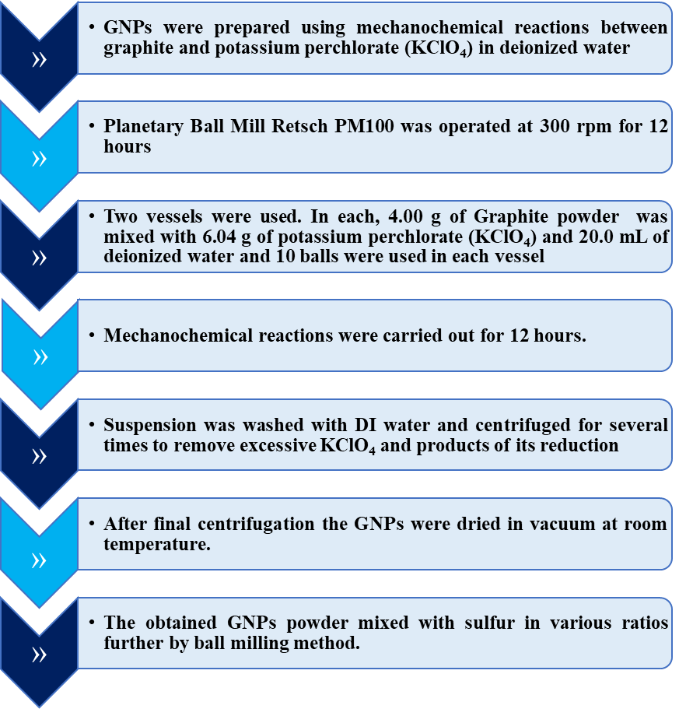
Fig. S1. Flow chart showing synthesis of sulfur and GNPs composites.

Fig. S2. WH Plot corresponds to the samples - (a) GNPs, (b) Pristine Sulfur, (c) SG-18, (d) SG-16, (e) SG-14 and (f) SG-12.

Fig. S3. EDX analysis of (a) SG-12, (b) SG-14, (c) SG-16, (d) SG-18 composites (e) elemental sulfur and (f) GNPs.
Fig. S4. Absorption spectra for (a) Blank MB (b) pristine GNPs (c) SG-12 (d) SG-14 (e) SG-16 (f) SG-18. Inset graph illustrates zoomed out view of absorption spectra in the wavelength range - 200 nm to 800 nm.
Fig. S5. Absorption spectra for (a) Blank MO (b) GNPs (c) SG-12 (d) SG-14 (e) SG-16 (f) SG-18.

Table S1. The values of the pseudo-zero, pseudo - first and pseudo -second-order rate constants, half-life times and the corresponding correlation coefficients for the photocatalytic degradation of Blank MB, GNPs, SG-12, SG-14, SG-16 and SG-18.
Sr. No. | Sample Name | Rate constant (k₀) (M min⁻¹) | R² | Half | Rate constant (k₁) (min⁻¹) | R² | Half | Rate constant (k₂) (M⁻¹ min⁻¹) | R² | Half
 |  |  |  | Life (C_{o}/2k₀) | Rate constant (k₁) (min⁻¹) | R² | Life | Rate constant (k₂) (M⁻¹ min⁻¹) | R² | Life
 |  |  |  | (in min) | Rate constant (k₁) (min⁻¹) | R² | (0.693/k₁) (in min) | Rate constant (k₂) (M⁻¹ min⁻¹) | R² | (1/k₂C_{o}) (in min)
 |  | Zero Order |  |  | First Order |  |  | Second Order
1. | Blank MB | 0.00178 | 0.96968 | 145.17 | 0.00418 | 0.97713 | 165.55 | 0.00989 | 0.98068 | 195.65
2. | GNPs | 0.00407 | 0.98518 | 138.50 | 0.00455 | 0.98317 | 152.31 | 0.00517 | 0.96863 | 171.57
3. | SG-12 | 0.00379 | 0.99301 | 119.22 | 0.00534 | 0.98621 | 129.78 | 0.00765 | 0.96645 | 144.65
4. | SG-14 | 0.0042 | 0.96515 | 108.29 | 0.00606 | 0.93841 | 114.36 | 0.00894 | 0.90403 | 122.97
5. | SG-16 | 0.00247 | 0.99575 | 100.99 | 0.00668 | 0.988 | 103.74 | 0.01859 | 0.96510 | 107.82
6. | SG-18 | 0.0055 | 0.99386 | 98.38 | 0.00701 | 0.97827 | 98.86 | 0.00923 | 0.93620 | 99.56

Table S2. The values of the pseudo-zero, pseudo - first and pseudo -second-order rate constants, half-life times and the corresponding correlation coefficients for the photocatalytic degradation of Blank MO, GNPs, SG-12, SG-14, SG-16 and SG-18.
Sr. No. | Sample Name | Rate constant (k₀) (M min⁻¹) | R² | Half | Rate constant (k₁) (min⁻¹) | R² | Half | Rate constant (k₂) (M⁻¹ min⁻¹) | R² | Half
 |  |  |  | Life (C_{o}/2k₀) | Rate constant (k₁) (min⁻¹) | R² | Life | Rate constant (k₂) (M⁻¹ min⁻¹) | R² | Life
 |  |  |  | (in min) | Rate constant (k₁) (min⁻¹) | R² | (0.693/k₁) (in min) | Rate constant (k₂) (M⁻¹ min⁻¹) | R² | (1/k₂C_{o}) (in min)
 |  | Zero Order |  |  | First Order |  |  | Second Order
1. | Blank MB | 0.00013927 | 0.99434 | 1846.05 | 0.000275 | 0.99473 | 2566.67 | 0.000542577 | 0.99508 | 3584.32
2. | GNPs | 0.000400818 | 0.98587 | 683.35 | 0.000761 | 0.98733 | 911.84 | 0.00145 | 0.98858 | 1258.95
3. | SG-12 | 0.000438818 | 0.96529 | 587.26 | 0.000892 | 0.96895 | 776.91 | 0.00181 | 0.97234 | 1071.96
4. | SG-14 | 0.000568364 | 0.96935 | 286.53 | 0.00195 | 0.96984 | 355.38 | 0.00669 | 0.96774 | 459.22
5. | SG-16 | 0.000776 | 0.97819 | 282.02 | 0.00197 | 0.97272 | 351.78 | 0.005 | 0.96476 | 456.93
6. | SG-18 | 0.000925 | 0.98211 | 234.43 | 0.00241 | 0.97762 | 287.55 | 0.00633 | 0.97056 | 364.26

Photocatalytic results for Methylene blue dye
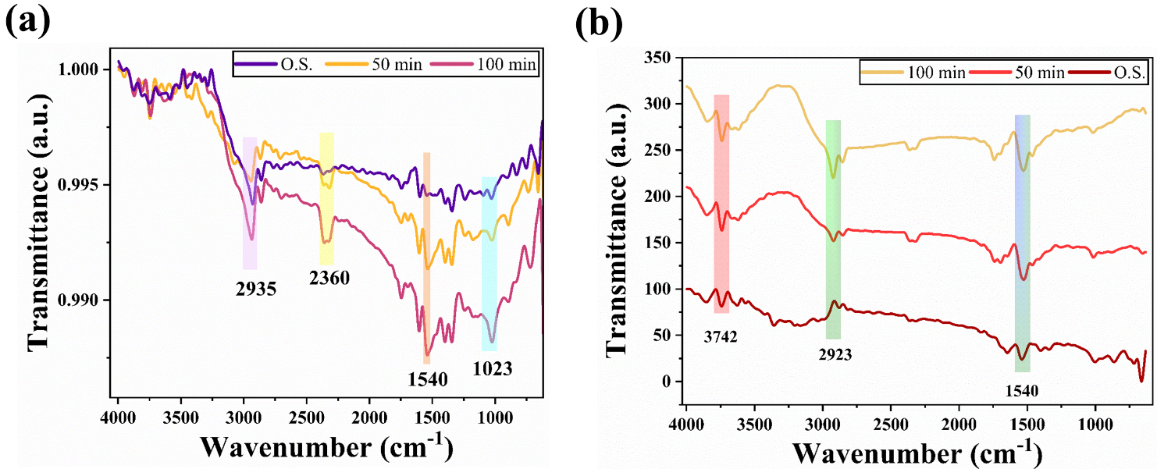
Fig. S6. (a) FTIR spectra of methylene blue solution before and after photodegradation using SG-12 catalyst at 0 min, 50 min and 100 min. (b) FTIR spectra of methylene blue solution before and after photodegradation using SG-16 catalyst at 0 min, 50 min and 100 min.
Fourier transform infrared spectroscopy technique (FTIR) is utilized to probe transformations in methylene blue solution and degraded methylene blue dye solution. Fig. S6 (a) illustrated the FTIR spectra of methylene blue solution before and after photodegradation using SG-12 catalyst at 0 min, 50 min and 100 min. The FTIR band at 2935 cm⁻¹ (Fig. S6 (a)) and 2923 cm⁻¹ (Fig. S6(b)) is on account of assigned to the vibrations of the CH groups of the heterocycle [1]. The prominent peak at 1540 cm⁻¹ is attributed to the C=C and C=N vibrations of methylene blue (Fig. S6 (a-b))[2]. Fig. S6 (b) illustrated FTIR spectra of methylene blue solution before and after photodegradation using SG-16 catalyst at 0 min, 50 min and 100 min. The transmittance observed at 3742 cm⁻¹ (shifted to higher frequency region) is on account of main chromophore undergoes degradation to synthesize H-OH [3].

Photocatalytic results for Methyl orange dye

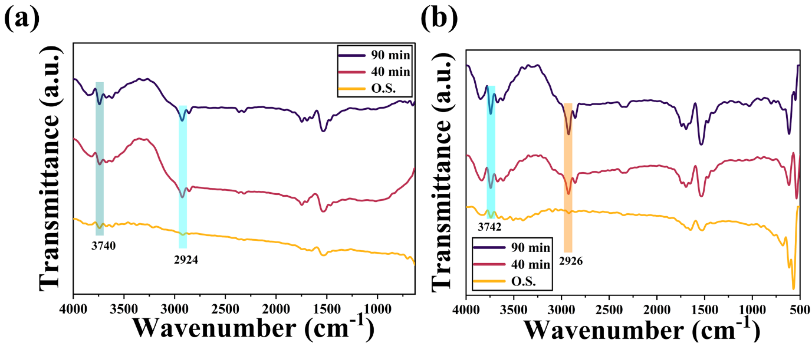
Fig. S7. (a) FTIR spectra of methyl orange solution before and after photodegradation using SG-12 catalyst at 0 min, 40 min and 90 min. (b) FTIR spectra of methyl orange solution before and after photodegradation using SG-18 catalyst at 0 min, 40 min and 90 min.
The maximal absorbance wavelength for methyl orange dye is 465 nm [4]. It is ardent from Fig. S7 (a-f) that degradation of methyl orange dye is hard [5]. The degree of degradation is greater in the order of graphene oxide content (Table S2, Fig. S7 (a-d)). The surface and contour plots have depicted statistically, that lower band and increased weight ratio, substantiates the increased efficiency (Fig. S7). Fig. S7 illustrates the analysis of degraded methyl orange dye solution. The peaks at 2924 and 2926 cm⁻¹ is associated to asymmetric -CH₃ stretching band [6], 1600-1400 cm⁻¹ is ascribed to aromatic C=C bonding [7]. 3740 cm⁻¹ is ascribed to O-H stretching (alcohol group)[8].

Fig. S8. Reusability plots for SG-18 (a) methylene blue dye (b) methyl orange dye.

References

1. Djellali S, Touati A, Semmeq A, Kebaili M, Badawi M, Bonilla-Petriciolet A. Unravelling the Methylene Blue Adsorption Mechanism on Doped and Nondoped Polyaniline: A Combined Molecular Modeling and Experimental Investigation. Ponnusamy SK, editor. Int J Chem Eng. 2022;2022:1–18. https://doi.org/10.1155/2022/3181963
2. Bartošová A, Blinová L, Sirotiak M, Michalíková A. Usage of FTIR-ATR as Non-Destructive Analysis of Selected Toxic Dyes. Res Pap Fac Mater Sci Technol Slovak Univ Technol. 2017;25(40):103–11. https://doi.org/10.1515/rput-2017-0012
3. Alshehri AA, Malik MA. Biogenic fabrication of ZnO nanoparticles using Trigonella foenum-graecum (Fenugreek) for proficient photocatalytic degradation of methylene blue under UV irradiation. J Mater Sci Mater Electron. 2019;30(17):16156–73. https://doi.org/10.1007/s10854-019-01985-8
4. Wu L, Liu X, Lv G, Zhu R, Tian L, Liu M, et al. Study on the adsorption properties of methyl orange by natural one-dimensional nano-mineral materials with different structures. Sci Rep. 2021;11(1):10640. https://doi.org/10.1038/s41598-021-90235-1
5. Kishor R, Purchase D, Saratale GD, Romanholo Ferreira LF, Hussain CM, Mulla SI, et al. Degradation mechanism and toxicity reduction of methyl orange dye by a newly isolated bacterium Pseudomonas aeruginosa MZ520730. J Water Process Eng. 2021;43:102300. https://doi.org/10.1016/j.jwpe.2021.102300
6. Kalyani DC, Telke AA, Govindwar SP, Jadhav JP. Biodegradation and Detoxification of Reactive Textile Dye by Isolated Pseudomonas sp. SUK1 . Water Environ Res. 2009;81(3):298–307. https://doi.org/10.2175/106143008x357147
7. PS H, Joseph L, A D. Photocatalytic degradation of textile dyes by hydrogel supported titanium dioxide nanoparticles. J Environ Eng Ecol Sci. 2013;2(1):2. https://doi.org/10.7243/2050-1323-2-2
8. Khan A, Naeem A, Mahmood T, Ahmad B, Ahmad Z, Farooq M, et al. Mechanistic study on methyl orange and congo red adsorption onto polyvinyl pyrrolidone modified magnesium oxide. Int J Environ Sci Technol. 2022;19(4):2515–28. https://doi.org/10.1007/s13762-021-03308-z

