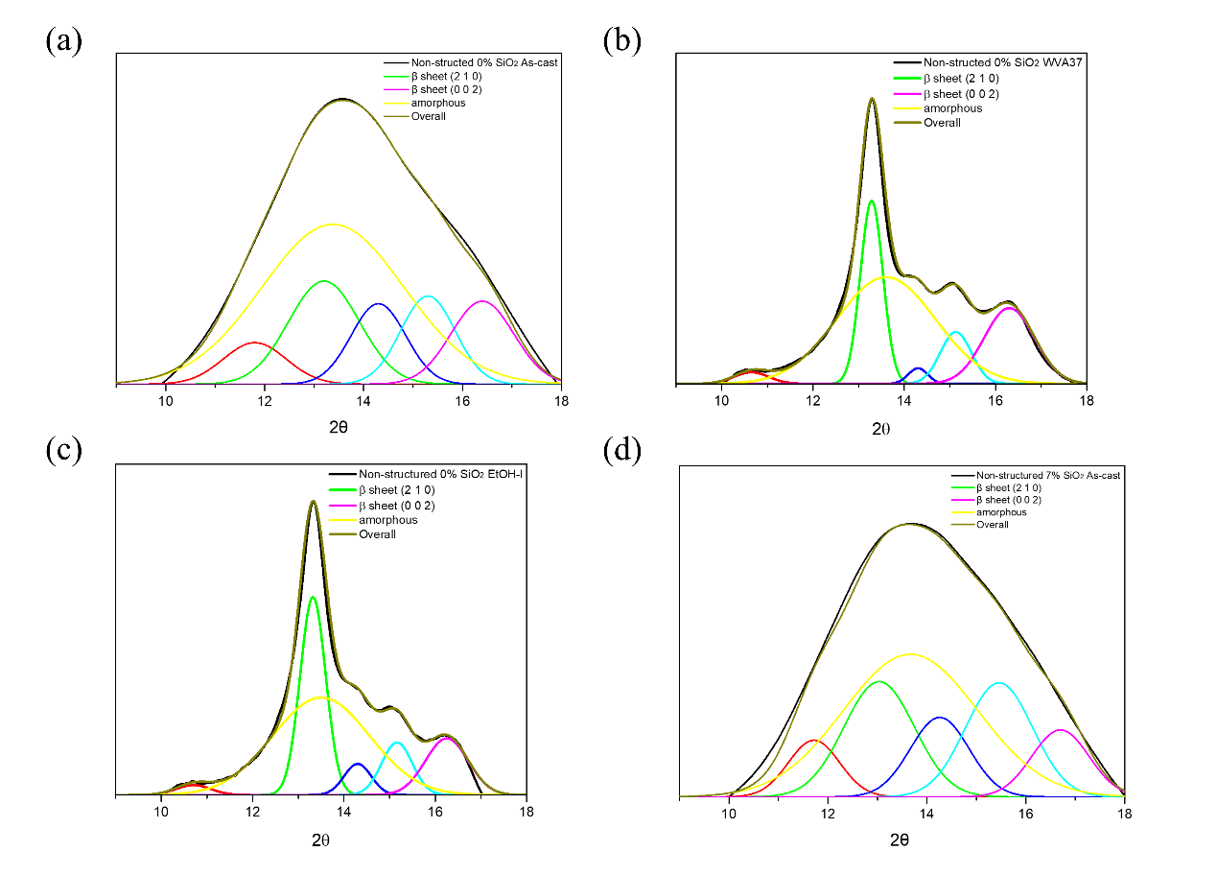
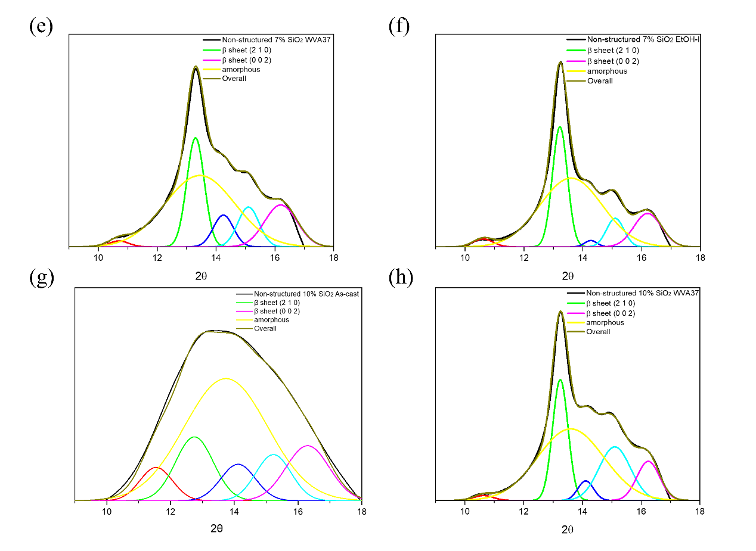
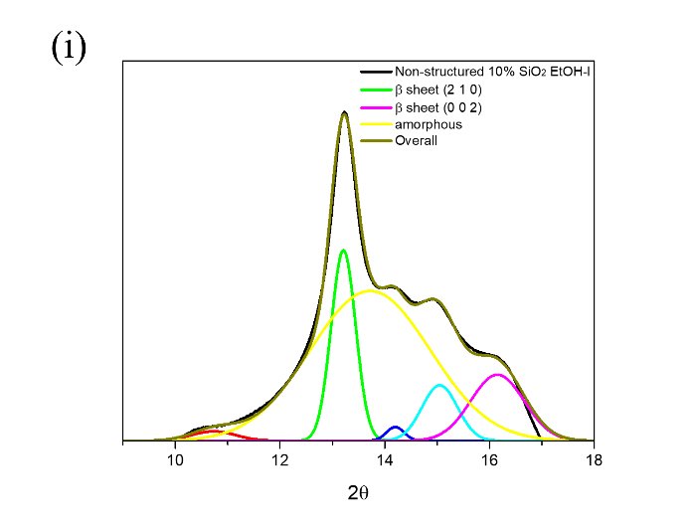
Figure S1 : XRD analysis of prepared films: (a) Non-structured 0% SiO₂ as-cast film; (b) Non-structured 0% SiO₂ film treated with WVA37; (c) Non-structured 0% SiO₂ film treated with EtOH-I; (d) Non-structured 7% SiO₂ as-cast film; (e) Non-structured 7% SiO₂ film treated with WVA37; (f) Non-structured 7% SiO₂ film treated with EtOH-I; (g) Non-structured 10% SiO₂ as-cast film; (h) Non-structured 10% SiO₂ film treated with WVA37; (i) Non-structured 10% SiO₂ film treated with EtOH-I.

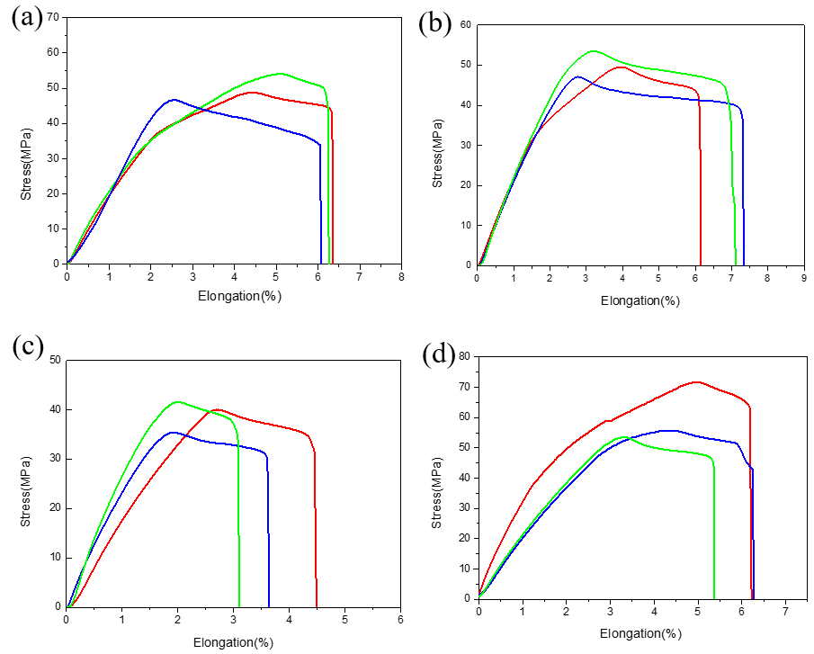
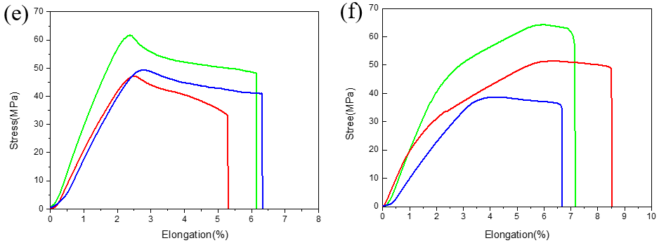

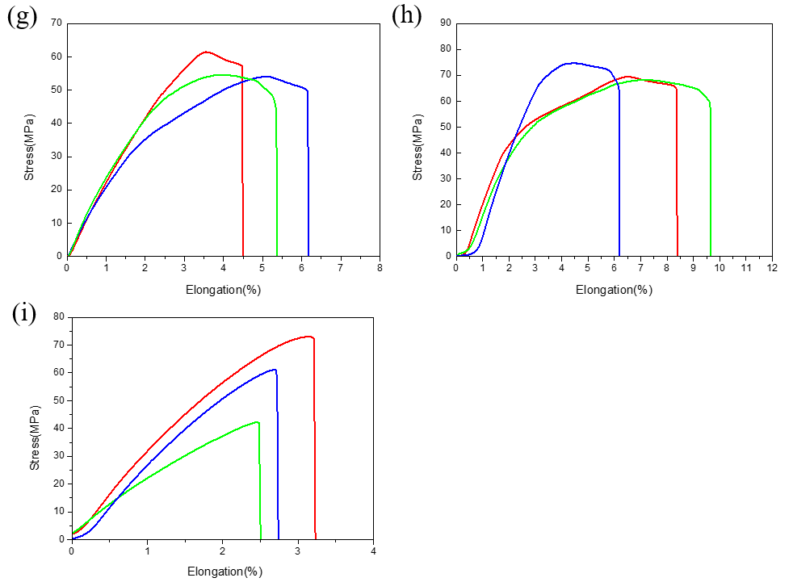

Figure S2: Tensile test of prepared films: (a) Non-structured 0% SiO₂ as-cast film; (b) Non-structured 7% SiO₂ as-cast film; (c) Non-structured 10% SiO₂ as-cast film; (d) Non-structured 0% SiO₂ film treated with WVA37; (e) Non-structured 7% SiO₂ film treated with WVA37; (f) Non-structured 10% SiO₂ film treated with WVA37; (g) Non-structured 0% SiO₂ film treated with EtOH-I; (h) Non-structured 7% SiO₂ film treated with EtOH-I; (i) Non-structured 10% SiO₂ film treated with EtOH-I.

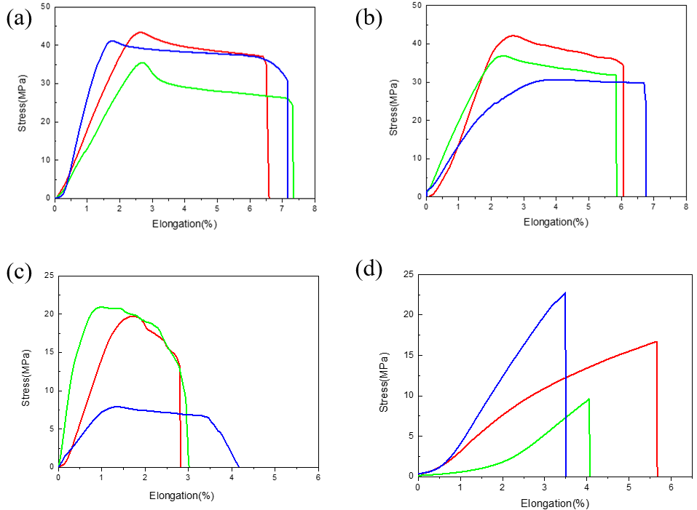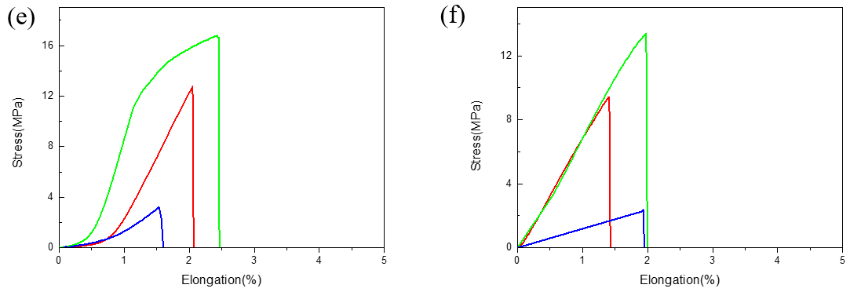
Figure S3: Tensile test of healed SF composite films: (a) Non-structured 0% SiO₂ as-cast film; (b) Non-structured 7% SiO₂ as-cast film; (c) Non-structured 10% SiO₂ as-cast film; (d) Non-structured 7% SiO₂ film treated with WVA37; (e) Non-structured 10% SiO₂ film treated with WVA37; (f) Non-structured 10% SiO₂ film treated with EtOH-I.

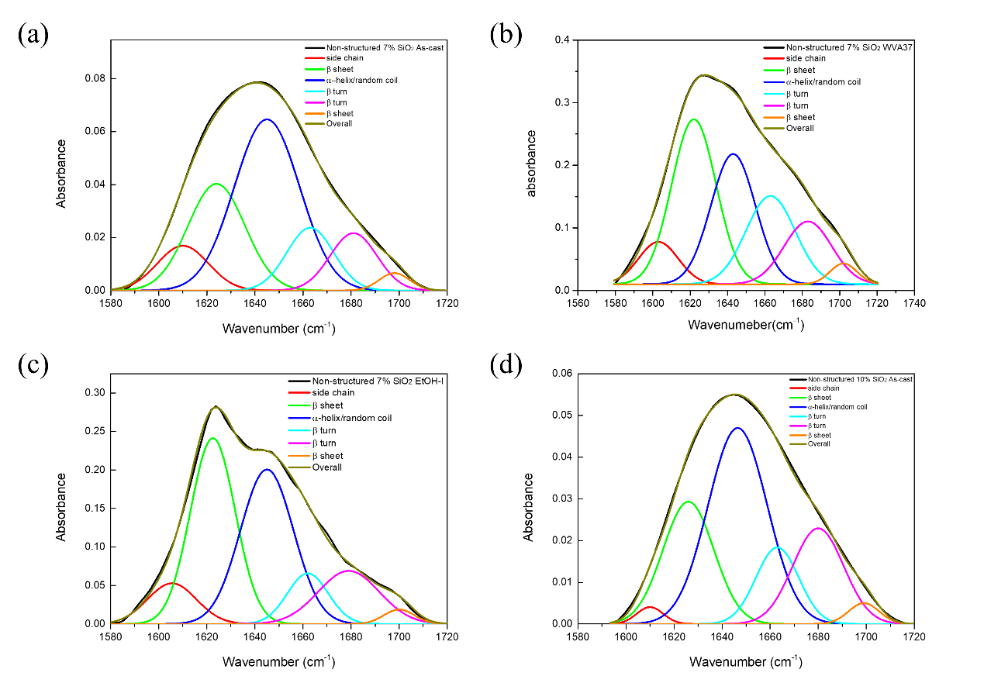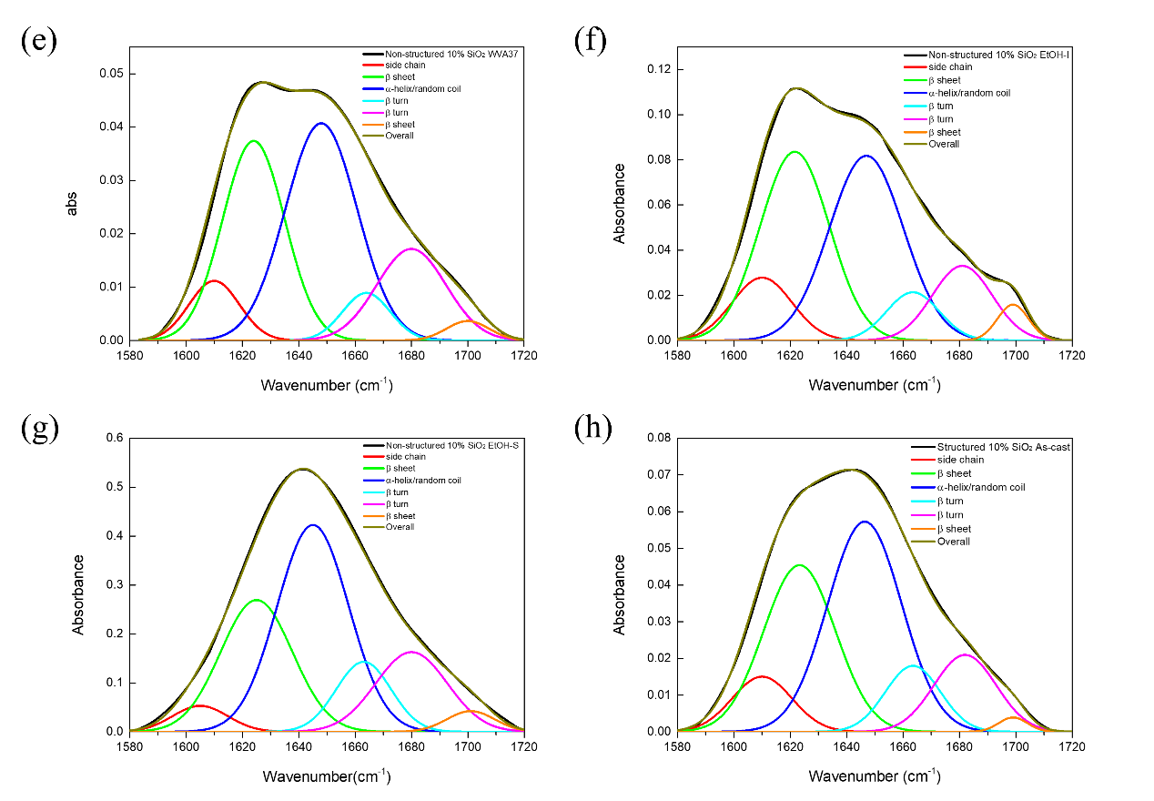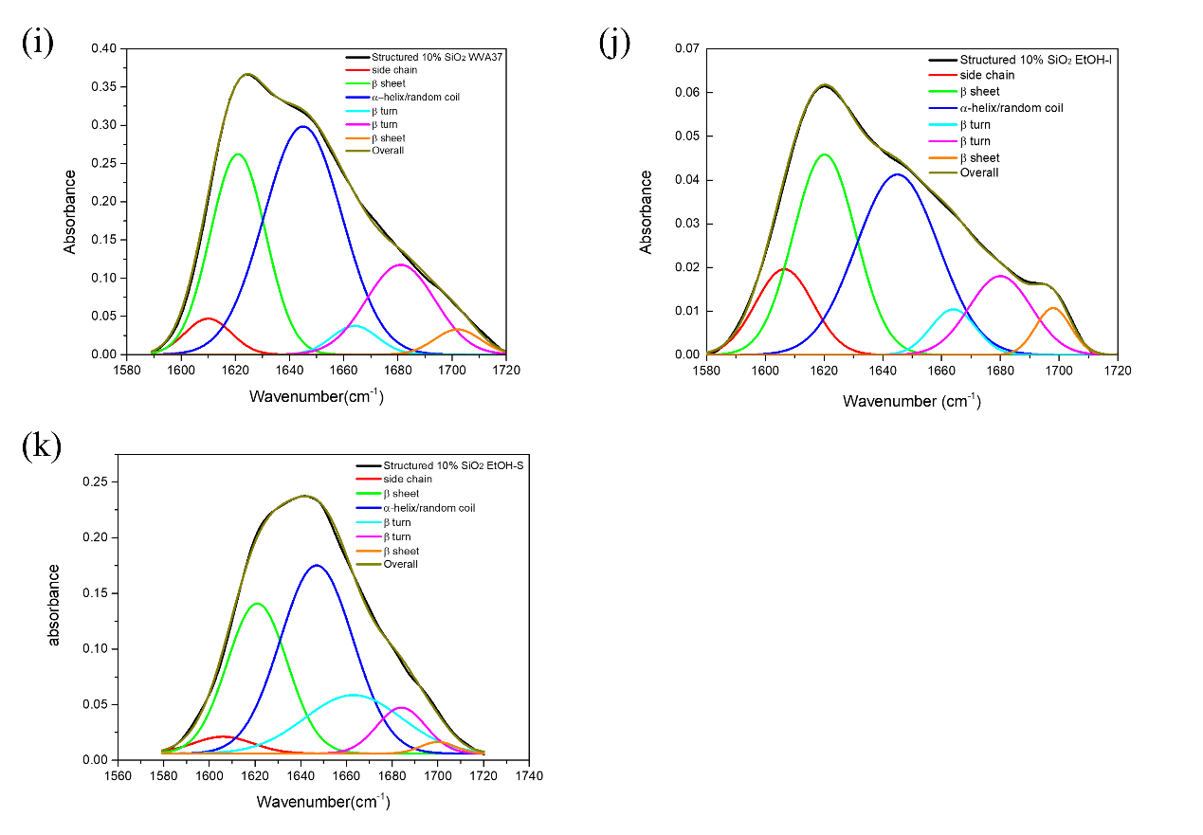
Figure S4 : FTIR analysis of prepared films: (a) Non-structured 7% SiO₂ as-cast film; (b) Non-structured 7% SiO₂ film treated with WVA37; (c) Non-structured 7% SiO₂ film treated with EtOH-I; (d) Non-structured 10% SiO₂ as-cast film; (e) Non-structured 10% SiO₂ film treated with WVA37; (f) Non-structured 10% SiO₂ film treated with EtOH-I; (g) Non-structured 10% SiO₂ film treated with EtOH-S; (h) Structured 10% SiO₂ as-cast film; (i) Structured 10% SiO₂ film treated with WVA37; (j) Structured 10% SiO₂ film treated with EtOH-I; (k) Structured 10% SiO₂ film treated with EtOH-S.

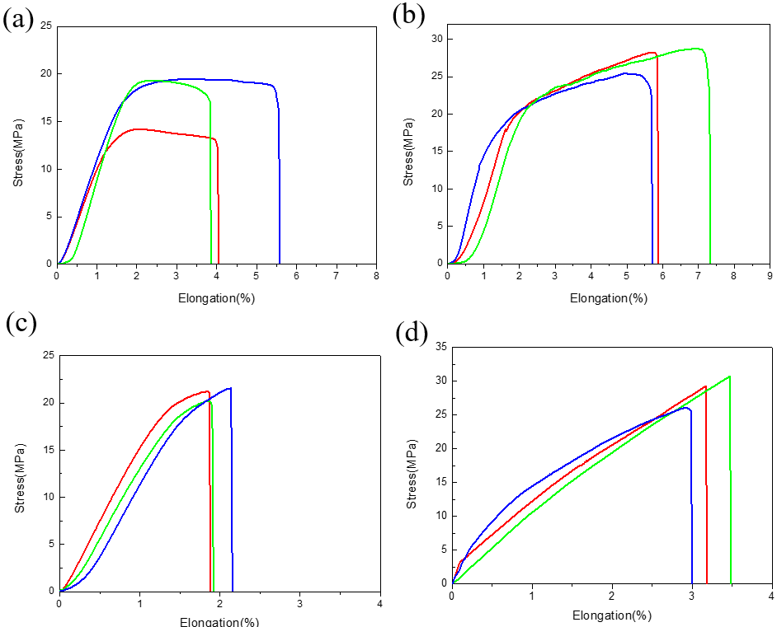

Figure S5: Tensile test of prepared SiO₂-SF composite films with replicated leaf surface microstructures: (a) as-cast film; (b) film treated with WVA37; (c) film treated with EtOH-S; (d) film treated with EtOH-I.

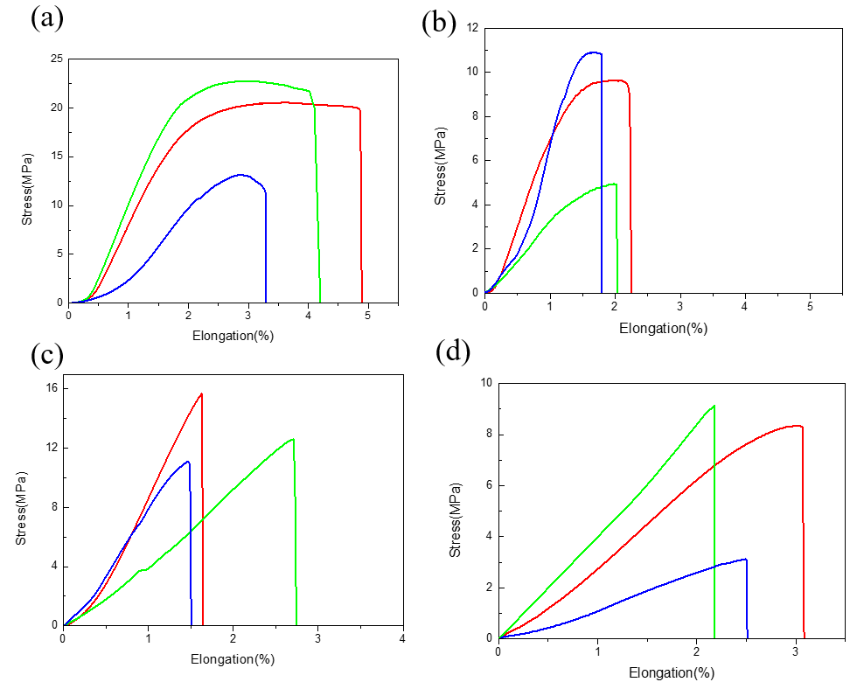

Figure S6: Tensile test of the healed SF composite films with replicated leaf surface microstructures: (a) as-cast film with the “st-st” bonding method; (b) as-cast film with the “st-flat” bonding method;; (c) EtOH-S- treated film with the “st-st” bonding method; (d) EtOH-S- treated film with the “st-flat” bonding method.

