Biodeterioration of gypsum pineapple fibre composites subjected to accelerated humid and fungal ageing
Achille Désiré Betené Omgba^{a,b*}, Julien Clerc Obamª, Suzie Viviane Obame^{a,b}, Florian Martoïa^{c}, Remy Legrand Ndoumou Belingaª, Cheryle Manfouo Tchoupmene^{a,c}, Christel Cedrig Laris Nsi Ongoª, Fabien Betené Ebanda^{a,b}, Atangana Ateba^{a,b}, Pierre J.J. Dumont^{c}.
ª Laboratory of Mechanics, Doctoral Training Unit in Engineering Sciences (UFD-SI), University of Douala, P.O. Box: 1872, Douala, Cameroon
^{b} Department of Mechanical Engineering, ENSET, University of Douala, P.O. Box: 1872, Douala, Cameroon
^{c} Univ. Lyon, INSA-Lyon, CNRS, LaMCoS, UMR5259, 69621 Villeurbanne, France
*Corresponding author’s: Achille Désiré Betené Omgba achilbetene@gmail.com

S.1. Historical, Technical and Environmental Context of Fibre-Reinforced Plaster in Heritage Buildings
Fibre-reinforced plaster has played an important role in the history of construction techniques since its adoption in the 19ᵗʰ century as a lightweight and ornamental material for false ceilings and decorative elements in architecturally significant buildings [1,2]. Its use relies on traditional attachment systems, consisting of fibre bundles embedded in plaster and securely anchored to wooden or steel structures [3,4]. This technique was widely implemented in numerous edifices, including theatres, hotels, community halls, and historic residences [5]. Several events have highlighted the vulnerability of such structures, notably the partial collapse of the Apollo Theatre in 2013, which injured 88 spectators [6,7], as well as other failures reported at the Savoy Theatre and in various heritage buildings [8]. Moisture-related phenomena constitute one of the main factors of deterioration observed in these constructions. Capillary rise, condensation, and water infiltration [2,9,10] create hygrometric imbalances that promote mould growth and biological degradation, particularly when relative humidity exceeds 70 % [8]. General descriptions of these mechanisms, together with examples of biodeterioration illustrated in Figure 1 which show sources of moisture in domestic buildings and their effects on false ceilings provide a broader context for understanding these processes, independent of the specific case study.
Table S.1. Mixture proportions with different fibre dosages and sample designation
Formulation |  |  | Factor 1 : | Factor 2 : |  | Volume fraction of plaster (%)
Ref. | Coding |  | $A$ : Exposure duration (Months) | $B$ : Volume fraction (vol%) |  | Volume fraction of plaster (%)
 | G0 |  | 0 | 0 |  | 100
 | GP1 |  | 0 | 1 |  | 99
 | GP1.35 |  | 0 | 1,35 |  | 98,65
 | GP2 |  | 0 | 2 |  | 98
 | 1G0 |  | 1 | 0 |  | 100
 | 1GP1 |  | 1 | 1 |  | 99
 | 1GP1.35 |  | 1 | 1,35 |  | 98,5
 | 1GP2 |  | 1 | 2 |  | 98
 | 3G0 |  | 3 | 0 |  | 100
 | 3GP1 |  | 3 | 1 |  | 99
 | 3GP1.35 |  | 3 | 1,35 |  | 98,5
 | 3GP2 |  | 3 | 2 |  | 98
 | 6G0 |  | 6 | 0 |  | 100
 | 6GP1 |  | 6 | 1 |  | 99
 | 6GP1.35 |  | 6 | 1,35 |  | 98,5
 | 6GP2 |  | 6 | 2 |  | 98
Note: Each sample was coded to indicate the exposure duration, the material type (G for gypsum, P for pineapple fibre), and the fibre percentage, with the addition of the letters HR or CH to specify the type of conditioning (humid or fungal).
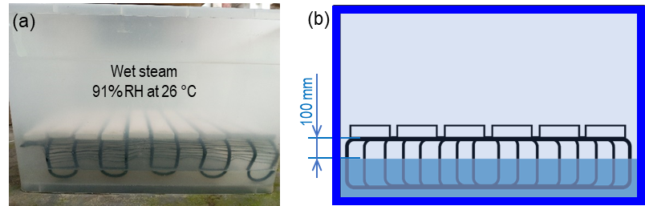
Figure S.1. Exposure device for gypsum composites at a relative humidity of 91% at 26°C: (a) saturated hermetic tank, and (b) 2D diagram of the experimental device.
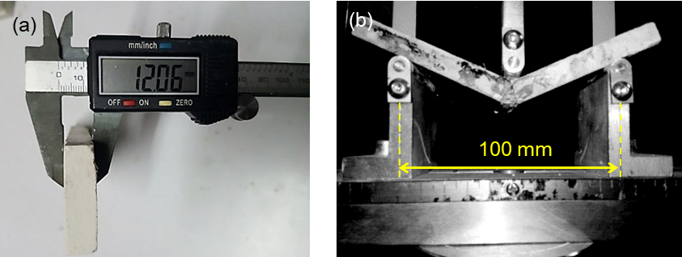
Figure S.2. Principle of (a) thickness measurement using a digital calliper and (b) three-point bending test of the composites.
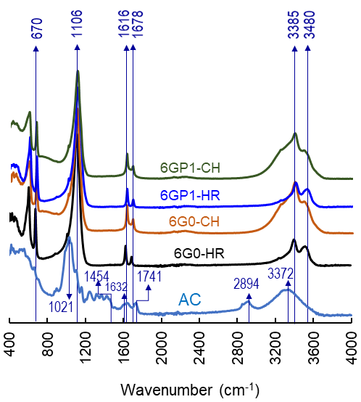
Figure S.3. FTIR spectra of pineapple fibre (AC), unreinforced gypsum (6G0-HR and 6G0-CH), and gypsum reinforced with 1 vol% pineapple fibres (6GP1-HR and 6GP1-CH). The AC spectrum shows characteristic bands of lignocellulosic components [11–14], including cellulose, hemicelluloses, and pectins. The gypsum samples exhibit typical peaks of calcium sulfate dihydrate, notably the sulfate group bands at 670 and 1106 cm⁻¹ [15]. The introduction of fibres attenuates the bands at 1021 and 1741 cm⁻¹, confirming the incorporation of lignocellulosic compounds into the matrix. Exposure to humidity (6G0-HR, 6GP1-HR) enhances the bands associated with water absorption, particularly around 1616 and 3480 cm⁻¹, a phenomenon amplified by the hydrophilic groups of the fibres. Under fungal conditioning (6G0-CH, 6GP1-CH), the most pronounced changes occur in the 1600-1750 cm⁻¹ region, with signatures attributed to polysaccharide degradation and microbial oxidation, notably near 1678 cm⁻¹. These spectra demonstrate the impact of humidity and fungal development on the chemical evolution of the composite, as well as the increased sensitivity of reinforced systems, particularly in the 1020-1750 cm⁻¹ range and above 2900 cm⁻¹, without gypsum transformation.
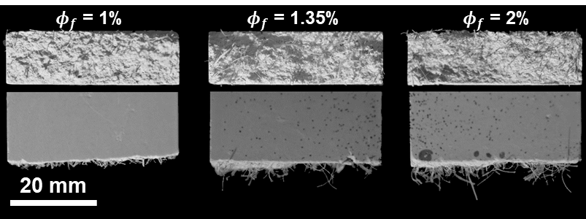
Figure S.4. Optical micrographs showing the fracture zone in the (x, z) and (x, y) planes of Ananas comosus-gypsum composites.

Table S.2. ANOVA analysis parameters ($CI=$ 95%) for the different models used to predict the physical and mechanical properties of gypsum/pineapple fibre composites.
Factors | Mass gain (%) | Density (kg/m³) | Volume deformation (%) | MOR (MPa) | MOE (MPa)
Model type | Design model | Cubic | 2FI | Cubic | Cubic
$t$ -Exposure time | 0.0009* | 0.0015* | 0.2449 | 0.0085* | 0.9540
$ϕ_{f}$-Volume fraction | 0.0180* | 0.8482 | 0.1404 | 0.0169* | 0.0001*
$M$- Exposure environment | < 0.0001* | < 0.0001* | < 0.0001* | < 0.0001* | 0.0006*
$t×ϕ_{f}$ | 0.2492 | 0.9747 | 0.0411* | 0.0737 | 0.3347
$t×M$ | 0.8756 | < 0.0001* | 0.0016* | 0.0001* | 0.0101*
$ϕ_{f}×M$ | 0.9627 | 0.8335 | 0.4995 | 0.1851 | 0.4510
$t^{2}$ | 0.0049* | < 0.0001* | 0.0048* | < 0.0001* | 0.0129*
$ϕ_{f}^{2}$ | 0.4101 | 0.7610 | 0.576 | < 0.0001* | < 0.0001*
$t×ϕ_{f}×M$ | 0.0720 | 0.8033 | - | 0.9643 | 0.8967
$t^{2}×ϕ_{f}$ | - | 0.8198 | - | 0.2043 | 0.7736
$t^{2}×M$ | - | < 0.0001* |  | 0.0098 | 0.1635
$t×ϕ_{f}^{2}$ | - | 0.9028 | - | 0.3598 | 0.0056*
$ϕ_{f}^{2}×M$ | - | 0.8599 |  | 0.9014 | 0.1000
$t^{3}$ | - | < 0.0001* | - | < 0.0001* | 0.0069*
$ϕ_{f}^{3}$ | - | 0.8957 | - | 0.0409* | 0.0002*
Mean | 37.56 | 1195.77 | -2.96 | 1.62 | 714.15
$CV$ (%) | 3.96 | 6.04 | 22.08 | 7.85 | 10.25
Adeq Precision | 61.3718 | 15.0766 | 14.7422 | 22.0516 | 16.5359
$R^{2}$ | 0.9982 | 0.9677 | 0.9121 | 0.9739 | 0.9353
Adjusted $R^{2}$ | 0.9971 | 0.9373 | 0.8810 | 0.9494 | 0.8747
Predicted $R^{2}$ | 0.9918 | 0.8831 | 0.8368 | 0.8895 | 0.6980
Model F-value | 874.90 | 31.91 | 29.39 | 39.79 | 15.42
Model p-value | < 0.0001* | < 0.0001* | < 0.0001* | < 0.0001* | < 0.0001*
Lack-of-Fit p-value | $>$0.05 | $>$0.75 | $>$0.05 | $>$0.50 | $>$0.07
*significant, $R^{2}$: Coefficient of determination, $CV$- Coefficient of variation

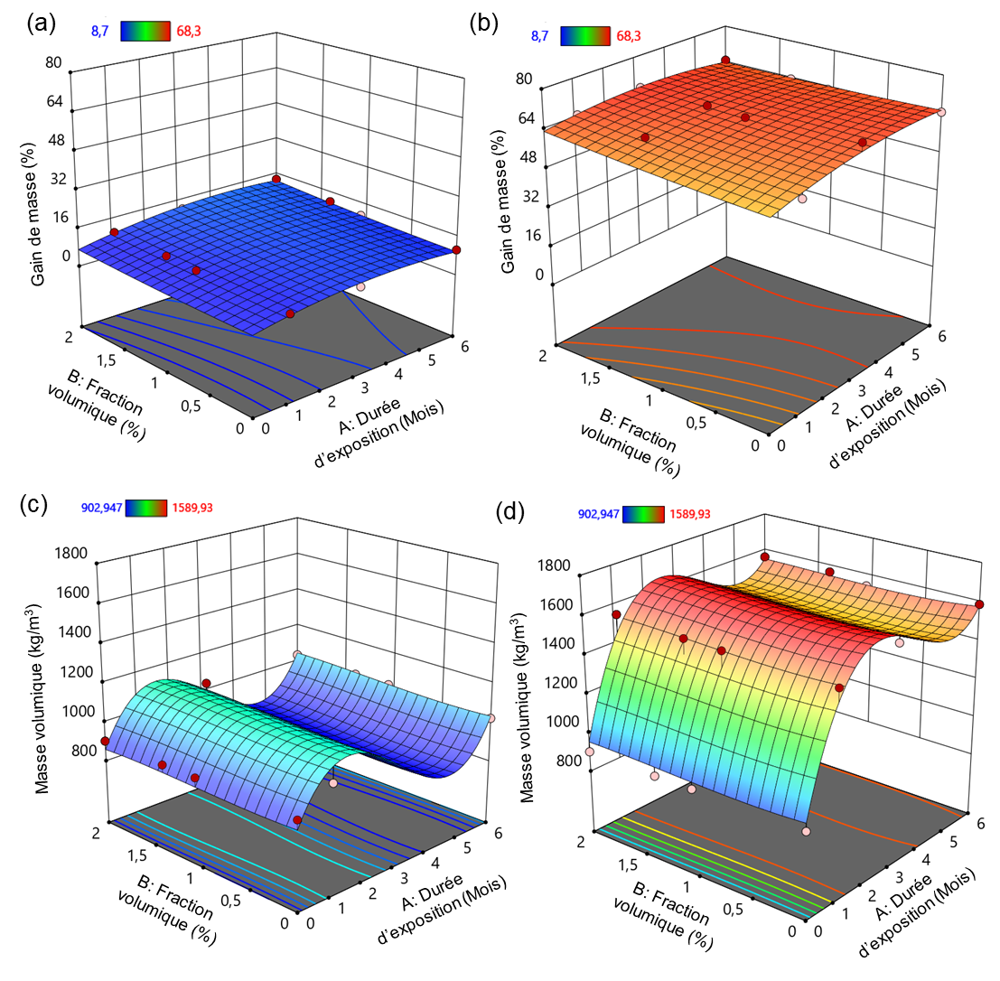
Figure S.5. 3D response surface illustrating changes in the mass gain of gypsum/pineapple fibre composites as a function of fibre volume fraction and conditioning time in humid (RH: a) and fungal (CH: b) environments.

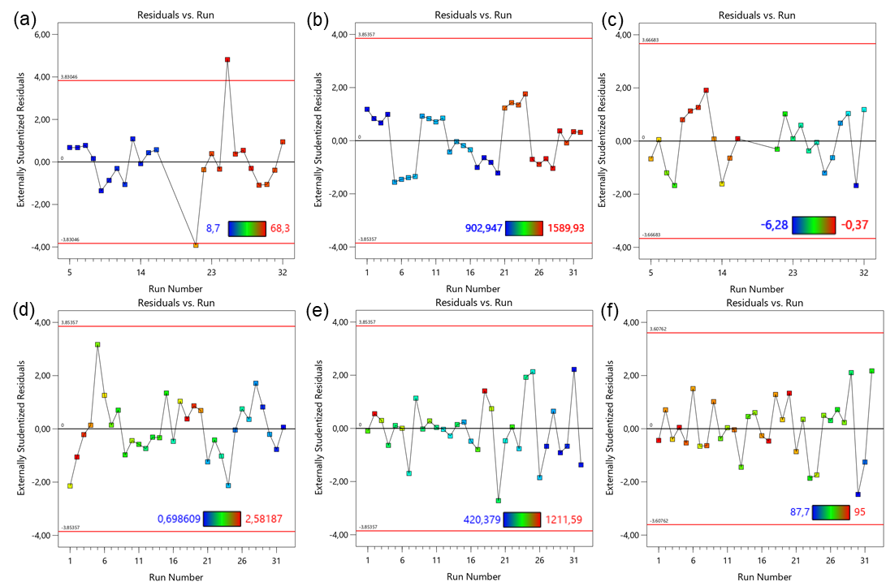
Figure S.6. Plot of residuals versus stroke for (a) mass gain, (b) density, (c) volume strain, (d) MOR, (e) MOE and (f) surface hardness of composites.
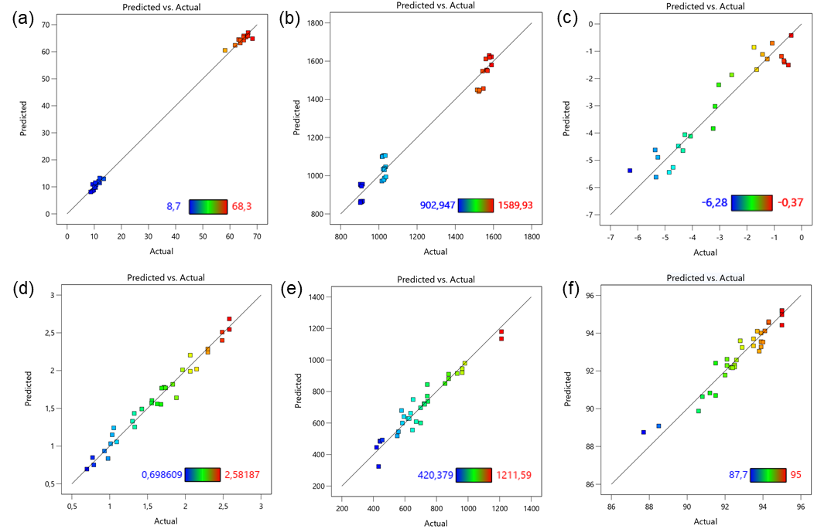
Figure S.7. Predicted values versus experimental values for (a) mass gain, (b) density, (c) volume strain, (d) MOR, (e) MOE and (f) surface hardness of composites.

References
[1] E.M. Payne, The Conservation of Plaster Casts in the Nineteenth Century, Stud. Conserv. 65 (2020) 37–58. https://doi.org/10.1080/00393630.2019.1610845.
[2] S. Awang Ngah, B. Dams, M.P. Ansell, J. Stewart, R. Hempstead, R.J. Ball, Structural performance of fibrous plaster. Part 1: Physical and mechanical properties of hessian and glass fibre reinforced gypsum composites, Constr. Build. Mater. 259 (2020) 120396. https://doi.org/10.1016/j.conbuildmat.2020.120396.
[3] S. Brookes, Historic plaster ceilings. Part 1: Development and causes of failure, Struct. Eng. J. Inst. Struct. Eng. 99 (2021) 20–24.
[4] B. Dams, Awang-Ngah ,Shamsiah, Stewart ,John, Harrison ,Robin, Ansell ,Martin P., Harney ,Marion, R.J. and Ball, Load Bearing Capacity and Failure Analysis of Fibrous Plaster Wads, Stud. Conserv. 70 (2025) 67–87. https://doi.org/10.1080/00393630.2024.2350278.
[5] J. Stewart, G. Buckley, R. Fenton, D. Harrison, A. Magrill, J. Riley, B. Ridout, Historic England 2019 Historic Fibrous Plaster in the UK: Guidance on its Care and Management, Hist. Engl. (2019). https://historicengland.org.uk/images-books/publications/historic-fibrous-plaster/heag269-historic-fibrous-plaster/ (accessed May 12, 2025).
[6] Apollo Theatre: Ceiling collapses during show in London, BBC News (2013). https://www.bbc.com/news/uk-england-25458009 (accessed May 12, 2025).
[7] C. Urquhart, R. Williams, Apollo theatre collapse injures more than 80 people in London’s West End, The Guardian (2013). https://www.theguardian.com/uk-news/2013/dec/19/apollo-theatre-london-balcony (accessed May 12, 2025).
[8] Z.C. Maundrill, B. Dams, M. Ansell, D. Henk, E.K. Ezugwu, M. Harney, J. Stewart, R.J. Ball, Moisture and fungal degradation in fibrous plaster, Constr. Build. Mater. 369 (2023) 130604. https://doi.org/10.1016/j.conbuildmat.2023.130604.
[9] K.A. van Laarhoven, H.P. Huinink, O.C.G. Adan, A microscopy study of hyphal growth of Penicillium rubens on gypsum under dynamic humidity conditions, Microb. Biotechnol. 9 (2016) 408–418. https://doi.org/10.1111/1751-7915.12357.
[10] P. Aramwit, D. Daniel Chin Vui Sheng, G. Krishna Moorthy, V. Guna, N. Reddy, Rice husk and coir fibers as sustainable and green reinforcements for high performance gypsum composites, Constr. Build. Mater. 393 (2023) 132065. https://doi.org/10.1016/j.conbuildmat.2023.132065.
[11] A.D.O. Betene, F.E. Betene, F. Martoïa, P.J.J. Dumont, A. Atangana, P.M.A. Noah, Physico-Chemical and Thermal Characterization of Some Lignocellulosic Fibres: Ananas comosus (AC), Neuropeltis acuminatas (NA) and Rhecktophyllum camerunense (RC), J. Miner. Mater. Charact. Eng. 8 (2020) 205–222. https://doi.org/10.4236/jmmce.2020.84014.
[12] R.L. Ndoumou Belinga, M. Lucien, O. Pierre, F. Betené Ebanda, N.P. Marcel, A.A. Jean, Physico-Chemical and Thermal Characterization of a Lignocellulosic Fiber, Extracted from the Bast of Cola lepidota Stem, J. Miner. Mater. Charact. Eng. 8 (2020) 377–392. https://doi.org/10.4236/jmmce.2020.85024.
[13] H. Bayangbé Dikmo, B. Ndiwe, A.D. Betené Omgba, A.B. Biwolé, A.E. Mewoli, A. Petrissans, C. Segovia, Characterisation of a novel lignocellulosic fibre extracted from Borassus aethiopum Mart. fruit waste as a bio-based reinforcement, Biomass Convers. Biorefinery (2025). https://doi.org/10.1007/s13399-025-06614-5.
[14] P.M.A. Noah, J.P. Essome Mbang, F. Betene Ebanda, L. Libog, Influence of the Boiling Water Extraction Technique on the Chemical, Physical, Thermal, and Mechanical Properties of the Midrib of Cavendish Variety Banana Plant Leaves from Cameroon, J. Macromol. Sci. Part B (2024). https://www.tandfonline.com/action/journalInformation?journalCode=lmsb20.
[15] L. Fan, X. Zhang, ATR-FTIR spectroscopic characterization of ferric arsenic-containing colloid and gypsum, Desalination Water Treat. 153 (2019) 130–135. https://doi.org/10.5004/dwt.2019.23721.

