STUDY OF SENSOR BEHAVIOR OF FUNCTIONALISED CELLULOSE
Akhil Chandran P¹, Darsana P M¹, Sowmya R Holla¹*, Sangeetha D N¹, Neelamma M K¹, Shounak De²
¹Department of Chemistry, Manipal Institute of Technology, Manipal Academy of Higher Education, Manipal - 576104, Karnataka, India.
²Department of Electronics and Communication Engineering, Manipal Institute of Technology, Manipal Academy of Higher Education, Manipal - 576104, Karnataka, India.
*Corresponding author- E-mail: sowmya.achar@manipal.edu

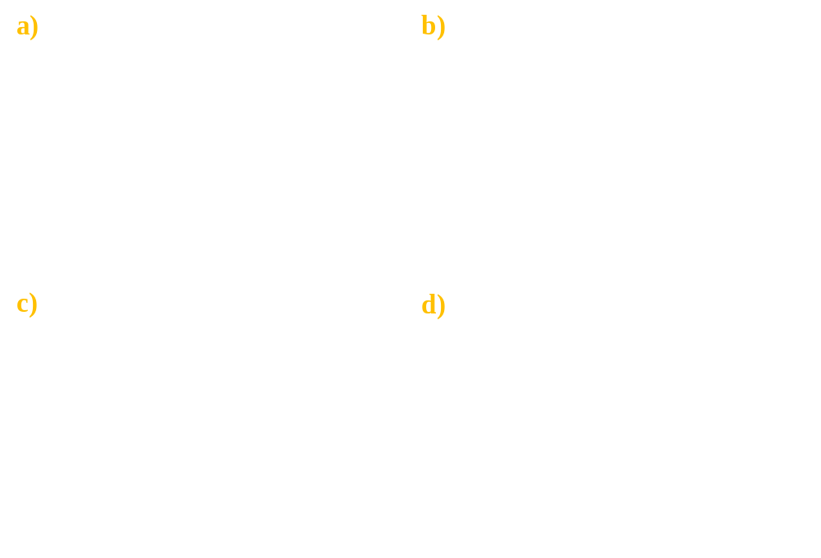
Fig S1. a-b) SEM images of Cellulose acetate at different magnifications c-d) SEM images of cellulose acetate polypyrrole at different magnifications.
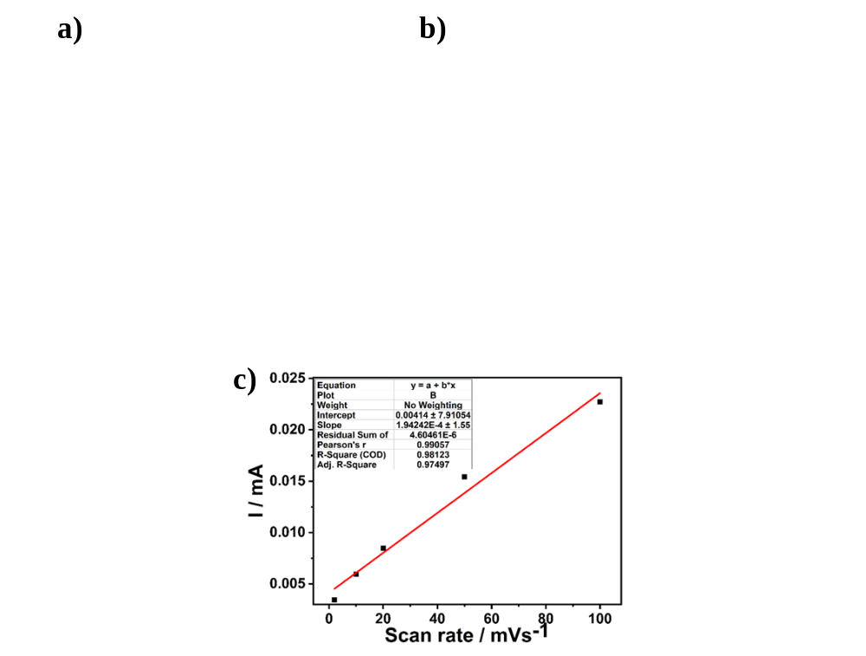
Fig S2.Cyclic voltammetry curves of cellulose acetate a) For varying concentrations of uric acid, b) Fixed concentration of analyte at different scan rates, C) Calibration curve of current vs. scan rate.

