Supplementary files
Fig.1 UV of leaf extract
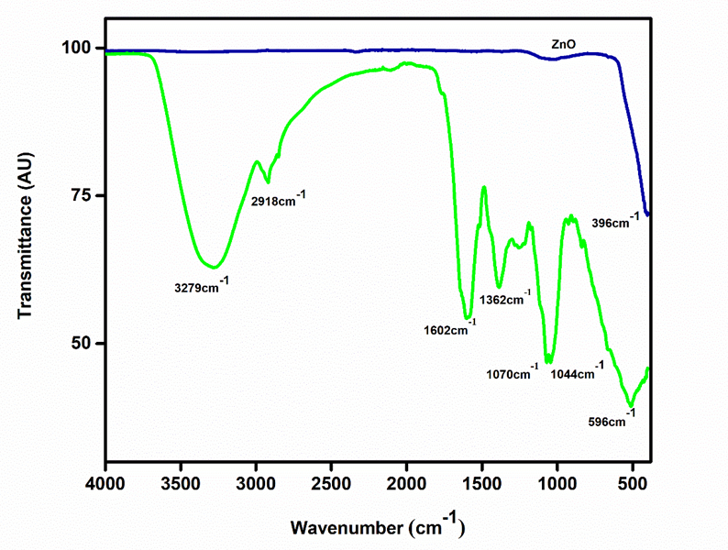
Fig.2 FTIR spectra of leaf and ZnO NPs
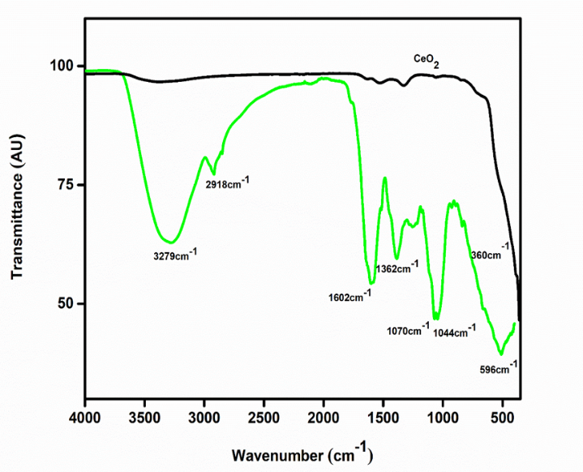
Fig.3 FTIR spectra of leaf and CeO₂ NPs

