Supplementary Information

Solvation-enhanced electrolyte on layered oxide cathode tailoring even and stable CEI for durable sodium storage
Sen Wang¹, Jiyu Zhang², Weibo Hua³, Longfei Wen², Guochuan Tang², Xin Wang², Cunshuang Ma², Weihua Chen^{2 *}
¹ College of Ecology and Environment, Zhengzhou University, Zhengzhou, Henan, 450001, China
² College of Chemistry & Green Catalysis Center, Zhengzhou University, Zhengzhou, Henan, 450001, China
³ School of Chemical Engineering and Technology, Xi’an Jiaotong University, Xian, Shanxi, 710049, China
*Correspondence: chenweih@zzu.edu.cn
S. Wang and J. Zhang contributed equally to this work

Preparation of materials
Ni_{1/3}Fe_{1/3}Mn_{1/3}(OH)₂ precursor was provided by Henan Kelong Group Co., Ltd. The sodium carbonate (Na₂CO₃) was purchased from Sinopharm Chemical Reagent Co., Ltd. (AR, ≥99.8%). A certain amount of Ni_{1/3}Fe_{1/3}Mn_{1/3}(OH)₂ precursor was weighed and placed in a mortar with an excess of 2% Na₂CO₃ and ground manually for 0.5 h. The samples were transferred to muffle furnace and calcined at 900 ºC for 12 h to obtain the final product.
Electrolyte solvents and sodium salt were purchased from Suzhou Do Do Chem Technology Co. A quantitative amount of NaPF₆ was dissolved in a binary solvent made by combining EC with DMC, EMC, DEC, and PC in a glove box, all with a volume ratio of 1:1 component and a salt concentration of 1 mol/L, and 5 wt% fluoroethylene carbonate (FEC) was added to make four electrolytes with different components were produced, named EC/DMC, EC/DEC, EC/EMC, and EC/PC, respectively.
Electrode sheet preparation and cell assembly
The active material, carbon black (Super P) and polyvinylidene fluoride (PVDF) were mixed evenly according to the mass ratio of 8:1:1 and applied to the aluminum foil with a slurry. The coated electrode sheets were dried overnight in a vacuum oven at 80 ºC, and the dried electrode sheets were cut into 13 mm diameter discs. The battery was assembled in a glove box filled with argon gas with water oxygen content less than 0.1 ppm. Sodium metal sheet was selected as the anode and glass fiber separator was assembled into CR2025-type coin cell with the above four different components of electrolyte. Constant current charge/discharge, DC impedance and galvanostatic intermittent titration technique (GITT) of batteries were tested in Shenzhen Neware CT-4008 charge/discharge instrument within a voltage range of 2.0-3.9 V. The linear scan voltammetry (LSV) test and cyclic voltammetry (CV) test were performed using Shanghai C&H 1000C and CHI604e electrochemical workstations, respectively. The AC impedance test (EIS) is performed using Solartron 1455 high-precision impedance analyser, with the test frequency range of 1 MHz to 0.01 Hz and the amplitude of 10 mV.
GITT calculation. The charging time was set at 600 s (τ), followed by a 600 s rest process. For calculating the diffusion coefficient of sodium ions (D), the equation can be as follows:
$\text{D}\text{ =} \frac{\text{4L²}}{ \text{πτ}}{\left(\frac{\text{∆}{\text{E}}_{\text{s}}}{\text{∆}{\text{E}}_{\text{τ}}}\right)}^{\text{2}} \left(\text{τ}\text{≪}{\text{L}}^{\text{2}}\text{/D}\right)$ (1)
where L, τ represent the thickness of the coated material on the electrode, and charging time per round, respectively.
Material characterization
The phases were analyzed using a Panaco Empyrean X-ray diffractometer (XRD) with the test conditions of Cu Kα radiation, 45 kV, 40 mA, scanning speed of 1°/min. X-ray absorption fine structure (XAFS) were collected on the beamline BL1606 by Canadian Light Source (CLS). The microscopic morphology, structure and element distribution of the materials were observed using a scanning electron microscope (SEM), equipped with EDS (Oxford X-Max) of the Merlin Compact type manufactured by ZEISS, Germany, and a transmission electron microscope (TEM) of the FEI Talos F200S, USA. The X-ray photoelectron spectroscopy (XPS) was performed using Thermo Escalab 250Xi.
In-situ differential electrochemical mass spectrometry (DEMS) experiments were conducted in a customized battery, which was assembled in an argon filled glove box. Using high-purity argon gas (99.999%) as the carrier gas. Purge the pipeline with a high flow rate to remove air. Then, control the flow rate at 1 mL min⁻¹ through the gas controller. The gas products during the battery charging and discharging process are carried through a low-temperature electrolyte vapor collection tube (-30 ℃) to condense the electrolyte vapor before entering the mass spectrometer (HPR-20 DEMS, Agilent). Real time monitoring of gas product types and contents through mass spectrometry.
Theoretical calculations
Structural relaxation was performed using VASP software. A projection enhanced wave (PAW) pseudopotential is used and the exchange correlation energy is solved using the Perdew-Burke-Ernzerhof (PBE) parametric generalized gradient approximation (GGA). The kinetic energy cutoff of the electron wave function is 400 eV. A conjugate gradient method is used for geometric optimization, setting the convergence threshold to an energy of 10⁻⁴ eV and a force of 0.03 eV Å⁻¹. The system uses a G-grid with k points to sample the Brillouin zone.

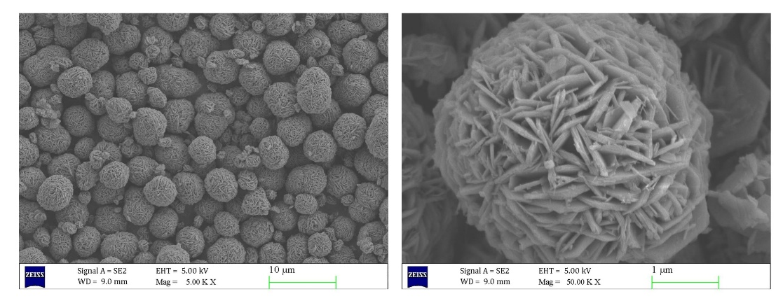
Fig. S1. SEM images of Ni_{1/3}Fe_{1/3}Mn_{1/3}(OH)₂ precursor.

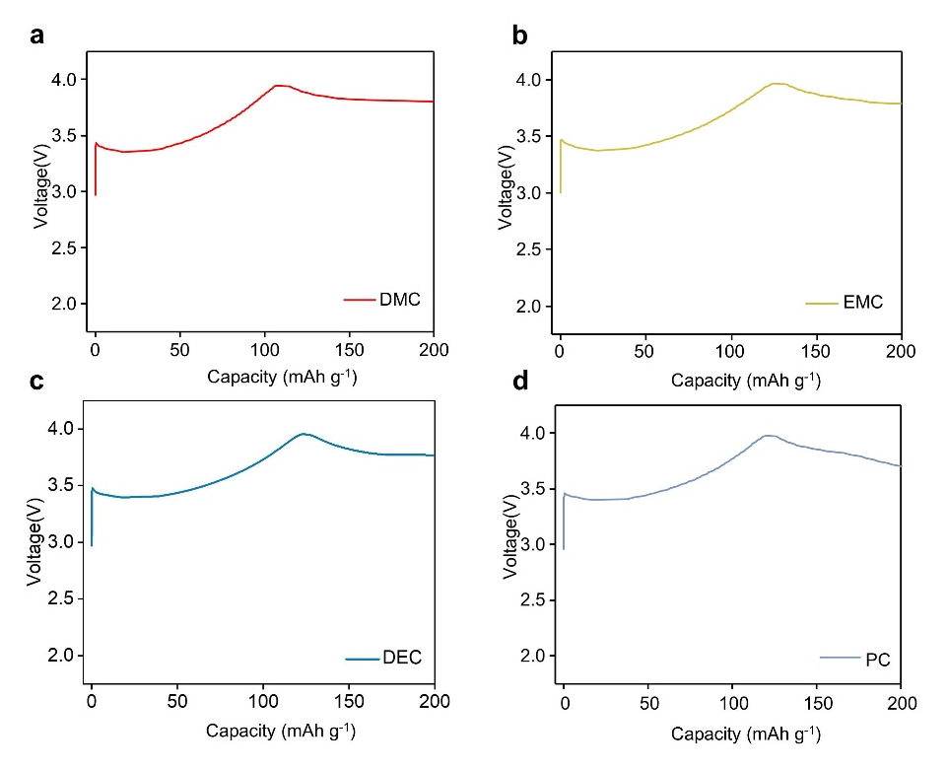
Fig. S2. Charge/discharge curves of four electrolytes within the voltage window of 2.0-4.0 V: (a) EC/DMC; (b) EC/EMC; (c) EC/DEC; (d) EC/PC.

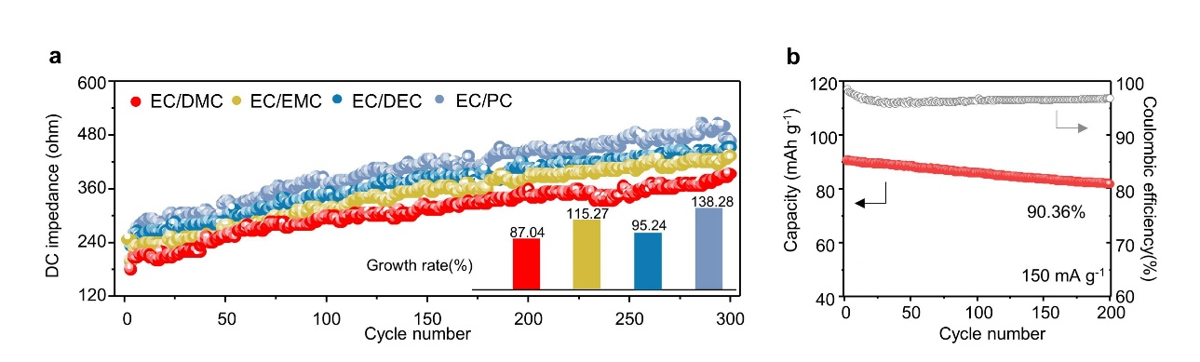
Fig. S3. Sodium storage performance of NFM cathodes in four electrolytes: (a) DC internal resistance of discharge during cycling; (b) Cycling performance and Coulomb efficiency of high-loading NFM cathode.

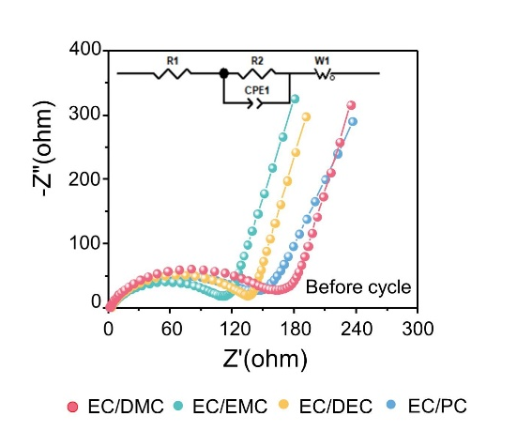
Fig. S4. EIS plots before initial cycle with fitted equivalent circuit model.

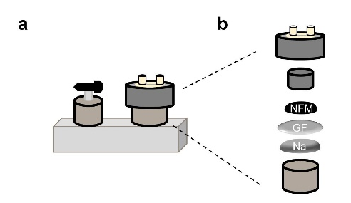
Fig. S5. (a-b) The schematic diagram of cell mold of the differential electrochemical mass spectrometry.
The jittery charge/discharge curve is strongly related to the test conditions of differential electrochemical mass spectrometry.
(1) The cell configuration of the differential electrochemical mass spectrometry (DEMS) is quite different from the that of coin cell. The schematic diagram is shown below, where a pressure cannot be applied to the cell system, which may cause the pole piece to be unable to make good contact with the anode, resulting in a jittering charge/discharge curve. Meanwhile, the sealing of the DEMS cell configuration is also not as good as that of cell cells, which may cause the electrolyte to be affected by the moisture in the air.
(2) The preparation of electrodes. In order to make the gas generated around the electrode inside the cell better detected during charge/discharge process, the cathode collector uses an aluminum mesh instead of aluminum foil. And the uneven distribution of active material on the aluminum mesh may further deteriorate the contact between active materials, and bring additional difficulties to desodiation/sodiation on the electrode surface.

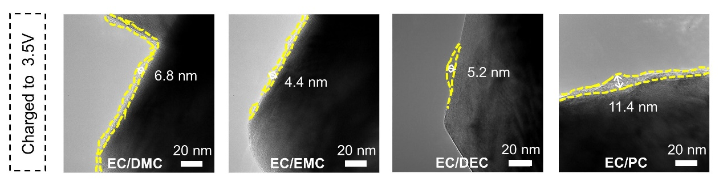
Fig. S6. TEM images of NFM cathodes in four electrolytes upon at charging to 3.5V.

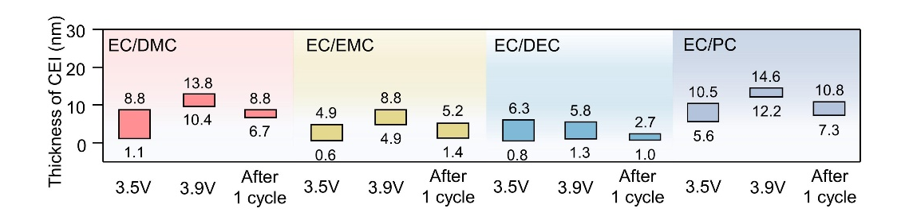
Fig. S7. Statistical thickness of CEI at various electrochemical states.

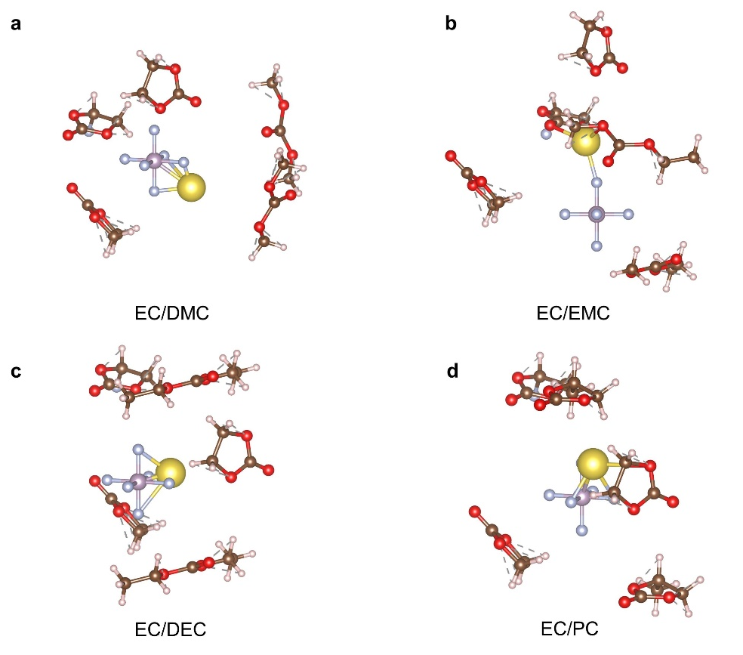
Fig. S8. Solvation behavior of four solvents at the bulk electrolyte: (a) EC/DMC; (b) EC/EMC; (c) EC/DEC; (d) EC/PC.

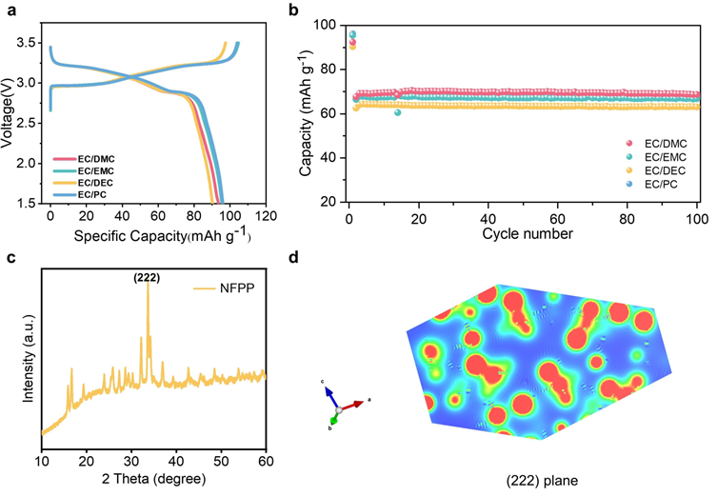
Fig. S9 Sodium storage performance of NFPP cathodes in four electrolytes: (a) Initial charge/discharge curves at 11.91 mA g⁻¹; (b) Cycling performance at 119.1 mA g⁻¹; Characterizations of NFPP material: (c) XRD pattern; (d) Electron density distributions of (222) plane of NFPP crystal.

The NFPP material was purchased from Shanghai Changgao New Material Technology Co. The similar charge/discharge curves of the NFPP cathode in the four electrolytes indicated the same desodiation/sodiation process (Figure S9a). The cathodes showed the highest initial discharged capacity of 96.1 mAh g⁻¹ in EC/PC electrolyte, followed by EC/EMC, EC/DMC with 95.5 mAh g⁻¹ and 92.3 mAh g⁻¹ respectively, and the lowest initial discharge capacity of 90.2 mAh g⁻¹ in EC/DEC electrolyte. After 100 cycles, the NFPP electrodes did not show a significant capacity decrease in the four electrolytes (Figure S9b). Thus, above experimental results did not well reflect the trend and phenomena that occurred in NFM cathodes.
The reasons for the performance difference could be attributed to the following two points:
(1) Differences in materials’ surface properties. The NFPP consisted of polyanionic frameworks, including PO₄ and P₂O₇ dimers (Chem. Soc. Rev., 2020, 49, 2342). In the framework of polyanionic compounds, the electron cloud of transition metal valence electrons and the transfer of electrons between transition metal ions were hindered. Therefore, the surficial electron conductivity of polyanionic-type materials was generally lower than those of layered oxides. On the other hand, central atoms in high valence states (P⁵⁺) inside polyanions could partially shield the nucleophilic properties of O atoms, inhibiting the excessive oxidation of electrolytes on the cathode surfaces. Thus, the polyanion-type cathodes usually suffered from slight interfacial and side reactions, enabling negligible electrochemical difference in the four electrolytes. Differently, the NFM was attributable to the layered transition metal oxide materials. Due to the high covalence and electronegativity of M-O bond in oxides, the coordinated O atoms showed strong nucleophile and electron-donating ability of O atoms on oxide surfaces to the electrolytes. Therefore, the oxides cathode usually displayed an increased nucleophilic attack ability of metal ions on electrolyte solvent (Chem. Soc. Rev., 2021, 50, 10486). Moreover, in the process of oxide-involved electrochemistry, the crystal structures of oxides tend to be instable with complex phase changes. It facilitates the dissolved metal ions and terrible O₂ gas, posing serious challenges for stable interface function and battery operations.
(2) Different properties of exposed crystal planes. The crystalline properties largely determined the electrochemical behaviors and reaction kinetics of the electrolytes on electrode surface (Nat. Commun., 2023, 14, 3701). The dominant (003) crystal plane of layered transition metal oxide materials NFM was selected for study in this manuscript. The (003) crystal plane showed rich electron-rich oxygen atoms, giving it a high electron density and strong nucleophilicity. This electron-rich electrode surface provides a strong electron supply capacity, which would promote further agglomeration of Na⁺-solvents coordination structures in electrolytes on cathode surface, exhibiting stronger Na⁺ solvation structures and interfacial reactivity. The EC/DMC electrolytes have a strong solvation structure due to the smaller spatial site resistance, and decomposition forms a robust and even CEI, ensuring good interfacial stability and reversible Na⁺ transfer. While NFPP crystal had a dominant (222) crystal plane (Figure S9c), whose electron density diffraction spectra featured less electron density and weaker nucleophilicity due to loosen atom arrangement (Figure S9d). It can be reasonably inferred that the low electron density of the crystal plane will bring weaker electron-donating ability, resulting in a higher decomposition potential of the electrolyte. Therefore, the electrolyte solvents have a stronger oxidation resistance on the (222) plane of NFPP crystals, and the enhanced oxidation resistance of the electrolyte could further strengthen the stability of cathode/electrolyte interface, which is different from that on NFM surface.
In summary, the interface rules of NFM electrodes in these four electrolytes may not be applicable to other cathodes. In fact, this is what we emphasize in this manuscript. In the study of electrode/electrolyte interface reaction and evolution, it is necessary to consider the influence of cathode material surface properties. More broadly, for cathode materials with special surface properties, it is imperative to develop suitable electrolytes.

Table S1 Refined XRD parameters of NFM material.
Atoms | Wyck. site | x | y | z | Occ.
Na | 3a | 0.00000 | 0.00000 | 0.00000 | 1.00000
Ni | 3b | 0.00000 | 0.00000 | 0.50000 | 0.33333
Fe | 3b | 0.00000 | 0.00000 | 0.50000 | 0.33333
Mn | 3b | 0.00000 | 0.00000 | 0.50000 | 0.33333
O | 6c | 0.00000 | 0.00000 | 0.23304 | 1.00000

F-1s |  |  | C-1s
 | C-F | Na-F | C-F | O=C-O | C=O | C-O | C-C/C=C
EC/DMC | 82.22% | 17.78% | 17.48% | 6.98% | 38.87% | / | 36.67%
EC/EMC | 74.03% | 25.97% | 7.39% | 19.92% | 13.83% | 46.03% | 12.83%
EC/DEC | 76.83% | 23.17% | 16.61% | 7.83% | 36.78% | / | 38.78%
EC/PC | 74.29% | 25.71% | 17.72% | 4.54% | 42.10% | / | 35.64%
Table S2 The XPS data of different bonds in the EC/DMC, EC/EMC, EC/DEC and EC/PC.

Table S3 R_{s}, R_{ct}, R_{CEI} and W_{s} were obtained from the fitted model in the EIS plots before and after initial cycle.
Before initial cycle | R_{s} | R_{ct} | R_{CEI} | W_{s}
EC/DMC | 1.3 | 141.2 | / | 105.5
EC/EMC | 1.9 | 101.2 | / | 33.6
EC/DEC | 2.3 | 144.1 | / | 33.3
EC/PC | 1.5 | 121.3 | / | 79.4
After initial cycle
EC/DMC | 2.0 | 125.3 | 51.0 | 117.7
EC/EMC | 4.6 | 92.7 | 43.2 | 79.3
EC/DEC | 1.4 | 126.4 | 74.3 | 94.2
EC/PC | 1.4 | 116.5 | 74.1 | 112.5

