Supporting Information

Moderate Active Fe³⁺ Doping Enables Improved Cationic and Anionic Redox Reactions for Wide-Voltage-Range Sodium Storage
Congcong Cai,^{1,2} Xinyuan Li,² Hao Fan,² Zhuo Chen,² Ting Zhu,² Jiantao Li,⁴ Ruohan Yu,² Tianyi Li,⁵ Ping Hu,^{1,2,3*} and Liang Zhou^{1,2*}

¹Hubei Longzhong Laboratory, Wuhan University of Technology (Xiangyang Demonstration Zone), Xiangyang 441000, Hubei, China.
²State Key Laboratory of Advanced Technology for Materials Synthesis and Processing, Wuhan University of Technology, Wuhan 430070, China.
³School of Microelectronics, Hubei University, Wuhan 430062, PR China
⁴Chemical Sciences and Engineering Division, Argonne National Laboratory, Lemont, IL 60439, USA.
⁵X-ray Science Division, Argonne National Laboratory, 9700 South Cass Avenue, Lemont, IL 60439, USA.
Corresponding authors: huping316@163.com (Ping Hu); liangzhou@whut.edu.cn (Liang Zhou)

Experimental Section
Materials preparation. The Na_{0.67}Mg_{0.1}Fe_{x}Mn_{0.9-x}O₂ (x = 0, 0.1, 0.2) compound was synthesized by a simple organic acid-assisted solid state reaction method. Firstly, oxalic acid (44 mmol) was dissolved in 20 mL deionized water and stirred vigorously for 2 h. Then, NaNO₃ (6.7 mmol, 5 wt.% in excess according to stoichiometry), Mg(NO₃)₂·6H₂O (1 mmol), Fe(NO₃)₃·9H₂O (10x mmol), Mn(CH₃COO)₂·4H₂O (9 – 10x mmol) were added stepwise and stirred for 2 h. The suspension was heated to 80 °C overnight to evaporate the water and further dried at 180 °C for 3 h. The as-obtained powder was ground manually and then heated to 500 °C for 2 h. Then the mixture was thoroughly mixed and ground in an agate mortar and pressed into pellets under pressure of 5 MPa. After further heated at in air at 800 °C for 10 h. Then, the sample was naturally cooled down to room temperature, and stored in an Ar-filled glovebox.
Material characterization. X-ray diffraction (XRD) was performed on a Bruker D8 Advance X-ray diffractometer with a Cu Kα X-ray source (λ = 1.5406 Å). Scanning electron microscopy (SEM) were performed on a JEOL-7100F microscope. Transmission electron microscopic (TEM) and high-resolution TEM (HRTEM) images were collected using a JEOL JEM-2100F. High-angle annular dark-field (HAADF)-scanning transmission electron microscopy (STEM) images were conducted on Titans Themis. Raman tests were performed using a Horiba LabRAM HR Evolution with a 532 nm excitation laser. X-ray photoelectron spectroscopy (XPS) was carried out on a Thermo-Fisher Scientific-ESCALAB 250Xi equipped with an Al Kα monochromated X-ray source. X-ray absorption spectroscopy (XAS) measurements were collected at 12-BM-B at the Advanced Photon Source (APS) in Argonne National Laboratory. The radiation was monochromatized by a Si (111) double-crystal monochromator.
Electrochemical Characterization: The electrochemical performances were tested by assembling CR2016 coin cells in the Ar-filled glove box. Sodium foil was used as both the counter and reference electrodes. The working electrodes were prepared by casting the slurry containing 70 wt.% of active materials, 20 wt.% of acetylene black, and 10 wt.% of polyvinylidene fluoride in N-methyl-2-pyrrolidone onto Al foil and dried at 100 °C in a vacuum oven overnight. 1.0 M NaPF₆ in propylene carbonate containing 5 % of fluoroethylene carbonate (FEC) was used as the electrolyte and glass fiber was used as the separator. The mass loading of active materials was 1–1.5 mg cm⁻². GCD measurements were performed on a NEWARE battery testing system within the potential range of 1.5–4.5 V (vs. Na⁺/Na). CV tests were conducted on CHI600E electrochemical workstations.
For in-situ XRD test, the electrodes were consisted of 80 wt.% of active materials, 10 wt.% acetylene black and 10 wt.% of polytetrafluoroethylene. For ex-situ measurements, the electrodes were disassembled from the coin cell, washed with electrolyte solution repeatedly, and dried in an Ar-filled glove box.

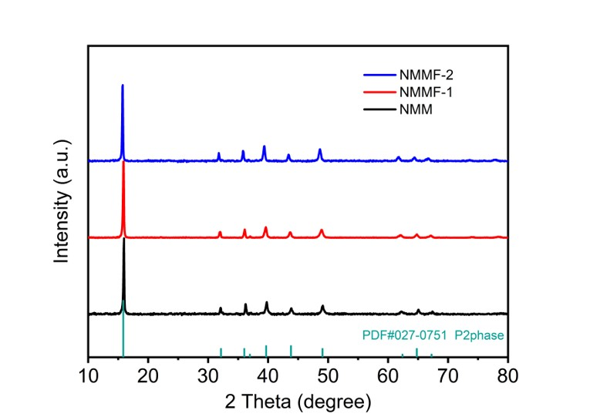
Fig. S1. XRD patterns of the NMMFs.

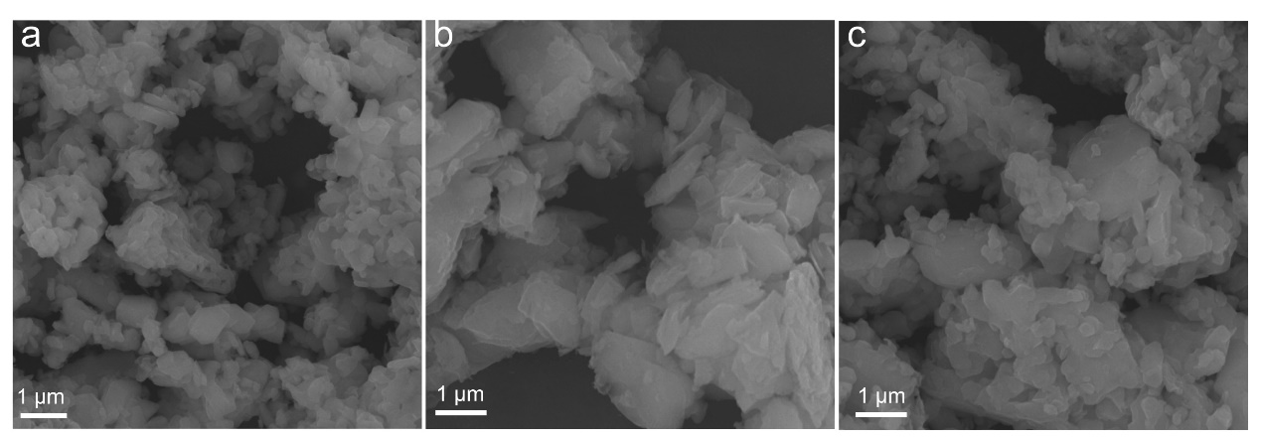
Fig. S2. SEM images of the (a) NMM, (b) NMMF-1, and (c) NMMF-2.

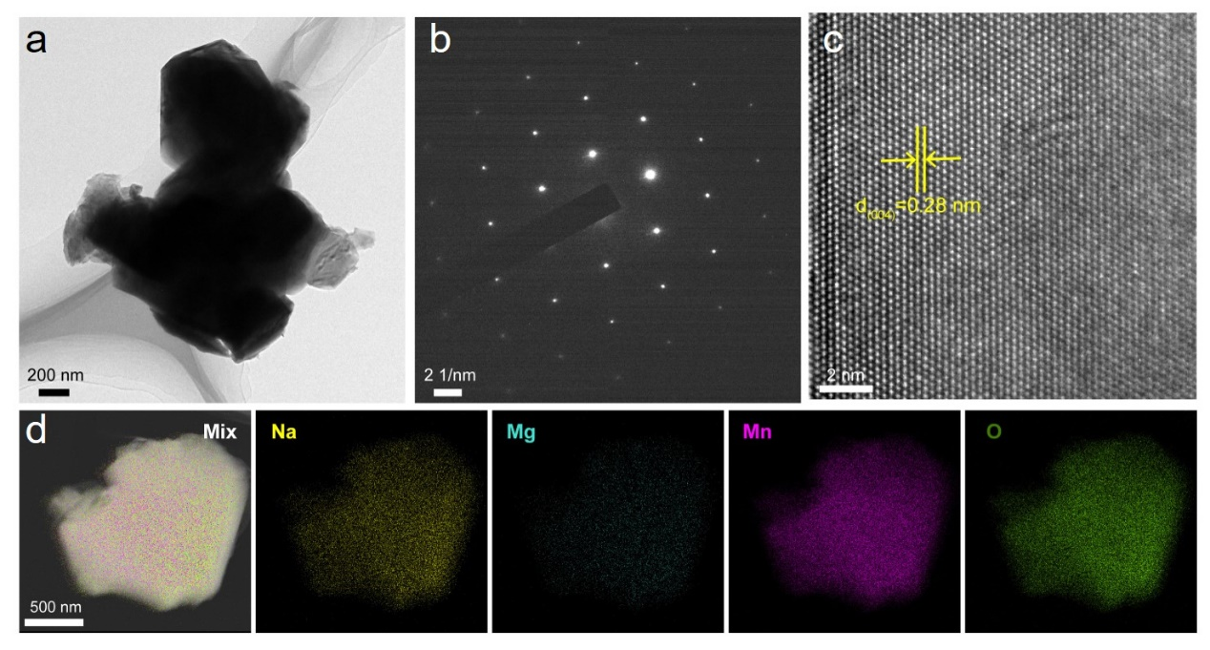
Fig. S3. (a) TEM image, (b) SAED, (c) HRTEM, and (d) EDS mapping of NMM.

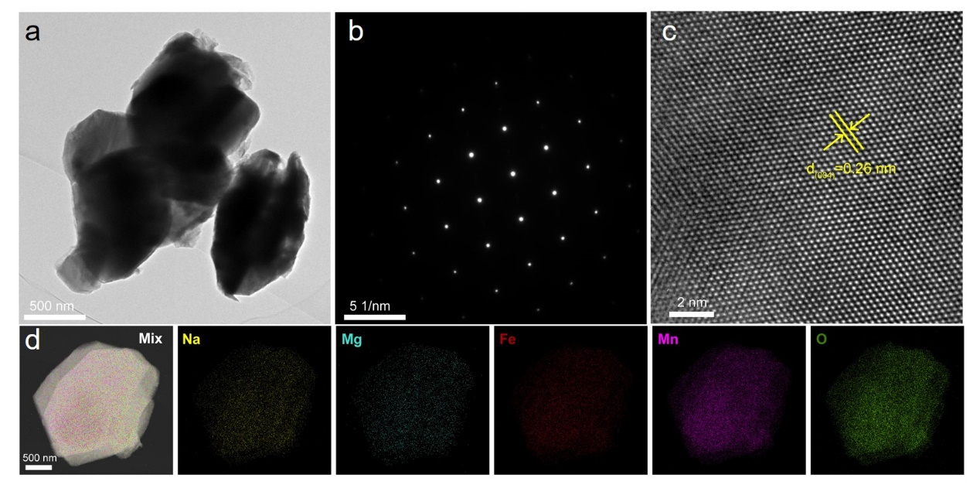
Fig. S4. (a) TEM image, (b) SAED, (c) HRTEM, and (d) EDS mapping of NMMF-2.

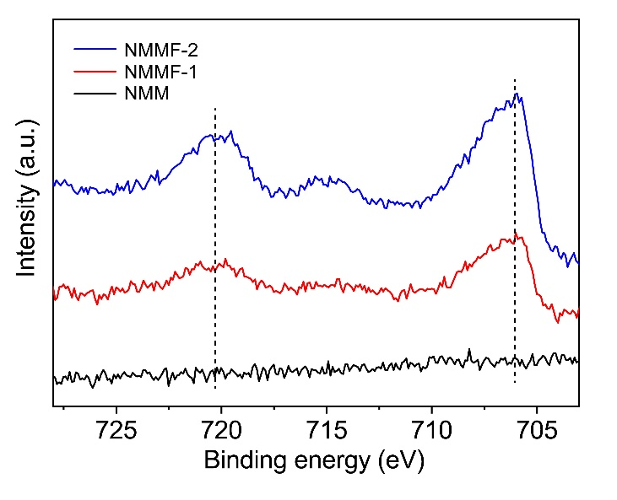
Fig. S5. Fe 2p_{1/2} and 2p _{3/2} XPS peaks of NMM, NMMF-1, and NMMF-2.

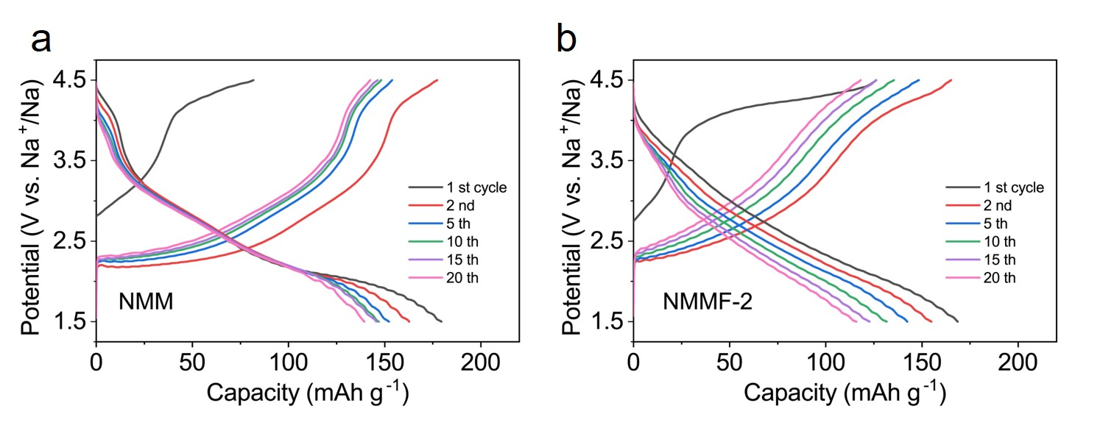
Fig. S6. The charge/discharge profiles of NMM and NMMF-2 at 20 mA g⁻¹ in different cycles

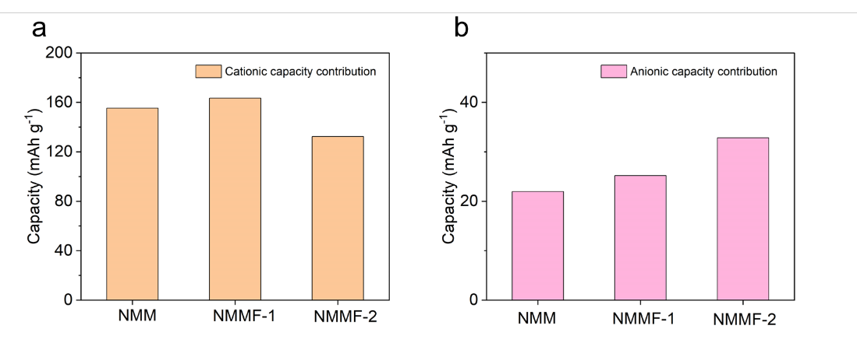
Figure S7. The (a) cationic and (b) anionic capacity contributions of NMMFs at the second charge process.

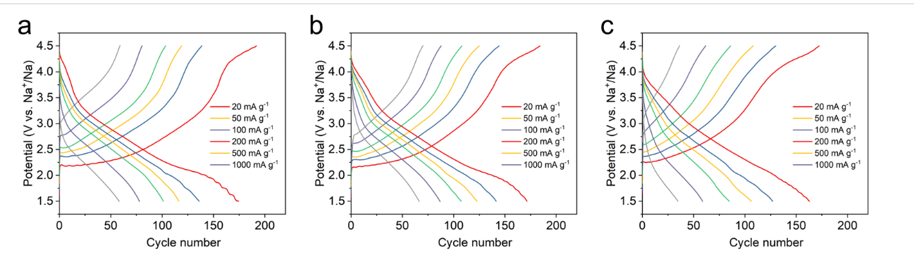
Figure S8. Charge/discharge profiles of (a) NMM, (b) NMMF-1, and (c) NMMF-2 at different current densities.

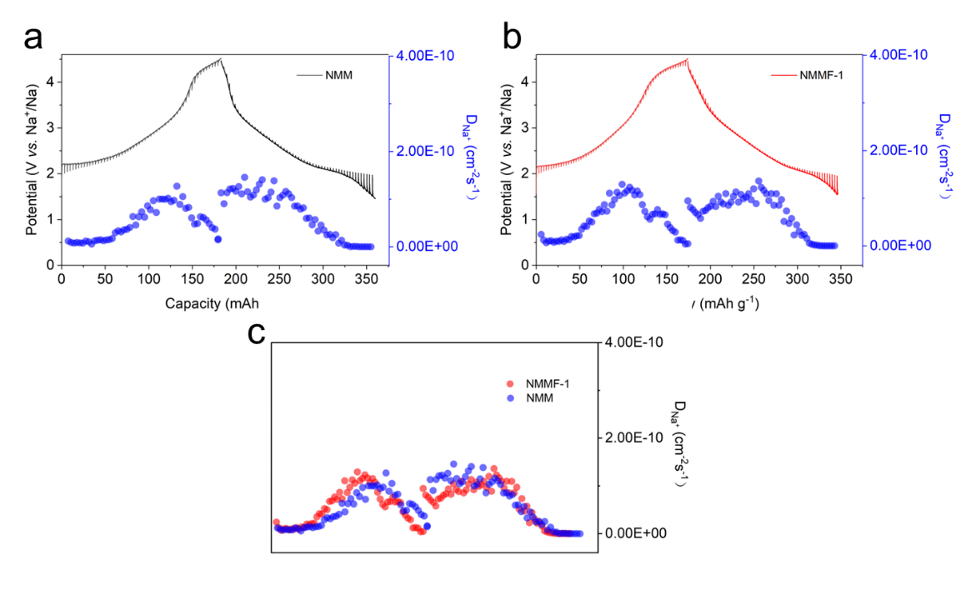
Figure S9. GITT tests for (a) NMM and (b) NMMF-1, and (c) the calculated Na diffusion coefficient ($D_{{Na}^{+}}$).

Table S1. Crystallographic parameters of NMM obtained from XRD Rietveld refinement.

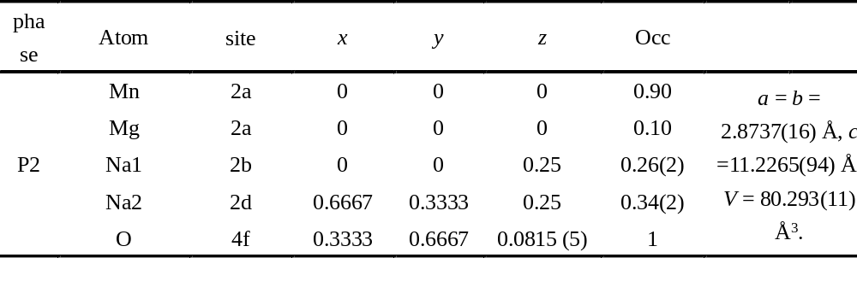

Table S2. Crystallographic parameters of NMMF-1 obtained from XRD Rietveld refinement.

